NG-NM-1015 and the 1765 Kandy booty
The Rijksmuseum’s description of the silver- and gold-inlaid cannon returned to Sri Lanka in 2023, set beside what the VOC’s Colombo resolutions of autumn 1765 say about a small silver-inlaid cannon taken at Kandy. References such as 3143/1070 are inventory/scan numbers in Nationaal Archief 1.04.02, readable through GLOBALISE.

Museum record: Rijksmuseum NG-NM-1015 | Archive: VOC Ceylon papers, 1765
IMAGE
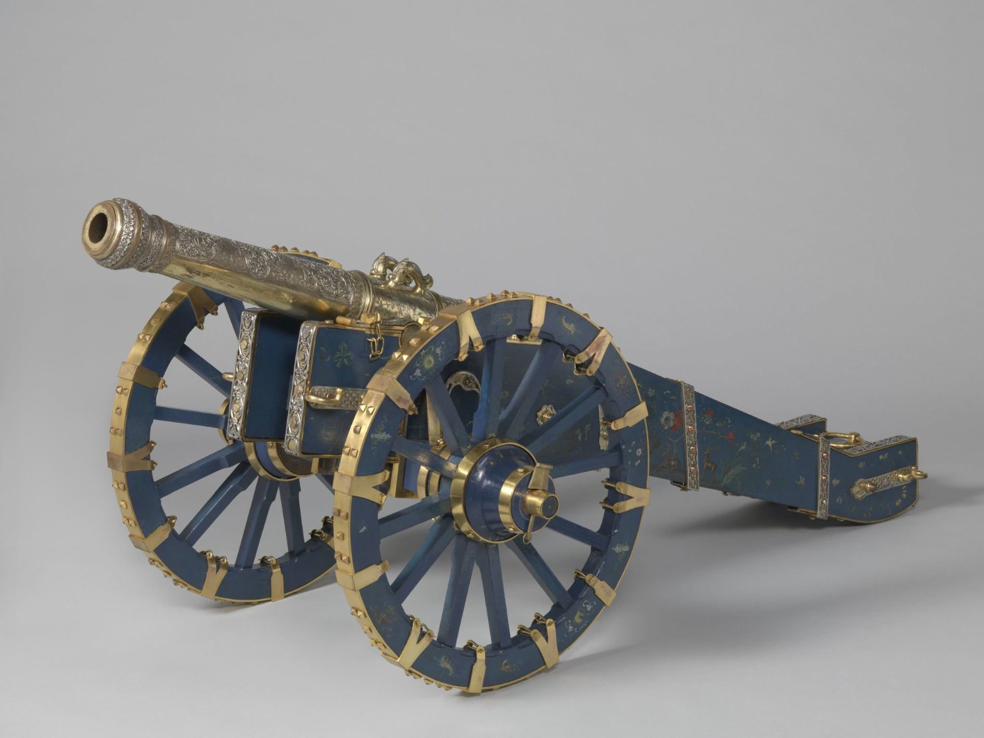  Rijksmuseum, NG-NM-1015, “Kanon”. Returned to Sri Lanka in 2023. Check the rights statement on the object page before reuse. | 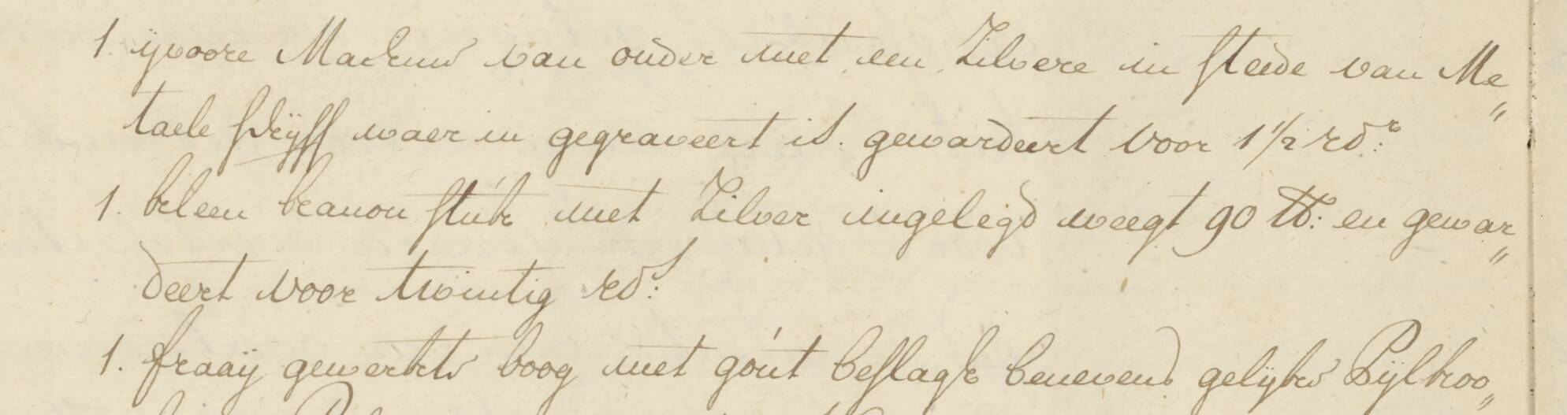  Crop of the Colombo resolution of 22 Oct 1765, Nationaal Archief 1.04.02, inv. 3143, scan 1070 (GLOBALISE transcription page). The middle entry reads “kleen kanon stuk met zilver ingelegd weegt 90 lb: en gewardeert voor twintig rd:s”.
NAME USED
Title “Kanon”; full Dutch title “Singalees kanon of Lewuke’s kanon”. Object types: cannon, gun mount, rammer, shovel. | “Kleen kanon stuk” in the lists of 28 Sept and 22 Oct 1765 (3143/0949, 3143/1070); “kannonnetje” in the council’s resolution of 22 Oct (3143/1069).
ORIGIN AND CAPTURE
Made in Sri Lanka, dated 1745. Curatorial text: captured by Dutch troops during the siege of Kandy in 1765; joint provenance research found involuntary loss of possession; returned to Sri Lanka in 2023 and now shown in the Colombo National Museum. | “In Candia buit gemaakt”, found in the estate of Governor Lubbert Jan van Eck (3143/0949, 3143/1070). A letter in inv. 3137 calls it “in Kandia veroverd” (3137/0097). The palace is not named for the cannon itself, though the estate’s other rarities are described as taken from the king’s palace (3200/0031).
MATERIALS
Bronze barrel with a wooden carriage; silver; precious stone (small rubies). | Not stated. The committee that weighed and tested the booty included the master of the Colombo type foundry (3143/1070).
DECORATION AND INLAY
Complex decoration on top, partly cast in relief and then covered in silver; the ground inlaid with gold and silver; small rubies set in places.  Seen in the photograph: gilded barrel with silver relief ornament, blue-painted carriage with animals and flowers, silver plaques and gilt mounts. | “Met zilver ingelegd”: silver inlay only. No gold, stones or painted carriage mentioned.  The same committee downgraded other “gold” items on the list to gilt iron or gilt copper (sword grip, staff mounts), so the omission of gold may reflect testing, or a short description.
SIZE AND WEIGHT
54 cm high × 181 cm wide × 77 cm deep, as catalogued. No barrel length, bore or weight in the record. | “Kleen” (small). Weight 90 lb, about 45 kg if Amsterdam pounds are meant (my conversion, not checked against the GLOBALISE measures glossary). Not stated whether the carriage is included.
FITTINGS, INSCRIPTION, EMBLEMS
Sinhala inscription on the barrel (the bibliography cites a 1945 article on a “Sinhala cannon of 1745”). Emblems of the King of Kandy: sun, crescent moon and Sinhalese lion. Ramrod and shovel; carriage painted with animals and flowers. | None mentioned.
VALUATION
None in the record. | 20 rixdollars (3143/1070), described as “eene enkelde rariteit zonder eenig verder gebruik” (3143/1069) and, by the governor, “geen stuk van waarde” (3138/0043). For scale on the same list: Buddha figure 200, bow with gilt mounts 60, sword 30, canopy 1,200 rixdollars. No euro equivalent is given because a meaningful conversion is not possible.
WHAT HAPPENED NEXT
Returned in 2023. The record carries no parsed provenance chain. The bibliography cites the provenance report “Sporen” (Mooren, Stutje, van Vree), Schulten on the French seizures of 1795–1815, Lunsingh Scheurleer on the Royal Cabinet of Rarities, and Grijzenhout on the Rijksmuseum under Louis Napoleon. Depicted persons tagged: William V, Van Eck, Vijaya Rajasinha. | On 22 Oct 1765 the council let the governor take it at the valuation, to be sent “volgens de intentie van den overleedenen” to Louis, Duke of Brunswick-Wolfenbüttel (3143/1069). The council informed the Heren XVII on 11 Nov 1765 (3143/1211); see also 3137/0097 and 3138/0043. It is absent from the list released to Van Eck’s heirs in May 1766 (3200/0031). No record of arrival in the Netherlands found.

Reading the comparison
Agreement: capture at Kandy in 1765, a cannon with silver inlay, and a cannon small enough to be a curiosity. Difference: the archive never mentions gold, stones, a painted carriage, an inscription or royal emblems. Not shown: any link between the cannon sent to Brunswick and the object later in Dutch hands. On the archive alone, the match is plausible but unproven.

What would prove they are the same object
- A document linking the Brunswick cannon to William V or the Stadholder’s cabinet: an inventory, gift record or shipping list. The Rijksmuseum provenance report “Sporen” and the Brunswick-Wolfenbüttel papers are the first places to look.
- An earlier description at the time of capture, possibly in the Kandy expedition diaries (inv. 3112 and 3138), which I have not read page by page.
- Physical checks: barrel weight against the 90 lb entry, and analysis of whether the “gold” inlay is gold or gilding.

Sources
Rijksmuseum, NG-NM-1015: https://www.rijksmuseum.nl/en/collection/NG-NM-1015
Nationaal Archief, VOC archive 1.04.02, inventories 3137, 3138, 3143, 3200 and 3203, via GLOBALISE: https://transcriptions.globalise.huygens.knaw.nl/detail/urn:globalise:NL-HaNA_1.04.02_3143_1070
Transcriptions are machine-read (HTR); the key line in 3143/1070 was checked against the scan.

