Dodo names in the GLOBALISE VOC transcriptions
Keyword search of the Nationaal Archief VOC records (1.04.02), 31 October 2026

Summary
We searched the GLOBALISE transcriptions (about 4.8 million machine-read pages) for the dodo under the spellings the Company writers used, then read every hit. Eight pages in five episodes genuinely use a dodo name. They are listed in the table on the next page, followed by the scans for two of them.
Names found. The writers spell it dodersen or dodeersen (1615, 1629, 1674), dodeers (1647) and dodaers or dodaersen (1669–70). "Walghvogel" appears once, as "walg vogels" split across a line break (1674). "Dronte" never occurs as a bird: every hit is Trondheim, a place called Dronten, or "drontenschap" (drunkenness).
What the pages say.
- 1615 and 1629, Mauritius (four pages). The birds are caught or listed as refreshment for ships, alongside tortoises, pigs and goats. Nothing is said about appearance or behaviour.
- 1647, Nagasaki (two pages). A live animal called dodeers is shown to the governor beside a hart. A list of unvalued goods dated 29 August carries "1 dodeers" with no description. The identification rests on the name and the setting.
- 1669–70, Mauritius (one page). A writer describes the dodaers as a red, hen-sized bird that cannot fly, comes to a waved red cap and can be killed with a stick. That is the red rail, not the dodo, and should not be cited as a dodo.
- 1674, Mauritius (one page). A recaptured runaway says he saw dodeersen twice in eleven years in the bush, "as large as a cassowary". The writer links them to the walgh-birds of the first discovery and adds that no Dutch resident has seen such birds. This is hearsay.
Latest reference. The latest reference I would defend is the 1674 page, as a report of the name and of a claimed sighting, not as an observation. The latest dodo whose identity is secure is the captive animal at Nagasaki in September 1647.
Limits. The search works on spelling. A bird described without a name, such as the 1638 red rail found with an embedding model, cannot be reached this way: keyword searches for Mauritius plus bird words in 1636–40, and for red hens before 1700, found nothing. Searches restricted by year skip inventories the finding aid does not date (mostly the Zeeland copies, 9000–11024); the open searches did not. The readings on 4005_0603, 4011_0411, 1165_0143 and 1164_0738 were checked against the scans. The 1615 and 1629 pages were read in the machine transcription only.

Pages that use a dodo name
Date | Place | Page ID | Words used | What the writer says the bird did | Confidence that it is the dodo
17–21 Apr 1615 | Mauritius (ship Wapen van Amsterdam) | NL-HaNA_1.04.02_1059_0277 | dodersen; dodeersen | Hunters bring tortoises and dodersen aboard (17 April). On 21 April "veel schilt padden dodeersen" and some geese and parrots are caught. | High  Name, island and use fit; no description.
c. 1 May 1615 | Mauritius (same ship) | NL-HaNA_1.04.02_1059_0278 | dodeersen | Nothing about the bird itself. Good refreshment was had "van dodeersen", tortoises of land and water, many lean pigs and goats. | High  Food list in the same voyage.
May 1615 | Mauritius (rhymed journal) | NL-HaNA_1.04.02_1059_0051 | dodersen | In verse, the island "gives" good wine, dodersen and partridges, geese and tortoises. A list of produce, not an observation. | Medium  Name fits, but a verse list may be conventional.
Jan 1629 | Mauritius (ship Nassau, bound for the Cape) | NL-HaNA_1.04.02_1095_0922 | dodeersen | Listed among refreshments obtained on Mauritius: goats, tortoises, velthoenders, dodeersen, pigs, palm heart, coconuts. No further comment. | High  Same food-list use as 1615.
29 Aug 1647 | Nagasaki (Dejima) | NL-HaNA_1.04.02_1164_0738 | dodeers | Nothing. One entry, "1 dodeers", in a list of unvalued goods ("ongetaxeert"). The page does not call it a bird. | Medium  Identification depends on the next row.
2 Sep 1647 | Nagasaki (Dejima) | NL-HaNA_1.04.02_1165_0143 | dodeers | At the governor’s request "het hert ende den dodeers" are taken to the council house to be inspected and brought back. The lord of Faccatta later views them on the island; the hart is ordered sent along to him, the dodeers is not mentioned again. | High  A live animal shown beside a hart; named only as dodeers.
After 1 Nov 1669 | Mauritius (report, volume 1668–70) | NL-HaNA_1.04.02_4005_0603 | dodaersen; dodaers | Listed among the land birds with pigeons and parrots. "De dodaers is een roode vogel, so groot als een haan", short-winged, cannot fly, scratches the ground like a hen for worms, runs to a waved red cap and can be clubbed with a stick; long pointed bill, slightly hooked at the end. | Low  The description fits the red rail, not the dodo.
1674 | Mauritius (journal, entries from 1 Jan 1674) | NL-HaNA_1.04.02_4011_0411 | dodeersen; walg vogels | A recaptured runaway says that in eleven years in the bush he saw dodeersen only twice, "as big as a cassowary". The writer takes them to be the walg vogels of the first discovery and says no Dutchman has seen such birds. | Medium  Hearsay; the size and the writer’s gloss favour the dodo.
Confidence is my estimate that the page refers to the dodo (Raphus cucullatus). High: name, place and use fit and nothing contradicts. Medium: name only, or hearsay. Low: the description points to another bird. The place is where the bird was, except at Nagasaki, where it is where the page was written. Page IDs link to the transcription viewer.

Scans
Figure 1. Nagasaki, 29 August 1647: list of goods and costs, "ongetaxeert" block (inventory 1164, scan 0738)
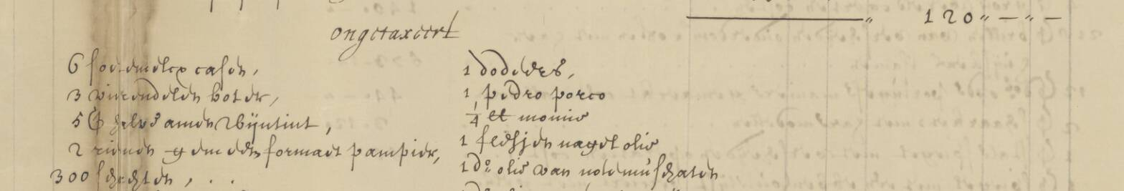
Right-hand column, first line: "1 dodeers". The heading above it reads "ongetaxeert" (unvalued). Machine transcription: "1 dodeers, 1 pedro porco, ¼ lb monnie …"
Viewer: NL-HaNA_1.04.02_1164_0738
Figure 2. Mauritius journal, 1674: the runaway’s report (inventory 4011, scan 0411, right-hand page)
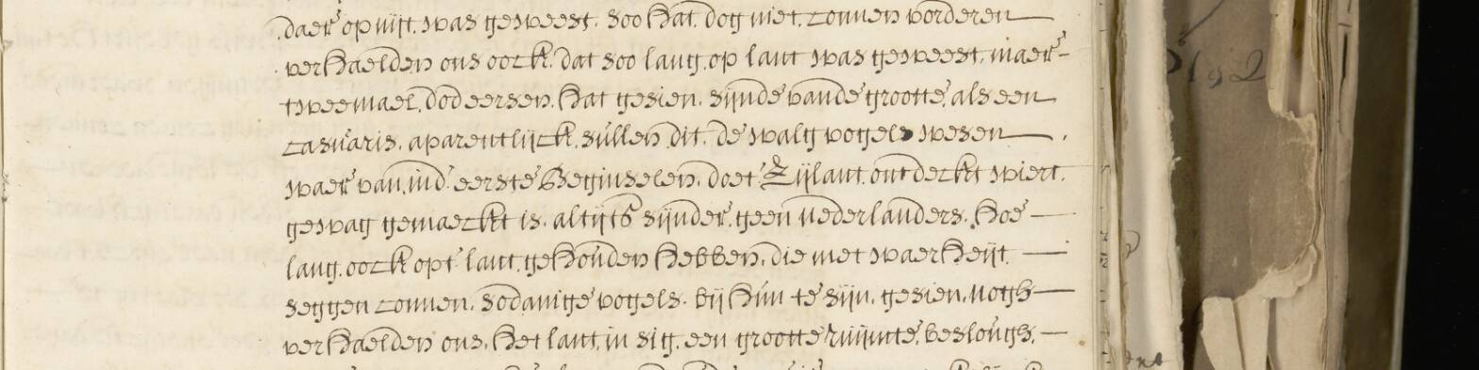
Machine transcription of the lines shown: "… dat soo lang, op lant was geweest, maer twee mael, dodeersen. hat gesien, sijnde vande grootte, als een casuaris. aparentlijck sullen dit de walg vogels wesen waer van in d’ eerste Beginselen, doet zijlant ontdeckt wiert. gewwag gemaeckt is…"
Viewer: NL-HaNA_1.04.02_4011_0411

Searches run
- "dodaer* OR dodaar* OR dodoor*", years to 1700: 2 pages.
- "dodeer* OR dodersen OR …" (further spellings), all years: 15 pages.
- Fuzzy ~1 on dodaers, dodeers, dodersen, dodaersen, dodeersen, doddaers, all years: 92 pages, nothing new.
- "walg vogel(s)" within three words, plus compounds such as walghvogel: 2 pages (compounds: none).
- "dodo OR doudo": 159 pages, all "ditto" abbreviations, the place Doudo, personal names and an English ship called The Dodo.
- "dronte*": 516 pages, all Trondheim, Dronten or drunkenness.
- Mauritius plus bird words, 1636–40 (64 dated inventories), and red hens plus Mauritius, to 1700: no red rail by name.

