Curves

*An official proposal of Kabir*

“*I think it’s time to publicly announce our relationship. I want to express my feelings to Neha in front of the public without any fear. But that moment should be special, memorable and mesmerizing. It should be the WOW factor proposal. I won’t say the cheesy lines like I love you and all, rather I will spell a code and she has to decipher it. Yes! That would be better. But……”*

With his geeky frames on and a spinner in one hand, he was walking restlessly here and there on his terrace, thinking about how to unfold his love to Neha officially. His pace became faster with each passing minute as his thoughts were fading away.

*“Think you idiot guy! Ok, let me take it from the top, first of all, what are Neha’s hobbies? Reading, writing, American TV sitcoms, dancing, shopping….nothing special can come out from her hobbies. Which subjects are easy for her- all c programming, java, mathematics…. Oh! Nothing new here also. Sigh.”*

He was now on the verge of becoming a frustrated personality as he couldn’t get any idea to apprise her with those 3 magical words. He had promised Neha that he will make that moment a memorable enough so that in future if their kids ask, they can proudly narrate the whole incident.

*“It should be in a very elusive manner, she has to catch the hints and decipher them. I will catch her reactions from each and every possible angle….. Let me call James for the camera set up. Canteen! Yes, the most crowded fragment of our college! Let me check her schedule for tomorrow”*

He glanced once again in his mind palace for any *out of the box* idea but again it was a nosedive.

*“Wait a minute, MATHEMATICS! EUREKA, EUREKA, EUREKA!”*

He informed James about how will be the situation and in which way he has to work. He called canteen manager *(Yup, he was famous in his college)* for the permission of use of the projector.

(Phone conversation)

Kabir- Hii Neha, come to college’s main canteen sharp at 2 tomorrow

Neha- What happened? Anything special for me?

Kabir- I want to play a little game with you, just do as I say.

Neha (curiously) - But tell me what the matter is.

Kabir- please! Do as I say.

(Phone conversation ends)

There was a mixture of emotions running through Neha’s mind.

*“What could it be? A game? Which type of? In front of these many students, what he’s up to?*

**The other day**

She was entangled in her own created curiosity web. With each passing lecture, her excitement level incremented.

She was wearing a plain black t-shirt and skin-tight black jeans. Her left hand’s index finger embraced a blue stone studded silver ring on it. As soon as she entered the canteen, the mob turned its attention towards her. As they knew what was going to happen.

Kabir saw her from Nestlé’s counter and started walking towards her. They were now in the middle of the canteen. Windows 10 desktop flashed on the white screen of the projector. He genuflected before her in the middle of the canteen.

Neha was dumbstruck by Kabir’s action. A tear rolled down from her right eye as she was shocked to the core. With both hands on her mouth she murmured- Just say it!

*“X=a, a>0*

*($x^{2}+y^{2}-1)= \sqrt[3]{x^{2}y^{3}}$*

$$x^{2}=y$$

*These are my 3 magical words Neha. Decipher it and draw the graph of each equation. I will reveal it on the projector screen once you are finished. Your time starts now!”*

Students there had no idea what just Kabir blurted out. They were eagerly waiting for the answer to the riddle. On the other hand, James had adjusted two cameras which were covering Neha and her expressions. There was a feeling of disgust on Neha’s face as she thought of that *I love you* sentence. Instead, this nerdy creature through an equation to be solved.

She screamed!

But in delight.

Because when she drew the graphs and merged it, it looked something like this-

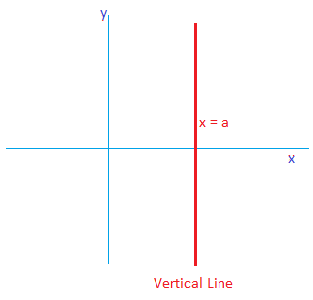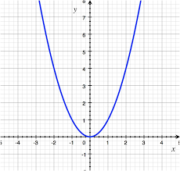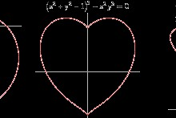

The crowd applauded, cheered, whistled, hooted and congratulated both of them as the pic flashed on the projected screen.

Neha- Terrific! Finally, you made it a remarkable one. *I adore you,* Mr. Kabir.

Regards,

Kintu