Review on relationship between three factors, GDP (PPP) per capita, Religiosity and Fertility

2023-05-11

# Analysis and Visualisation for the PSY6422 module project

## Background

Vandenbroucke (2016) claimed that there is generally an inverse correlation between income and the total fertility rate within and between nations. Higher income allows people to have an access to the higher the degree of education. It was found that fewer children are born in any developed country. According Rowthorn (2011), the married women who share the same religion with her spouse tend to have more babies, and less likely to not produce any. Also, Storm (2017) found that lower income is associated with more religiosity, a negative relationship. In this analysis I wanted to confirm if their claim is to be true. Thus following three hypotheses were formulated.

### Hypotheses:

1: Countries with greater PPP per capita would show lower fertility rate.

2: Countries with greater religiosity would show greater fertility rate.

3: Countries with greater PPP per capita would be less religious.

### Methods

## Data collection

For ‘PPP per capita’, International Monetary Fund (IMF) data from Statistics Times (2021)is used for the analysis. For ‘fertility rate’, Dataset for World Population Review (2023) is used for analysis.

## Analysis

#libraries  
library(conflicted)

## Warning: package 'conflicted' was built under R version 4.2.3

library(tidyverse)

## Warning: package 'tidyverse' was built under R version 4.2.3

## Warning: package 'ggplot2' was built under R version 4.2.3

## Warning: package 'tibble' was built under R version 4.2.3

## Warning: package 'dplyr' was built under R version 4.2.3

## ── Attaching core tidyverse packages ──────────────────────── tidyverse 2.0.0 ──  
## ✔ dplyr 1.1.2 ✔ readr 2.1.4  
## ✔ forcats 1.0.0 ✔ stringr 1.5.0  
## ✔ ggplot2 3.4.2 ✔ tibble 3.2.1  
## ✔ lubridate 1.9.2 ✔ tidyr 1.3.0  
## ✔ purrr 1.0.1

conflict_prefer("filter", "dplyr")

## [conflicted] Will prefer dplyr::filter over any other package.

conflict_prefer("lag", "dplyr")

## [conflicted] Will prefer dplyr::lag over any other package.

library(readxl) # Load the readxl package; data is excel file

## Warning: package 'readxl' was built under R version 4.2.3

library(ggplot2)  
library(ggrepel)

## Warning: package 'ggrepel' was built under R version 4.2.3

library(gganimate)

## Warning: package 'gganimate' was built under R version 4.2.3

#library(ggrepel) for naming the dots in regional scatter?  
  
# Set the working directory to the folder 'kinu1004.github.io'  
setwd("C:/Users/kinu1/Documents/kinu1004.github.io")  
  
# Import the data using the read_excel function  
data <- read_excel("data/Fertility_data.xlsx")  
  
# Remove rows with missing values  
df<- data[complete.cases(data), ]  
  
# Rename the variables  
colnames(df) <- c("Country", "PPP", "Religiosity", "Fertility", "Region")

## Scatterplots

### The Gengeral relationship between PPP per capita and Fertility rate

ggplot(df, aes(x = PPP, y = Fertility, color = Fertility)) +  
 geom_point() +  
 labs(x = "PPP per capita (in USD)", y = "Fertility rate", title = "Relationship between PPP per capita (in USD) \nand Fertility rate", caption = "Data Source: Statistics Times and World Population Review") +  
 scale_color_viridis_c(option = "magma") +  
 geom_smooth(method = "lm", se = FALSE, color = "black") +  
 theme_classic() +  
 theme(  
 plot.title = element_text(size = 16, face = "bold", hjust = 0.5),  
 axis.title = element_text(size = 12, face = "bold"),  
 axis.text = element_text(size = 10))

## `geom_smooth()` using formula = 'y ~ x'

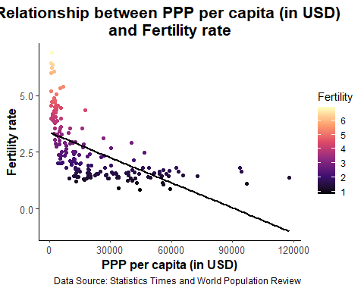

## Animation  
df_sorted1 <- df[order(df$PPP), ] #sort data by PPP  
  
# Initial plot object setting  
p1 <- ggplot(df_sorted1, aes(x = PPP, y = Fertility, color = Fertility)) +  
 geom_point() +  
 labs(x = "PPP per Capita (in USD)", y = "Fertility rate",   
 title = "Relationship between PPP per Capita (in USD) \nand Fertility rate",   
 caption = "Data Source: Statistics Times and World Population Review") +  
 scale_color_viridis_c(option = "magma") +  
 theme_classic() +  
 theme(  
 plot.title = element_text(size = 16, face = "bold", hjust = 0.5),  
 axis.title = element_text(size = 12, face = "bold"),  
 axis.text = element_text(size = 10))  
  
# Animate the plot  
animated_plot1 <- p1 + transition_manual(PPP, cumulative = TRUE) +  
 enter_grow()  
  
# Preview the animation  
animate(animated_plot1)



The general relationship between fertility rate and PPP show a negative correlation. Therefore, hypothesis 1 is supported here.

### Regional difference in the relationship

### Africa

# Subset the dataframe to include only Africa data  
df_africa <- subset(df, Region == "Africa")  
  
ggplot(df_africa, aes(x = PPP, y = Fertility, color = Fertility)) +  
 geom_point() +  
 labs(x = "PPP per capita (in USD)", y = "Fertility rate", title = "Relationship between PPP per capita (in USD) \nand Fertility rate in Africa", caption = "Data Source: Statistics Times and World Population Review") +  
 scale_color_viridis_c(option = "magma") +  
 geom_text_repel(aes(label = ifelse(!is.na(Country), Country, "")), size = 3, color = "black", show.legend = FALSE) +  
 geom_smooth(method = "lm", se = FALSE, color = "black", linewidth = 0.5) +  
 theme_classic() +  
 theme(  
 plot.title = element_text(size = 16, face = "bold", hjust = 0.5),  
 axis.title = element_text(size = 12, face = "bold"),  
 axis.text = element_text(size = 10),  
 plot.caption = element_text(size = 10, color = "gray"))

## `geom_smooth()` using formula = 'y ~ x'

## Warning: ggrepel: 23 unlabeled data points (too many overlaps). Consider  
## increasing max.overlaps

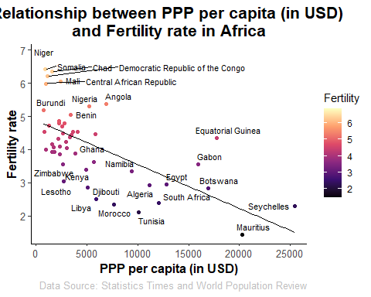

African fertility rate and PPP show a negative correlation.

### Asia

# Subset the dataframe to include only Asia data  
df_asia <- subset(df, Region == "Asia")  
  
ggplot(df_asia, aes(x = PPP, y = Fertility, color = Fertility)) +  
 geom_point() +  
 labs(x = "PPP per capita (in USD)", y = "Fertility rate", title = "Relationship between PPP per capita (in USD) \nand Fertility rate in Asia", caption = "Data Source: Statistics Times and World Population Review") +  
 scale_color_viridis_c(option = "magma") +  
 geom_text_repel(aes(label = ifelse(!is.na(Country), Country, "")), size = 3, color = "black", show.legend = FALSE) +  
 geom_smooth(method = "lm", se = FALSE, color = "black", linewidth = 0.5) +  
 theme_classic() +  
 theme(  
 plot.title = element_text(size = 16, face = "bold", hjust = 0.5),  
 axis.title = element_text(size = 12, face = "bold"),  
 axis.text = element_text(size = 10),  
 plot.caption = element_text(size = 10, color = "gray"))

## `geom_smooth()` using formula = 'y ~ x'

## Warning: ggrepel: 10 unlabeled data points (too many overlaps). Consider  
## increasing max.overlaps

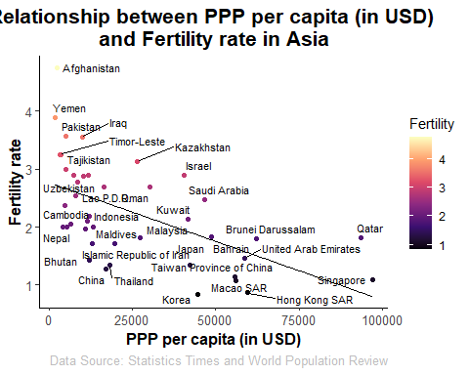

Asian fertility rate and PPP show a negative correlation.

## Europe

# Subset the dataframe to include only Europe data  
df_europe <- subset(df, Region == "Europe")  
  
ggplot(df_europe, aes(x = PPP, y = Fertility, color = Fertility)) +  
 geom_point() +  
 labs(x = "PPP per capita (in USD)", y = "Fertility rate", title = "Relationship between PPP per capita (in USD) \nand Fertility rate in Europe", caption = "Data Source: Statistics Times and World Population Review") +  
 scale_color_viridis_c(option = "magma") +  
 geom_text_repel(aes(label = ifelse(!is.na(Country), Country, "")), size = 3, color = "black", show.legend = FALSE) +  
 geom_smooth(method = "lm", se = FALSE, color = "black", linewidth = 0.5) +  
 theme_classic() +  
 theme(  
 plot.title = element_text(size = 16, face = "bold", hjust = 0.5),  
 axis.title = element_text(size = 12, face = "bold"),  
 axis.text = element_text(size = 10),  
 plot.caption = element_text(size = 10, color = "gray"))

## `geom_smooth()` using formula = 'y ~ x'

## Warning: ggrepel: 8 unlabeled data points (too many overlaps). Consider  
## increasing max.overlaps

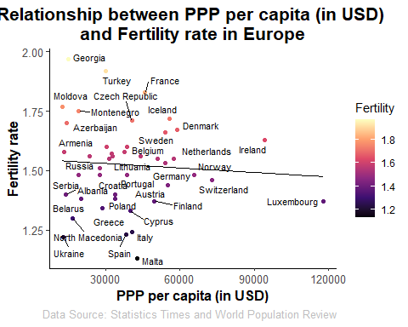

European fertility rate and PPP show a slightly negative correlation.

### Oceania

# Subset the dataframe to include only Oceania data  
df_oceania <- subset(df, Region == "Oceania")  
  
ggplot(df_oceania, aes(x = PPP, y = Fertility, color = Fertility)) +  
 geom_point() +  
 labs(x = "PPP per capita (in USD)", y = "Fertility rate", title = "Relationship between PPP per capita (in USD) \nand Fertility rate in Oceania", caption = "Data Source: Statistics Times and World Population Review") +  
 scale_color_viridis_c(option = "magma") +  
 geom_text_repel(aes(label = ifelse(!is.na(Country), Country, "")), size = 3, color = "black", show.legend = FALSE) +  
 geom_smooth(method = "lm", se = FALSE, color = "black", linewidth = 0.5) +  
 theme_classic() +  
 theme(  
 plot.title = element_text(size = 16, face = "bold", hjust = 0.5),  
 axis.title = element_text(size = 12, face = "bold"),  
 axis.text = element_text(size = 10),  
 plot.caption = element_text(size = 10, color = "gray"))

## `geom_smooth()` using formula = 'y ~ x'

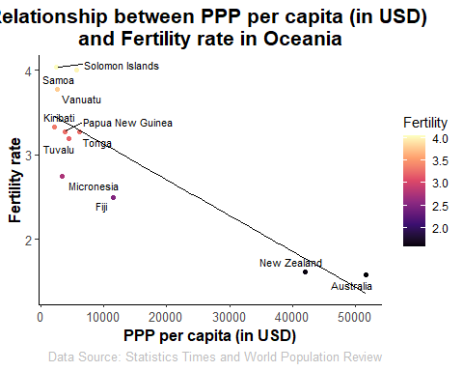

The relationship of the variables is found negative. Although there are two countries, New zealand and Australia that seem to pulling the best-fit line, the correlation would still be slightly negative looking at the pattern of other countries.

### North America

# Subset the dataframe to include only North America data  
df_northa <- subset(df, Region == "North America")  
  
ggplot(df_northa, aes(x = PPP, y = Fertility, color = Fertility)) +  
 geom_point() +  
 labs(x = "PPP per capita (in USD)", y = "Fertility rate", title = "Relationship between PPP per capita (in USD) \nand Fertility rate in North America", caption = "Data Source: Statistics Times and World Population Review") +  
 scale_color_viridis_c(option = "magma") +  
 geom_text_repel(aes(label = ifelse(!is.na(Country), Country, "")), size = 3, color = "black", show.legend = FALSE) +  
 geom_smooth(method = "lm", se = FALSE, color = "black", linewidth = 0.5) +  
 theme_classic() +  
 theme(  
 plot.title = element_text(size = 16, face = "bold", hjust = 0.5),  
 axis.title = element_text(size = 12, face = "bold"),  
 axis.text = element_text(size = 10),  
 plot.caption = element_text(size = 10, color = "gray"))

## `geom_smooth()` using formula = 'y ~ x'

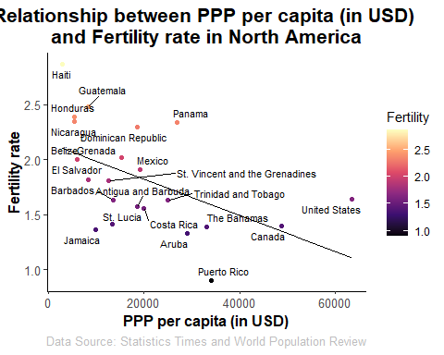

The relationship between fertility rate and PPP of North American countries is found negative.

### South America

# Subset the dataframe to include only South America data  
df_southa <- subset(df, Region == "South America")  
  
ggplot(df_southa, aes(x = PPP, y = Fertility, color = Fertility)) +  
 geom_point() +  
 labs(x = "PPP per capita (in USD)", y = "Fertility rate", title = "Relationship between PPP per capita (in USD) \nand Fertility rate in South America", caption = "Data Source: Statistics Times and World Population Review") +  
 scale_color_viridis_c(option = "magma") +  
 geom_text_repel(aes(label = ifelse(!is.na(Country), Country, "")), size = 3, color = "black", show.legend = FALSE) +  
 geom_smooth(method = "lm", se = FALSE, color = "black", linewidth = 0.5) +  
 theme_classic() +  
 theme(  
 plot.title = element_text(size = 16, face = "bold", hjust = 0.5),  
 axis.title = element_text(size = 12, face = "bold"),  
 axis.text = element_text(size = 10),  
 plot.caption = element_text(size = 10, color = "gray"))

## `geom_smooth()` using formula = 'y ~ x'

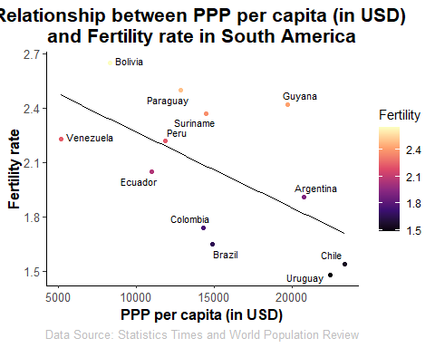

The relationship between two variables found negative in South American countries.

### The general relationship regarding regional differences

ggplot(df, aes(x = PPP, y = Fertility, color = Region)) +  
 geom_point(size = 3) +  
 labs(x = "PPP per capita (in USD)", y = "Fertility",   
 title = "Relationship between PPP per capita (in USD)\nand Fertility rate by region", caption = "Data Source: Statistics Times and World Population Review") +  
 scale_color_manual(values = c("red", "blue", "green", "purple", "orange", "#FFD700")) +  
 geom_smooth(method = "lm", se = FALSE, aes(group = Region, color = Region)) +  
 theme_minimal() +  
 theme(  
 plot.title = element_text(size = 16, face = "bold", hjust = 0.5, lineheight = 1.2),  
 axis.title = element_text(size = 12, face = "bold"),  
 axis.text = element_text(size = 10),  
 legend.position = "bottom")

## `geom_smooth()` using formula = 'y ~ x'

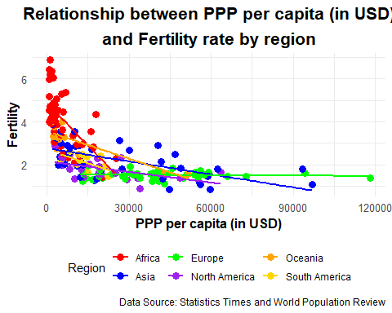

According to the scatter plot above, the six regions all demostrated negative association between PPP per capita and religiosity. However, the strength of them were not similar. Region of country seems to have an effect on the correlations.

### The Gengeral relationship between Religiosity and Fertility rate

ggplot(df, aes(x = Religiosity, y = Fertility, color = Fertility)) +  
 geom_point() +  
 labs(x = "Religiosity", y = "Fertility rate", title = "Relationship between Religiosity \nand Fertility rate", caption = "Data Source: Statistics Times and World Population Review") +  
 scale_color_viridis_c(option = "magma") +  
 geom_smooth(method = "lm", se = FALSE, color = "black") +  
 theme_classic() +  
 theme(  
 plot.title = element_text(size = 16, face = "bold", hjust = 0.5),  
 axis.title = element_text(size = 12, face = "bold"),  
 axis.text = element_text(size = 10))

## `geom_smooth()` using formula = 'y ~ x'

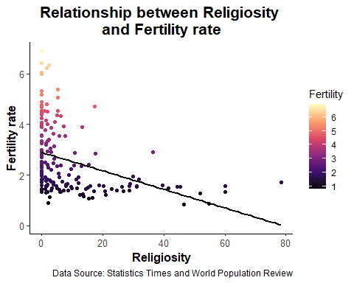

## Animation  
# Sort the data by Religiosity  
df_sorted2 <- df[order(df$Religiosity), ]  
  
# Create the initial plot object  
p2 <- ggplot() +  
 geom_point(data = df_sorted2, aes(x = Religiosity, y = Fertility, color = Fertility)) +  
 labs(x = "Religiosity", y = "Fertility rate",   
 title = "Relationship between Religiosity \nand Fertility rate",   
 caption = "Data Source: Statistics Times and World Population Review") +  
 scale_color_viridis_c(option = "magma") +  
 theme_classic() +  
 theme(  
 plot.title = element_text(size = 16, face = "bold", hjust = 0.5),  
 axis.title = element_text(size = 12, face = "bold"),  
 axis.text = element_text(size = 10))  
  
# Animate the plot  
animated_plot2 <- p2 + transition_manual(Religiosity, cumulative = TRUE) +  
 enter_grow()  
  
# Preview the animation  
animate(animated_plot2)

## nframes and fps adjusted to match transition



Unlike the initial assumption, more religious countries did not show greater fertility rate. It turned out rather opposite. The hypothesis 2 that religious countries would have more babies, is rejected.

### Regional difference in the relationship

### Africa

# Subset the dataframe to include only Africa data  
df_africa <- subset(df, Region == "Africa")  
  
ggplot(df_africa, aes(x = Religiosity, y = Fertility, color = Fertility)) +  
 geom_point() +  
 labs(x = "Religiosity", y = "Fertility rate", title = "Relationship between Religiosity \nand Fertility rate in Africa", caption = "Data Source: Statistics Times and World Population Review") +  
 scale_color_viridis_c(option = "magma") +  
 geom_text_repel(aes(label = ifelse(!is.na(Country), Country, "")), size = 3, color = "black", show.legend = FALSE) +  
 geom_smooth(method = "lm", se = FALSE, color = "black", linewidth = 0.5) +  
 theme_classic() +  
 theme(  
 plot.title = element_text(size = 16, face = "bold", hjust = 0.5),  
 axis.title = element_text(size = 12, face = "bold"),  
 axis.text = element_text(size = 10),  
 plot.caption = element_text(size = 10, color = "gray"))

## `geom_smooth()` using formula = 'y ~ x'

## Warning: ggrepel: 16 unlabeled data points (too many overlaps). Consider  
## increasing max.overlaps

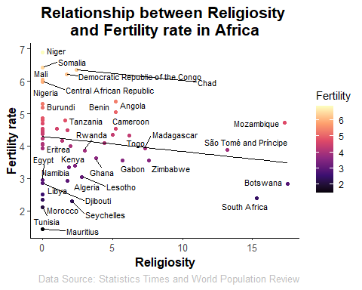

African fertility rate and religiosity show a negative correlation.

### Asia

# Subset the dataframe to include only Asia data  
df_asia <- subset(df, Region == "Asia")  
  
ggplot(df_asia, aes(x = Religiosity, y = Fertility, color = Fertility)) +  
 geom_point() +  
 labs(x = "Religiosity", y = "Fertility rate", title = "Relationship between Religiosity \nand Fertility rate in Asia", caption = "Data Source: Statistics Times and World Population Review") +  
 scale_color_viridis_c(option = "magma") +  
 geom_text_repel(aes(label = ifelse(!is.na(Country), Country, "")), size = 3, color = "black", show.legend = FALSE) +  
 geom_smooth(method = "lm", se = FALSE, color = "black", linewidth = 0.5) +  
 theme_classic() +  
 theme(  
 plot.title = element_text(size = 16, face = "bold", hjust = 0.5),  
 axis.title = element_text(size = 12, face = "bold"),  
 axis.text = element_text(size = 10),  
 plot.caption = element_text(size = 10, color = "gray"))

## `geom_smooth()` using formula = 'y ~ x'

## Warning: ggrepel: 20 unlabeled data points (too many overlaps). Consider  
## increasing max.overlaps

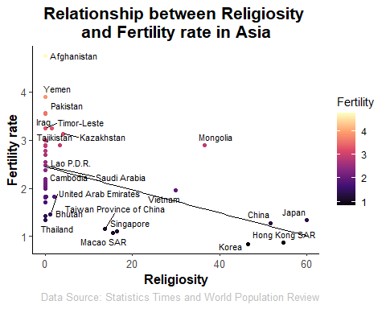

Asian fertility rate and religiosity show a negative correlation.

## Europe

# Subset the dataframe to include only Europe data  
df_europe <- subset(df, Region == "Europe")  
  
ggplot(df_europe, aes(x = Religiosity, y = Fertility, color = Fertility)) +  
 geom_point() +  
 labs(x = "Religiosity", y = "Fertility rate", title = "Relationship between Religiosity \nand Fertility rate in Europe", caption = "Data Source: Statistics Times and World Population Review") +  
 scale_color_viridis_c(option = "magma") +  
 geom_text_repel(aes(label = ifelse(!is.na(Country), Country, "")), size = 3, color = "black", show.legend = FALSE) +  
 geom_smooth(method = "lm", se = FALSE, color = "black", linewidth = 0.5) +  
 theme_classic() +  
 theme(  
 plot.title = element_text(size = 16, face = "bold", hjust = 0.5),  
 axis.title = element_text(size = 12, face = "bold"),  
 axis.text = element_text(size = 10),  
 plot.caption = element_text(size = 10, color = "gray"))

## `geom_smooth()` using formula = 'y ~ x'

## Warning: ggrepel: 4 unlabeled data points (too many overlaps). Consider  
## increasing max.overlaps

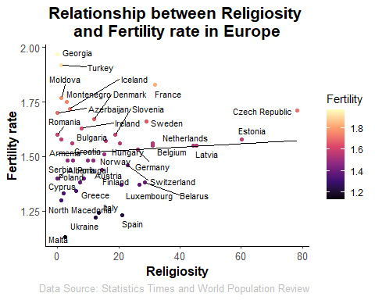

Unlike Africa and Asia, European fertility rate and religiosity had a slightly positive correlation.

### Oceania

# Subset the dataframe to include only Oceania data  
df_oceania <- subset(df, Region == "Oceania")  
  
ggplot(df_oceania, aes(x = Religiosity, y = Fertility, color = Fertility)) +  
 geom_point() +  
 labs(x = "Religiosity", y = "Fertility rate", title = "Relationship between Religiosity \nand Fertility rate in Oceania", caption = "Data Source: Statistics Times and World Population Review") +  
 scale_color_viridis_c(option = "magma") +  
 geom_text_repel(aes(label = ifelse(!is.na(Country), Country, "")), size = 3, color = "black", show.legend = FALSE) +  
 geom_smooth(method = "lm", se = FALSE, color = "black", linewidth = 0.5) +  
 theme_classic() +  
 theme(  
 plot.title = element_text(size = 16, face = "bold", hjust = 0.5),  
 axis.title = element_text(size = 12, face = "bold"),  
 axis.text = element_text(size = 10),  
 plot.caption = element_text(size = 10, color = "gray"))

## `geom_smooth()` using formula = 'y ~ x'

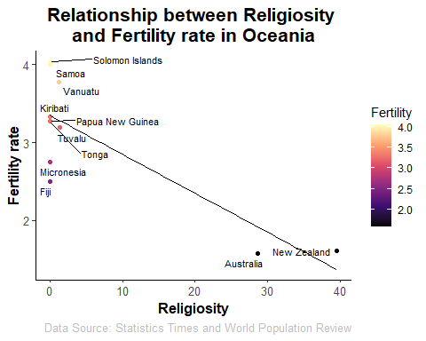

Again, fertility rate and religiosity of Oceanic countries is negatively correlated.

### North America

# Subset the dataframe to include only North America data  
df_northa <- subset(df, Region == "North America")  
  
ggplot(df_northa, aes(x = Religiosity, y = Fertility, color = Fertility)) +  
 geom_point() +  
 labs(x = "Religiosity", y = "Fertility rate", title = "Relationship between Religiosity \nand Fertility rate in North America", caption = "Data Source: Statistics Times and World Population Review") +  
 scale_color_viridis_c(option = "magma") +  
 geom_text_repel(aes(label = ifelse(!is.na(Country), Country, "")), size = 3, color = "black", show.legend = FALSE) +  
 geom_smooth(method = "lm", se = FALSE, color = "black", linewidth = 0.5) +  
 theme_classic() +  
 theme(  
 plot.title = element_text(size = 16, face = "bold", hjust = 0.5),  
 axis.title = element_text(size = 12, face = "bold"),  
 axis.text = element_text(size = 10),  
 plot.caption = element_text(size = 10, color = "gray"))

## `geom_smooth()` using formula = 'y ~ x'

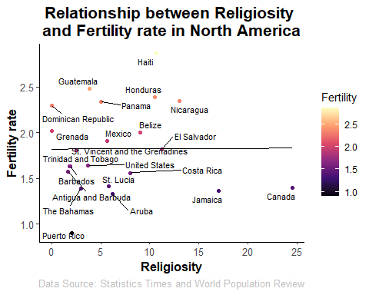

The relationship between fertility rate and religiosity of North American countries is found slightly positive like Europe.

### South America

# Subset the dataframe to include only South America data  
df_southa <- subset(df, Region == "South America")  
  
ggplot(df_southa, aes(x = Religiosity, y = Fertility, color = Fertility)) +  
 geom_point() +  
 labs(x = "Religiosity", y = "Fertility rate", title = "Relationship between Religiosity \nand Fertility rate in South America", caption = "Data Source: Statistics Times and World Population Review") +  
 scale_color_viridis_c(option = "magma") +  
 geom_text_repel(aes(label = ifelse(!is.na(Country), Country, "")), size = 3, color = "black", show.legend = FALSE) +  
 geom_smooth(method = "lm", se = FALSE, color = "black", linewidth = 0.5) +  
 theme_classic() +  
 theme(  
 plot.title = element_text(size = 16, face = "bold", hjust = 0.5),  
 axis.title = element_text(size = 12, face = "bold"),  
 axis.text = element_text(size = 10),  
 plot.caption = element_text(size = 10, color = "gray"))

## `geom_smooth()` using formula = 'y ~ x'

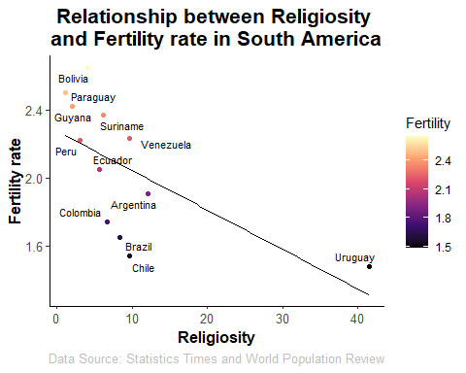

The relationship between the two variables found negative in South American countries.

### The general relationship regarding regional differences

ggplot(df, aes(x = Religiosity, y = Fertility, color = Region)) +  
 geom_point() +  
 labs(x = "Religiosity", y = "Fertility", title = "Relationship between Religiosity \nand Fertility", caption = "Data Source: Statistics Times and World Population Review") +  
 scale_color_manual(values = c("red", "blue", "green", "purple", "orange", "#FFD700")) +  
 geom_smooth(method = "lm", se = FALSE, aes(group = Region, color = Region)) +  
 theme_minimal() +  
 theme(  
 plot.title = element_text(size = 16, face = "bold", hjust = 0.5, lineheight = 1.2),  
 axis.title = element_text(size = 12, face = "bold"),  
 axis.text = element_text(size = 10),  
 legend.position = "bottom")

## `geom_smooth()` using formula = 'y ~ x'

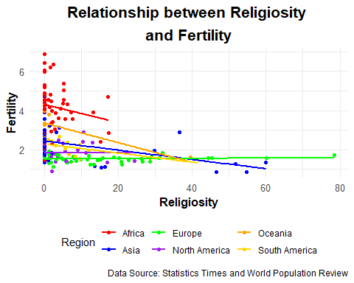

The scatterplots demonstrate more negative-like correlations between religiosity and fertility rate. Two of six regions, Europe and North America showed weak but positive relationship interestingly. Religiosity does not seem to be strong predictor of fertility rate compared to PPP per capita.

### The Gengeral relationship between PPP per capita and Religiosity

ggplot(df, aes(x = PPP, y = Religiosity, color = Religiosity)) +  
 geom_point() +  
 labs(x = "PPP per capita (in USD)", y = "Religiosity", title = "Relationship between PPP per capita (in USD) \nand Religiosity", caption = "Data Source: Statistics Times and World Population Review") +  
 scale_color_viridis_c(option = "magma") +  
 geom_smooth(method = "lm", se = FALSE, color = "black") +  
 theme_classic() +  
 theme(  
 plot.title = element_text(size = 16, face = "bold", hjust = 0.5),  
 axis.title = element_text(size = 12, face = "bold"),  
 axis.text = element_text(size = 10))

## `geom_smooth()` using formula = 'y ~ x'

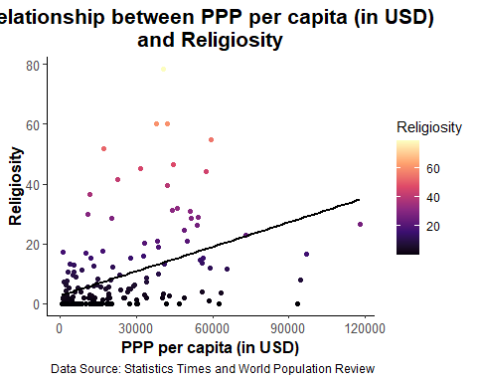

## Animation  
# Sort the data by Religiosity  
df_sorted1 <- df[order(df$PPP), ]  
  
# Create the initial plot object  
p3 <- ggplot() +  
 geom_point(data = df_sorted1, aes(x = PPP, y = Religiosity, color = Religiosity)) +  
 labs(x = "PPP per Capita (in USD)", y = "Religiosity",   
 title = "Relationship between PPP per Capita \nand Religiosity",   
 caption = "Data Source: Statistics Times and World Population Review") +  
 scale_color_viridis_c(option = "magma") +  
 theme_classic() +  
 theme(  
 plot.title = element_text(size = 16, face = "bold", hjust = 0.5),  
 axis.title = element_text(size = 12, face = "bold"),  
 axis.text = element_text(size = 10))  
  
# Animate the plot  
animated_plot3 <- p3 + transition_manual(PPP, cumulative = TRUE) +  
 enter_grow()  
  
# Preview the animation  
animate(animated_plot3)



Again, hypothesis 3, expecting a negative relationship between PPP per capita and religiosity, is rejected.

### Regional difference in the relationship

### Africa

# Subset the dataframe to include only Africa data  
df_africa <- subset(df, Region == "Africa")  
  
ggplot(df_africa, aes(x = PPP, y = Religiosity, color = Religiosity)) +  
 geom_point() +  
 labs(x = "PPP per capita (in USD)", y = "Religiosity", title = "Relationship between PPP per capita (in USD) \nand Religiosity in Africa", caption = "Data Source: Statistics Times and World Population Review") +  
 scale_color_viridis_c(option = "magma") +  
 geom_text_repel(aes(label = ifelse(!is.na(Country), Country, "")), size = 3, color = "black", show.legend = FALSE) +  
 geom_smooth(method = "lm", se = FALSE, color = "black", linewidth = 0.5) +  
 theme_classic() +  
 theme(  
 plot.title = element_text(size = 16, face = "bold", hjust = 0.5),  
 axis.title = element_text(size = 12, face = "bold"),  
 axis.text = element_text(size = 10),  
 plot.caption = element_text(size = 10, color = "gray"))

## `geom_smooth()` using formula = 'y ~ x'

## Warning: ggrepel: 27 unlabeled data points (too many overlaps). Consider  
## increasing max.overlaps

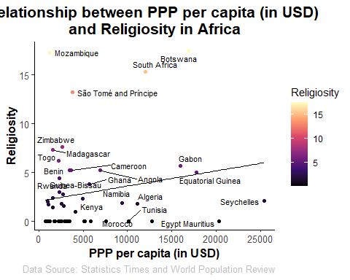

African fertility rate and religiosity show a positive correlation.

### Asia

# Subset the dataframe to include only Asia data  
df_asia <- subset(df, Region == "Asia")  
  
ggplot(df_asia, aes(x = PPP, y = Religiosity, color = Religiosity)) +  
 geom_point() +  
 labs(x = "PPP per capita (in USD)", y = "Religiosity", title = "Relationship between PPP per capita (in USD) \nand Religiosity in Asia", caption = "Data Source: Statistics Times and World Population Review") +  
 scale_color_viridis_c(option = "magma") +  
 geom_text_repel(aes(label = ifelse(!is.na(Country), Country, "")), size = 3, color = "black", show.legend = FALSE) +  
 geom_smooth(method = "lm", se = FALSE, color = "black", linewidth = 0.5) +  
 theme_classic() +  
 theme(  
 plot.title = element_text(size = 16, face = "bold", hjust = 0.5),  
 axis.title = element_text(size = 12, face = "bold"),  
 axis.text = element_text(size = 10),  
 plot.caption = element_text(size = 10, color = "gray"))

## `geom_smooth()` using formula = 'y ~ x'

## Warning: ggrepel: 27 unlabeled data points (too many overlaps). Consider  
## increasing max.overlaps

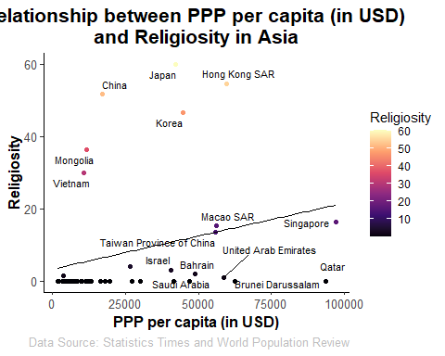

The relationship was observed to be positive for Asian countries. Although it seems there are number of outliers only looking at Asian countries, it would still show positive relationship even if they are removed.

## Europe

# Subset the dataframe to include only Europe data  
df_europe <- subset(df, Region == "Europe")  
  
ggplot(df_europe, aes(x = PPP, y = Religiosity, color = Religiosity)) +  
 geom_point() +  
 labs(x = "PPP per capita (in USD)", y = "Religiosity", title = "Relationship between PPP per capita (in USD) \nand Religiosity in Europe", caption = "Data Source: Statistics Times and World Population Review") +  
 scale_color_viridis_c(option = "magma") +  
 geom_text_repel(aes(label = ifelse(!is.na(Country), Country, "")), size = 3, color = "black", show.legend = FALSE) +  
 geom_smooth(method = "lm", se = FALSE, color = "black", linewidth = 0.5) +  
 theme_classic() +  
 theme(  
 plot.title = element_text(size = 16, face = "bold", hjust = 0.5),  
 axis.title = element_text(size = 12, face = "bold"),  
 axis.text = element_text(size = 10),  
 plot.caption = element_text(size = 10, color = "gray"))

## `geom_smooth()` using formula = 'y ~ x'

## Warning: ggrepel: 18 unlabeled data points (too many overlaps). Consider  
## increasing max.overlaps

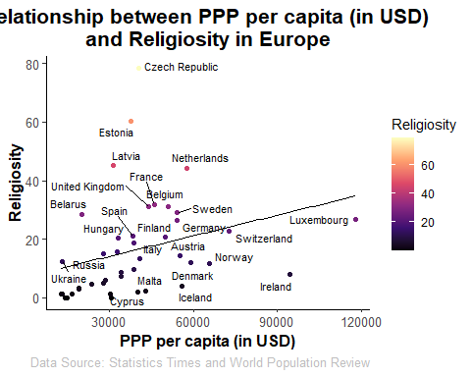

European PPP and religiosity show a positive correlation.

### Oceania

# Subset the dataframe to include only Oceania data  
df_oceania <- subset(df, Region == "Oceania")  
  
ggplot(df_oceania, aes(x = PPP, y = Religiosity, color = Religiosity)) +  
 geom_point() +  
 labs(x = "PPP per capita (in USD)", y = "Religiosity", title = "Relationship between PPP per capita (in USD) \nand Religiosity in Oceania", caption = "Data Source: Statistics Times and World Population Review") +  
 scale_color_viridis_c(option = "magma") +  
 geom_text_repel(aes(label = ifelse(!is.na(Country), Country, "")), size = 3, color = "black", show.legend = FALSE) +  
 geom_smooth(method = "lm", se = FALSE, color = "black", linewidth = 0.5) +  
 theme_classic() +  
 theme(  
 plot.title = element_text(size = 16, face = "bold", hjust = 0.5),  
 axis.title = element_text(size = 12, face = "bold"),  
 axis.text = element_text(size = 10),  
 plot.caption = element_text(size = 10, color = "gray"))

## `geom_smooth()` using formula = 'y ~ x'

## Warning: ggrepel: 8 unlabeled data points (too many overlaps). Consider  
## increasing max.overlaps

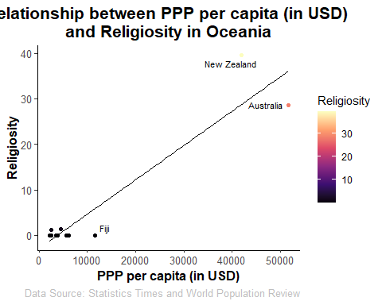

Again, PPP and religiosity of Oceanic countries is positively correlated. However, two countries, ,affecting the relationship as they have considerably greater PPP and religiosity.

### North America

# Subset the dataframe to include only North America data  
df_northa <- subset(df, Region == "North America")  
  
ggplot(df_northa, aes(x = PPP, y = Religiosity, color = Religiosity)) +  
 geom_point() +  
 labs(x = "PPP per capita (in USD)", y = "Religiosity", title = "Relationship between PPP per capita (in USD) \nand Religiosity in North America", caption = "Data Source: Statistics Times and World Population Review") +  
 scale_color_viridis_c(option = "magma") +  
 geom_text_repel(aes(label = ifelse(!is.na(Country), Country, "")), size = 3, color = "black", show.legend = FALSE) +  
 geom_smooth(method = "lm", se = FALSE, color = "black", linewidth = 0.5) +  
 theme_classic() +  
 theme(  
 plot.title = element_text(size = 16, face = "bold", hjust = 0.5),  
 axis.title = element_text(size = 12, face = "bold"),  
 axis.text = element_text(size = 10),  
 plot.caption = element_text(size = 10, color = "gray"))

## `geom_smooth()` using formula = 'y ~ x'

## Warning: ggrepel: 1 unlabeled data points (too many overlaps). Consider  
## increasing max.overlaps

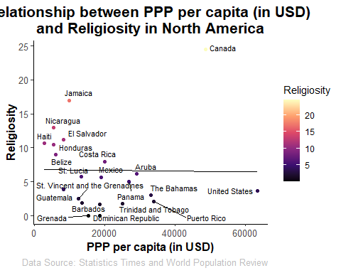

North America is the first sample that showed negative relationship. The strength might look small. However, two respective places seem to have an impact on the strength as outliers. If removed, the relationshp would look more negative.

### South America

# Subset the dataframe to include only South America data  
df_southa <- subset(df, Region == "South America")  
  
ggplot(df_southa, aes(x = PPP, y = Religiosity, color = Religiosity)) +  
 geom_point() +  
 labs(x = "PPP per capita (in USD)", y = "Religiosity", title = "Relationship between PPP per capita (in USD) \nand Religiosity in South America", caption = "Data Source: Statistics Times and World Population Review") +  
 scale_color_viridis_c(option = "magma") +  
 geom_text_repel(aes(label = ifelse(!is.na(Country), Country, "")), size = 3, color = "black", show.legend = FALSE) +  
 geom_smooth(method = "lm", se = FALSE, color = "black", linewidth = 0.5) +  
 theme_classic() +  
 theme(  
 plot.title = element_text(size = 16, face = "bold", hjust = 0.5),  
 axis.title = element_text(size = 12, face = "bold"),  
 axis.text = element_text(size = 10),  
 plot.caption = element_text(size = 10, color = "gray"))

## `geom_smooth()` using formula = 'y ~ x'

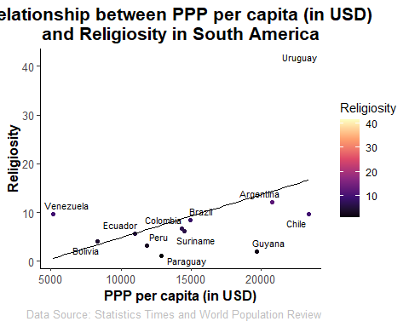

Unlike North America, PPP and religiosity of South American countries is positively correlated.

### The general relationship regarding regional differences

ggplot(df, aes(x = PPP, y = Religiosity, color = Region)) +  
 geom_point(size = 3) +  
 labs(x = "PPP per capita (in USD)", y = "Religiosity", title = "Relationship between Religiosity and Fertility", caption = "Data Source: Statistics Times and World Population Review") +  
 scale_color_manual(values = c("red", "blue", "green", "purple", "orange", "#FFD700")) +  
 geom_smooth(method = "lm", se = FALSE, aes(group = Region, color = Region)) +  
 theme_minimal() +  
 theme(  
 plot.title = element_text(size = 16, face = "bold", hjust = 0.5, lineheight = 1.2),  
 axis.title = element_text(size = 12, face = "bold"),  
 axis.text = element_text(size = 10),  
 legend.position = "bottom")

## `geom_smooth()` using formula = 'y ~ x'

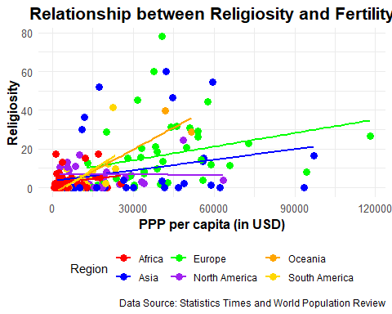

Again, hypothesis 3, relatively financially comfortable countries would show low religiosity, is rejected except for North America. Although the spread of plots is expanding, the relationship between PPP and religiosity looks quite positive. The region, again, seemed to have effect on the differences in the strength of correlation. The interesting finding is that North America is the only group that showed different patterns compared to other groups. The reason for such phenomenon is not conclusive.

## Additional analysis

### Box plot 1: Fertility difference by Regions

# Subset the data to only include the columns we need  
df2 <- subset(df, select = c("Region", "Fertility"))  
  
# Create the box plot  
# Define the color palette for each region  
region_colors <- c("Africa" = "red", "Asia" = "blue", "Europe" = "green", "North America" = "purple", "Oceania" = "orange", "South America" = "yellow")  
  
# Create the box plot with customizations  
ggplot(df2, aes(x = Region, y = Fertility, fill = Region)) +  
 geom_boxplot(color = "black") +  
 labs(x = "Region", y = "Fertility Rate",   
 title = "Box Plot of Fertility Rate by Region", caption = "Data Source: Statistics Times and World Population Review") +  
 theme_bw() +  
 theme(plot.title = element_text(size = 18, face = "bold"),  
 axis.text = element_text(size = 12),  
 axis.title = element_text(size = 14),  
 panel.grid.major = element_blank(),  
 panel.grid.minor = element_blank(),  
 legend.position = "none") +  
 scale_fill_manual(values = region_colors) +  
 scale_color_manual(values = region_colors)

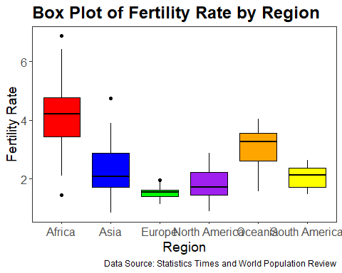

When compared the fertility rates only by different regions, African countries showed considerably greater mean rate than the others. And Europe showed least mean rate and IQR.

## Box plot 2: Religiosity difference by Region

# Subset the data to only include the columns we need  
df3 <- subset(df, select = c("Region", "Religiosity"))  
  
# Create the box plot  
# Define the color palette for each region  
region_colors <- c("Africa" = "red", "Asia" = "blue", "Europe" = "green", "North America" = "purple", "Oceania" = "orange", "South America" = "yellow")  
  
# Create the box plot with customizations  
ggplot(df3, aes(x = Region, y = Religiosity, fill = Region)) +  
 geom_boxplot(color = "black") +  
 labs(x = "Region", y = "Religiosity",   
 title = "Box Plot of Religiosity by Region", caption = "Data Source: Statistics Times and World Population Review") +  
 theme_bw() +  
 theme(plot.title = element_text(size = 18, face = "bold"),  
 axis.text = element_text(size = 12),  
 axis.title = element_text(size = 14),  
 panel.grid.major = element_blank(),  
 panel.grid.minor = element_blank(),  
 legend.position = "none") +  
 scale_fill_manual(values = region_colors) +  
 scale_color_manual(values = region_colors)

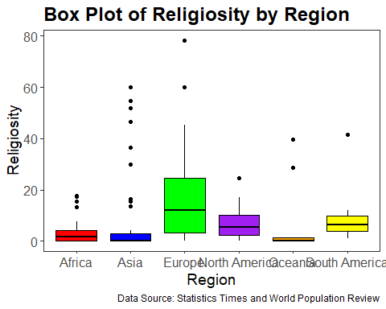

Another box plot was generated to compare the religiosity by region. Although Asia displayed number of outliers, the five regions except Europe showed similar level of religiosity. Europe showed greatest IQR. Yet, Europe showed the least fertility rate considering its greater average religiosity compared to the others.

### Additional scatter plot 1 : Relationship between PPP per capita, Religiosity and Fertlity rate

ggplot(df, aes(x = PPP, y = Religiosity, color = Fertility)) +  
 geom_point(size = 3) +  
 scale_x_continuous(labels = scales::comma, name = "PPP per capita (in USD)") +  
 scale_y_continuous(name = "Religiosity") +  
 scale_color_gradient(low = "skyblue", high = "red", limits = c(1, 8),  
 breaks = c(1, 2, 3, 4, 5, 6, 7, 8),   
 guide = guide_colorbar(title = "Fertility Rate")) +  
 labs(title = "Relationship between PPP, Religiosity, and Fertility",  
 caption = "Data source: Statistics Times and World Population Review") +  
 theme_bw() +  
 theme(plot.title = element_text(size = 18, face = "bold"),  
 axis.title = element_text(size = 14),  
 axis.text = element_text(size = 12),  
 legend.text = element_text(size = 12),  
 legend.position = "right",  
 panel.grid.major = element_blank(),  
 panel.grid.minor = element_blank())

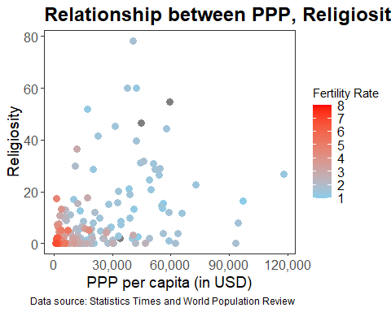

This plot clearly shows that there is a dense cluster at low religiosity and low PPP. Both GDP and PPP are strongly associated with education level and access to health medical services. The scatter plots suggest an environment that would provide less SES and no strong belief to organised religions is more likely to result greater fertility rate.

## Counclusion

The first hypothesis, PPP per capita would be negatively correlated with fertility rate was not denied. However, the other two hypotheses, assumed positive relationship between religiosity and fertility rate and negative one between PPP per capita and religiosity, were rejected. Interestingly, countries with greater PPP per capita rather demonstrated deeper religiosity. Although possible effect of region as a covariate on these relationship was questioned, the effect seemed not big enough to change the direction of correlations except the strenght of association. However, there was interesting pattern found in North America as they showed more accepting those two rejected hypotheses. Further research is recommended to find out what is causing this different findings from the past research.

# References

Least Religious Countries 2023. (2023). World Population Review. <https://worldpopulationreview.com/country-rankings/least-religious-countries>

List of Countries by GDP (PPP) per capita. (2021, Jun 21). Statistics Times.https://statisticstimes.com/economy/countries-by-gdp-capita-ppp.php

Rowthorn, R. (2011). Religion, fertility and genes: a dual inheritance model. Proceedings of the Royal Society B: Biological Sciences, 278(1717), 2519-2527.

Storm, I. (2017). Does economic insecurity predict religiosity? Evidence from the European social survey 2002–2014. Sociology of Religion, 78(2), 146-172.

Vandenbroucke, G. (2016). The link between fertility and income. Federal Reserve Bank of, St Louis, USA. Dec, 13.