PPV / IPPV - Nagra CA Related Questions

I. Questions – PPV/IPPV SMS CA integration Test (EMC SMS system vendor - CableSoft)
Several questions/problems have been reported by CableSoft (EMC SMS system vendor) staff in recent SMS PPV functionality integration tests conducted at EMC CA lab as listed below. Please provide answers, instructions, advises, clarifications and insights to help EMC and CableSoft complete the necessary tests.
---------------------------------------
- CableSoft (EMC SMS vendor) system analyst needs samples of real event listing generated by Product Builder in XML format for EMC SMS PPV/iPPV related functionality planning purposes. The sample XML files given previously either in electronic file format or in technical documentation provided by NagraVision were too simple (and many fields were empty) to use. We would like to have some sample event listings with a varity combination of events, such as PPV, iPPV, different prices, special event callback, and events with other unusual attributes.
Answer received (08/17 through Megan of IDT) from NagraVision: In order to do this, EMC needs to create some event products including PPV, iPPV with difference prices. Make sure those events span through a few days so they can be included in the export file. I will set the data exporter to export those files automatically. I will send you the export files once they are done.
[AQI] This has been done already. The export file was sent Aug 24.
- Purchase list event names of PPV orders made from SMS were not displayed correctly for both Chinese and English characters when viewed from STB OSD. However iPPV purchase list information was displayed OK. For both PPV and iPPV orders, purchase list information are displayed correctly through an OpenTV middleware application.
[AQI] The fact that the OpenTV apps can display both lists correctly means that both lists have the correct contents. The first thing EMC should check with is the STB.
- After issuing a CA callback command from SMS and the STB made a return call and uploaded return information to CA headend, it seems that the information sent back from the STB is not cleared immediately after the return call. At what time the information stored in the smart card and sent back to headend will be cleared from the smart card? Is this time period configurable and/or controllable by the SMS.
[AQI] The purchase list on the smartcard will be cleared provided that they have been expired for more than 30 days. (This is stated in the “SMS Gateway Interface Definition”) This 30 days is configurable on the CAS only.
- After SMS CA command gateway issued a command to receive returned STB information, it seems that the CA headend will begin transmit FeedBack data of all (not just the specified one) STBs stored in the headend.
[AQI] Which command is used for this? If it’s command 111, then it’s normal to return all the history as defined in the spec.
- STB FeedBack Data transmitted from the headend system to the SMS sometimes duplicated (i.e., same data sent more than once) but have no fixed pattern was detected. Please advise on the CA commands need to be sent from SMS to acknowledge a successful transmission of each STB return information. So far, no such command was found in NagraVision documentation.
[AQI] We need more specific example regarding this. What kind of data? What was the exact procedure? Etc.
[GARY KUEH] SasGwySpe has all the commands listed. Refer to chapter on SMS Feedback Commands. The SasGwySpe was sent on Sept 2002.
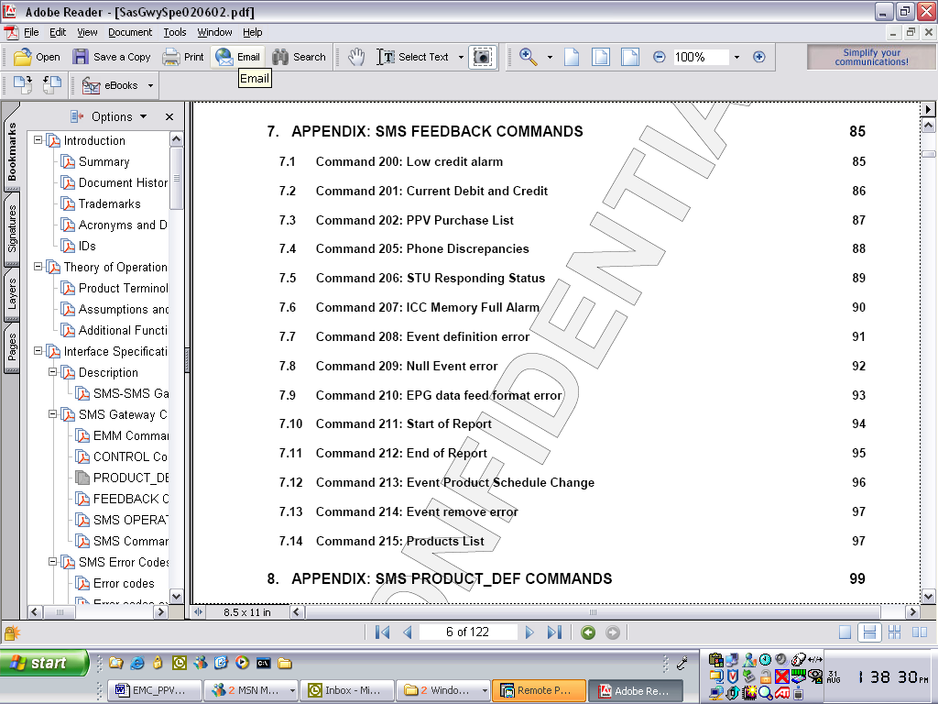

- The PPV program listings can be generated and exported from Nagra CA system: (1) new program list and (2) change listing. Are there any ways to let SMS know which customers have ordered the PPV events that have been changed in order to take necessary actions to minimize the changes’ impact on customers.
[AQI] The SMS is responsible for keeping track of all the subscriber related issues. Based on the export list and call-back information, the SMS can make accurate decisions.
- Immediate Callback function test was OK, but no return call was received after issuing the shortest time schedule callback command to the test STB.
[AQI] Please be more specific. Are we talking about regular callbacks here or immediate callback?
- Downloaded and stored token points are reset to zero after an immediate callback was make. Is this a normal behavior by design, or something has not been working properly?
[AQI] I need to know the exact procedure to re-produce this. Does the “stored token points” mean the available credit?
- Is it true that any one of the smart card token related CA commands—set, add, subtract—can be issued only once per day to one STB?
[AQI] Yes the credit record can only be updated once per one GMT day.
- Special event callback function has never been successfully tested in the CA lab. Some configurations need to be modified in the headend CA system to help shorten the special event callback time intervals.
[AQI] The re-configuration of the special event callback time interval has global impact on how the smartcards behave, this has been discussed before. Basically it will cause all the STBs to call a lot more often than they should, flooding the phone lines to the operators call collectors.
- Although PPV/iPPV Preview time control and order window functionalities were enabled EMC CA Lab headend systems, yet it might not be properly configured because PPV/iPPV events could be purchased almost at anytime, i.e., before air time, after preview time, and even after air time! Also, all PPV events purchased are listed as “watched” even before air time?
[AQI] The Preview time has nothing to do when the event can be purchased. The STB application has the responsibility to restrict purchase when the event is over.
[GARY] The preview time is defined as the preview of the event when it is marked as free access. Please elaborate how did you know that the events are “watched”.
Furthermore, please explain (1) why PPV event orders could be canceled from the SMS system during a PPV’s broadcasting time and even after air time? And, why these canceled PPV orders are all removed from purchase list? (2) why all PPV event orders are immediately marked as “watched” regardless whether they have actually been watched?
[AQI] This is normal, the PPV event products can be added/cancelled via SMS commands.
- It seems all PPV events are purchased and recorded by Product ID not Event ID. Are Event Ids used in anywhere and for what purposes in relation to SMS system?
[AQI] Event IDs are used in product export files to identify the (i)PPV events.
- Could one PPV event be purchased twice: one PPV order, one iPPV purchase?
[AQI] No. A PPV can’t be purchased as an iPPV. An iPPV event CAN be purchased as a PPV event, but the purchase window won’t show up after this since it’s already bought.
- According to NagraVision technical documentation, the Purge PPV and IPPV Records commands are used to erase and clear data stored in the smart card. However, in lab tests, although the lab headend CA system returned “OK”, these commands didn’t work as expected. That is, the data stored in the smart card was not cleared. All such commands issued either from SMS or headend console failed.
[AQI] The product records will only be cleared after they are more than 30 days expired.
How did you make this assumption that the commands failed? Were you able to read the smart card contents ? The commands did not execute as all the conditions are not met. But I am very interested to know why you make the assumptions.
How to clear all canceled and expired channel subscription rights from the smart card? (1) memory full callback? (2) schedule callback? (3) immediate callback? (4) Purge PPV and IPPV Records command? Or either one will do?
[AQI] Any type of callback would clear the expired rights (subscription & PPV) provided they are more than 30 days expired. The purge commands also follows the same rules.
I. Questions – PPV/IPPV SMS CA integration Test ( Lab Test)
1. SI generator can not properly work all the time. It will not generate all PSI/SI tables without reason.
When it happen, STB can not scan any channels.
[AQI] This has been solved. There was a misconfiguration on the MUX.
2. We scramble an event as PPV/IPPV, then submit user right to a smart card for this event through CAS01 SMS emulator.
Wait seconds, check STB, the user right is record on smart card and purchase window disappear.
Everything seems OK except the screen is blank.
[AQI] Also resolved.
3. Submit SMS commands through CAS01 SMS emulator not working all the time.
For example, add credit to a smart card. Monitoring EMB service, see number of EMM increase.
It mean command is processing. But sometime, it receive credit in seconds, sometime no credit is received.
It is not normal in laboratory circumstance.
[AQI] First, the SMS simulator is not meant for the operator’s to use. Second, in the example above, the credit record can only be updated once per day.
4. Smart card can not dump data back to system when immediate call back.
It retry 8 times because protocol not complete. And all data in smart card are not be clean.
[AQI] Please be more specific.
5. EIT-schedule not broadcasting, but EIT-p/f do.
[AQI] This is not true. The EIT schedule is available.
[GARY] Our investigation showed that the CAS was stable and both EITp/f and EIT schedule were present. Please elaborate your testing/measurement method …

After reboot server machines and restart some services, some questions mention above will disappear.
But it still there and will happen later.
The CA system in out laboratory seems not stable. Could it possible the DATABASE corrupt.
[AQI] Rebooting the servers is NOT the solution. The CAS is stable. Most of the problems are caused either by mis-operation or bad configuration of the end to end system.

