申報明細檔欄位說明

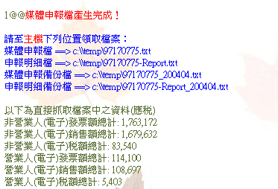
報表內容說明：
- 檔案說明
  - 媒體申報檔➔取Inv001.BusinessId.txt 為檔案名稱
  - 申報明細檔➔以 Inv001.BusinessId-Report.txt命名
  - 媒體申報備份檔➔Inv001.BusinessId_Inv099.YearMonth.txt
  - 申報明細備份檔➔ Inv001.BusinessId-Report _Inv099.YearMonth.txt

- 發票資料說明
註: 以下抓取的所有資料前提為 Inv007. IsObsolete=’N’ (不為作廢之資料)
{以下為直接抓取檔案中之資料(應稅)}
- 非營業人(電子)發票額總計➔
A == Sum(InvAmount)
Where Inv007. IsObsolete=’N’ and Inv007. InvFormat=1 and Inv007. BusinessId is null

And Inv007.TaxType=1

- 非營業人(電子)銷售額總計➔
B == Sum(SaleAmount)
Where Inv007. IsObsolete=’N and Inv007. InvFormat=1 and Inv007. BusinessId is null

and Inv007.TaxType=1

- 非營業人(電子)稅額總計➔
C == Sum(TaxAmount)
Where Inv007. IsObsolete=’N’ and Inv007. InvFormat=1 and Inv007. BusinessId is null

And Inv007.TaxType=1

- 營業人(電子)發票額總計➔
D == Sum(InvAmount)
Where Inv007. IsObsolete=’N’ and Inv007. InvFormat=1 and Inv007. BusinessId is not null

And Inv007.TaxType=1

- 營業人(電子)銷售額總計➔
E == Sum(SaleAmount)
Where Inv007. IsObsolete=’N’ and Inv007. InvFormat=1
and Inv007. BusinessId is not null
And Inv007.TaxType= 1

- 營業人(電子)稅額總計➔
F == Sum(TaxAmount)
Where Inv007. IsObsolete=’N’ and Inv007. InvFormat=1
and Inv007. BusinessId is not null
And Inv007.TaxType=1

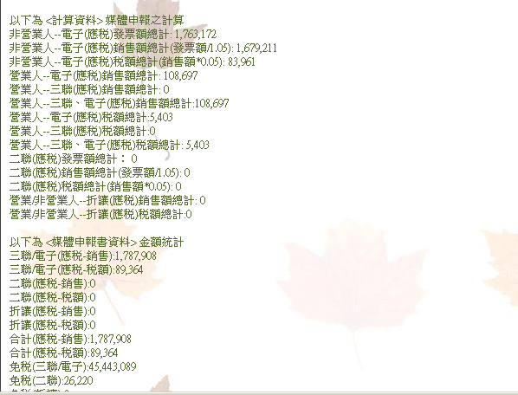
{以下為<計算資料>媒體申報之計算}
- 非營業人--電子(應稅)發票額總計➔
公式1: G == (Sum(InvAmount)
Where Inv007. IsObsolete=’N’ and Inv007. InvFormat=1 and Inv007. BusinessId is null and Inv007. TaxType=1)

公式2: G=A

- 非營業人--電子(應稅)銷售額總計{發票額 / 1.05}➔
H == (Round( G ÷ 1.05),0)

- 非營業人--電子(應稅)稅 額總計{銷售額 × 0.05}➔
I == (Round( H × 0.05 ), 0)

- 營業人--電子(應稅)銷售額總計➔
公式1: J == (Sum(SaleAmount)
Where Inv007. IsObsolete=’N’ and Inv007.InvFormat=1 and Inv007.BusinessId is not null and Inv007.TaxType=1)

公式2: J=E

- 營業人--三聯(應稅)銷售額總計➔
K == (Sum(InvAmount) ➔此處應為 SaleAmount
Where Inv007. IsObsolete=’N’ and Inv007.InvFormat=3 and Inv007.BusinessId is not null and Inv007.TaxType=1)

- 營業人--三聯、電子(應稅)銷售額總計➔

L == J + K

- 營業人--電子(應稅)稅額總計➔
M == (Sum(TaxAmount)
Where Inv007. IsObsolete=’N’ and Inv007.InvFormat=1 and Inv007.BusinessId is not null and Inv007.TaxType=1)

- 營業人--三聯(應稅)稅額總計➔
N == (Sum(TaxAmount)
Where Inv007. IsObsolete=’N’ and Inv007.InvFormat=3 and Inv007.BusinessId is not null and Inv007.TaxType=1)

- 營業人--三聯、電子(應稅)稅額總計➔

O == M + N

- 二聯(應稅)發票額總計➔
P== (Sum(InvAmount)
Where Inv007. IsObsolete=’N’ and Inv007.InvFormat=2 and Inv007.TaxType=1 )

- 二聯(應稅)銷售額總計{發票額 / 1.05}➔
Q == (Round( P ÷ 1.05),0)

- 二聯(應稅)稅 額總計{銷售額 × 0.05}➔
R == (Round( Q × 0.05 ), 0)

- 營業/非營業人-折讓(應稅)銷售額總計➔
S == Sum(Inv014. SaleAmount)

- 營業/非營業人-折讓(應稅)稅額總計➔
T == Sum(Inv014.TaxAmount)

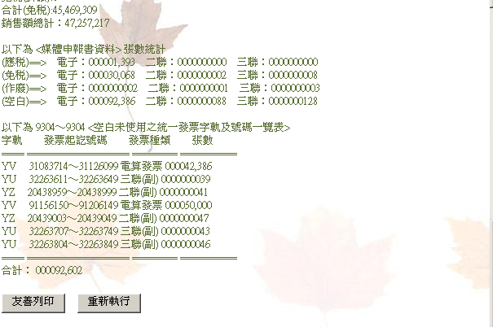
{以下為媒體申報金額統計} --以收據申報
- 三聯/電子(應稅-銷售)總計➔

U= H + L

- 三聯/電子(應稅-稅額)總計➔

V = I + O

- 二聯(應稅-銷售)總計➔

X = G2

- 二聯(應稅-稅額)總計➔

X = R

- 折讓(應稅-銷售)總計➔
公式1: Y == (Sum(SaleAmount)
Where Inv014.TaxType=1 )

公式2: Y = S

- 折讓(應稅-稅額)總計➔
公式1: Z == (Sum(TaxAmount )
Where Inv014. TaxType=1 )

公式2: Z = T

- 合計(應稅-銷售)總計➔

AA == U + W - Y

- 合計(應稅-稅額)總計➔

BB == V + X - Z

- 三聯/電子(免稅-銷售)總計➔
CC == (Sum (恢復Saleamount)
Where Inv007. IsObsolete=’N’ and Inv007. InvFormat in (1,3) and Inv007. BusinessId is null and Inv007. TaxType=3 )

- 三聯/電子(免稅-稅額)總計 二聯(免稅) ➔
DD == (Sum(TaxAmount Saleamount)
Where Inv007. IsObsolete=’N’ and Inv007. InvFormat in ( 2) and Inv007. BusinessId is null and Inv007. TaxType=3 )

- 折讓(免稅)總計➔
EE == (Sum(SaleAmount)
Where Inv014.TaxType=3 )

- 合計(免稅)➔

FF == CC + DD – EE

CC2.三聯/電子(零稅率)總計➔
CC2 == (Sum(Saleamount)Where Inv007. IsObsolete=’N’ and Inv007. InvFormat in (1,3) and Inv007. TaxType=2 )

DD2.二聯(零稅率) 總計➔
DD2 == (Sum(Saleamount)
Where Inv007. IsObsolete=’N’ and Inv007. InvFormat in (2) and Inv007. TaxType=2 )

EE2.折讓(零稅率)總計➔
EE2 == (Sum(SaleAmount) Where Inv014.TaxType=2 )

FF2.合計(零稅率)➔
FF2 == CC2 + DD2 – EE2

- 銷售額總計➔

GG == U + W – Y
GG== AA +FF + FF2 (恢復此計算)

GG2. 印花稅總繳總額➔ A08畫面傳入的印花稅總額的金額欄位值

{以下為<媒體申報參考資料>張數統計表}

^{使用狀況}  _{發票格式} | 電子 | 二聯 | 三聯
(應稅)➔ | HH | II | JJ
(零稅率) | KK2 | LL2 | MM2
(免稅)➔ | KK | LL | MM
(作廢)➔ | OO | PP | QQ
(空白)➔ | RR | SS | TT

- 電子-應稅張數統計➔
Count(*) from inv007 where IsObsolete=’N’ and TaxType=1 and InvFormat=1

- 二聯-應稅張數統計➔
Count(*) from inv007 where IsObsolete=’N’and TaxType=1 and InvFormat=2

- 三聯-應稅張數統計➔
Count(*) from inv007 where IsObsolete=’N’ and TaxType=1 and InvFormat=3

- 電子-免稅張數統計➔
Count(*) from inv007 where IsObsolete=’N’ and TaxType=3 and InvFormat=1

- 二聯-免稅張數統計➔
Count(*) from inv007 where IsObsolete=’N’ and TaxType=3 and InvFormat=2

- 三聯-免稅張數統計➔
Count(*) from inv007 where IsObsolete=’N’ and TaxType=3 and InvFormat=3

KK2.電子-零稅率張數統計➔
Count(*) from inv007 where IsObsolete=’N’ and TaxType=2 and InvFormat=1

LL2.二聯-零稅率張數統計➔
Count(*) from inv007 where IsObsolete=’N’ and TaxType=2 and InvFormat=2

MM2.三聯-零稅率張數統計➔
Count(*) from inv007 where IsObsolete=’N’ and TaxType=2 and InvFormat=3

- 電子-作廢張數統計➔
Count(*) from inv007 where IsObsolete=’N and InvFormat=1

- 二聯-作廢張數統計➔
Count(*) from inv007 where IsObsolete=’N and InvFormat=2

- 三聯-作廢張數統計➔
Count(*) from inv007 where IsObsolete=’N and InvFormat=3

- 電子-空白張數統計➔
(Inv099. EndNum － Inv099. CurNum ＋ 1 ) from inv099 where InvFormat=1 and YearMonth=

- 二聯-空白張數統計➔
(Inv099. EndNum － Inv099. CurNum ＋ 1 ) from inv099 where InvFormat=2 and YearMonth=
- 三聯-空白張數統計➔
(Inv099. EndNum － Inv099. CurNum ＋ 1 ) from inv099 where InvFormat = 3 and YearMonth=???

{以下為 9303~9304 <空白未使用之統一發票字軌及號碼一覽表>}
字軌 | 發票起/訖號碼 | 發票種類 | 張數
TT | UU | VV | WW
Inv099. Prefix | Inv099. CurNum / Inv099. EndNum | Inv099. InvFormat | Inv099. EndNum － Inv099. CurNum ＋ 1
Select inv099.Prefix, Inv099.CurNum, Inv099.EndNum, Inv099.InvFormat, Inv099.EndNum-Inv099.CurNum+1
From Inv099
Where 條件

