## 团队成员（Team members）



覃雄，520项目发起人。作为资深区块连投资人和全球风险管理协会成员，他拥有超过20年金融从业背景，曾于渣打银行、花旗银行和永隆银行担任大中华区及中东地区高管，带领团队为大中华区和中东众多跨国公司提供贸易和结构性融资解决方案。

Yan Xiong, 520 project sponsor. As a senior block investor and member of the Global Risk Management Association, he has over 20 years of financial background and has served as a senior executive in Greater China and the Middle East at Standard Chartered Bank, Citibank and Wing Lung Bank, leading the team to Greater China and Many multinational companies in the Middle East provide trade and structured financing solutions.



向斌，520联合创始人兼CEO，他是资深投资人与网络运营师，拥有丰富的投资与网络运营经验，是国内早期参与区块链投资的天使投资人。

Xiang Bin, co-founder and CEO of 520, is a veteran investor and network operator with extensive investment and network operations experience. He is an angel investor who participated in blockchain investment in China.



刘登攀，资深程序开发者，数字经济培训师，同时也是520联合创始人。他是国内的顶级区块链开发管理者，在尖端技术和安全应用程序开发方面拥有超过10年的专业经验。09年接触到比特币后开始研究加密货币及区块链技术，曾主导开发公链及交易平台。

Liu Dengpan, senior program developer, digital economic trainer, is also the co-founder of 520. He is the top blockchain development manager in the country and has over 10 years of expertise in cutting-edge technology and security application development. After consulting Bitcoin in 2009, he began to study cryptocurrency and blockchain technology, and led the development of public and trading platforms.

  
贺佳林，520联合创始人，也是知名网络运营专家、培训师，与BOTTEGA VENETA SSA、日内瓦CHEZ MA COUSINE深度合作多年，非常擅长网络运营。

He Jialin, co-founder of 520, is also a well-known network operation expert and trainer. He has worked closely with BOTTEGA VENETA SSA and Geneva CHEZ MA COUSINE for many years and is very good at network operation.



贺彪，520联合创始人兼总经理，作为企业管理师、数字货币策划师，贺彪利用专业知识管理企业，为520项目做长远可行的战略策划。

He Wei, 520 co-founder and general manager, as a corporate manager and digital currency planner, He Wei uses professional knowledge to manage the company and make long-term and feasible strategic planning for the 520 project.

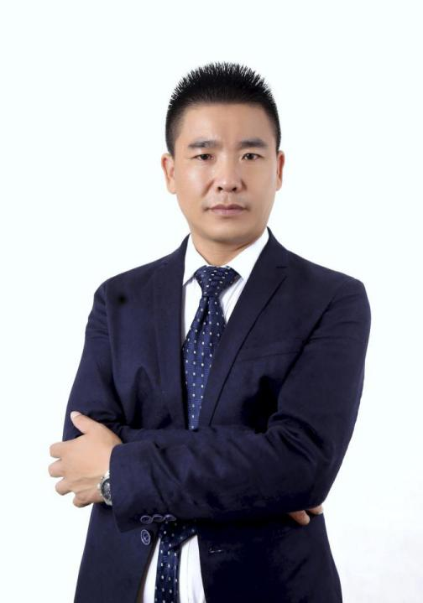  
黄长江，520联合创始人，同样是数字货币资深研究者、企业管理师，黄长江与贺彪两位专家联手，打造520成为新一代传奇。

Huang Changjiang, co-founder of 520, is also a senior researcher and corporate manager of digital currency. Huang Changjiang and He Wei have teamed up to create a new generation of legends.



谢小晴，资深加密货币从业者，拥有多年行业经验的她为520提供实际可行的战略规划建议。

Xie Xiaoqing, a senior cryptocurrency practitioner with years of industry experience, provides practical strategic planning advice for 520.



杨久青，520法律顾问，法律与经济学研究者，为520项目提供法律服务。

Yang Jiuqing, 520 Legal Counsel, Law and Economics Researcher, provides legal services for the 520 project.

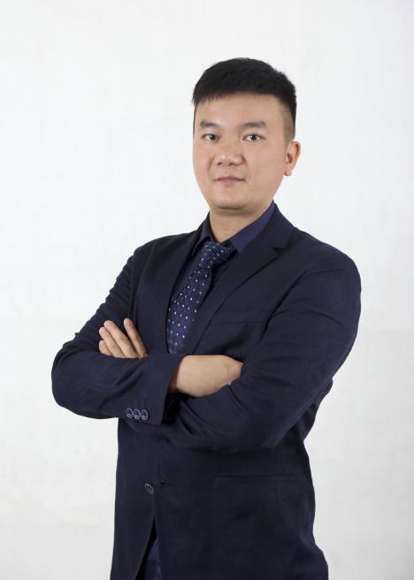

蔡佳，520投资顾问，作为数字资产领域从业者，拥有多年投资经验。

Cai Jia, 520 Investment Consultant, has many years of investment experience as a practitioner in the field of digital assets.



吴明军，520市场总监，专注研究数字货币多年，同时也是知名的市场营销专家。

Wu Mingjun, 520 Marketing Director, has been focusing on digital currency for many years and is also a well-known marketing expert.



覃良平，数字经济从业者，同时也是社会工程学研究者，为520项目提供数字经济战略建议。

Yan Liangping, a digital economic practitioner and a social engineering researcher, provides digital economic strategy advice for the 520 project.



黄力，程序开发师、软件主管，是一位全能的开发人员和安全专家，在开发区块链技术和高级安全移动应用方面拥有超过7年的经验。同时，他也是密码学方面的专家。

Huang Li, Program Developer and Software Supervisor, is an all-round developer and security expert with over 7 years of experience in developing blockchain technology and advanced secure mobile applications. At the same time, he is also an expert in cryptography.



张露露，520市场经理，是网络运营师、网络推广师，拥有多年丰富的网络运营与推广经验。

Zhang Lulu, 520 Marketing Manager, is a network operator and network promoter. He has many years of experience in network operation and promotion.



张园园，客服经理，主要负责客户服务。

Zhang Yuanyuan, customer service manager, is mainly responsible for customer service.



周金平，高级程序员，资深ＪＡＶＡ技术开发师，新加坡欧洲大学硕士毕业，曾任新加波顶尖软件开发公司，担任《血战刀塔》大型游戏高级产品架构师。有多年大数据平台Hadoop Storm Hbase经验，曾参与主导知名大数据公司索答的数据和机器学习平台建设、丰富的云平台运维DevOps经验，主导产品快速迭代和自动化运维机制。

Zhou Jinping, senior programmer, senior JAVA technology developer, graduated from the European University of Singapore, and served as the top software development company of Singapore, serving as the senior product architect for the large game of Blood War Knife. Has many years of experience in the big data platform Hadoop Storm Hbase, has participated in the data and machine learning platform construction led by well-known big data company, rich cloud platform operation and maintenance DevOps experience, leading product rapid iteration and automatic operation and maintenance mechanism.



陈绍后，网络推广师、讲师培训师，拥有多年培训经验，成功培育了大批专业网络讲师。

Chen Shaohou, a network promoter and lecturer trainer, has many years of training experience and successfully cultivated a large number of professional network lecturers.

## **团队顾问 （**Team Consultant）



李密，区块链项目构建导师、UToken联合创始人、区块链资深投资人。

Li Mi, block tutor project construction tutor, UToken co-founder, blockchain senior investor.



谢晓杰，比特基金会（新加坡）主席、比特控股国际有限公司（香港）董事长、全球节点联盟创始人、Bitpay公链（比特支付）创始人、BTCC比特爱链创始人、深圳比特信科技有限公司董事长、深圳比特文化传媒有限公司董事长和比特旅游（深圳）有限公司董事长。

Xie Xiaojie, Chairman of Bit Foundation (Singapore), Chairman of Bit Holdings International Limited (Hong Kong), Founder of Global Node Alliance, Founder of Bitpay Public Chain (Bit Payment), Founder of BTCC Bit Love Chain, Shenzhen Bitson Technology Co., Ltd. Chairman of the Board of Directors, Chairman of Shenzhen Bit Culture Media Co., Ltd. and Chairman of Bit Travel (Shenzhen) Co., Ltd.

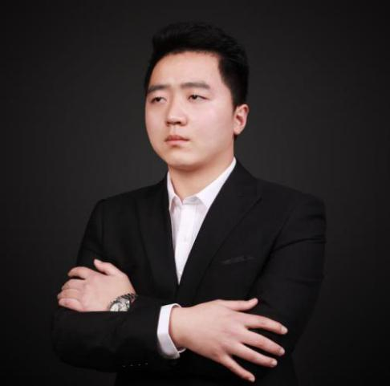

王旭，金言资本联合创始人、币马温财经联合创始人。

Wang Xu, co-founder of Jinyan Capital, co-founder of Ma Wen Finance.

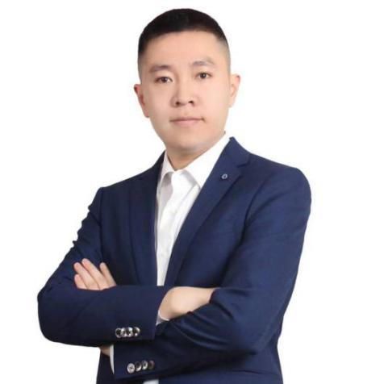

李鹏，比特财经创始人、香港比特控股CTO、亚洲链改委员会秘书长。

# Li Peng, founder of Bitcoin, CTO of Hong Kong Bit Holdings, and Secretary General of the Asian Chain Reform Commission.