Online Book Shop — READhub
Deliverable #3: Iteration 2 / Sprint 2
Module: Book Management System

Group Members
Name | Roll Number
Kinza Saeed | 24L-2527
Fajar Owaes | 24L-2532
Syeda Urwa | 24L-2561

Date of Submission: 15 April 2025
Sprint Duration: Week 3 – Week 4

Project Title
Online Book Shop — READhub

Introduction
READhub is a comprehensive web-based online bookstore platform designed to bridge the gap between readers and books in the digital age. The platform addresses the limitations of traditional physical bookstores by offering a centralized, accessible, and efficient system for browsing, purchasing, renting, and downloading books.

In Iteration 2 (Sprint 2), the focus is on the Book Management System the core backbone of the entire platform. This sprint covers the administrative and user-facing book management features, including adding and managing books, category organization, search functionality, and rating visibility.

Sprint 2 builds directly upon the User & Admin Authentication module completed in Sprint 1, and lays the groundwork for the Purchase & Request System in Sprint 3.

Sprint 2 Module
Module Name: Book Management System
This module enables administrators to maintain a comprehensive, up-to-date book catalog while allowing users to easily discover and evaluate books through search, categories, and ratings.

User Stories — Sprint 2

US-01: Add New Books (Admin)
Story ID | US-01
User Story | As a Admin, I want to add new books to the system, so that the catalog stays up-to-date and users can discover new titles.
Priority | High
Story Points | 5 points
Sub-Story 1 | As an Admin, I want to fill in a form with book title, author, genre, ISBN, price, and stock quantity so that all essential book information is recorded.
Sub-Story 2 | As an Admin, I want to upload a book cover image so that users can visually identify the book.
Sub-Story 3 | As an Admin, I want to assign the book to one or more categories (e.g., Fiction, Science) so that it is properly organized.
Sub-Story 4 | As an Admin, I want to set book type as Physical or eBook so that the system handles it accordingly.
Sub-Story 5 | As an Admin, I want to receive a success confirmation after saving a book so that I know the entry was recorded correctly.

US-02: Update Book Details (Admin)
Story ID | US-02
User Story | As a Admin, I want to edit existing book information, so that any inaccuracies or outdated data can be corrected promptly.
Priority | High
Story Points | 3 points
Sub-Story 1 | As an Admin, I want to search for a book by title or ISBN and open its edit form so that I can quickly locate the book to modify.
Sub-Story 2 | As an Admin, I want to update fields like title, price, author, or stock count so that the catalog reflects current information.
Sub-Story 3 | As an Admin, I want to change the book's category assignment so that the book is correctly classified.
Sub-Story 4 | As an Admin, I want to save changes and see a confirmation message so that I know the update was successful.

US-03: Delete Books (Admin)
Story ID | US-03
User Story | As a Admin, I want to remove books from the system, so that discontinued or unavailable titles do not mislead users.
Priority | Medium
Story Points | 2 points
Sub-Story 1 | As an Admin, I want to select a book and click a Delete button so that I can initiate the removal process.
Sub-Story 2 | As an Admin, I want to see a confirmation dialog before deletion so that accidental deletions are prevented.
Sub-Story 3 | As an Admin, I want the book to be removed from all category listings and search results after deletion so that users no longer see it.

US-04: Categorize Books by Genre (Admin)
Story ID | US-04
User Story | As a Admin, I want to create and assign genre-based categories, so that books are logically organized and easy to browse.
Priority | High
Story Points | 4 points
Sub-Story 1 | As an Admin, I want to create new categories (e.g., Horror, Biography) so that books can be organized by genre.
Sub-Story 2 | As an Admin, I want to assign one or multiple categories to a book when adding or editing it so that it appears in relevant listings.
Sub-Story 3 | As an Admin, I want to rename or delete an empty category so that the category structure remains clean and relevant.
Sub-Story 4 | As an Admin, I want to view a list of all categories with their book counts so that I can manage the catalog effectively.

US-05: Search for Books (User)
Story ID | US-05
User Story | As a User, I want to search for books by title, author, or genre, so that I can quickly find a specific book without browsing the entire catalog.
Priority | High
Story Points | 5 points
Sub-Story 1 | As a User, I want a visible search bar on the main page so that I can start a search at any time.
Sub-Story 2 | As a User, I want to type a keyword and receive a filtered list of matching books so that I find relevant results instantly.
Sub-Story 3 | As a User, I want to filter search results by category or book type (Physical/eBook) so that I can narrow down my results.
Sub-Story 4 | As a User, I want to see book title, author, cover image, and price in search results so that I can evaluate books at a glance.
Sub-Story 5 | As a User, I want a 'No results found' message if nothing matches my query so that I know to try a different search.

US-06: View Books by Category and Rating (User)
Story ID | US-06
User Story | As a User, I want to browse books by category and see their ratings, so that I can discover books that match my interests and find highly-rated titles easily.
Priority | Medium
Story Points | 4 points
Sub-Story 1 | As a User, I want to see a list of all available categories on the homepage so that I can choose a genre to browse.
Sub-Story 2 | As a User, I want to click on a category and see all books under it so that I can explore books in a specific genre.
Sub-Story 3 | As a User, I want each book card to display an average star rating (1–5) so that I can quickly identify popular books.
Sub-Story 4 | As a User, I want to sort books within a category by rating (highest first) so that I can find the best-reviewed titles.
Sub-Story 5 | As a User, I want to rate a book I have purchased using a 1–5 star system so that I can share my opinion with other readers.
Design

Activity Diagrams
Activity diagrams illustrate the workflow and step-by-step processes within the Book Management System. The three main activities selected correspond directly to the primary user stories of this sprint.

Activity Diagram 1 — Add New Book (Admin)
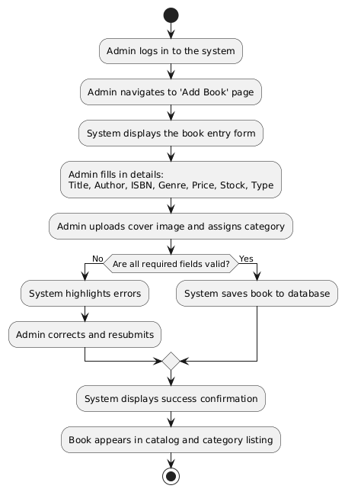

Activity Diagram 2 — Search for a Book (User)
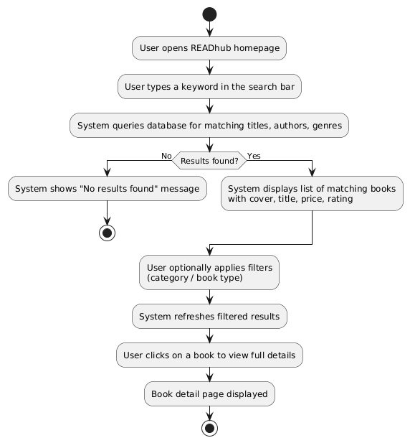

Activity Diagram 3 — Browse by Category and Rate a Book (User)
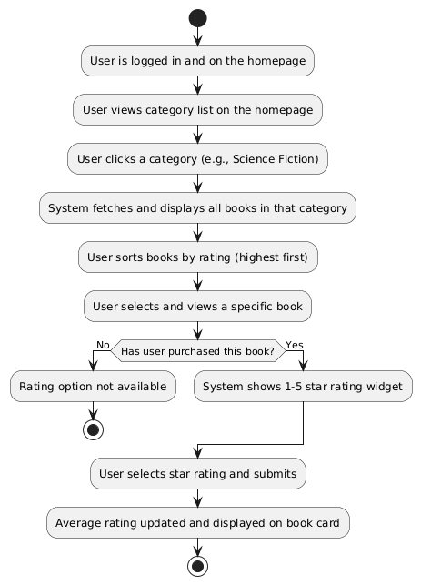

Use Case Diagram

The Use Case Diagram shows all system actors and their interactions with the Book Management System.

Actors
- Admin — Manages the book catalog, categories, and inventory.
- User (Registered) — Browses, searches, rates, and views books.
- System (Database) — Stores and retrieves all book and category data.

Use Cases
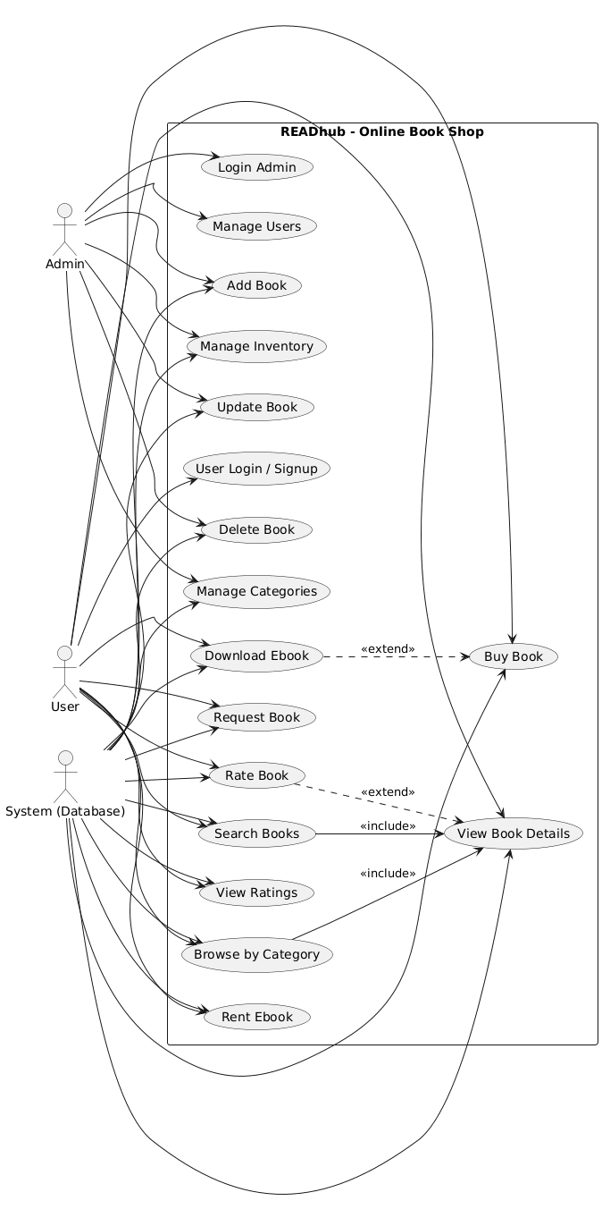

Sequence Diagrams
Sequence diagrams show the order of interactions between actors and system components for the three main processes.

Sequence Diagram 1 — Add New Book
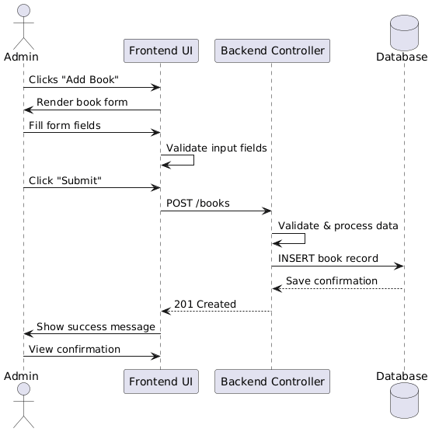

Sequence Diagram 2 — Search for a Book
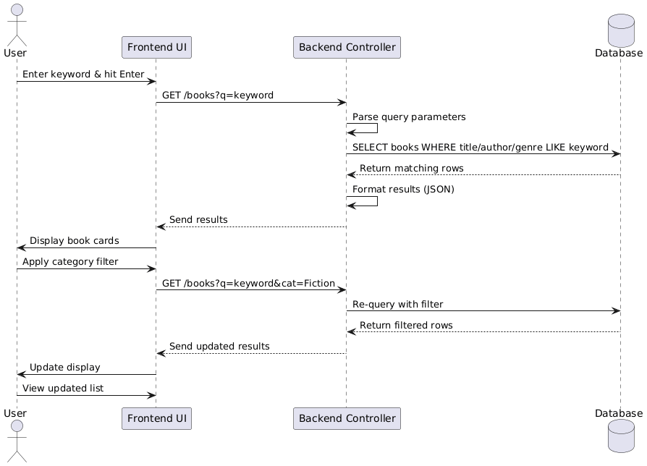

Sequence Diagram 3 — Rate a Book
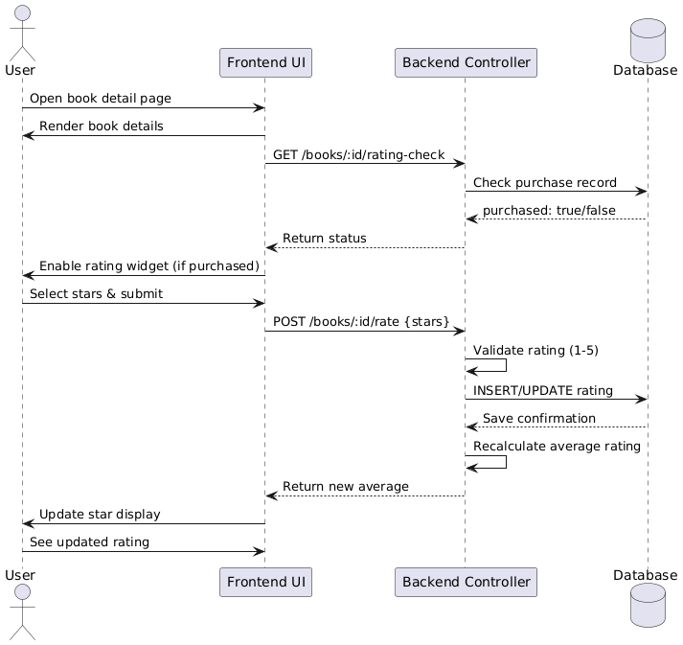

Class Diagram
The following classes form the core structure of the Book Management System, along with their attributes, methods, and relationships.

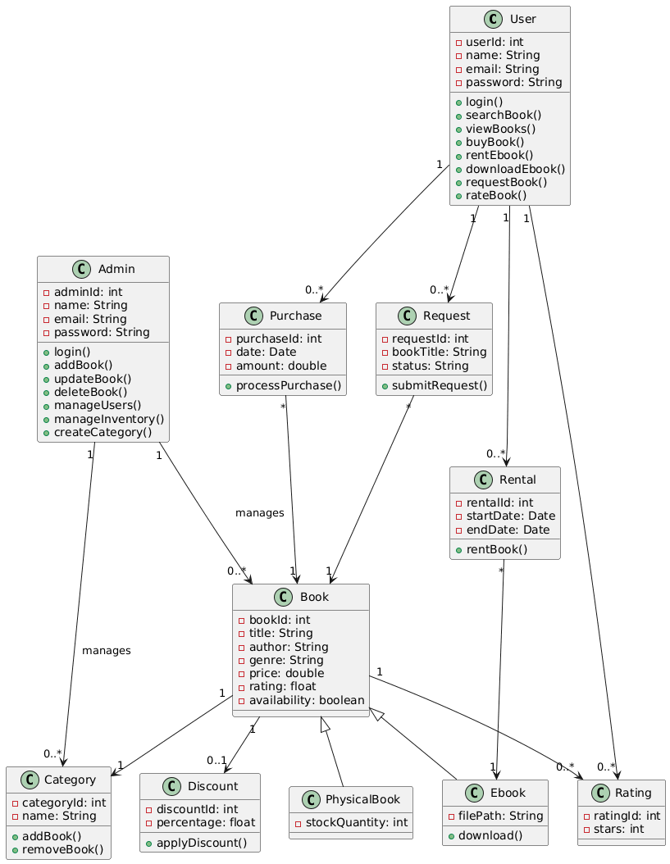

Scrum Board (Trello)

Sprint Backlog
Story ID | User Story / Task | Assigned To | Priority | Status
US-01 | Add New Books (Admin) | Fajar Owaes | High | In Progress
US-01.1 | Book entry form with all required fields | Fajar Owaes | High | Done
US-01.2 | Cover image upload functionality | Syeda Urwa | Medium | In Progress
US-01.3 | Category assignment during add | Fajar Owaes | High | To Do
US-02 | Update Book Details (Admin) | Fajar Owaes | High | To Do
US-02.1 | Search book by title/ISBN for editing | Syeda Urwa | High | To Do
US-02.2 | Edit form with pre-filled values | Fajar Owaes | High | To Do
US-03 | Delete Books (Admin) | Syeda Urwa | Medium | To Do
US-03.1 | Delete button with confirmation dialog | Syeda Urwa | Medium | To Do
US-04 | Categorize Books by Genre (Admin) | Kinza Saeed | High | In Progress
US-04.1 | Create/edit/delete category | Kinza Saeed | High | In Progress
US-04.2 | View category list with book counts | Kinza Saeed | Medium | To Do
US-05 | Search Books (User) | Fajar Owaes | High | To Do
US-05.1 | Search bar on homepage | Syeda Urwa | High | To Do
US-05.2 | Filter by category and book type | Fajar Owaes | Medium | To Do
US-06 | Browse by Category and View Ratings (User) | Syeda Urwa | Medium | To Do
US-06.1 | Category listing on homepage | Syeda Urwa | Medium | To Do
US-06.2 | Star rating widget for purchased books | Kinza Saeed | Medium | To Do

Trello Board Screenshots

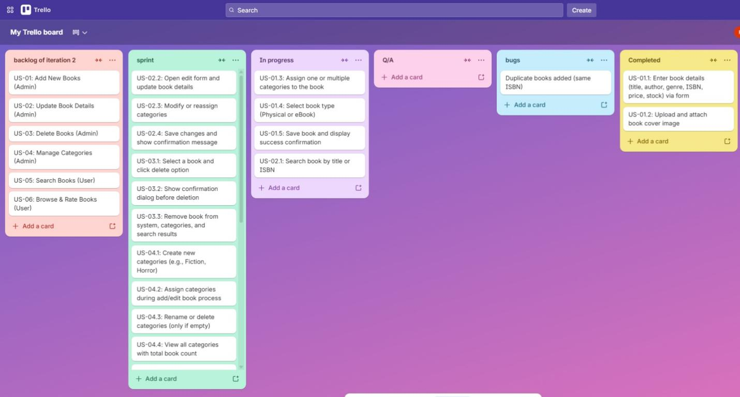
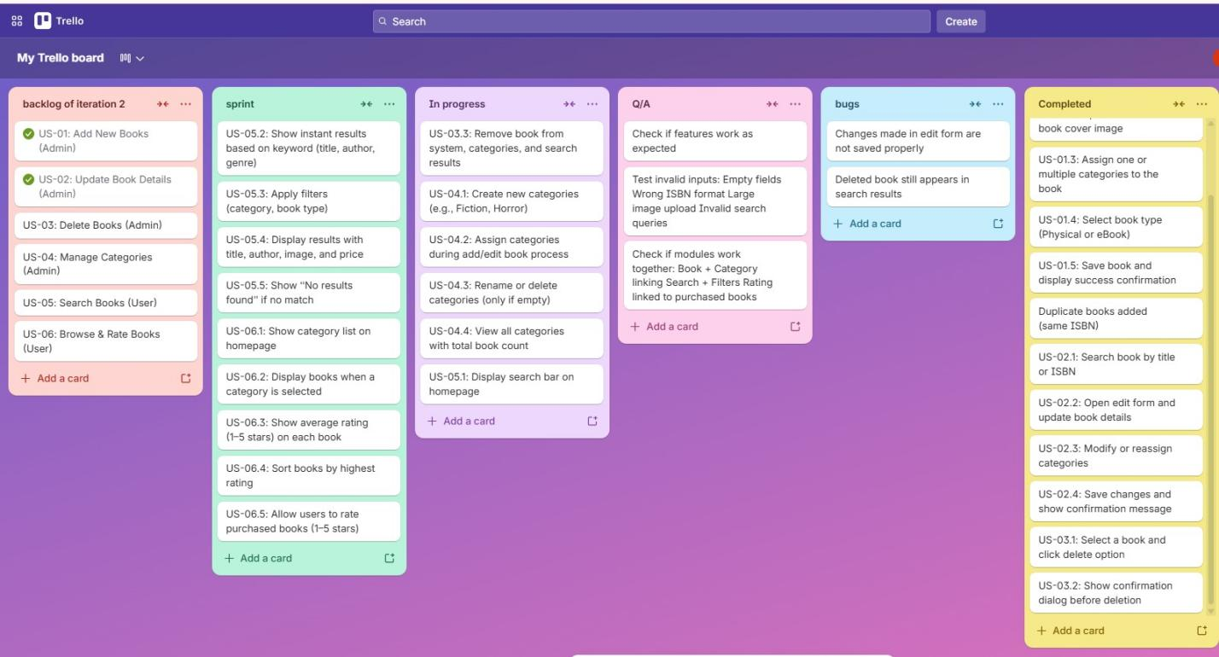
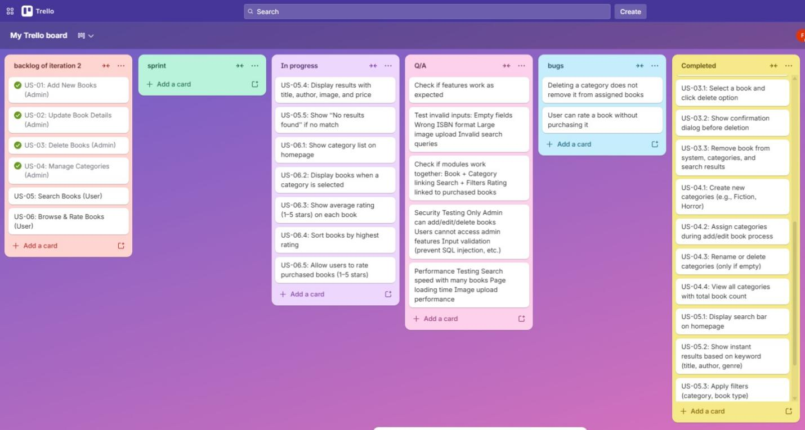

Work Division

Team Member | Roll No. | Role | Sprint 2 Responsibilities
Kinza Saeed | 24L-2527 | Project Lead / Requirement Engineer | User story definition, sprint planning, Trello board management, category management feature oversight, documentation and report compilation
Fajar Owaes | 24L-2532 | System Architect / Developer | Backend API development (CRUD for books), database schema for books/categories/ratings, search query implementation, book form frontend
Syeda Urwa | 24L-2561 | Developer / Tester | Frontend UI for book listing/search/browse, star rating widget implementation, test case writing, bug identification and fixing

Implementation Screenshots

User— Home Page
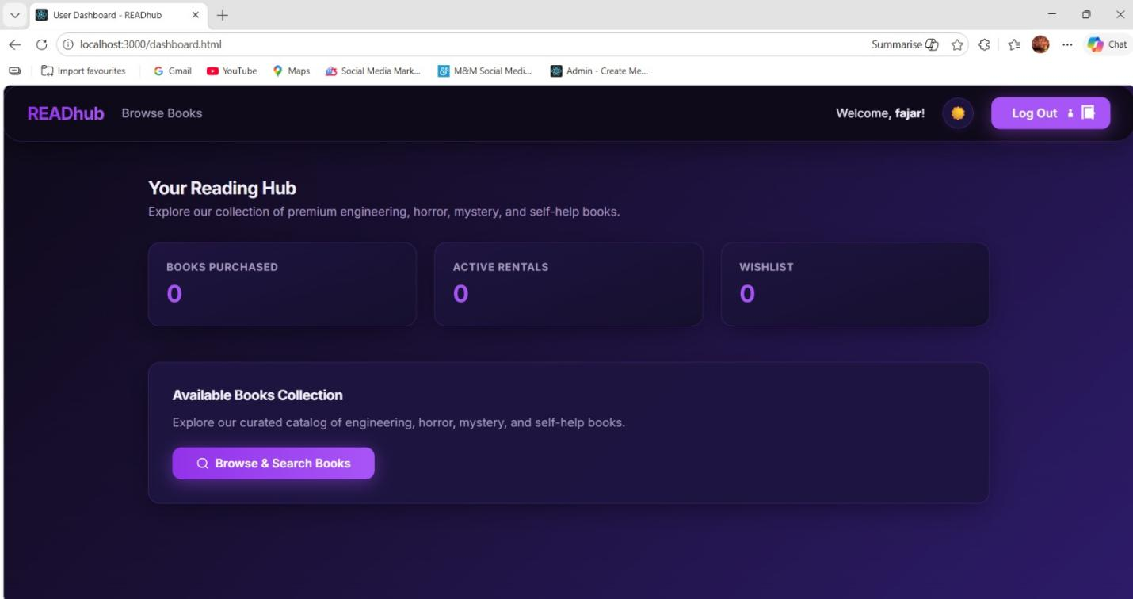

User— Rating
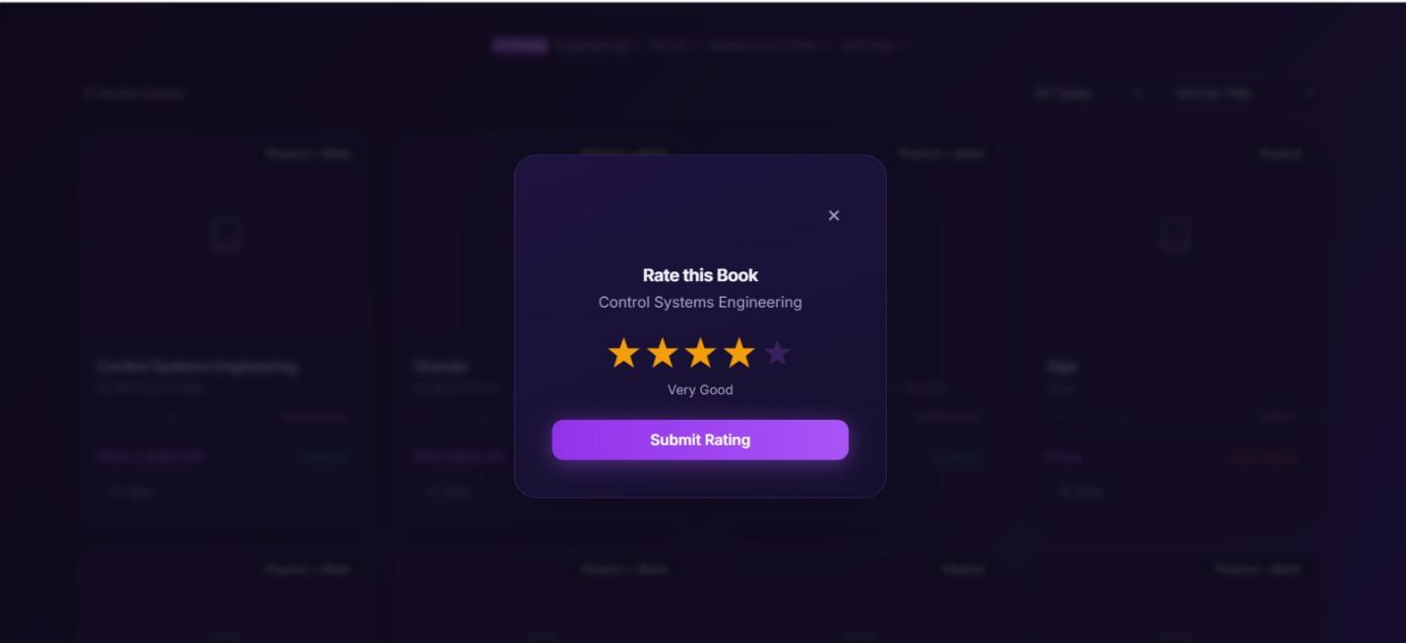

User— Sort By
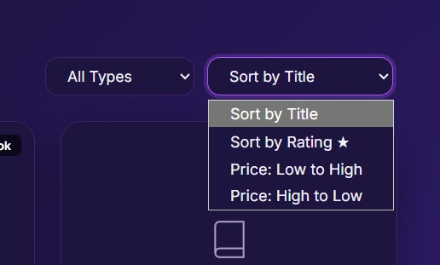

Admin — Dashboard
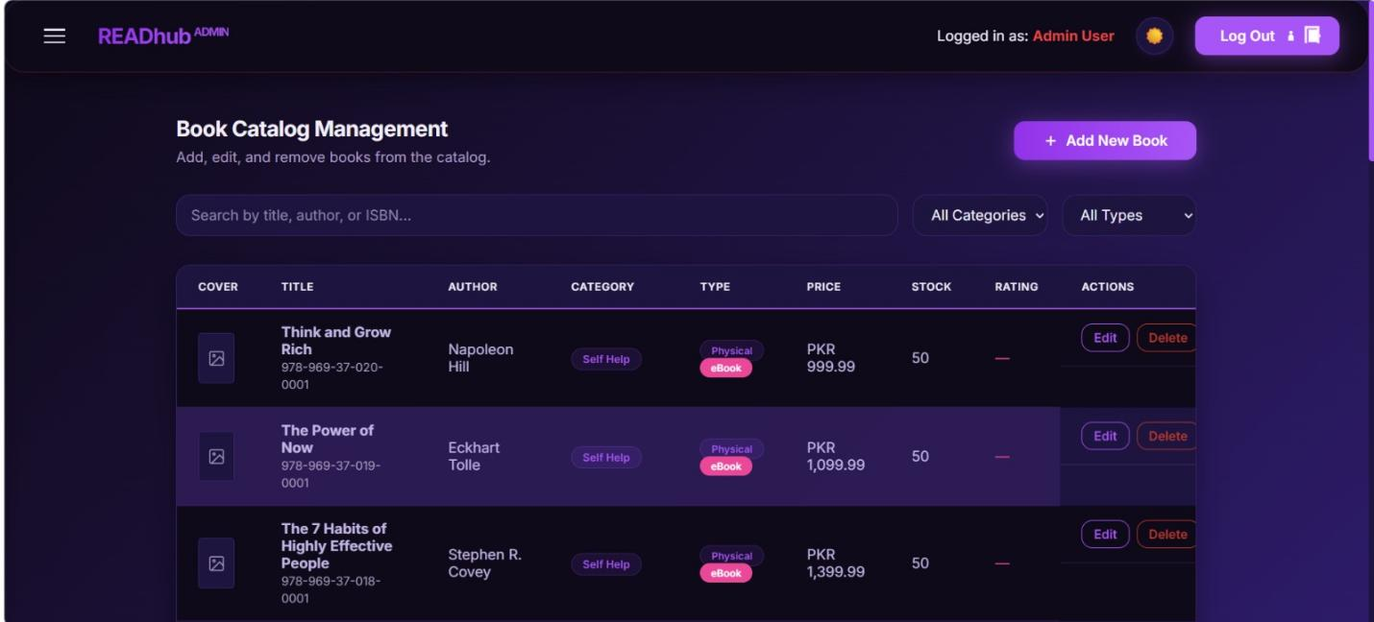

Admin — Add Book Form
