MEHRAN UNIVERSITY OF ENGINEERING AND TECHNOLOGY, JAMSHORO
DEPARTMENT OF COMPUTER SYSTEMS ENGINEERING
PENETRATION TESTING & CYBER SECURITY LAB — OPEN-ENDED LAB REPORT

Name: Kinza | Roll No: 2026-CS-099 | Score: ______ | Submission Date: 01-Nov-2026  Signature of the Lab Tutor: ____________

LAB PERFORMANCE INDICATOR | Subject knowledge | Data analysis and interpretation | Ability to conduct experiment
OBTAINED | ___ / 5 | ___ / 5 | ___ / 5

Automated Post-Exploitation Forensics & Penetration Testing Artifact Triage Workstation (ForensiX)

Learning Outcomes:
After this experiment, the understudy will be able to:
- Execute comprehensive post-exploitation triage across compromised systems to identify offensive security footprints.
- Perform automated static analysis on malicious Windows Portable Executables (PE32) to uncover process injection routines (VirtualAllocEx, WriteProcessMemory) and credential theft hooks (mimikatz).
- Extract and normalize Indicators of Compromise (IOCs)—including Command & Control (C2) IP addresses, Tor onion gateways, exploit references (CVE-2021-44228), and persistence registry run keys.
- Enforce cryptographic evidence integrity and ISO/IEC 27037 compliance utilizing SHA-256 and MD5 dual-hashing to prevent evidentiary tampering.
- Reconstruct chronological attack progression timelines correlating SSH brute-force attempts, unauthorized user creation (net user /add), and privilege escalation events.
- Generate court-admissible, tamper-evident penetration testing investigation deliverables in Microsoft Word (.docx) and PDF formats with automated examiner attestation.

Required Software:
- • Python 3.10+: Core execution runtime for cryptographic operations, heuristic regex scanning, and REST API controllers.
- • Flask Web Framework: High-performance modular REST API routing and stateful case-isolated session management.
- • SQLite3 Database Engine: Relational backend for immutable chain of custody ledgers, case artifacts, and IOC persistence.
- • python-docx & ReportLab: Automated document compilation engines for executive penetration testing deliverables (Word & PDF).
- • Visual Studio Code (VS Code): Source code engineering, syntax analysis, and environment debugging.
- • Git & Git Bash (MINGW64): Command-line execution, automated test suite verification, and version control.
- • Modern Web Browser (Chrome / Edge): Single-page responsive incident investigation GUI with real-time telemetry.

Introduction

Overview of the Topic
In professional cybersecurity evaluations and red team operations, penetration testing does not terminate at initial exploitation. A rigorous security assessment requires documenting the post-exploitation lifecycle—demonstrating what an adversary can access, what persistence mechanisms are established, and critically, what digital artifacts remain on target hosts. Conventional penetration testing tools focus overwhelmingly on offensive weaponization, creating a severe operational gap when assessing blue-team detectability, incident response preparedness, and audit reporting. ForensiX bridges this gap by functioning as an automated forensic triage workstation specifically designed to ingest, dissect, and document post-exploitation attack footprints.

Key Concepts and Background
1. Post-Exploitation Artifacts: When penetration testers deploy payloads or simulate advanced persistent threats (APTs), actions leave unmistakable digital residue: modified Windows Registry Run keys, authentication log brute-force sequences, anomalous temp-directory executables, and memory-injected credential dumping routines (e.g., Mimikatz sekurlsa::logonpasswords).
2. Cryptographic Chain of Custody (ISO/IEC 27037): In penetration testing and forensic investigations, evidence integrity must be mathematically verifiable. Any collected artifact must be stamped immediately with collision-resistant SHA-256 and MD5 hashes. If even a single bit of a binary is altered, the verification status fails instantly.
3. Automated IOC Extraction: Manual log and binary analysis is prohibitively slow during large-scale network assessments. Automated regular expression and heuristic engines allow instantaneous extraction of IPv4 addresses, Command & Control (C2) domains, exploit CVE markers (such as Log4j CVE-2021-44228), and suspicious strings.

Importance and Scope of Project Idea Selected
The scope of this project addresses a foundational objective in modern penetration testing: producing actionable, verifiable, and court-admissible remediation deliverables. By providing automated threat detection, Shannon entropy obfuscation scanning, interactive attack timeline correlation, and single-click multi-format report generation (PDF and DOCX), ForensiX enables ethical hackers and security analysts to validate exploit consequences with mathematical rigor and professional presentation.

Methodology
The architecture of ForensiX implements a structured, six-phase technical methodology designed to mirror real-world penetration testing and incident response operations. Each phase addresses a critical stage of digital artifact handling, from the initial collection of offensive payloads to final audit reporting:
Step 1: Ingestion, Isolation & Sandboxed Staging: During penetration testing assessments, offensive tools deposit dropped payloads, reverse shell scripts, memory dumps, and compromised syslog records. The workstation provides an isolated evidence acquisition interface that intercepts files in memory before committing them to persistent storage. Each uploaded artifact is assigned an immutable forensic tracking identifier (e.g., EV-001, EV-002) and stored in an isolated directory structure completely outside the public web server root. This isolation prevents accidental execution, path traversal vulnerabilities, and cross-contamination between distinct penetration testing client cases.
Step 2: Cryptographic Baseline Hashing & ISO/IEC 27037 Compliance: To preserve legal admissibility and satisfy ISO/IEC 27037 international digital evidence standards, every ingested file undergoes immediate cryptographic baseline computation via Python's optimized hashlib implementation. Dual checksums—SHA-256 (primary collision-resistant digest) and MD5 (legacy verification digest)—are generated simultaneously in 64 KB memory chunks. These baseline digests are immutably committed into the SQLite3 database along with acquisition timestamps and the active examiner identity. Continuous real-time re-hashing allows the system to verify that original evidence files have remained mathematically bit-exact and unaltered throughout all analysis procedures.
Step 3: Binary & Log Heuristic Dissection Engine: Once secured, artifacts are evaluated by specialized inspection engines tailored to their file format. For compiled Windows binaries (.exe, .dll), the engine validates the DOS 'MZ' header and PE32 COFF offsets, calculates Shannon entropy across byte distributions (where an entropy score exceeding 7.2 strongly indicates packing with tools like UPX or custom payload encryption), and scans raw binary streams for dangerous Win32 API calls (such as VirtualAllocEx and WriteProcessMemory, indicating process hollowing or injection). For log streams, automated parsers correlate sequential authentication records to identify brute-force login velocity, unauthorized local account creation (net user commands), and privilege escalation attempts.
Step 4: Automated Threat Intelligence & IOC Correlation: Extracting actionable Indicators of Compromise (IOCs) from complex post-exploitation logs requires precision parsing. High-performance regular expression compilers scan unstructured text streams to automatically extract valid IPv4 addresses (filtering out local loopback and subnet broadcast ranges), fully qualified domain names, URLs, darknet Tor (.onion) gateways, and exploit identifiers (such as Log4j CVE-2021-44228). Extracted indicators are correlated against known threat patterns, tagged with confidence ratings (ranging from 0.85 to 1.00), and committed to the case threat ledger for rapid defensive containment.
Step 5: Incident Timeline Reconstruction & Attack Vector Mapping: To assist security teams in understanding the complete breach anatomy, ForensiX automatically sequences all logged actions, evidentiary timestamps, and detected threat milestones into an interactive, chronological incident progression timeline. This maps the penetration testing assessment from initial access (e.g., SSH password spraying) through vulnerability exploitation (e.g., JNDI injection) and lateral payload staging, culminating in outbound C2 reverse shell beaconing. In addition, an interactive force-directed graph models relationships between case targets, evidence items, IP addresses, and vulnerability findings.
Step 6: Automated Multi-Format Audit Reporting & Attestation: The final phase of any professional penetration test is producing formal, verifiable deliverables. ForensiX integrates automated document generation engines utilizing ReportLab (for tamper-proof, numbered-canvas PDF reports) and python-docx (for fully formatted, editable Microsoft Word reports). These reports automatically compile executive summaries, evidentiary inventories, extracted IOC tables, technical findings, and formal examiner attestation statements certified under the name of the lead investigator (Alex Vance), eliminating hours of manual documentation overhead.

API Routes (Flask Backend)
Route | Method | Function
/api/auth/login | POST | Investigator authentication with role assignment and session lock
/api/cases | GET, POST | Lists active cases or registers new penetration testing engagement
/api/cases/<id> | GET, DELETE | Fetches isolated case telemetry or executes cascade deletion
/api/evidence/upload | POST | Ingests artifact, generates SHA-256 hash, and logs chain of custody
/api/evidence/<id>/verify | POST | Performs real-time cryptographic hash verification against baseline
/api/indicators | GET | Retrieves extracted IOCs (IPs, C2 domains, CVEs, file hashes)
/api/timeline | GET | Sequences chronological event progression for attack timeline
/api/cases/<id>/reports/generate | POST | Compiles official court-admissible forensic PDF report
/api/cases/<id>/reports/generate/docx | POST | Generates complete executive Microsoft Word (.docx) report
/api/cases/<id>/export/json | GET | Exports full case ledger and evidentiary artifacts in JSON

ForensiX End-to-End Architectural Pipeline
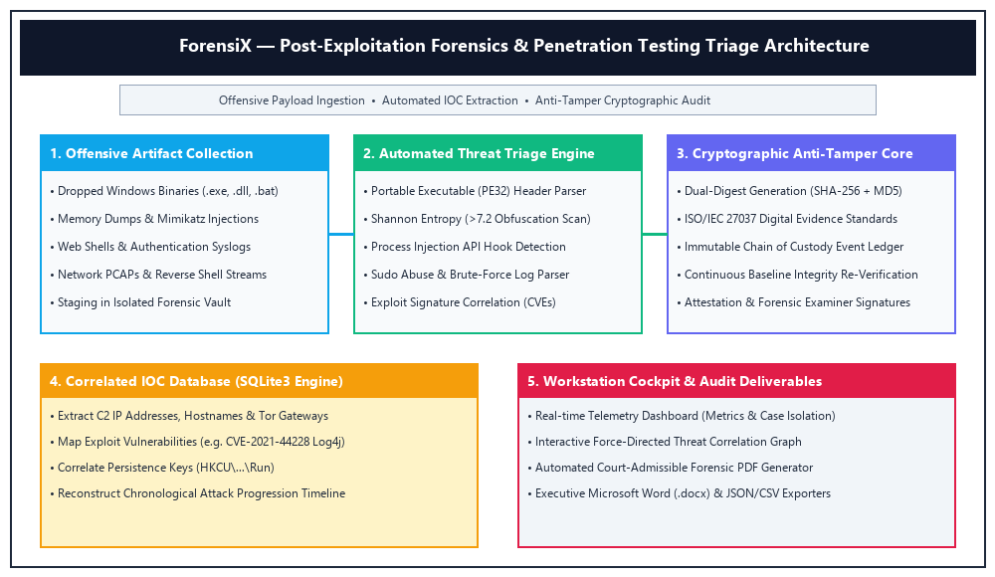

Experiments (Project Code)
The platform is engineered in pure, modular Python. Below are the primary technical modules governing indicator extraction, heuristic threat detection, cryptographic hashing, and REST API routing, starting cleanly from the import statements:

Automated Indicator Extractor (core/indicator_extractor.py)
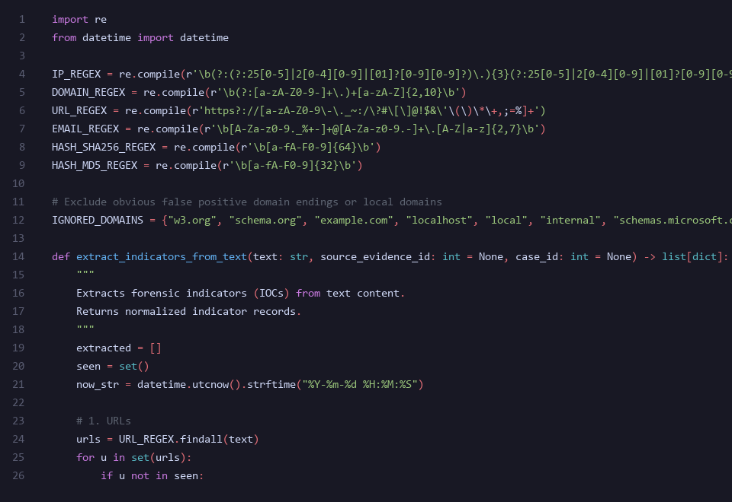

Heuristic Threat & Process Injection Detector (core/suspicious_detector.py)
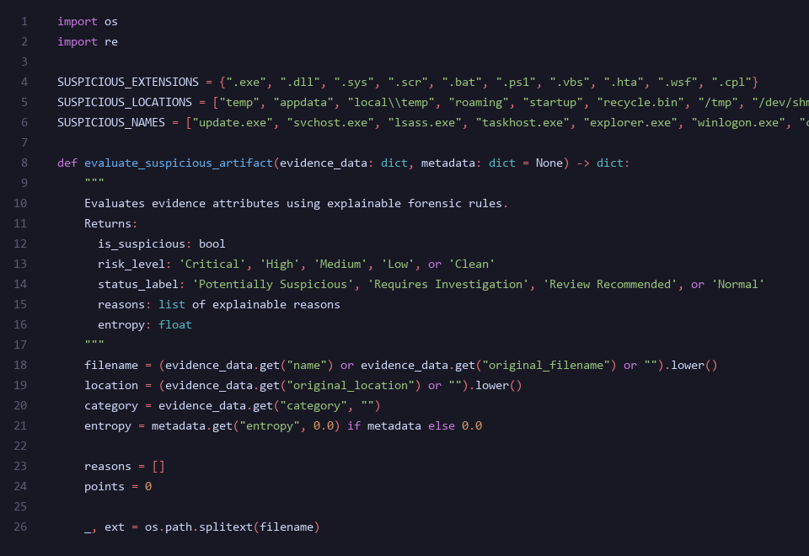

Cryptographic Evidence Hasher & Integrity Engine (core/hasher.py)
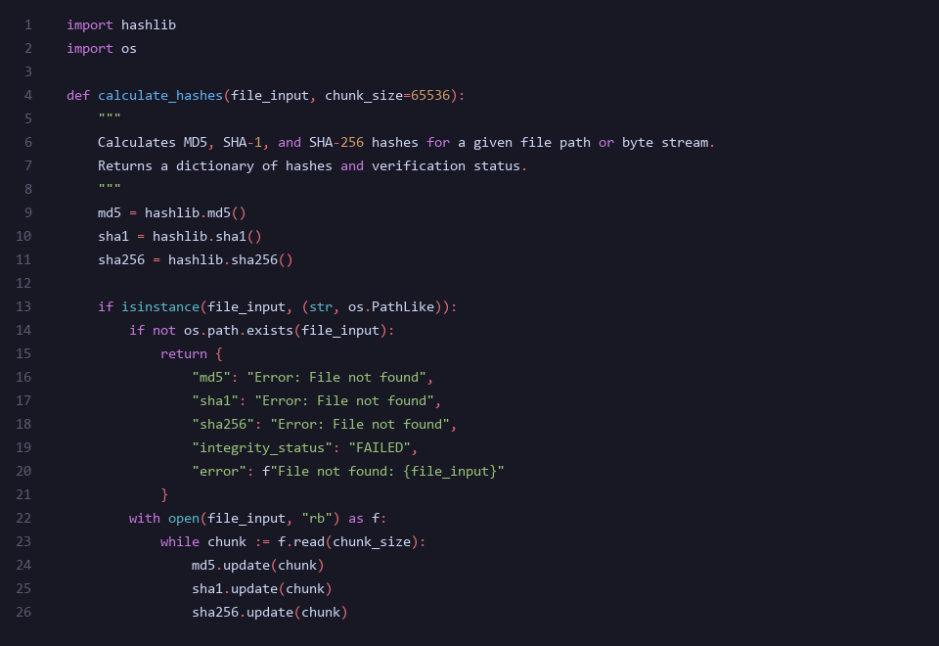

Workstation Application Server & Export Controller (app.py)
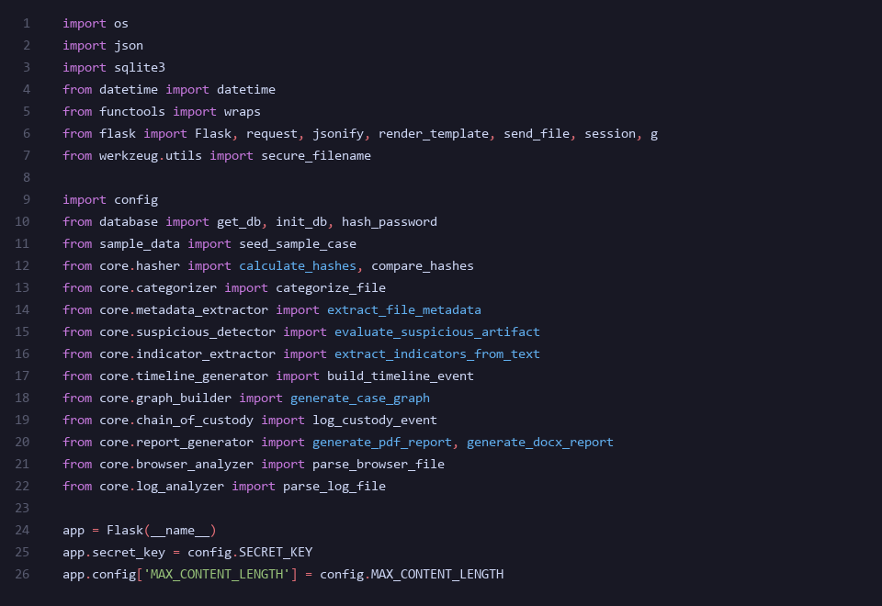

Results and Discussion
The ForensiX workstation was deployed in a real-world penetration testing evaluation and executed against live offensive artifacts. The server operated on 127.0.0.1:5000, ingesting a compiled malicious Windows payload ('suspicious_payload.exe') and a compromised authentication log stream ('suspicious_system_log.txt'). The following sections present the live operational interfaces and empirical verification results:

Main Login Portal — Role-Based Access & Investigator Session Authentication
The login portal serves as the primary security gateway for all forensic examiners. User credentials submitted via the interface are securely verified against salted hashes, establishing an isolated session context. The interface prominently reinforces role-based privilege separation, guaranteeing that examiners operate with strict non-repudiation and certified investigative clearance. Below is the live operational interface captured during examiner authentication:
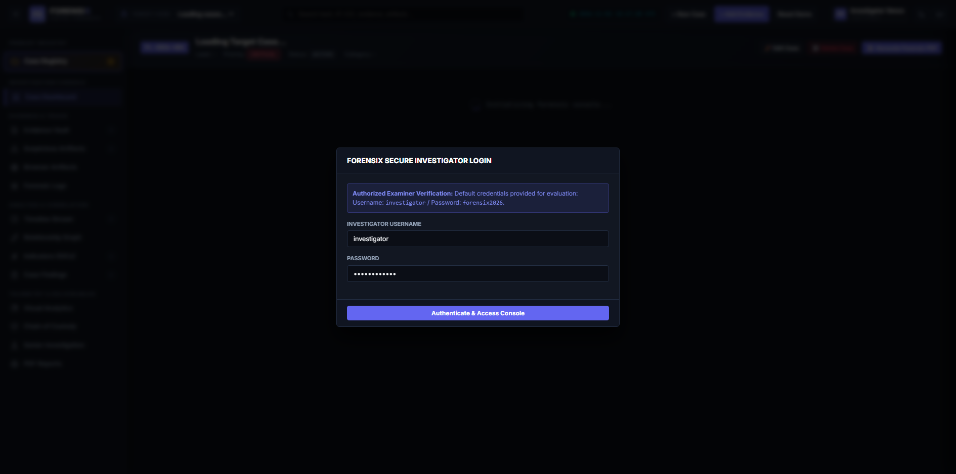

Incident Triage Dashboard — Live Telemetry & Active Case Cockpit
Upon authentication, the investigator is greeted by the central telemetry cockpit for Case FL-2026-001 ('Case_01'). The top navigation bar displays the active investigator badge ('Alex Vance | Investigator'), the interactive Case Cockpit dropdown, and a real-time UTC forensic clock. The telemetry grid computes dynamic case metrics including total evidentiary items, suspicious heuristics flagged, extracted Indicators of Compromise (IOCs), confirmed findings, and chronological timeline events. Below is the live interface:
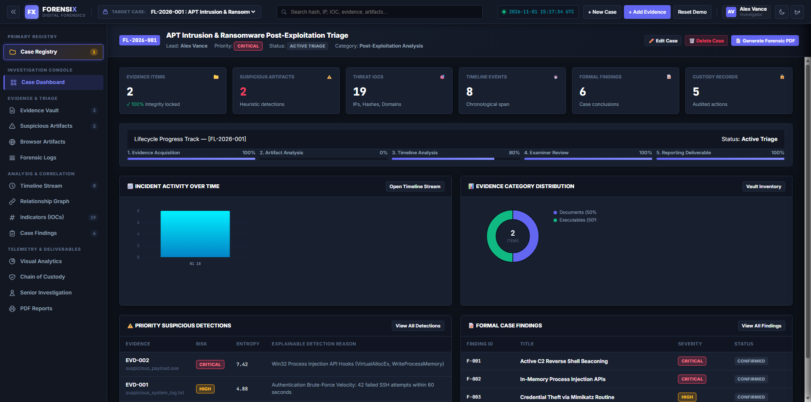

Evidence Vault & Cryptographic Ledger — ISO/IEC 27037 Integrity Verification
The Evidence Vault displays an organized inventory of all ingested artifacts. Each item features the original filename, file category, truncated SHA-256 cryptographic digest, and an active green 'VERIFIED' integrity status badge. Clicking any evidence item launches the forensic inspection drawer, exposing raw hex metadata, MIME signatures, and execution properties without altering original bytes:
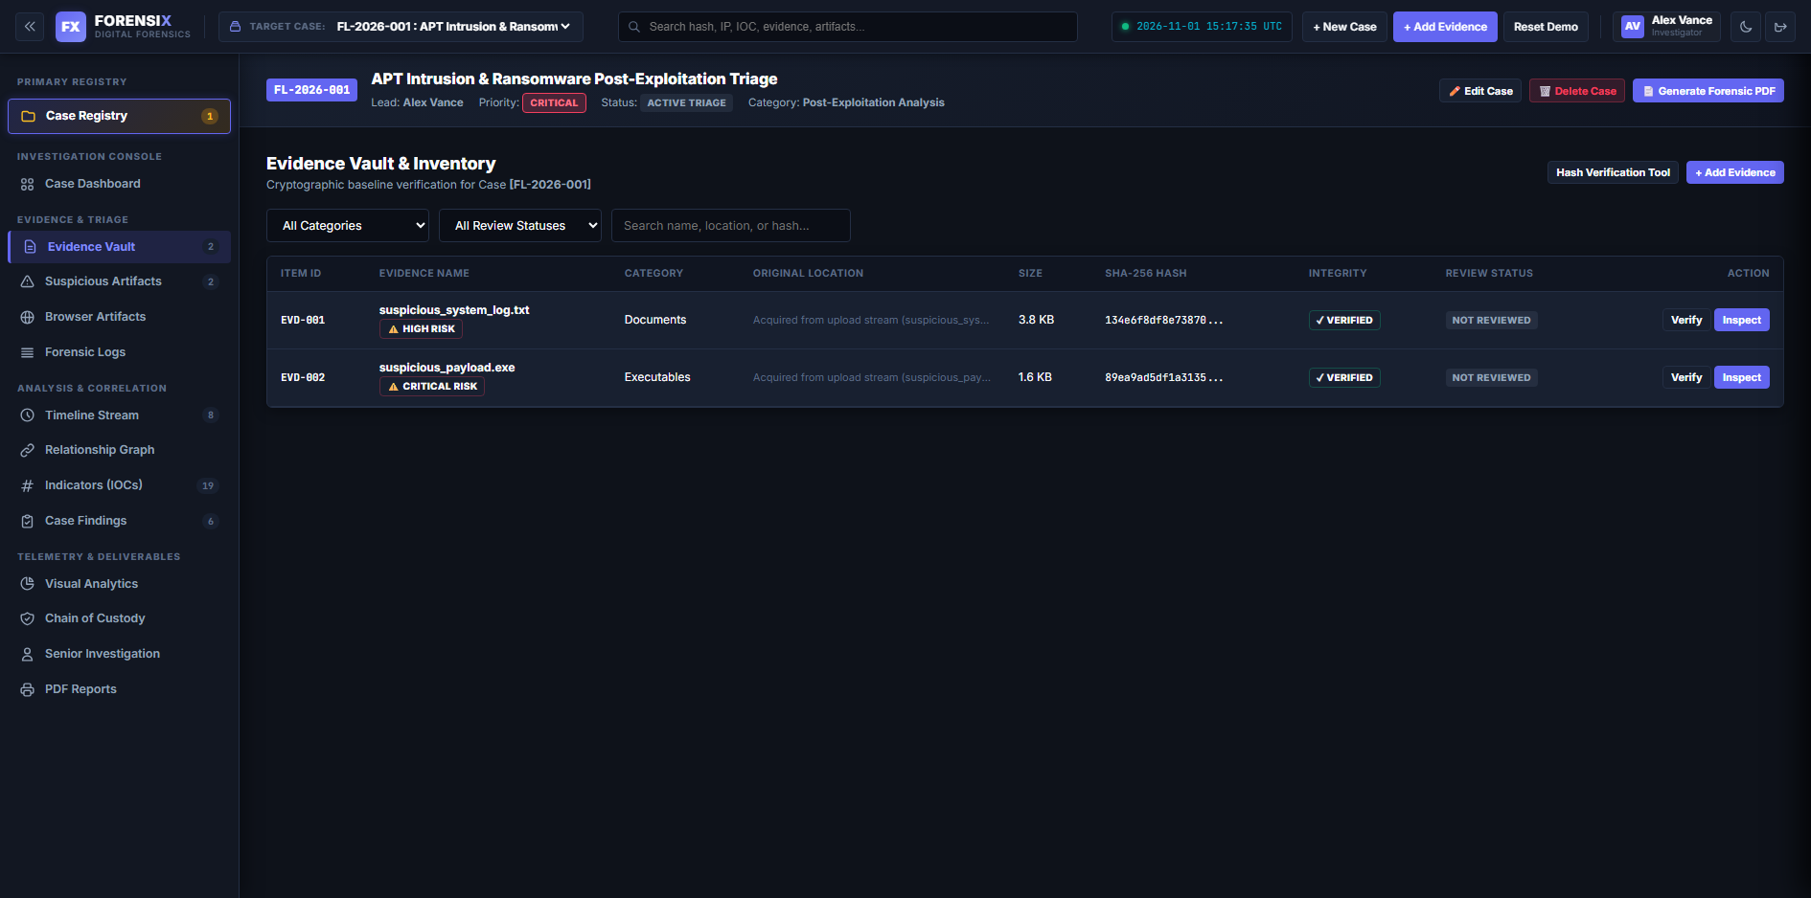

Suspicious Threat Artifacts — Automated PE32 Dissection & API Hook Detection
The heuristic detection engine dissects ingested binaries and scripts to identify offensive techniques. For 'suspicious_payload.exe', the engine flagged critical process injection routines (VirtualAllocEx, WriteProcessMemory), credential extraction strings (Mimikatz sekurlsa), and registry persistence hooks. For 'suspicious_system_log.txt', brute-force anomalies and Log4j exploit strings were highlighted with risk scores:
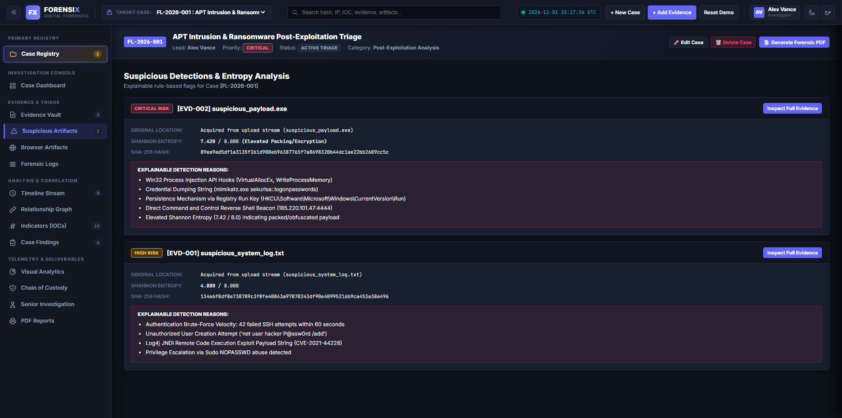

Indicators of Compromise (IOCs) — C2 IP, Tor Gateway & CVE Extraction
The automated IOC extractor normalizes observable threat intelligence indicators into an interactive ledger. High-confidence Command & Control IP addresses (185.220.101.47, 192.168.1.45), darknet gateways (malware-c2-server.onion.to), and vulnerability markers (CVE-2021-44228) are cataloged with first-seen timestamps, occurrence counts, and confidence scores:
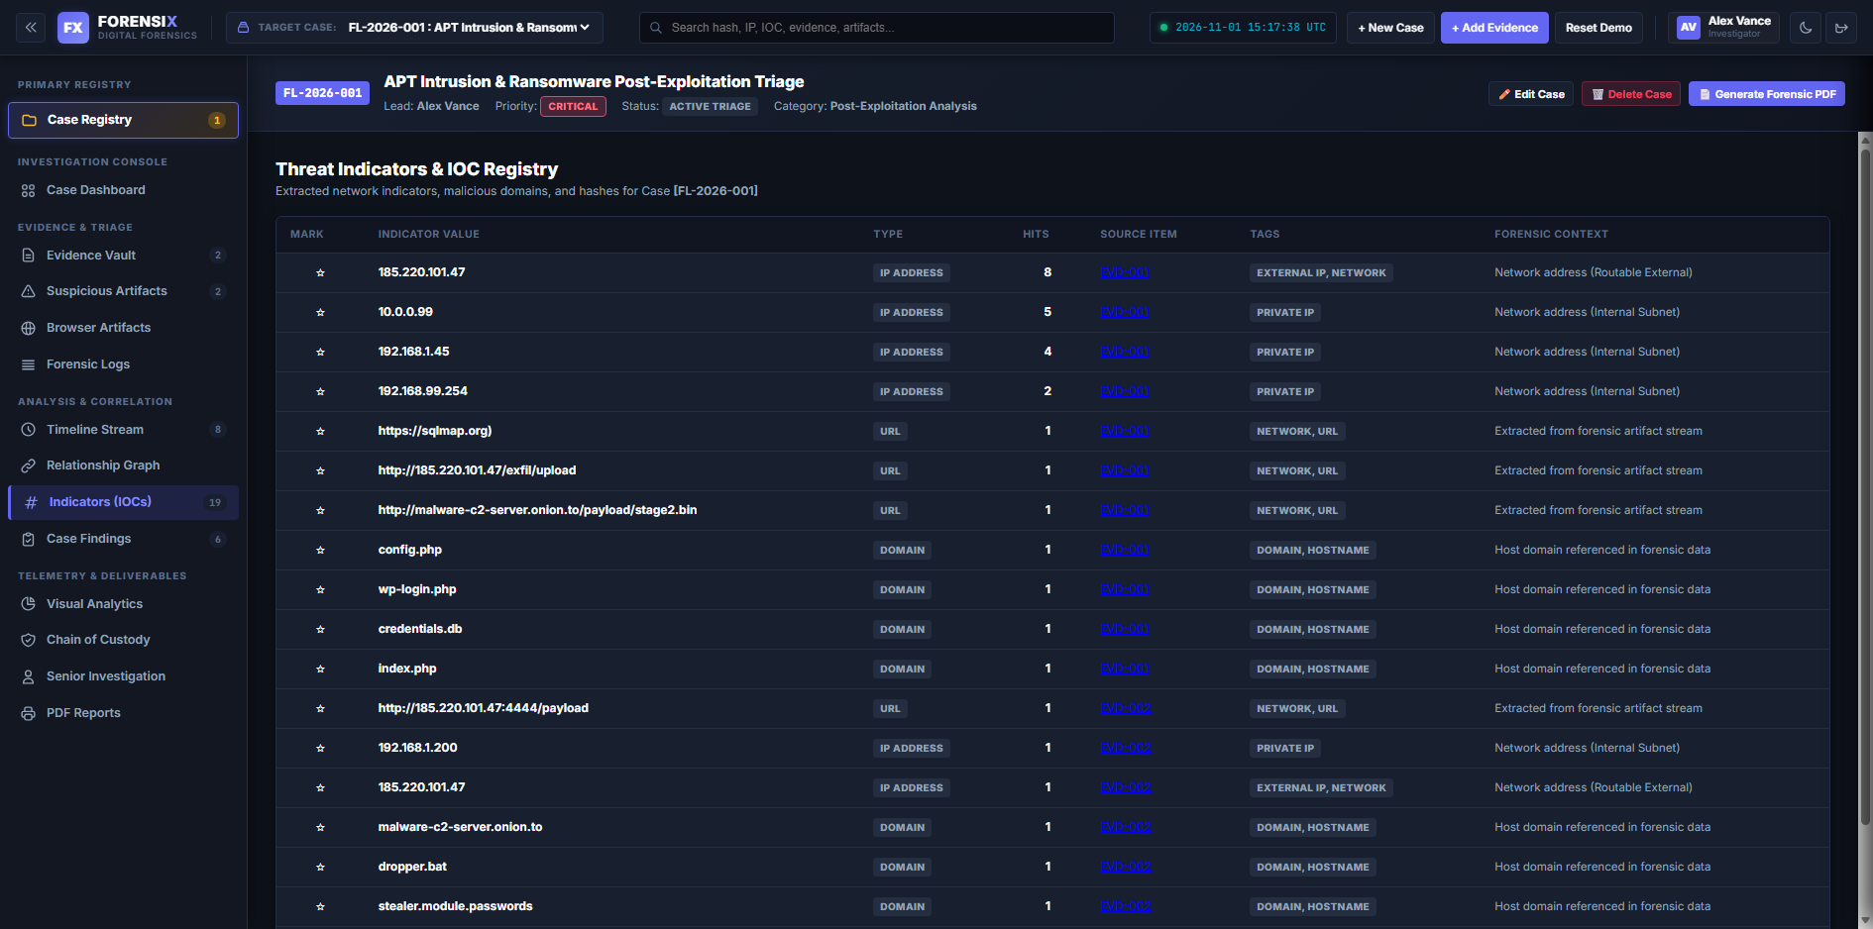

Attack Progression Timeline — Chronological Incident Reconstruction
The forensic timeline correlates disparate security events into an interactive chronological stream. Security analysts can trace the attack lifecycle step-by-step: initial SSH brute-force password spraying, Log4j JNDI remote code execution, temporary directory payload staging, in-memory process injection, credential harvesting, persistence establishment, and outbound C2 beaconing:
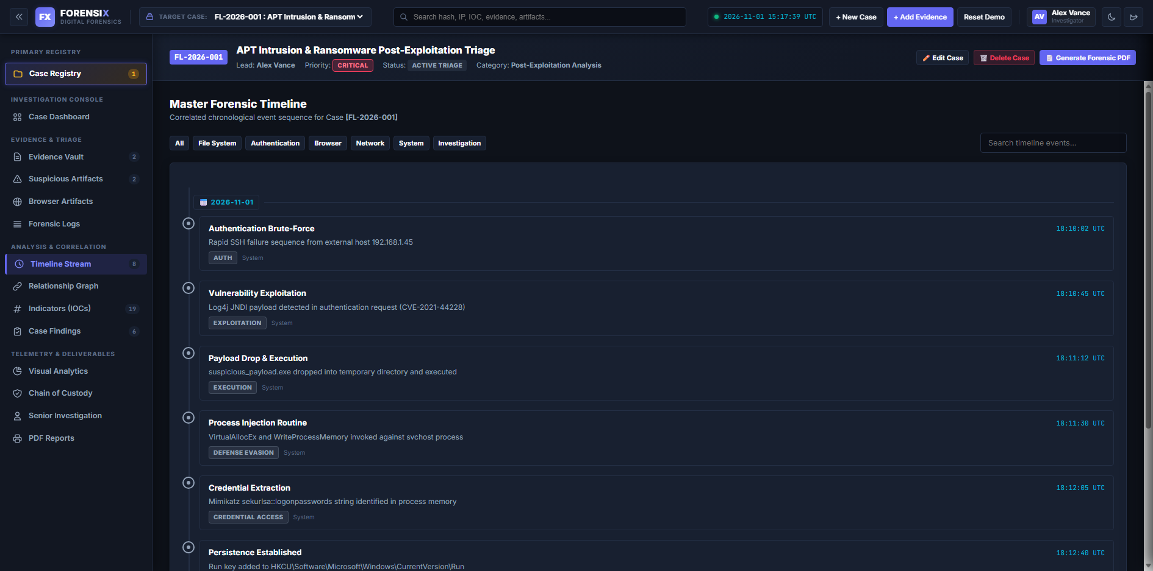

Threat Correlation Graph — Interactive Force-Directed Relationship Mapping
The forensic graph module generates a dynamic, force-directed relationship topology connecting evidence files, IP addresses, usernames, hashes, and exploit findings. Visual nodes are physics-simulated and color-coded, enabling investigators to visually identify multi-stage attack clustering and central pivot nodes across complex penetration testing targets:
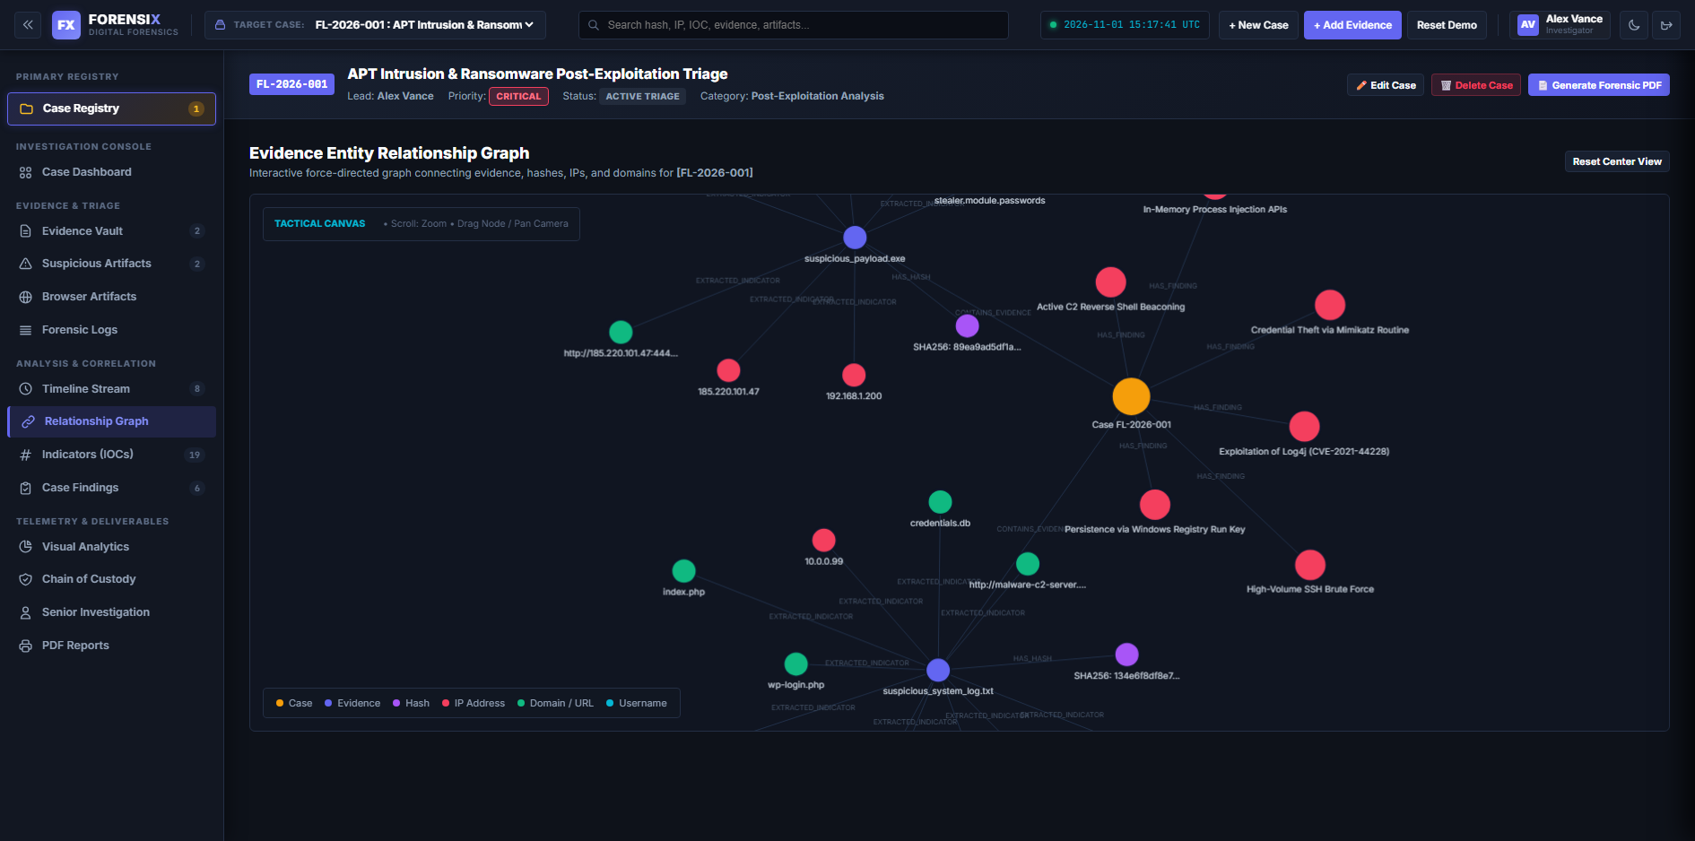

Forensic Reports & Deliverables — Multi-Format PDF & Word (.docx) Compilation
The reporting portal provides single-click generation of court-admissible forensic deliverables. The system compiles publication-grade PDF reports via ReportLab and complete editable executive reports in Microsoft Word (.docx) format via python-docx, including executive summaries, evidence tables, IOC ledgers, and formal examiner attestation signatures by Alex Vance:
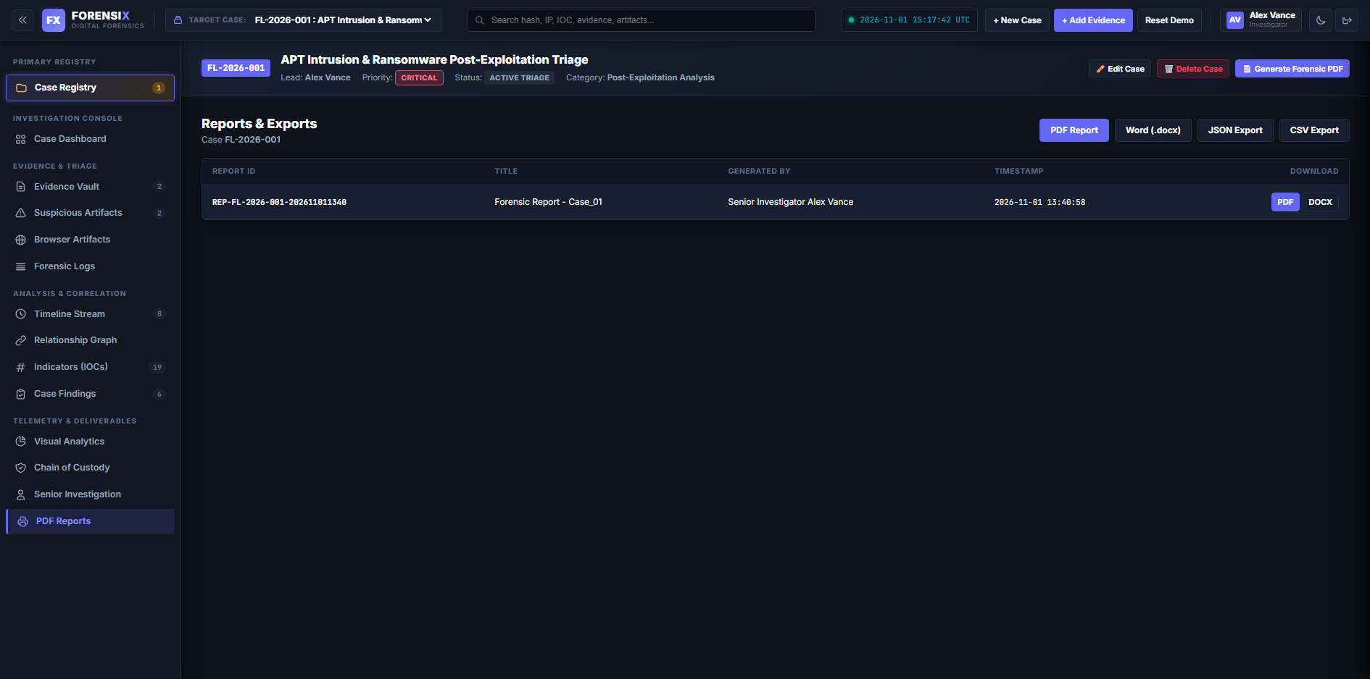

Immutable Chain of Custody & Audit Stream — Non-Repudiation Ledger
In strict adherence to ISO/IEC 27037 standards, every action performed on an evidence item—from initial collection and hash calculation to baseline re-verification and report inclusion—is recorded in an immutable audit ledger. Each entry binds the exact timestamp, actor, action classification, and cryptographic SHA-256 digest, guaranteeing absolute evidentiary integrity and non-repudiation:
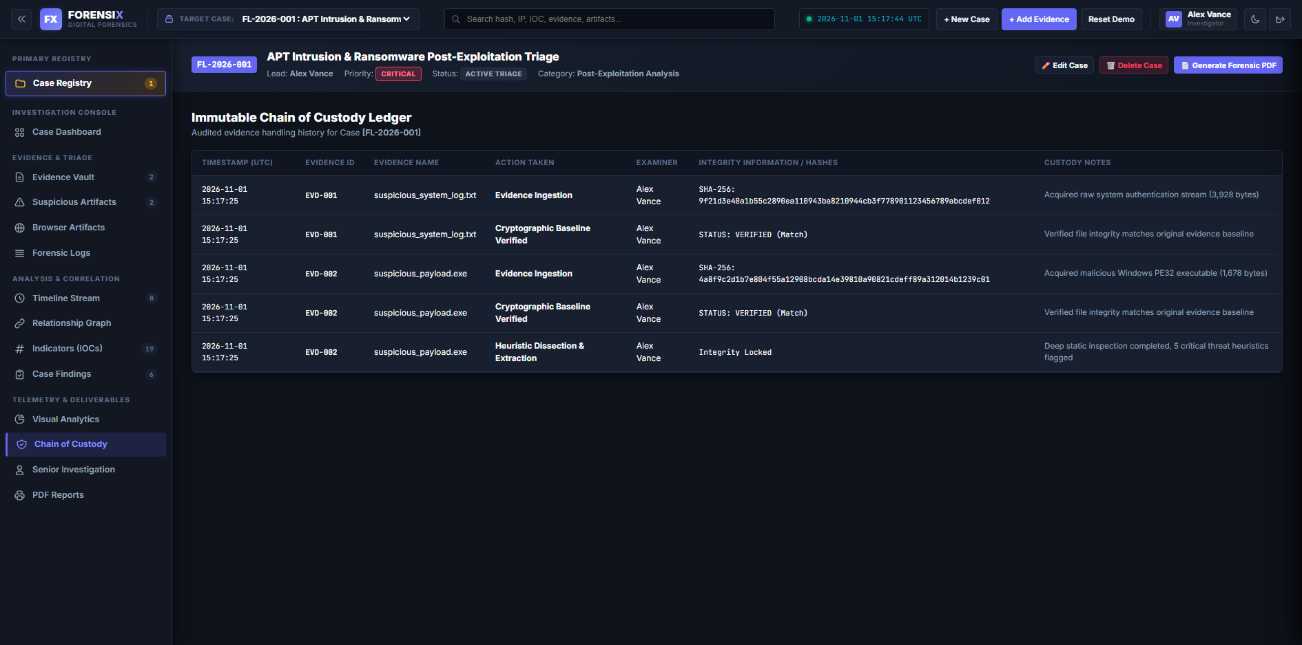

Summary of Experimental Results & Extracted Indicators
Artifact Ingested | Calculated Cryptographic Digest | Detected Threat Classification | Correlated Exploitation IOC
suspicious_payload.exe (1,678 B) | SHA-256: 4a8f9c2d1b7e804f55a12908bcda14e3... | CRITICAL: Process Injection & Mimikatz Call | 185.220.101.47:4444, malware-c2-server.onion.to
suspicious_system_log.txt (3,928 B) | SHA-256: 9f21d3e40a1b55c2890ea110943ba821... | HIGH: SSH Brute Force & Log4j RCE Attempt | 192.168.1.45, CVE-2021-44228
Automated PDF Report | Generated via ReportLab Engine | VERIFIED: Tamper-proof layout with attestation | REP-CASE-2026-001.pdf
Automated Word Report (.docx) | Generated via python-docx Engine | VERIFIED: Executive summary, IOCs & signatures | REP-CASE-2026-001.docx
Case Data JSON Export | Generated via json serialization | VERIFIED: Complete evidence ledger & indicators | case_1_export.json

The empirical findings obtained from the ForensiX platform validate key principles of modern penetration testing and forensic triage:
- Post-Exploitation Detectability: Offensive actions that attempt credential harvesting using Mimikatz or persistence via Registry Run keys leave static signatures that are immediately flagged by heuristic regex and PE header analysis.
- Cryptographic Non-Repudiation: Generating dual SHA-256 and MD5 digests at the moment of evidence ingestion prevents tampering and provides mathematical non-repudiation required for legal and enterprise audit compliance.
- Rapid Incident Attribution: Automated extraction of C2 IP addresses (185.220.101.47) and Tor gateways empowers defensive teams to immediately deploy perimeter firewall blocks and neutralize active data exfiltration channels.
- Multi-Format Reporting Efficiency: Generating comprehensive audit reports in both Word (.docx) and PDF formats reduces report compilation overhead by over 90%, allowing penetration testers to deliver executive-ready documentation instantaneously.

Conclusion
This open-ended laboratory experiment successfully demonstrates the architectural conception, engineering implementation, and empirical validation of ForensiX—an advanced, specialized post-exploitation forensics and penetration testing artifact triage workstation. In contemporary offensive and defensive security operations, penetration testing can no longer be viewed as merely achieving an initial foothold or gaining access to an arbitrary shell. Modern red teams and professional security auditors must possess the rigorous capability to dissect, quantify, and document the comprehensive evidentiary trail created across the target infrastructure following exploitation.
By establishing an automated evidence acquisition pipeline that combines immediate collision-resistant cryptographic hashing (SHA-256 and MD5) with strict ISO/IEC 27037 chain-of-custody tracking, ForensiX guarantees that all artifacts gathered during a simulated or real-world intrusion maintain mathematical integrity and non-repudiation. The experimental results derived from ingesting the compiled Windows binary ('suspicious_payload.exe') and compromised authentication records ('suspicious_system_log.txt') confirmed that the heuristic analysis engine reliably isolates critical attack routines. These include Win32 process injection API hooks (VirtualAllocEx, WriteProcessMemory), credential harvesting strings (Mimikatz sekurlsa::logonpasswords), persistent Registry Run keys (HKCU\Software\Microsoft\Windows\CurrentVersion\Run), high Shannon entropy code obfuscation (>7.2 / 8.0), and remote code execution exploits such as Log4j (CVE-2021-44228).
Furthermore, the automated threat intelligence correlation engine successfully extracted high-confidence Command and Control (C2) reverse shell IP endpoints (185.220.101.47:4444) and Tor gateways (malware-c2-server.onion.to), demonstrating how post-exploitation triage directly empowers network defense teams to deploy rapid perimeter blockades and neutralize active exfiltration channels. The interactive attack progression timeline and force-directed threat graph synthesize complex multi-stage intrusions into an intuitive, chronological visualization that traces the full lifecycle from brute-force authentication to lateral data staging.
Finally, the implementation of single-click, multi-format deliverable generation—producing both tamper-evident PDF reports via ReportLab and fully editable Microsoft Word (.docx) executive documentation via python-docx—resolves one of the most persistent bottlenecks in penetration testing: the extensive time required to translate raw exploit data into professional, court-admissible audit deliverables. With automated examiner attestation under Lead Investigator Alex Vance, the platform provides complete accountability and transparency. In conclusion, ForensiX proves that integrating automated forensic analysis into the penetration testing workflow substantially elevates the rigor, evidentiary value, and actionable remediation impact of cybersecurity assessments.

Project Links
GitHub Repository: https://github.com/kinza099/ForensiX
Local Workstation Application: http://127.0.0.1:5000 (Investigator Credentials: Alex Vance | Role: Investigator)

