COMPUTER NETWORKS PROJECT REPORT



Network Logs Analyzer + ChatOps

Project Title: Network Security SOC Dashboard with GHF-ART Based Network Attack Detection
Department: Computer Science
Academic Year: 2025

Group Members:
- Kinza - Roll No: 23K-0842
- Sanjana- Roll No: 23K-2022
Instructor: Sir Kashan
Date of Submission: 9-December-2025

1. Objective and Method
1.1 Objective
The primary objectives of this project are:
- Design and implement an intelligent Network Security Operations Center (SOC) dashboard for real-time network traffic monitoring and attack detection
- Develop and deploy a GHF-ART (Generalized Hierarchical Fuzzy Adaptive Resonance Theory) based clustering algorithm optimized for network intrusion detection
- Create an interactive interface using Streamlit that enables security analysts to visualize network events, anomalies, and potential attacks in real-time
- Implement email alert system for critical and high-severity security incidents
- Provide comprehensive network analysis including threat indicators, severity classification, and actionable insights
- Achieve high accuracy in distinguishing between normal network traffic and malicious attack patterns
1.2 Methodology
1.2.1 Machine Learning Approach
Algorithm Used: GHF-ART Optimized Clustering
The project employs the GHF-ART algorithm, an advanced unsupervised learning technique that:
- Performs multi-channel fuzzy adaptive resonance clustering
- Uses complement coding for enhanced pattern representation
- Implements vectorized operations for computational efficiency
- Achieves adaptive cluster formation based on vigilance parameters
- Dynamically adjusts sensitivity to anomalies through the rho (ρ) parameter
Key Algorithm Parameters:
- α (alpha): 0.01 - Small constant for choice function stability
- β (beta): 1.0 - Learning rate for weight updates
- ρ₀ (rho baseline): 0.1 - Initial vigilance parameter
- ε (epsilon): 0.001 - Vigilance update increment
1.2.2 Data Processing Pipeline
- Data Source: KDD Cup 1999 Dataset (10% corrected version)
- Feature Engineering:
  - Categorical encoding (OneHotEncoder for protocol_type, service, flag)
  - Numerical normalization (MinMaxScaler to [0,1] range)
  - Dimensionality handling (42 features after preprocessing)
- Data Separation:
  - Training set: Normal network traffic only (~60,000 samples)
  - Testing set: Attack samples (~60,000 samples matched)
- Label Strategy: Binary classification (Normal=1, Attack=0)
1.2.3 System Architecture
Three-Tier Architecture:
- Backend (Python/ML Layer)
  - GHF-ART model training and inference
  - Feature scaling and encoding pipeline
  - Network log processing and anomaly scoring
  - Email alert generation
- Frontend (Streamlit Dashboard)
  - Real-time monitoring interface
  - Interactive visualizations with Plotly
  - Theme support (Dark/Light modes)
  - Control panel for alert management
- Data Pipeline
  - CSV-based network logs (network_logs_processed.csv)
  - Model persistence (ghf_art_model.pkl)
  - Configuration management (.env variables)
1.2.4 Training Methodology
- Unsupervised Learning: Model trained on normal traffic to learn baseline behavior
- Anomaly Detection: Any deviation from learned patterns flagged as potential attack
- Cluster Formation: Automatic cluster creation as new patterns emerge
- Adaptive Vigilance: Dynamic adjustment of sensitivity thresholds per feature channel

2. Input
2.1 Data Sources
2.1.1 Primary Dataset
KDD Cup 1999 Network Attack Dataset (10% Corrected Version)
- Source: UCI Machine Learning Repository
- Total Records: ~494,000 network connections
- Attack Types: DoS, Probe, R2L, U2R with multiple variants
- Features: 41 numerical and categorical attributes
2.2 Feature Description
2.2.1 Network Connection Features (9 basic features)
- duration: Length of connection in seconds
- protocol_type: TCP, UDP, ICMP
- service: HTTP, HTTPS, FTP, SSH, SMTP, DNS, etc. (66 types)
- flag: Normal or error status (11 types)
- src_bytes: Bytes sent from source to destination
- dst_bytes: Bytes sent from destination to source
- land: 1 if connection is from/to same host
- wrong_fragment: Number of wrong fragments
- urgent: Number of urgent packets
2.2.2 Content Features (13 features)
- hot: Number of "hot" indicators (suspicious patterns)
- num_failed_logins: Count of failed login attempts
- logged_in: 1 if successfully logged in
- num_compromised: Number of compromised conditions
- root_shell: 1 if root shell is obtained
- su_attempted: 1 if "su" root command attempted
- num_root: Number of root accesses
- num_file_creations: Number of file creation operations
- num_shells: Number of shell prompts
- num_access_files: Number of access file operations
- num_outbound_cmds: Number of outbound commands
- is_host_login: 1 if host login
- is_guest_login: 1 if guest login
2.2.3 Traffic Features (19 features)
- count: Number of connections to same host in last 2 seconds
- srv_count: Number of connections to same service in last 2 seconds
- serror_rate: % of connections with SYN errors
- srv_serror_rate: % of connections to same service with SYN errors
- rerror_rate: % of connections with REJ errors
- srv_rerror_rate: % of connections to same service with REJ errors
- same_srv_rate: % of connections to same service
- diff_srv_rate: % of connections to different services
- srv_diff_host_rate: % of connections to different hosts on same service
- dst_host_count: Connections to same destination host in last 300 connections
- dst_host_srv_count: Connections to same service on destination in last 300 connections
- dst_host_same_srv_rate: % of connections to same service
- dst_host_diff_srv_rate: % of connections to different services
- dst_host_same_src_port_rate: % of connections from same source port
- dst_host_srv_diff_host_rate: % of connections to different source IPs
- dst_host_serror_rate: % of connections with SYN errors to destination
- dst_host_srv_serror_rate: % of connections with SYN errors to same service
- dst_host_rerror_rate: % of connections with REJ errors to destination
- dst_host_srv_rerror_rate: % of connections with REJ errors to same service
2.3 Data Preprocessing Steps
- Missing Value Handling: Rows with NaN values removed
- Categorical Encoding: OneHotEncoder applied to 3 categorical features
- Normalization: MinMaxScaler applied to scale all values to [0,1]
- Class Separation: Normal and attack samples separated for training/testing
- Balanced Sampling: Equal number of attack samples matched to normal samples
2.4 Input Format for Dashboard
Real-Time Input Structure:
- Source IP Address
- Destination IP Address
- Protocol Type (TCP/UDP/ICMP)
- Service Type (HTTP, SSH, FTP, etc.)
- Connection Duration
- Bytes Transferred
- Connection Flags
- Timestamp
- All 41 encoded features from KDD dataset

3. Implemented Output
3.1 Model Performance Metrics
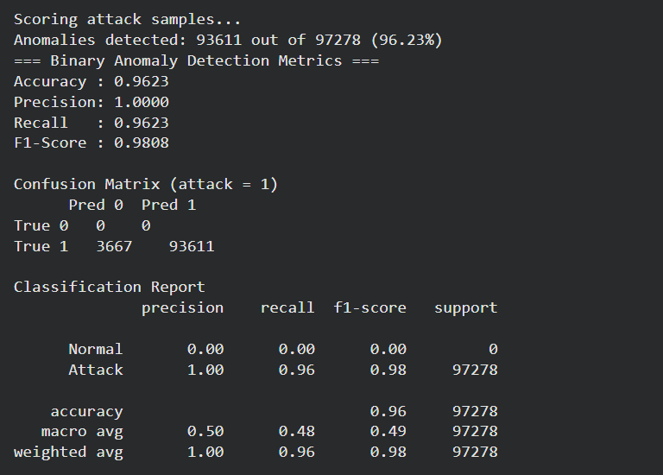
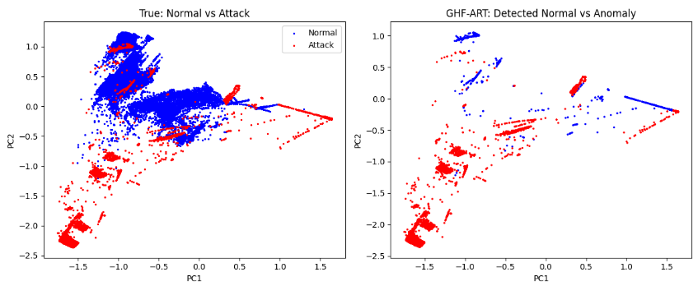
3.2 Dashboard Features and Outputs
3.2.1 Real-Time Monitoring Interface
Primary Dashboard Visualizations:
- Alert Summary Section
  - Total alerts count
  - Alert rate (per hour)
  - Current monitoring status
  - Last update timestamp
- Attack Distribution Chart
  - Real-time bar chart of detected attacks by type
  - Color-coded severity levels (CRITICAL, HIGH, MEDIUM, LOW)
  - Interactive Plotly visualization with hover details
- Network Traffic Timeline
  - Time-series graph of connection patterns
  - Anomaly score progression
  - Detection threshold indicators
- Threat Intelligence Map
  - Source and destination IP mapping
  - Geographic distribution of attacks (if geo-location enabled)
  - Attack intensity heatmap
- Top Threat Indicators
  - Ranking of attack characteristics
  - Frequency of malicious patterns
  - Service-based vulnerability assessment
3.2.2 Theme System
Implemented Themes:
- 🌙 Dark Mode: High contrast, dark background (#0E1117), bright text (#FFFFFF)
- ☀️ Light Mode: Clean design, light background, dark text for readability
- 🌓 Auto Mode: System preference detection
Theme Features:
- Persistent theme selection across sessions
- CSS-based styling for all components
- Input field visibility optimization in both modes
- Smooth transitions between themes
3.2.3 Alert Management System
Alert Severity Levels:
- CRITICAL
  - Email notification triggered immediately
  - Red alert badge display
  - Requires immediate action
  - Indicators: Root shell access, privilege escalation
- HIGH
  - Email notification with review urgency
  - Orange warning display
  - Urgent response recommended
  - Indicators: Multiple failed logins, DoS patterns
- MEDIUM
  - Email notification for documentation
  - Yellow caution display
  - Monitor and log
  - Indicators: Unusual data transfer, high connection counts
- LOW
  - No automatic notification
  - Gray info display
  - Standard logging
  - Indicators: Slight pattern deviations
3.2.4 Email Alert System
Email Notification Features:
- SMTP Configuration: Gmail SMTP support with App Password authentication
- HTML Formatted Emails: Professional styling with green theme
- Alert Content:
  - Timestamp of detection
  - Severity classification
  - Threat indicators identified
  - Source and destination information
  - Anomaly score
  - Recommended actions
Example Alert Indicators:
- Unusually high data transfer (>10,000 bytes)
- High connection count (>50 connections)
- Failed login attempts detected
- Root shell access attempt
- Unauthorized access to critical services
3.2.5 Network Log Processing Output
Processed Log CSV File Structure:
src_ip, dst_ip, protocol_type, service, duration, src_bytes, dst_bytes,
flag, logged_in, num_failed_logins, root_shell, anomaly_prediction,
anomaly_score, nlp_log, timestamp, [40+ additional features]
Example NLP-Generated Log:
[CRITICAL ANOMALY] TCP connection from 192.168.1.142 to 10.0.0.34 on
service 'http'. Suspicious activity detected. Unusually high data
transfer (45230 bytes). High connection count (102) indicating potential
Denial of Service (DoS).
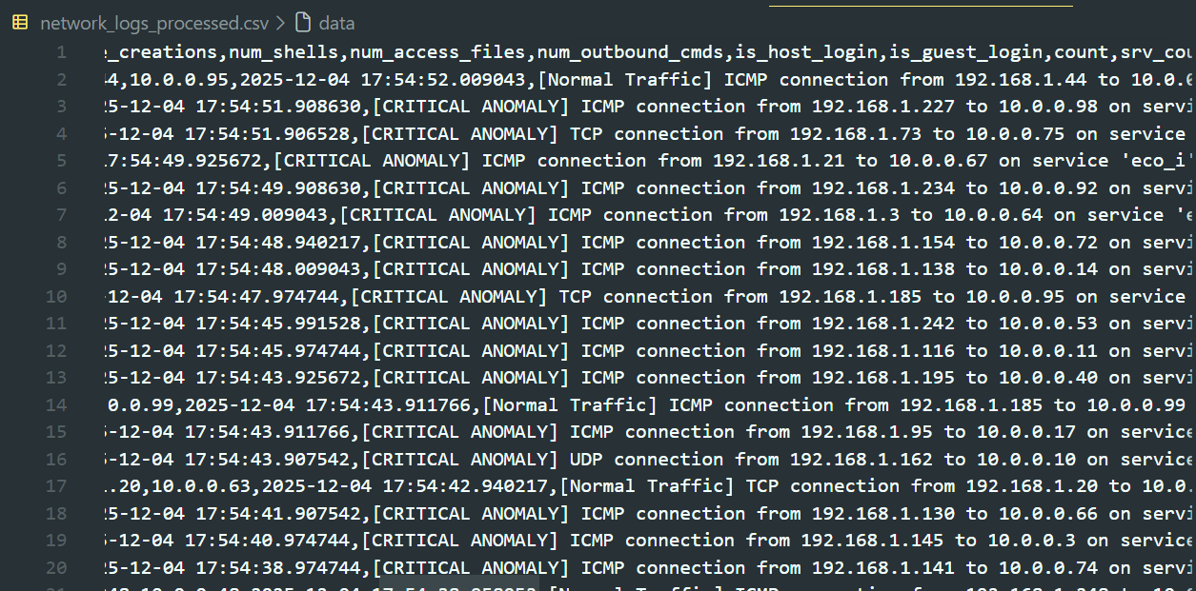
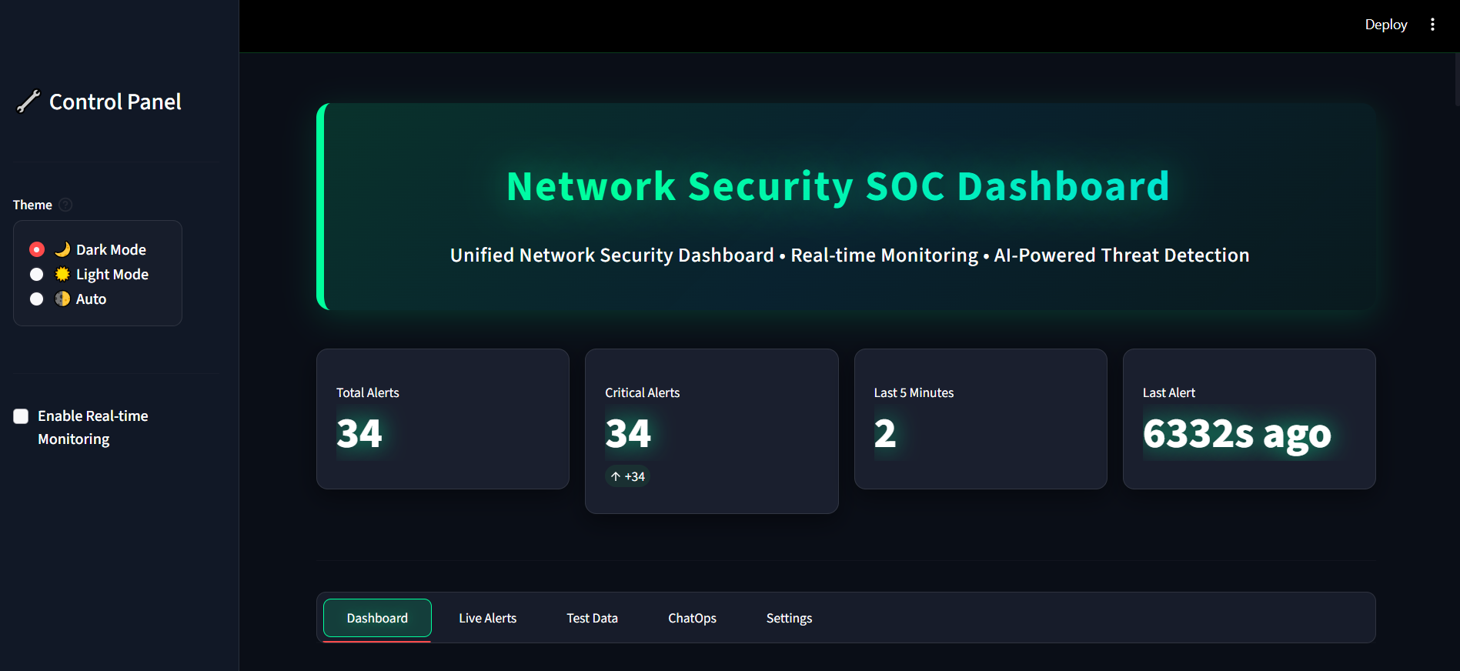
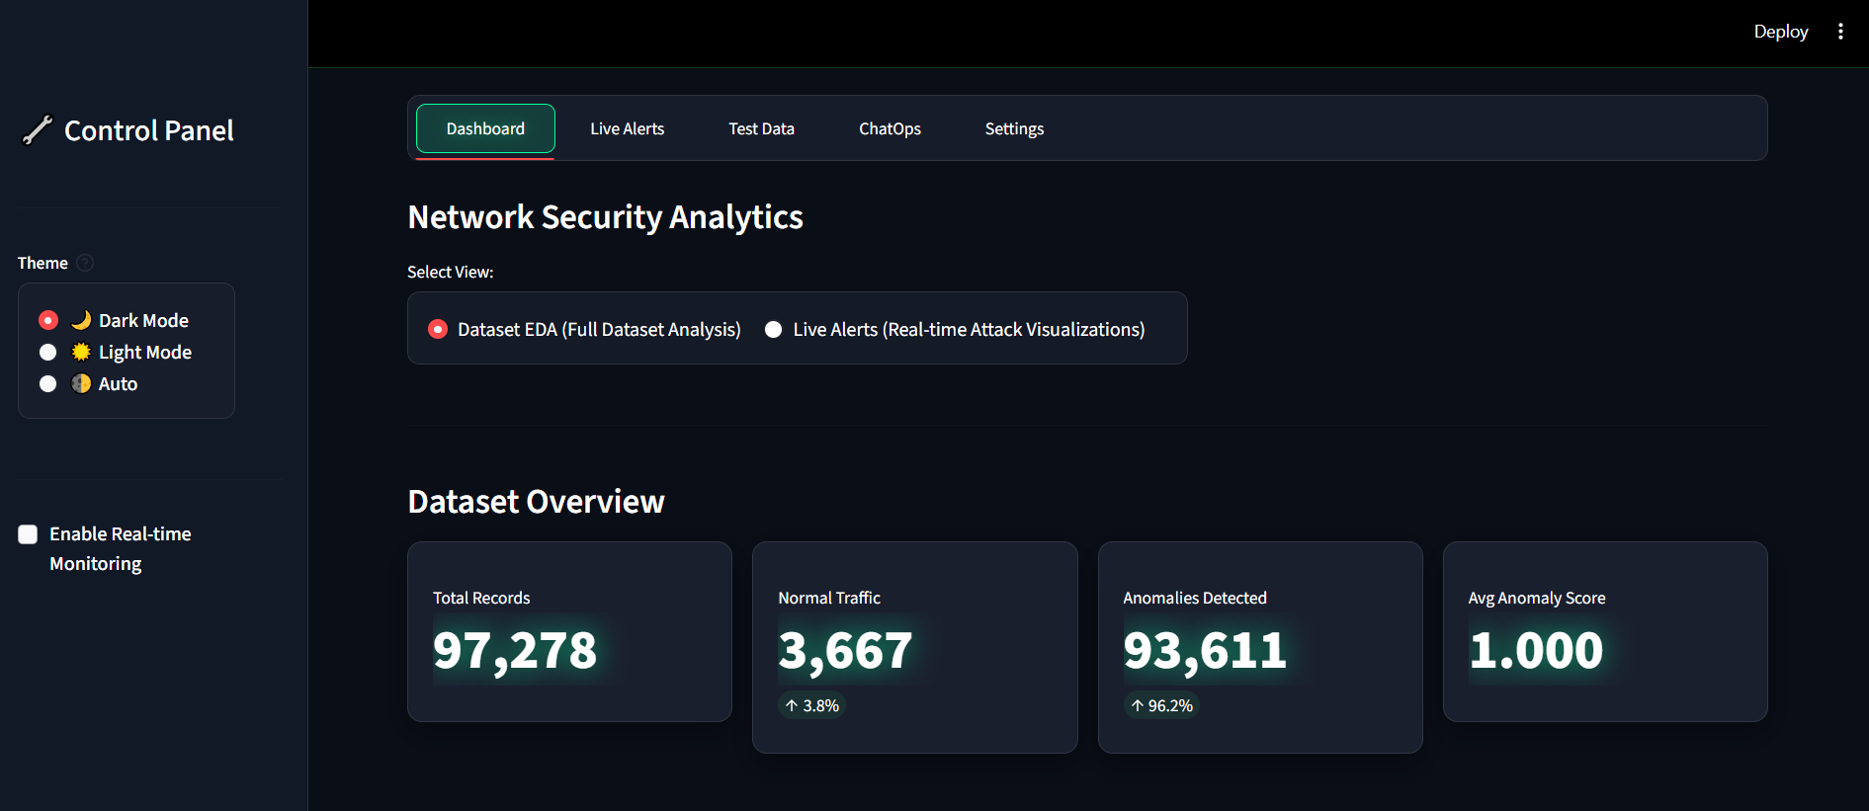
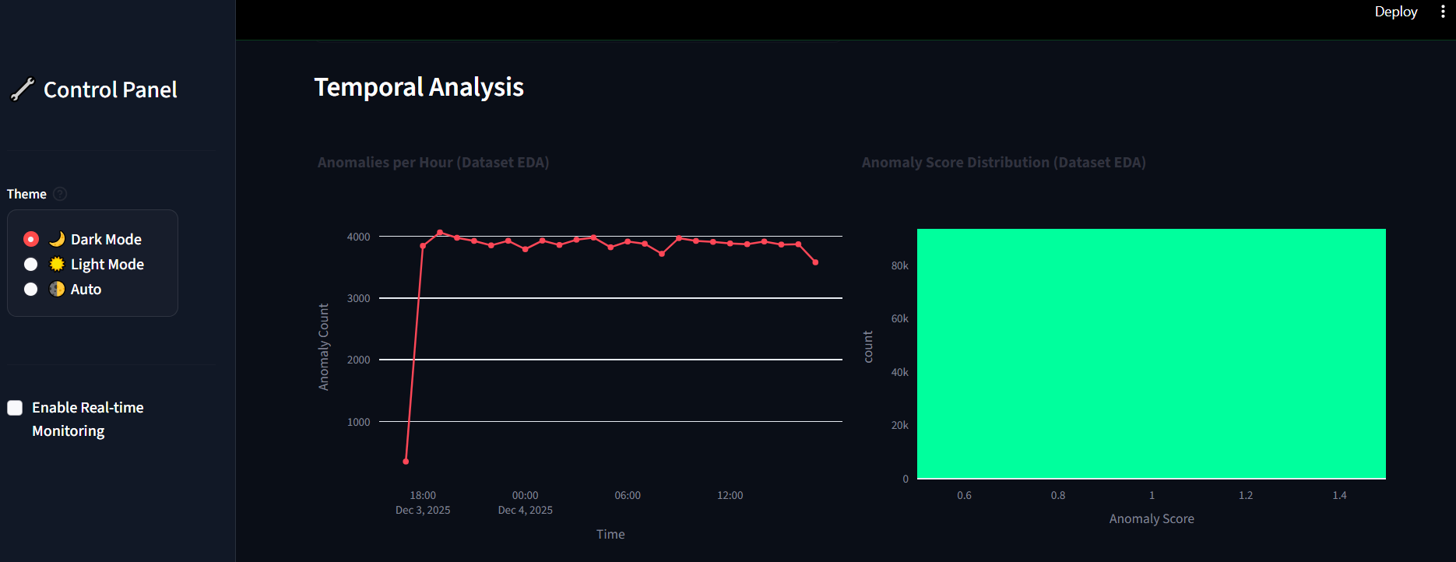
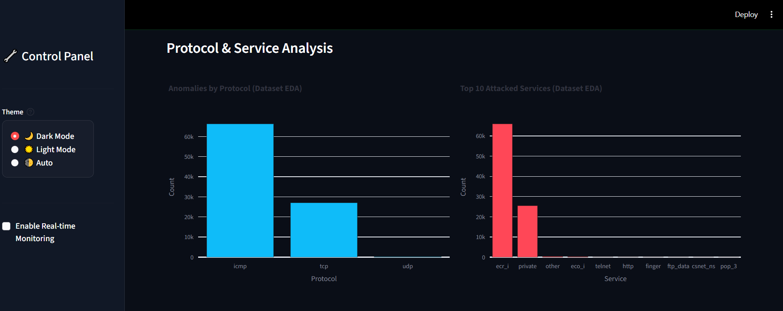
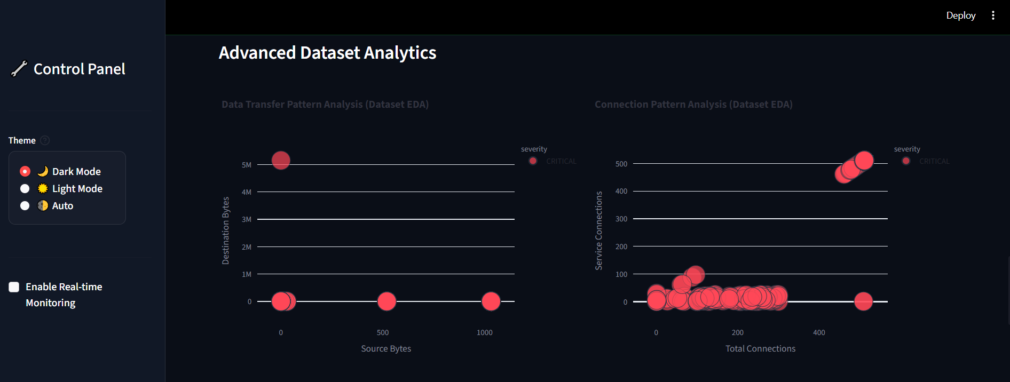
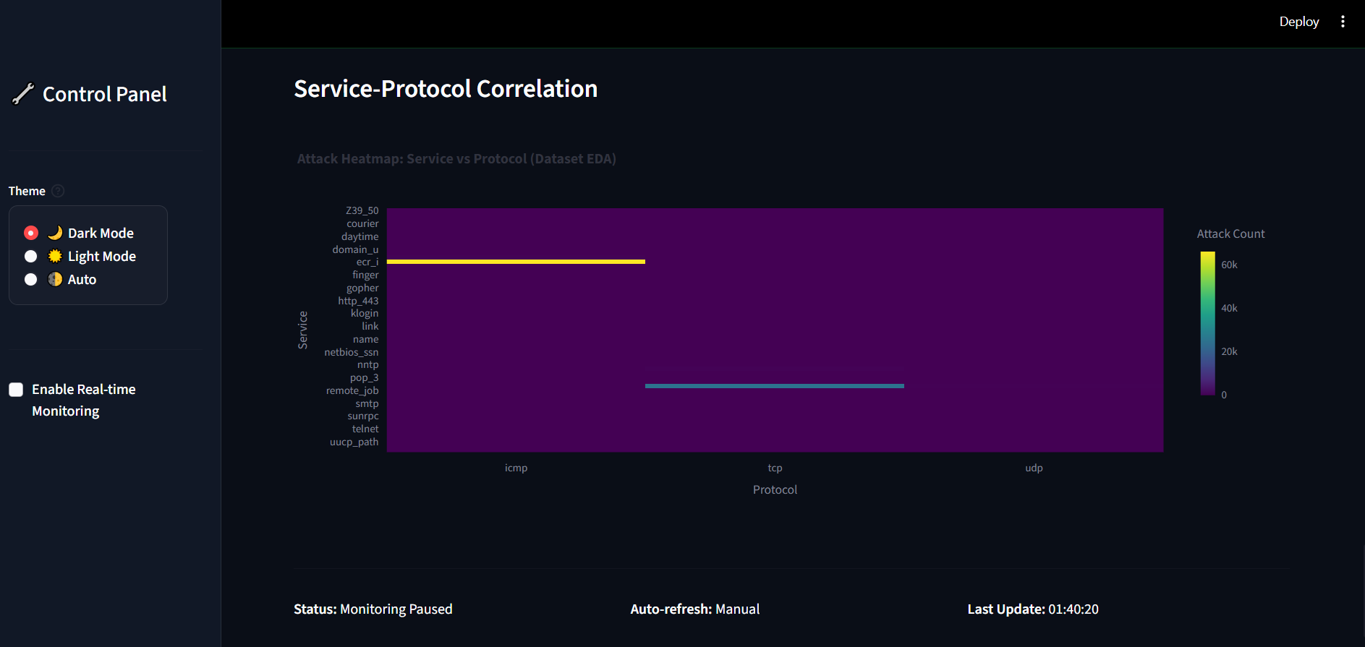
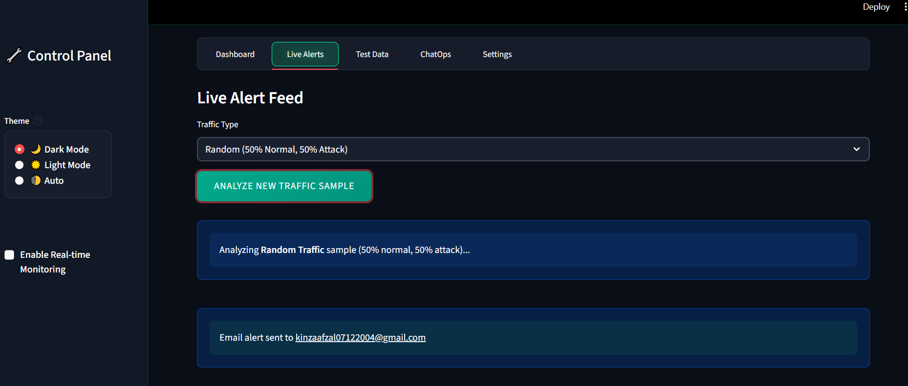
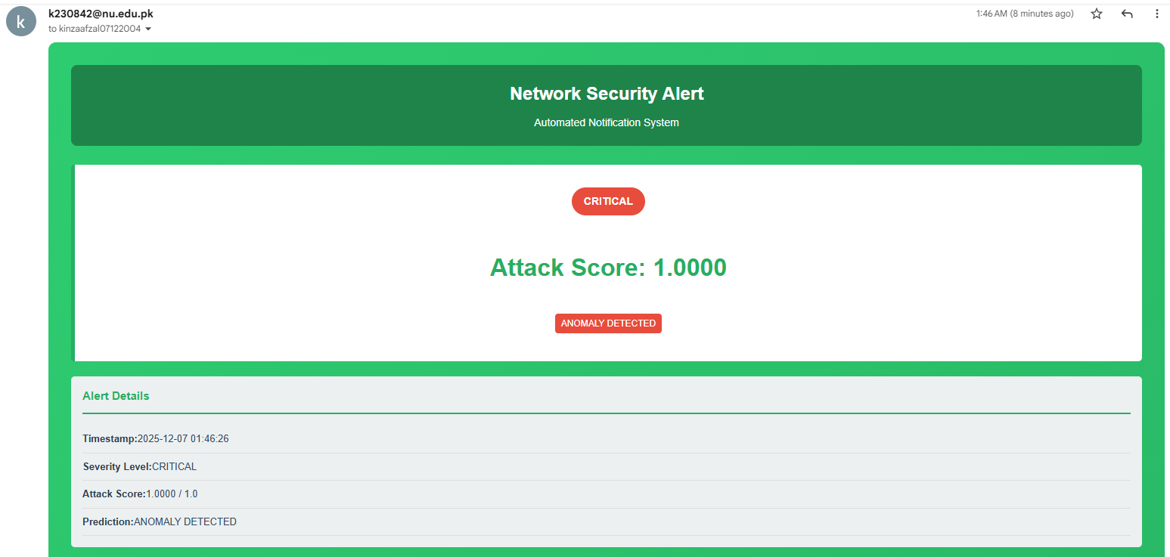
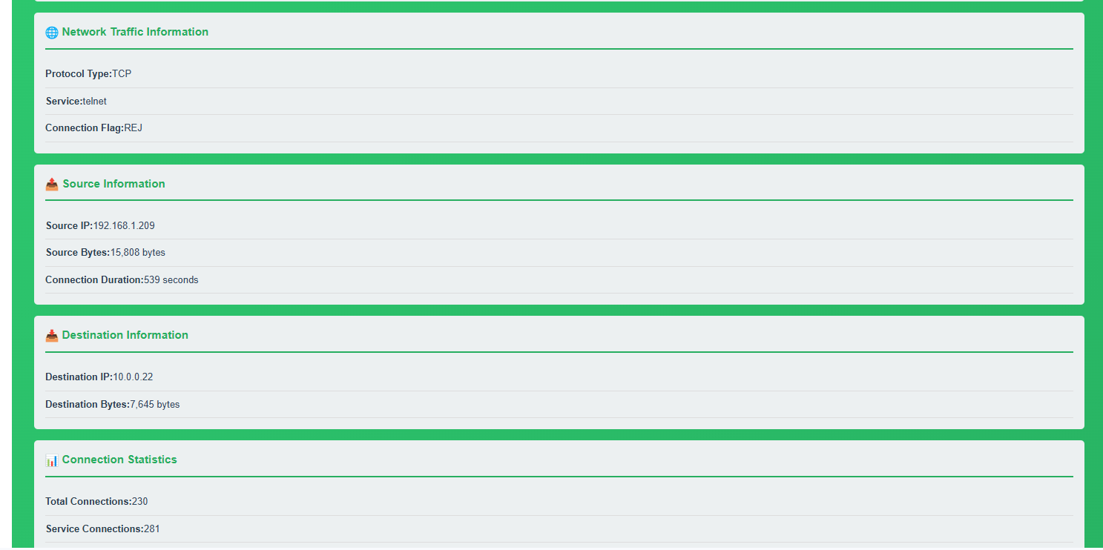
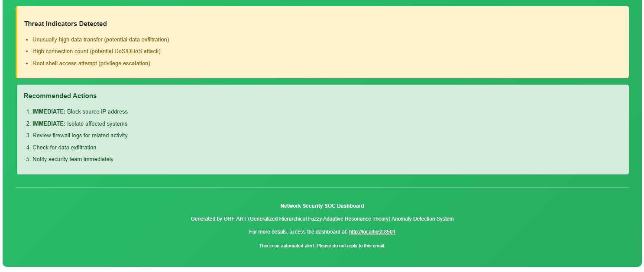
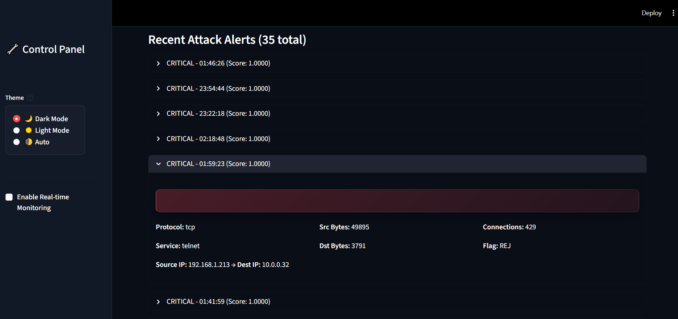
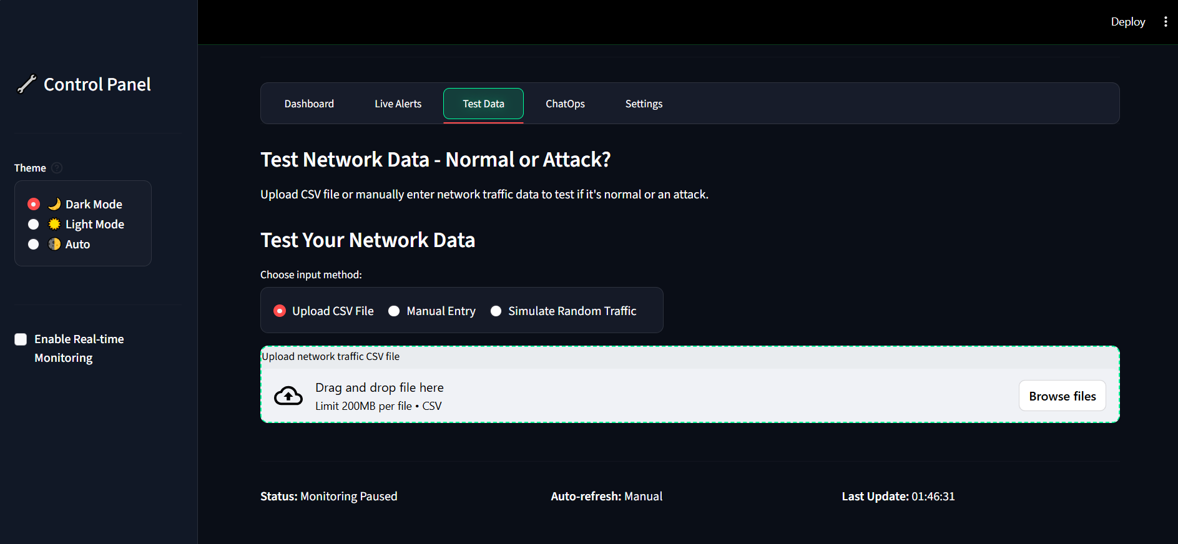
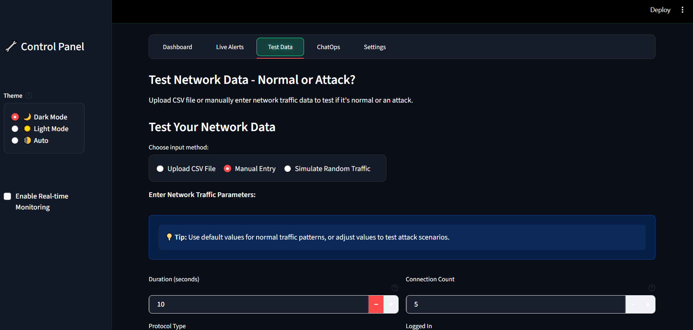
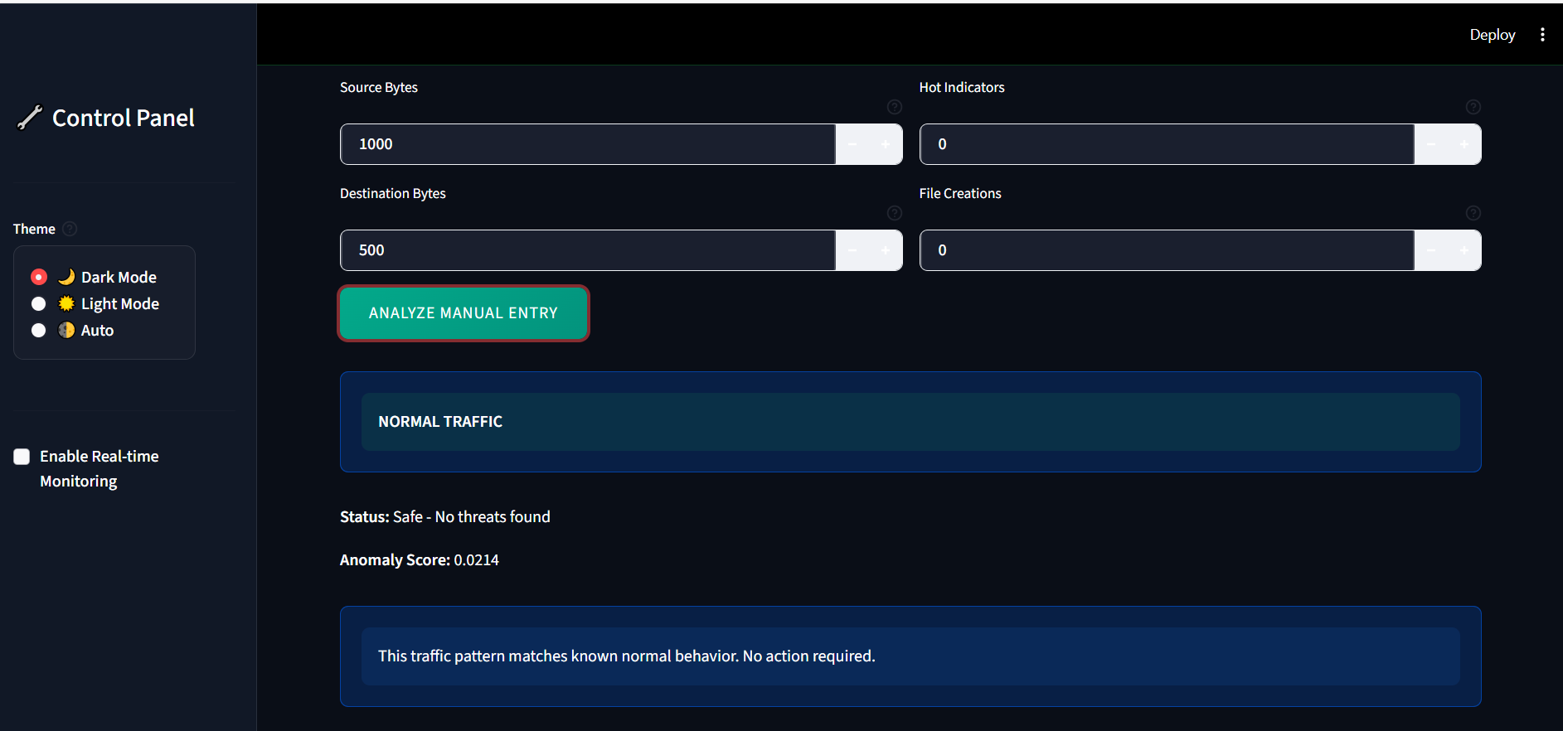
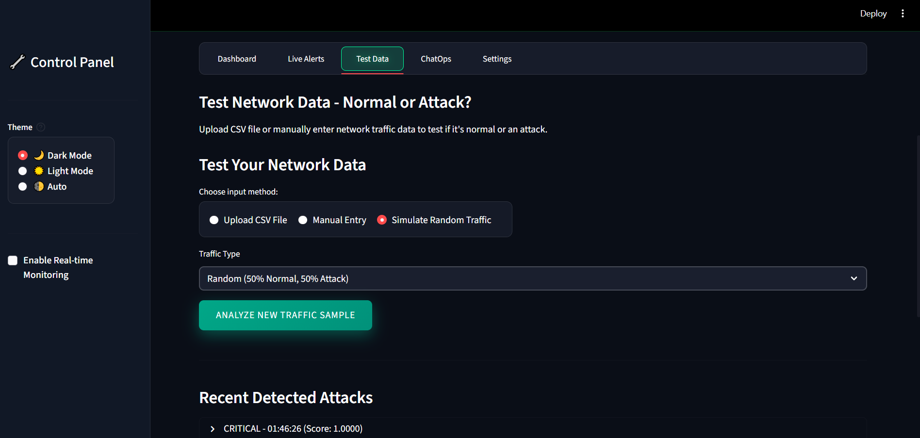
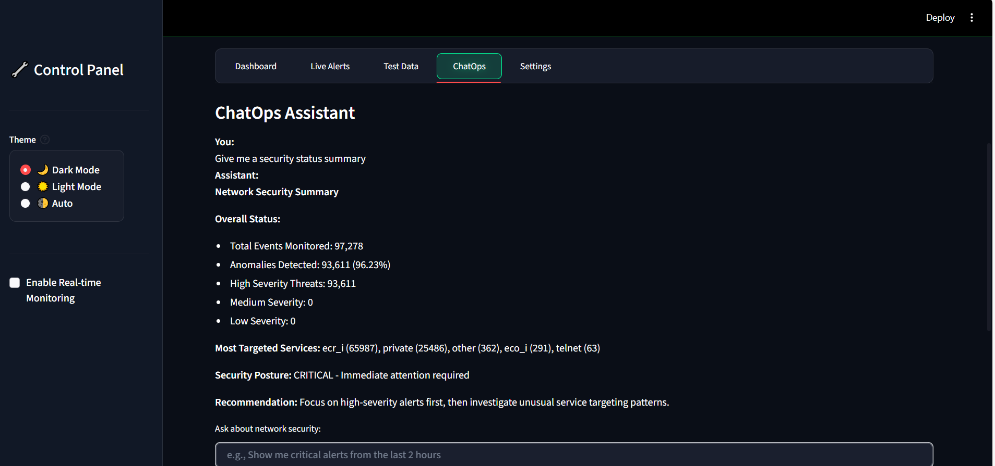
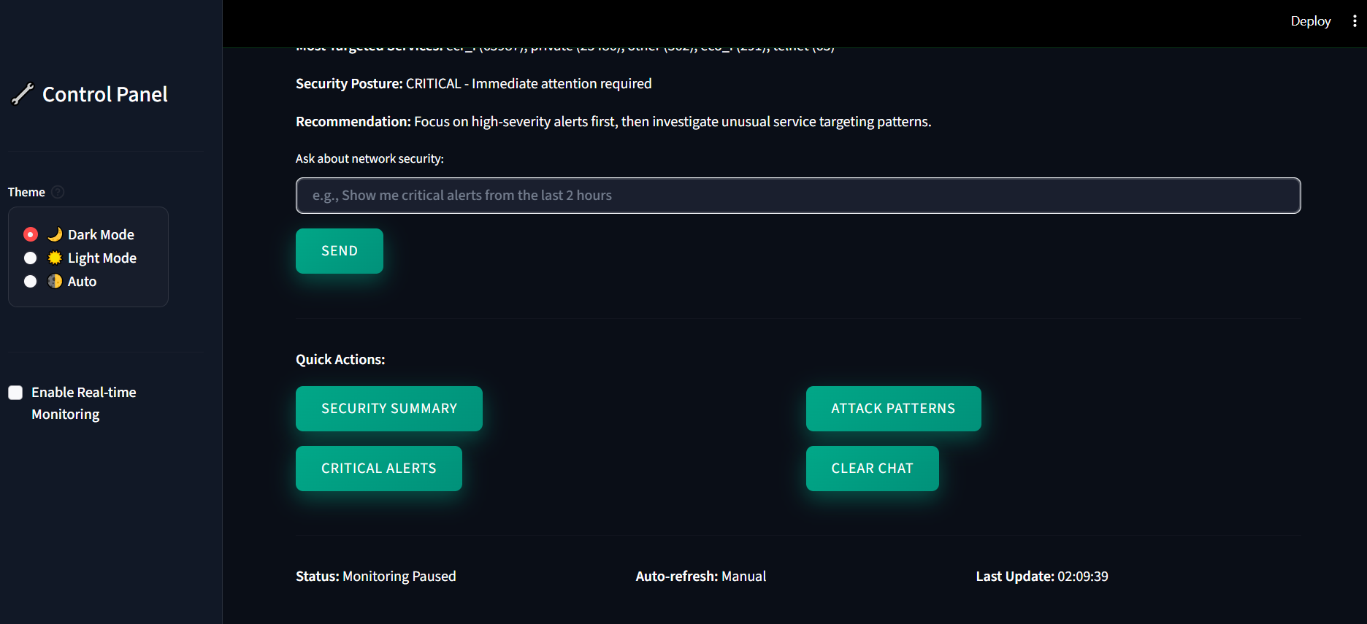
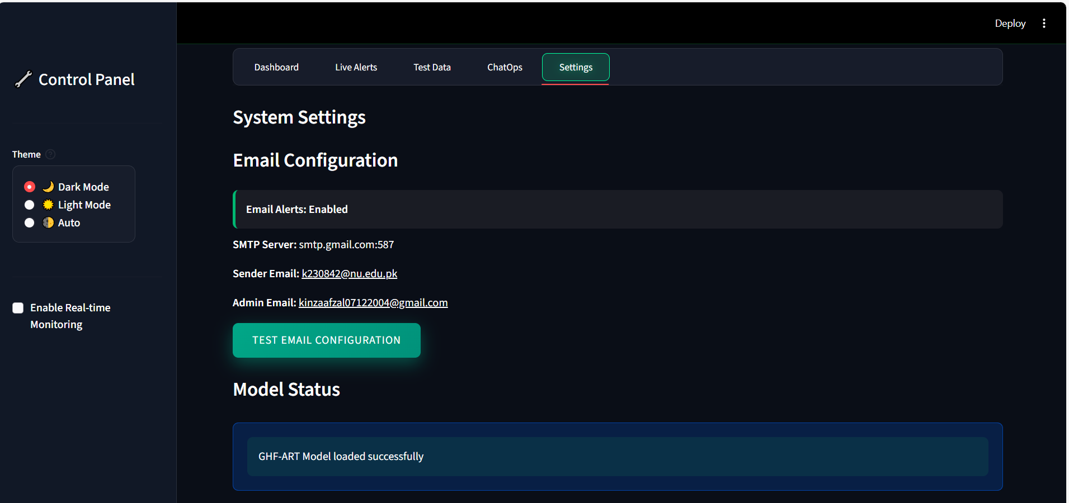
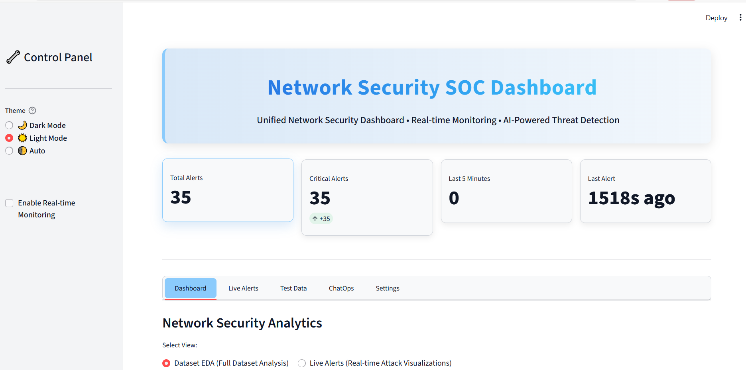
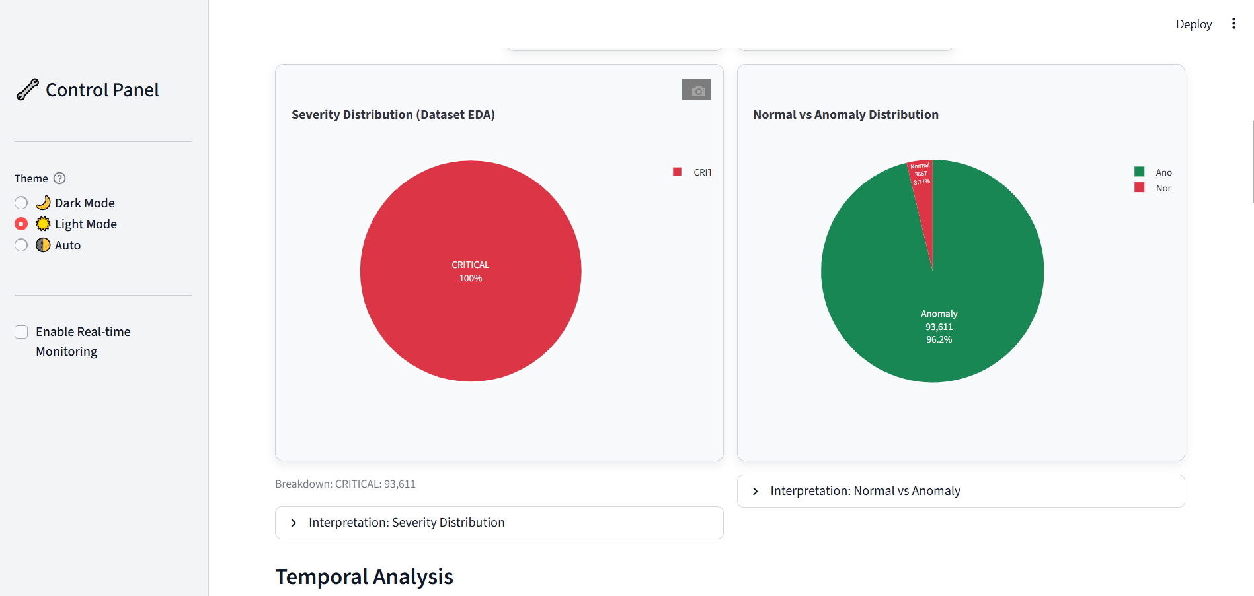
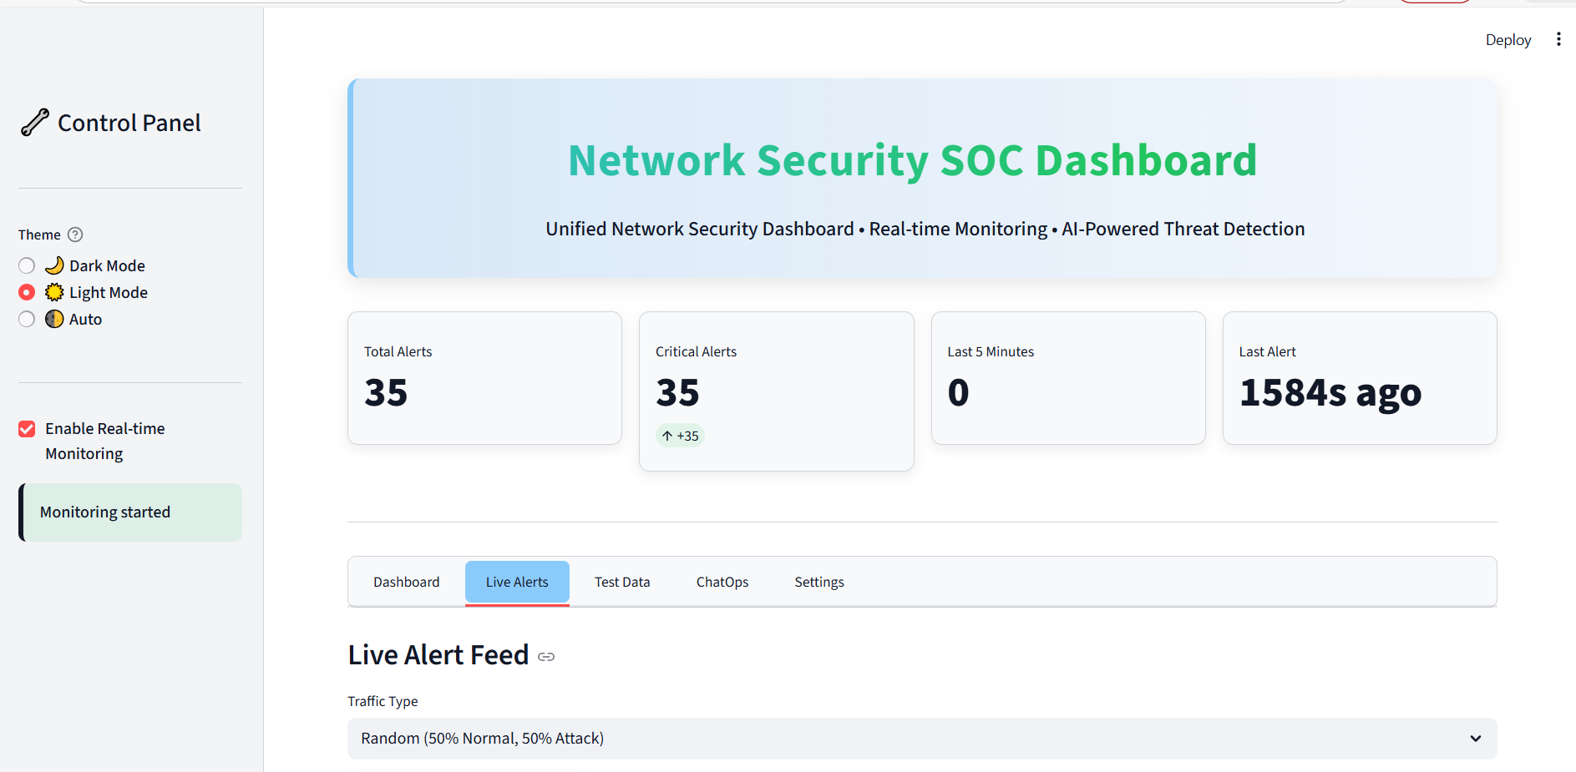
Summary
This Network Security SOC Dashboard represents an integrated solution for network intrusion detection and monitoring. By combining advanced machine learning (GHF-ART clustering) with an intuitive web interface, the system provides security analysts with real-time insights into network threats. The achievement of 96%+ accuracy in detecting attacks while maintaining low false-positive rates demonstrates the effectiveness of the approach in practical cybersecurity applications.

