REST API - Complete Notes
Beginner Concepts → Interview-Ready Depth
Node.js / Express Edition

Contents
1. What is an API & REST?
2. HTTP vs HTTPS
3. DNS & What Happens When You Hit a URL
4. HTTP Methods (GET, POST, PUT, PATCH, DELETE...)
5. HTTP Status Codes (Full Reference)
6. Middleware in Node.js / Express
7. Your Code - Line by Line Walkthrough
8. REST Principles & Best Practices
9. Interview Q&A Rapid Fire

1. What is an API & REST?
API (Application Programming Interface) - a contract that lets two software systems talk to each other. It defines what requests you can send and what responses you'll get.
REST (Representational State Transfer) - an architectural style (not a protocol) for designing networked APIs, proposed by Roy Fielding in 2000. An API that follows REST rules is called a RESTful API.
Core REST Concepts
Term | Meaning
Resource | Any object/data (a note, a user, a product) - identified by a URL, e.g. /notes/5
Representation | The format resource data is sent in - usually JSON (also XML, HTML)
Statelessness | Server stores no client session between requests — each request has all info needed
Client-Server | Frontend (client) and backend (server) are separate and communicate over HTTP
Uniform Interface | Same conventions (URLs + HTTP verbs) used consistently across the API

Interview tip: "Is REST a protocol?" → No. REST is a set of architectural constraints/guidelines. HTTP is the protocol typically used to implement it.

2. HTTP vs HTTPS
HTTP | HTTPS
HyperText Transfer Protocol | HTTP + SSL/TLS encryption layer
Data sent in plain text | Data encrypted in transit
Port 80 | Port 443
Vulnerable to man-in-the-middle attacks | Secure — verified via SSL certificate

HTTP is a stateless, text-based protocol used for communication between client and server. It works on a request-response model: Client sends Request → Server processes & sends Response → Client renders/uses the data.
An HTTP request has: method (GET/POST...), URL, headers (metadata like content-type, auth token), and optionally a body. A response has: status code, headers, and a body.

3. DNS & What Happens When You Hit a URL
When you type https://api.example.com/notes in a browser or call it from code, this sequence happens:
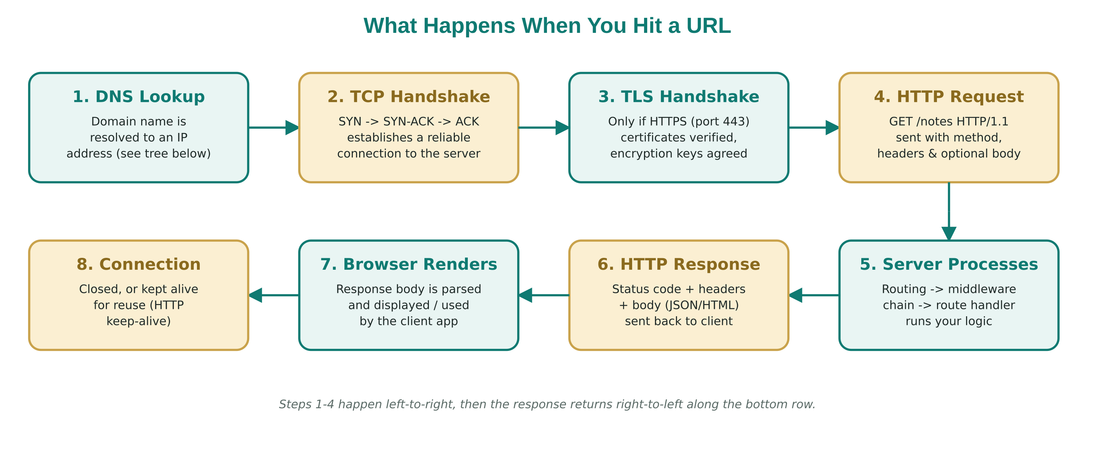
- 1. DNS Lookup — domain name resolved to an IP address
- 2. TCP Handshake — SYN / SYN-ACK / ACK
- 3. TLS Handshake — only if HTTPS
- 4. HTTP Request sent to the server
- 5. Server processes the request
- 6. HTTP Response sent back
- 7. Connection closed or reused (keep-alive)
DNS (Domain Name System)
DNS is the "phonebook of the internet" — it translates human-readable domain names (like google.com) into IP addresses (like 142.250.183.14) that computers use to locate each other.
Full resolution hierarchy, from your device down to the server that finally owns the answer:
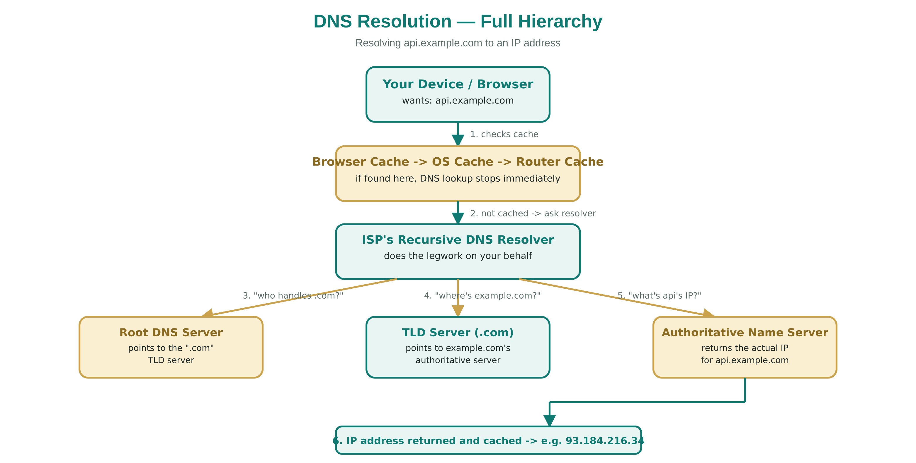
Note: Once the IP is known, your machine opens a TCP connection to the server on port 80 (HTTP) or 443 (HTTPS), then sends the actual HTTP request line: GET /notes HTTP/1.1

Interview tip: "What's the difference between a domain name and an IP address?" → Domain = human-friendly alias; IP = actual network address DNS resolves it to.

4. HTTP Methods
Method | Purpose | Idempotent? | Safe? | Has Body?
GET | Read/fetch a resource | Yes | Yes | No
POST | Create a new resource | No | No | Yes
PUT | Replace a resource entirely | Yes | No | Yes
PATCH | Partially update a resource | No (usually) | No | Yes
DELETE | Remove a resource | Yes | No | Optional
HEAD | Like GET but headers only, no body | Yes | Yes | No
OPTIONS | Discover allowed methods (CORS preflight) | Yes | Yes | No

Safe vs Idempotent — the two words every interviewer asks
- Safe = doesn't change server state at all (read-only). Only GET, HEAD, OPTIONS are safe.
- Idempotent = calling it once or 100 times has the same effect on server state. GET, PUT, DELETE are idempotent. POST is NOT (calling it twice creates two resources). PATCH is technically not guaranteed idempotent.
PUT vs PATCH (classic interview question)
PUT | PATCH
Replaces the entire resource | Updates only specified fields
You must send the full object | You send only the fields to change
Idempotent | Not guaranteed idempotent
Missing fields may be wiped/nulled | Other fields stay untouched

Note: In your code, the PATCH route only updates description and leaves the rest of the note object as-is — this is exactly correct PATCH behavior.

5. HTTP Status Codes - Full Reference
Status codes are grouped into 5 classes:
Class | Meaning
1xx | Informational — request received, continuing process
2xx | Success — request was received, understood, and accepted
3xx | Redirection — further action needed to complete the request
4xx | Client Error — request has a problem (bad syntax, unauthorized, not found)
5xx | Server Error — server failed to fulfil a valid request

Most commonly used (memorize these for interviews)
Code | Name | When used
200 | OK | Generic success (GET, PATCH, PUT success)
201 | Created | Resource successfully created (POST) — used in your /notes POST route
204 | No Content | Success but nothing to return (e.g. DELETE with no body)
301 | Moved Permanently | Resource permanently moved to new URL
302 | Found | Temporary redirect
304 | Not Modified | Cached version is still valid
400 | Bad Request | Malformed request / invalid data sent by client
401 | Unauthorized | Authentication missing/invalid (you're not logged in)
403 | Forbidden | Authenticated but not allowed to access this resource
404 | Not Found | Resource doesn't exist — used when a note isn't found
405 | Method Not Allowed | e.g. DELETE called on a route that only supports GET
409 | Conflict | Request conflicts with current server state (duplicate entry)
422 | Unprocessable Entity | Syntactically correct but semantically invalid data (validation failure)
429 | Too Many Requests | Rate limiting triggered
500 | Internal Server Error | Generic server crash / unhandled exception
502 | Bad Gateway | Server acting as gateway got an invalid response upstream
503 | Service Unavailable | Server temporarily down/overloaded (maintenance, overload)
504 | Gateway Timeout | Upstream server took too long to respond

Interview tip: "401 vs 403?" → 401 = "I don't know who you are" (no/invalid credentials). 403 = "I know who you are, but you can't do this" (permission denied).

6. Middleware in Node.js / Express
Middleware = a function that sits between the incoming request and the final route handler. It has access to req, res, and a special function next().
1 function myMiddleware(req, res, next) {
2 console.log("Request received:", req.method, req.url);
3 next(); // pass control to the next middleware/route
4 }

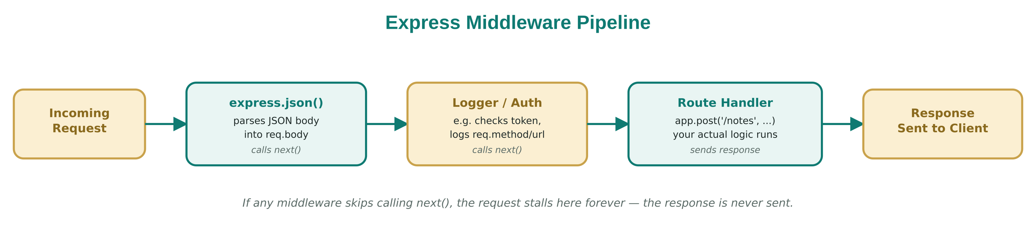
Why middleware matters
- Runs in the order it's defined — order matters!
- Used for: logging, authentication, parsing request bodies, CORS, error handling, rate limiting, validation
- If you don't call next(), the request hangs forever (no response sent)
Types of middleware in Express
Type | Example
Application-level | app.use(express.json()) — runs for every request
Router-level | Middleware attached to a specific express.Router()
Built-in | express.json(), express.static()
Third-party | cors, morgan, helmet
Error-handling | Takes 4 args: (err, req, res, next)

In your code, app.use(express.json()) is a built-in middleware that parses incoming JSON request bodies and attaches the parsed object to req.body — that's why req.body works in your POST route.
Critical ordering rule: app.use(express.json()) must be declared before any route that needs req.body. In your file it's declared after the app.get('/') route but before the POST route — that's fine since it's before the routes that need it.

Interview tip: "What is next()?" → It hands off control to the next middleware in the stack. Skipping it stalls the request; calling it with an argument like next(err) jumps straight to error-handling middleware.

7. Your Code — Line by Line Walkthrough
1 const express = require("express");
2 const app = express();

Imports Express and creates an app instance — this app object represents your whole server and its routing.
1 app.get('/', (req, res) => {
2 res.send("Hello world from server");
3 })

Defines a GET route on the root path /. res.send() sends a plain text/HTML response (defaults to status 200).
1 const notes = [];
2 app.use(express.json());

notes is your in-memory "database" (array). express.json() middleware parses JSON bodies from incoming requests.
1 app.post('/notes', (req, res) => {
2 console.log(req.body);
3 notes.push(req.body);
4 res.status(201).json({ message: "Note saved!", note: req.body });
5 })

POST /notes — creates a new note. 201 Created is the semantically correct status here (not 200), because a new resource was created.
1 app.get('/notes', (req, res) => {
2 res.status(200).json({ note: notes });
3 })

GET /notes — returns all notes with 200 OK.
1 app.delete('/notes/:index', (req, res) => {
2 const index = req.params.index;
3 delete notes[index];
4 res.status(200).json({ "notes": "Note deleted!" });
5 })

DELETE /notes/:index — :index is a route/URL parameter, accessed via req.params.index.
Gotcha to know for interviews: delete notes[index] removes the value but leaves a hole (undefined) in the array — array length stays the same. A cleaner approach is notes.splice(index, 1), which actually removes the element and shifts indices down.

1 app.patch('/notes/:index', (req, res) => {
2 const index = req.params.index;
3 if (!notes[index]) {
4 return res.status(404).json({ message: "Note not found" });
5 }
6 notes[index].description = req.body.description;
7 res.status(200).json({ message: "note updated", note: notes[index] })
8 })

PATCH /notes/:index — partially updates just the description field. Correctly returns 404 if the note doesn't exist — good practice.
1 module.exports = app;

Exports the configured app so it can be imported elsewhere (separating app config from server startup — good practice for testing).
1 const app = require("./src/app.js");
2 const PORT = 3000;
3 app.listen(PORT, () => {
4 console.log(`Server is running on port {PORT}`);
5 })

This is your entry file — it imports the app and starts the actual server, listening for incoming connections on port 3000. app.listen() internally creates an HTTP server via Node's http module.
Improvements to mention in an interview
- Use notes.splice(index, 1) instead of delete to avoid holes in the array
- Validate req.body in POST (e.g. reject empty notes) → return 400 if invalid
- Add a 404 check in DELETE too (currently deletes even if index doesn't exist)
- Use a real ID (like uuid) instead of array index, since indices shift/aren't stable identifiers
- Add centralized error-handling middleware at the bottom of the middleware stack

8. REST Principles & Best Practices
- Use nouns, not verbs, in URLs: /notes not /getNotes
- Use plural resource names: /notes/5 not /note/5
- Use HTTP methods to express action, not the URL (the method already says GET/POST/etc.)
- Nesting for relationships: /users/3/notes = notes belonging to user 3
- Statelessness: don't store client session on server between requests; each request is self-contained (auth token included every time)
- Use proper status codes — don't just return 200 for everything
- Versioning: /api/v1/notes so future breaking changes don't affect old clients
- Filtering/sorting/pagination via query params: /notes?limit=10&page=2&sort=desc

9. Interview Q&A — Rapid Fire
Q: What's the difference between PUT and PATCH?
A: PUT replaces the whole resource; PATCH updates part of it.

Q: Is REST stateless?
A: Yes — server holds no client context between requests; each request must carry everything needed to process it (e.g. auth headers).

Q: What does idempotent mean?
A: Repeating the same request multiple times produces the same result/state as doing it once. GET, PUT, DELETE are idempotent; POST is not.

Q: What is middleware and why does order matter?
A: Functions that intercept req/res before the final handler. Order matters because each middleware can modify req/res or short-circuit the chain before the next one runs.

Q: What happens when you type a URL and hit enter?
A: DNS resolves domain → IP, TCP (and TLS if HTTPS) handshake happens, browser sends an HTTP request, server processes and responds, browser renders the response.

Q: Difference between 401 and 403?
A: 401 = not authenticated. 403 = authenticated but not authorized/permitted.

Q: Why 201 instead of 200 for POST?
A: 201 explicitly signals "a new resource was created," giving the client clearer semantic info than a generic 200.

Q: What's the role of express.json()?
A: Middleware that parses incoming requests with a JSON body and populates req.body, so route handlers can use it directly.

Q: REST vs SOAP?
A: REST is lightweight, uses HTTP verbs + JSON/XML, resource-based. SOAP is a strict protocol using XML only, with built-in standards for security/transactions — heavier but more rigid.

Q: What is a query parameter vs a route parameter?
A: Route param is part of the URL path (/notes/:id → req.params.id). Query param comes after "?" (/notes?limit=5 → req.query.limit).

