Economic Effect on Climate Change
Introduction
The upswing in industrial, commercial, and economic pursuits has led to profound and lasting shifts in temperatures and weather patterns, commonly referred to as 'climate change.' These alterations, including changes in rainfall, rising temperatures, and sea level increases, are potential threats to human life. Consequently, climate change has become a central topic in global discussions among leaders striving to address its impact on humanity and our lifestyle. This study focuses on a key contributor to climate change, CO2 emissions, and aims to link it with GDP per capita of nations.

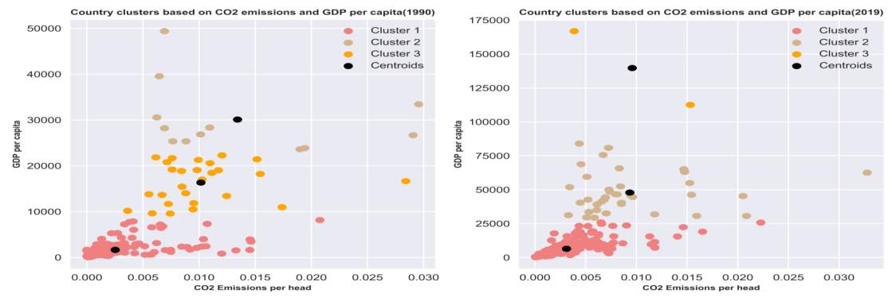
Figure I Figure II
Figure I displays a cluster analysis depicting correlation between global countries concerning CO2 emissions per capita and GDP per capita. Covering years 1990 and 2019, analysis tracks changes in clusters over time, seeking to clarify relationship between economic indicators and CO2 emissions. visual representation indicates a prevalent decline in CO2 emissions per capita, evident in leftward movement of clusters, accompanied by a consistent rise in GDP per capita from 1990 to 2019

GDP PER CAPITA PROJECTIONS
To offer a glimpse into future trends, this study presents GDP per capita projections for next two decades (from 2021), focusing on three countries, each representing a distinct cluster from Figure I. Burundi, characterized by lowest CO2 emissions per capita and GDP per capita, is juxtaposed with Qatar and Luxembourg, symbolizing medium and high CO2 emissions per capita and GDP per capita. Figure 2 delineates anticipated growth rates for GDP per capita in these chosen nations.

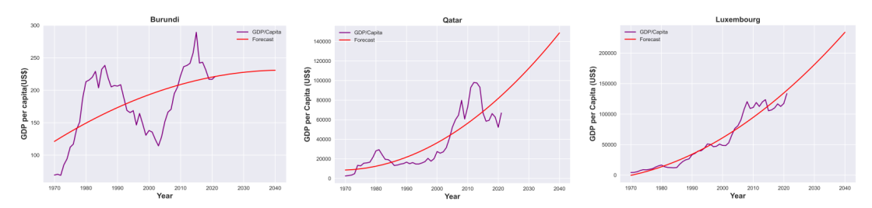

GDP per capita forecast for Burundi suggests a trajectory towards stability rather than significant growth in the next two decades. The economic outlook for the country does not indicate substantial expansion in the near future. | Contrastingly, Qatar's GDP per capita is projected to experience exponential growth, indicating a likelihood of substantial economic advancement in the coming years.

CONCLUSION
Luxembourg is poised to uphold its position as one of the world's wealthiest nations, with an anticipated exponential surge in GDP per capita, solidifying its economic standing. This research underscores a decline in CO2 emissions per capita, potentially linked to the global population rise. Despite the overall rise in GDP per capita, it raises apprehensions about potential environmental repercussions, particularly linked to factors such as urbanization. This emphasizes the imperative need for proactive measures to mitigate the environmental impact of global technological advancements

