SOFTWARE REQUIREMENT SPECIFICATIONS

Project Topic: Snake Game

Submitted by: Kinzang Wangchuk(12190062)

1. **Introduction**
2. **Purpose**

This game aims to change the way people think of traditional snake game. It will offer the experience of commercial multiplayer games to the player retaining the simplicity of traditional snake game.

## Scope of the Project:

## System Scope

## To develop a mobile application with following features:

## Offline based game

## Settings: it contains

## Level Selection

## Sound selection

## Restart

## New Game.

## User Scope

The scope of this project is mainly for the interested users.

**2. Requirements**

a) Functional Requirements

The app will have features like select level (Easy, medium and hard) up to as per player’s desire. Even app will have sound on or off system. After game over score will be generate.

b) Non- Functional Requirement

The Non-Functional Requirements are

1) The app can be easily portable to different version of android and it is independent of the size of the android phone and tablets. The content of the app will be constant throughout the version and size of the android phones and tablets.

2) Usability is provided for user so that they are engaged for enjoyment and for fun and after playing, they came know their capability looking at the score have they have scored.

c) Software Requirement

|  |  |
| --- | --- |
| Items | Specification |
| Java version | Java Standard Edition Development Kit (JDK) 8 |
| Operating System | Microsoft Windows 10/8 (32- or 64-bit) or ubuntu 20 |
| Android SDK | Android SDK version 16 |
| Android Studio | Version 3.0 and above |
| DB Browser | Version 3.12.1 |

**3. Hardware Requirement**

|  |  |
| --- | --- |
| Item | Specification |
| Disk Space | Java Standard Edition Development Kit |
| Screen resolution | 1280x800 |
| RAM | 4-16 GB RAM |
| Laptop | 3icore + |
| Processor | 2.X86-64 processor |

**4. System Design**

**A) EDR**

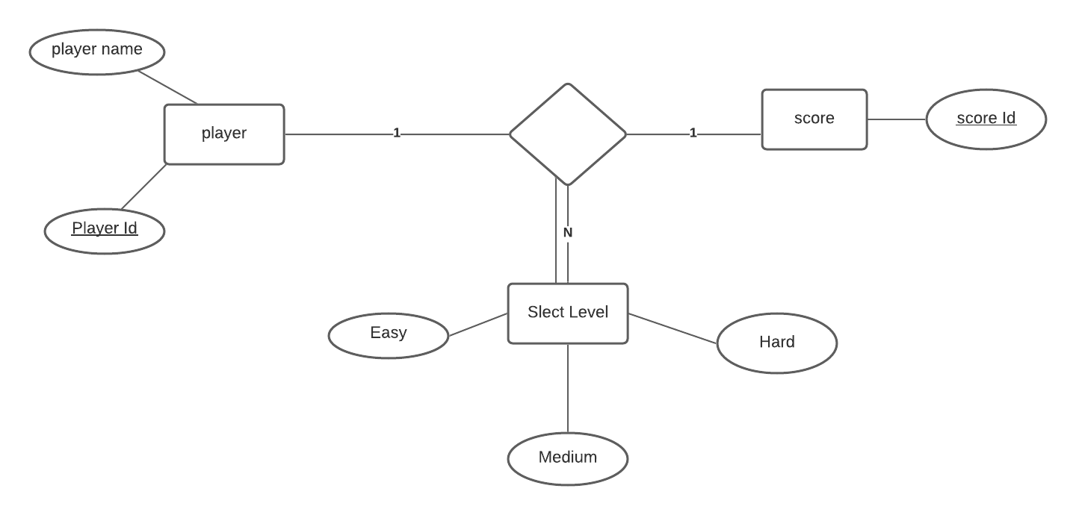

**B) Relational Schema**

Player

|  |  |
| --- | --- |
| Player Id | Player name |

Select Level

|  |  |  |  |
| --- | --- | --- | --- |
| Select Level | Easy | Medium | Hard |

Score

|  |
| --- |
| Score Id |

**C) Sequence Diagram**

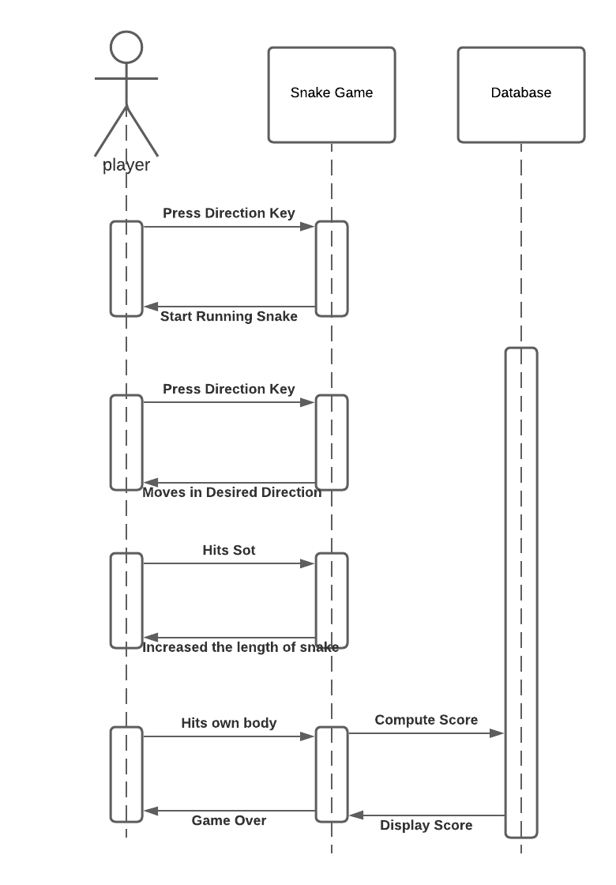

Sequence Diagrams are used to focus the time as well as to show the order of the interaction visually with the help of vertical axis that will represent the time in order to send messages. It validates the logic of the working of app within itself and also the user who uses.

**D) Use case Diagram**

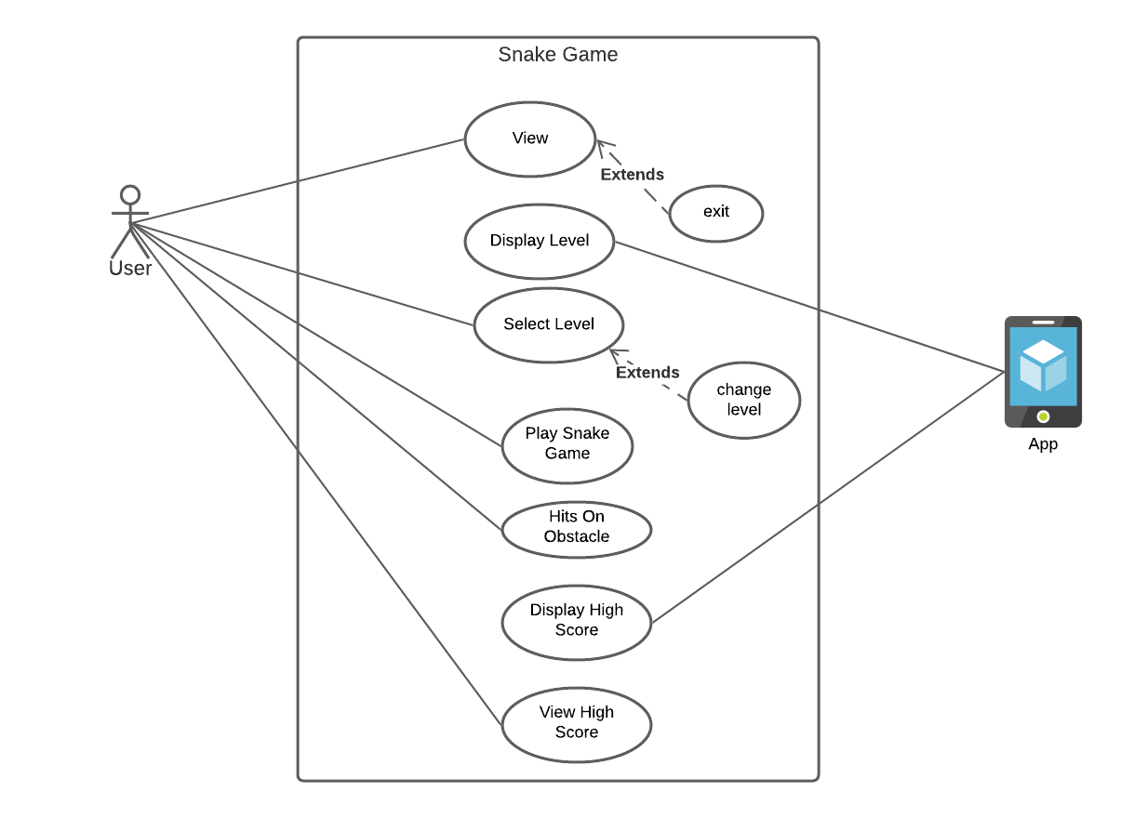

A use case models the functionality of a system as perceived by outside agents, called actors that interact with the system from a particular viewpoint. Its main purpose is to help development team visualize the functional requirements of a system, including the relationship of actors to essential processes and also among different use cases. The actor identified for this project is any user of the app. The interactions of the actor and its functionalities are shown below.