School Of Electrical Engineering and Computer Science

**Electrical engineering**

Open Ended Lab

E-COMMERCE SYSTEM

**Submitted To:**

Lab Instructor: Mr. Moeed Ahmed

Class Instructor: Dr. Muhammad Zeeshan

**Submitted By:**

Aymen Shahbaz(505831)

Maryam Khan(518697)

Kinza Zubair (501161)

RESULTS

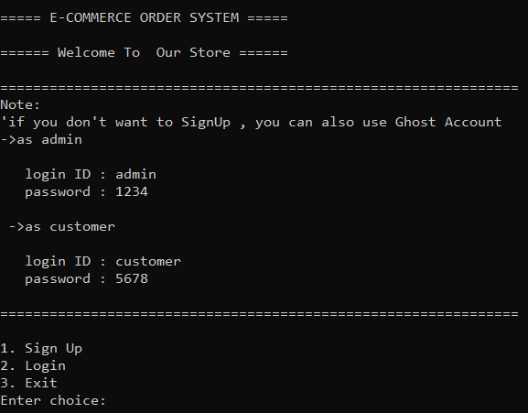BASIC LYOUT

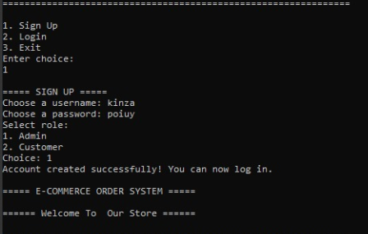

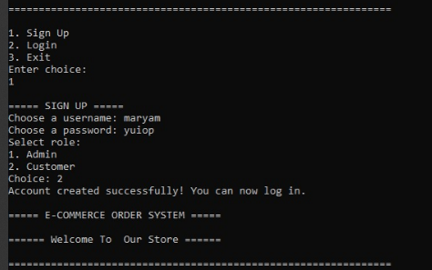

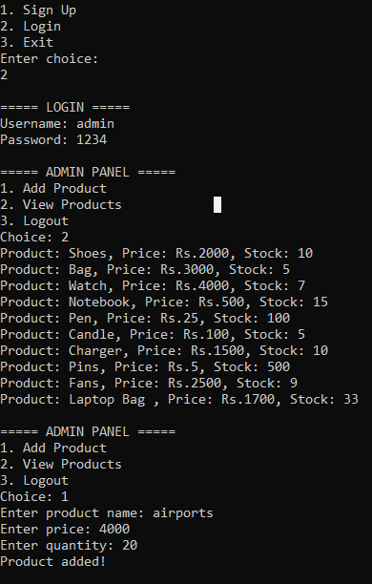Admin Panel with Ghost Account

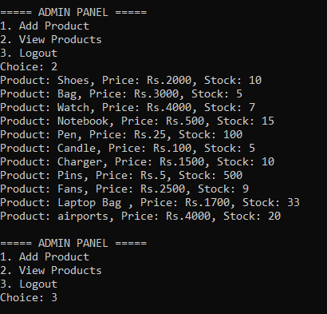

Customer Panel Successfully with ghost Account

