
University of Engineering and Technology, Taxila

Department of Computer Engineering
Lab Report - 01
Course – Programming for AI
Submitted by – Kinza Habib
Registration no – 25-MS-AI-11
Submitted to – Dr Naveed Khan
Submission Date – Nov 6, 2025

Objective

The purpose of this lab is to build a strong foundation in Python programming, which is essential for Artificial Intelligence and Machine Learning.
This lab covers variables, operators, strings, conditionals, loops, functions, data structures, and basic file handling.

Component | Details
Python Version | 3.11.0
Operating System | Windows 10 (64-bit)
Editor | Visual Studio Code
Virtual Environment | .venv
Built-in Modules Used | math, csv, json, re, functools
External Libraries | None

A1) Hello & Variables
Code Summary:
This task demonstrates how to create and use variables in Python. Two variables name (string) and age (integer) are defined and printed using the print() function. The type() function is also used to check their data types.
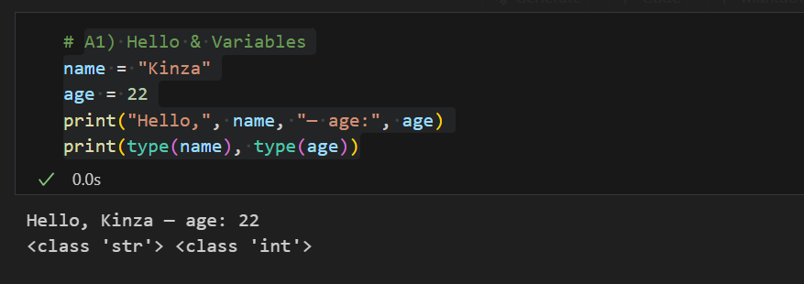

Explanation:
- name stores a string value and age stores an integer.
- print() displays the values on screen.
- type() confirms that name is of type string and `age* is an integer.

A2) Arithmetic & Operators
Code Summary:
This task demonstrates the use of arithmetic and bitwise operators in Python using two variables a and b.
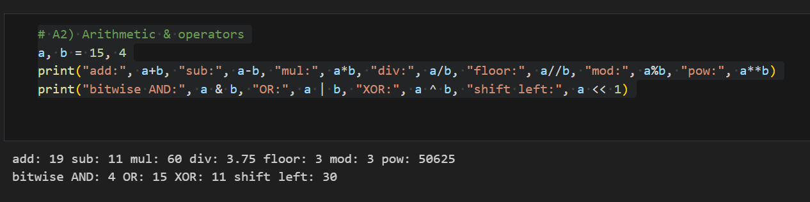
Explanation:
- Arithmetic operators (+, -, *, /, //, %, **) perform basic mathematical operations.
- Bitwise operators (&, |, ^, <<) act on the binary representation of integers.
- For example, 15 & 4 performs a bitwise AND operation, and a << 1 shifts bits of a one place to the left (multiplies by 2).

A3) Strings: Slicing & Methods
This task shows string manipulation techniques such as trimming, lowercasing, slicing, and checking membership.
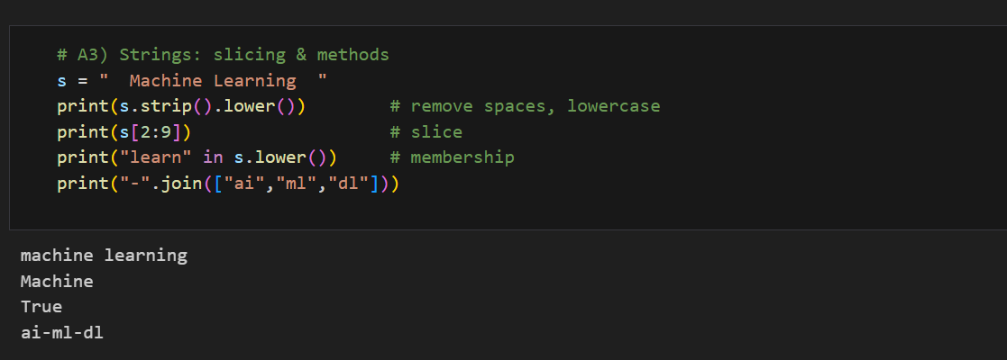
Explanation:
- strip() removes extra spaces; lower() converts to lowercase.
- s[2:9] extracts a substring.
- The in operator checks if a word exists in the string.
- "join" combines list elements into one string separated by -.

A4) f-Strings (Formatting)
This task demonstrates formatted output using f-strings.
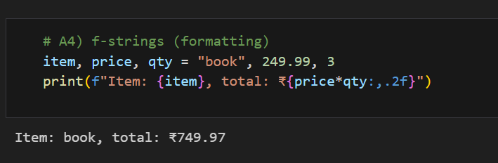
Explanation:
- f-strings embed variables inside strings using {}.
- :,.2f formats numbers with commas and two decimal places.
- The result displays a readable total price.

A5) If / Elif / Else
This task uses conditional statements to assign a grade based on a numeric score.
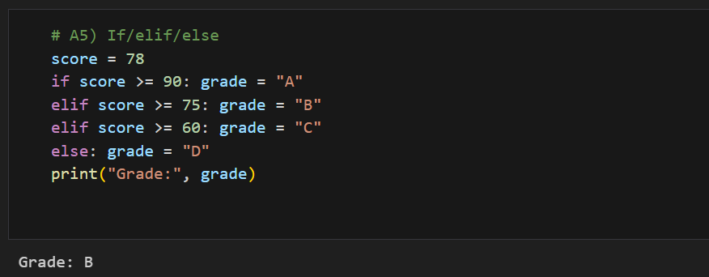
Explanation:
- if-elif-else checks conditions in sequence.
- Only the first true condition executes.
- The program prints the grade based on the score.

A6) Loops & Range
This task demonstrates the use of for and while loops along with the continue statement.
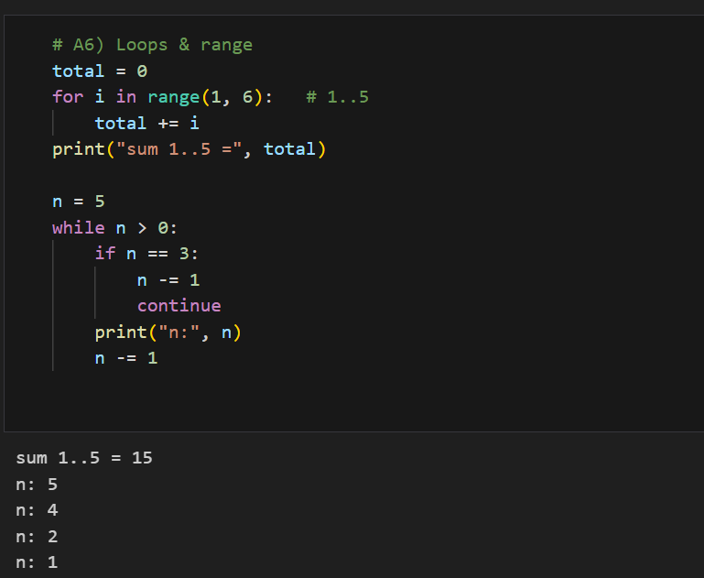
Explanation:
- The for loop calculates the sum of numbers from 1 to 5.
- The while loop counts down from 5, skipping n = 3 using continue.

A7) Lists & Common Methods
This task shows how to manipulate lists by adding, removing, sorting, and slicing elements.
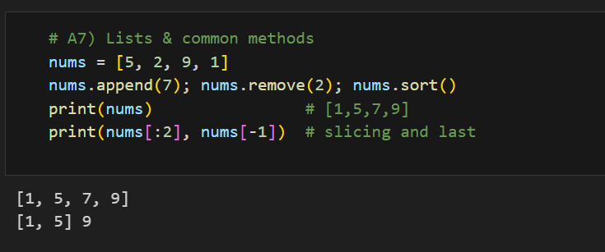
Explanation:
- append() adds an element, remove() deletes one.
- sort() arranges values in ascending order.
- List slicing retrieves subsets or last elements.

A8) Dictionaries & Lookup
This task demonstrates dictionary creation, key lookup, and average calculation.
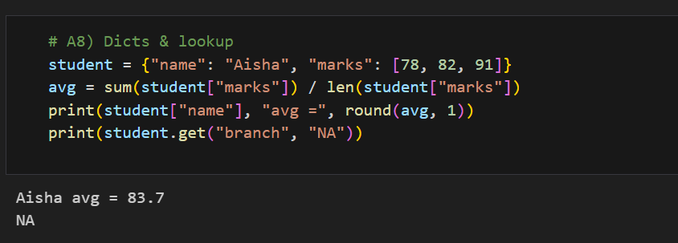
Explanation:
- Dictionary keys store related data.
- sum() and len() compute averages.
- get() safely retrieves a value or returns a default.

A9) Functions & Default Arguments
This task introduces defining and calling a Python function with default parameters.
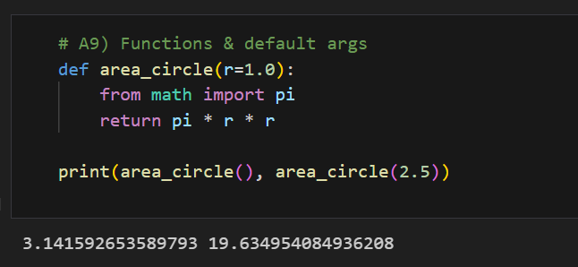
Explanation:
- A function is created to calculate the area of a circle.
- The default radius is 1.0 if no argument is provided.
- The math.pi constant is used for precision.

A10) Try/Except + File I/O
This task demonstrates file writing, reading, and handling exceptions.
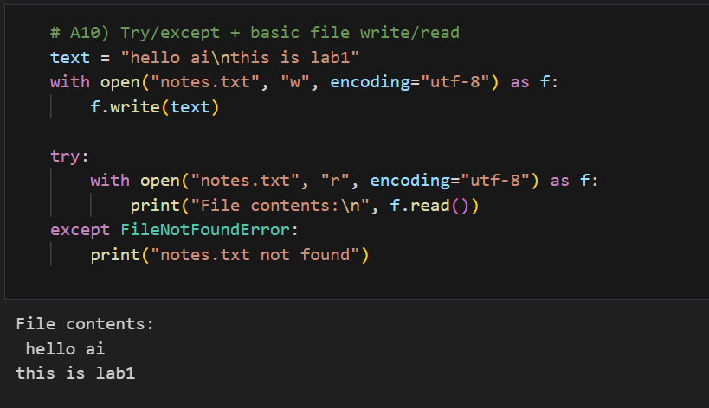
Explanation:
- The with open() block writes text into a file safely.
- The second block reads and prints file contents.
- The try/except structure prevents crashes if the file is missing.

B1) Fibonacci (Iteration & Recursion)
This task demonstrates two methods to generate the Fibonacci sequence — one using iteration and the other using recursion. The Fibonacci series is a fundamental example of sequence generation and recursion in programming.
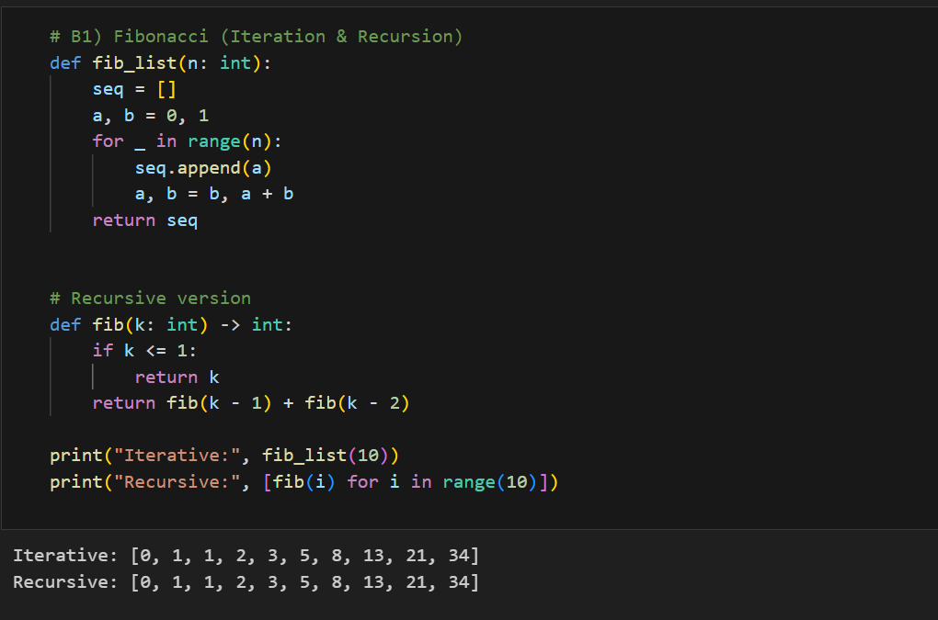
Explanation:
- The iterative version builds the sequence step by step using two variables a and b.
- The recursive version defines the Fibonacci rule F(n)=F(n−1)+F(n−2)F(n) = F(n-1) + F(n-2)F(n)=F(n−1)+F(n−2).
- Both versions generate the first 10 Fibonacci numbers:
0, 1, 1, 2, 3, 5, 8, 13, 21, 34.
- This exercise highlights the difference between iterative loops and recursive calls.

B2) Prime Checker & List Comprehension
This task defines a function to check whether a number is prime and then uses a list comprehension to generate all prime numbers between 2 and 50.
It demonstrates both conditional logic and Python’s concise functional programming features.
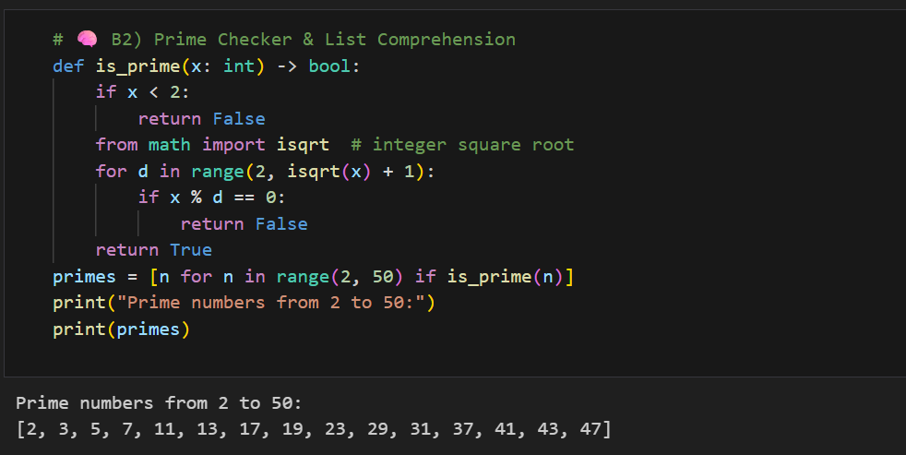
Explanation:
- The function is_prime() checks divisibility from 2 up to the square root of the number.
- If any divisor divides x evenly, the number is not prime.
- The list comprehension [n for n in range(2, 50) if is_prime(n)] collects all prime numbers in that range.
- This approach efficiently combines logic and list building in a single readable line.

B3) Word Frequency (Dictionary + Cleanup)
This task demonstrates how to clean and process text data in Python using regular expressions and dictionaries.
It counts the frequency of each word in a given sentence after converting the text to lowercase and removing punctuation.
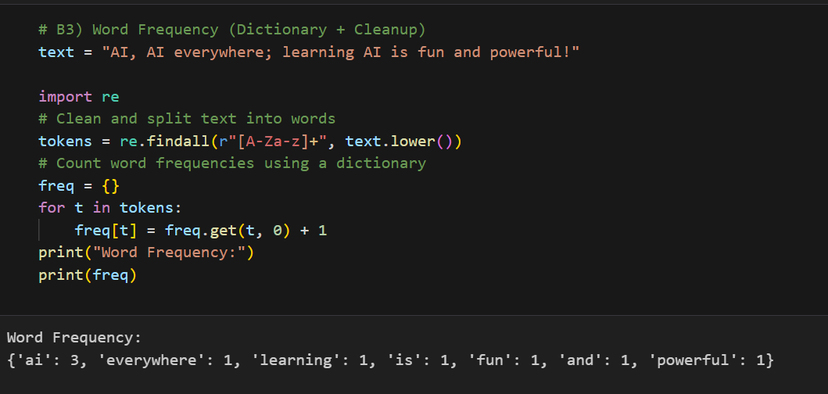
Explanation:
- The re.findall() function extracts only alphabetic words and ignores punctuation.
- The text.lower() ensures consistent counting by converting all words to lowercase.
- A dictionary freq stores each unique word as a key and its frequency as the value.
- The program outputs the count of each word, showing how often “AI” and other words appear.

B4) Matrix Operations with Lists
This task performs matrix multiplication using nested list comprehensions in Python.
It shows how to handle two-dimensional lists (matrices) and apply element-wise multiplication and summation to compute a result matrix.
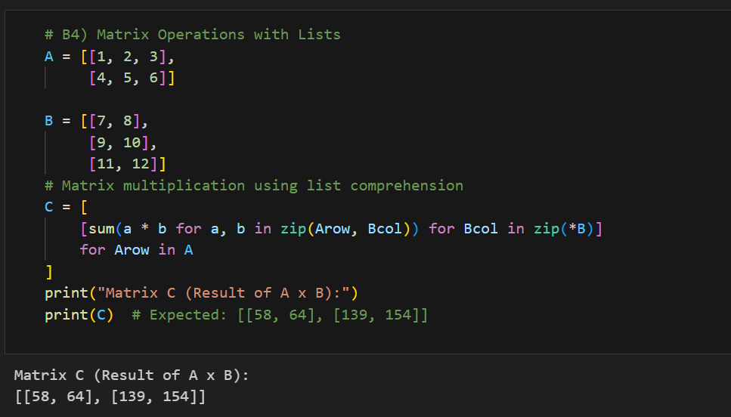
- zip(*B) transposes matrix B, allowing column-wise access.
- For each row in A and column in B, the sum(a * b for a, b in zip(Arow, Bcol)) computes the dot product.
- The final list comprehension builds the result matrix C.
- The output [[58, 64], [139, 154]] confirms correct matrix multiplication for a (2×3) × (3×2) operation.

B5) Set Operations (Dedupe + Overlap)
This task demonstrates how to use Python sets for operations such as union, intersection, and difference. Sets automatically remove duplicate elements and are ideal for comparing collections of unique items.
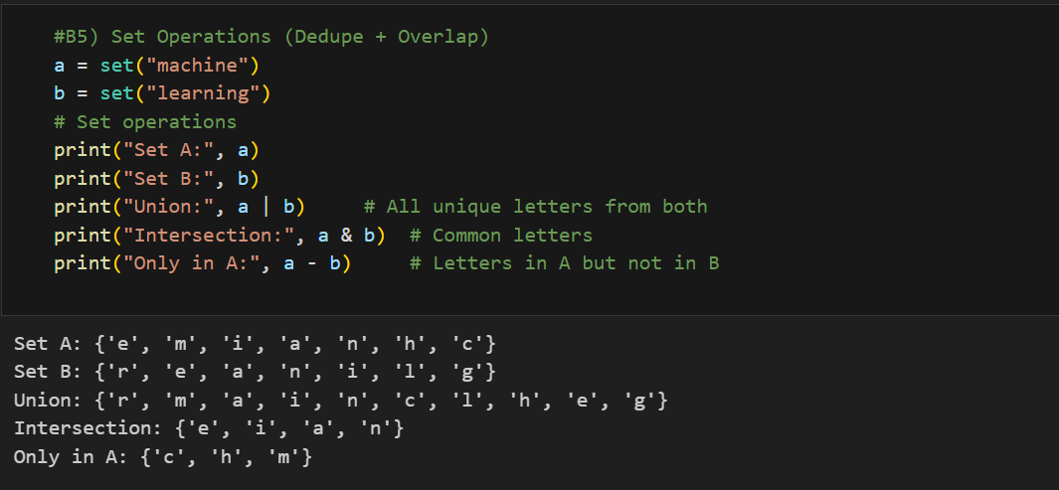
Explanation:
- set("machine") and set("learning") convert the words into sets of unique characters.
- a | b → Union combines all distinct letters from both sets.
- a & b → Intersection gives common letters.
- a - b → Difference shows letters present only in a.
- This demonstrates how sets help in removing duplicates and finding overlaps or differences between data groups.

B6) Safe Divide with Exception Handling
This task shows how to handle runtime errors gracefully in Python using the try-except block. The program defines a function that performs division safely, even when the denominator is zero.

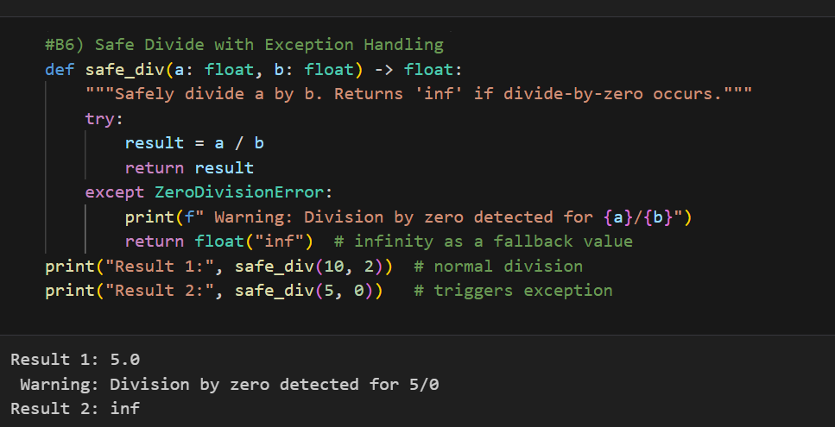
Explanation:
- The function safe_div() attempts to divide a by b.
- If b is 0, a ZeroDivisionError occurs — handled by the except block.
- Instead of crashing, it prints a warning and returns float("inf") (infinity).
- This example demonstrates robust programming — preventing runtime errors from interrupting execution.

B7) Map, Filter, and Reduce Mini Example
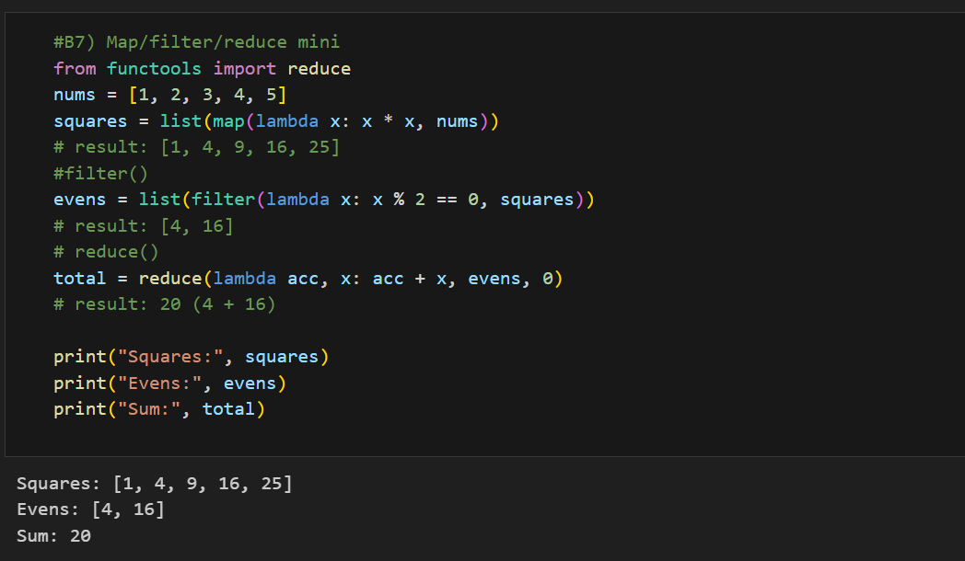
This task demonstrates how to perform functional-style data processing in Python using the built-in functions map(), filter(), and reduce().
Explanation:
- map() applies a function to each element of a list — here it squares each number.
- filter() selects only those elements that satisfy a condition — only even squares.
- reduce() combines all items into a single value by applying a function cumulatively — computes the sum of even squares.
- The output shows how these three higher-order functions can be chained together for efficient data transformations.

B8) Title-Casing Names Using String Methods
This task demonstrates how to clean and format text data using Python’s built-in string methods such as strip(), split(), and capitalize().
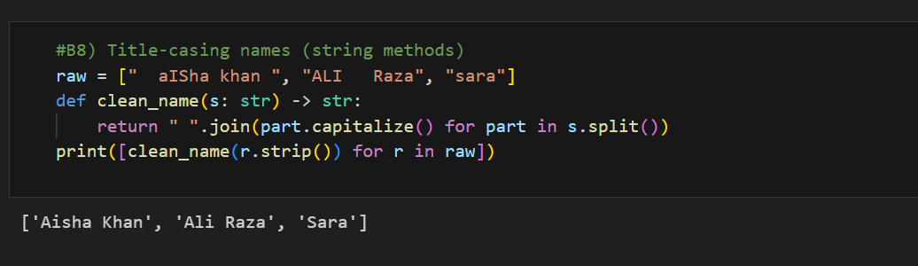
Explanation:
- strip() removes extra spaces from the beginning and end of each name.
- split() divides a name into separate words (e.g., first and last names).
- capitalize() ensures each part of the name starts with a capital letter.
- join() combines the cleaned words back into a single string.
- The result converts irregularly formatted names like " aISha khan " or "ALI Raza" into proper title case, e.g., "Aisha Khan", "Ali Raza", "Sara".

B9) Mini Grading Report (Dictionary + Loops + Formatting)
This task shows how to use dictionaries, loops, and string formatting to summarize students’ marks and calculate averages.

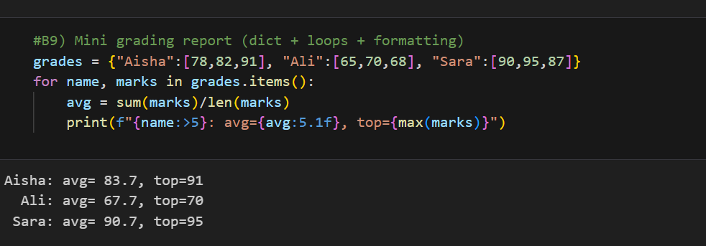
Explanation:
- A dictionary grades stores student names as keys and their marks as lists.
- The for name, marks in grades.items() loop iterates through each student.
- sum(marks)/len(marks) calculates the average score.
- max(marks) finds the highest mark for each student.
- The formatted string f"{name:>5}: avg={avg:5.1f}, top={max(marks)}" neatly aligns names and numeric results for a clear, report-like output.

B10) CSV Read/Write (No Pandas)
This task demonstrates how to perform file input/output operations using Python’s built-in csv module without relying on external libraries like Pandas.
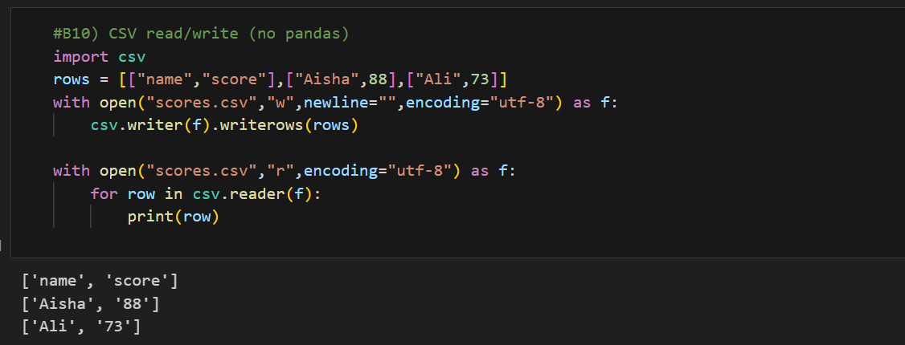
Explanation:
- The csv module is used to handle Comma-Separated Values files.
- A list of lists rows stores tabular data with headers.
- csv.writer(f).writerows(rows) writes all rows into the file scores.csv.
- The second with open(...) block reads the file using csv.reader() and prints each row to verify the contents.
- Using the with statement ensures files are automatically closed after use.

Task 1 — Counting Odd and Even Numbers
This task counts how many numbers in a list are odd and how many are even, using generator expressions and the sum() function.
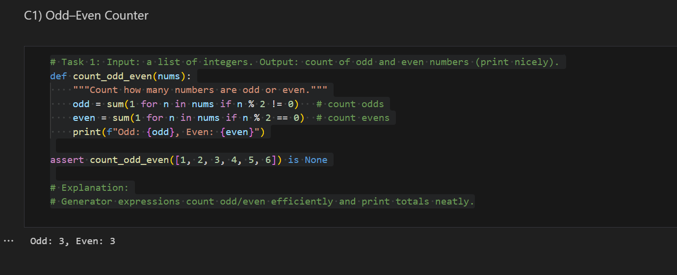
Explanation:
- The function iterates over all elements in the list nums.
- sum(1 for n in nums if n % 2 != 0) counts how many are odd.
- sum(1 for n in nums if n % 2 == 0) counts how many are even.
- The results are displayed neatly using formatted strings (f-strings).
- The assert statement confirms that the function executes correctly and returns None since it only prints results.

Task 2 — String Reversal and Palindrome Check
This task demonstrates how to reverse a string and check if a string is a palindrome, ignoring spaces, punctuation, and case.
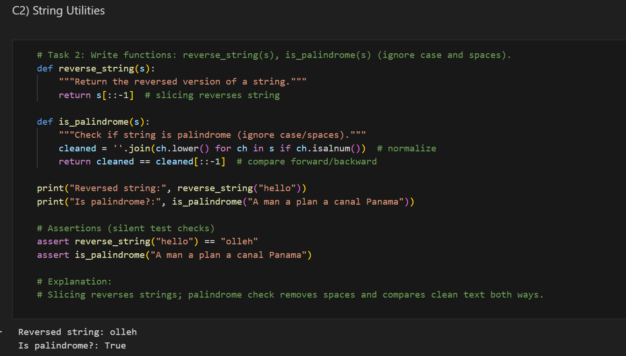
Explanation:
- The reverse_string() function uses Python slicing [::-1] to reverse a string.
- The is_palindrome() function:
  - Removes all non-alphanumeric characters and converts to lowercase for a clean comparison.
  - Compares the cleaned string with its reversed version to decide if it’s a palindrome.
- The assert statements silently test both functions for correctness.

