
JOMO KENYATTA UNIVERSITY OF AGRICULTURE AND TECHNOLOGY
SCHOOL OF ELECTRICAL, ELECTRONIC AND INFORMATION ENGINEERING
DEPARTMENT OF ELECTRONIC AND COMPUTER ENGINEERING
DBMS PROJECT REPORT
GROUP 5 MEMBERS
NAME | ADMISSION
GEORGE JOHN OCHIERE | ENE212-0281/2021
MUGAISI EUGENE MURULI | ENE212-0083/2020
KOECH CINDY CHEBET | ENE212-0069/2020
KIRUI ABIGAEL CHEROTICH | ENE212-0070/2020
IAN KIOGORA MWENDA | ENE212-0251/2021
COURSE: B.Sc. ELECTRONIC AND COMPUTER ENGINEERING
ICS 2206
INTRODUCTION TO DATABASE MANAGEMENT SYSTEMS
TITLE: KENYA POWER ELECTRICAL SYSTEMS MANAGEMENT APPLICATION
LECTURER: MR. PETER M KARANJA
DATE OF SUBMISSION: JANUARY 23RD, 2026

Table of Contents
Table of Contents 1
1. Executive Summary 2
1.1 Project Overview 2
1.2 Key Features 2
1.3 Technology Stack 3
2. System Architecture 4
2.1 High-Level Architecture 4
2.2 Blueprint Architecture 4
3. Database Design 5
3.1 Entity-Relationship Diagram 5
3.2 Database Tables Overview 6
3.3 Key Relationships 6
4. Authentication and Authorization 7
4.1 Dual Authentication System 7
Staff Authentication (Flask-Login) 7
Customer Authentication (Custom Session) 7
4.2 Role-Based Access Control Matrix 7
5. Design Objectives Verification 8
5.1 Customer Connection Management 8
5.2 Fault Reporting and Resolution 8
5.3 Maintenance Scheduling 9
5.4 Performance Reporting 9
6. Compliance Summary 10
7. Default Credentials & Quick Reference 11
7.1 Staff Login Credentials 11
7.2 Application URLs 11
7.3 Quick Start Guide 11
7.4 Demonstration Checklist 11

PART I: PROJECT DOCUMENTATION

1. Executive Summary

1.1 Project Overview
The Kenya Power Electrical Systems Management Application is a comprehensive web-based solution designed to manage electrical utility operations for Kenya Power. The system provides two distinct portals:
- Staff Portal: For Kenya Power employees (administrators, managers, technicians, and customer service agents) to manage customers, electrical connections, fault reports, maintenance schedules, and generate performance reports.
- Customer Portal: A self-service interface for Kenya Power customers to view their connections, report faults, submit service requests, communicate with customer support, and manage their profiles.

1.2 Key Features
- Customer Management: Complete CRUD operations for customer accounts with unique account numbering
- Connection Management: Track electrical connections/meters with status management
- Fault Management: Report, assign, track, and resolve electrical faults
- Maintenance Scheduling: Schedule and track preventive and corrective maintenance
- Performance Reporting: Analytics dashboards with charts and KPIs
- Role-Based Access Control: Four staff roles with granular permissions
- Real-Time Notifications: System notifications for important events

1.3 Technology Stack
Technology | Purpose | Justification
Python Flask | Web Framework | Lightweight, flexible, extensive ecosystem
MySQL | Database | Industry-standard RDBMS, ACID compliance
SQLAlchemy | ORM | Pythonic database operations, relationship management
Flask-Login | Authentication | Secure session management for staff users
Bootstrap 5 | UI Framework | Responsive design, modern components
Jinja2 | Templating | Server-side rendering, template inheritance

2. System Architecture

2.1 High-Level Architecture
The application follows a three-tier architecture pattern:
CLIENT LAYER
Staff Portal (Bootstrap 5) | Customer Portal (Bootstrap 5)
↓
APPLICATION LAYER (Flask)
Routes | Models | Utils | Templates
↓
DATA LAYER (MySQL)
kenya_power_db: users | customers | connections | faults | maintenance

2.2 Blueprint Architecture
The application is organized into 9 blueprints:
Blueprint | URL Prefix | Purpose
auth_bp | / | Staff authentication (login, logout, register)
main_bp | / | Landing page and dashboard
customers_bp | /customers | Customer account management
connections_bp | /connections | Electrical connection management
faults_bp | /faults | Fault reporting and tracking
maintenance_bp | /maintenance | Maintenance scheduling
reports_bp | /reports | Performance reporting and analytics
staff_bp | /staff | Staff member management (admin only)
customer_bp | /portal | Customer self-service portal

3. Database Design

3.1 Entity-Relationship Diagram
The following diagram illustrates the complete database schema with all 10 interconnected tables:
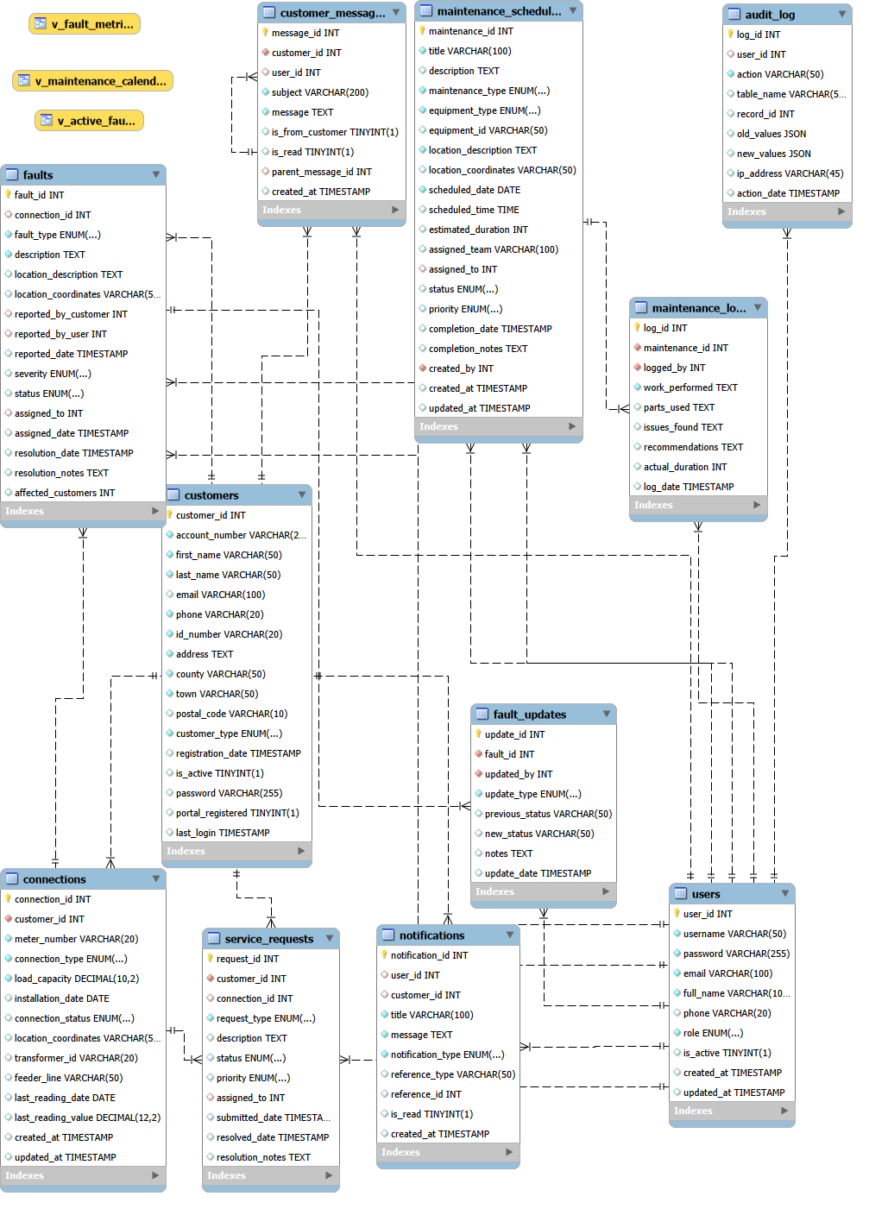

Figure 1: Entity-Relationship Diagram

3.2 Database Tables Overview
Table | Description
users | Staff/admin accounts for system authentication and authorization
customers | Kenya Power customer information and portal credentials
connections | Electrical connections/meters linked to customers
faults | Electrical fault reports with full lifecycle tracking
fault_updates | Status changes and notes added to fault reports
maintenance_schedules | Scheduled maintenance activities with assignments
maintenance_logs | Work performed during maintenance activities
service_requests | Customer service requests (new connection, upgrade, etc.)
notifications | System notifications for users and customers
customer_messages | Two-way messaging between customers and support staff

3.3 Key Relationships
- Customer → Connections: One-to-Many (a customer can have multiple electrical connections)
- Connection → Faults: One-to-Many (a connection can have multiple fault reports)
- Fault → FaultUpdates: One-to-Many (a fault can have multiple status updates)
- User → Faults: One-to-Many (technicians are assigned to faults)
- MaintenanceSchedule → MaintenanceLogs: One-to-Many (maintenance can have multiple work logs)

4. Authentication and Authorization

4.1 Dual Authentication System
The application implements two separate authentication systems:

Staff Authentication (Flask-Login)
- Library: Flask-Login with server-side session management
- User Model: User class extending UserMixin

Customer Authentication (Custom Session)
- Implementation: Custom session-based authentication in app/utils/customer_auth.py
- Storage: Flask session with customer_id tracking

4.2 Role-Based Access Control Matrix
Role | Customers | Connections | Faults | Maintenance | Reports | Staff
Admin | Full | Full | Full | Full | View | Full
Manager | Full | Full | Full | Full | View | None
Technician | View | Add/Edit | Assigned | Assigned | None | None
Customer Svc | Full | View | Report | View | None | None

PART II: USER GUIDE & VERIFICATION

5. Design Objectives Verification
This section details each design objective with step-by-step procedures to demonstrate compliance.

5.1 Customer Connection Management
OBJECTIVE: Track customer connections, handle connection requests, manage installation dates, and monitor service status.
Requirement | Status | Implementation
Track customer connections | MET | Connection model with full lifecycle tracking
Connection requests | MET | ServiceRequest model with new_connection type
Installation dates | MET | installation_date field in Connection model
Service status | MET | connection_status: pending/active/suspended/disconnected
HOW TO PROVE THIS OBJECTIVE IS MET:
- Login as admin at /login using credentials: admin / admin123
- Navigate to Customers > Add Customer to create a new customer
- Observe the auto-generated account number (format: KP-2026-XXXX)
- Navigate to Connections > Add Connection for the new customer
- Observe the auto-generated meter number (format: MTR-XXX-NNNNNN)
- Demonstrate status lifecycle: pending > active > suspended > disconnected

5.2 Fault Reporting and Resolution
OBJECTIVE: Enable fault reporting, log repair requests, track resolution process, and ensure timely repairs.
Requirement | Status | Implementation
Report faults | MET | Staff: /faults/report, Customer: /portal/faults/report
Log repair requests | MET | FaultUpdate model tracks all changes
Track resolution | MET | 6-stage workflow: reported → resolved → closed
Timely repairs | MET | Resolution time calculation, technician notifications
HOW TO PROVE THIS OBJECTIVE IS MET:
- Login as customer service agent (cs_agent1 / password123)
- Navigate to Faults > Report Fault and submit a new fault
- Login as manager (manager1 / password123) and assign fault to technician
- Login as technician (tech1 / password123) and update status to "Resolved"
- View fault details showing resolution time calculation

5.3 Maintenance Scheduling
Requirement | Status | Implementation
Preventive maintenance | MET | MaintenanceSchedule model with type="preventive"
Distribution lines | MET | equipment_type: feeder_line, transformer, etc.
Reduce outage risk | MET | Calendar view, priority levels, assignments

5.4 Performance Reporting
Requirement | Status | Implementation
Maintenance reports | MET | /reports/maintenance with completion rates
Fault resolution times | MET | /reports/faults with avg resolution calculation
Performance metrics | MET | /reports/performance with KPI dashboard
Visual representations | MET | Chart.js: doughnut, bar, line charts

6. Compliance Summary
Category | Total | Met | Partial | Not Met
Design Objectives | 5 | 5 | 0 | 0
Specifications | 5 | 5 | 0 | 0
Expected Deliverables | 5 | 5 | 0 | 0
TOTAL | 15 | 15 | 0 | 0

7. Default Credentials & Quick Reference

7.1 Staff Login Credentials
Role | Username | Password | Access Level
Administrator | admin | admin123 | Full system access
Manager | manager1 | password123 | Operations + Reports
Technician | tech1 | password123 | Assigned work only
Technician 2 | tech2 | password123 | Assigned work only
Customer Service | cs_agent1 | password123 | Customer management

7.2 Application URLs
Function | URL
Landing Page | http://127.0.0.1:5000/
Staff Login | http://127.0.0.1:5000/login
Staff Dashboard | http://127.0.0.1:5000/dashboard
Customer Portal Login | http://127.0.0.1:5000/portal/login
Customer Registration | http://127.0.0.1:5000/portal/register
Reports Dashboard | http://127.0.0.1:5000/reports/

7.3 Quick Start Guide
- Initialize Database: python init_db.py
- Start Application: python run.py
- Access Application: Open browser to http://127.0.0.1:5000/
- Login as Admin: Username: admin / Password: admin123

7.4 Demonstration Checklist
- Start application: python run.py
- Login as admin to show full access
- Create a customer (observe auto-generated account number)
- Create a connection (observe auto-generated meter number)
- Report a fault and assign to technician
- Schedule maintenance and view calendar
- View reports and charts
- Login as different roles to show access restrictions
- Access customer portal to demonstrate self-service features

This documentation was prepared for academic assessment purposes.
Kenya Power Electrical Systems Management Application
Comprehensive Project Documentation & User Guide

