

CLOUD-BASED NETWORK MANAGEMENT SYSTEM
SYSTEM DOCUMENTATION
SUBMITTED BY,
GABRIEL KIOK KUNTEREI
REG. NO: ______________________

A SYSTEM DOCUMENTATION SUBMITTED IN PARTIAL FULFILMENT FOR THE AWARD OF DIPLOMA IN INFORMATION TECHNOLOGY BY ZETECH UNIVERSITY

SEPTEMBER 2026

DECLARATION
I, Gabriel Kiok Kunterei, do declare that this is my original work and it has never been submitted elsewhere for any academic award.
Student Name: Gabriel Kiok Kunterei Sign: _________________ Date: ____________
Reg. No: _____________________________

This project has been submitted for examination with my approval as the university supervisor.
Supervisor Name: _________________________ Sign: _________________ Date: ____________

DEDICATION
This project is dedicated to my family for their constant support, encouragement and understanding throughout my academic journey. Their motivation and belief in my abilities gave me the strength to complete this project successfully.
It is also dedicated to my lecturers, friends and fellow students pursuing knowledge and innovation in information technology and computer networking.

ACKNOWLEDGEMENT
I thank God for the strength, good health and guidance throughout the planning, design, development, testing and documentation of this project.
I sincerely appreciate my project supervisor and the lecturers of Zetech University for their academic guidance, constructive feedback and encouragement at every milestone. I am also grateful to my classmates who acted as test users and gave honest feedback on the system, and to my family and friends for their continuous support.

ABSTRACT
Organisations depend on computer networks for communication, learning platforms, business applications and cloud services, yet many small and medium-sized institutions still monitor their routers, switches, firewalls and servers manually or with several disconnected tools. This delays the detection of faults, makes historical performance information hard to organise and gives administrators little visibility when they are away from the network. This project designed and developed a Cloud-Based Network Management System (CloudNMS) that gives authorised administrators one secure, browser-based console for monitoring network devices.
Lightweight monitoring agents installed at the site push device metrics (CPU, memory, latency, link utilisation and packet loss) over HTTPS to a REST API hosted in the cloud. A monitoring engine validates each sample, stores it, compares it with configurable thresholds and automatically raises, escalates and resolves alerts; devices that stop reporting are marked offline through a heartbeat check. The web console provides a live dashboard, device inventory and search, per-device performance charts, alert management, availability/performance/fault reports with CSV export, user management with role-based access control and a security audit log. The system was developed with the Python Flask framework, SQLAlchemy and SQLite, HTML, CSS, JavaScript and Chart.js, following an Agile, milestone-based approach, and is deployed on the PythonAnywhere cloud platform. A suite of 26 automated tests covering authentication, authorisation, device management, the metrics API, fault detection and reporting passes in full with 79% code coverage. The system improves network visibility, shortens the time needed to notice faults and supports evidence-based network management decisions.

DEFINITION OF KEY TERMS
Network Management System (NMS) – Software used to monitor, analyse and control the devices that make up a computer network, such as routers, switches, firewalls and servers.
Cloud Computing – A model for enabling on-demand network access to a shared pool of configurable computing resources that can be rapidly provisioned with minimal management effort (Mell & Grance, 2011).
Monitoring Agent – A small program installed on or near a managed device that collects performance data and sends it to the central management server.
Heartbeat – A regular signal (here, a metric submission) that shows a device is alive; the absence of a heartbeat for a set period indicates that the device is unreachable.
Threshold – A configured limit for a metric (for example CPU utilisation of 90%) which, when reached, causes the system to raise an alert.
Alert – A system notification recording a detected fault or abnormal condition, with a severity (critical or warning) and a status (open, acknowledged or resolved).
Latency – The time taken for data to travel from a source to a destination and back, measured in milliseconds (ms).
Bandwidth (Link) Utilisation – The percentage of a network link's capacity that is being used at a given time.
Role-Based Access Control (RBAC) – A security approach in which users are granted permissions according to their assigned role rather than individually.
Audit Log – A chronological record of security-relevant and administrative events such as log-ins, failed log-ins and configuration changes.
Dashboard – A graphical user interface that summarises key information, such as device status, active alerts and performance trends, on one screen.
Deployment – The process of making the system available for use by hosting it on a server so that users can access it over the internet.

ABBREVIATIONS AND ACRONYMS
Abbreviation | Meaning
API | Application Programming Interface
CPU | Central Processing Unit
CSRF | Cross-Site Request Forgery
CSS | Cascading Style Sheets
CSV | Comma-Separated Values
DFD | Data Flow Diagram
ERD | Entity Relationship Diagram
HTML | Hypertext Markup Language
HTTP/HTTPS | Hypertext Transfer Protocol / Secure
IDE | Integrated Development Environment
IP | Internet Protocol
JSON | JavaScript Object Notation
MTTR | Mean Time To Resolve
NIST | National Institute of Standards and Technology
NMS | Network Management System
ORM | Object-Relational Mapping
OWASP | Open Worldwide Application Security Project
PaaS | Platform as a Service
RBAC | Role-Based Access Control
REST | Representational State Transfer
SNMP | Simple Network Management Protocol
SQL | Structured Query Language
TCP | Transmission Control Protocol
UI | User Interface
UML | Unified Modeling Language
URL | Uniform Resource Locator
WSGI | Web Server Gateway Interface

TABLE OF CONTENTS
DECLARATION i
DEDICATION ii
ACKNOWLEDGEMENT iii
ABSTRACT iv
DEFINITION OF KEY TERMS v
ABBREVIATIONS AND ACRONYMS vi
TABLE OF CONTENTS vii
LIST OF FIGURES ix
LIST OF TABLES xi
CHAPTER ONE: PROJECT PLANNING AND ANALYSIS 1
1.1 Statement of Problem 1
1.2 Study Justification 1
1.3 System Objectives 2
1.3.1 General Objective 2
1.3.2 Specific Objectives 2
1.4 Functional Requirements 3
1.5 Breakdown of Tools & Resources to Be Used 4
1.6 Gantt Chart 6
CHAPTER TWO: DESIGN AND MODELING 7
2.1 Introduction to Modelling 7
2.2 User Interface Models 7
2.2.1 Login Page 7
2.2.2 Dashboard 8
2.2.3 Device Management 9
2.2.4 Device Details 10
2.2.5 Alerts 11
2.2.6 Reports 12
2.3 Logic Models 13
2.3.1 System Architecture 13
2.3.2 Login Process Flowchart 14
2.3.3 System Flowchart 15
2.3.4 Monitoring and Fault Detection Flowchart 16
2.3.5 Data Flow Diagrams 17
2.3.6 Entity Relationship Diagram 19
2.3.7 Use Case Diagram 20
2.3.8 Class Diagram 21
CHAPTER THREE: SYSTEM IMPLEMENTATION 22
3.1 Introduction 22
3.2 User Interface Development 22
3.2.1 Login Page Development 22
3.2.2 Dashboard 24
3.2.3 Navigation Bar 24
3.2.4 Device Inventory and Search 25
3.2.5 Add New Device Form 27
3.2.6 Device Details and Performance 29
3.2.7 Alerts 30
3.2.8 Reports 32
3.2.9 User Management, Thresholds and Audit Log 35
3.3 Logic Development 39
3.3.1 Database Models 39
3.3.2 Login 39
3.3.3 Role-Based Access Control 40
3.3.4 Dashboard 41
3.3.5 Device Management 42
3.3.6 Metrics API and Monitoring Agent 43
3.3.7 Fault Detection and Alerts 44
3.3.8 Reports 46
3.4 Testing 47
3.5 Deployment 51
CHAPTER FOUR: CONCLUSION AND RECOMMENDATION 54
4.1 Conclusion 54
4.2 Recommendation 54
REFERENCES 56

LIST OF FIGURES
Figure 2.1: Login page wireframe 7
Figure 2.2: Dashboard wireframe 8
Figure 2.3: Device list and device form wireframe 9
Figure 2.4: Device details wireframe 10
Figure 2.5: Alerts wireframe 11
Figure 2.6: Reports wireframe 12
Figure 2.7: System architecture 13
Figure 2.8: Login process flowchart 14
Figure 2.9: System flowchart 15
Figure 2.10: Monitoring and fault detection flowchart 16
Figure 2.11: Context (level 0) data flow diagram 17
Figure 2.12: Level 1 data flow diagram 18
Figure 2.13: Entity relationship diagram 19
Figure 2.14: Use case diagram 20
Figure 2.15: Class diagram 21
Figure 3.1: Login page development 23
Figure 3.2: Login page showing a failed login attempt 23
Figure 3.3: Dashboard development 24
Figure 3.4: Navigation bar and top search bar 25
Figure 3.5: Device inventory 26
Figure 3.6: Device search results 26
Figure 3.7: Add new device form 27
Figure 3.8: Add device form rejecting a duplicate IP address 28
Figure 3.9: Newly registered device showing its agent API key 28
Figure 3.10: Device details – web server with high memory utilisation 29
Figure 3.11: Device details – Wi-Fi access point latency trend 30
Figure 3.12: Active alerts 31
Figure 3.13: Full alert history 32
Figure 3.14: Device availability report 33
Figure 3.15: Performance summary report 34
Figure 3.16: Fault and alert report 35
Figure 3.17: User management 36
Figure 3.18: Add user form 37
Figure 3.19: Alert threshold settings 37
Figure 3.20: Audit log 38
Figure 3.21: Access-denied page shown to an IT Technician 38
Figure 3.22: Device and Metric database models 39
Figure 3.23: Python-based user authentication implemented with Flask 40
Figure 3.24: role_required() access-control decorator 41
Figure 3.25: Dashboard backend development 41
Figure 3.26: Device validation and registration backend 42
Figure 3.27: Metrics submission API 43
Figure 3.28: Monitoring agent data collection 44
Figure 3.29: Threshold evaluation with debounce and hysteresis 45
Figure 3.30: Metric ingestion and heartbeat checking 46
Figure 3.31: Alert acknowledgement and resolution 46
Figure 3.32: Availability report calculation 47
Figure 3.33: Automated test run with coverage 49
Figure 3.34: Simulator and monitoring agent sending data to the server 50
Figure 3.35: Deployment diagram 51

LIST OF TABLES
Table 1.1: Functional requirements 3
Table 1.2: Non-functional requirements 4
Table 1.3: Project schedule breakdown 6
Table 2.1: Database tables 20
Table 3.1: Project structure 22
Table 3.2: Test cases and results 48
Table 3.3: Deployment verification checklist 53

CHAPTER ONE: PROJECT PLANNING AND ANALYSIS

1.1 Statement of Problem
Computer networks support communication, information sharing, learning platforms, business applications and access to cloud services. As networks grow in size and complexity, administrators need reliable ways of observing the state of every device and of identifying service problems before users are affected. Network management therefore involves collecting information from managed devices, interpreting that information and taking appropriate administrative action (Clemm, 2006).
In many small and medium-sized institutions, however, network administration is still carried out manually or with several disconnected tools. An administrator may have to log in to each router or switch individually, interpret command-line output, consult separate utilities for bandwidth and server health, or be physically present in the server room. Records of past incidents are kept in notebooks or spreadsheets, if at all. As a result, faults such as a failed access switch, an overloaded firewall or a congested wireless access point are often discovered only when users complain, historical performance data is not available for planning, and there is no single view of which devices are healthy at any moment. Access to monitoring information is also tied to the local network, so an administrator who is away from the site has no visibility at all.
There is, therefore, a need for a centralised, secure and remotely accessible platform that continuously collects status and performance information from network devices, automatically detects faults, alerts administrators, and organises the information into reports. The Cloud-Based Network Management System developed in this project addresses this need by hosting the management console and data store in the cloud, where authorised administrators can reach it from any internet-connected device.

1.2 Study Justification
The project is justified by the practical need to move network administration from reactive, manual checking to proactive, data-driven monitoring. When faults are detected automatically, the time between a failure and the administrator's response is reduced, which directly limits downtime for the people and services that depend on the network. A centralised history of device performance also allows administrators to identify recurring problems, such as a wireless access point that becomes congested every evening, and to justify upgrades with evidence rather than guesswork.
Hosting the system in the cloud removes the dependence on a single local workstation and allows secure access from any location. Cloud platforms provide on-demand computing resources without the cost of buying and maintaining dedicated servers, which makes the solution affordable for smaller institutions (Mell & Grance, 2011). Using an agent that pushes data out to the cloud over HTTPS means that no inbound firewall ports need to be opened on the organisation's network, which is simpler and safer than exposing management interfaces to the internet.
Security is a further justification. Network management data is sensitive; the system therefore enforces authentication, role-based access control, account lockout and audit logging in line with widely used guidance such as the OWASP cheat sheets and NIST digital identity guidelines (OWASP Foundation, n.d.-a; Grassi et al., 2017). Finally, the project is academically valuable because it integrates networking, cloud computing, web development, databases, software engineering and information security into one working information system.

1.3 System Objectives

1.3.1 General Objective
- To develop a cloud-based network management system that enables authorised administrators to centrally monitor network devices, performance, faults and alerts and to generate reports through a secure web-based dashboard.

1.3.2 Specific Objectives
- To develop secure user authentication with role-based access control, account lockout and audit logging.
- To develop a device management module for registering, searching, editing, pausing and deleting network devices.
- To develop a cloud-hosted metrics API and monitoring agent that collect device availability and performance metrics (CPU, memory, latency, link utilisation and packet loss).
- To implement automatic fault detection that raises, escalates and resolves alerts using configurable thresholds and device heartbeats.
- To develop a reporting module that produces availability, performance and fault reports with CSV export.
- To test and deploy the system on a cloud platform so that it is accessible from any internet-connected device.

1.4 Functional Requirements
Requirements were gathered by reviewing how network devices are currently checked in a typical institutional network, studying existing network management practice and the user responsibilities identified in the project proposal. The system has three human users and one automated actor. Table 1.1 summarises what each user does and the system features that support those activities.
User | User Activities | Features
System Administrator | Log in and log out securely | Login page with account lockout and session management
 | Create, edit, activate and deactivate user accounts and assign roles | User management module with role-based access control
 | Configure alert thresholds for CPU, memory, latency, link utilisation and packet loss | Threshold settings page
 | Review security and administrative events | Audit log with event filtering
 | Delete devices and rotate device API keys | Restricted device administration actions
Network Administrator | Register, edit, pause and resume monitoring of network devices | Device management module with input validation
 | Check device reachability on demand | “Poll now” TCP reachability probe
 | Acknowledge and resolve alerts | Alert management page
IT Technician | View network status, device details and performance trends | Dashboard, device list, device detail page with charts
 | Search and filter devices | Search by name, IP address, vendor or location; filter by status and type
 | Acknowledge alerts and generate reports | Alert list; availability, performance and fault reports with CSV export
Monitoring Agent (automated) | Submit device metrics at regular intervals | REST API endpoint /api/v1/metrics authenticated with a per-device API key
Table 1.1: Functional requirements
In addition to the functional requirements, the system must satisfy the non-functional requirements in Table 1.2.
Category | Requirement
Security | Passwords stored as salted hashes; CSRF protection on all forms; per-device API keys compared in constant time; secure, HTTP-only session cookies; generic login error messages; audit logging.
Performance | Dashboard and device pages should load within 2 seconds for a network of up to 100 devices; a metric submission should be processed in well under one second.
Availability | The application should be reachable whenever the cloud host is operational; agents continue running and the server marks silent devices offline if connectivity is lost.
Usability | Consistent navigation, clear colour-coded status indicators, readable tables and validation messages; usable on desktop and mobile browsers.
Reliability | Invalid metric data is rejected without corrupting stored records; duplicate alerts for the same fault are prevented.
Scalability & maintainability | Modular code (authentication, monitoring, reporting, API) so that new device types, metrics or protocols such as SNMP can be added.
Table 1.2: Non-functional requirements

1.5 Breakdown of Tools & Resources to Be Used
1. Software Tools
- Back-end framework: Flask (Python 3.11) – a lightweight web framework used for routing, request handling, templates, the REST API and security features, extended with Flask-Login (sessions), Flask-WTF (CSRF protection) and Flask-SQLAlchemy (database access).
- Front-end: HTML5, CSS3 and JavaScript – used to structure and style the responsive web console; Chart.js is used for the performance and status charts.
- Database: SQLite through the SQLAlchemy ORM – a file-based relational database that stores users, devices, metrics, alerts, reports, settings and audit logs; the ORM allows migration to MySQL or PostgreSQL later.
- Monitoring agent: Python with psutil and requests – collects CPU, memory and network counters on the managed host, measures latency with TCP probes and sends the data to the cloud API over HTTPS.
2. Development Environment
- IDE: Visual Studio Code for writing and debugging front-end and back-end code.
- Version control: Git for tracking changes locally and GitHub as the remote repository for backup and deployment.
- Testing: pytest and pytest-cov for automated unit, integration and system tests; Chromium web browser for interface testing.
3. Deployment Resources
- Application hosting: PythonAnywhere (Platform as a Service) hosts the Flask application, the SQLite database and a scheduled task that performs heartbeat checks.
- Secure access: HTTPS provided by the hosting platform, with configuration secrets supplied through environment variables.
4. Hardware Resources
- Client devices: desktop computers, laptops and smartphones for accessing and testing the system.
- Development machine: a laptop (Core i5, 8 GB RAM) used for development and as a test host for the monitoring agent.
- Network devices: a laboratory network of routers, switches, a firewall, servers and a wireless access point, supplemented by a device simulator when physical equipment was not available.
5. Human Resources
- System developer: responsible for requirements analysis, design, development, testing, deployment and documentation.
- Test users: classmates who used the system as network administrators and technicians during user acceptance testing.
- Project supervisor: provides guidance, monitoring and evaluation throughout the project.

1.6 Gantt Chart
The project was divided into six milestones, each linked to a part of the system documentation. Table 1.3 shows the schedule, with shaded cells indicating the weeks in which each milestone was carried out.
WEEKS | Project Planning & Analysis  (Cover page & Chapter One) | Project Design & Modeling  (Chapter Two) | Project Development & Testing  (Chapter Three) | Project Deployment  (Chapter Three) | Final Touches of System Documentation  (Preliminary pages, Chapter Four & References) | Project Presentation
4-8 May
11-15 May
18-22 May
25-29 May
1-5 Jun
8-12 Jun
15-19 Jun
22-26 Jun
29 Jun-3 Jul
6-10 Jul
13-17 Jul
20-24 Jul
31 Jul
Table 1.3: Project schedule breakdown

CHAPTER TWO: DESIGN AND MODELING

2.1 Introduction to Modelling
This chapter presents the designs and models that were produced to visualise the Cloud-Based Network Management System before implementation began. The user interface models show how administrators interact with each screen, while the logic models (architecture, flowcharts, data flow diagrams, the entity relationship diagram, the use case diagram and the class diagram) describe how the system is structured, how data moves through it and how its main processes behave. Modelling the system before development helped to clarify the requirements, identify potential problems early (for example, how to detect a device that has silently failed) and provide a clear blueprint that guided the implementation, resulting in a well-structured and reliable system.

2.2 User Interface Models
Low-fidelity wireframes were drawn for the main screens. All authenticated screens share a left navigation bar and a top bar with a device search box, so that the administrator can move between modules and find a device from anywhere.

2.2.1 Login Page
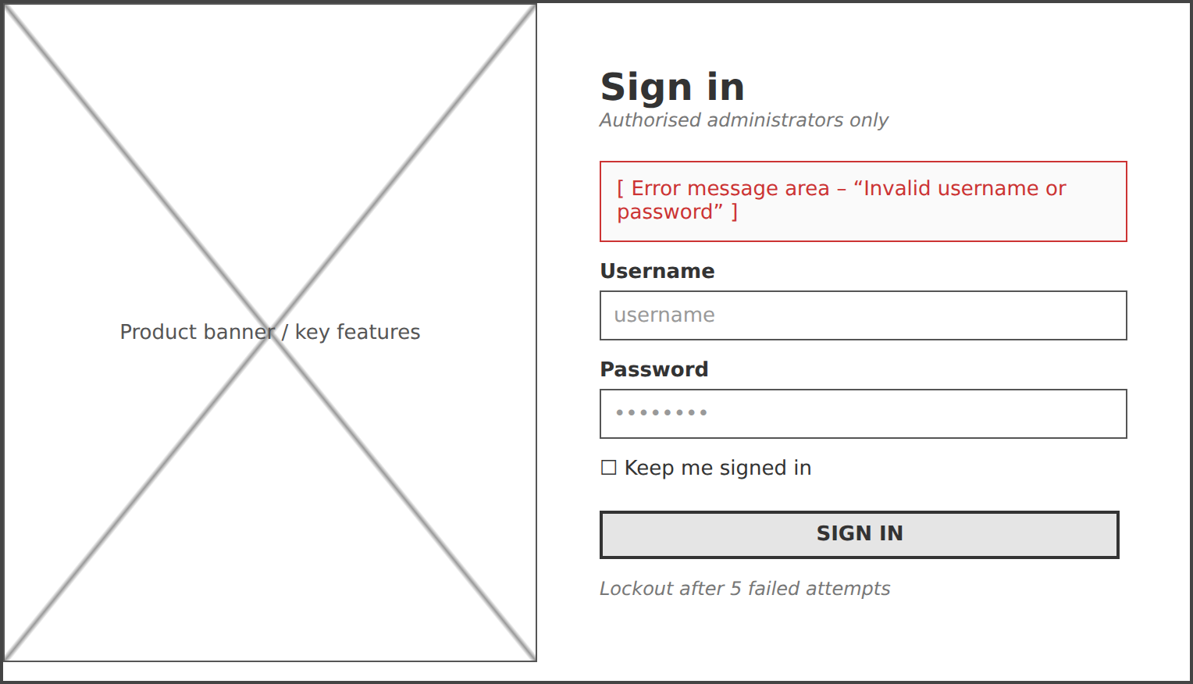
Figure 2.1: Login page wireframe
The login page provides a simple and secure interface where registered users enter their username and password. An error area displays a generic message for invalid credentials, and a note informs users that accounts are locked temporarily after repeated failed attempts.

2.2.2 Dashboard
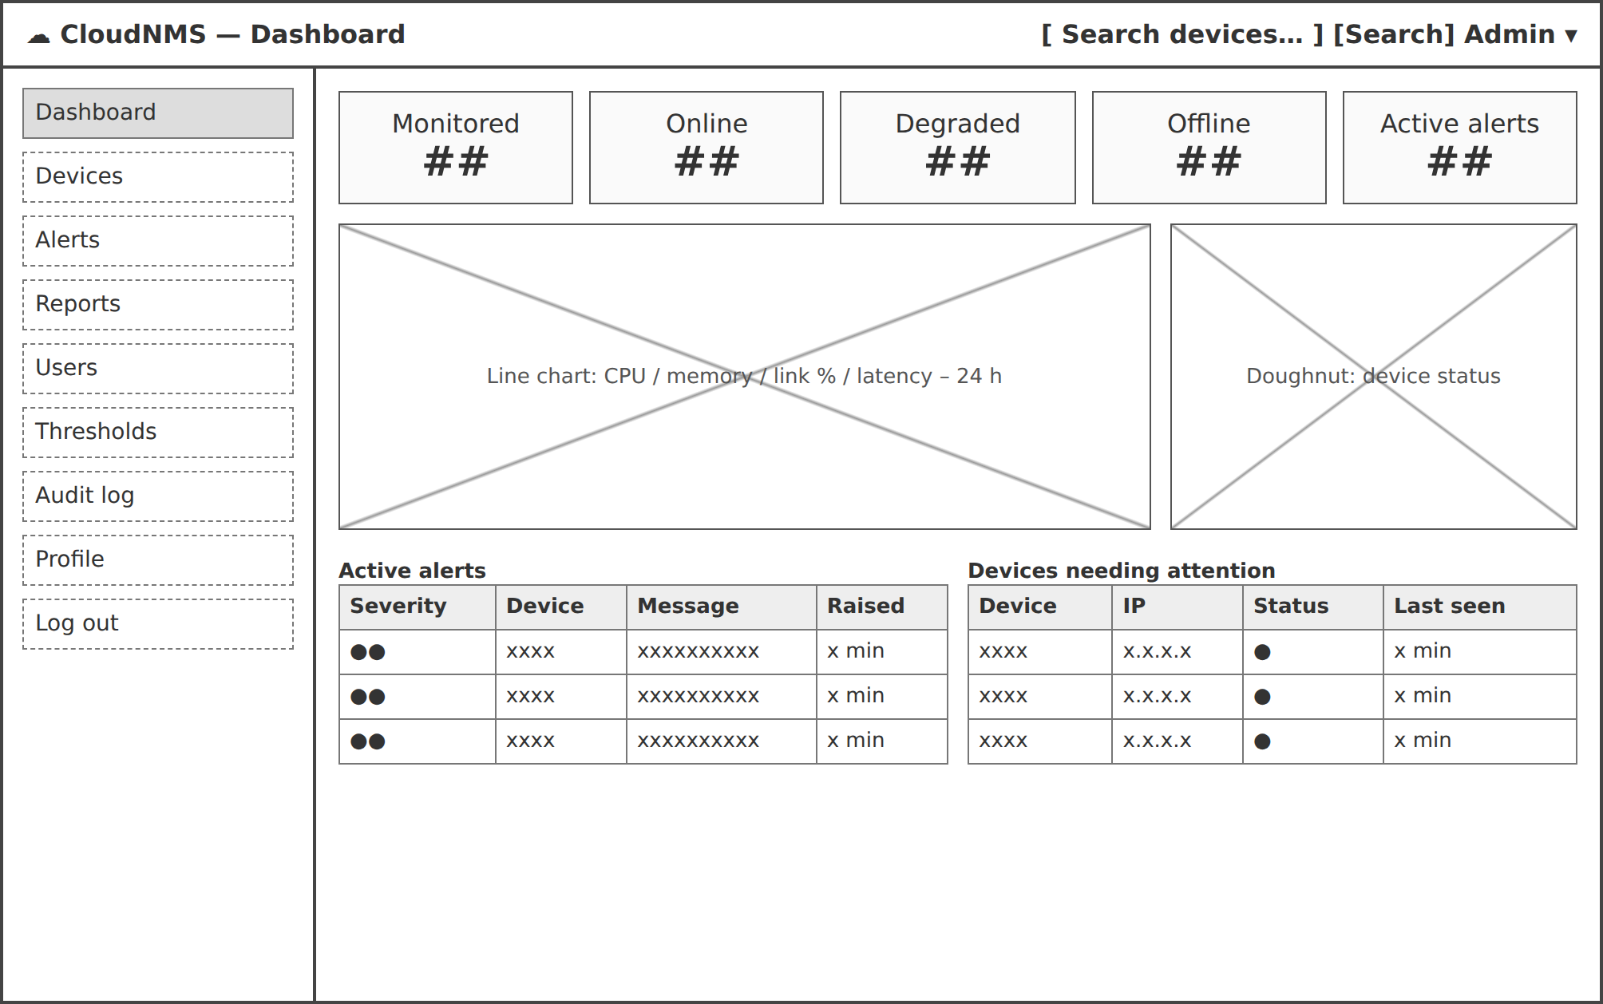
Figure 2.2: Dashboard wireframe
The dashboard prioritises the information an administrator needs most often: summary cards for monitored, online, degraded and offline devices and active alerts; a 24-hour network performance chart; a device status chart; and tables of active alerts and devices that need attention.

2.2.3 Device Management
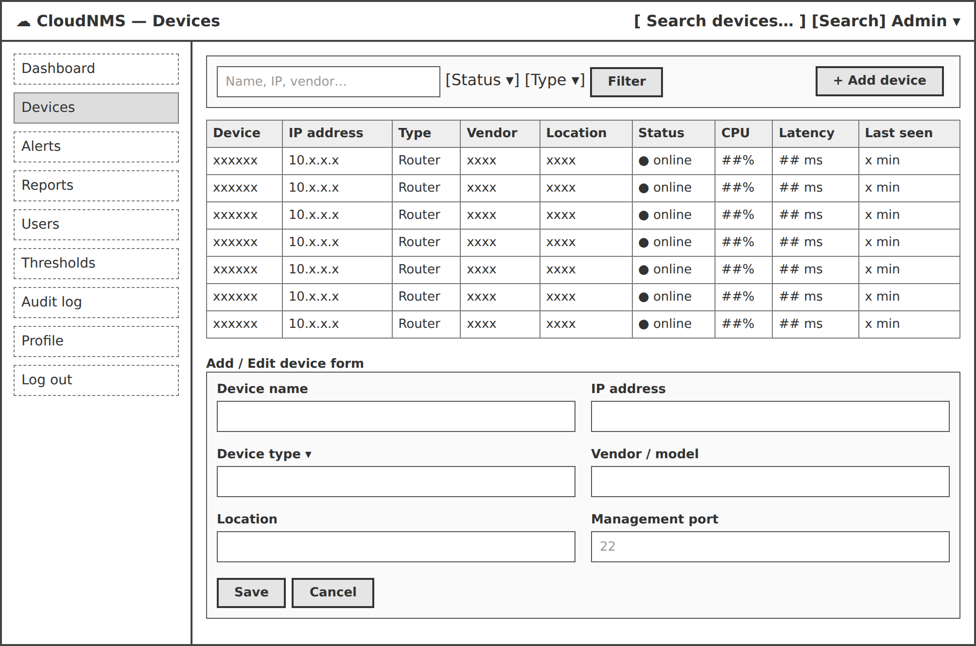
Figure 2.3: Device list and device form wireframe
The device management screen lists all registered devices with their IP address, type, vendor, location, status, latest CPU and latency values and time last seen. It provides search and filters, and an add/edit form that captures the device name, IP address, type, vendor, location and management port.

2.2.4 Device Details
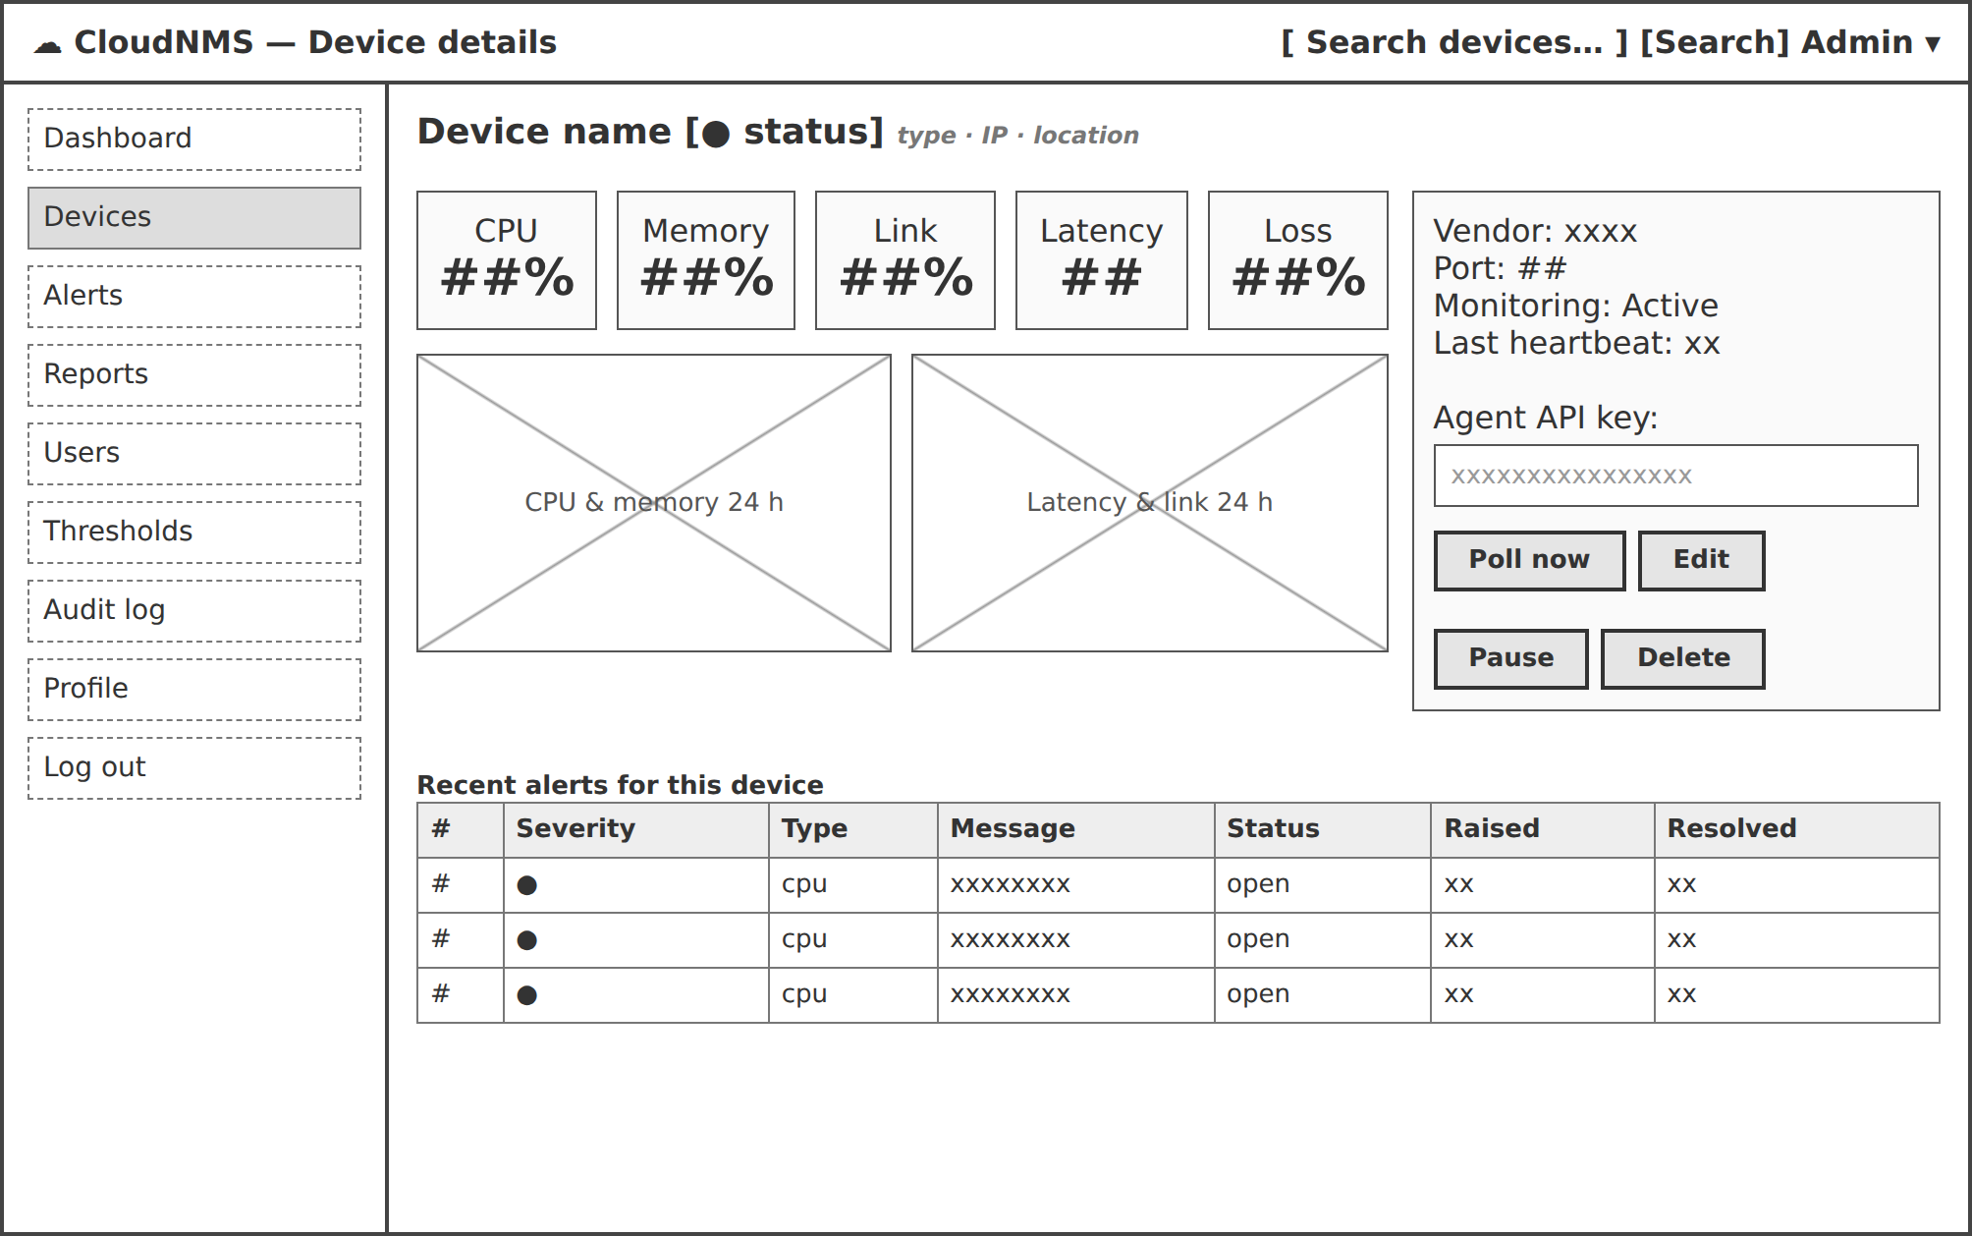
Figure 2.4: Device details wireframe
The device details screen shows the current value of each metric with a gauge, 24-hour charts, the device's configuration and agent API key, action buttons (Poll now, Edit, Pause, Delete) and the device's recent alerts.

2.2.5 Alerts
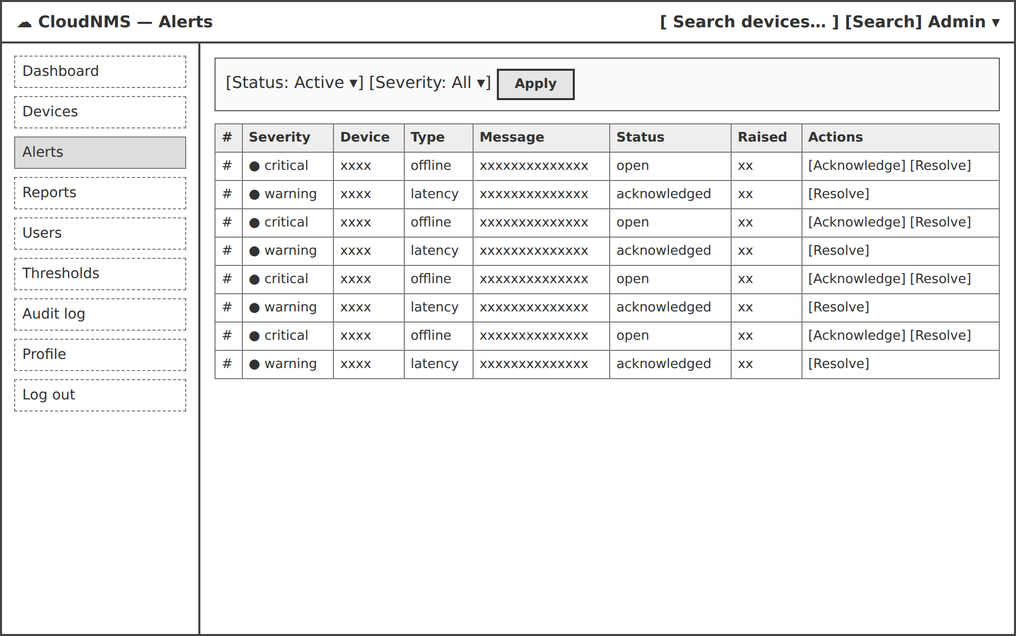
Figure 2.5: Alerts wireframe
The alerts screen lists faults with their severity, device, type, message, status and time, with filters and buttons to acknowledge or resolve each alert.

2.2.6 Reports
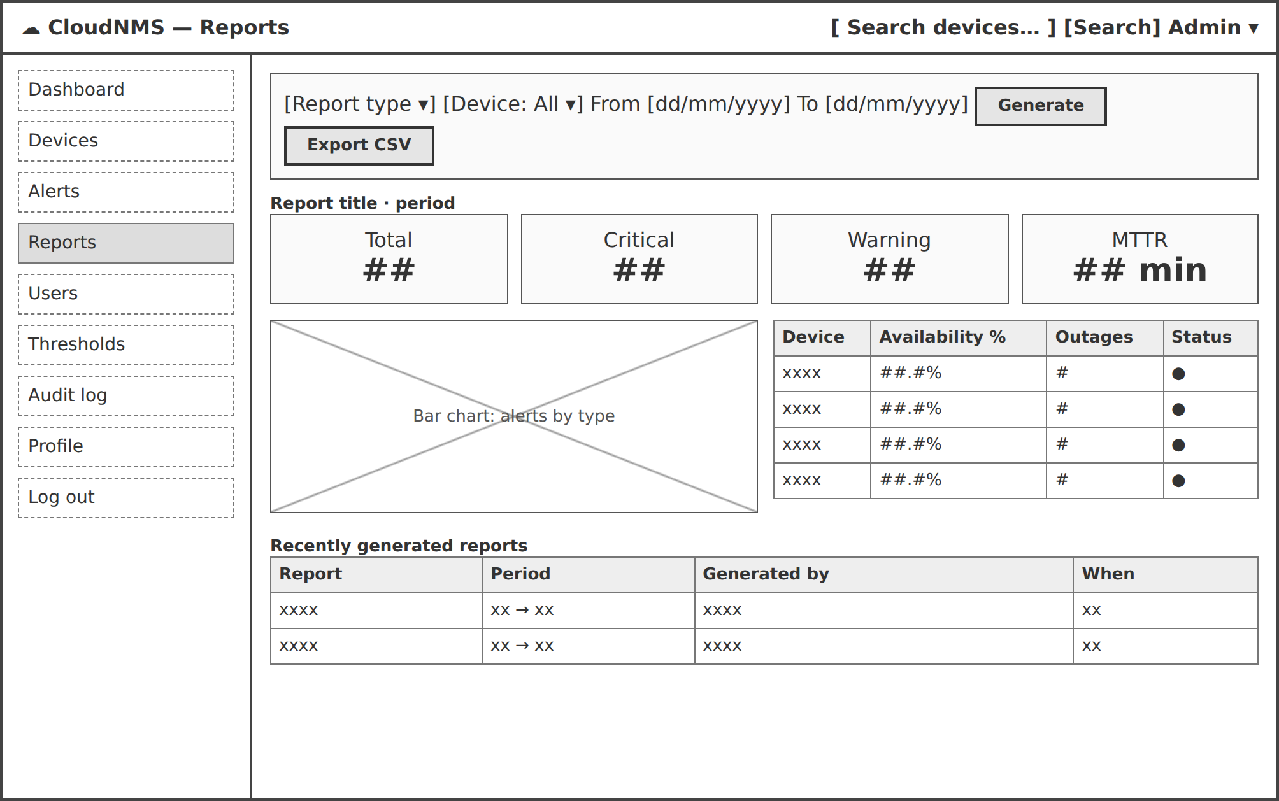
Figure 2.6: Reports wireframe
The reporting screen lets the user choose a report type, device and date range, then displays summary figures, a chart and a detailed table, with an option to export the report as a CSV file.

2.3 Logic Models

2.3.1 System Architecture
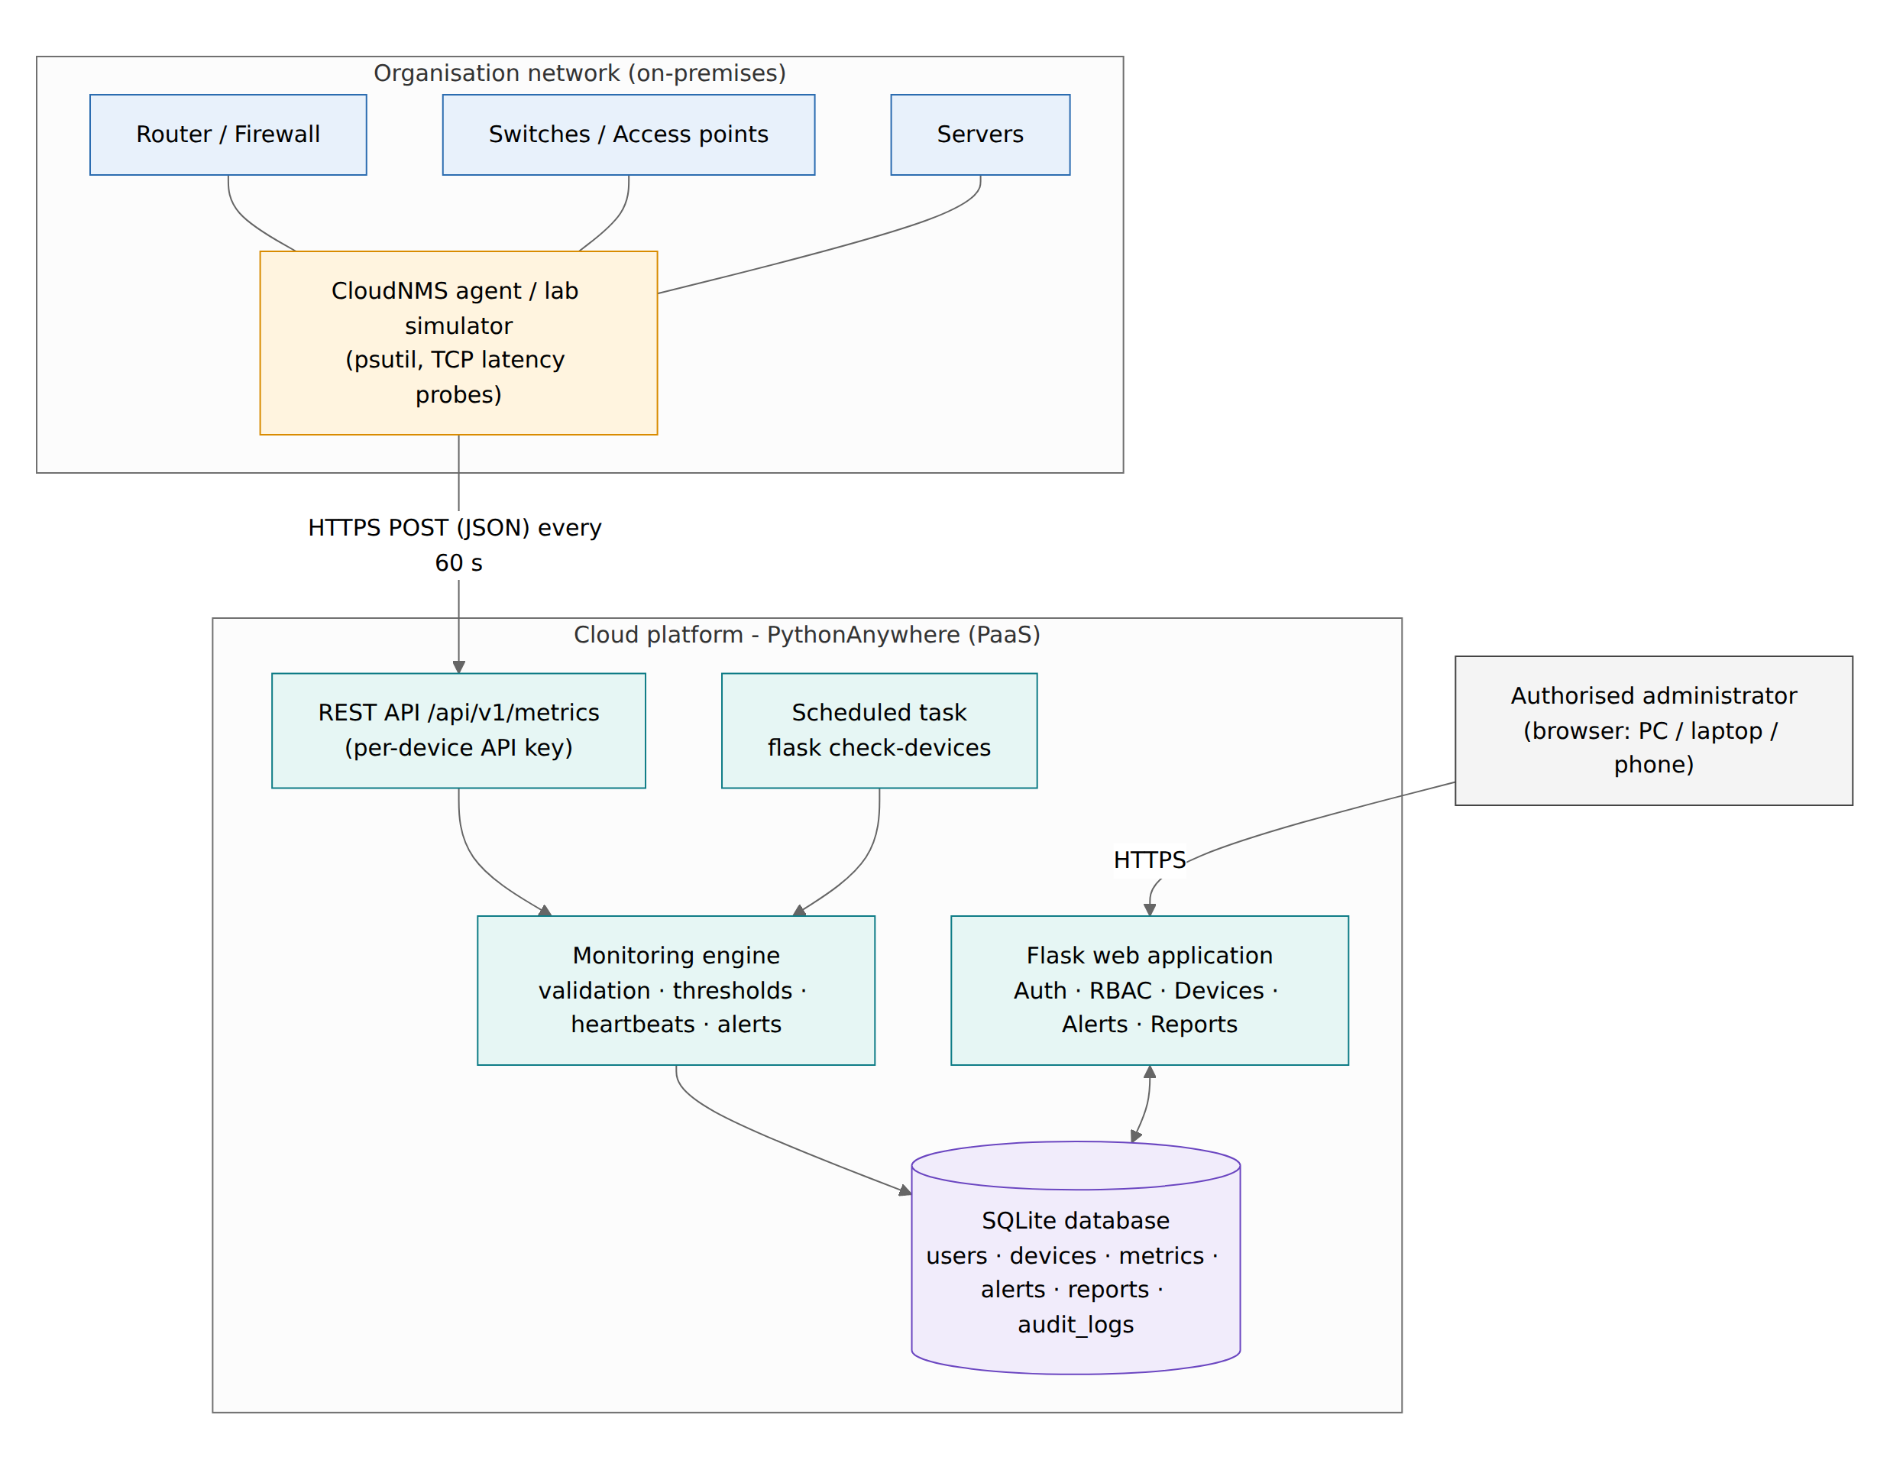
Figure 2.7: System architecture
The system follows a three-part cloud architecture. At the organisation's site, the monitoring agent (or the laboratory simulator) collects metrics from routers, switches, firewalls and servers and sends them every 60 seconds as JSON over HTTPS to the cloud. In the cloud (PythonAnywhere), the REST API authenticates each submission with the device's API key and passes it to the monitoring engine, which validates the data, stores it in the database and evaluates thresholds. A scheduled task periodically checks device heartbeats. The Flask web application reads the same database to present dashboards, alerts and reports to authorised administrators, who connect from any browser over HTTPS. Because the agents initiate all connections, no inbound ports need to be opened on the organisation's firewall.

2.3.2 Login Process Flowchart
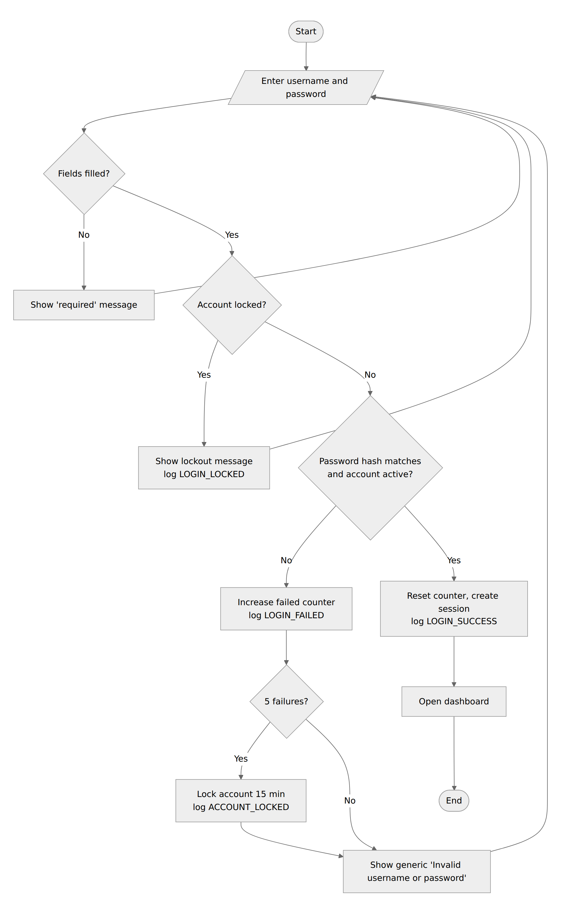
Figure 2.8: Login process flowchart
This flowchart illustrates the steps involved when a user logs in. The system checks that both fields are filled, whether the account is locked, and whether the password hash matches an active account. Failed attempts are counted and logged; after five failures the account is locked for fifteen minutes. A successful login resets the counter, creates a session, records the event and opens the dashboard.

2.3.3 System Flowchart
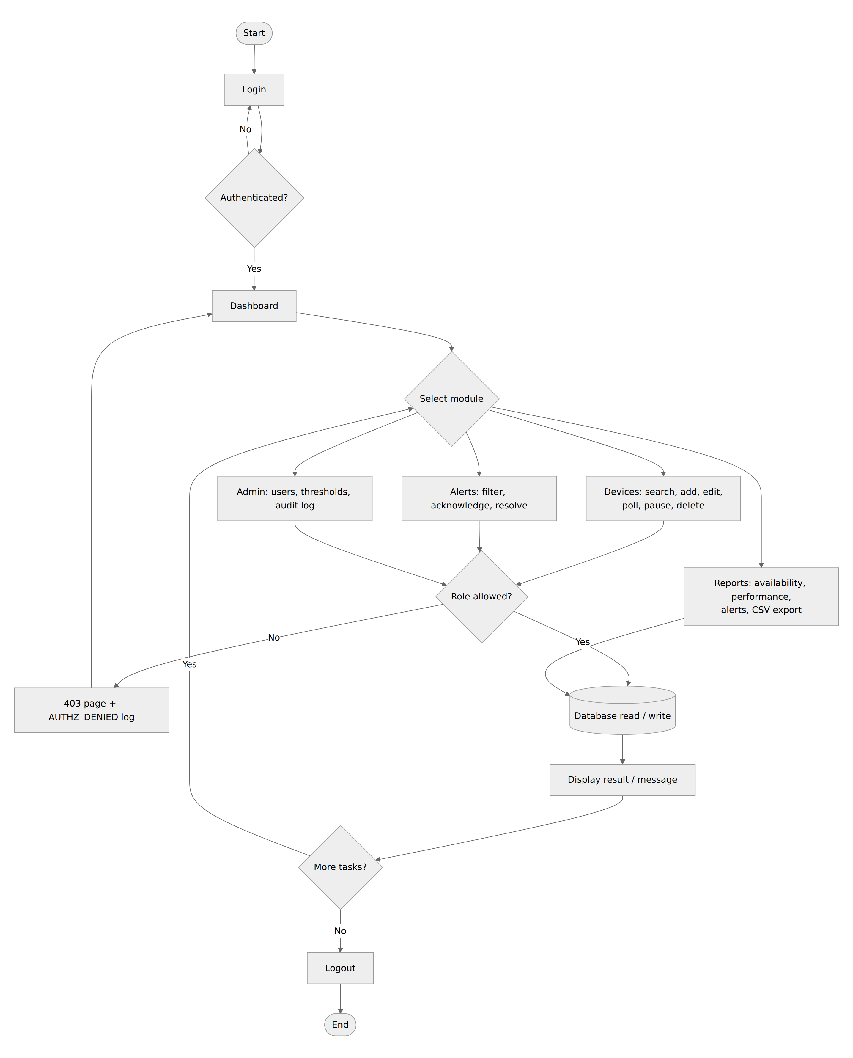
Figure 2.9: System flowchart
The system flowchart shows how the system operates from start to finish. After authentication the user reaches the dashboard and selects a module: devices, alerts, reports or administration. Before any protected action, the system checks whether the user's role permits it; if not, an access-denied page is shown and the attempt is logged. Permitted actions read from or write to the database, the result is displayed, and the user either continues with another task or logs out.

2.3.4 Monitoring and Fault Detection Flowchart
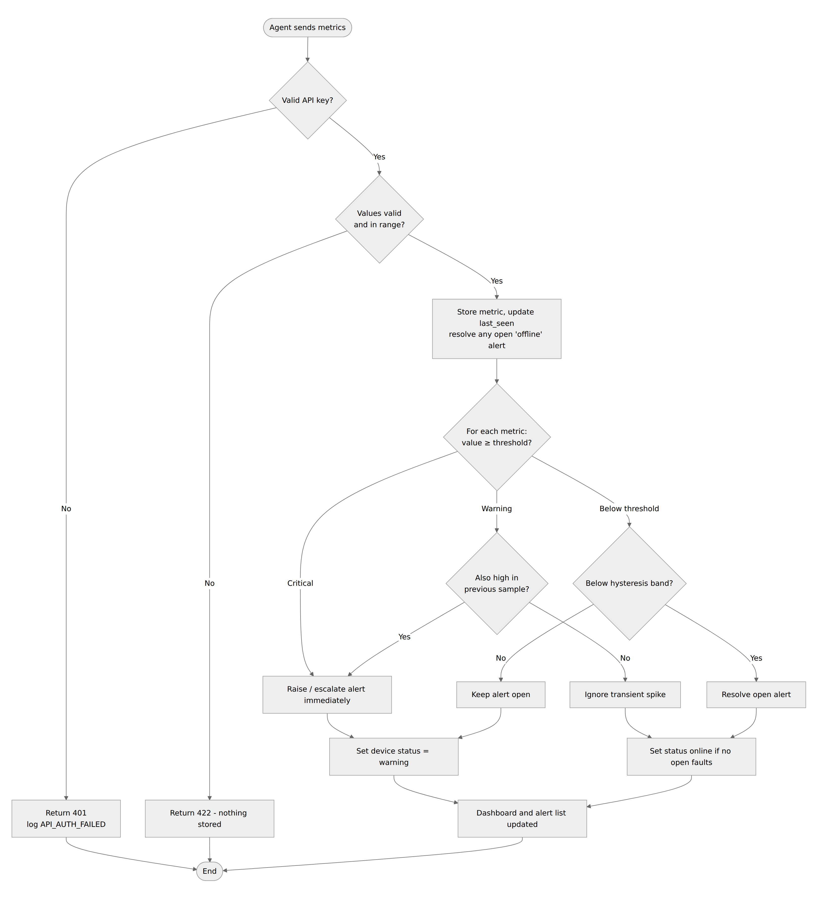
Figure 2.10: Monitoring and fault detection flowchart
This flowchart describes the core monitoring logic. Each submission from an agent is rejected if the API key is invalid (401) or the values are missing or out of range (422). Valid data is stored, the device's last-seen time is updated and any open offline alert is resolved. Each metric is then compared with its thresholds: critical values raise an alert immediately; warning values raise an alert only if the previous sample was also high, which filters out one-off spikes; values that fall back below the hysteresis band resolve the alert. The device status is set to warning while any fault is open, otherwise online.

2.3.5 Data Flow Diagrams
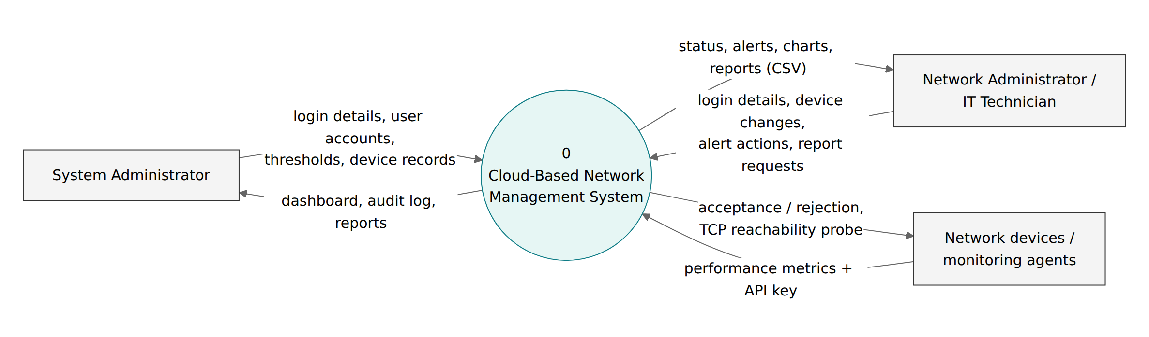
Figure 2.11: Context (level 0) data flow diagram
The context diagram shows the system as a single process exchanging data with three external entities: the System Administrator, who supplies user accounts, thresholds and device records and receives dashboards, reports and the audit log; Network Administrators and IT Technicians, who submit device changes, alert actions and report requests and receive status information, alerts and reports; and the network devices through their monitoring agents, which submit performance metrics and receive acceptance or rejection responses.
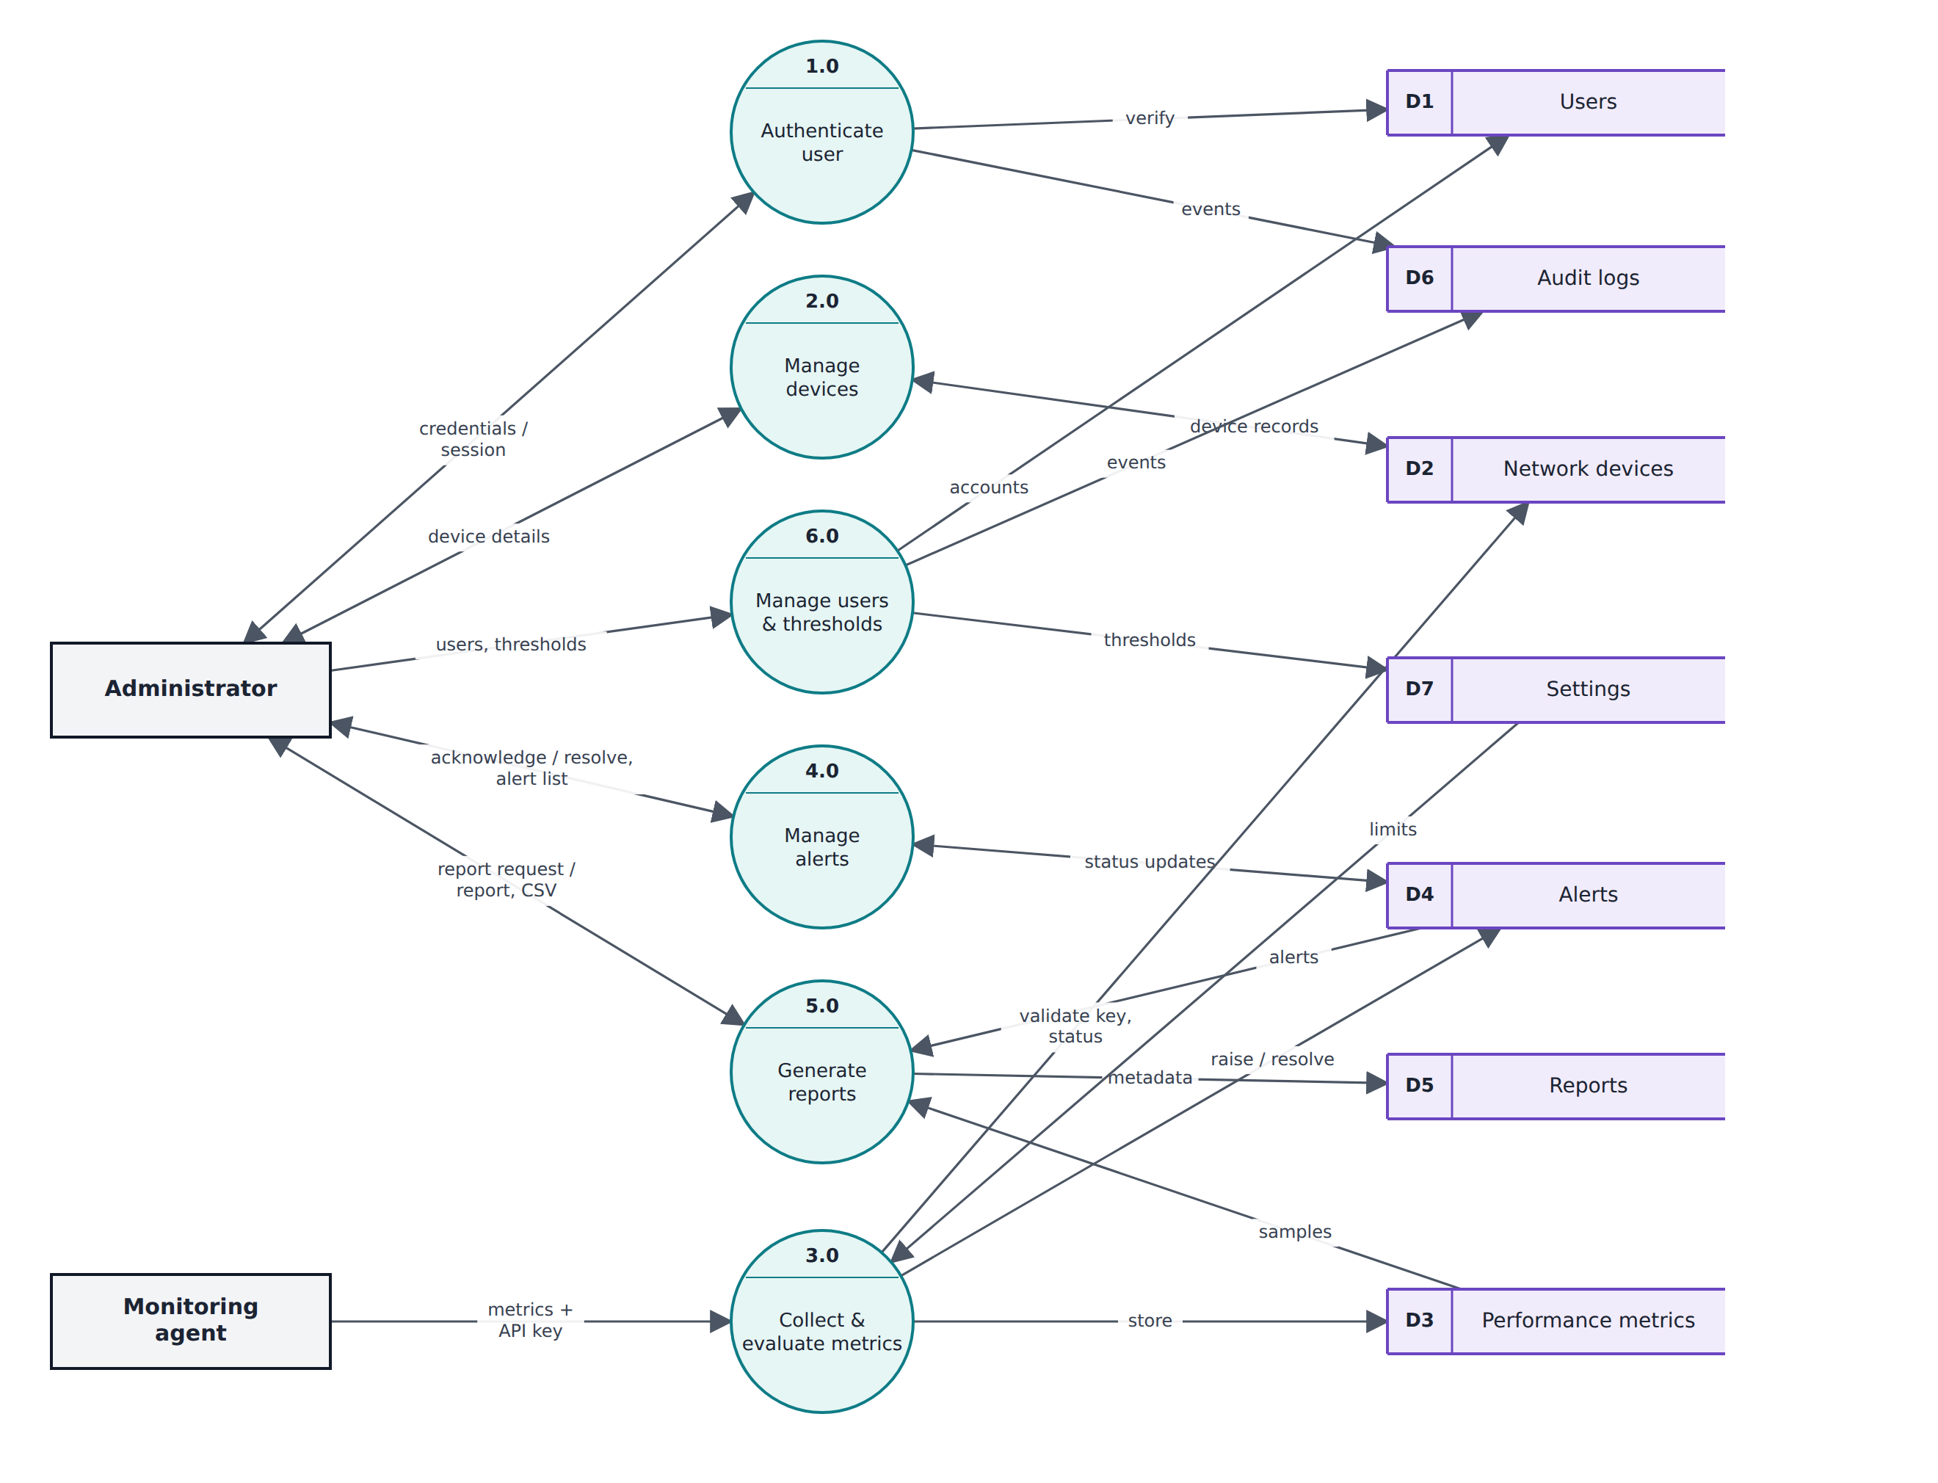
Figure 2.12: Level 1 data flow diagram
The Level 1 DFD decomposes the system into six processes: 1.0 Authenticate user, 2.0 Manage devices, 3.0 Collect and evaluate metrics, 4.0 Manage alerts, 5.0 Generate reports and 6.0 Manage users and thresholds. The processes exchange data with seven data stores (D1 Users, D2 Network devices, D3 Performance metrics, D4 Alerts, D5 Reports, D6 Audit logs and D7 Settings). For example, process 3.0 validates the agent's API key against D2, stores samples in D3, reads limits from D7 and raises or resolves alerts in D4; process 5.0 reads D3 and D4 to produce reports and records report metadata in D5.

2.3.6 Entity Relationship Diagram
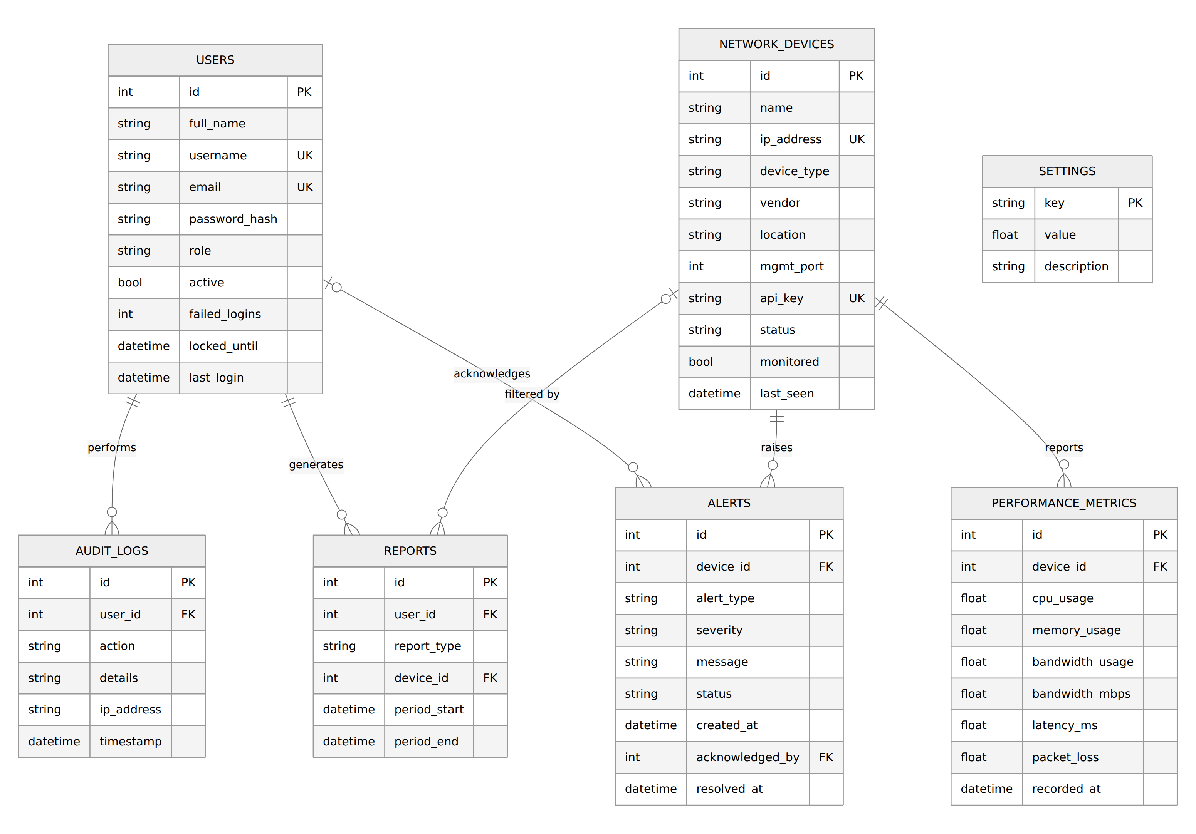
Figure 2.13: Entity relationship diagram
The ERD represents the database structure. The USERS entity stores account details, the hashed password, role and lockout information. NETWORK_DEVICES stores each managed device with a unique IP address and unique API key. One device has many PERFORMANCE_METRICS and many ALERTS, each linked by the foreign key device_id. A user performs many AUDIT_LOGS entries, generates many REPORTS and may acknowledge many alerts (acknowledged_by). A report can optionally be filtered by one device. SETTINGS is a stand-alone key–value table holding the alert thresholds. Table 2.1 summarises the database tables.
Table | Key fields | Purpose
users | id (PK), username (UK), email (UK), password_hash, role, active | Authorised system users and their roles
network_devices | id (PK), ip_address (UK), api_key (UK), device_type, status, last_seen | Managed devices and their current state
performance_metrics | id (PK), device_id (FK), cpu_usage, memory_usage, latency_ms, bandwidth_usage, packet_loss, recorded_at | Time-series performance samples
alerts | id (PK), device_id (FK), alert_type, severity, status, created_at, resolved_at, acknowledged_by (FK) | Detected faults and their life cycle
reports | id (PK), user_id (FK), report_type, device_id (FK), period_start, period_end | History of generated reports
audit_logs | id (PK), user_id (FK), action, details, ip_address, timestamp | Security and administrative events
settings | key (PK), value, description | Configurable alert thresholds
Table 2.1: Database tables

2.3.7 Use Case Diagram
The use case diagram illustrates the interactions between the actors and the system. The IT Technician can log in, view the dashboard, search devices, view device performance, acknowledge alerts and generate reports. The Network Administrator inherits these use cases and can also add, edit and pause devices, poll devices and resolve alerts. The System Administrator inherits all of the above and additionally manages users and roles, sets alert thresholds, views the audit log, deletes devices and rotates API keys. The monitoring agent is an automated actor that submits metrics.
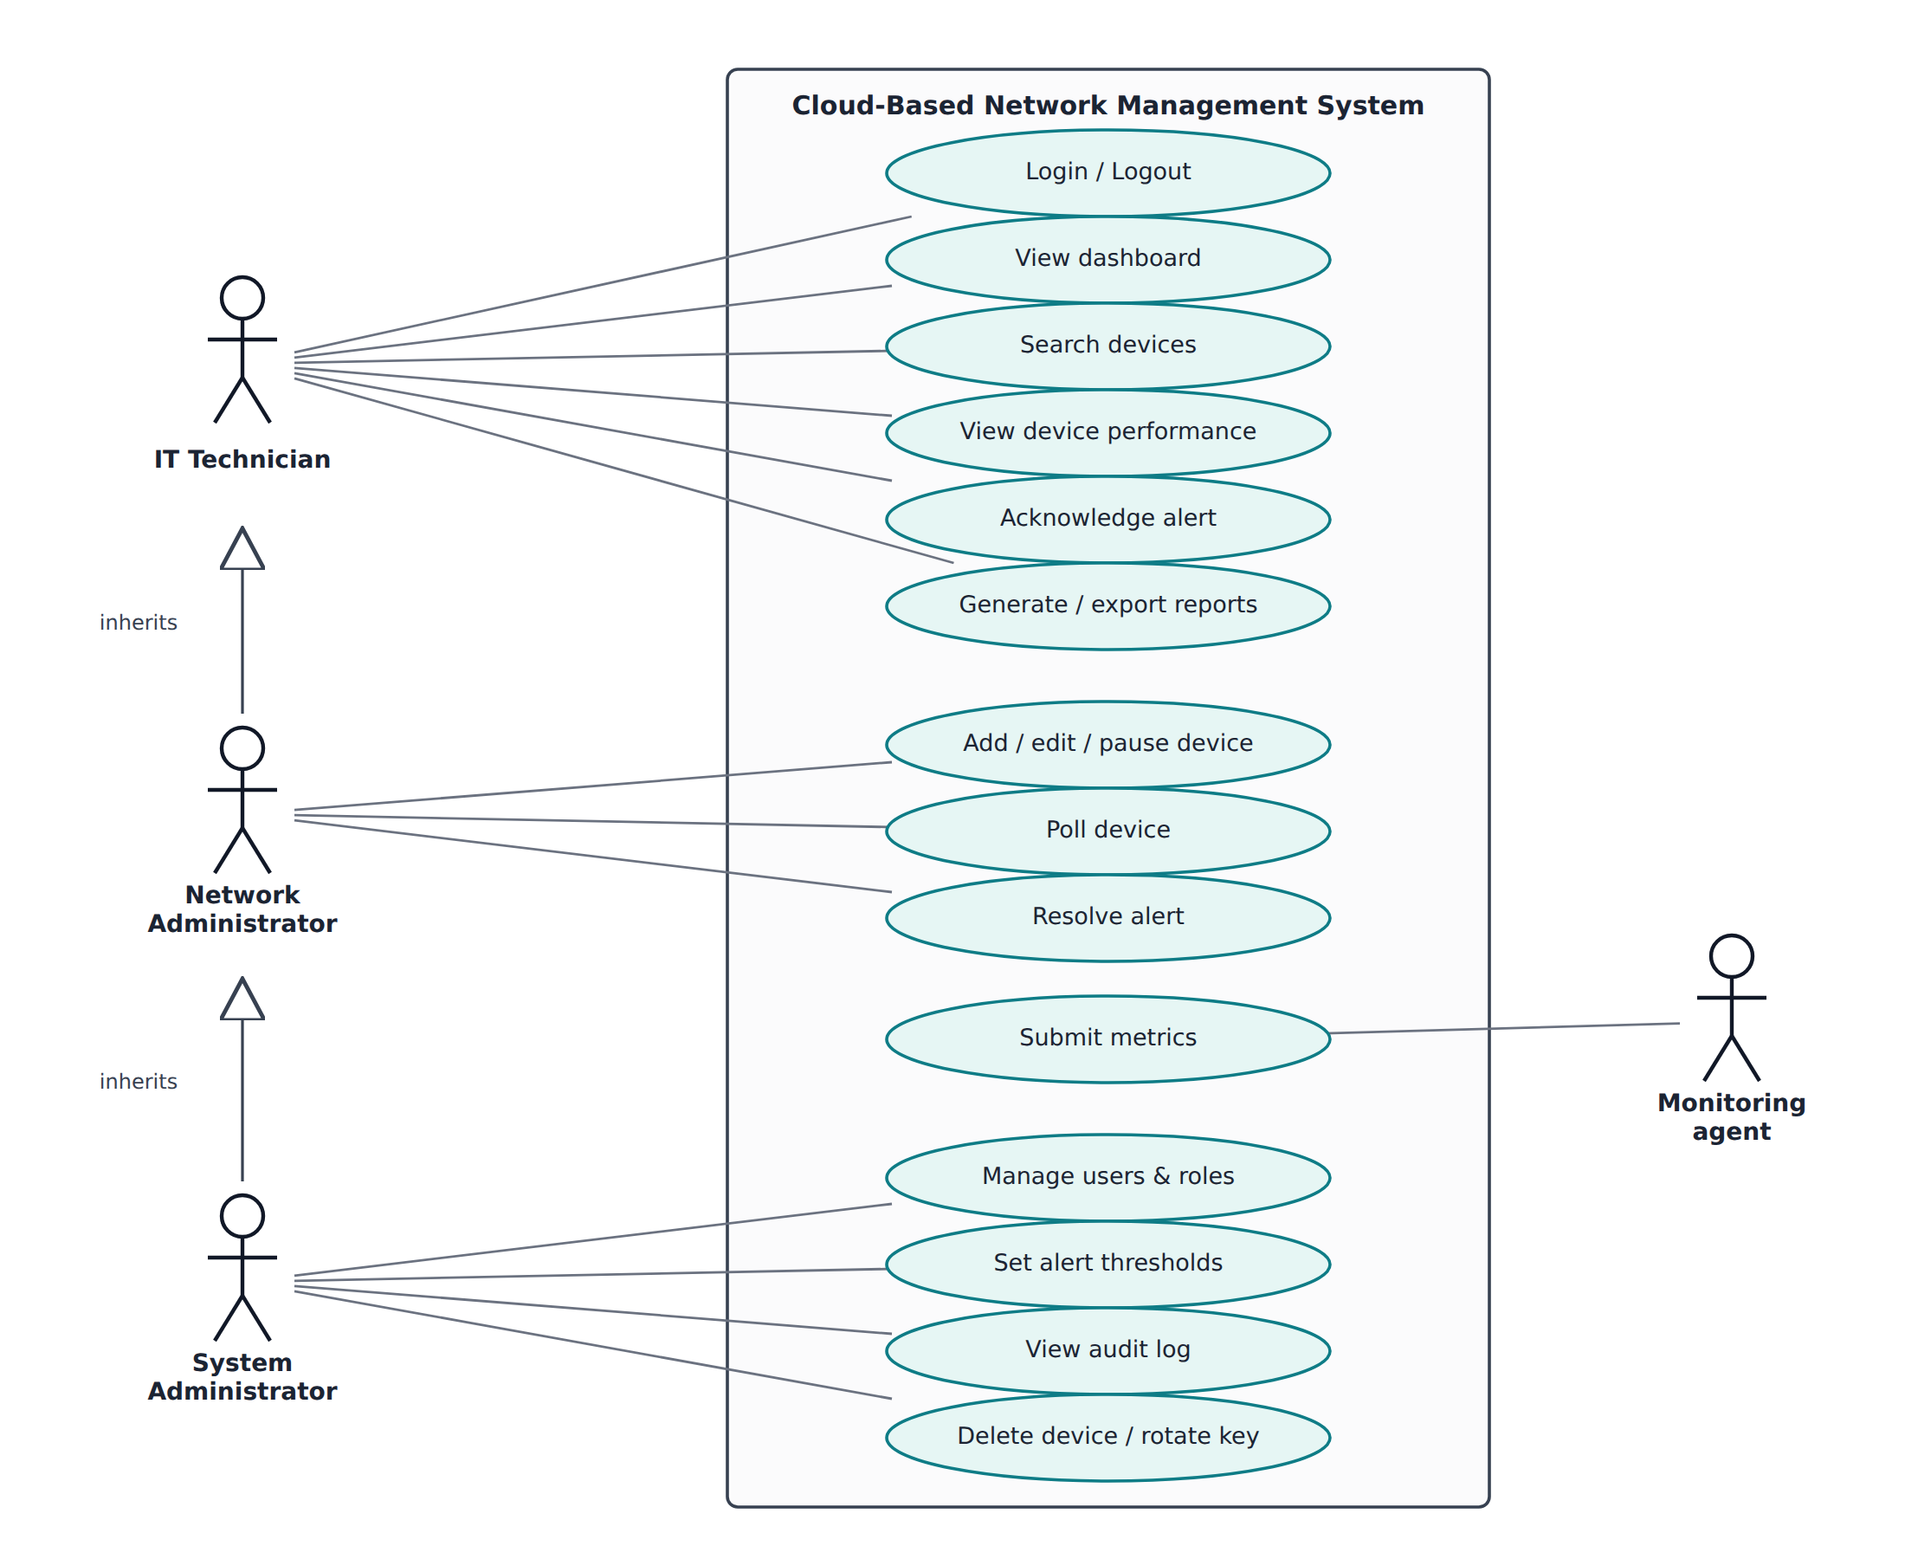
Figure 2.14: Use case diagram

2.3.8 Class Diagram
The class diagram shows the main classes and how they relate. User, Device, Metric, Alert, Report and AuditLog are persistent model classes. A Device is composed of its Metrics and Alerts, which are deleted with it. The MonitoringEngine module creates Metrics, updates the Device status and raises or resolves Alerts, while the ReportService module aggregates Metrics and summarises Alerts to produce reports.
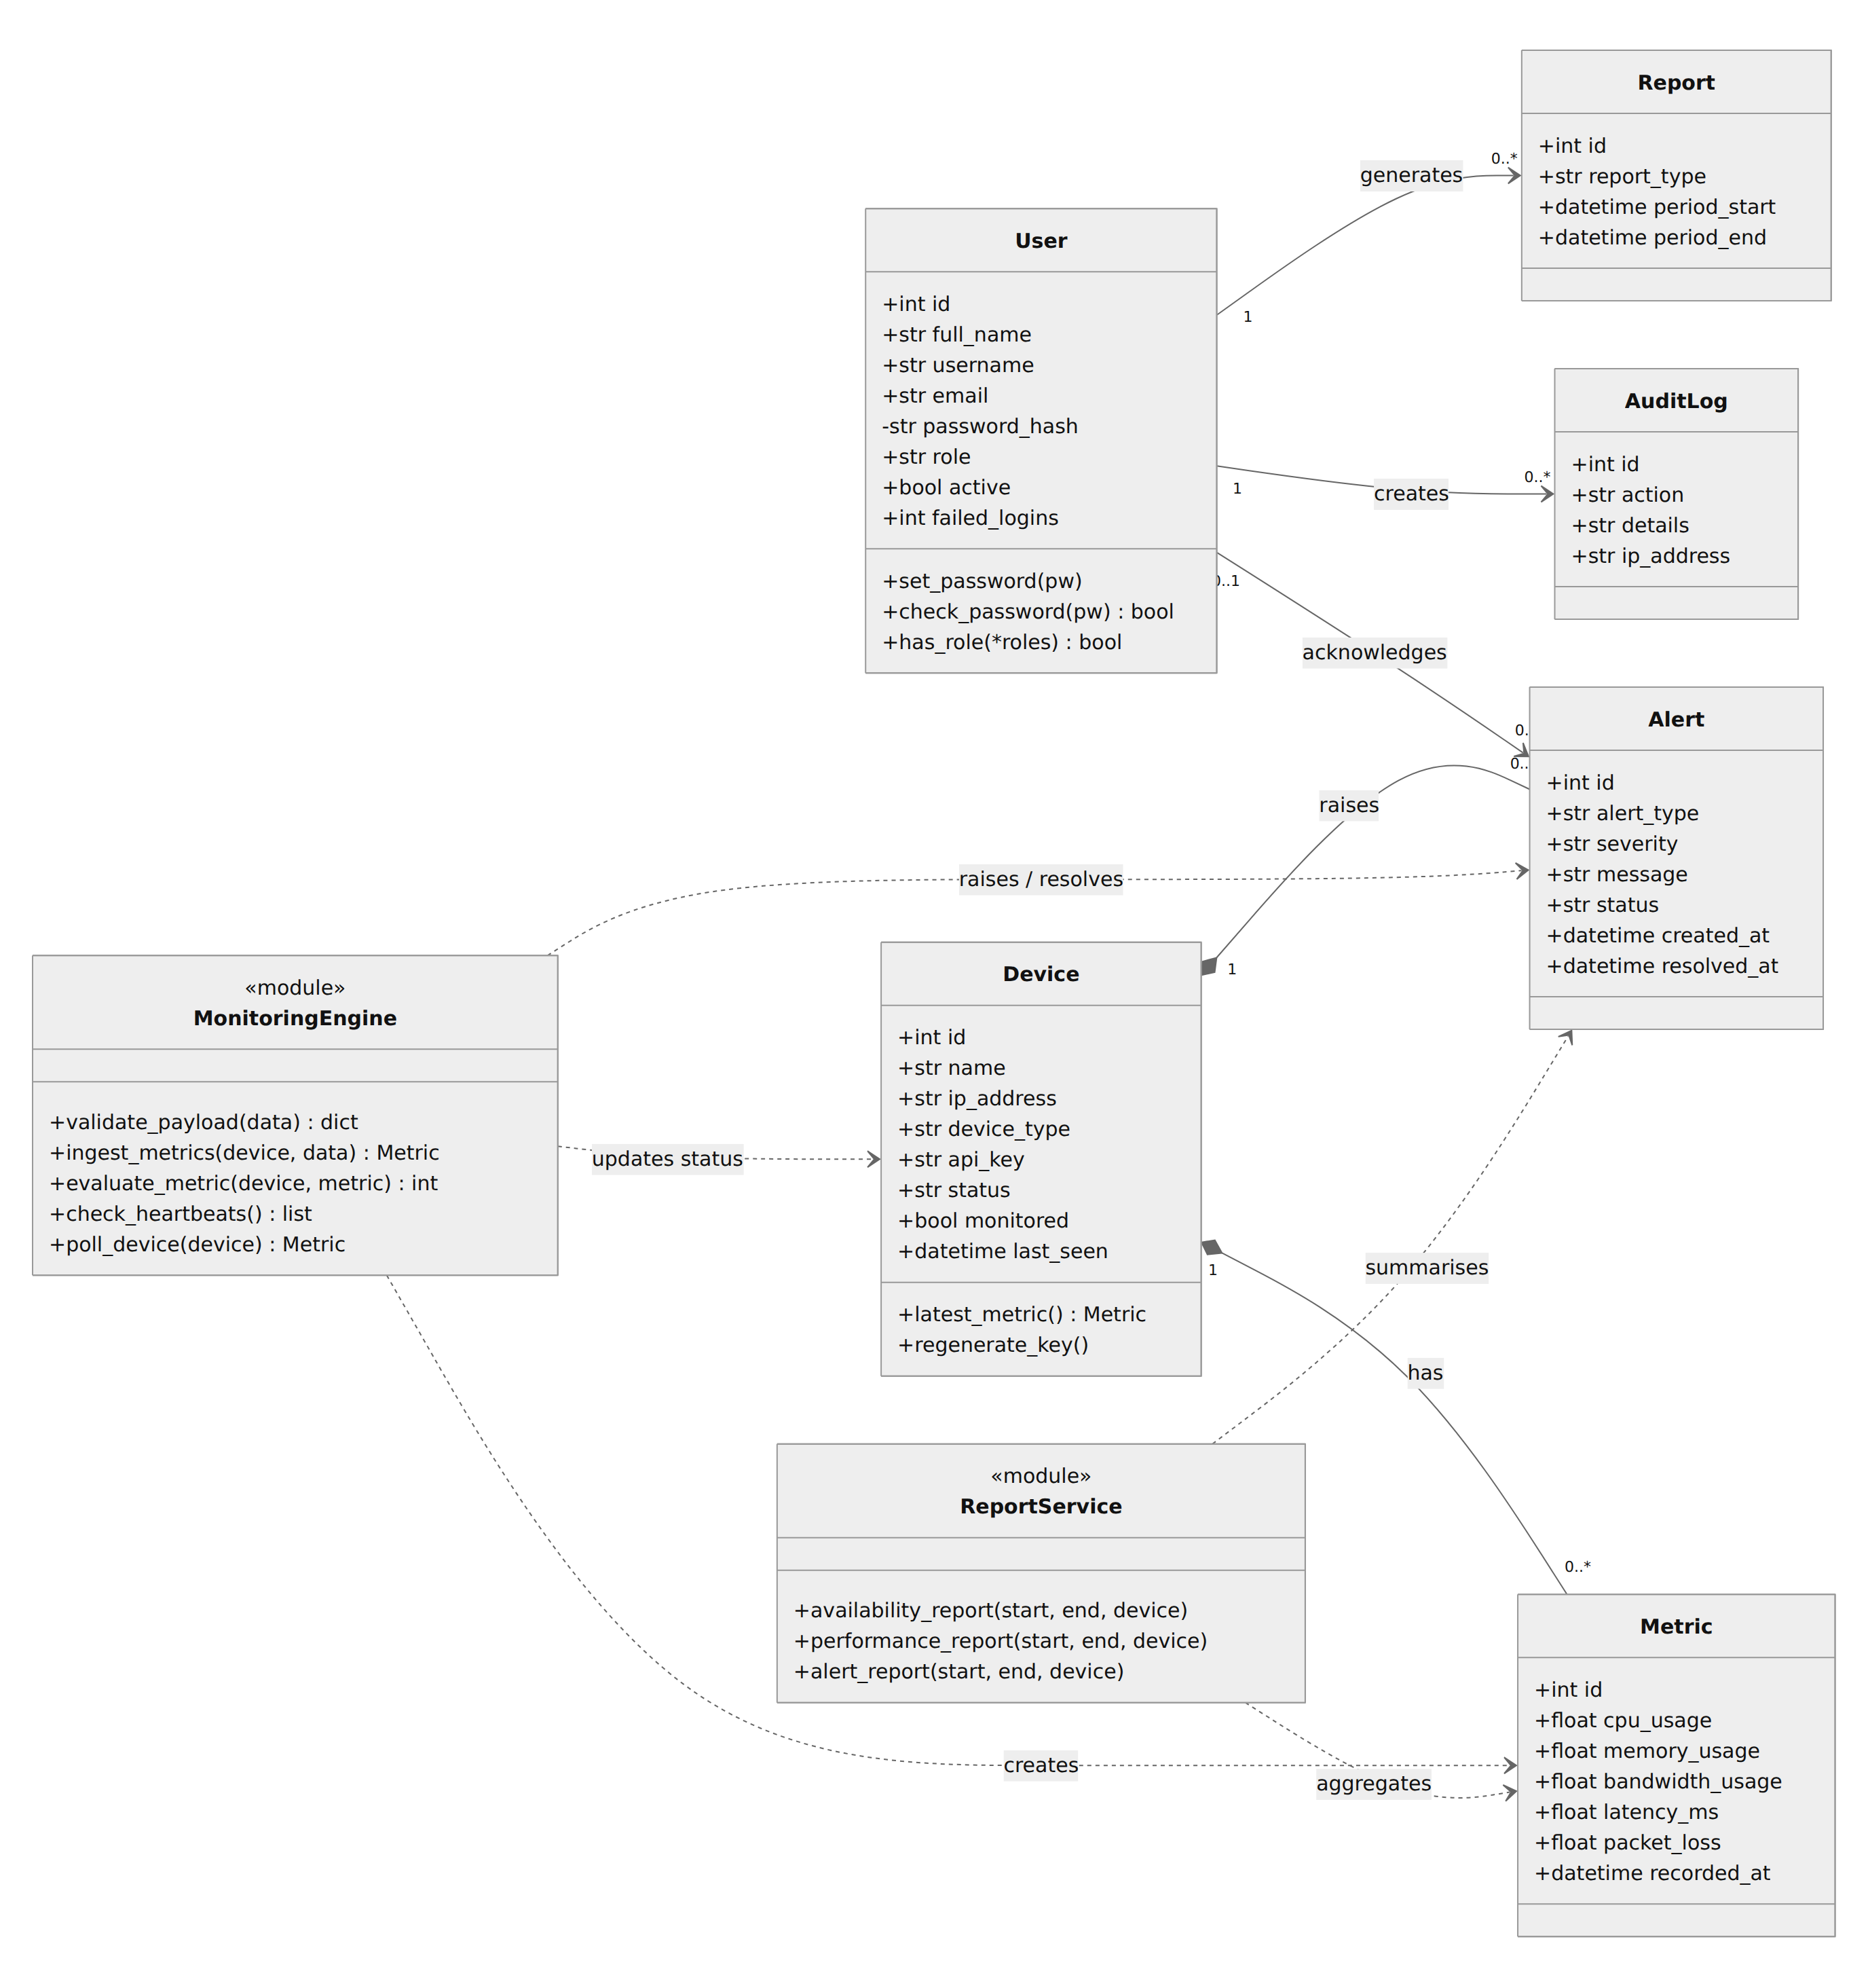
Figure 2.15: Class diagram

CHAPTER THREE: SYSTEM IMPLEMENTATION

3.1 Introduction
This chapter describes the implementation of the Cloud-Based Network Management System, from development to deployment. It explains how the designs in Chapter Two were turned into a working application using Python, Flask, SQLAlchemy, SQLite, HTML, CSS, JavaScript and Chart.js; how the system was tested and the errors that testing revealed were corrected; and how the system is deployed to the cloud. The source code is organised into modules as shown in Table 3.1.
File / folder | Responsibility
app/__init__.py | Application factory: configuration, extensions (database, login manager, CSRF), blueprints, error pages
app/models.py | Database models: User, Device, Metric, Alert, Report, AuditLog, Setting
app/auth.py | Login, logout, account lockout and password change
app/decorators.py | role_required() decorator implementing role-based access control
app/main.py | Dashboard, devices, alerts, reports, users, thresholds and audit log pages
app/api.py | REST API for agents (/api/v1/metrics) and chart data
app/monitoring.py | Metric validation, threshold evaluation, heartbeat checks, alerts and TCP probes
app/reports.py | Availability, performance and alert report calculations
app/templates/, app/static/ | Jinja2 HTML templates, CSS and Chart.js
agent/nms_agent.py, agent/simulator.py | Monitoring agent and laboratory device simulator
tests/ | Automated test suite (pytest)
config.py, wsgi.py, seed.py | Configuration, WSGI entry point for hosting, demonstration data loader
Table 3.1: Project structure

3.2 User Interface Development

3.2.1 Login Page Development
The login page allows users to securely access the system by entering a valid username and password. It is built as a two-panel responsive page: a banner describing the system and a sign-in form protected by a CSRF token. When the credentials are wrong the form is redisplayed with a generic “Invalid username or password” message that does not reveal whether the username exists, and the attempt is recorded in the audit log.
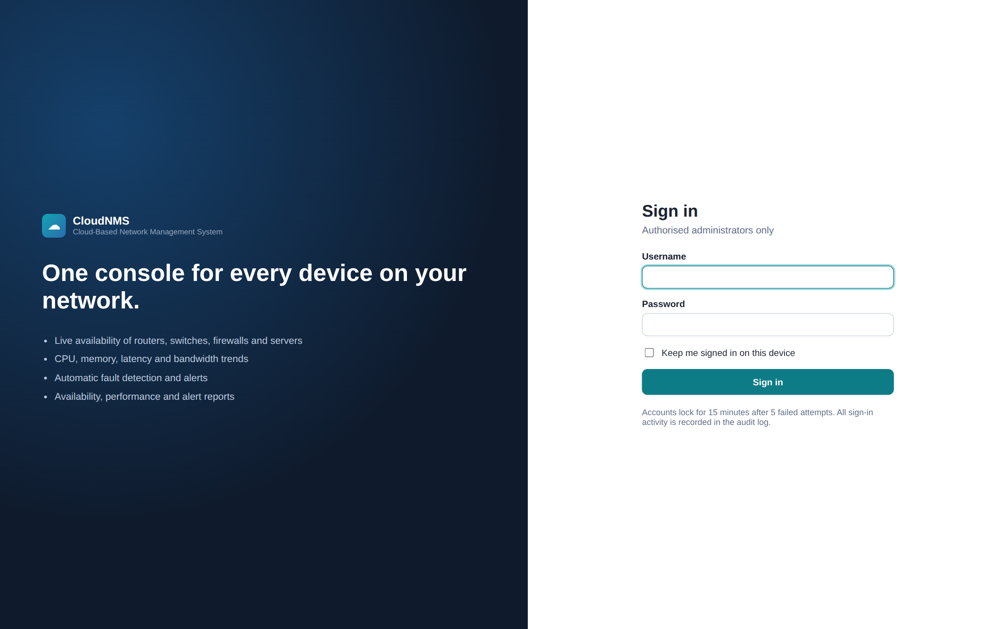
Figure 3.1: Login page development
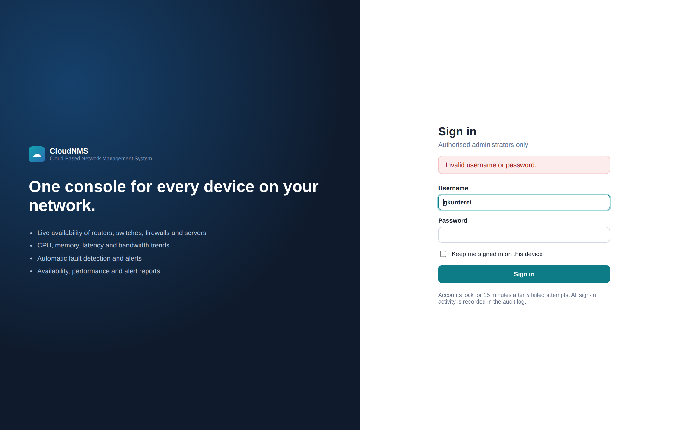
Figure 3.2: Login page showing a failed login attempt

3.2.2 Dashboard
The dashboard provides a live overview of the network. Summary cards show the number of monitored devices and the percentage reachable, and the numbers of online, degraded and offline devices and active alerts. A Chart.js line chart shows hourly averages of CPU, memory, link utilisation and latency across all devices for the last 24 hours, and a doughnut chart shows the status mix. The lower tables list active alerts and the devices needing attention, so the administrator can go straight to a problem. In the figure, the library access switch is offline after losing power and the web server is degraded because of high memory use.
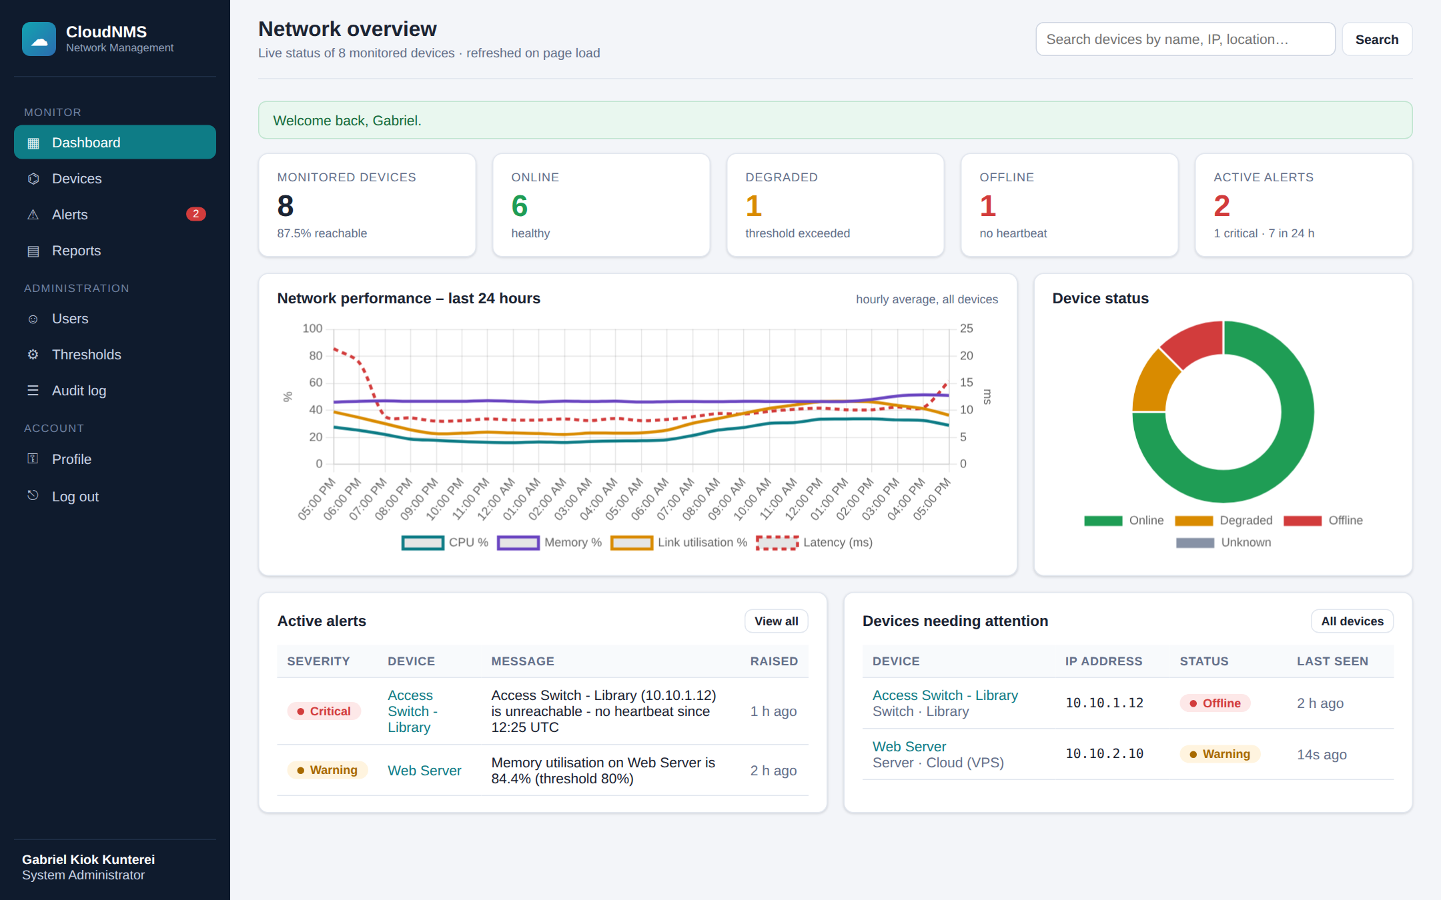
Figure 3.3: Dashboard development

3.2.3 Navigation Bar
The navigation bar on the left gives quick access to the Dashboard, Devices, Alerts (with a red badge counting active alerts) and Reports. Administration links (Users, Thresholds and Audit log) are shown only to System Administrators. The account section provides Profile and Log out, and the signed-in user's name and role appear at the bottom. The top bar contains a global device search box available on every page.
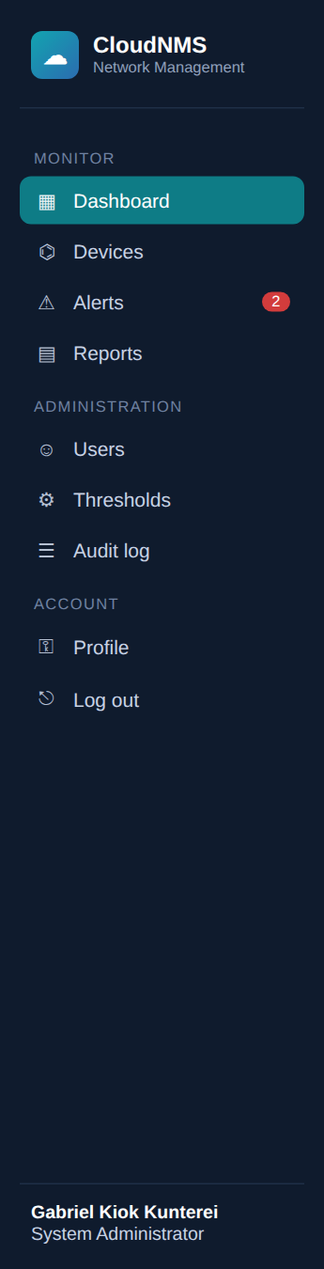
Figure 3.4: Navigation bar and top search bar

3.2.4 Device Inventory and Search
The device inventory lists every registered device with its IP address, type, vendor, location, colour-coded status, latest CPU and latency values and the time it was last seen. Users can search by name, IP address, vendor or location and filter by status and device type; the second screenshot shows the results of searching for “switch”.
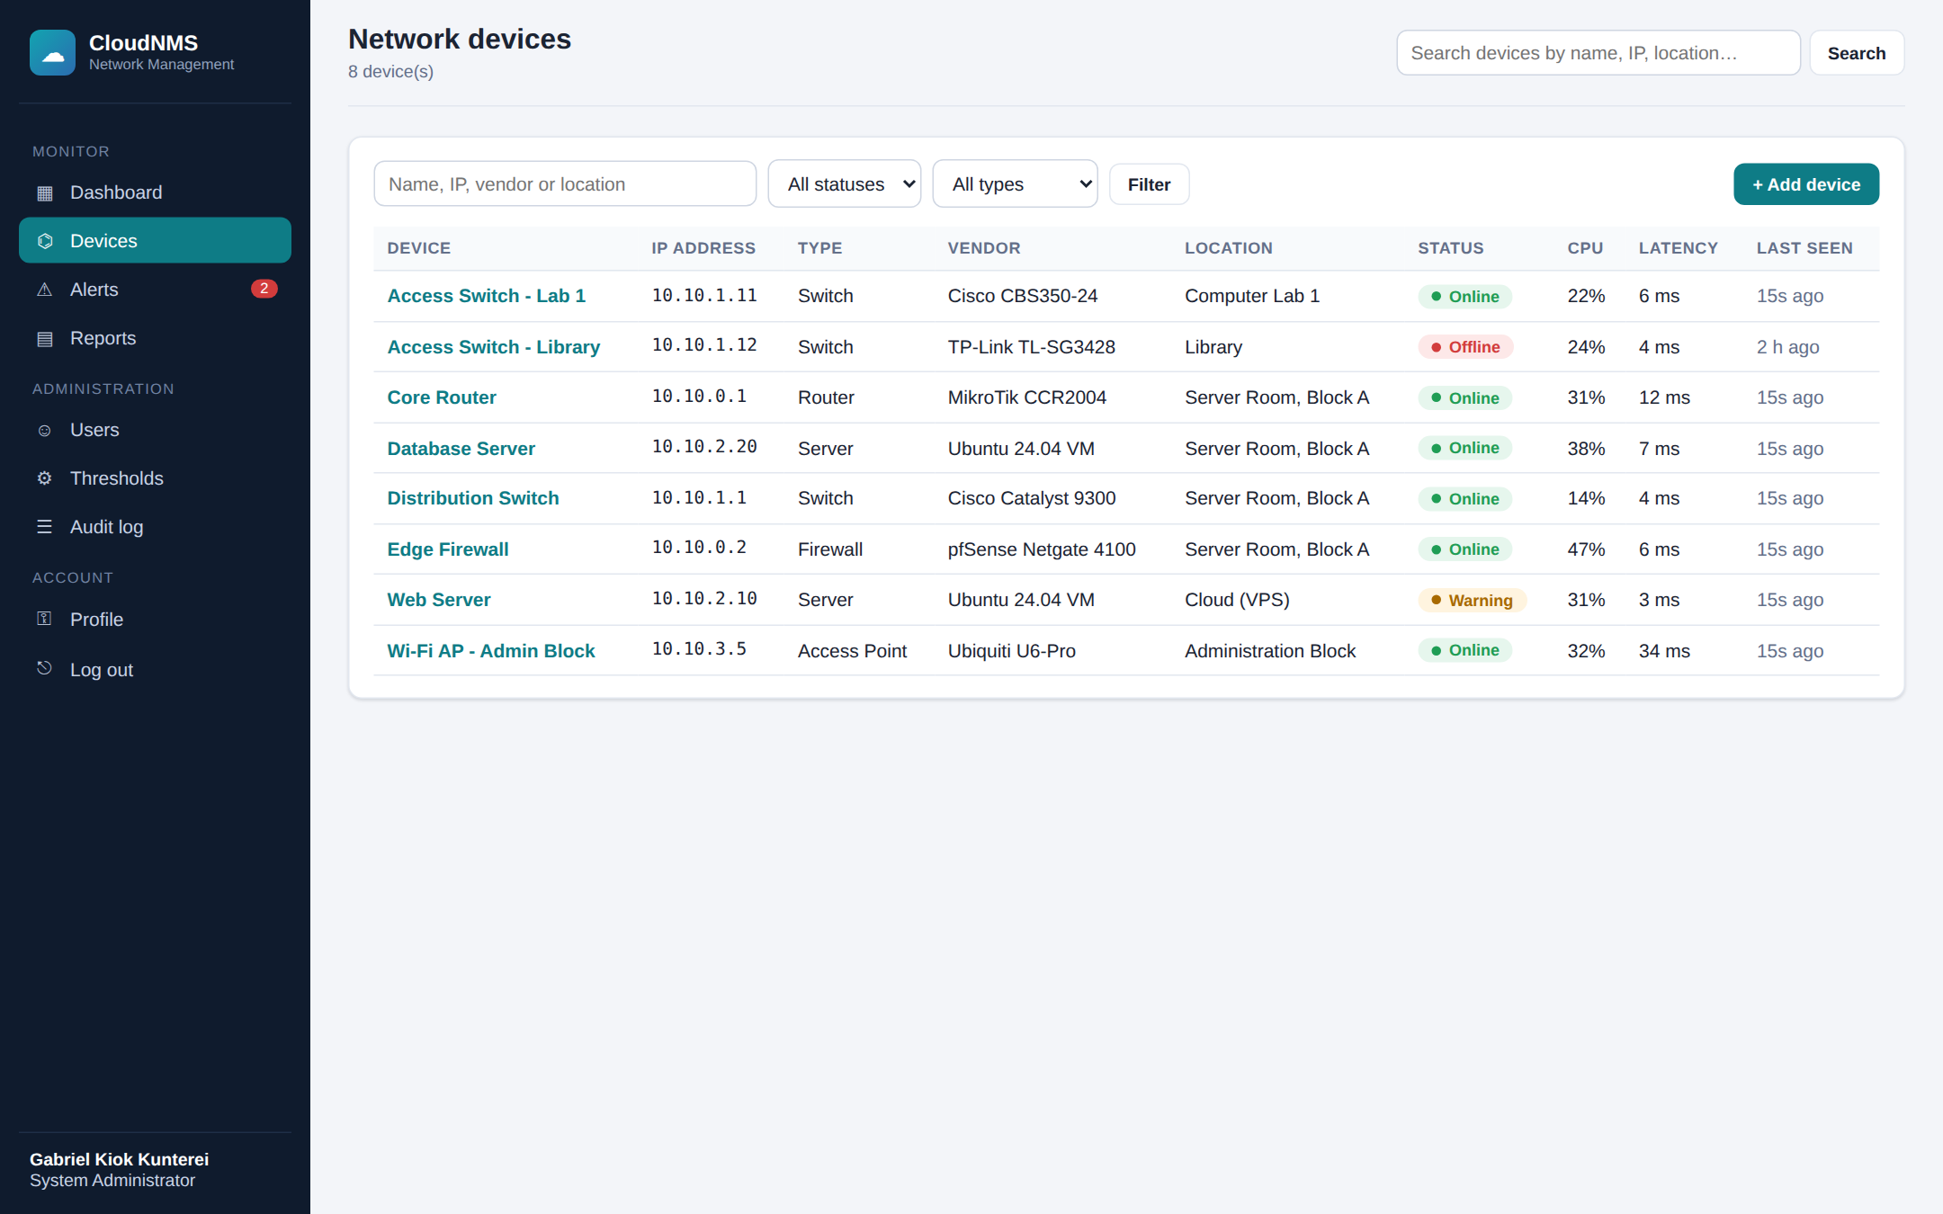
Figure 3.5: Device inventory
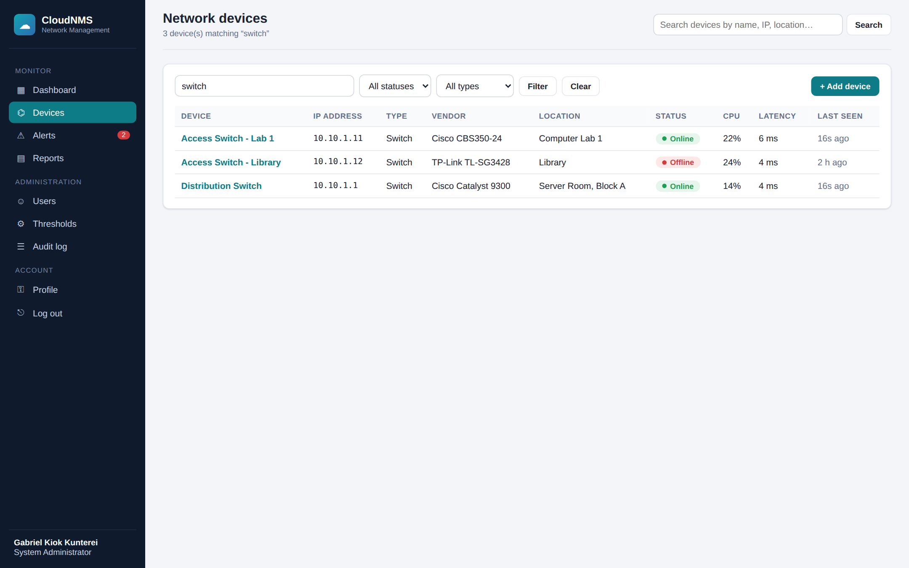
Figure 3.6: Device search results

3.2.5 Add New Device Form
The Add Device form is used by Network and System Administrators to register a device. It validates that the name is present, that the IP address is a valid IPv4 or IPv6 address and not already registered, that a valid device type is selected and that the management port is between 1 and 65535. In the second screenshot the administrator tried to register an IP address that already belongs to the Core Router, and the system refused it. After a successful registration the device page opens and displays the unique API key to be configured in the device's agent.
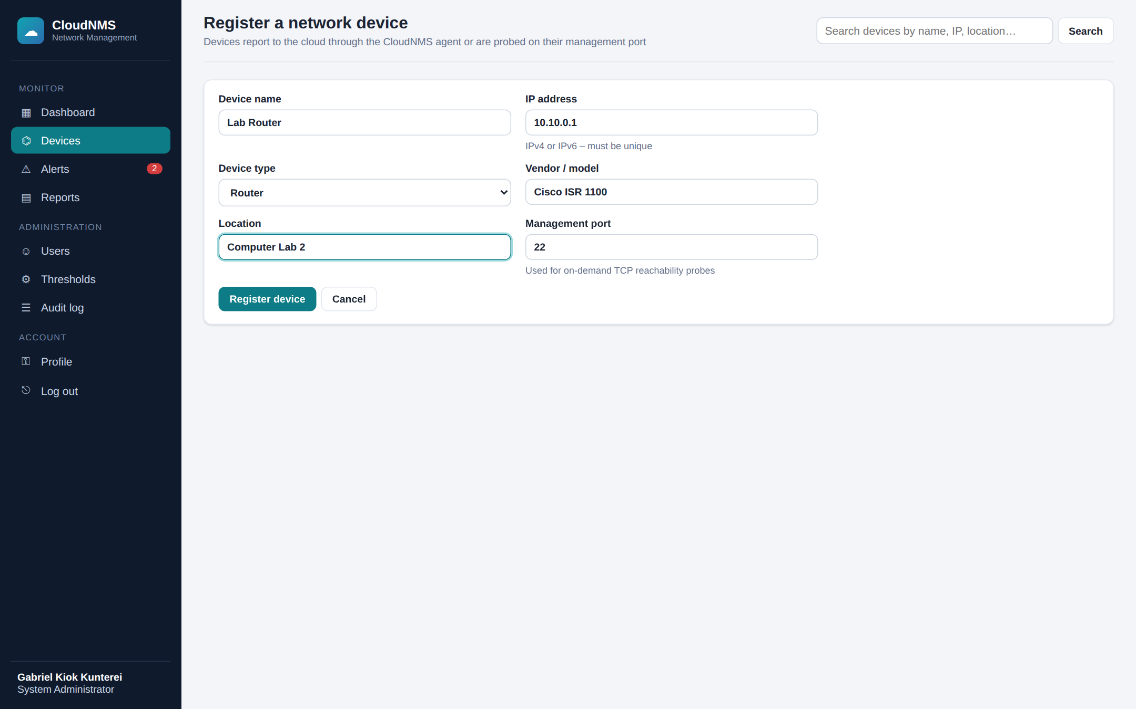
Figure 3.7: Add new device form
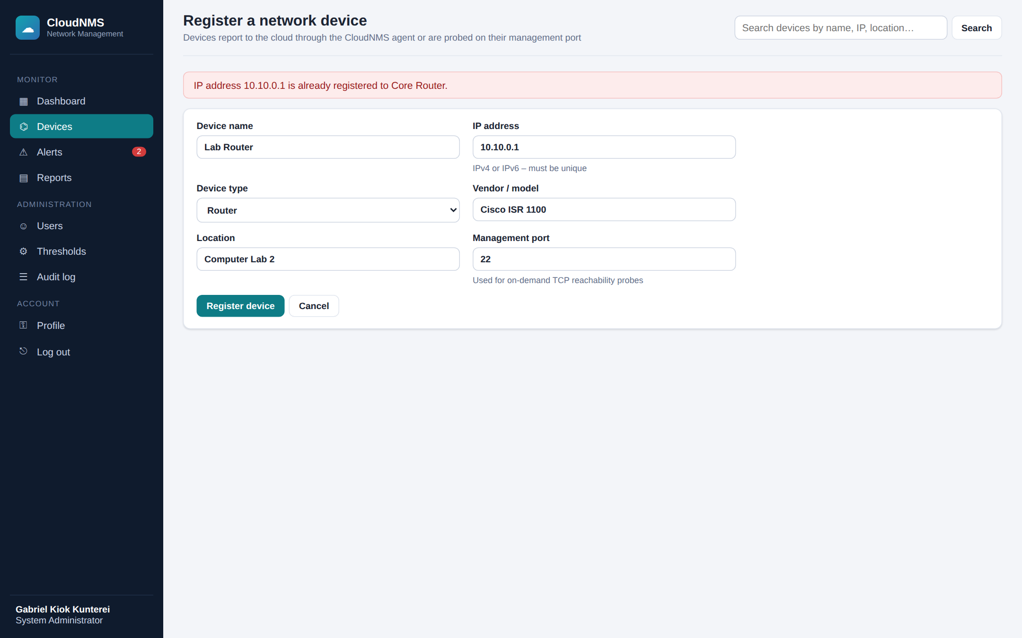
Figure 3.8: Add device form rejecting a duplicate IP address
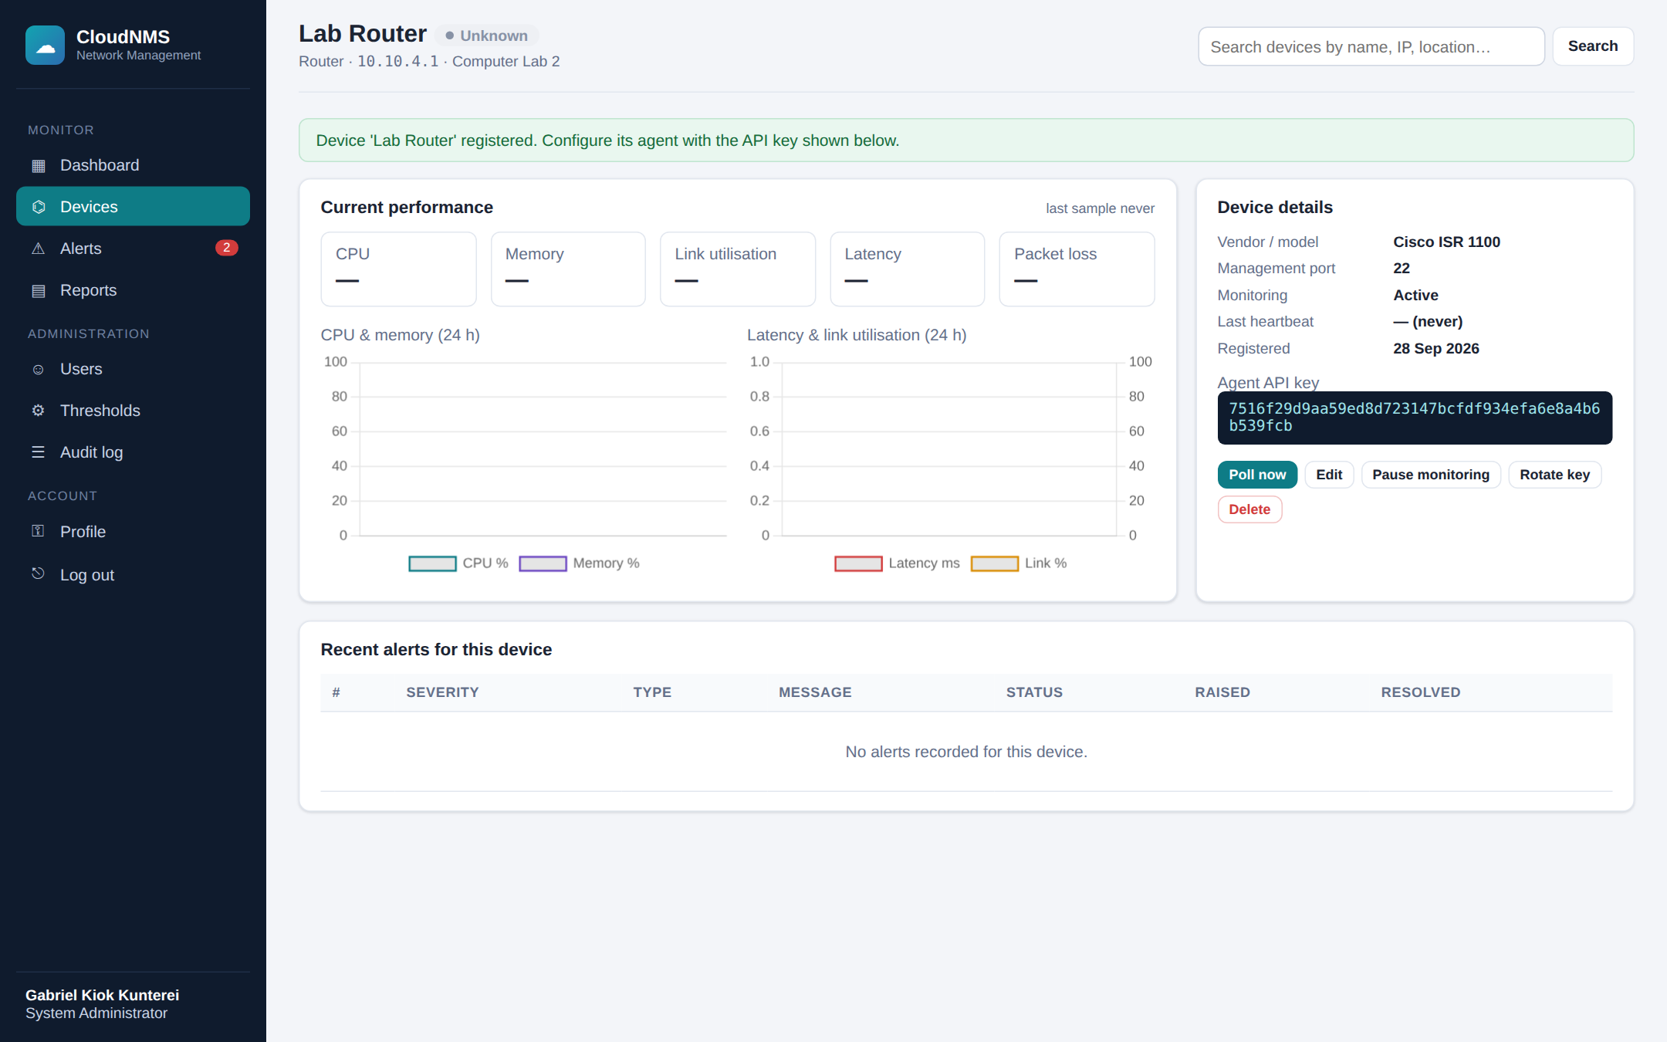
Figure 3.9: Newly registered device showing its agent API key

3.2.6 Device Details and Performance
The device details page shows the current CPU, memory, link utilisation, latency and packet loss values with colour-coded gauges (green, amber, red), 24-hour charts, the device's configuration and agent API key, action buttons and recent alerts. The first screenshot shows the web server with memory utilisation above the 80% warning threshold; the second shows the Wi-Fi access point, whose latency chart reveals congestion peaks every evening.
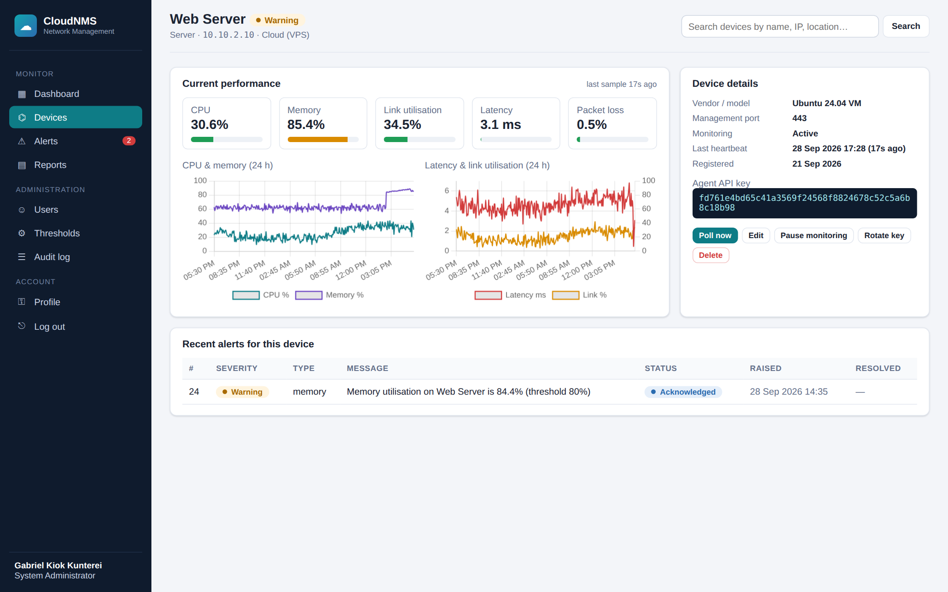
Figure 3.10: Device details – web server with high memory utilisation
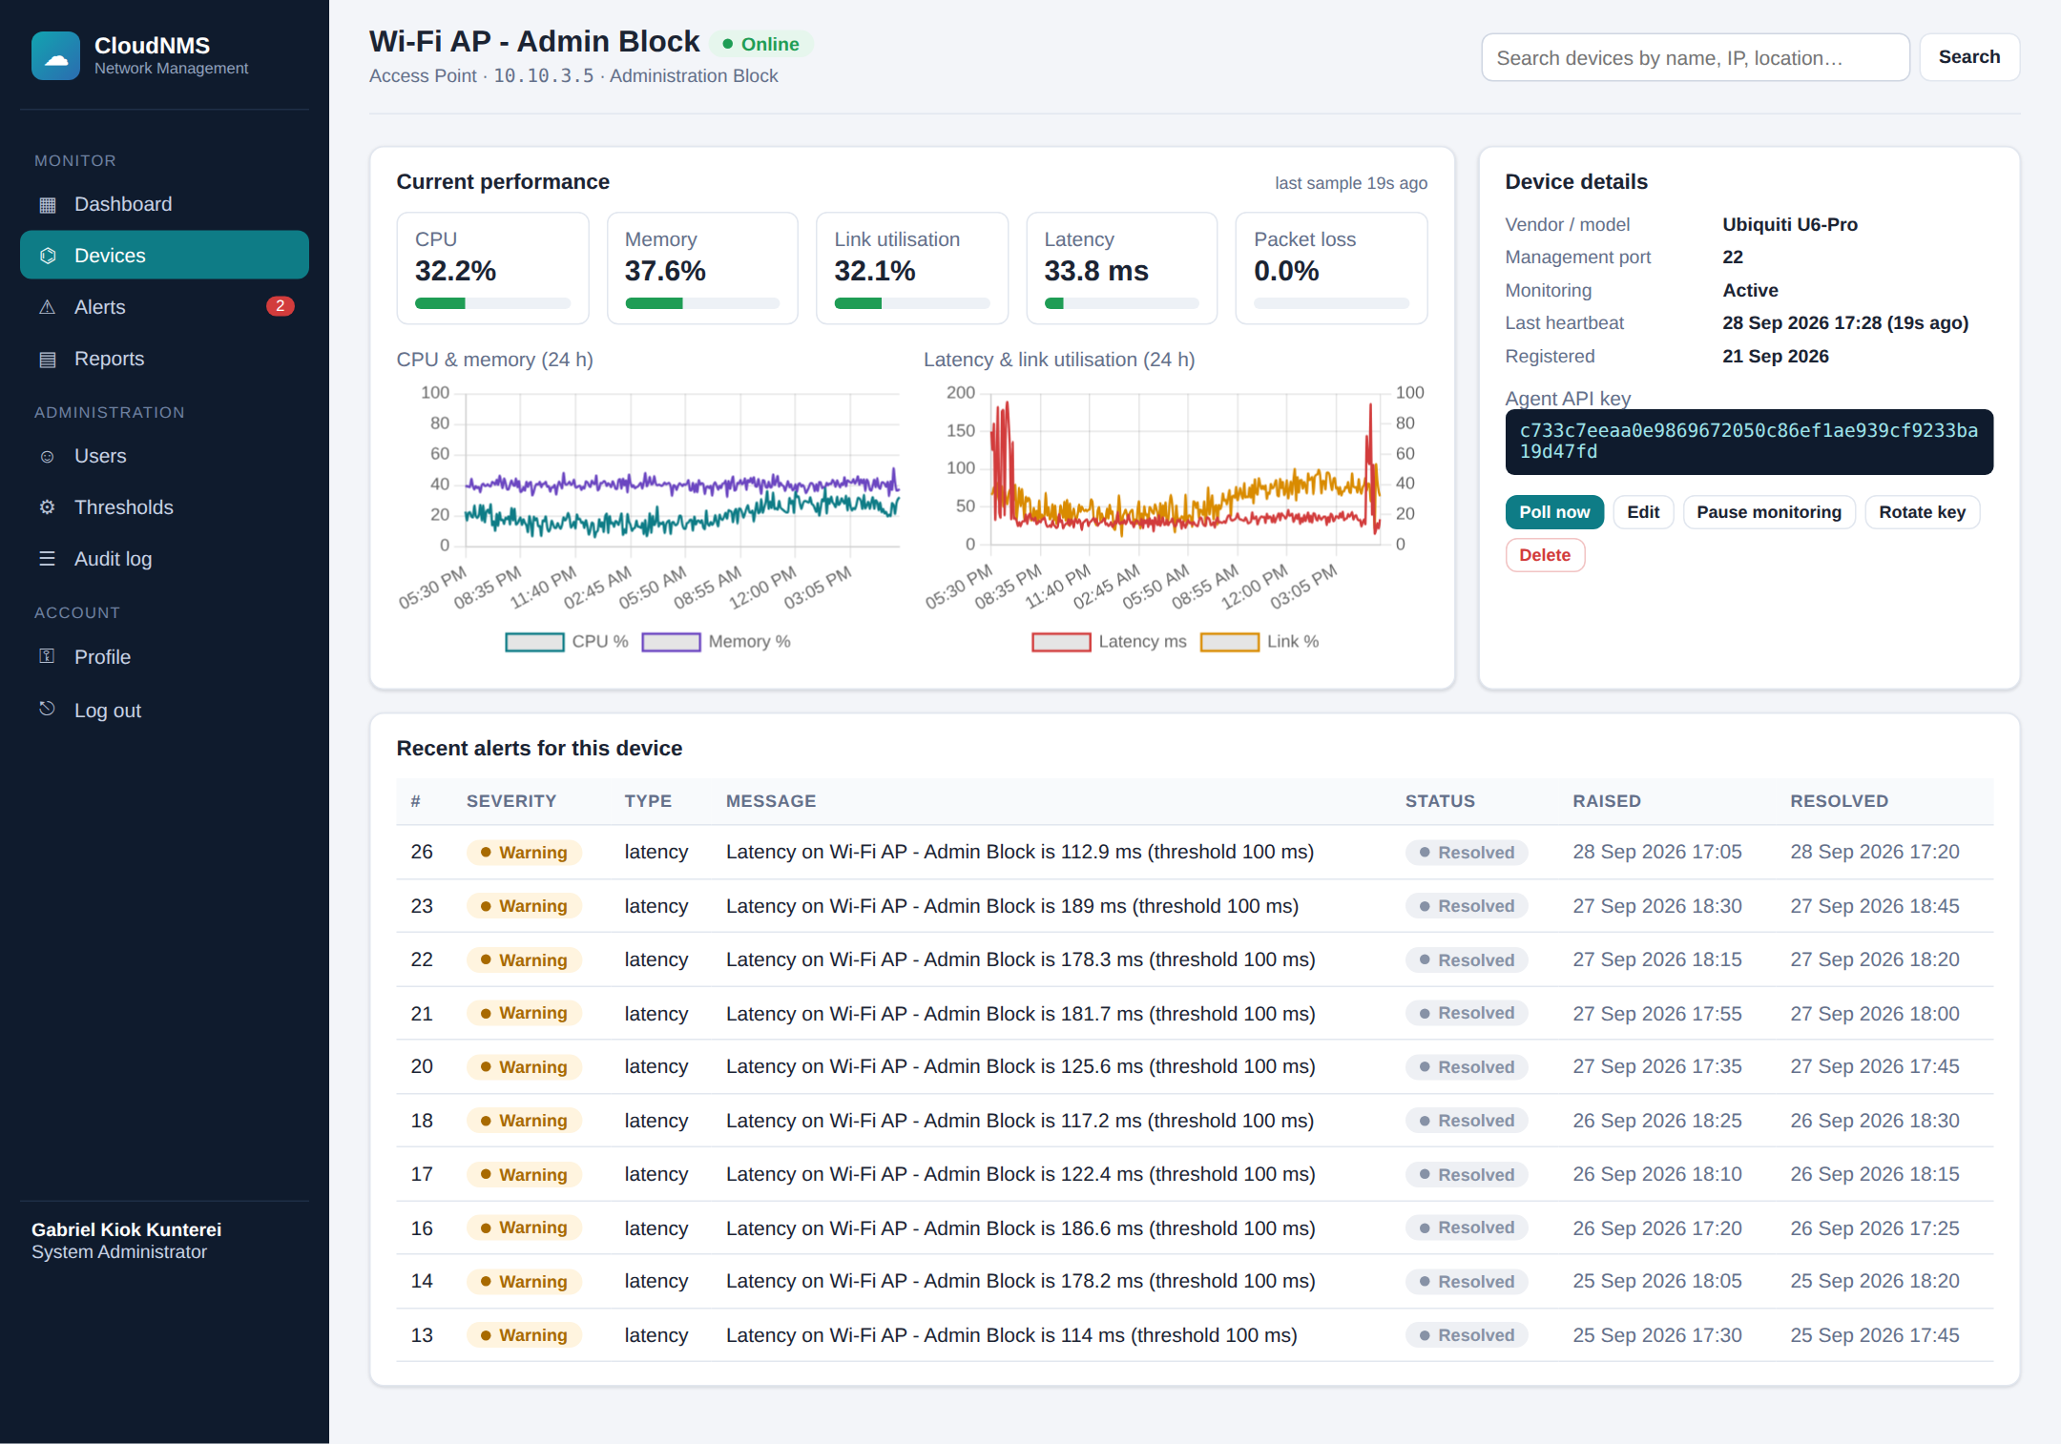
Figure 3.11: Device details – Wi-Fi access point latency trend

3.2.7 Alerts
The alerts page lists faults with their severity, device, type, message, status and time raised. By default it shows active alerts (open and acknowledged); filters allow viewing resolved or all alerts and filtering by severity. Any user can acknowledge an open alert, which records who acknowledged it, while Network and System Administrators can resolve alerts.
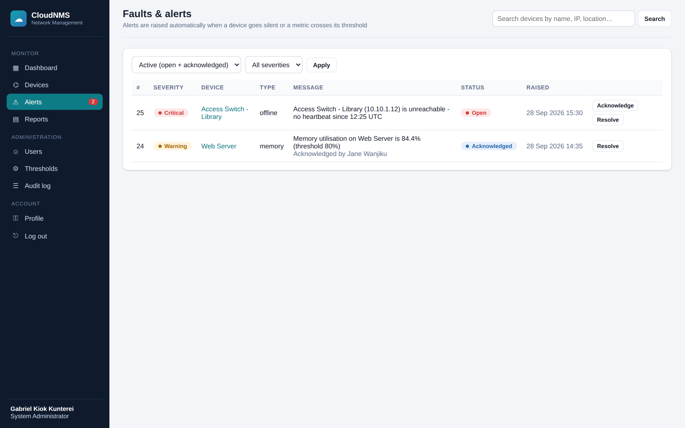
Figure 3.12: Active alerts
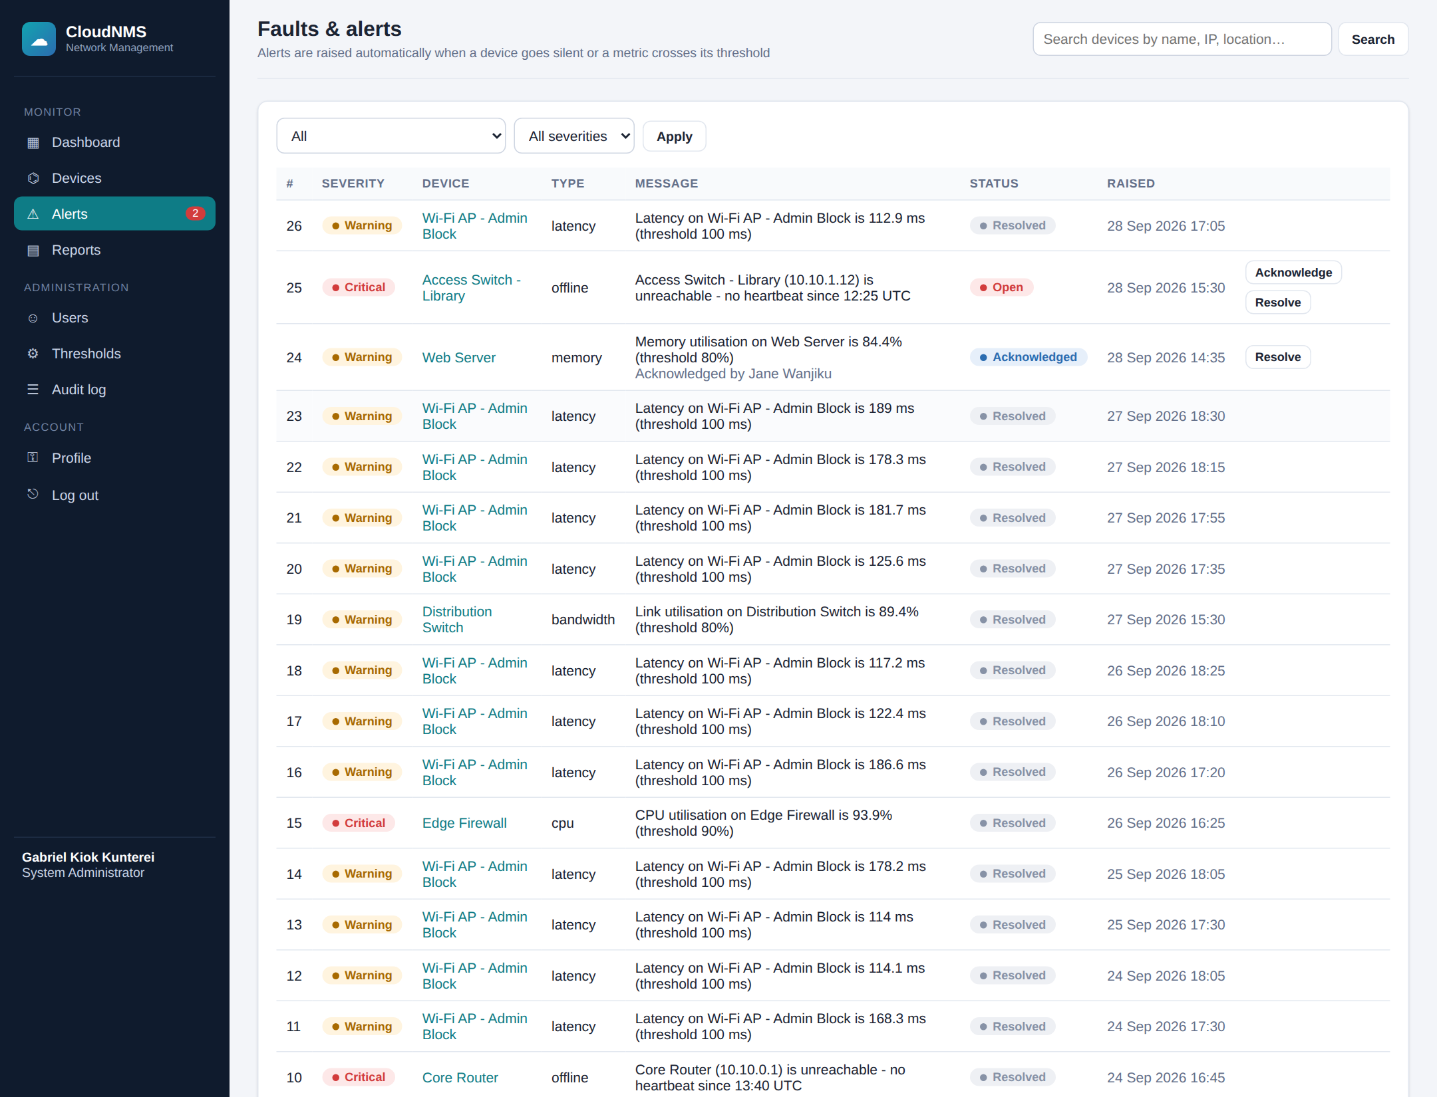
Figure 3.13: Full alert history

3.2.8 Reports
The Reports centre generates three reports for any period up to 92 days, for all devices or a single device. The Device Availability Report shows the percentage of five-minute windows in which each device reported, together with outage counts. The Performance Summary Report shows average and maximum CPU, memory, latency and link utilisation. The Fault & Alert Report shows totals by severity and type, mean time to resolve (MTTR) and the alert list. Every report can be exported as a CSV file, and recently generated reports are listed for accountability.
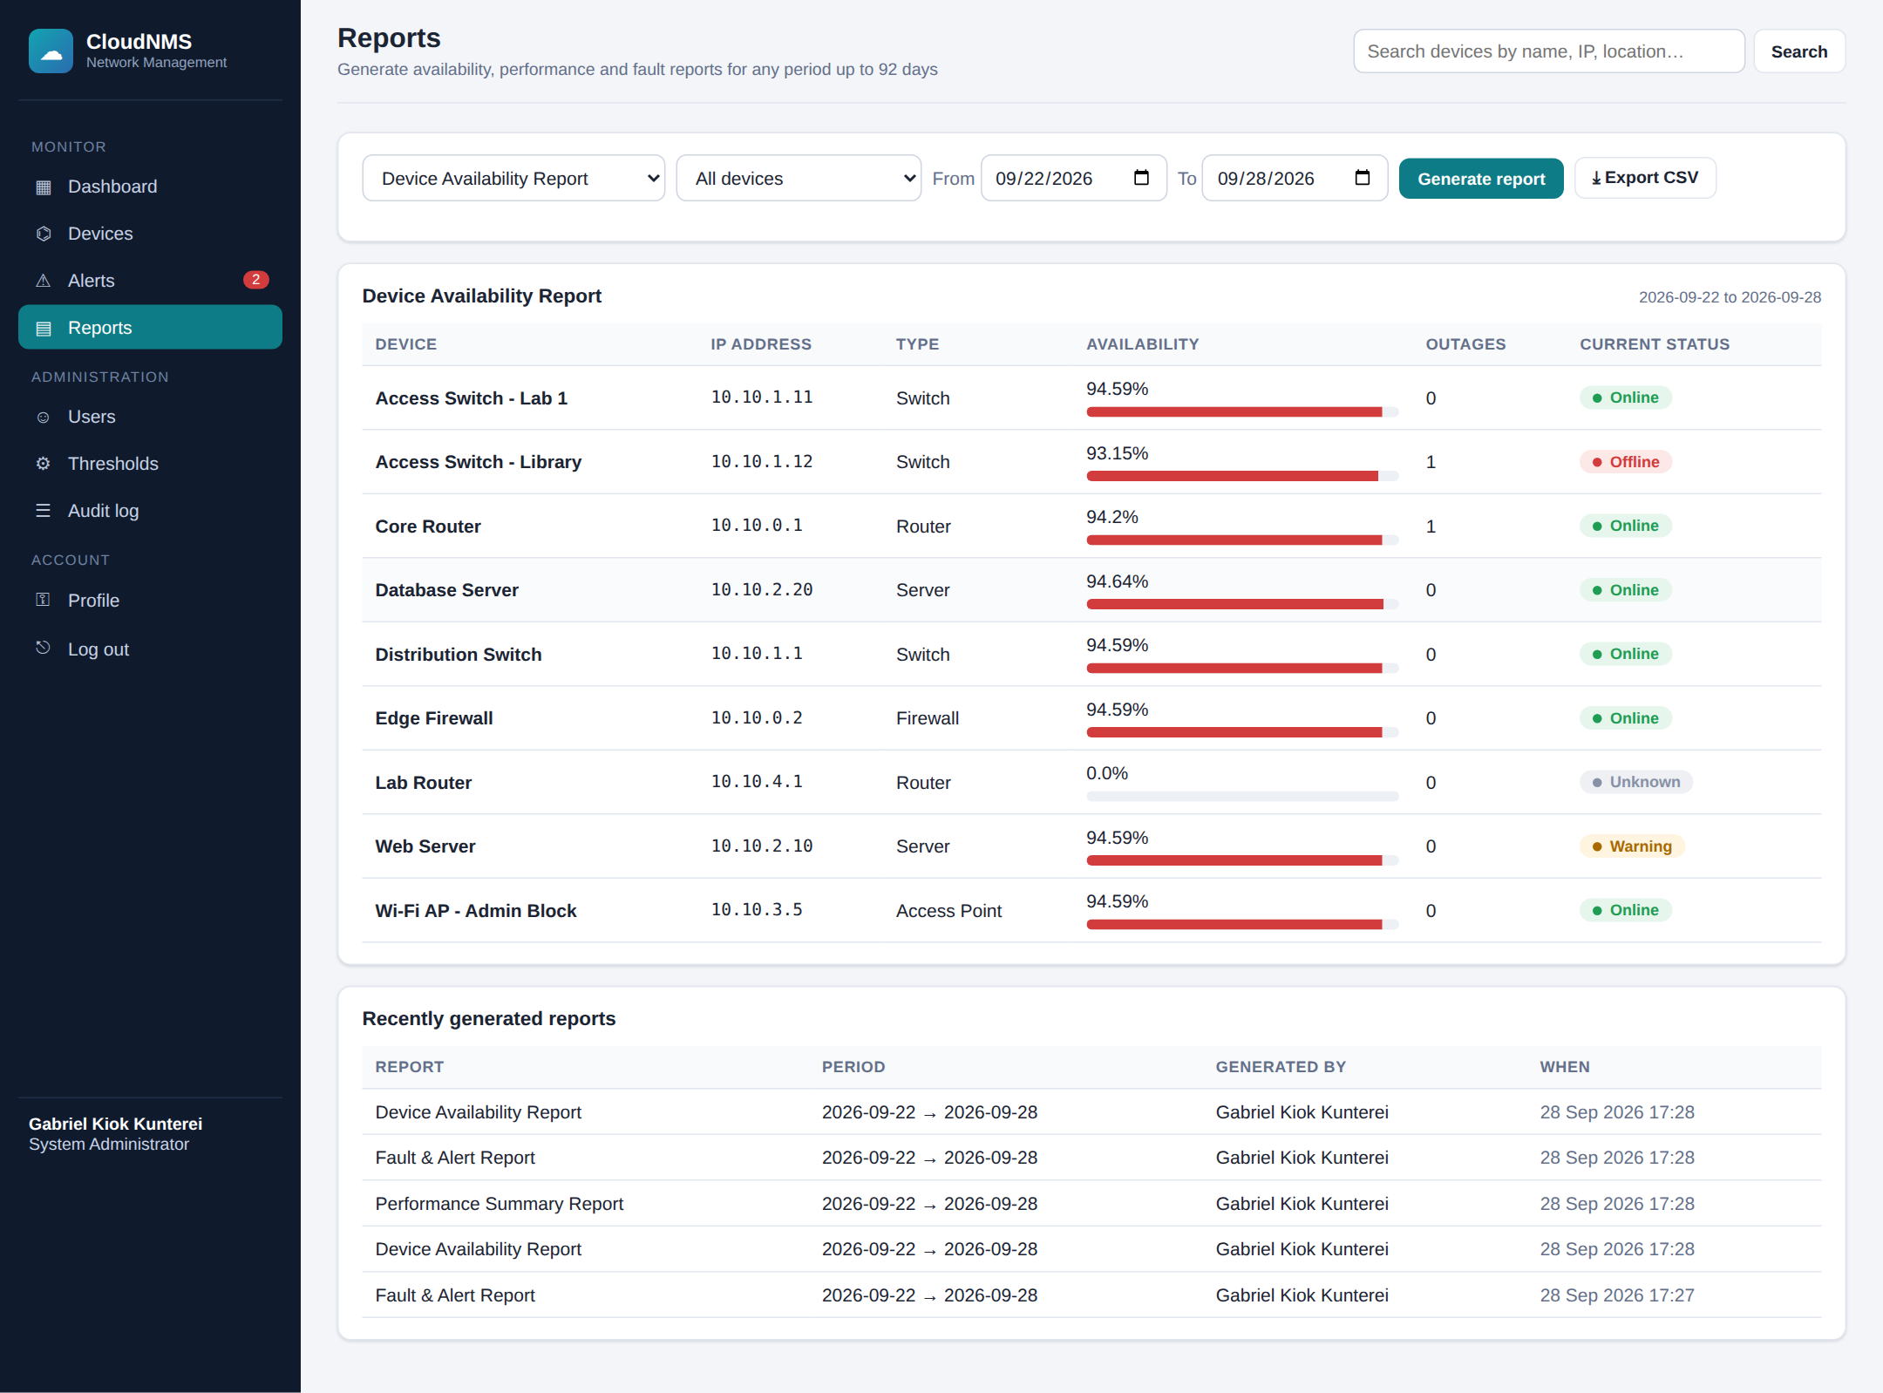
Figure 3.14: Device availability report
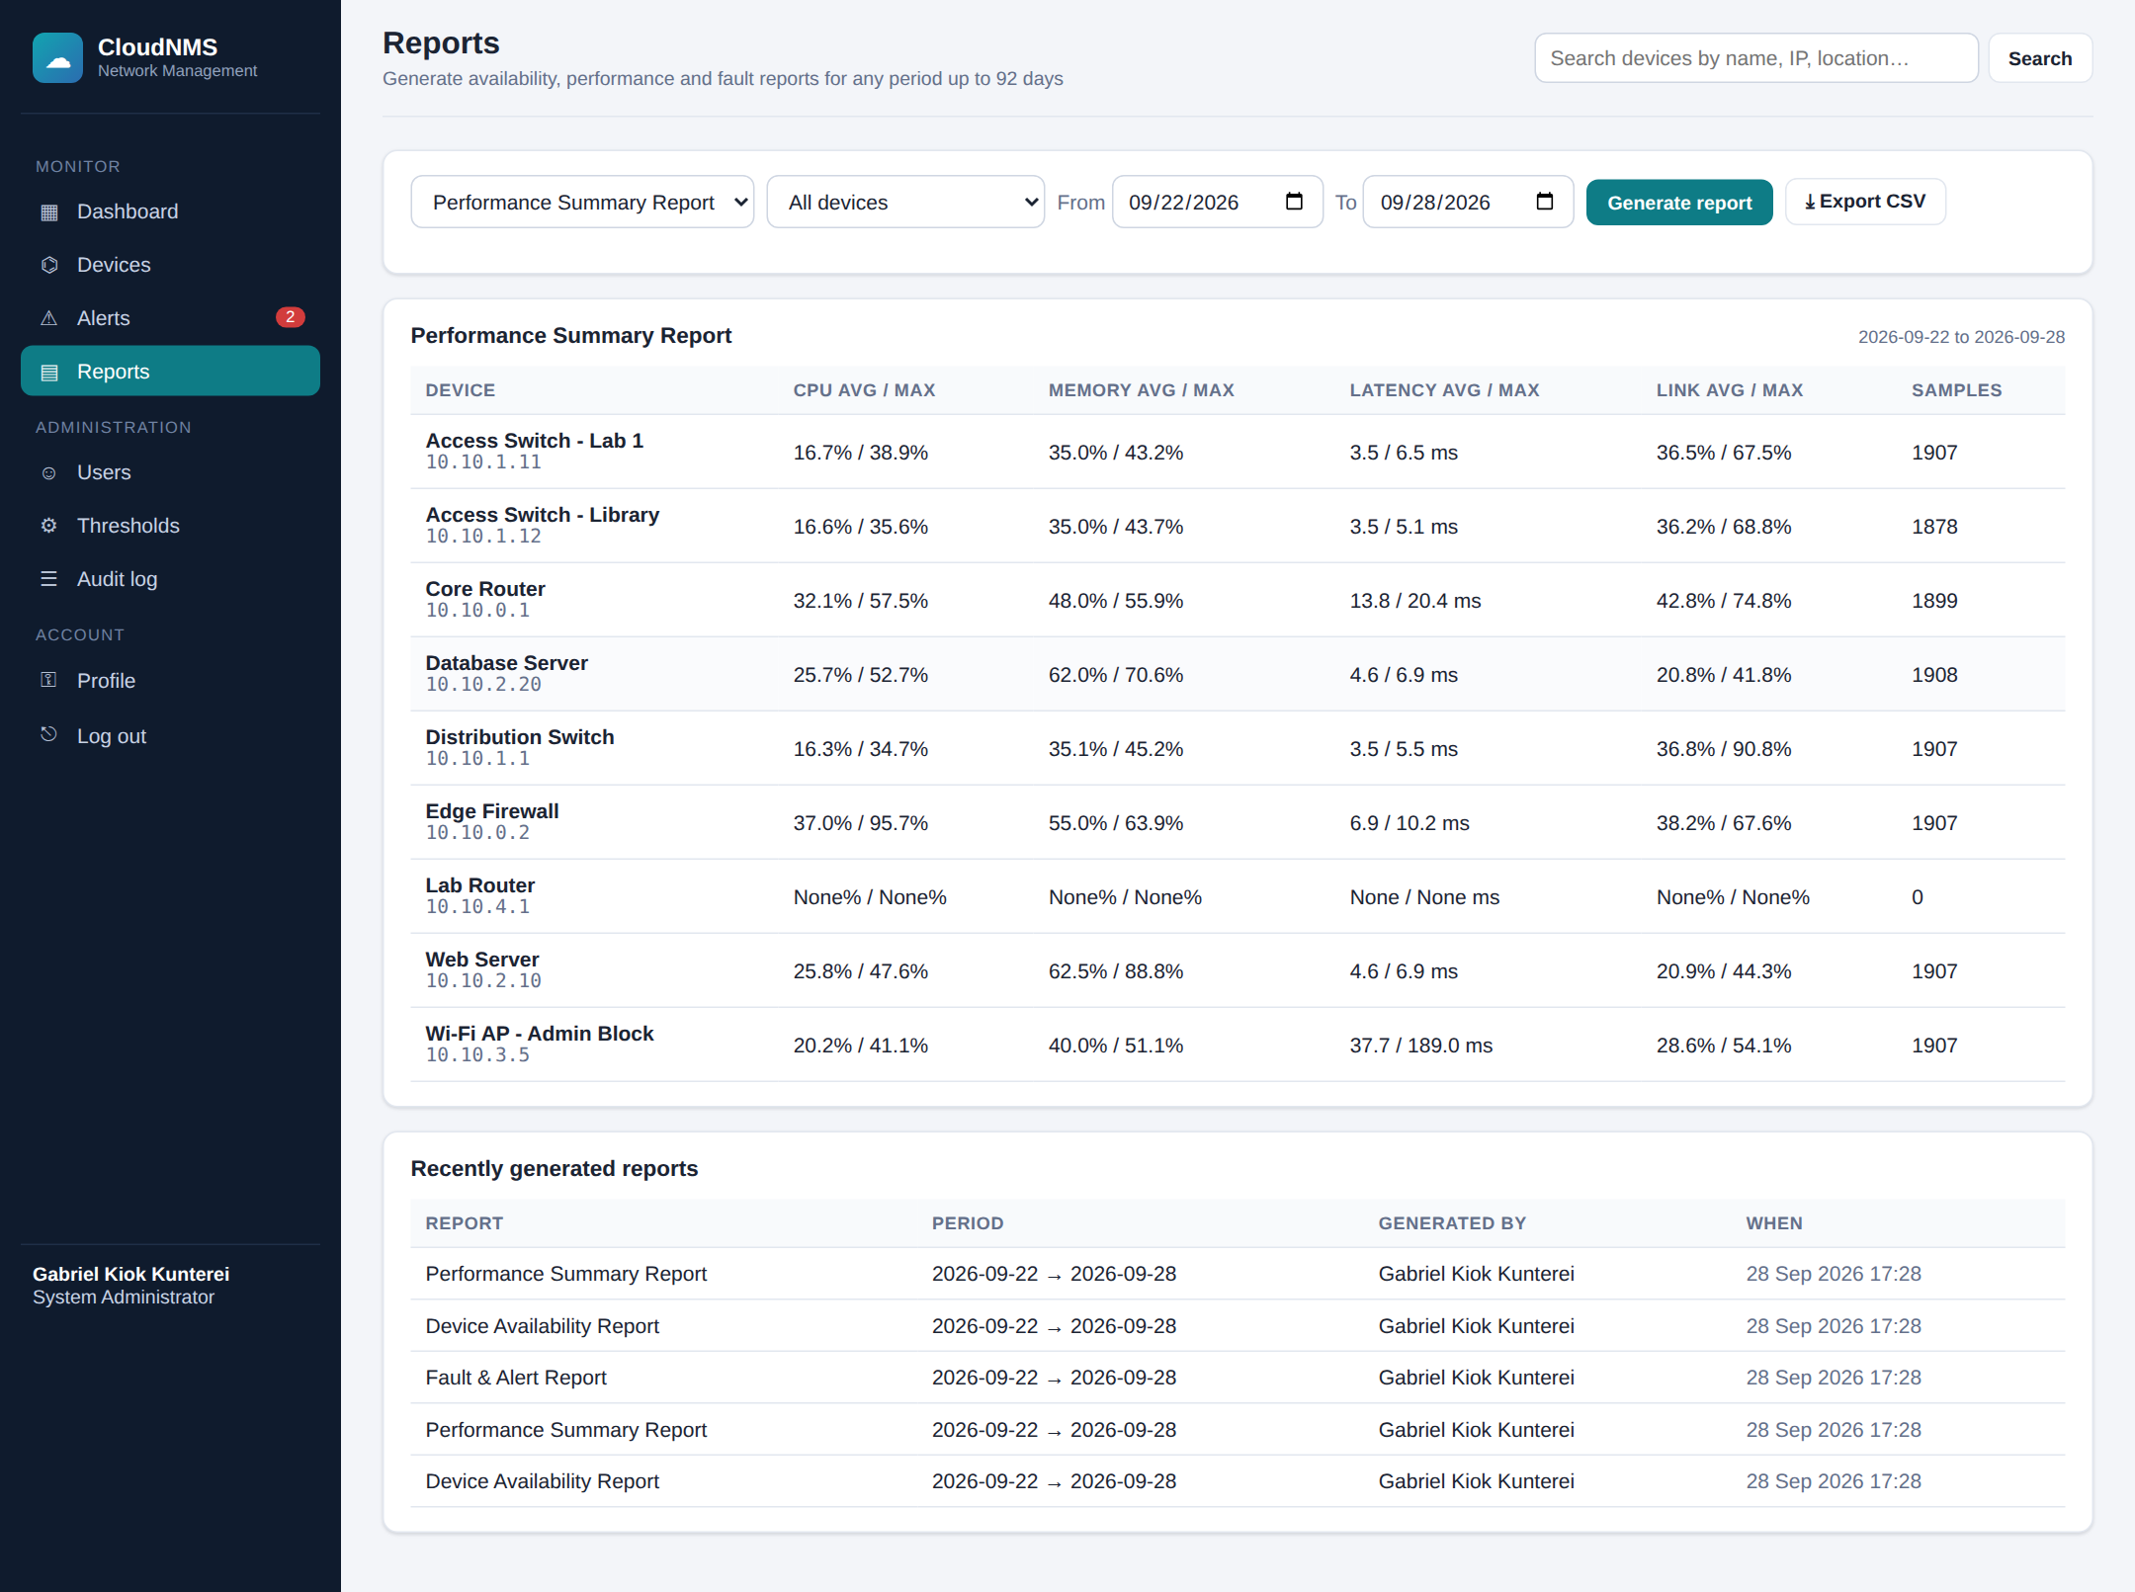
Figure 3.15: Performance summary report
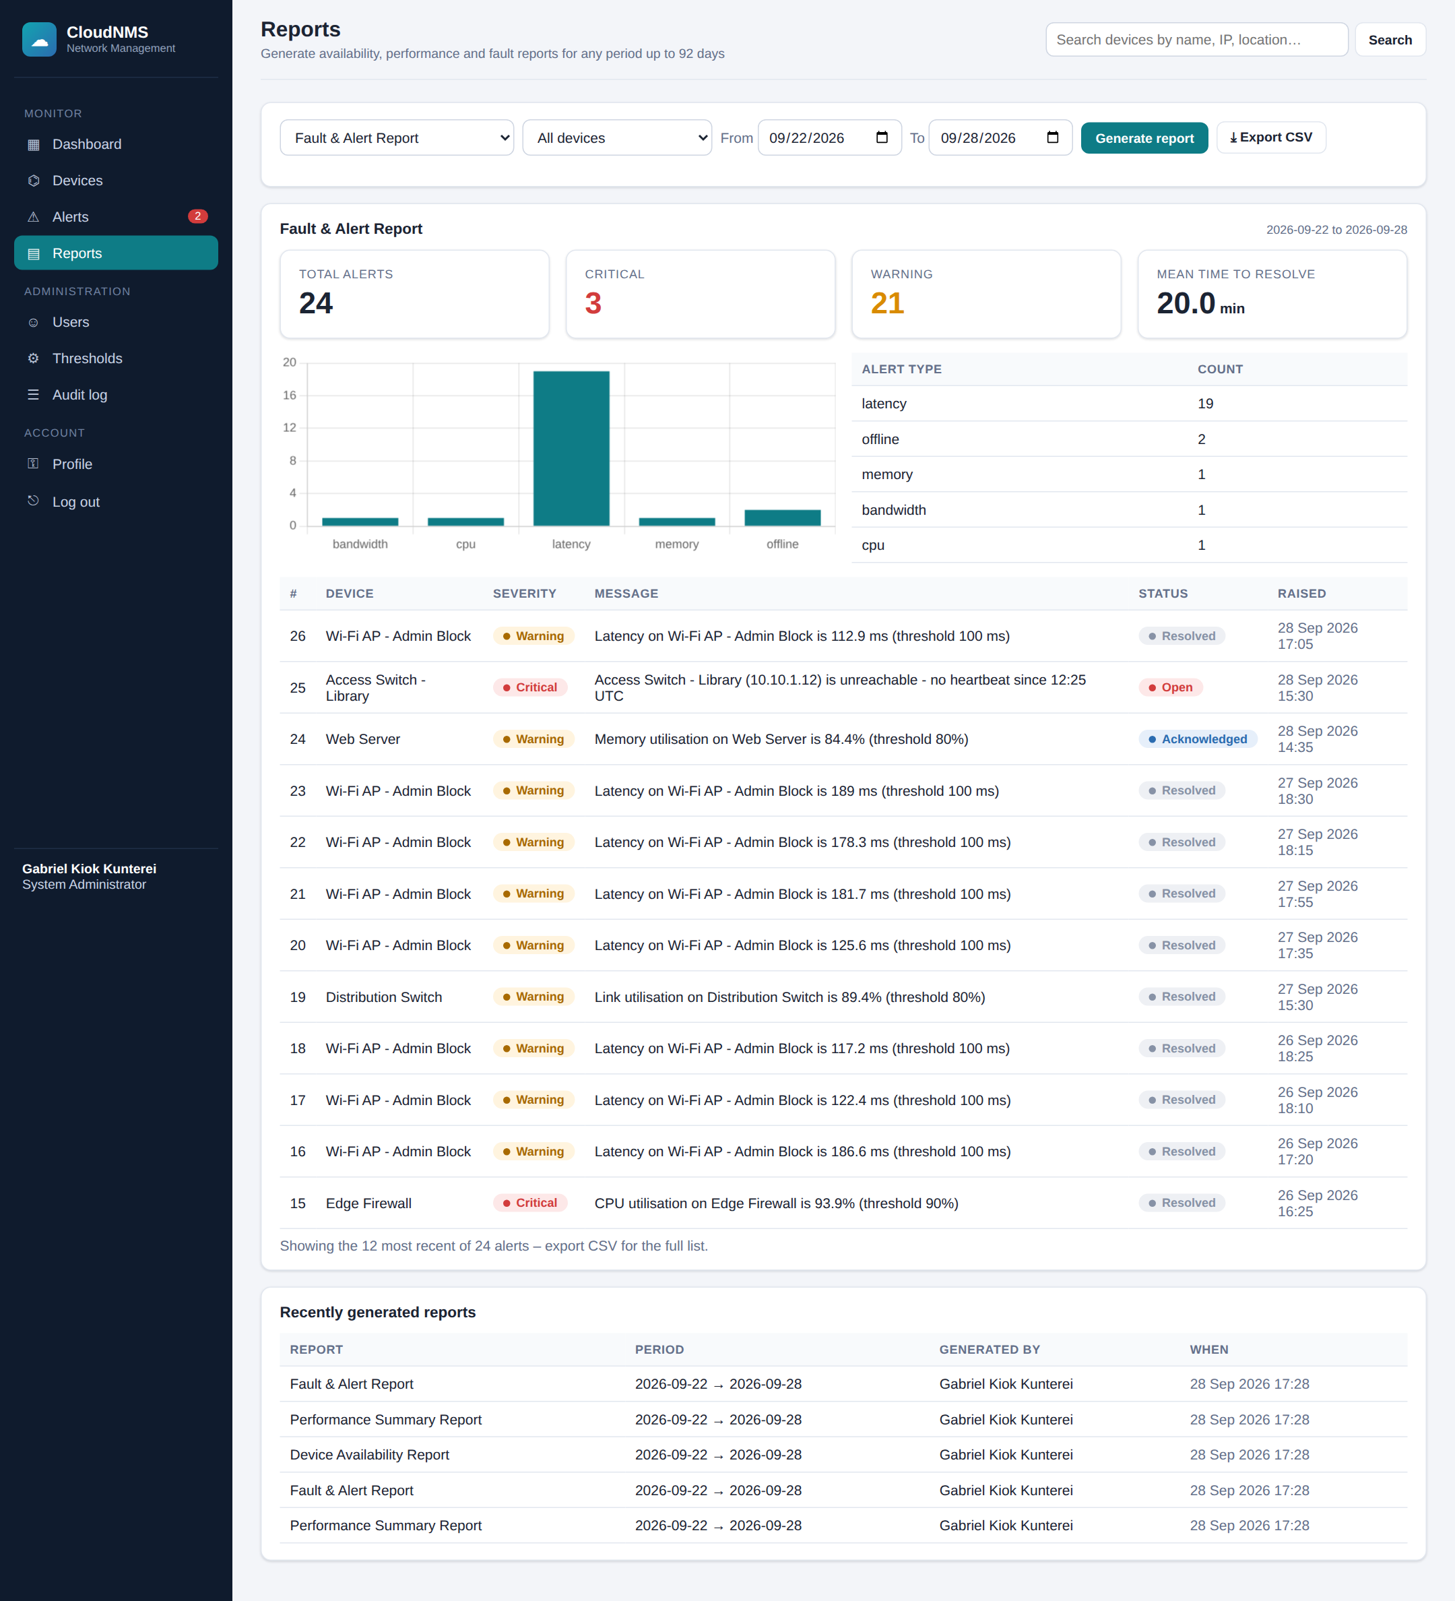
Figure 3.16: Fault and alert report

3.2.9 User Management, Thresholds and Audit Log
System Administrators manage accounts from the Users page, where they can add users, change roles and activate or deactivate accounts (an administrator cannot deactivate their own account). The Thresholds page allows the warning and critical limits for each metric to be adjusted without changing code. The Audit log records security-relevant events such as successful and failed logins, access-denied attempts, rejected API keys, device changes and report generation, together with the user and source IP address. When a user tries to open a page outside their role, an access-denied page is displayed.
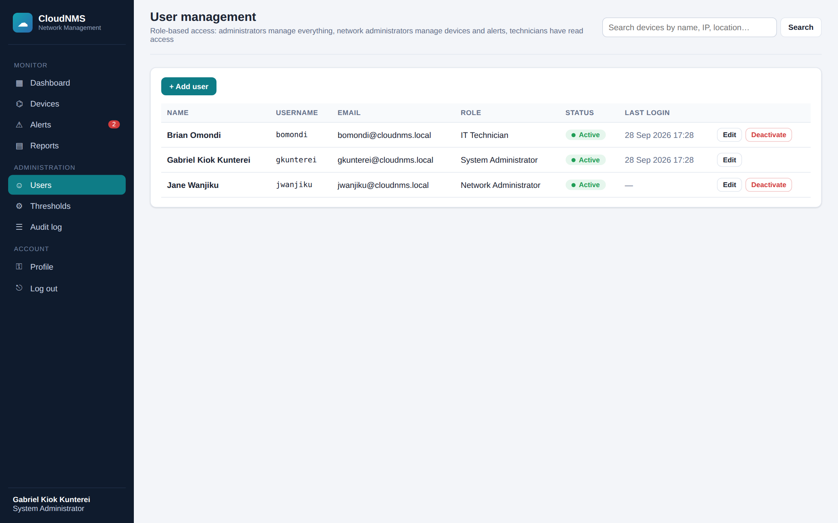
Figure 3.17: User management
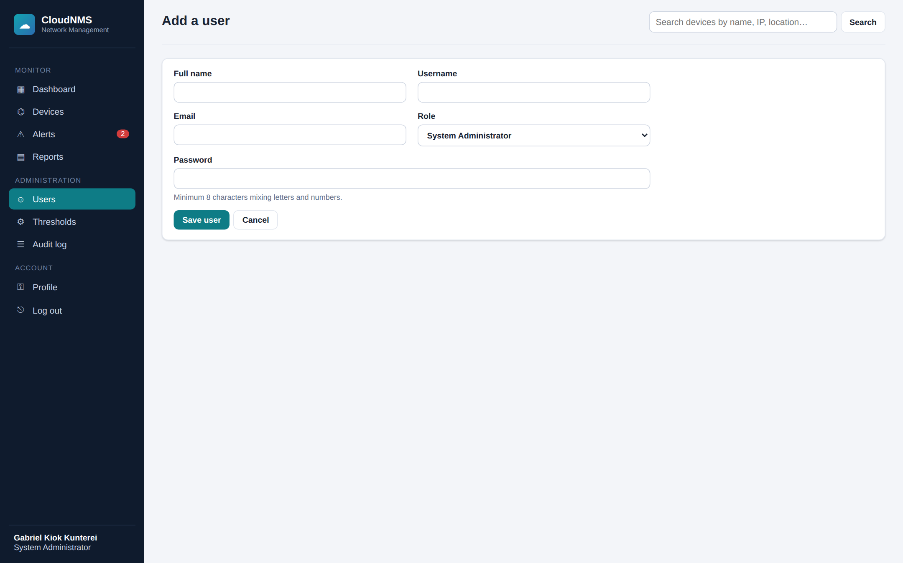
Figure 3.18: Add user form
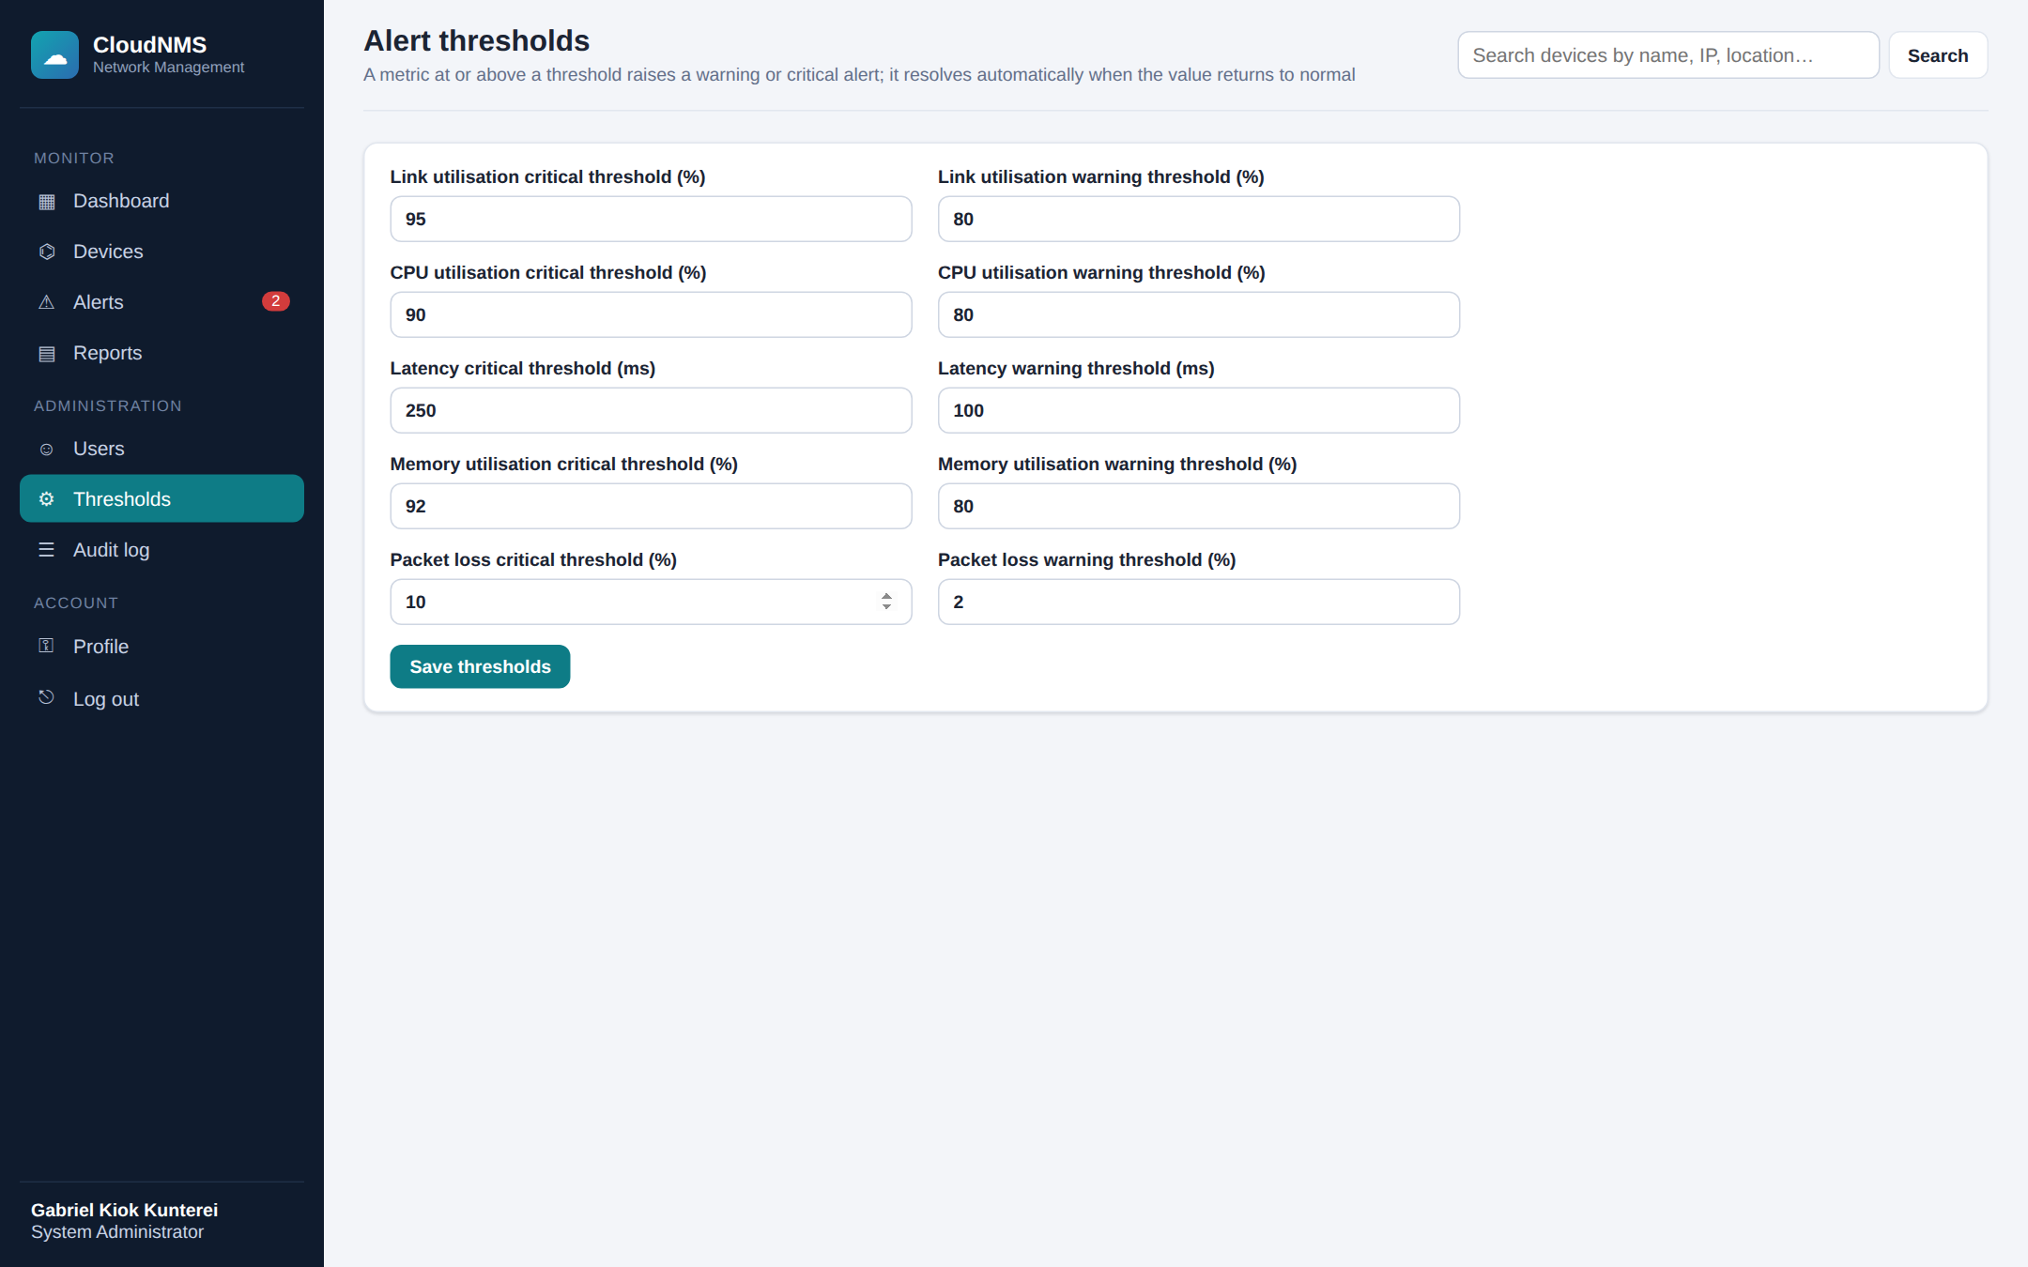
Figure 3.19: Alert threshold settings
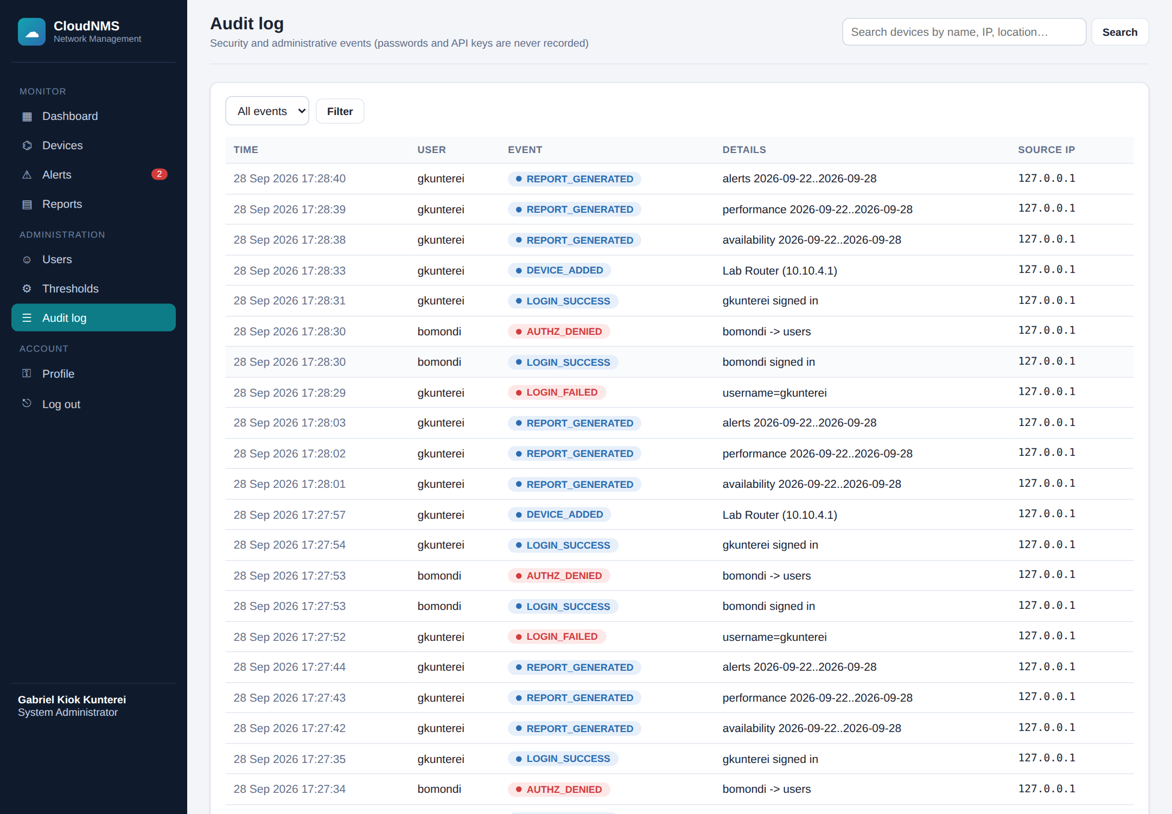
Figure 3.20: Audit log
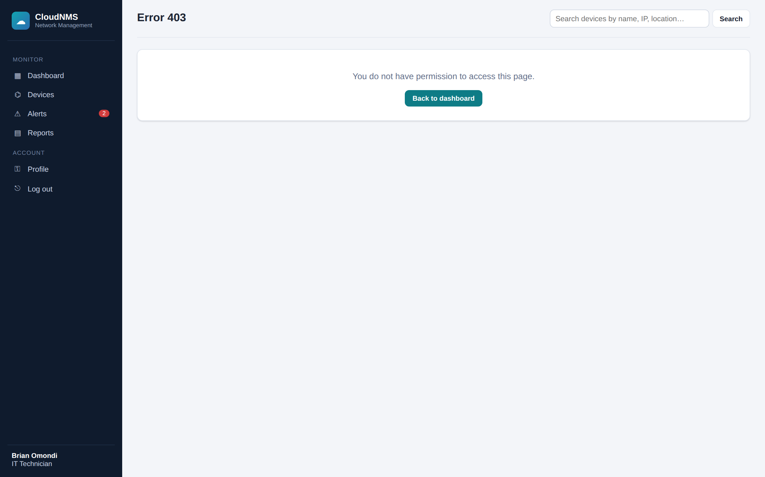
Figure 3.21: Access-denied page shown to an IT Technician

3.3 Logic Development

3.3.1 Database Models
The database was implemented with SQLAlchemy models, which map Python classes to the tables designed in the ERD. Unique constraints on the IP address and API key prevent duplicate devices, and indexes on frequently queried columns (device_id, recorded_at, status) keep the dashboard and reports fast. The relationships use cascading deletes so that removing a device also removes its metrics and alerts. The tables are created automatically when the application starts, and default thresholds are inserted if they are missing.
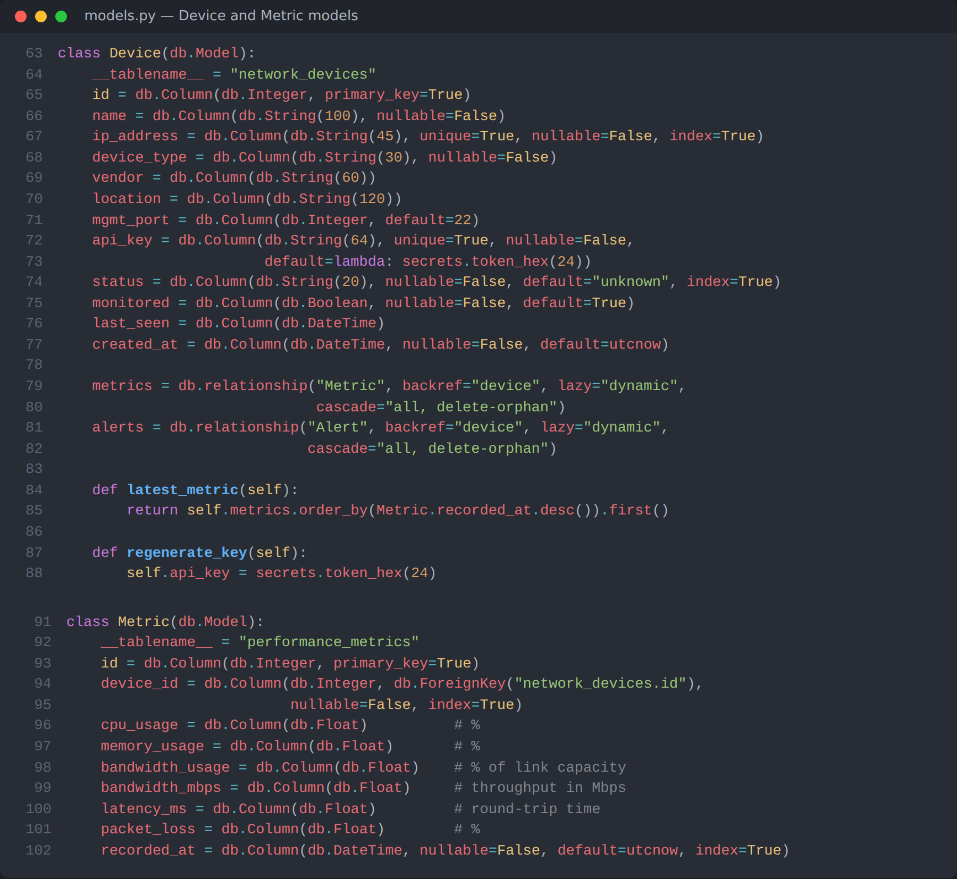
Figure 3.22: Device and Metric database models

3.3.2 Login
The login route redirects users who are already authenticated to the dashboard. For a POST request it reads the username and password, rejects empty fields, and refuses access if the account is locked. It verifies the password against the stored hash; on failure it increments the failed-login counter, locks the account for fifteen minutes after five failures, logs the attempt and shows a generic error. On success it resets the counter, records the login time, starts the session with Flask-Login, logs the event and redirects the user to the page they originally requested – but only if that is a local path, which prevents open-redirect attacks.
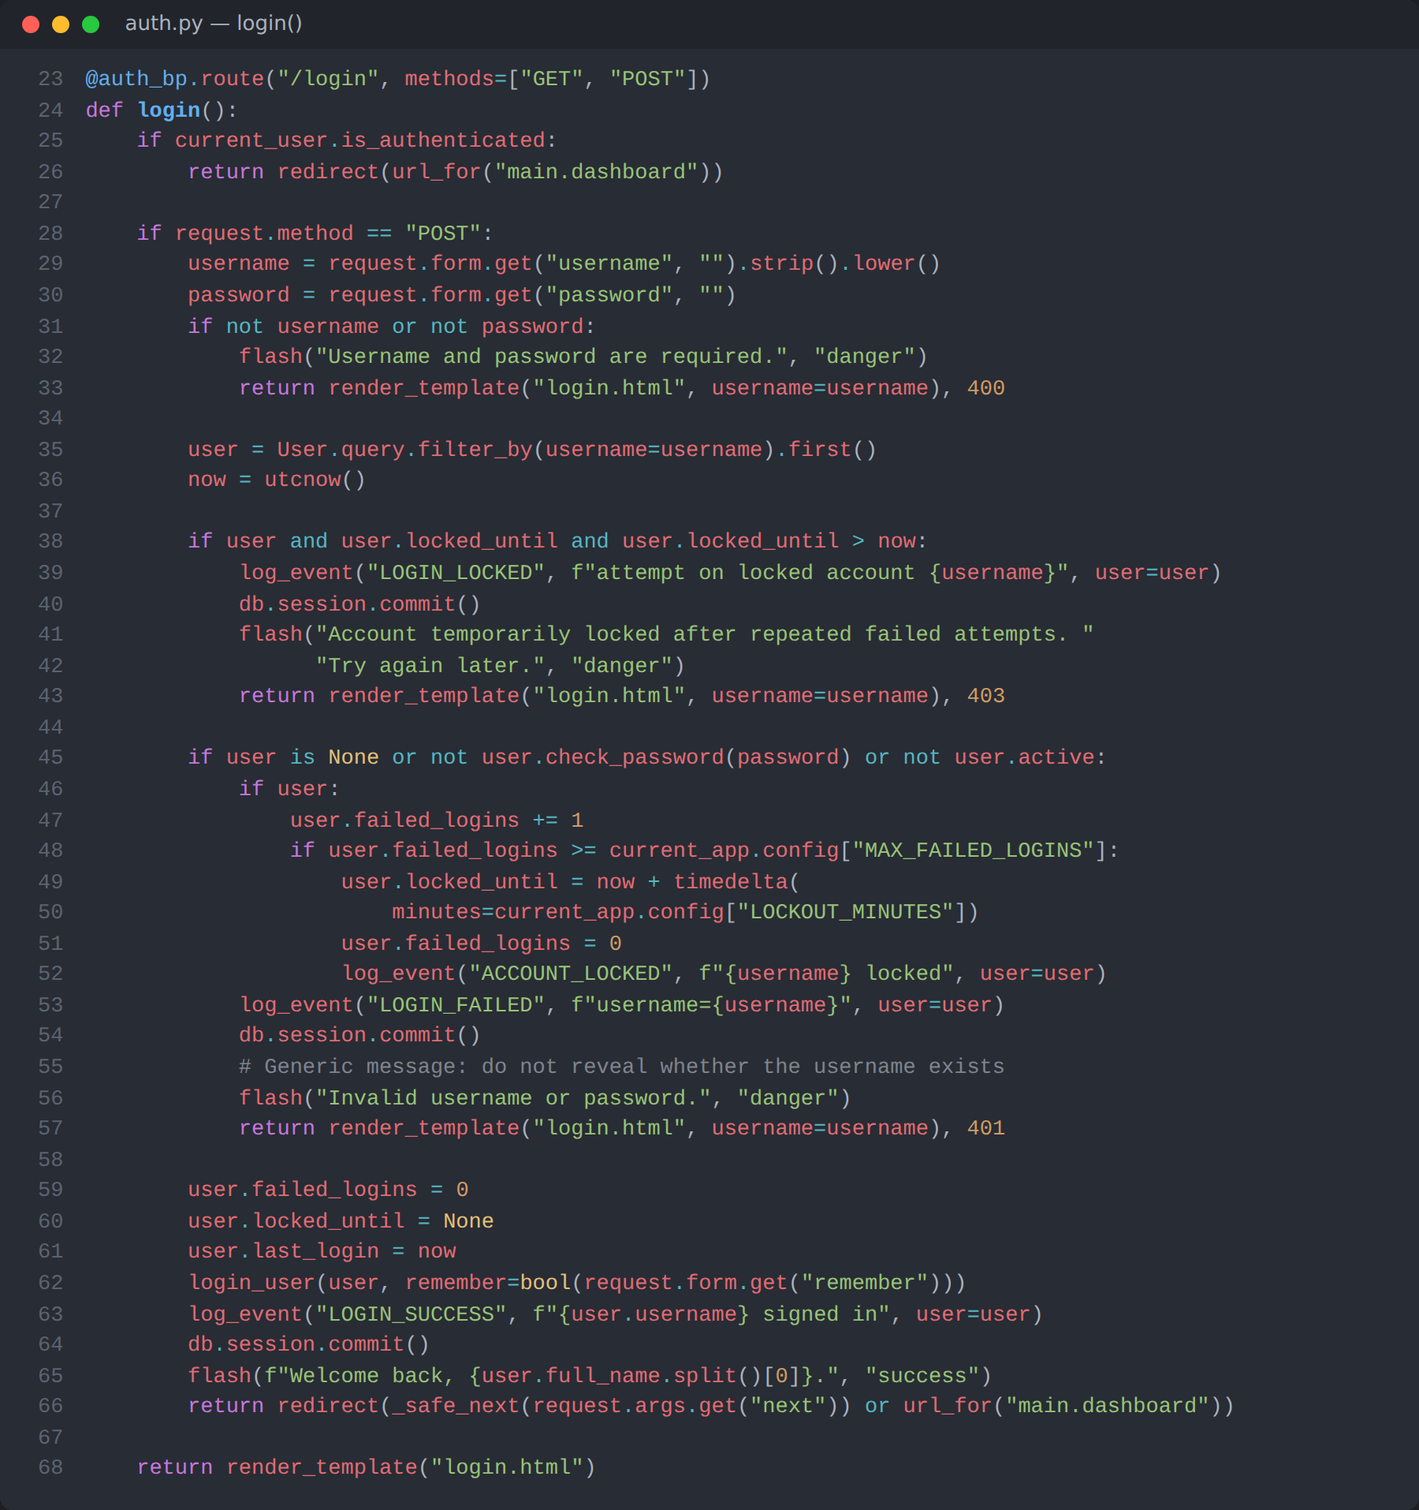
Figure 3.23: Python-based user authentication implemented with Flask

3.3.3 Role-Based Access Control
Access control is implemented with a reusable decorator. Each protected route declares the roles allowed to use it; any other user receives an HTTP 403 response and the attempt is recorded as AUTHZ_DENIED in the audit log. This follows the OWASP principle of denying access by default and applying least privilege (OWASP Foundation, n.d.-b).
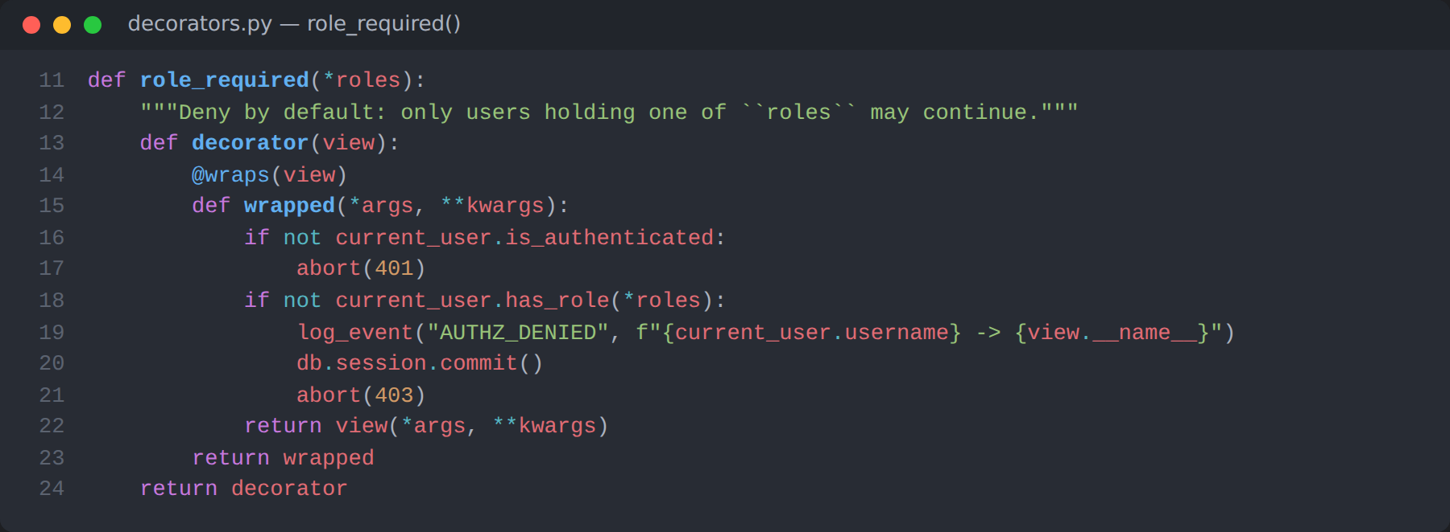
Figure 3.24: role_required() access-control decorator

3.3.4 Dashboard
The dashboard route first runs the heartbeat check, so that devices that have gone silent are marked offline even between scheduled tasks. It then counts devices by status, retrieves the six most recent active alerts, counts alerts in the last 24 hours and critical open alerts, lists the devices that are offline or degraded and calculates the percentage of reachable devices. The chart data is loaded separately by JavaScript from the /api/v1/summary endpoint, which returns hourly averages grouped in the database.
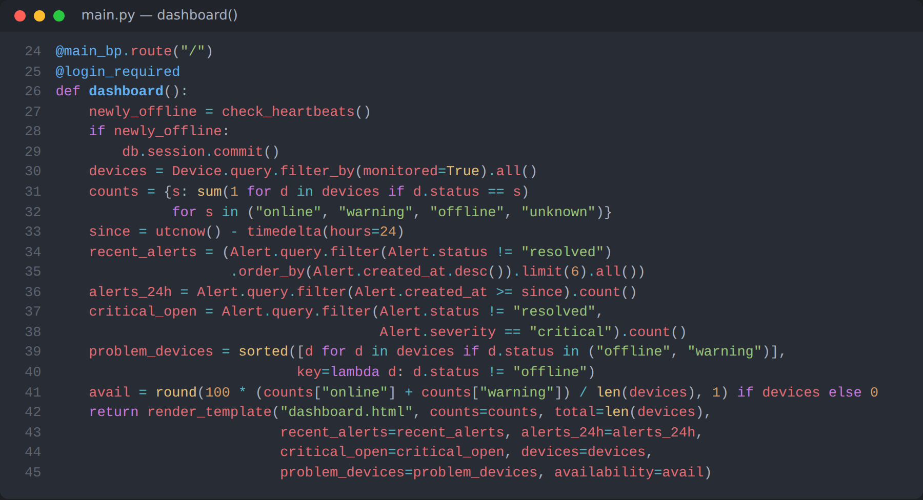
Figure 3.25: Dashboard backend development

3.3.5 Device Management
Device creation and editing share one validation function. It checks the name length, uses Python's ipaddress module to validate the IP address, ensures that the IP is not already registered to another device, checks the device type and the management port range. The add_device route is limited to System and Network Administrators; it saves the device, which automatically receives a random 48-character API key, logs the action and opens the device page. Other routes allow editing, pausing or resuming monitoring, on-demand polling, rotating the API key and deleting the device (administrators only).
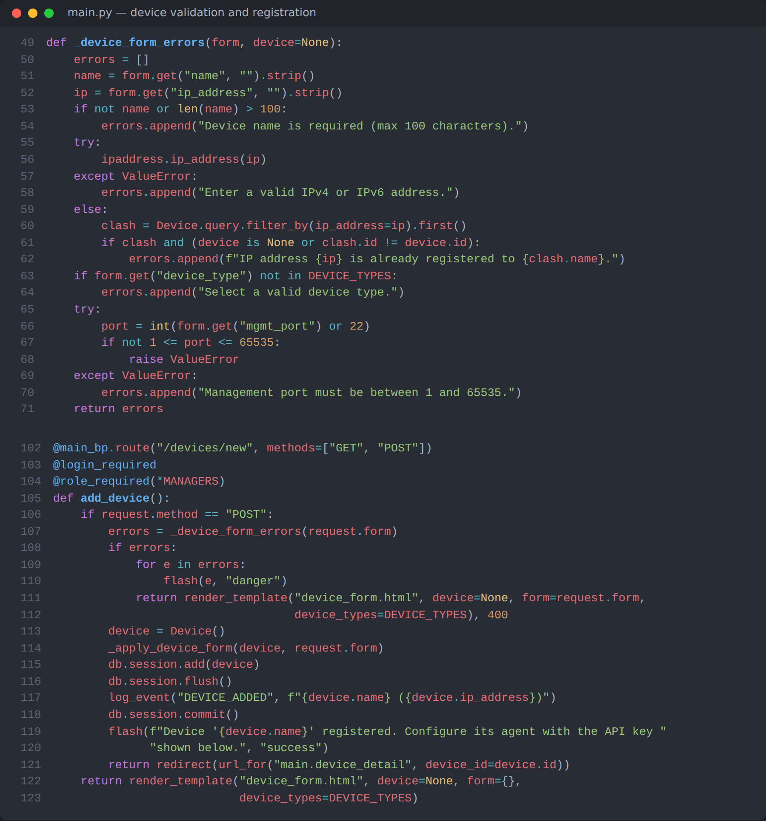
Figure 3.26: Device validation and registration backend

3.3.6 Metrics API and Monitoring Agent
The /api/v1/metrics endpoint receives data from monitoring agents. It identifies the device by the X-API-Key header, comparing keys in constant time to avoid timing attacks, and logs rejected keys. Valid submissions are passed to the monitoring engine; invalid data returns HTTP 422 and nothing is stored. The endpoint is exempt from CSRF protection because agents authenticate with API keys instead of browser sessions.
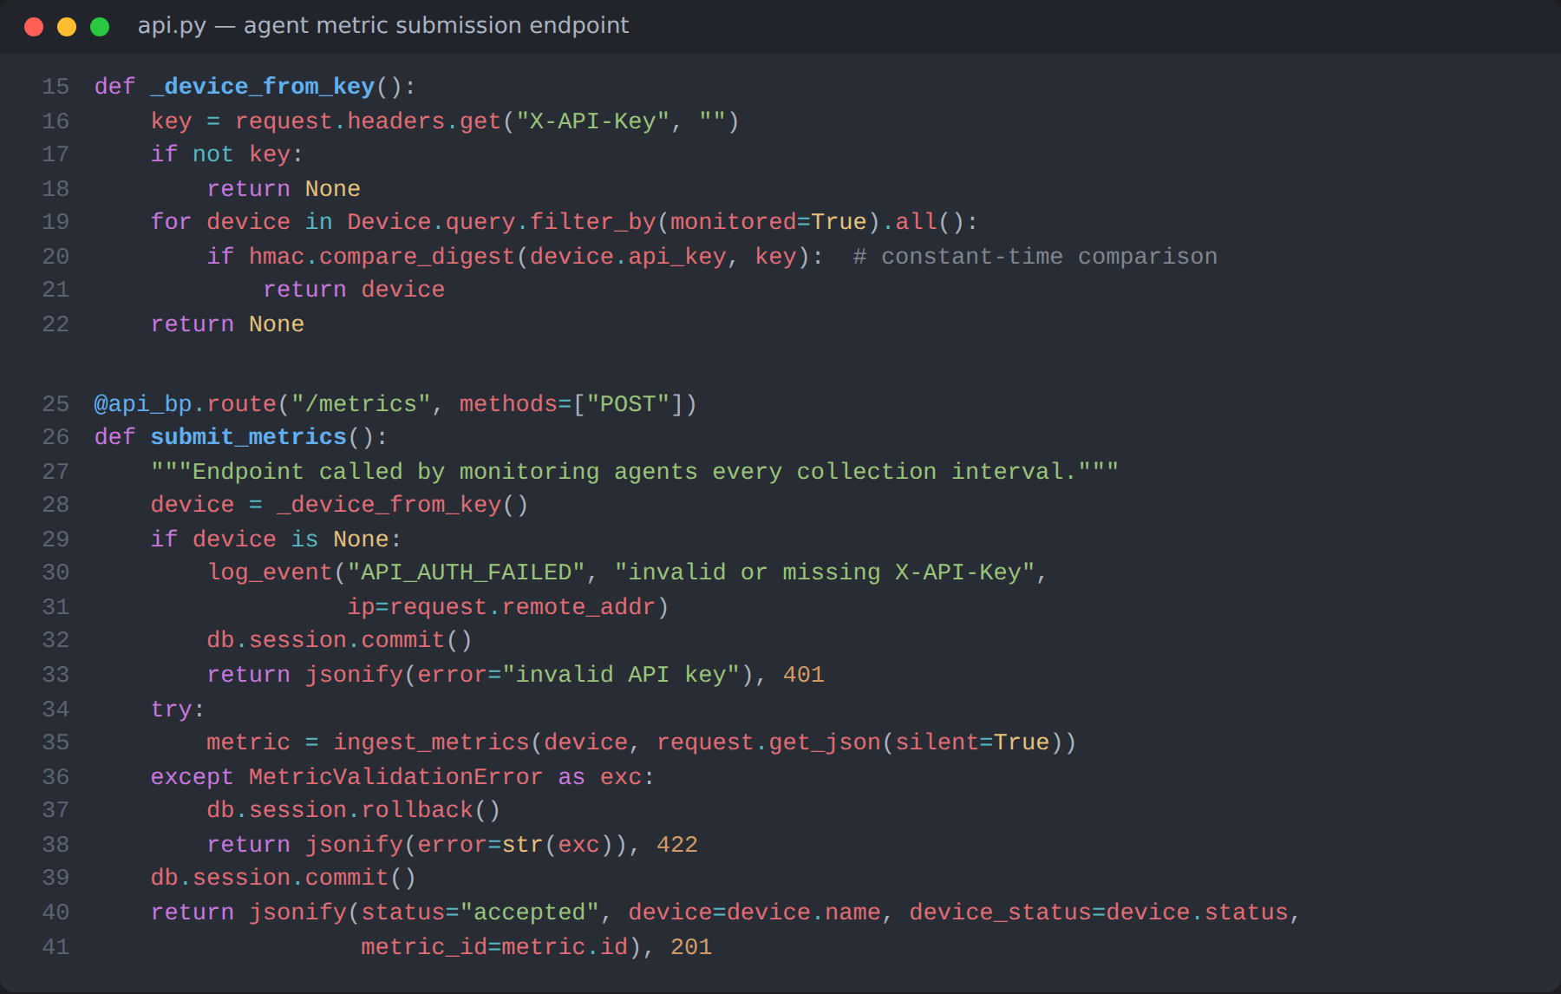
Figure 3.27: Metrics submission API
The monitoring agent runs on a host at the site. Every interval it measures CPU and memory utilisation with the psutil library, calculates throughput and link utilisation from the change in network byte counters, measures latency and packet loss with TCP handshakes to a target host, and posts the sample as JSON to the cloud API. If the network is down it keeps running, and the server marks the device offline until data arrives again.
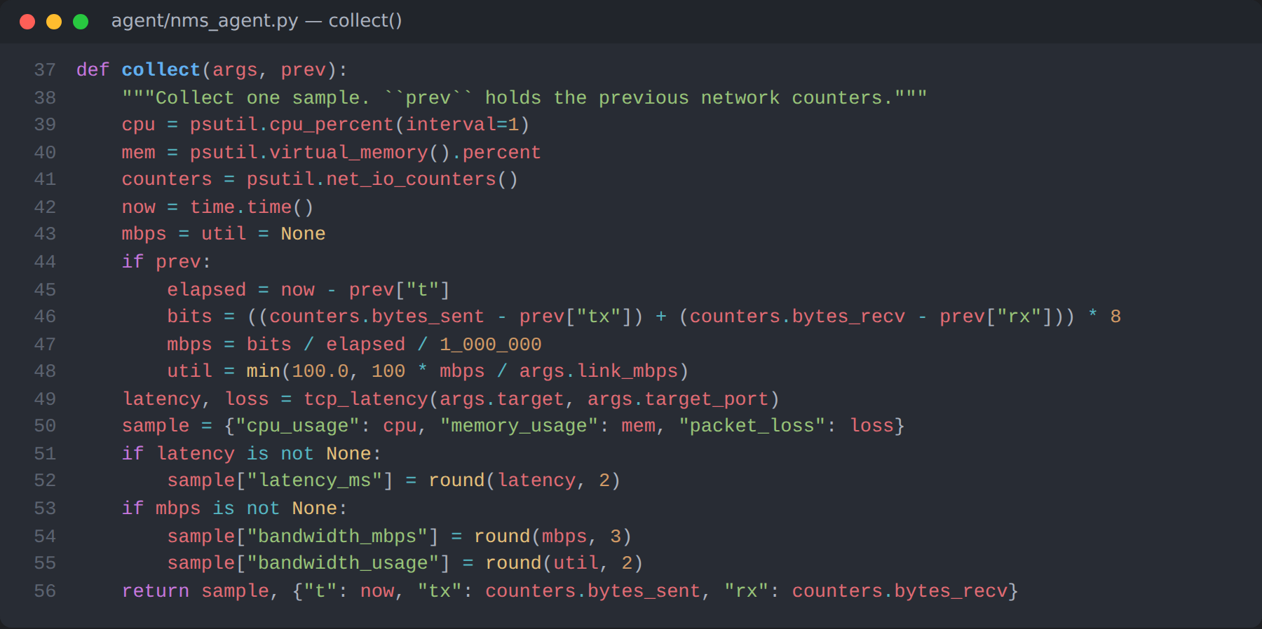
Figure 3.28: Monitoring agent data collection

3.3.7 Fault Detection and Alerts
The monitoring engine evaluates every sample against the thresholds stored in the settings table. A critical value raises an alert immediately. A warning value raises an alert only if the previous sample was also above the warning level, and an open alert is cleared only when the value drops at least 15% below the warning level (hysteresis). Only one alert is kept open per device and fault type; if the value worsens, the existing alert is escalated to critical rather than duplicated.
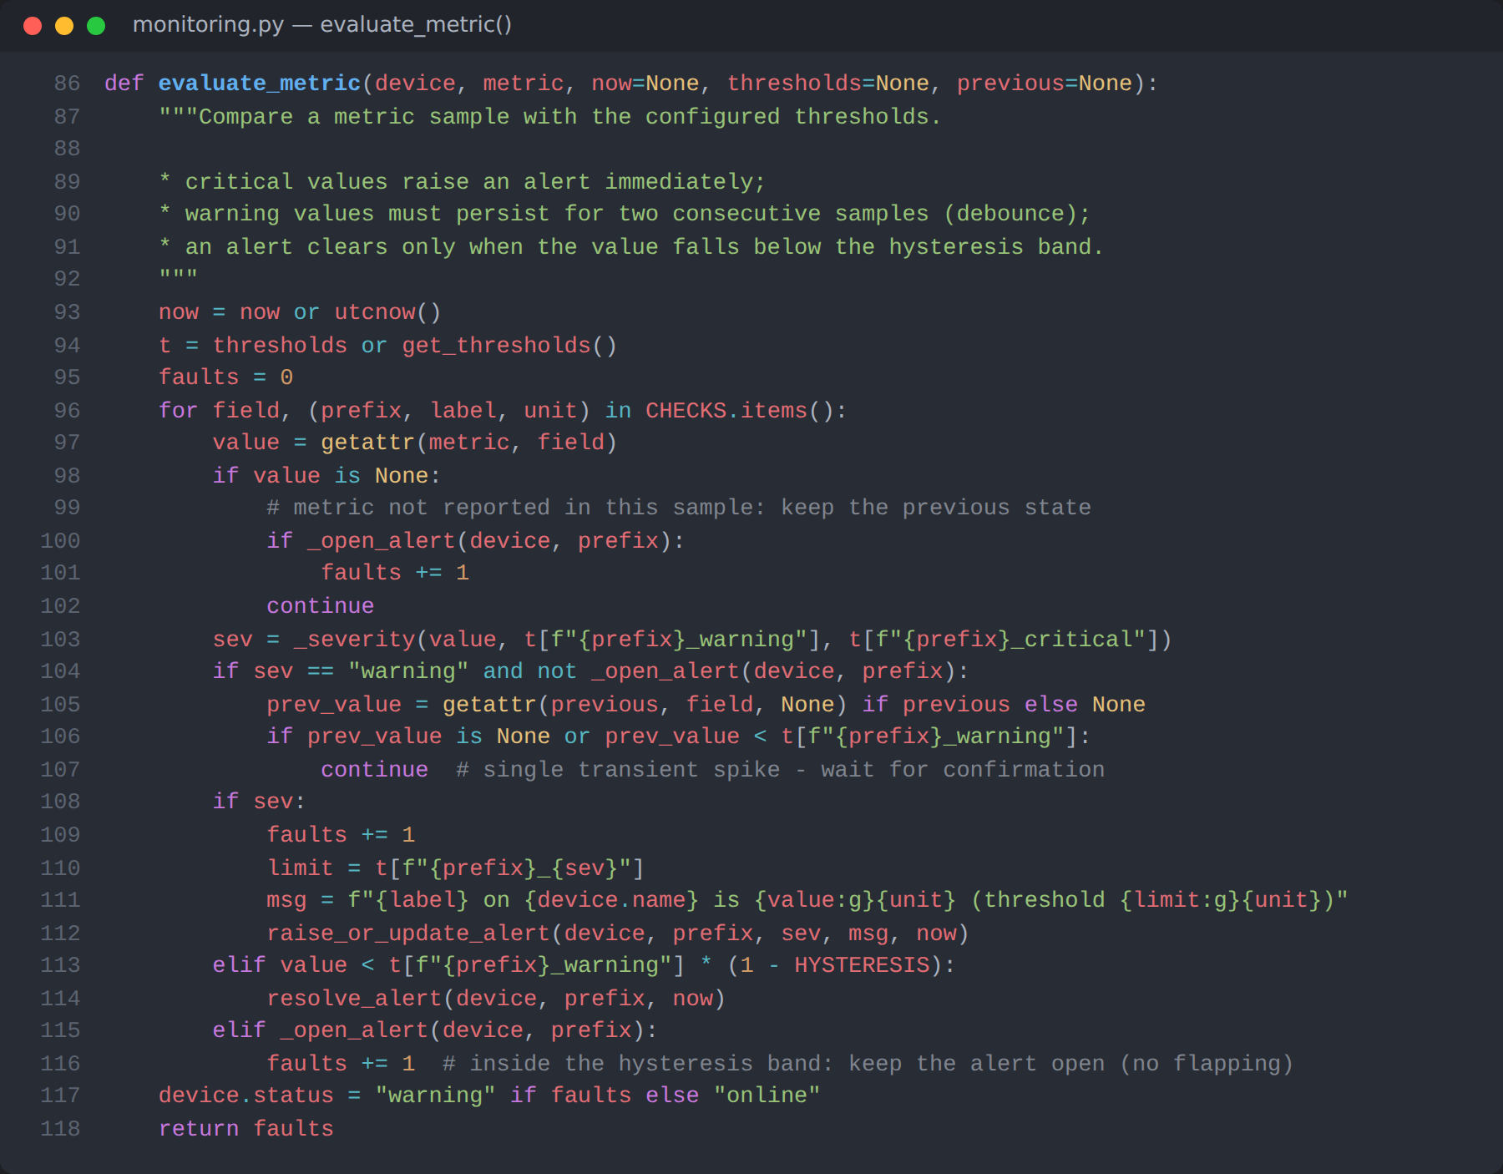
Figure 3.29: Threshold evaluation with debounce and hysteresis
The ingest_metrics function validates and stores a sample, updates the device's last-seen time, automatically resolves any open offline alert (the device has recovered) and calls the evaluation. The check_heartbeats function is run by the scheduled task and on dashboard load: any monitored device that has not reported within the heartbeat timeout (180 seconds by default) is marked offline and a critical offline alert is raised.
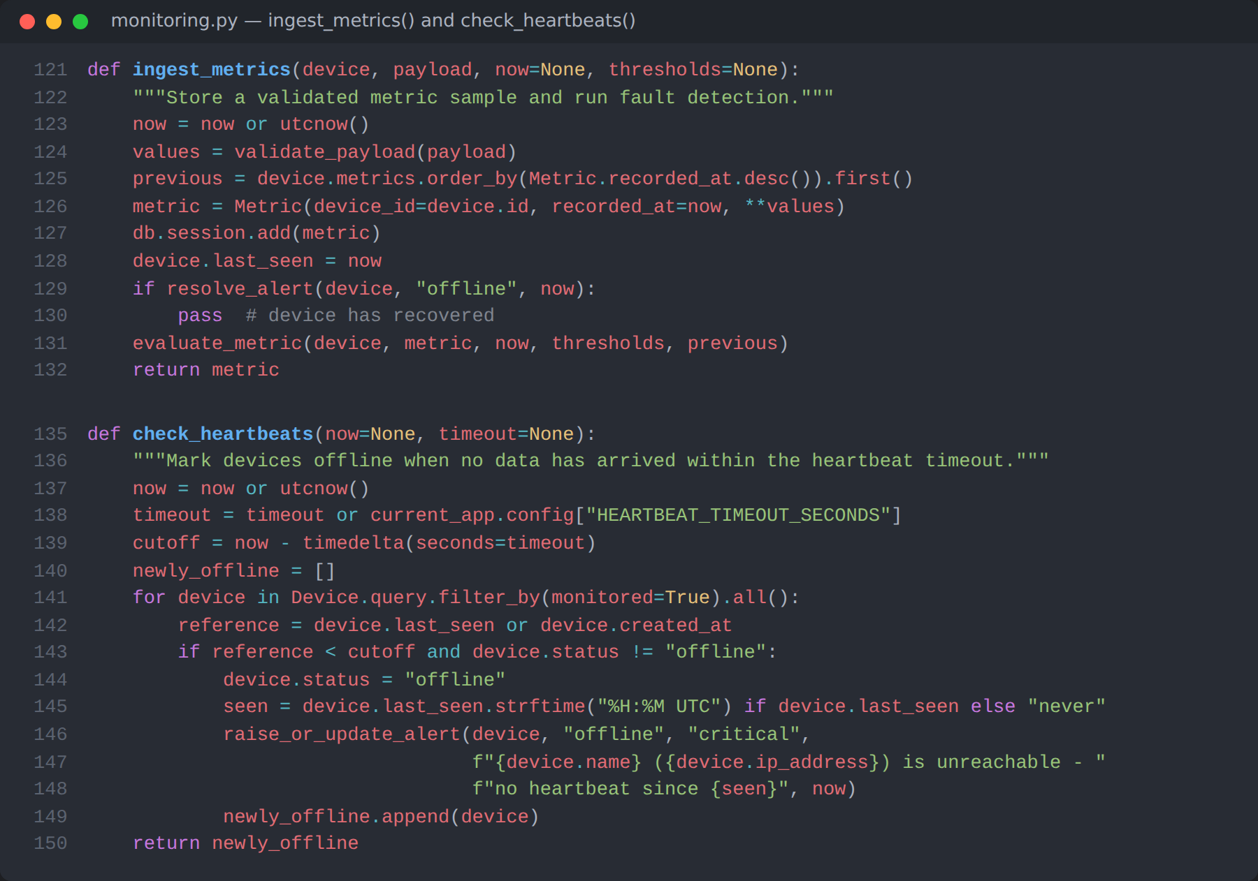
Figure 3.30: Metric ingestion and heartbeat checking
Users act on alerts through the alert_action route: any user may acknowledge an open alert, which records the user and time, but only Network and System Administrators may resolve an alert.
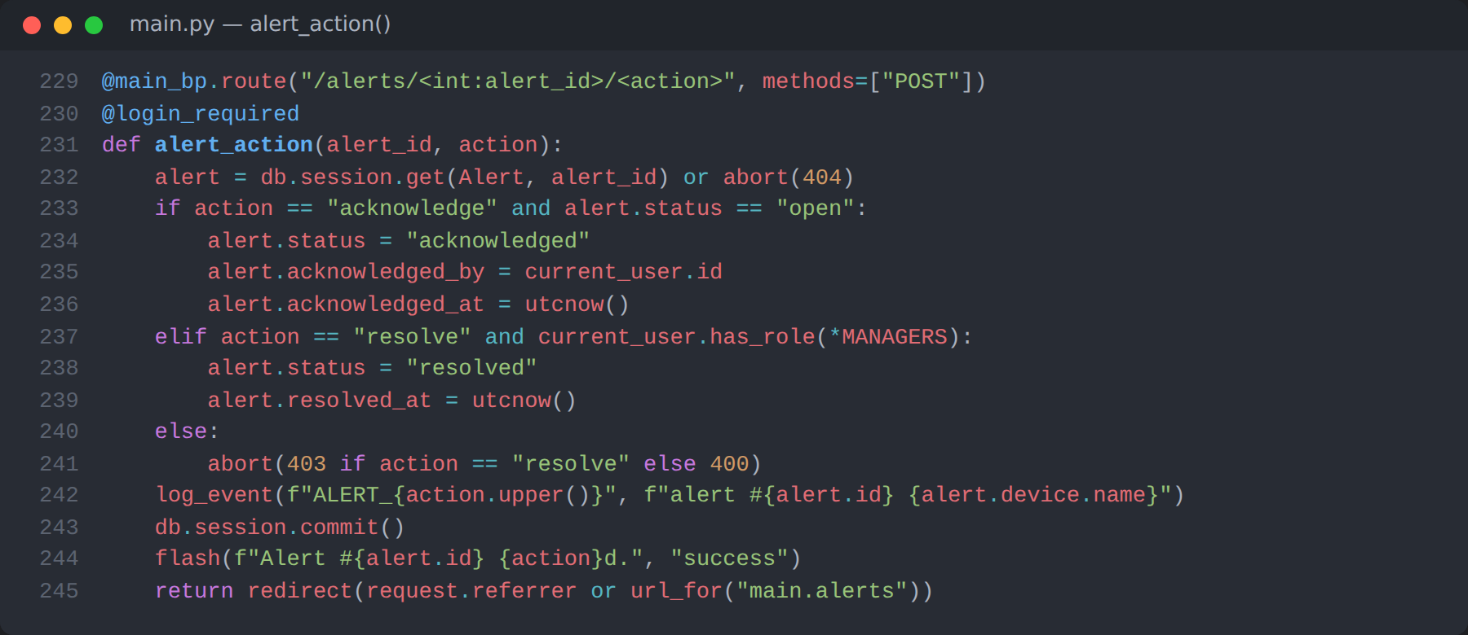
Figure 3.31: Alert acknowledgement and resolution

3.3.8 Reports
The report functions query the database for the selected period and device. The availability report counts the distinct five-minute windows in which each device sent at least one sample and divides this by the number of windows expected since the device was registered, giving an availability percentage; it also counts offline alerts as outages. The performance report uses SQL aggregate functions (AVG, MAX, COUNT) per device, and the alert report groups alerts by severity and type and calculates the mean time to resolve. The export route writes the same data to a CSV file.
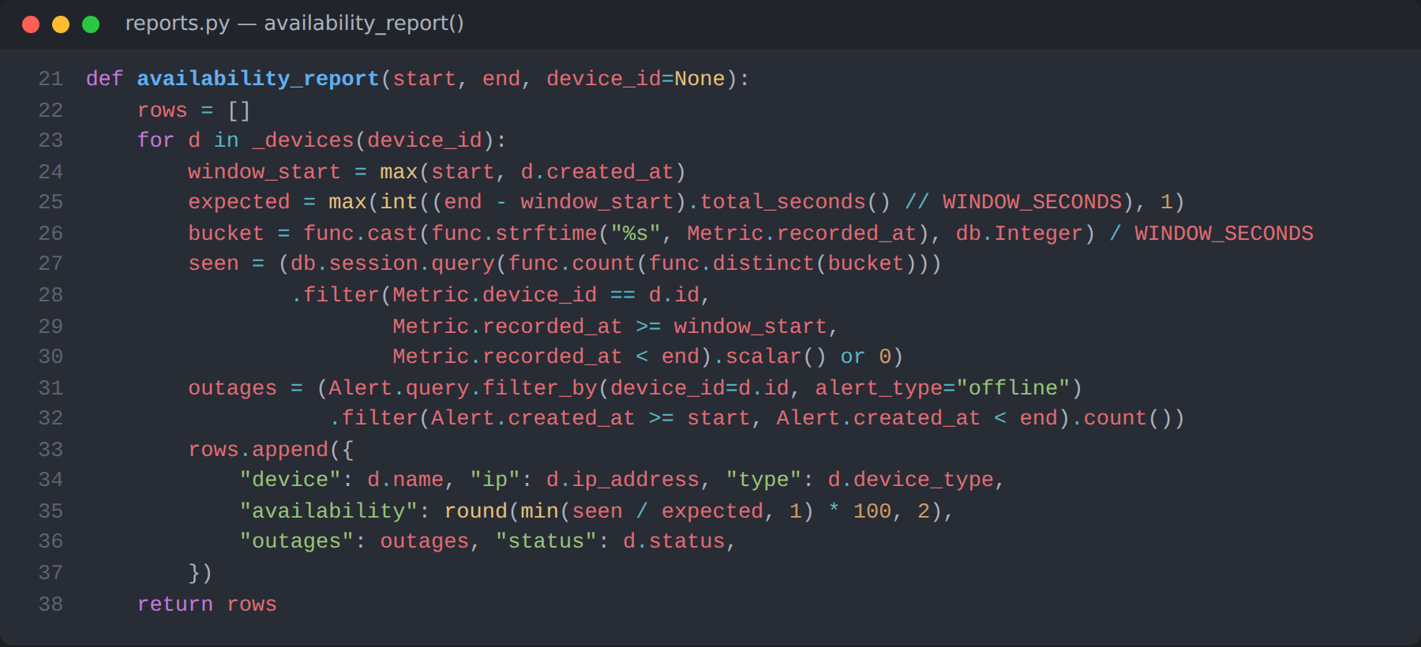
Figure 3.32: Availability report calculation

3.4 Testing
Testing was carried out at four levels. Unit tests checked individual functions such as metric validation and threshold evaluation. Integration tests used Flask's test client to exercise complete requests through routes, the database and the monitoring engine. System tests ran the full application with seven days of simulated data for eight devices (16,104 metric samples) and live agents, and every screen and button was exercised in a browser. User acceptance testing was done with classmates acting as network administrators and technicians. The automated suite contains 26 tests; the final run passed all 26 with 79% statement coverage (Figure 3.33).
ID | Feature | Test | Expected result | Actual result
TC01 | Login | Enter valid credentials | User reaches dashboard; LOGIN_SUCCESS logged | Passed
TC02 | Login | Enter invalid credentials; then 5 wrong passwords | Access denied with generic message and event logged; account locked after 5 failures | Passed
TC03 | Users | Administrator creates a valid user; weak password | User stored with role; weak password rejected | Passed
TC04 | Devices | Add a valid device | Device listed and receives a 48-character API key | Passed
TC05 | Devices | Search by partial IP and by a non-existent name | Matching device shown; “No devices match” message | Passed
TC06 | Monitoring | Agent submits valid metrics | HTTP 201; metric stored; last_seen updated; status online | Passed
TC07 | Faults | Device stops reporting beyond timeout, then reports again | Device offline and critical alert raised; alert resolved on recovery | Passed
TC08 | Performance | Submit CPU of 95% (critical) and latency above warning | Critical alert immediately; warning only after two consecutive high samples | Passed
TC09 | Reports | Generate availability, performance and alert reports; export CSV | Reports displayed; CSV contains correct values | Passed
TC10 | Authorisation | Technician opens user management and add-device pages; network admin deletes device | HTTP 403 and AUTHZ_DENIED logged; device not deleted | Passed
TC11 | Validation | Submit invalid IP, duplicate IP and out-of-range metrics | Validation message; no record stored; API returns 422 | Passed
TC12 | Logout | Log out then open a protected page | Session ends; user redirected to login | Passed
TC13 | API security | Submit metrics with a wrong API key | HTTP 401 and API_AUTH_FAILED logged | Passed
Table 3.2: Test cases and results
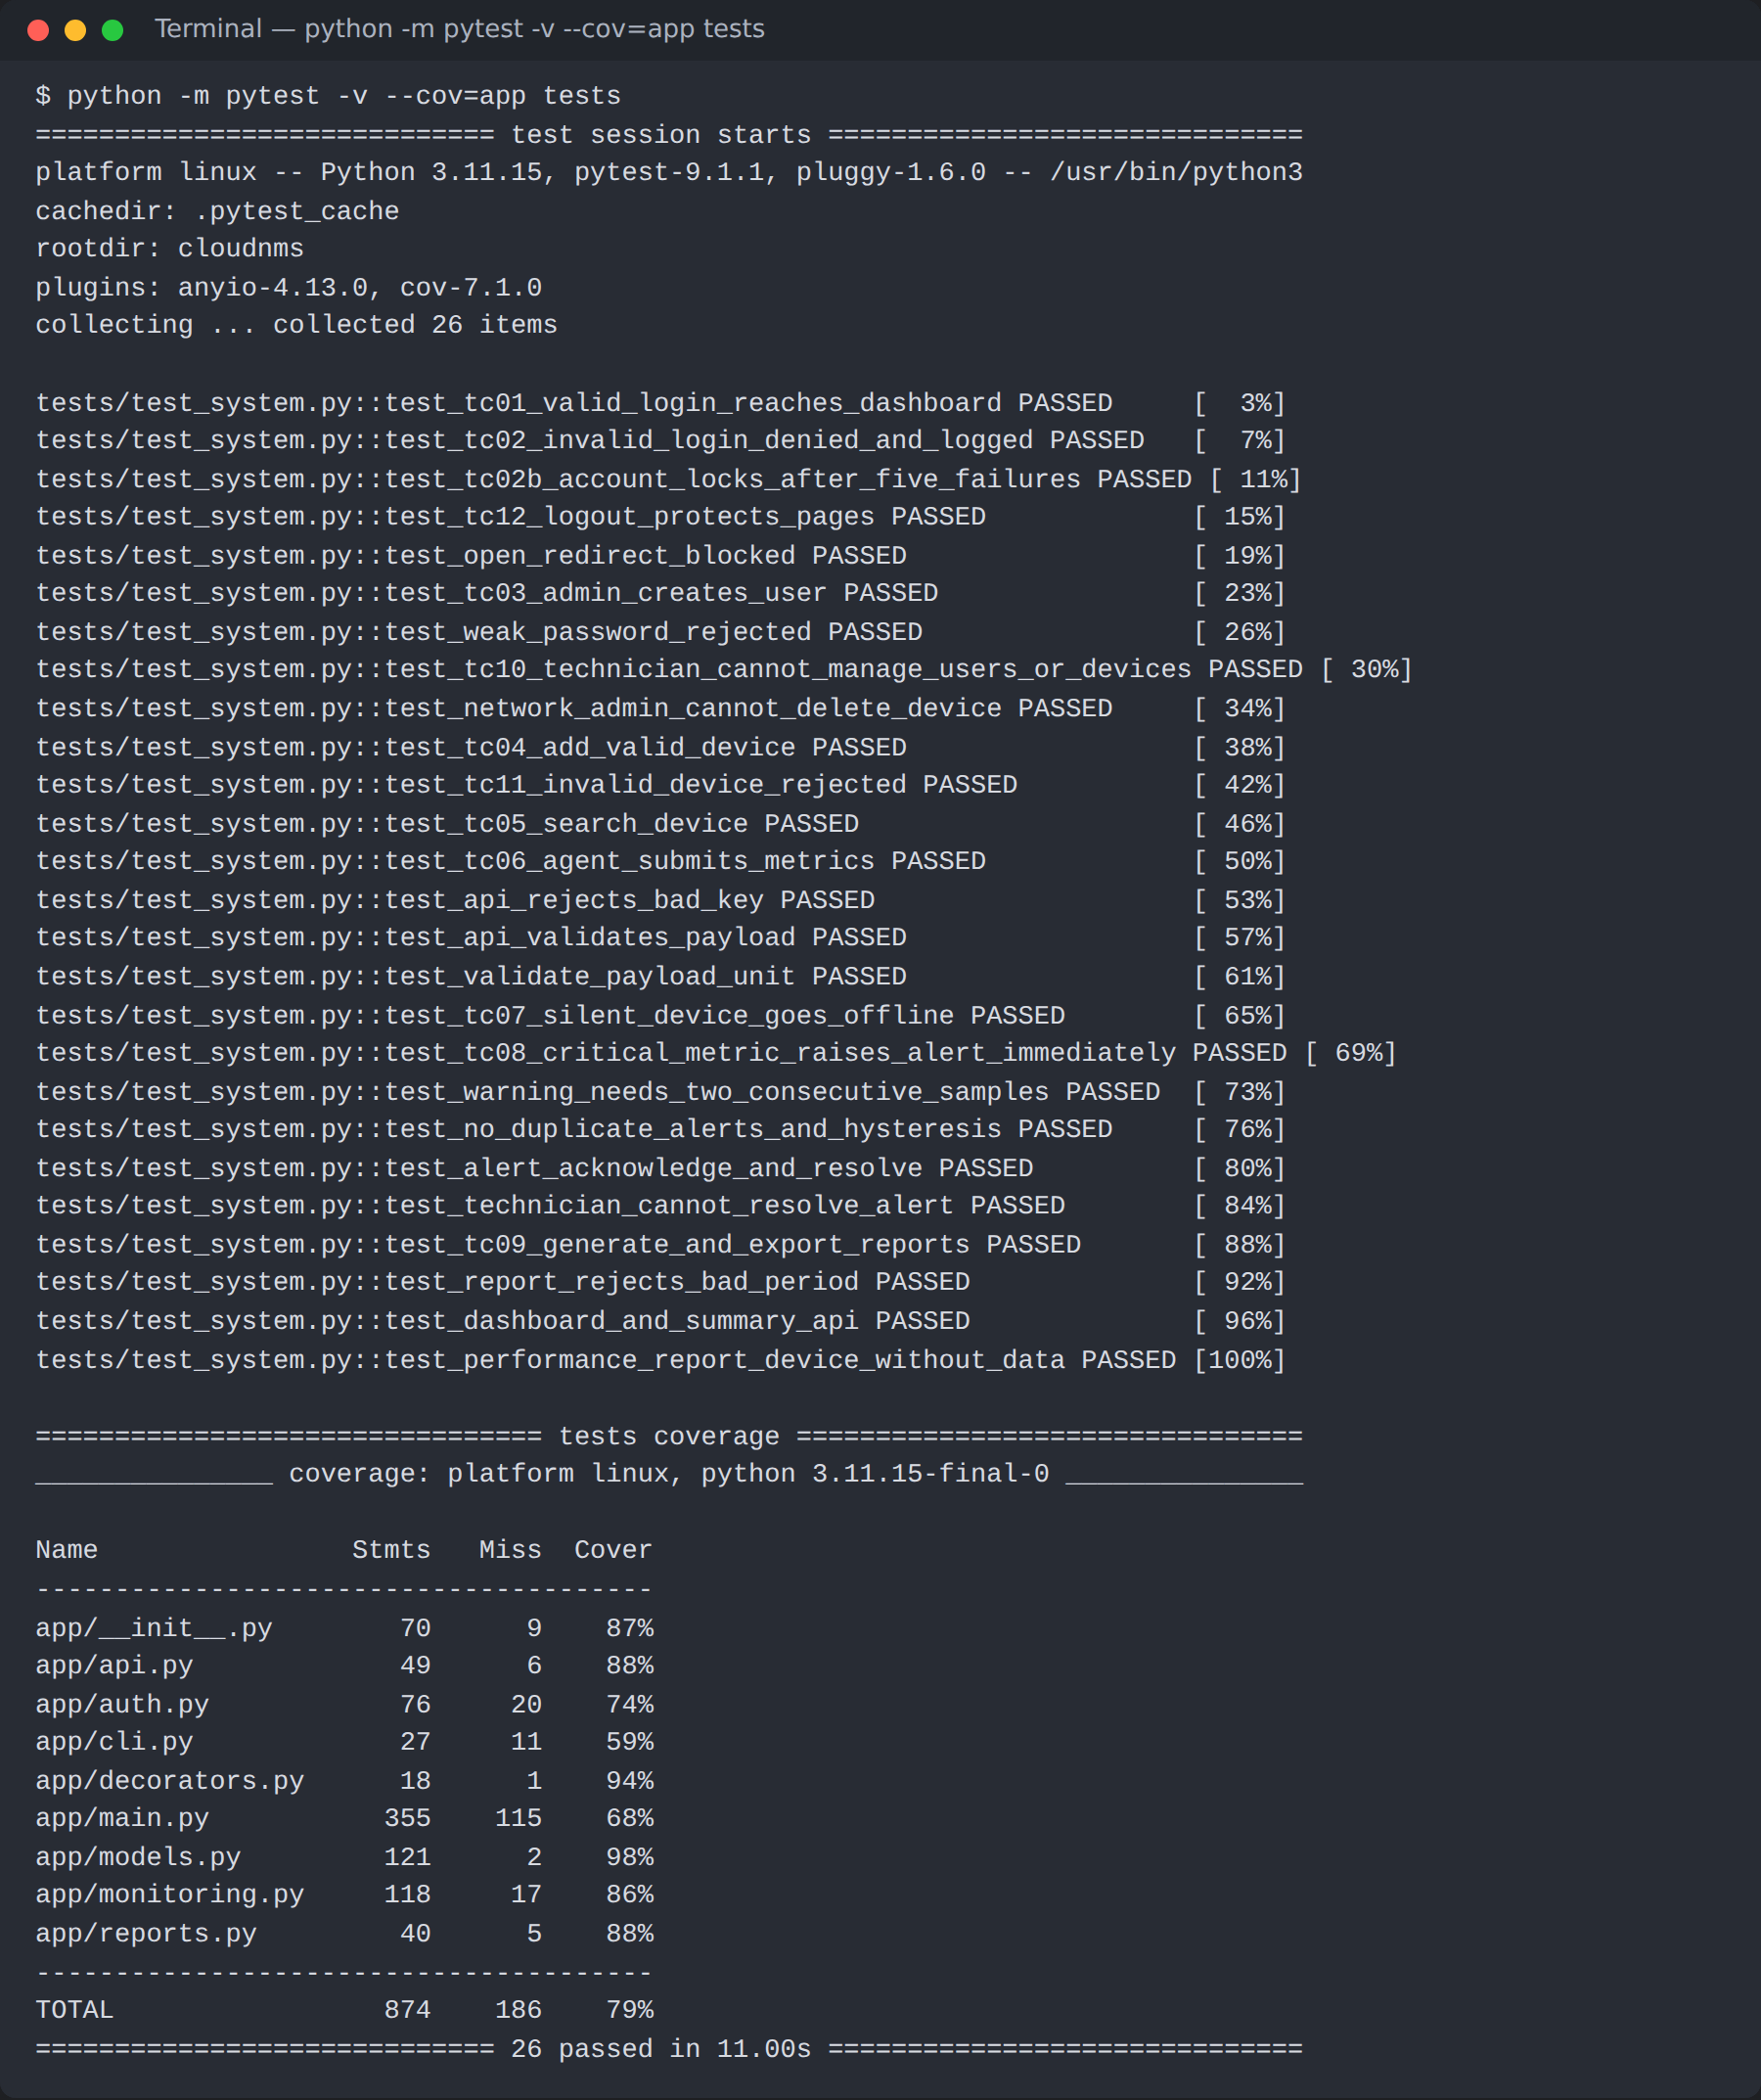
Figure 3.33: Automated test run with coverage
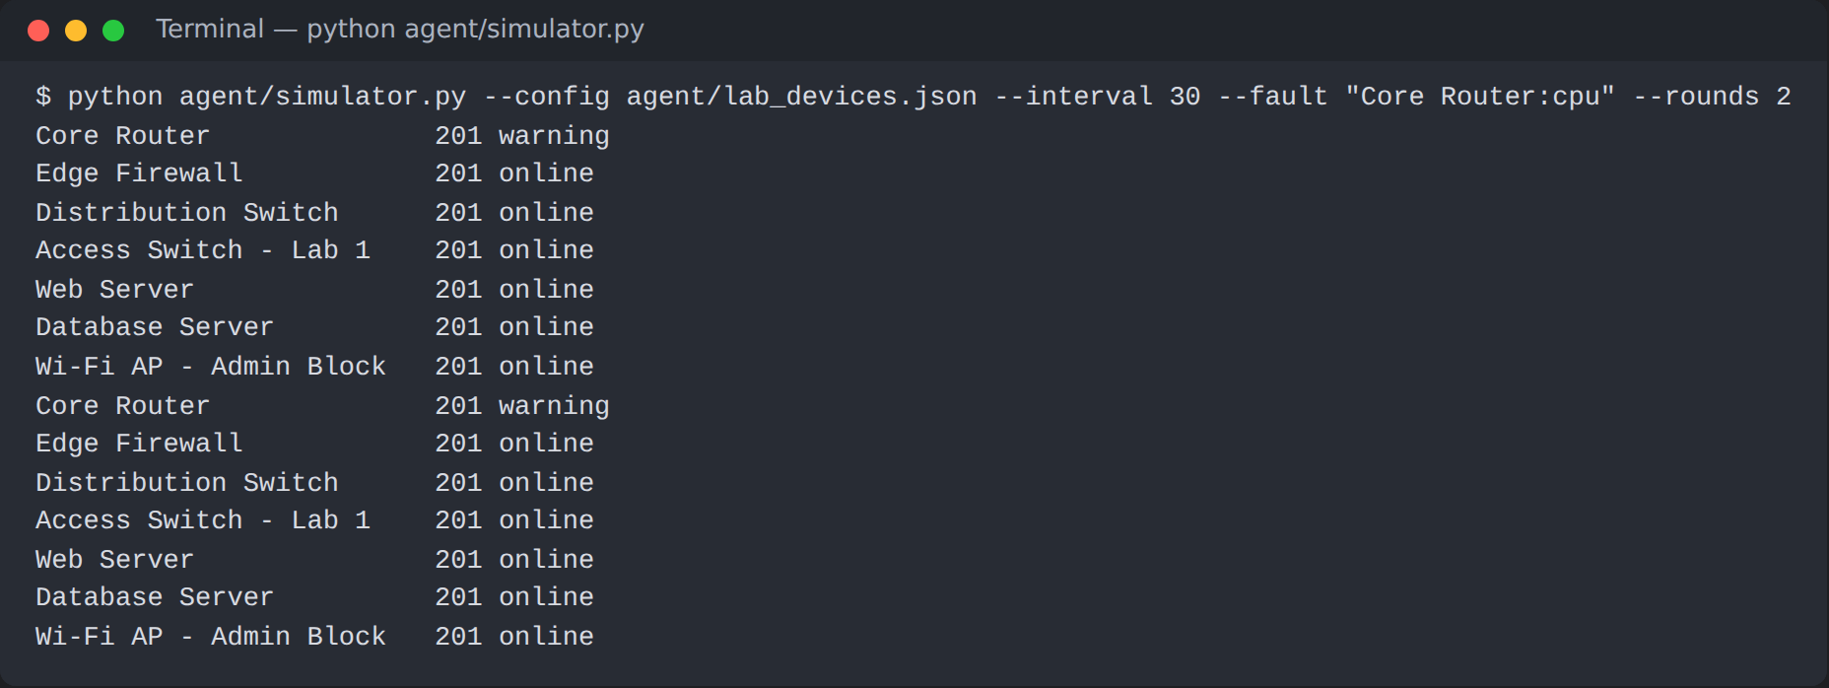
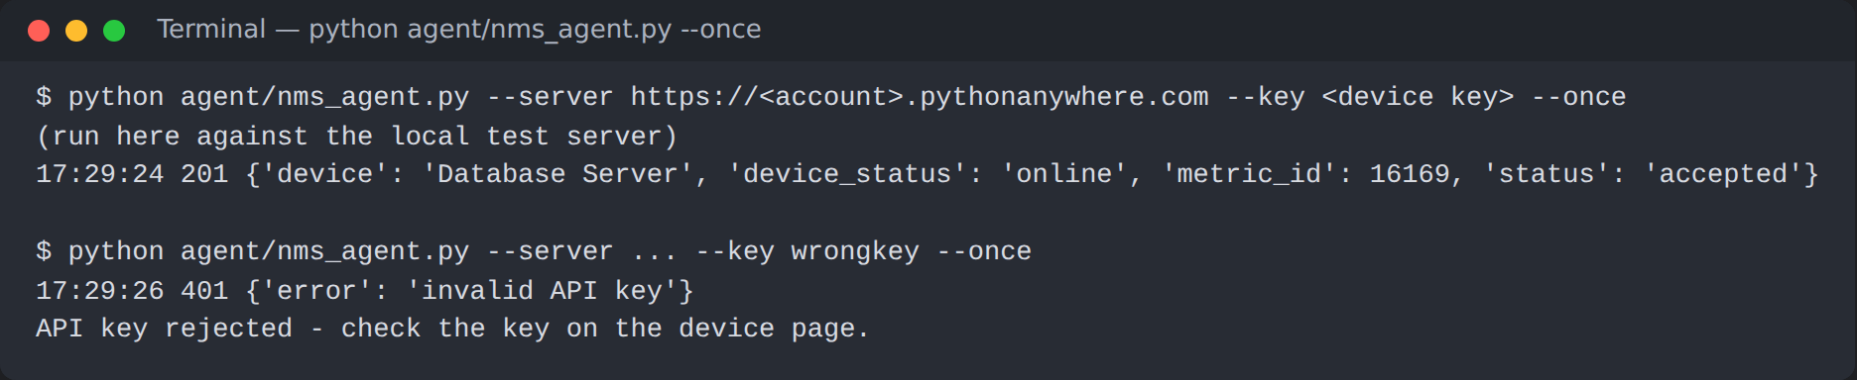
Figure 3.34: Simulator and monitoring agent sending data to the server
The following problems were found during testing and corrected:
- Monitoring engine – partial samples. Testing action: the “Poll now” feature was reviewed, which records only latency. Result: because missing CPU and memory values were treated as normal, an on-demand poll would wrongly resolve open CPU or memory alerts. Correction: metrics that are not present in a sample are now skipped and the previous alert state is kept.
- Alert flapping. Testing action: seven days of simulated data were processed by the monitoring engine. Result: the Wi-Fi access point, whose latency hovered around the 100 ms threshold during evening congestion, produced many alerts lasting only five minutes – 50 alerts in total for the week. Correction: a two-sample confirmation (debounce) for warnings and a 15% hysteresis band for clearing alerts were added. On the same data the number of alerts fell to 25 while every genuine incident (router outage, firewall CPU surge, switch link saturation, web-server memory leak and library switch failure) was still detected.
- Performance report for new devices. Testing action: a new device was registered and a performance report was generated. Result: the report displayed “None%” for the device because it had no data yet. Correction: the report now shows “No data received in this period”, and a regression test was added.
- Report period display. Testing action: the list of recently generated reports was checked. Result: the end date appeared one day later than selected because the period is stored with an exclusive end time. Correction: a display filter now shows the inclusive end date.
- Navigation bar on long pages. Testing action: all pages were scrolled to the bottom in the browser. Result: on long pages such as reports the dark navigation background stopped at the height of the screen. Correction: the layout CSS was changed so the navigation background extends the full height of the page.
- System navigation and buttons. Testing action: all menus, filters and buttons were clicked with each of the three roles. Result: each link opened the correct page and restricted actions were hidden or refused according to the user's role.

3.5 Deployment
The system is deployed on PythonAnywhere, a cloud Platform-as-a-Service for Python web applications. PythonAnywhere runs the Flask application continuously behind HTTPS without the need to manage a server, so administrators can reach the console from any device with internet access. Figure 3.35 shows the deployment arrangement.
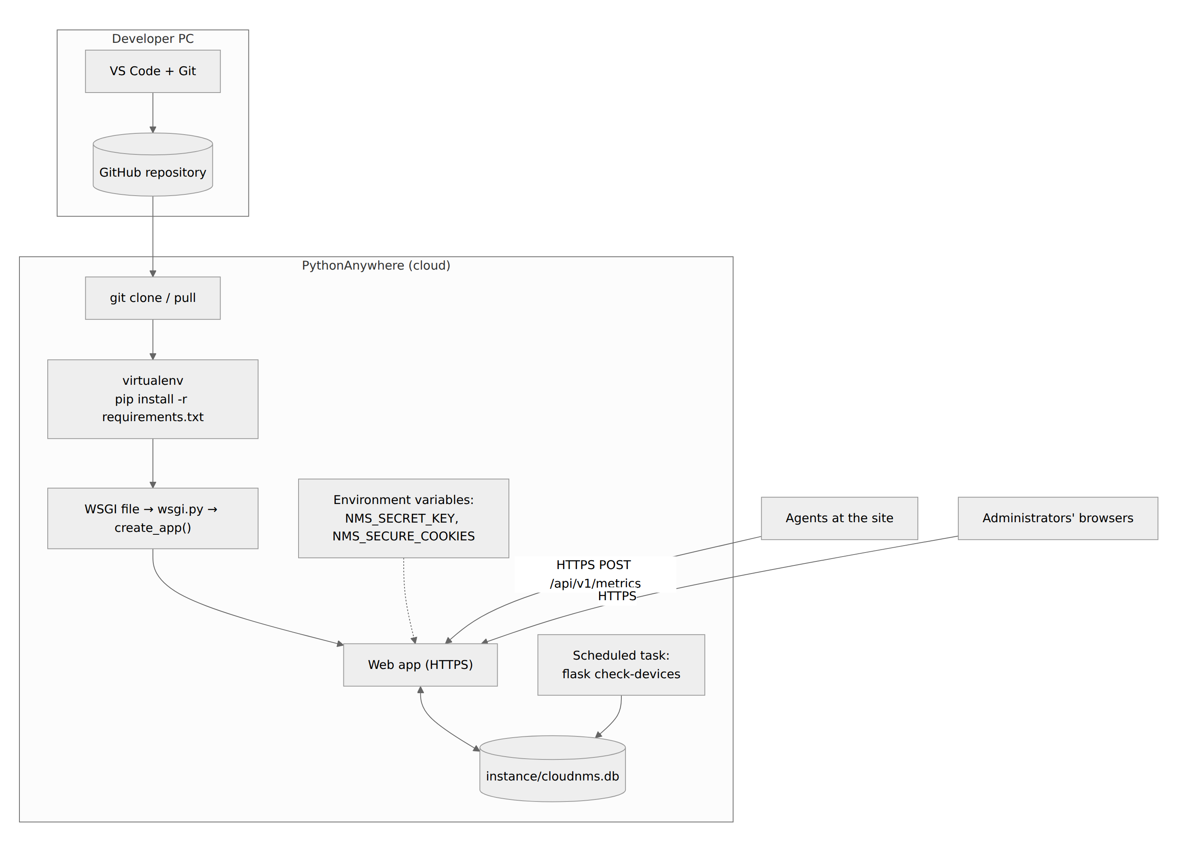
Figure 3.35: Deployment diagram
The deployment was carried out in the following steps:
- The source code was committed to Git and pushed to a GitHub repository.
- In a PythonAnywhere Bash console the repository was cloned into the home directory and a virtual environment was created: mkvirtualenv --python=/usr/bin/python3.11 cloudnms-env followed by pip install -r requirements.txt.
- On the Web tab a new web application was added using Manual configuration with Python 3.11, and the virtual environment and source directory were set.
- The WSGI configuration file was edited to add the project to the Python path, supply the secret key and secure-cookie setting as environment variables and import the application (see below).
- A static-files mapping was added from the URL /static/ to the app/static folder so that CSS and Chart.js are served efficiently.
- The database was created automatically on first start, and the first System Administrator account was created with flask --app wsgi create-admin.
- “Force HTTPS” was enabled and the web application was reloaded.
- A scheduled task was created to run flask --app wsgi check-devices, which marks silent devices offline and raises alerts. (Heartbeats are also checked each time the dashboard loads.)
- Devices were registered in the console and the monitoring agent was started at the site with each device's API key and the cloud URL.
# /var/www/<username>_pythonanywhere_com_wsgi.py
import os, sys
path = "/home/<username>/cloudnms"
if path not in sys.path:
sys.path.insert(0, path)
os.environ["NMS_SECRET_KEY"] = "<long random secret>"
os.environ["NMS_SECURE_COOKIES"] = "1"
from wsgi import app as application

After deployment, the checks in Table 3.3 were used to confirm that the system works in the cloud environment and not only on the development computer.
Check | Expected evidence
Application reachable | Login page loads over HTTPS at the PythonAnywhere address
Login and lockout | Successful login reaches the dashboard; failed login shows an error and appears in the audit log
Agent connectivity | Agent receives HTTP 201 responses and the device appears online on the dashboard
Fault detection | Stopping the agent marks the device offline after the heartbeat timeout; restarting it resolves the alert
Thresholds | Running the simulator with a forced CPU fault raises a critical alert
Reports | Reports generate and CSV export downloads
Authorisation | Technician account is refused access to Users, Thresholds and Audit log
Logout | Protected pages redirect to login after logout
Table 3.3: Deployment verification checklist
A note on the hosting environment: agents push data to the cloud, so they work from any network with outbound HTTPS. The on-demand “Poll now” probe works in the other direction, from the cloud server to the device, so it can only reach devices with a publicly reachable management address, and free PythonAnywhere accounts restrict outbound connections and limit scheduled tasks to once a day; heartbeat checks on dashboard load cover the gap between scheduled runs.
Access the live system here: https://<username>.pythonanywhere.com (replace with the address of your deployed application).

CHAPTER FOUR: CONCLUSION AND RECOMMENDATION

4.1 Conclusion
The aim of this project was to develop a Cloud-Based Network Management System that gives authorised administrators a single, secure and remotely accessible platform for monitoring network devices. Chapter One described the problem of manual and fragmented network monitoring, justified the project and set out the objectives, requirements, tools and schedule. Chapter Two presented the design of the system through user interface wireframes, the system architecture, flowcharts, data flow diagrams, the entity relationship diagram, the use case diagram and the class diagram. Chapter Three described the implementation of the user interface and logic with Flask, SQLAlchemy and Chart.js, the testing of the system and its deployment on PythonAnywhere.
All the specific objectives were achieved. The system authenticates users with account lockout and enforces three roles; it registers and manages devices; agents submit CPU, memory, latency, link-utilisation and packet-loss data through a secure API; faults are detected automatically from thresholds and heartbeats and managed through alerts; availability, performance and fault reports can be generated and exported; and the application runs in the cloud. All 26 automated tests pass, and system testing with seven days of simulated data showed that every scripted incident was detected. Testing also revealed weaknesses that were corrected – most importantly, alert flapping, which was halved by adding debounce and hysteresis to the fault-detection logic.
Through this project I gained practical knowledge of web development with Flask, relational database design with SQLAlchemy, REST API design, network performance metrics, secure authentication and authorisation, automated testing and cloud deployment. The main challenges were designing fault detection that is sensitive to real problems without flooding administrators with alerts, and testing a network system without a large production network, which was overcome by building a device simulator. These challenges strengthened my problem-solving and programming skills.

4.2 Recommendation
Although the system meets its objectives, the following improvements are recommended for future development:
- SNMP and additional protocols. Add SNMPv3 polling so that routers and switches that cannot run an agent can be monitored directly, and support NetFlow or sFlow for per-application traffic analysis (Harrington et al., 2002).
- Notifications. Send critical alerts by email, SMS or messaging apps so that administrators are informed even when they are not viewing the dashboard.
- Scalable database. Migrate from SQLite to PostgreSQL or MySQL, or a time-series database, and add data retention policies to support larger networks and many concurrent users.
- Stronger authentication. Add multi-factor authentication for administrator accounts and single sign-on with the organisation's directory.
- Network topology and configuration management. Draw an automatic network map and back up device configurations so that changes can be tracked and rolled back.
- Predictive analytics. Use historical data to forecast link saturation or disk exhaustion and warn administrators before failures occur.

REFERENCES
Beck, K., Beedle, M., van Bennekum, A., Cockburn, A., Cunningham, W., Fowler, M., … Thomas, D. (2001). Manifesto for agile software development. https://agilemanifesto.org/
Clemm, A. (2006). Network management fundamentals. Cisco Press.
Grassi, P. A., Fenton, J. L., Newton, E. M., Perlner, R. A., Regenscheid, A. R., Burr, W. E., … Theofanos, M. F. (2017). Digital identity guidelines: Authentication and lifecycle management (NIST Special Publication 800-63B). National Institute of Standards and Technology. https://doi.org/10.6028/NIST.SP.800-63b
Harrington, D., Presuhn, R., & Wijnen, B. (2002). An architecture for describing Simple Network Management Protocol (SNMP) management frameworks (RFC 3411). Internet Engineering Task Force. https://www.rfc-editor.org/rfc/rfc3411
Kurose, J. F., & Ross, K. W. (2021). Computer networking: A top-down approach (8th ed.). Pearson.
Laudon, K. C., & Laudon, J. P. (2022). Management information systems: Managing the digital firm (17th ed.). Pearson Education.
Liu, F., Tong, J., Mao, J., Bohn, R., Messina, J., Badger, L., & Leaf, D. (2011). NIST cloud computing reference architecture (NIST Special Publication 500-292). National Institute of Standards and Technology. https://doi.org/10.6028/NIST.SP.500-292
Mell, P., & Grance, T. (2011). The NIST definition of cloud computing (NIST Special Publication 800-145). National Institute of Standards and Technology. https://doi.org/10.6028/NIST.SP.800-145
OWASP Foundation. (n.d.-a). Authentication cheat sheet. OWASP Cheat Sheet Series. https://cheatsheetseries.owasp.org/cheatsheets/Authentication_Cheat_Sheet.html
OWASP Foundation. (n.d.-b). Authorization cheat sheet. OWASP Cheat Sheet Series. https://cheatsheetseries.owasp.org/cheatsheets/Authorization_Cheat_Sheet.html
OWASP Foundation. (n.d.-c). Logging cheat sheet. OWASP Cheat Sheet Series. https://cheatsheetseries.owasp.org/cheatsheets/Logging_Cheat_Sheet.html
Pallets Projects. (n.d.). Flask documentation. https://flask.palletsprojects.com/
PythonAnywhere LLP. (n.d.). PythonAnywhere help: Setting up Flask applications. https://help.pythonanywhere.com/pages/Flask/
Sommerville, I. (2016). Software engineering (10th ed.). Pearson.

