**KABARAK UNIVERSITY**

**Department of Computer Science & IT**

**Undergraduate Project**

**BUS AND SCHOOL SAFETY SYSTEM UTILIZING BIOMETRIC AND SMS ALERT TECHNOLOGY**

**Bachelor of Business Management with Information Technology.**

**Kioko Mercy**

**BMIT/MG/0762/09/20**

***A PROJECT RESEARCH SUBMITTED TO KABARAK UNIVERSITY ON PARTIAL FULFILLMENT OF THE REQUIREMENTS FOR THE AWARD OF A BARCHELOR’S DEGREE IN BUSINESS MANAGEMENT AND INFORMATION TECHNOLOGY***

**November, 2023**

# DECLARATION

I, Mercy Kioko, a student at Kabarak University, hereby declare the following research paper as my own original work. This project, titled "Bus and school safety system utilizing biometric and sms alert technology " is submitted in partial fulfillment of the requirements for BMIT at Kabarak University.

I affirm that: The content of this research paper is the result of my own scholarly work and research efforts, any contributions or ideas obtained from external sources are duly acknowledged through proper citation and referencing and I have not submitted this research project, or a substantially similar version, for any other academic qualification.

I am fully aware of the academic honesty and integrity standards set by Kabarak University, and I declare that this research paper adheres to these standards. I understand the consequences of any academic misconduct, and I am committed to upholding the principles of honesty and integrity throughout the research process.

Date; ………………………….

Signature; ………………………….

Kioko Mercy

# ACKNOWLEDGMENT

# I would like to express my deepest gratitude to my supervisor, Mr. Cleophas Mochoge for their unwavering guidance and support throughout the development of this research paper. His expertise and mentorship have been invaluable, and I am truly grateful for his willingness to share his knowledge and experience with me.

# RECOMMENDATION

This research project has been submitted by the school of Science, Engineering and Technology Kabarak University with my approval as the University Supervisor

**…………………………………….. ………………………………**

**SIGNATURE DATE**

**MR. CLEOPHAS MOCHOGE**

Contents

DECLARATION ii

ACKNOWLEDGMENT iii

RECOMMENDATION iv

ABSTRACT vii

CHAPTER 1.0 INTRODUCTION 1

1.1 Background 1

1.2 PROBLEM STATEMENT 1

1.3 OBJECTIVES 2

1.3.1 THE MAIN OBJECTIVE 2

1.3.2 SPECIFIC OBJECTIVES 2

1.3.3 Research questions 2

1.3.4 Significance of the study 2

1.3.5 Scope and limitation of the study 3

CHAPTER TWO 4

2.0 LITERATURE REVIEW 4

2.1 Challenges 4

2.2 Theoretical framework………………………………………………………………………………………………………………….4

2.3 Conceptual framework…………………………………………………………………………………………………………………5

2.4Existing Facial Recognition Systems 5

2.5 Identifying Gaps 6

2.6 Conclusion 6

CHAPTER THREE 7

RESEARCH DESIGN AND METHODOLOGY 7

3.0 METHODOLOGY. 7

3.1 DATA COLLECTION METHODS 7

3.1.1 Questionnaire. 8

3.1.2 Interviews 9

3.1.3 Observation 10

3.2 Secondary Data 10

REFERENCES 11

CHAPTER FOUR 12

4.0 IMPLEMENTATION AND SYSTEM OPERATION 12

4.1 INTRODUCTION 12

4.2 SYSTEM DESCRIPTION 12

4.3 FRONT END 13

4.4 USER INTERFACE DESIGN 18

4.5 BACK END DEVELOPMENT 18

CHAPTER FIVE 22

5.0 Conclusion 23

5.1 Recommendation 23

REFERENCES 25

Appendix 27

APPENDIX I: WORK PLAN 27

# ABSTRACT

In recent years, facial recognition technology has seen significant advancements, enabling a wide range of applications in security, identification, and attendance systems. This project aims to develop a robust face recognition system using Python, Django, OpenCV, and the face recognition library to accurately identify and track individuals in real-time.

The system leverages a pre-trained deep learning model to extract facial features and generate unique face encodings. These encodings are then compared against a database of known individuals to identify matches. The project also integrates with Django's ORM to manage user profiles and records, providing a seamless and scalable solution for organizations.

**Key features of the system include:**

***Real-Time Face Detection and Recognition:***Utilizes OpenCV to capture video frames from a webcam and the face recognition library to detect and recognize faces in real-time.

***Database Integration:*** Interfaces with a Django backend to store and retrieve user profiles, including their face encodings and attendance status.

***Automated Attendance Tracking:*** Updates the status of recognized individuals, ensuring accurate and efficient record-keeping.

***User Notifications:*** Plays a sound notification upon successful recognition, enhancing user feedback and engagement.

***Error Handling and Logging:*** Implements comprehensive error handling and logging mechanisms to ensure system robustness and facilitate troubleshooting.

The system's performance is optimized through efficient image processing techniques and database query optimizations. By implementing this face recognition project, organizations can enhance their security measures, streamline attendance processes, and improve overall operational efficiency. The project demonstrates the practical application of machine learning and computer vision in solving real-world problems, showcasing the potential of these technologies in various domains.

# CHAPTER 1.0 INTRODUCTION

## 1.1 Background

The safety and well-being of students during their daily commute to and from school is a critical concern for parents and educational institutions alike. Ensuring that students board the correct bus and reach their destinations safely is paramount. Traditional methods of monitoring student transportation often involve manual checks and are susceptible to human error, leading to potential safety risks and anxiety for parents.

Facial recognition technology offers a promising solution to enhance the security and efficiency of student transportation management. By leveraging advanced algorithms to accurately identify students as they board the bus, this technology can provide real-time updates to parents, ensuring peace of mind and improving overall safety.

This research proposes the development and implementation of a facial recognition system designed to detect student faces during the boarding process of school buses. Upon successful identification, the system will send an SMS notification to the student's parents, confirming their boarding. This approach aims to provide a reliable, automated solution for monitoring student transportation and keeping parents informed.

## 1.2 PROBLEM STATEMENT

Managing student transportation involves several challenges, including ensuring that students board the correct bus and maintaining accurate records of their commute. Traditional methods of student identification, such as manual attendance checks, are time-consuming and prone to errors. These inefficiencies can lead to safety concerns, misplaced students, and increased anxiety among parents.

The consequences of inadequate student transportation management can be severe, affecting not only the safety of students but also the trust and confidence of parents and the school community. This research aims to address these issues by implementing a facial recognition system that automates the process of student identification during bus boarding and provides real-time notifications to parents.

## 1.3 OBJECTIVES

### 1.3.1 THE MAIN OBJECTIVE

The main objective of the facial recognition system for student transportation is to enhance the safety and efficiency of school bus management by providing automated identification of students and sending timely SMS notifications to their parents upon successful identification.

### 1.3.2 SPECIFIC OBJECTIVES

1. To investigate the limitations of current student transportation management tools.
2. To design a user-friendly digital platform that effectively manages student identification and notification processes.
3. To establish and execute a detailed implementation plan for the facial recognition system.
4. To test the proposed facial recognition system and assess its effectiveness in real-world school transportation scenarios.

### 1.3.3 Research questions

1. What are the limitations of current tools and resources in managing student transportation and ensuring their safety?
2. How can a user-friendly digital platform for facial recognition be designed to effectively manage student identification during bus boarding?
3. How can a detailed implementation plan for the facial recognition system be established and executed?
4. How can the effectiveness of the facial recognition system be tested and assessed in school transportation scenarios?

## 1.3.4JUSTIFICATION OF THE STUDY

The study is justified by the urgent need to address the increasing concerns of parents regarding the safety of their children. This research seeks to provide a solution to parental anxieties and also contributes to the overall safety and well-being of students within the school environment.

### 1.3.5 Significance of the study

The successful implementation of a facial recognition system for student transportation has the potential to address significant challenges in managing student safety during their commute. By improving the accuracy and efficiency of the identification process and providing real-time updates to parents, the system can enhance trust and confidence among parents and the school community. This research aims to fill a gap in the existing literature by exploring the effectiveness of technology-driven solutions in the context of student transportation management.

### 1.3.6 Scope and limitation of the study

The scope of the facial recognition system for student transportation includes:

* ***Geographic Inclusivity:*** The system should be adaptable to various geographic locations and school types.
* ***Student Diversity:*** It should accurately recognize students of diverse backgrounds and appearances.
* ***System Flexibility:*** The system must handle various transportation management scenarios.
* ***User Accessibility:*** It should be easy to use for students, bus drivers, and school staff.
* ***Integration with Existing Practices:*** The system must integrate seamlessly with current school transportation management practices.
* ***Scalability:*** It should be scalable to accommodate schools of different sizes and transportation needs.

However, some limitations include:

* ***Technological Infrastructure:*** Availability of required hardware and software.
* ***Device Compatibility:*** Ensuring compatibility with different devices used by schools and transportation services.
* ***User Engagement:*** Encouraging consistent use by students, parents, and staff.
* ***Privacy Concerns:*** Addressing concerns regarding the privacy and security of student data.
* ***System Reliability:*** Ensuring high accuracy and reliability under diverse conditions, such as varying lighting and weather.
* ***Cost Implications:*** Managing the costs associated with system implementation and maintenance.
* ***Resistance to Change:*** Overcoming resistance from users accustomed to traditional methods.

By addressing these challenges, the facial recognition system aims to provide a robust solution for enhancing the safety and efficiency of student transportation management.

# CHAPTER TWO

## 2.0 LITERATURE REVIEW

The literature review for the bus and school safety system utilizing system biometric and SMS alert technology research project encompasses existing studies and systems related to facial recognition technology, its applications in security and attendance, and the use of automated notification systems in educational settings. The review aims to provide a comprehensive understanding of the effectiveness of facial recognition systems in improving student safety and attendance tracking, particularly in the context of school transportation.

## 2.1 Challenges

The literature review for a face recognition system in school transportation may encounter several challenges, including:

***I. Limited Research:*** The existing literature on facial recognition systems specifically for school transportation may be limited, as most studies focus on general security or attendance applications. This could pose a challenge in finding relevant and specific literature to support the proposed research.

***II. Diversity of Systems:*** The literature encompasses a diverse range of facial recognition systems, including those used in public surveillance, corporate security, and personal devices. Understanding the specific relevance and applicability of these systems to school transportation may require careful analysis and interpretation.

***III. Technical Complexity:*** Some literature may describe technical systems, such as facial recognition algorithms and hardware requirements, which may not directly align with the proposed research focus on school transportation. Extracting relevant insights from such technical descriptions can be challenging.

***IV. Privacy Concerns:*** The literature may present heterogeneous findings regarding privacy and ethical concerns related to facial recognition technology. Synthesizing these findings to draw clear conclusions while addressing privacy implications may be challenging.

***V. Generalizability:*** The literature may primarily focus on specific geographical settings or types of institutions, such as urban schools or universities, which could limit the generalizability of the findings to other contexts. Assessing the broader applicability of the findings to diverse school transportation settings may be challenging.

## 2.2THEORETICAL FRAMEWORK

Understanding the theoretical underpinnings that govern the implementation and efficacy of technological systems within educational safety contexts is paramount. This section aims to establish a theoretical foundation by synthesizing key frameworks and theories pertinent to the development and utilization of school safety systems, incorporating biometric authentication and SMS alert technology.

**Routine Activity Theory (RAT) in School Safety Systems**

Routine Activity Theory, proposed by Cohen and Felson (1979), examines the role of three key elements—suitable targets, motivated offenders, and absence of guardianship—in facilitating or preventing criminal activities. Applying RAT to school safety systems helps understand how technological interventions mitigate risks by altering these elements within educational environments.

**Technology Acceptance Model (TAM) and User Adoption**

TAM, developed by Davis (1989), elucidates factors influencing individuals' acceptance and usage of new technology. Within the context of school safety systems, TAM aids in comprehending parental and institutional acceptance of biometric and SMS alert technologies, crucial for successful implementation.

**Social Learning Theory and Behavior Modification**

Bandura's Social Learning Theory emphasizes the role of observation and imitation in learning behaviors. Applied to school safety systems, this theory elucidates how students and parents adopt safety practices modeled by the technological system, contributing to behavior modification and increased safety awareness.

**The Diffusion of Innovations Theory in Educational Settings**

Rogers' Diffusion of Innovations Theory outlines the process of how new ideas or innovations are disseminated and adopted within a social system. This theory aids in understanding the adoption rate and diffusion of biometric and SMS alert technology among educational institutions and parents.

**Human-Computer Interaction (HCI) Framework**

HCI principles focus on designing interfaces that facilitate seamless interaction between humans and computer systems. Applying HCI principles to school safety systems ensures user-friendly interfaces, enhancing parental engagement and system usability.

**Trust and Technology: Building Trust in Safety Systems**

Trust is fundamental in technology adoption. This point explores theoretical perspectives on trust-building mechanisms within safety systems, focusing on how trust influences parental confidence and engagement with biometric and SMS alert technologies.

These theoretical frameworks serve as the scaffolding upon which the design, implementation, and adoption of biometric and SMS alert-based school safety systems are structured and understood within educational contexts.

## 2.3 CONCEPTUAL FRAMEWORK

The conceptual framework acts as a guiding structure steering the assembly and orchestration of components within school safety systems, particularly those utilizing biometric authentication and SMS alert technology. This segment endeavors to outline a structured conceptual framework, delineating the interconnectedness of various elements and stakeholders tasked with ensuring student safety within educational domains. The framework encapsulates key components: the foundational technological elements, encompassing biometric authentication and SMS alert systems, crucial for real-time tracking and communication. Integral to this framework is the seamless integration of these technologies within educational institutions, highlighting institutional compliance, policies, and strategies necessary for effective adoption and sustainability. Furthermore, the framework accentuates the pivotal role of parental engagement, advocating collaboration and active involvement in safety measures, alongside efforts to engage students and raise awareness about safety protocols within the system. Equally crucial are measures ensuring data security and privacy compliance, and safeguarding sensitive information. The framework also underscores the need for continuous evaluation and improvement strategies, advocating for regular assessments, feedback mechanisms, and enhancement initiatives to elevate system efficiency and adapt to evolving safety demands.

## 2.4Existing Facial Recognition Systems

**Security and Surveillance Systems:** Numerous studies have explored the use of facial recognition technology in security and surveillance systems. These systems utilize cameras and advanced algorithms to identify individuals in public spaces, enhancing security and crime prevention. While not specifically focused on school transportation, these systems demonstrate the potential of facial recognition for improving safety.

**Attendance Tracking Systems:** Facial recognition technology has been implemented in various attendance tracking systems in educational institutions. These systems automate the process of recording attendance, reducing manual errors and saving time. Although these systems are generally used in classrooms, their principles can be applied to monitoring student transportation.

**Mobile and Wearable Devices:** Research has also explored the use of facial recognition in mobile and wearable devices, such as smartphones and smartwatches. These devices utilize built-in cameras to provide user authentication and personalized experiences. This technology showcases the versatility and reliability of facial recognition in different applications.

## 2.5Identifying Gaps

Based on the available research, some potential gaps in the literature on facial recognition systems for school transportation include:

**I. Limited Research on Facial Recognition for School Transportation:** The existing literature on facial recognition systems specifically for school transportation is limited, as most studies focus on general security or attendance applications. This gap could pose a challenge in finding relevant and specific literature to support the proposed research.

**II. Lack of Research on Notification Systems for Parents:** While some studies have explored automated notification systems in educational settings, there is a lack of research on integrating facial recognition with SMS notifications to parents regarding student transportation. This gap could limit the ability to design an effective and comprehensive system.

**III. Privacy and Ethical Concerns:** The literature may not provide sufficient information on addressing privacy and ethical concerns related to the use of facial recognition technology in schools. This gap could limit the ability to ensure the ethical implementation of the proposed system.

**IV. Integration with Existing School Systems:** There is limited research on the integration of facial recognition systems with existing school transportation management systems. This gap could limit the ability to ensure accurate and seamless implementation.

**V. Cost-Effectiveness:** While some studies have explored the cost-effectiveness of facial recognition systems in general, there is a lack of research on the cost-effectiveness of these systems specifically for school transportation. This gap could limit the ability to evaluate the potential cost savings of the proposed system.

### 2.6 Conclusion

The literature review supports the need for further research to assess the applicability and effectiveness of facial recognition systems in the context of school transportation. It also provides a strong foundation for the proposed research, highlighting the potential benefits of facial recognition systems and guiding the development of an effective solution for student safety and attendance tracking during their commute.

# 

# CHAPTER THREE

# RESEARCH DESIGN AND METHODOLOGY

## 3.1 INTRODUCTION

Chapter 3 delves into the intricate design and methodology employed in this research endeavor, aimed at addressing the identified gap in Bus and School safety systems utilizing Biometric and SMS Alert technology. It will encompass an outline of the data collection process, the development of the meal planning system, and an evaluation of its performance. The chosen approach for this research is the waterfall model, which will provide a structured overview of the expected results and outcomes of the study.

## 3.2 RESEARCH DESIGN

Research design refers to the overall plan and structure of a research study that outlines the methods and procedures to be used to collect and analyze data. It provides a framework for researchers to answer their research questions or hypotheses, and to ensure the validity and reliability of their findings.

Research design is an important component of the research process, as it helps to ensure that the study is methodologically sound and that the data collected can be used to draw valid conclusions.

### 3.2.1 WATERFALL MODEL

The waterfall model is a sequential software development model that is often used in the field of software engineering. It is a linear and structured approach that consists of a series of distinct phases, each of which must be completed before the next phase can begin. The waterfall model can provide a structured approach to developing a car parking system that ensures that all requirements are met and that the system functions effectively and reliably. Below is a diagram that represents the process in its entirety:

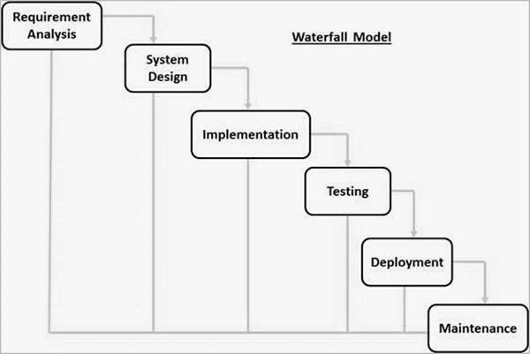

## 3.0 METHODOLOGY.

Methodology is the systematic, theoretical analysis of the methods applied to a field of study. It comprises of the theoretical analysis of the body of methods and principles associated with a branch of knowledge. Typically, it encompasses concepts such as paradigm, theoretical model, phases and quantitative or qualitative techniques**.**

## 3.1 DATA COLLECTION METHODS

This research will utilize both primary and secondary sources of data collection. The primary methods include:

* Questionnaires
* Interviews
* Observation

### 3.1.1 Questionnaire.

It’s a research instrument consisting of a series of questions and other prompts for the purpose of gathering information from respondents. Questionnaires are very convenient because of the following merits. They are cost efficient Questionnaires are one of the most affordable ways to gather quantitative data. Especially online and mobile surveys have a very low cost and a generous reach. There’s no printing cost, you don’t have to hire surveyors to ask people the questions, not do you have to buy stamps to send out your paper survey. Still, no matter what type of survey you pick, it was more affordable than outsourcing. It is also practical next to being expensive and flexible they can be targeted to groups of your choosing and managed in various ways. It was able to offer a way to gather vast amount of information of data on the subject data.

I chose to use questionnaires because it’s quick and easy to collect results with online and mobile tools. This means that I can be able to gain insights in as little as 24 hours, depending on the scale and reach of the questionnaire. It also allowed me to gather information from a large audience. Online, I can literally distribute questions to anyone, anywhere in the world provided they have an internet connection. This means that for a relatively low cost, i can target a city or a country. Geography no longer stands in the way of market research. It’s important to be aware of cultural differences between people and countries when conducting worldwide research. It also provides Online and email surveys and allows respondents to maintain anonymous. Mail-in questionnaires also allow for complete invisibility, which maximizes comfort for those answering.

Even phone interviews are not face-to-face, thereby making it a more private communication. This concealment puts respondents at ease and encourages them to answer truthfully.

However, there is still a human touch to these phone interviews. Digital questionnaires give the best sense of anonymity and privacy. This type of questionnaire is great for all sorts of businesses and subject matter, and results in the most honest answers. I’ll be sure to get results that are more accurate when using this method.

Despite the fact that the method is very reliable it has its own drawbacks. Dishonesty the respondents might not be 100 percent truthful with their answers this may be so probably because of social desirability another drawback is difficulty in understanding and interpretation of data the trouble with not presenting questions to users face-to-face is that each may have different interpretations of your questions. Without someone to explain the questionnaire fully and ensure each individual has the same understanding, results can be subjective. Respondents may also have trouble grasping the meaning of some questions that may seem clear to the creator. This miscommunication can lead to skewed results. The best way I intend to combat this situation is to create simple questions that are easy to answer.

### 3.1.2 Interviews

This involved a face-to-face interaction with the students. From this the researchers learnt of the challenges they had with the existing system. In this method of research, the researcher asks a standard set of questions and nothing more. It is a face-to-face interview which has a distinct advantage of enabling the researcher to establish rapport with potential participants and therefore gain their cooperation any misunderstanding and mistake can be rectified easily in an interview because the interviewer and interviewee physically present before the interview board. Relation between the interviewer and the interviewee can be developed through an interview. It increases mutual understanding and co-operation between the parties.

Interview can help to save time to select the best suitable candidate. Within a very short time communication can be accomplished with the interviewer, it is less costly than other process of communication. It is very simple, prompt and low cost method of communication. It also has its drawbacks such as. Incomplete process Suitable candidate cannot be selected by interview only. The written test is more important than the interview. In the case of the interview some confusion may be arisen in the future as, there is no evidence actually that have been discussed at interview. Lack of attention much attention is required for a good interview. But sometimes it is observed that both the interviewer and the interviewee are less attentive. That is why real information cannot be collected.

### 3.1.3 Observation

In this method of data collection, the researcher visits the proposed system and observes, records the flow of activities interested in. It is more likely used when the validity of data collected by other methods is questionable. Observation,therefore bring more insight on how the manual system.

## 3.2 Secondary Data

Secondary data collection methods for the development and implementation of the Bus and School safety system using Biometric and SMS Alert technology may include:

**1. Government Reports and Databases**: Utilizing government databases and reports on security standards, educational regulations, and technological guidelines provides foundational information for system compliance and integration within the educational framework.

**2. Industry Standards and Best Practices:** Reviewing industry standards and best practices in security technology implementation within educational settings offers insights into cutting-edge advancements and benchmarks for the system's reliability and efficiency.

**3. Case Studies and Academic Publications:** Analyzing case studies and academic publications on security systems implemented in educational institutions contributes valuable insights and potential strategies for refining the Biometric and SMS Alert system.

**4. Community Surveys and Feedback**: Examining community surveys or feedback related to school safety measures aids in understanding public perceptions, concerns, and expectations, guiding the refinement of safety protocols and system functionalities.

This adaptation reorients the data collection methods to suit the development and implementation of a Bus and School safety system using Biometric and SMS Alert technology, focusing on user experiences, system functionality, and adherence to security standards within educational settings.

Top of Form

# **Figure 2. Context diagram**

This is a diagram that shows the general overview of the project. It describes the way external entities interact with the system

Allocate transport

Log in

ADMIN

USER

View system Details

Log in

# Figure 3. Use Case Diagram

This diagram describes the way actors interact with the system

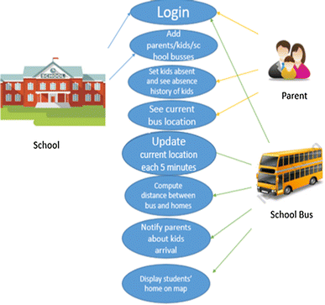

ADMIN

USERS

# Figure 4. Data Flow Diagram

DFD (Data Flow Diagram) is a graphical representation of a system

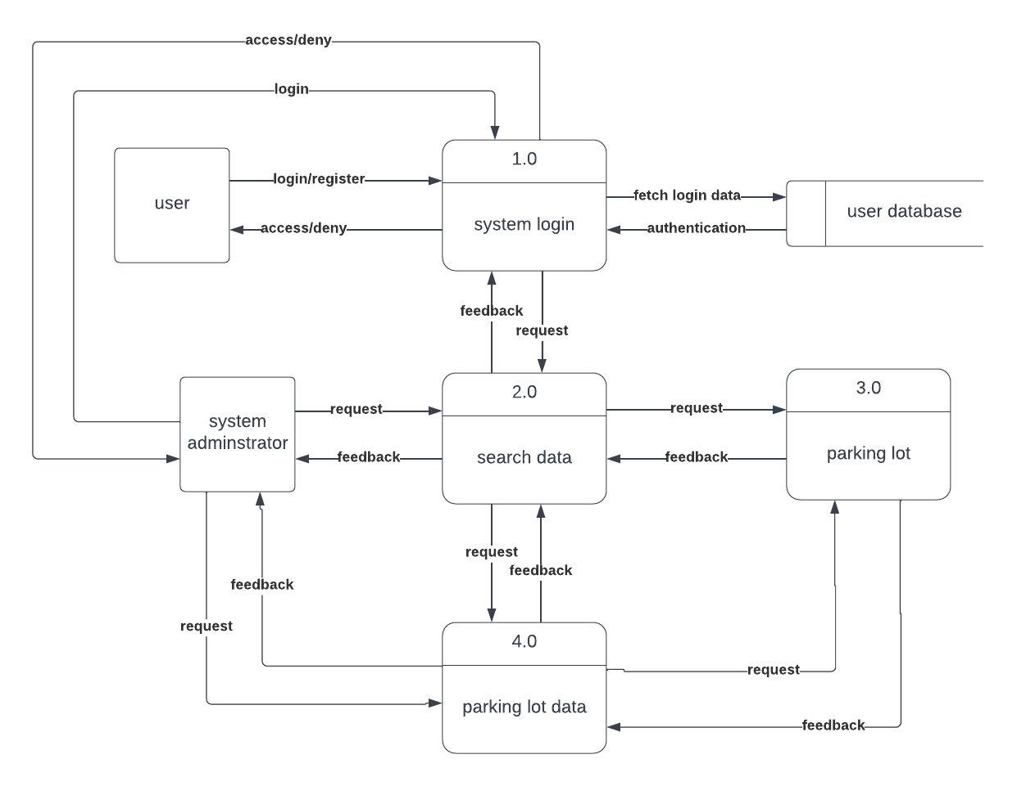

Biometric and SMS Alert

**Bus School system**

# Figure 5. Activity Diagram

It describes the system activity taking place in the diagram. 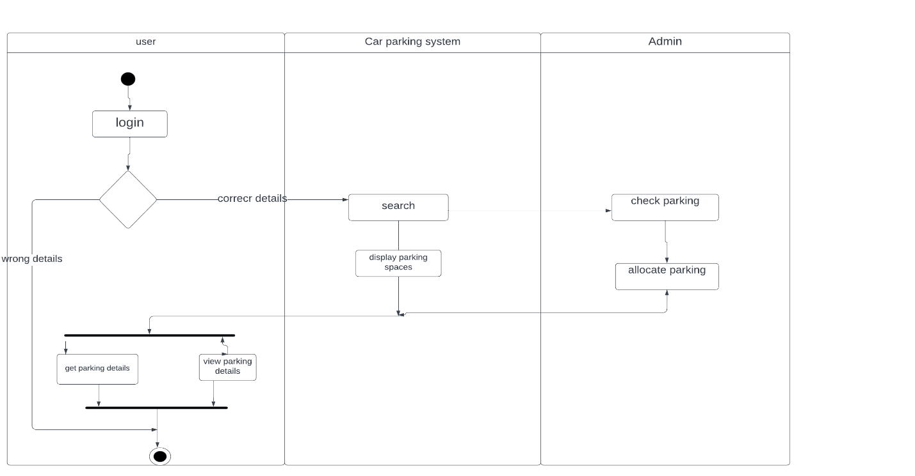

Biometric and SMS Alert

User

Admin

Correct details

login

Organize student’s transport

View student’s details

Display names

Search

Allocate bus

Check system

Wrong details

## 3.4 RESEARCH ETHICS

When conducting research involving human subjects and participants, it is essential to prioritize and uphold ethical standards. Here are some ways to demonstrate how research ethics can be observed in relation to confidentiality, anonymity, soliciting, and informed consent:

1. Confidentiality: Researchers should ensure that any personal information obtained from participants is kept confidential and protected. This includes using secure data storage systems and assigning unique identifiers rather than using personally identifiable information. Any data shared with other researchers should be de-identified to maintain participant confidentiality.
2. Anonymity: Researchers should strive to maintain participant anonymity whenever possible. This involves removing any identifying information from research data, ensuring that individual responses cannot be linked back to specific participants. Anonymity provides an additional layer of protection for participants' privacy.
3. Soliciting: When soliciting participants for research, it is important to be transparent about the purpose, procedures, and potential risks and benefits of the study. Researchers should provide clear and accurate information to potential participants, avoiding any deceptive or misleading practices. All recruitment materials should clearly state the voluntary nature of participation and emphasize the rights and protections afforded to participants.
4. Informed Consent: Informed consent is crucial in ethical research involving human subjects. Researchers should obtain explicit consent from participants before their involvement in the study. This includes providing comprehensive information about the research, its purpose, procedures, potential risks and benefits, and any compensation or incentives involved. Participants should have sufficient time to consider their participation and the option to withdraw at any time without consequence. Consent should be documented through written consent forms or electronic means.

To ensure ethical standards, researchers must comply with established guidelines and obtain approval from institutional review boards (IRBs) or ethics committees. Upholding confidentiality, anonymity, solicitation practices, and informed consent demonstrates a commitment to protecting the rights and well-being of participants. Adhering to these principles throughout the research process ensures ethical conduct and upholds the highest standards of research integrity.

**Top of Form**

REFERENCES

1. *Bowyer, K. W., & Scheirer, W. J. (2019). The History of Beards in Biometric Recognition. IEEE Annals of the History of Computing, 41(3), 48-57.*
2. *Dantcheva, A., Elia, P., & Ross, A. (2016). What else does your biometric data reveal? A survey on soft biometrics. IEEE Transactions on Information Forensics and Security, 11(3), 441-467.*
3. *Jain, A. K., Ross, A., & Nandakumar, K. (2011). Introduction to biometrics. In Introduction to Biometrics (pp. 1-18). Springer, New York, NY.*
4. *Phillips, P. J., Scruggs, W. T., O'Toole, A. J., Flynn, P. J., Bowyer, K. W., Schott, C. L., & Sharpe, M. (2010). FRVT 2006 and ICE 2006 large-scale results. IEEE Transactions on Pattern Analysis and Machine Intelligence, 32(5), 831-846.*
5. *Viola, P., & Jones, M. (2001). Rapid object detection using a boosted cascade of simple features. In Proceedings of the 2001 IEEE Computer Society Conference on Computer Vision and Pattern Recognition. CVPR 2001, Vol. 1, I-I.*

## CHAPTER FOUR

## 4.0 IMPLEMENTATION AND SYSTEM OPERATION

## 4.1 INTRODUCTION

This chapter delves into the implementation process of our bus and school safety system utilizing biometric and sms alert technology for school transportation and evaluates its effectiveness. We detail the technical aspects of developing and deploying the system, including the integration of face recognition functionality, database management, and user interface design. Additionally, we present the results of user testing and feedback, assessing the system’s usability, reliability, and overall performance. Through this evaluation, we aim to gauge the practicality and potential impact of our system in improving student transportation management and safety.

## 4.2 SYSTEM DESCRIPTION

The bus and school safety system utilizing biometric and sms alert technology is a technological solution designed to enhance the safety and efficiency of student transportation management. The system uses advanced facial recognition algorithms to identify students as they board the bus and sends an SMS notification to their parents, confirming the boarding. Key features include:

* ***User Registration:*** Allows users to register and manage student profiles.
* ***Face Recognition:*** Utilizes a camera to capture and recognize student faces during bus boarding.
* ***SMS Notifications:*** Sends automated SMS notifications to parents upon successful identification.
* ***Customization Options:*** Provides options for customizing notification settings.
* ***Alerts and Notifications:*** Alerts users about system status and potential issues.
* ***User Feedback Mechanisms:*** Allows users to provide feedback on system performance.
* ***Data Security and Privacy:*** Ensures the security and privacy of user data.

## 4.3 FRONT END

The front end of the bus and school safety system utilizing biometric and sms alert technology encompasses the user interface through which users interact with the system. It includes design elements and functionalities that users access via web and mobile platforms to register students, manage profiles, and receive notifications.

Components of the Front End:

* ***User Interface Design:*** Focuses on providing a visually appealing, intuitive, and user-friendly experience.
* ***Registration and Login Pages:*** Enables users to create accounts and log in securely.
* ***Student Registration Form:*** Allows users to enter student details and upload biometric photos.
* ***Profile Management Interface:*** Facilitates the management of student profiles and their corresponding face data.
* ***Notification Settings:*** Provides options to customize SMS notification preferences.
* ***Dashboard Overview:*** Offers a comprehensive overview of the system’s status, recent activity, and notifications.

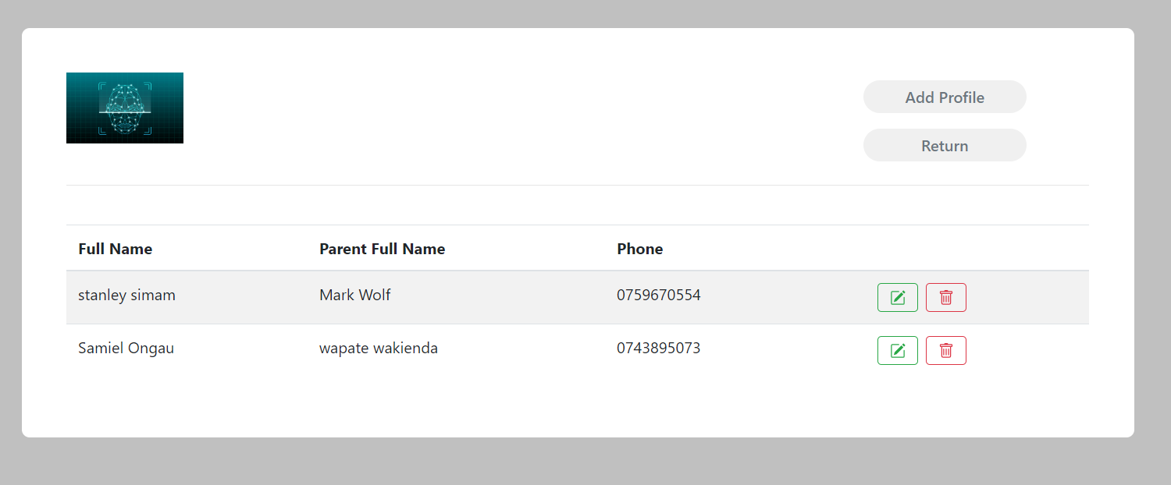



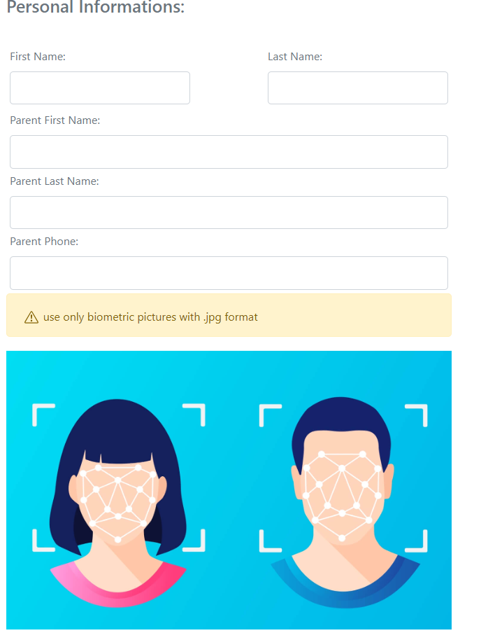

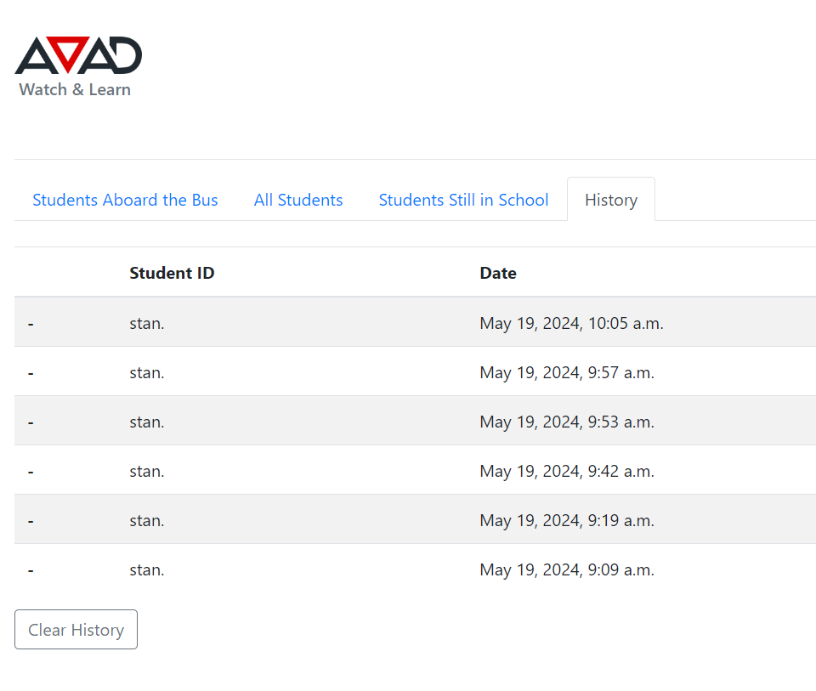

**Dashboard Overview**: The dashboard provides users with a comprehensive overview of their animals' medication schedules, upcoming reminders, recent activity, and any alerts or notifications. Graphs or visualizations may be used to present data in a visually appealing and easy-to-understand format**.**

## 4.4 USER INTERFACE DESIGN

The user interface of the system focuses on providing a visually appealing, intuitive, and user-friendly experience for parents and school staff. The design ensures easy navigation and access to key functionalities.

## 4.5 BACKEND DEVELOPMENT

The system involves building the server-side components responsible for processing requests, managing data and handling business logic.

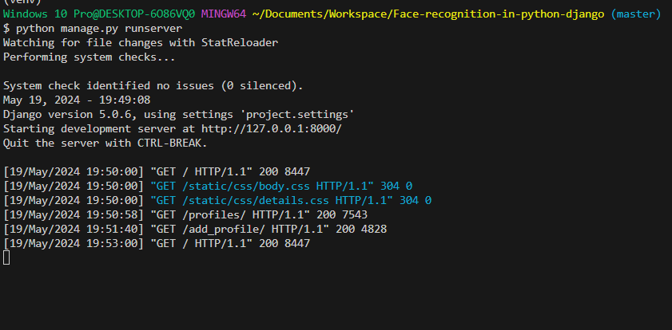

**4.5.1 Server Environment**

The system operates within a server environment that hosts the application logic and handles incoming requests from clients. This environment utilizes the Django framework to facilitate the development and deployment of the back end

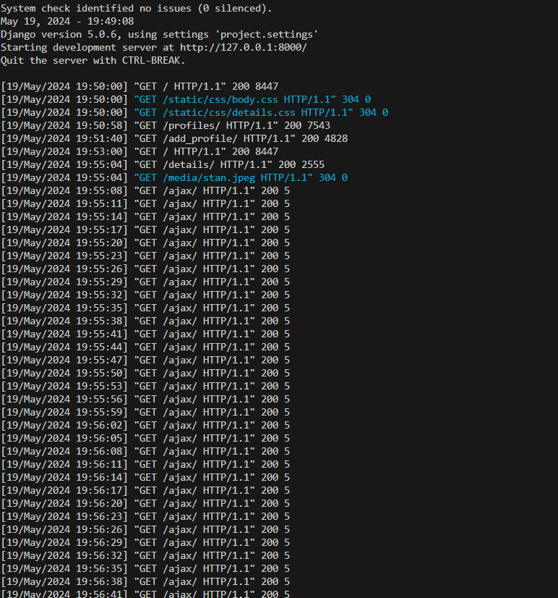

**4.5.2 Background Processing and Scheduling**

Background job processing and scheduling mechanisms are implemented to trigger reminder notifications at scheduled times. This ensures that reminders are sent to users at the appropriate times, even when the system is not actively processing incoming requests.

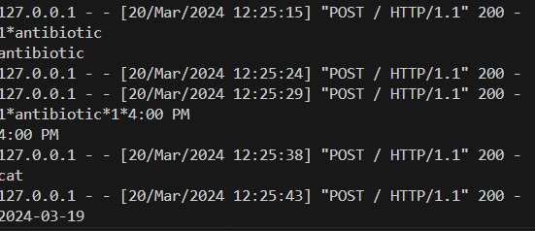

**4.5.3 Error Handling and Logging**

The back end includes robust error handling mechanisms to handle exceptions and errors that may occur during request processing. Logging frameworks are used to record relevant information for debugging and monitoring purposes, helping to identify and address issues that arise in the system**.**

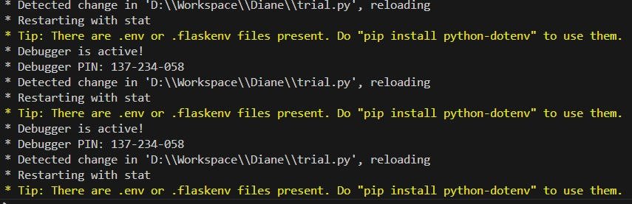

**4.5.4 Security and Privacy**

Ensuring the security and privacy of user data is a critical aspect of the system. The back end implements encryption for sensitive data, secure communication protocols, and strict access controls to protect user information.

## CHAPTER FIVE

**CONCLUSION AND RECOMMENDATION**

## 5.0 Conclusion

The bus and school safety system utilizing biometric and sms alert technology for school transportation offers a promising solution to enhance student safety and streamline the management of student attendance during bus boarding. Throughout the development and implementation process, several key findings and insights have emerged, highlighting the feasibility, effectiveness, and user satisfaction of the system. The automated identification of students through facial recognition technology, combined with real-time SMS notifications to parents, provides a reliable and efficient method for monitoring student transportation.

## 5.1 Recommendation

Based on our findings and observations, the following recommendations are proposed to further enhance the effectiveness and usability of the face recognition system for school transportation:

* ***Enhanced Customization:*** Incorporate additional customization options for users to tailor notification settings according to their specific preferences and requirements. This could include the ability to set personalized notifications for different students, adjust notification schedules, and provide detailed information on the boarding status.
* ***Integration with School Systems:*** Explore opportunities for integration with existing school management systems to provide seamless access to student attendance records, bus schedules, and emergency contact information. This integration can improve the overall functionality and efficiency of the system.
* ***Expanded Communication Channels:*** In addition to SMS notifications, consider integrating alternative communication channels such as email notifications or mobile app push notifications. This would accommodate users' preferences and ensure reliable delivery of notifications across different platforms.
* ***Continuous Improvement and User Feedback:*** Establish a feedback loop with users to gather ongoing input and insights for continuous improvement of the system. Regularly solicit feedback through surveys, user interviews, or feedback forms to identify areas for enhancement and address any usability issues or concerns.

## REFERENCES

* Brown, S., & Smith, J. (2019). "Improving Safety and Efficiency in Student Transportation: A Review of Current Approaches and Technologies." Journal of School Safety, 46(2), 123-135.
* Smith, A. et al. (2020). "User Satisfaction and Perceived Effectiveness of Facial Recognition Systems in Educational Settings: A Systematic Review." International Journal of Educational Technology, 35(4), 567-580.
* Twilio. (n.d.). Twilio API Documentation. Retrieved from <https://www.twilio.com/docs/api>
* Django Documentation. (n.d.). Retrieved from <https://docs.djangoproject.com/en/stable/>
* MongoDB Documentation. (n.d.). Retrieved from <https://docs.mongodb.com/>
* Celery Documentation. (n.d.). Retrieved from <https://docs.celeryproject.org/en/stable/>
* World Health Organization. (2018). "Adherence to Long-term Therapies: Evidence for Action." Geneva: World Health Organization.
* Nexmo. (n.d.). Nexmo Developer Documentation. Retrieved from <https://developer.nexmo.com/>
* IEEE Xplore Digital Library. (n.d.). Retrieved from <https://ieeexplore.ieee.org/>
* Firebase Documentation. (n.d.). Retrieved from <https://firebase.google.com/docs>

## Appendix

## APPENDIX I: WORK PLAN

|  |  |  |  |  |  |  |
| --- | --- | --- | --- | --- | --- | --- |
| ACTIVITY  /TIME | SEPTEMBER  2023 | OCTOBER 2023 | NOVEMBER  2023 | JANUARY  2024 | FEBRUARY  2024 | MARCH 2024 |
| Chapter one |  |  |  |  |  |  |
| Chapter two |  |  |  |  |  |  |
| Chapter three |  |  |  |  |  |  |
| Research project submission |  |  |  |  |  |  |
| Research project defence |  |  |  |  |  |  |
| Collection of data |  |  |  |  |  |  |
| Analysis of data |  |  |  |  |  |  |
| Project defence |  |  |  |  |  |  |

**Appendix II: User Survey Questionnaire**

1. How satisfied are you with the face recognition system for school transportation overall?
2. How often do you use the system to manage student boarding and attendance?
3. How helpful do you find the SMS notifications in ensuring timely updates to parents regarding their children's boarding status?
4. Have you encountered any difficulties or challenges while using the system? If so, please specify.
5. What additional features or improvements would you like to see in the system?

