DRIFTBOUND
GAME DESIGN DOCUMENT - V1.0
Top-down 2D Pixel Space Action RPG
Survive the void. Salvage the dead. Build a home among the stars.
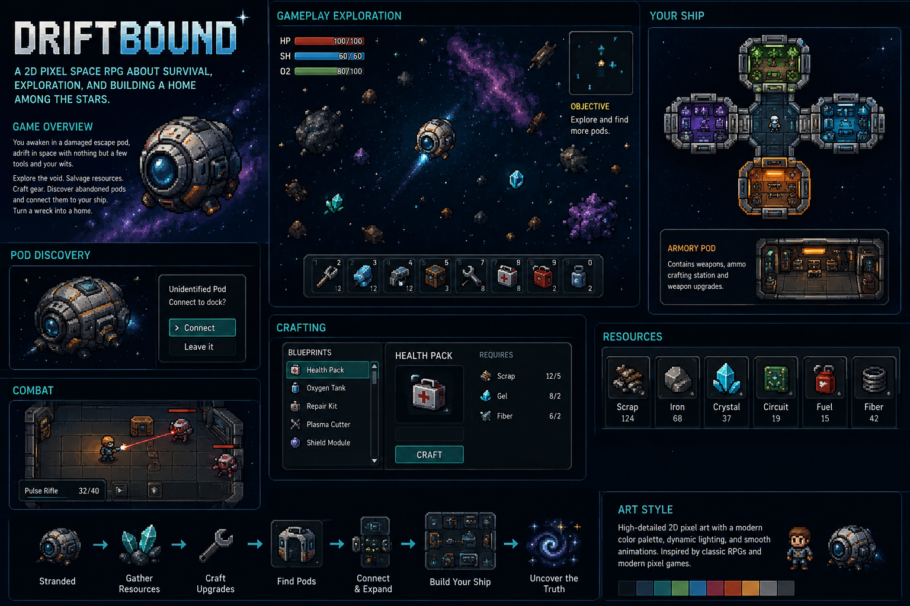

1. Project North Star
Driftbound is a top-down 2D pixel-art space survival action RPG. The player begins alone inside a damaged escape pod, with limited oxygen, power, tools, and information. The defining mechanic is that the player's ship is not selected from a menu or upgraded as a single object: it is physically assembled by discovering, clearing, repairing, docking, and repurposing abandoned pods found throughout space.
Every successful expedition should visibly change the player's home. The emotional arc is: stranded -> capable -> established -> powerful -> curious about what happened here.

Design Pillars
- BUILD THE SHIP YOU LIVE IN - progression must be physically visible in the connected pod layout.
- DISCOVERY HAS CONSEQUENCES - an unknown pod can contain safety, loot, enemies, survivors, hazards, or story.
- SURVIVAL WITHOUT BUSYWORK - oxygen, power, hull condition, and resources create decisions, not constant chores.
- SMALL-SCALE SPACE FEELS PERSONAL - the player's character, rooms, tools, and objects should remain readable and tactile.
- MYSTERY DRIVES EXPLORATION - every region and derelict should answer one question while creating another.

2. Player Fantasy & Core Loop
Player fantasy: "I started with almost nothing, survived the void, and built this strange ship myself from what I found."
- Scan nearby space and choose a destination, wreck, asteroid field, signal, or unidentified pod.
- Travel/explore while managing immediate risks such as oxygen, hazards, hostile life, machines, or debris.
- Gather salvage: scrap, metals, crystals, circuitry, fuel, fibers, biological material, blueprints, and rare components.
- Enter or breach discovered structures and clear hazards/enemies.
- Decide whether a pod is worth recovering.
- Repair or craft the required docking/connection components.
- Attach the pod to the player's growing ship.
- Restore, specialize, furnish, or repurpose the new room.
- Craft better gear and ship systems, opening access to more dangerous regions.
- Follow signals and environmental clues toward the larger mystery.

3. Camera, Presentation & Art Direction
- Camera: top-down / slight three-quarter top-down readability inspired by classic handheld monster-catching RPG map presentation, but NOT a direct visual copy.
- Rendering target: modern high-detail pixel art; visually closer to a contemporary '32/64-bit-feeling' pixel production than strict 16-bit limitations.
- Tile-based environments with enough detail to make machinery, doors, consoles, pipes, storage, hazards, and room identity immediately readable.
- Lighting is important: emissive screens, warning lights, suit lamps, nebula glow, weapon effects, darkness in unpowered pods.
- Animations should be smoother than classic handheld RPGs while retaining deliberate pixel construction.
- Space exterior: deep dark backgrounds, colorful nebulae, drifting debris, distant stars, asteroids, derelicts, resource clusters.
- Interior palette: dark industrial metals with strong room-specific accent colors and readable silhouettes.

4. Player & Controls
System | MVP Requirement | Later Expansion
Movement | 8-direction movement; responsive acceleration; collision. | Dash/boost, suit mobility upgrades.
Interaction | Context interact for doors, loot, consoles, docking, crafting. | Remote tools, hacking, contextual skills.
Combat | Real-time top-down action combat. | Weapon classes, status effects, builds, companions.
Vitals | Health + suit/ship oxygen or equivalent expedition pressure. | Radiation, temperature, contamination where region-specific.
Inventory | Limited but forgiving inventory with hotbar. | Storage networks, auto-sort, filters.

5. Ship & Pod System - Signature Feature
The ship is a connected graph of physical rooms/pods. A pod has docking points. Once recovered, it can be attached to a valid docking point and becomes part of the playable interior. The player walks through the actual connected rooms.

Pod Recovery States
- Detected - appears as a signal/contact.
- Identified - scan reveals partial information (type, damage, danger, unknowns).
- Boarded - player enters the pod.
- Secured - enemies/hazards/objectives are resolved.
- Recoverable - docking requirements are known.
- Attached - physically connected to the ship.
- Restored - power/oxygen/basic functionality repaired.
- Specialized - upgraded or repurposed for a chosen function.

Example Pod Types
- Armory - weapons, ammo/energy cells, weapon bench, upgrade slots.
- Workshop/Fabricator - advanced crafting and repair recipes.
- Med Bay - healing, status recovery, biological research.
- Hydroponics/Garden - renewable biological resources and food/oxygen bonuses.
- Storage/Cargo - expands storage and logistics.
- Reactor/Power - increases ship power budget.
- Life Support - oxygen capacity, filtration, expedition support.
- Navigation/Scanner - better map data, signal detection, route options.
- Crew Quarters - survivor/companion capacity.
- Research Lab - analyzes artifacts, organisms, technology, and story items.
- Unknown/Unique Pods - one-off story or mechanic rooms.

6. Exploration Structure
The game should feel like traveling through connected pockets of space rather than walking on a giant empty map. Regions contain navigable exterior zones and points of interest: wrecks, resource clusters, distress signals, stations, asteroids, anomalies, hostile nests, and drifting pods.
- Early region: relatively safe salvage field; teaches movement, oxygen, salvage, first docking.
- Mid regions: stronger hazards, locked systems, hostile factions/robots/organisms, multi-room derelicts.
- Late regions: severe environmental conditions, rare resources, high-value pods, major story structures.
- Exploration must regularly return something useful: materials, blueprint, pod, lore, shortcut, survivor, upgrade, or new signal.

7. Combat
Combat is real-time top-down action combat, not turn-based. It should be readable, quick, and dangerous enough that entering an unidentified pod creates tension.
- MVP weapon: pulse rifle or compact energy weapon with aim/fire/reload or heat behavior.
- Melee/tool option: plasma cutter or salvage tool that can double as an emergency weapon.
- Enemies telegraph attacks clearly; pixel effects should not obscure hit readability.
- Environmental combat can include explosive canisters, electrical panels, vacuum breaches, doors, cover-like machinery.
- Enemy categories can include malfunctioning security machines, scavengers, alien organisms, infected/altered entities, and later intelligent factions.

8. Resources, Crafting & Economy
Resource | Primary Use | Design Note
Scrap | Basic repairs / structures | Common universal salvage.
Iron/Alloy | Hull, tools, pod restoration | Structural material.
Crystal | Energy systems / advanced gear | More region-dependent.
Circuitry | Electronics, scanners, automation | Found in technical wreckage.
Fuel/Energy Cells | Travel and powered systems | Should create planning, not grind.
Fiber/Biomass | Medical, filters, biological recipes | Supports organic systems.
Rare Components | Major upgrades / special pods | Gate meaningful progression.

Crafting Rules
- Crafting begins simple: health pack, oxygen tank/refill, repair kit, basic ammunition/energy, docking component.
- Blueprints unlock new recipes; important progression recipes should be discoverable through exploration rather than random grind.
- Advanced crafting should depend on specialized rooms such as Workshop, Armory, Med Bay, or Research Lab.
- Do not overload the game with dozens of near-identical resources during MVP.

9. Progression
- CHARACTER: suit capacity, health, oxygen, movement, tool efficiency, weapon handling.
- EQUIPMENT: weapon tiers, mods, salvage tools, scanner, protection modules.
- SHIP: more pods, more docking options, power, storage, life support, scanner range, travel capability.
- KNOWLEDGE: blueprints, map information, decoded logs, faction/alien understanding.
- ACCESS: new regions require combinations of ship capability, equipment, and story discoveries.
Progression should avoid simple stat inflation as the only reward. The best upgrades unlock a new action, destination, room function, strategy, or way to solve a problem.

10. Narrative Framework
The opening intentionally provides limited context. The player awakens or regains control in a damaged pod and must solve immediate survival problems before understanding the larger situation. Story is delivered primarily through environmental evidence, recovered logs, strange signals, unique pods, survivors, and major derelicts.
- Central question: Why is this region filled with disconnected pods and wreckage, and what caused the collapse/disaster?
- Secondary question: Who was the player before becoming stranded, and why were they here?
- The ship itself becomes a record of the player's journey: recovered rooms can retain markings, damage, logs, or artifacts from prior owners.
- Avoid locking the final lore too early; prototype the gameplay mystery first, then write canon around the strongest mechanics.

11. UI / UX
- HUD: Health, shield/suit integrity if used, oxygen, compact objective, quick-access hotbar.
- Map/scanner: nearby signals, known pods, resources, hazards, home ship marker.
- Pod interaction: clear options such as Scan, Board, Connect, Leave; show docking requirements.
- Ship layout screen: readable top-down connected-room diagram with power/function status.
- Crafting: blueprint list, item preview, required materials, owned/required counts, craft action.
- Inventory/resource UI should favor icon + name + count; never rely on color alone.

12. MVP / Vertical Slice
The first playable milestone should prove the pod fantasy before building a large universe.
- 1 playable character with 8-direction movement and basic animations.
- 1 starting escape pod/home room.
- 1 small exterior space/salvage region.
- 3 resource types minimum.
- 1 craft station and 4-6 useful recipes.
- 1 ranged weapon + 1 salvage/melee tool.
- 2 enemy types.
- 3 discoverable pods: Armory, Workshop, and one mystery/utility pod.
- Boarding, clearing, repairing, docking, and physically walking into an attached pod.
- Basic ship power/oxygen logic.
- One short narrative thread leading to a larger signal.
- Save/load.
VERTICAL SLICE SUCCESS TEST: A new player should be able to start stranded, leave home, gather salvage, fight or evade danger, discover a pod, acquire the resources to recover it, attach it, enter the newly expanded ship, and use the new room function within one short session.

13. Explicit Non-Goals for Early Development
- No procedural galaxy at MVP.
- No massive open-world map.
- No multiplayer until the single-player pod loop is proven.
- No dozens of weapons, resources, factions, or biomes before the core loop works.
- No fully simulated orbital physics requirement.
- No turn-based combat unless playtesting shows action combat fundamentally fails.
- Do not build decorative ship customization before pod connection, room function, and exploration are fun.

14. Rules for the Game Design Agent
- Treat the modular pod/ship system as the game's primary differentiator. Do not remove or reduce it to a menu-only upgrade system.
- When proposing features, explain how they improve exploration, survival, pod discovery, ship growth, combat, or mystery.
- Prioritize a playable vertical slice over content volume.
- Keep systems understandable enough for a solo/small-team 2D project unless explicitly told to expand scope.
- Use placeholders for undecided lore rather than inventing permanent canon without approval.
- Maintain top-down modern pixel-art readability in all environment, UI, enemy, and animation recommendations.
- Every new resource must have a distinct gameplay purpose. Avoid resource bloat.
- Every pod type must create a meaningful function, decision, or story payoff.
- When designing a region, include: visual identity, hazard, resources, enemy set, pod opportunities, story clue, and progression requirement.
- When designing an enemy, include: silhouette, behavior, attack telegraph, counterplay, drops, and why it belongs in that region.
- When designing an item or upgrade, specify acquisition, recipe/cost, effect, progression tier, and what new decision it enables.
- Flag any suggestion that materially increases scope before implementing it.

15. Open Design Questions
- Does the character physically fly/jet through exterior space, pilot the starting pod, or use a small EVA craft?
- How freeform is pod placement: fixed docking nodes, grid-based attachment, or limited structural rules?
- Can pods be detached/rearranged later?
- Is ship power a global budget or room-by-room network?
- How punishing should oxygen be?
- Death model: reload, rescue/recovery, dropped salvage, clone/med system, or another fiction?
- Will friendly survivors/crew eventually inhabit recovered rooms?
- Hand-authored regions only, procedural encounter placement, or hybrid?
- Final title: Driftbound or replacement?

16. Immediate Production Order
- Lock movement scale, character sprite size, tile size, and camera framing.
- Prototype one starting pod interior.
- Prototype one exterior salvage area.
- Implement interaction + inventory + three resources.
- Implement crafting for repair/docking component.
- Create one abandoned pod with a hostile encounter.
- Implement pod secured state and docking.
- Make attached pod become a seamless walkable room on the home ship.
- Add one functional reward inside it (Armory recommended).
- Only after this loop feels good: expand enemies, rooms, regions, story, and progression.

DRIFTBOUND - V1 DESIGN NORTH STAR

