**Darkroom**

Progress Report #1

26 February 2014

Kyle Patterson, kip10

Blake Needleman, bsn5

Michael Knobloch, msk96

Eric Klawitter, exk218

**Abstract**

Darkroom is a website for photographers, video artists, or interested individuals to network and share quality pieces within a fine-arts community. Features such as commenting, rating, and guestbook-style communication are available to users to encourage community growth.

1. **Introduction**

Darkroom is a website and corresponding mobile application designed for sharing high quality photos and videos with people of similar interests. Darkroom provides the capability for other users to rate and comment on their work in the relevant categories, thus giving photographers an idea as to how to improve their work. The user system allows users to follow other users in order to keep up with their most recent work. Furthermore, the user profile allows users to display their personal or professional interests, as well as their equipment and contact info, which provides a social atmosphere in which users are able to discuss interests and got in contact with other users for professional requests.

* 1. **Project goals**
* Provide users the capability to sign up, post photos/videos, search users/photos/videos by title, rating and genre.
* Provide a “feed” which allows users to view the most relevant work based on who they are following and what their preferred genre is.
* Provide both a mobile app (android) and a website to work synchronously with the server and database with similar functionality.
  1. **Related systems**

Flickr is the most similar system, which provides a website designed primarily for photo sharing and a corresponding social media designed. Darkroom differs from Flickr primarily in that Darkroom allows users to sign in with Facebook or with an e-mail address whereas Flickr (owned by Yahoo!) requires a Yahoo! account to sign up. This difference allows for a more vibrant social media atmosphere due to Facebook’s popularity, as well as the convenience for not having to sign up for any third party (such as Yahoo! or Facebook). All that is required is an email address.

Instagram is another similar system. Darkroom, like Flickr, is different in that it targets a more professional audience than Instagram. Further, Darkroom’s primary interface will be via website, as opposed to Instagram which is primarily focused on its mobile application. This distinction allows for more high definition viewing and uploading. The rating and user profile system will also be more comprehensive than this.

Youtube/Vine are two video uploading applications. Aside from the obvious difference that Darkroom also provides image hosting, its video hosting will also be more professionally oriented than Vine, which limits videos to a six-second length.

* 1. **Advantages**
* Comprehensive rating and commenting system that allows users to rate work in various different categories
* Photo and Video uploading
* Facebook integration
  1. **Disadvantages**
* As with any startup website, the initial community may be small

1. **Application**
   1. **Features**

* Users can upload and share images and video
* Users can communicate directly with each other in an informal guestbook-style area
* Professional reviews and ratings can be left on a user’s profile, user’s galleries, and user’s individual files
* Users can enable/disable reviews, ratings, and comments for profiles, galleries, and files individually
* Users can configure presentation of galleries according to several predefined templates
* Users can tag uploaded files, and search through tags to find similar items
* Users can follow other accounts to track the activity of other users in a feed
* Integration with users’ existing Facebook account

1. **Methodology**
   1. **Data problems**

Security is a primary concern in Darkroom’s current data structure. Currently, there are no plans to detect malicious code hidden within uploaded files; files are simply being stored with read-only permissions, and any execution of files within the parent directory is blocked. Further, users are restricted to uploading files that meet the following conditions:

Images: JPEG, PNG, TIFF, BMP; Under 10 MB in size.

Video: MP4, WebM, Ogg; Under 1 GB in size.

These conditions have been chosen to meet constraints present in both HTML5 compatibility as well as server capabilities.

Data access is also a security concern for Darkroom. To protect against SQL attacks, the database will only be opened to internal communication. Parameter binding in addition to restricted access (i.e, no schema-level privileges) for a local database account will be utilized to avoid injection attacks.

1. **Software Design**
   1. **Software architecture**

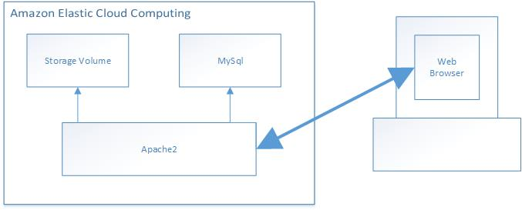

Darkroom will operate off of a traditional LAMP software stack. The entire package will be run from a virtual machine using Ubuntu 12.04 and hosted by Amazon Web Services. Apache2 will serve requests from client browsers via traditional HTTP and will use PHP for page generation and SQL queries. Files uploaded by clients, such as images and video, will be stored in regular storage volume space, with file permissions as detailed in §3.1. Information will be stored in a MySQL database.

**Figure 1** The software architecture, with arrows to show direction of control

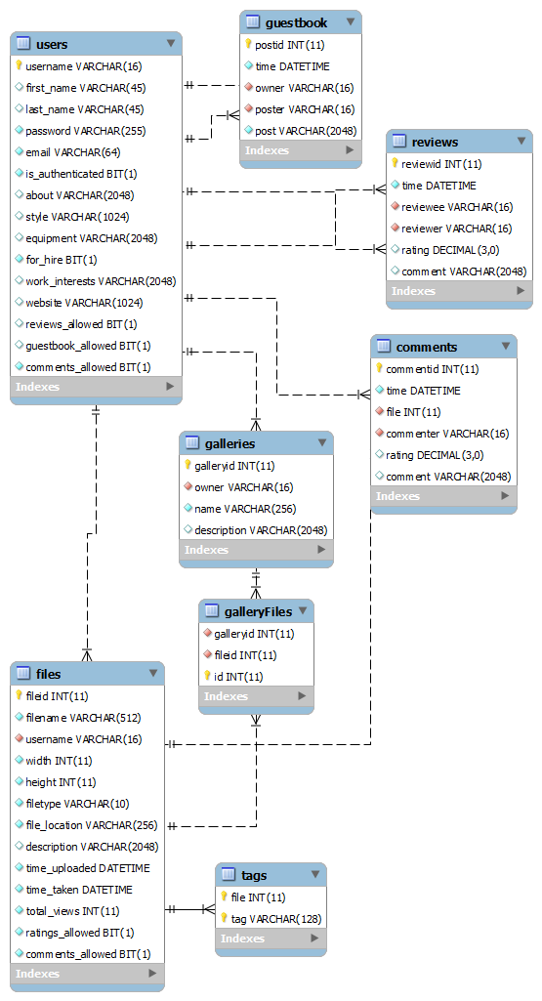

Data within the database is separated according to role in the application. The primary divisions lay in the users table, which maintains information on user accounts; the files table, which maintains information on all users’ images and videos; the galleries table, which works in junction with the galleryFiles table to maintain state data for users’ groups of files; and the communication system, which is split between the guestbook, the reviews, and comments. The guestbook table records entries between user’s guestbooks, a feature common in earlier web sites of the MySpace era; the reviews table records ratings and reviews on the photographer’s account; lastly, the comments table maintains a record of comments and reviews per file.

**Figure 2** The current schema design

1. **Project Management**
   1. **Roles & Responsibilities**

Kyle – Project Manager. Responsible for documentation, server maintenance, GUI design, webpage development.

Blake – Database control, including stored procedures and queries; file storage and retrieval

Michael – Identity management; communication features (e.g., comments, reviews); “follow” features.

Eric – File uploading; gallery system; tagging & search system.

* 1. **Milestones**
* Implementation of server-side infrastructure (COMPLETED)
* Construction of database schema (COMPLETED)
* Users can create an account, sign in, and upload a file (IN PROGRESS)
* Users can follow other users, create galleries, and communicate with other users via guestbook
* Users can review galleries and reply to existing comments
  1. **Deliverables**
* Fully functional HTML5 & PHP website
* Database schema

1. **User Interface**

In general, Darkroom maintains a warm, welcoming, and professional presentation to encourage the feelings of community and fine arts.

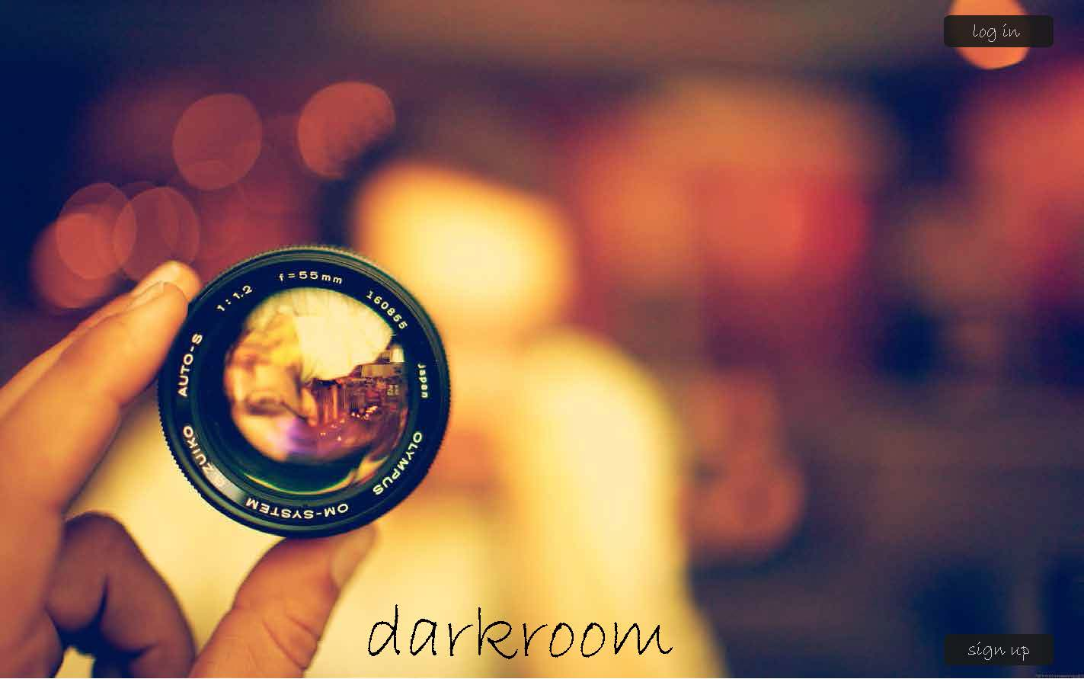

**Page 1** The homepage of darkroom

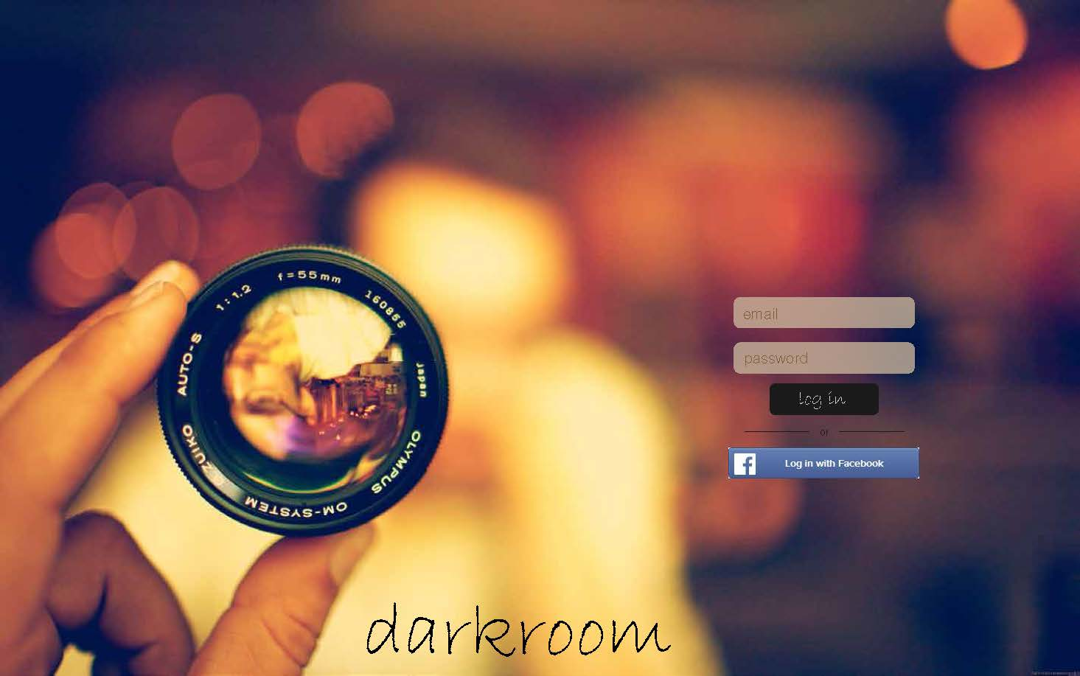

**Page 2** The login page for darkroom

The default screen of Darkroom will seek a minimalist, warm style to present a high-quality, welcoming, and fine-art atmosphere to users.

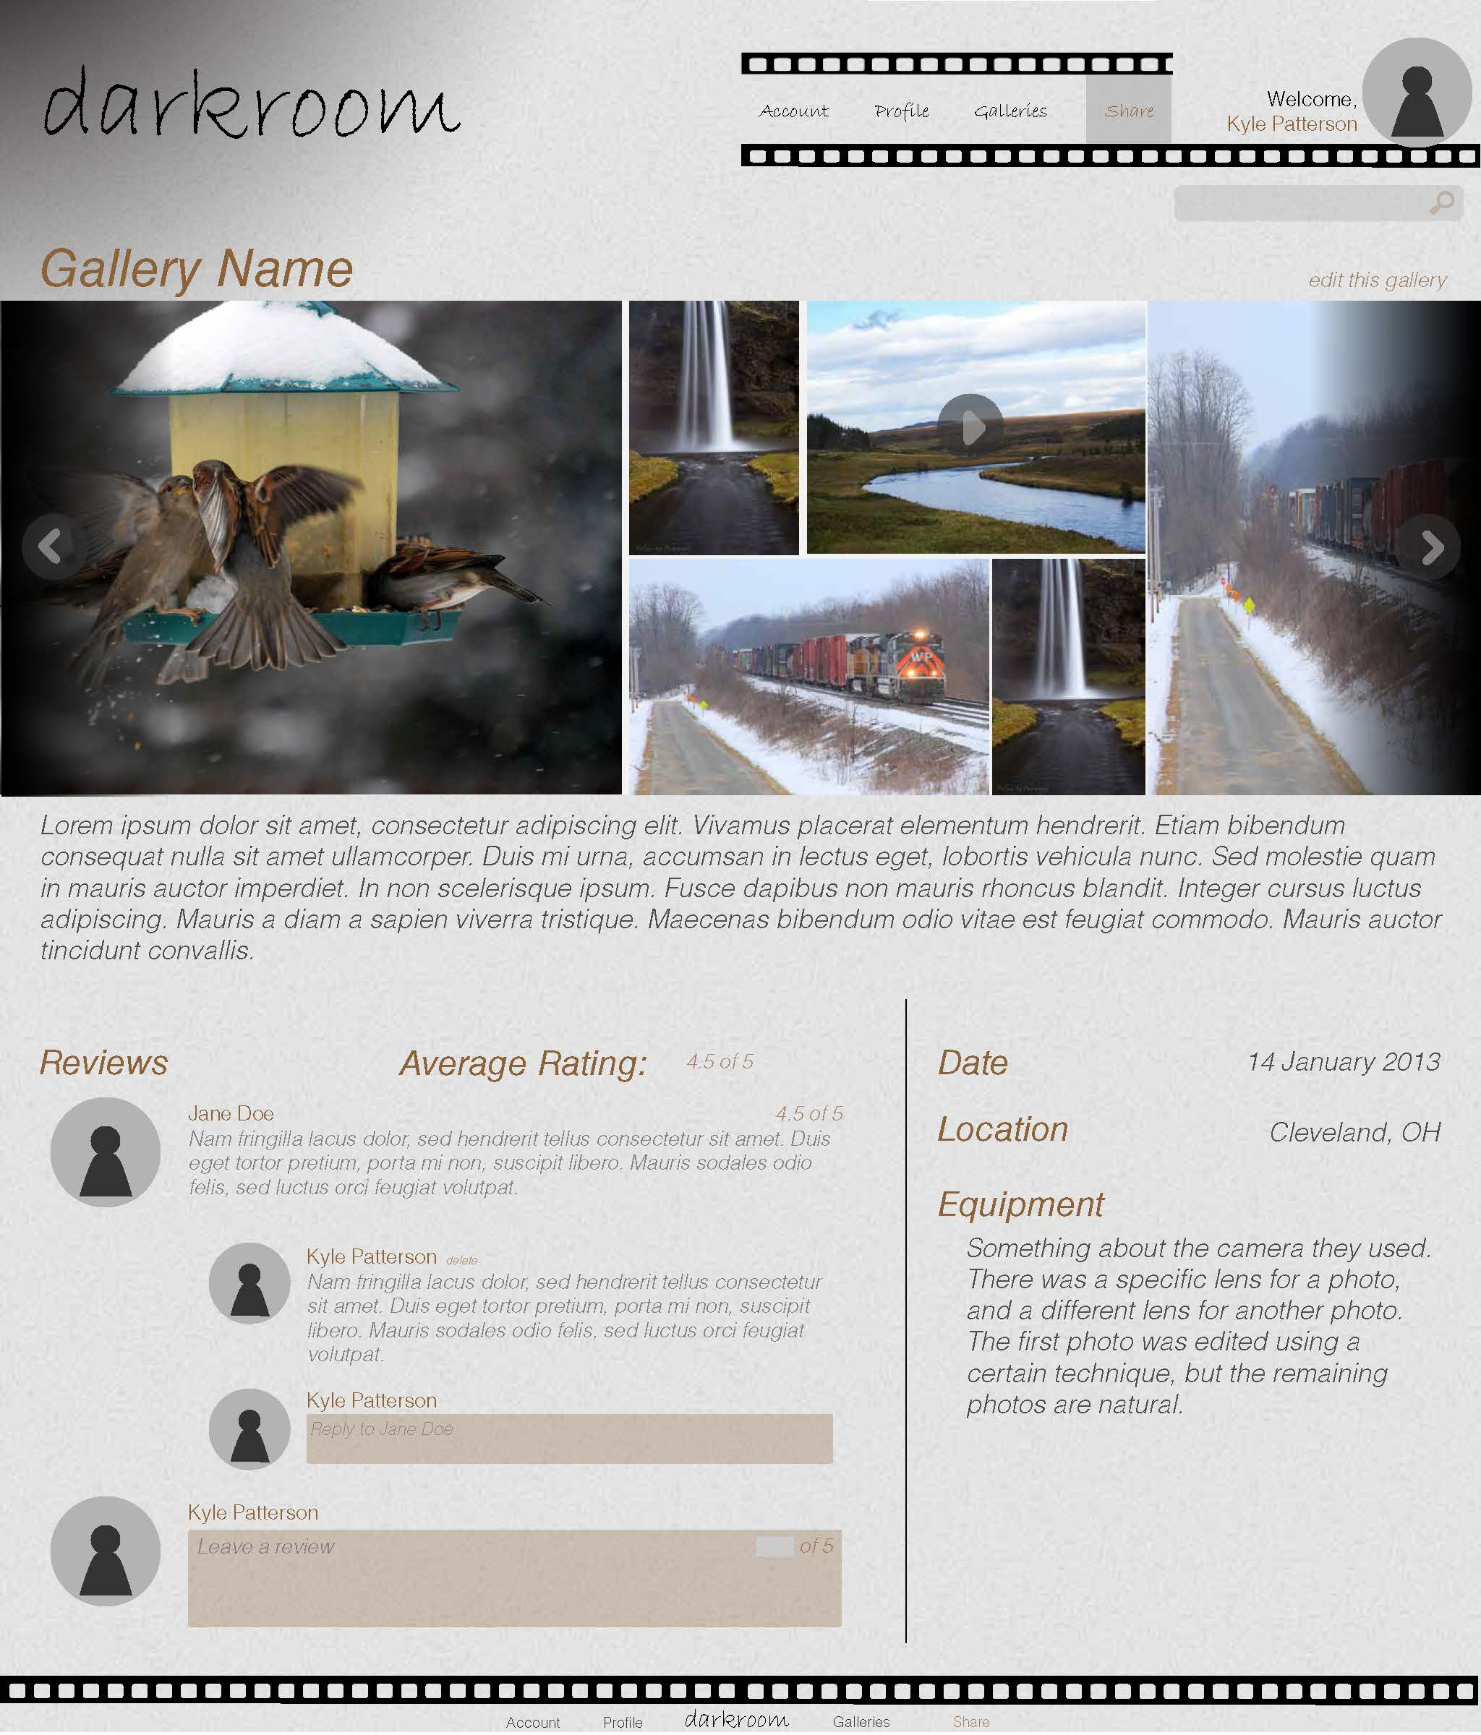

**Page 3** The gallery view

Toying with elements familiar to most professional photographers, darkroom will focus gallery presentations on three key items: the files within the gallery, the reviews and conversations within the gallery, and detailed information on the gallery’s contents. Gallery owners may customize the gallery’s presentation (such as image order) according to pre-defined templates.

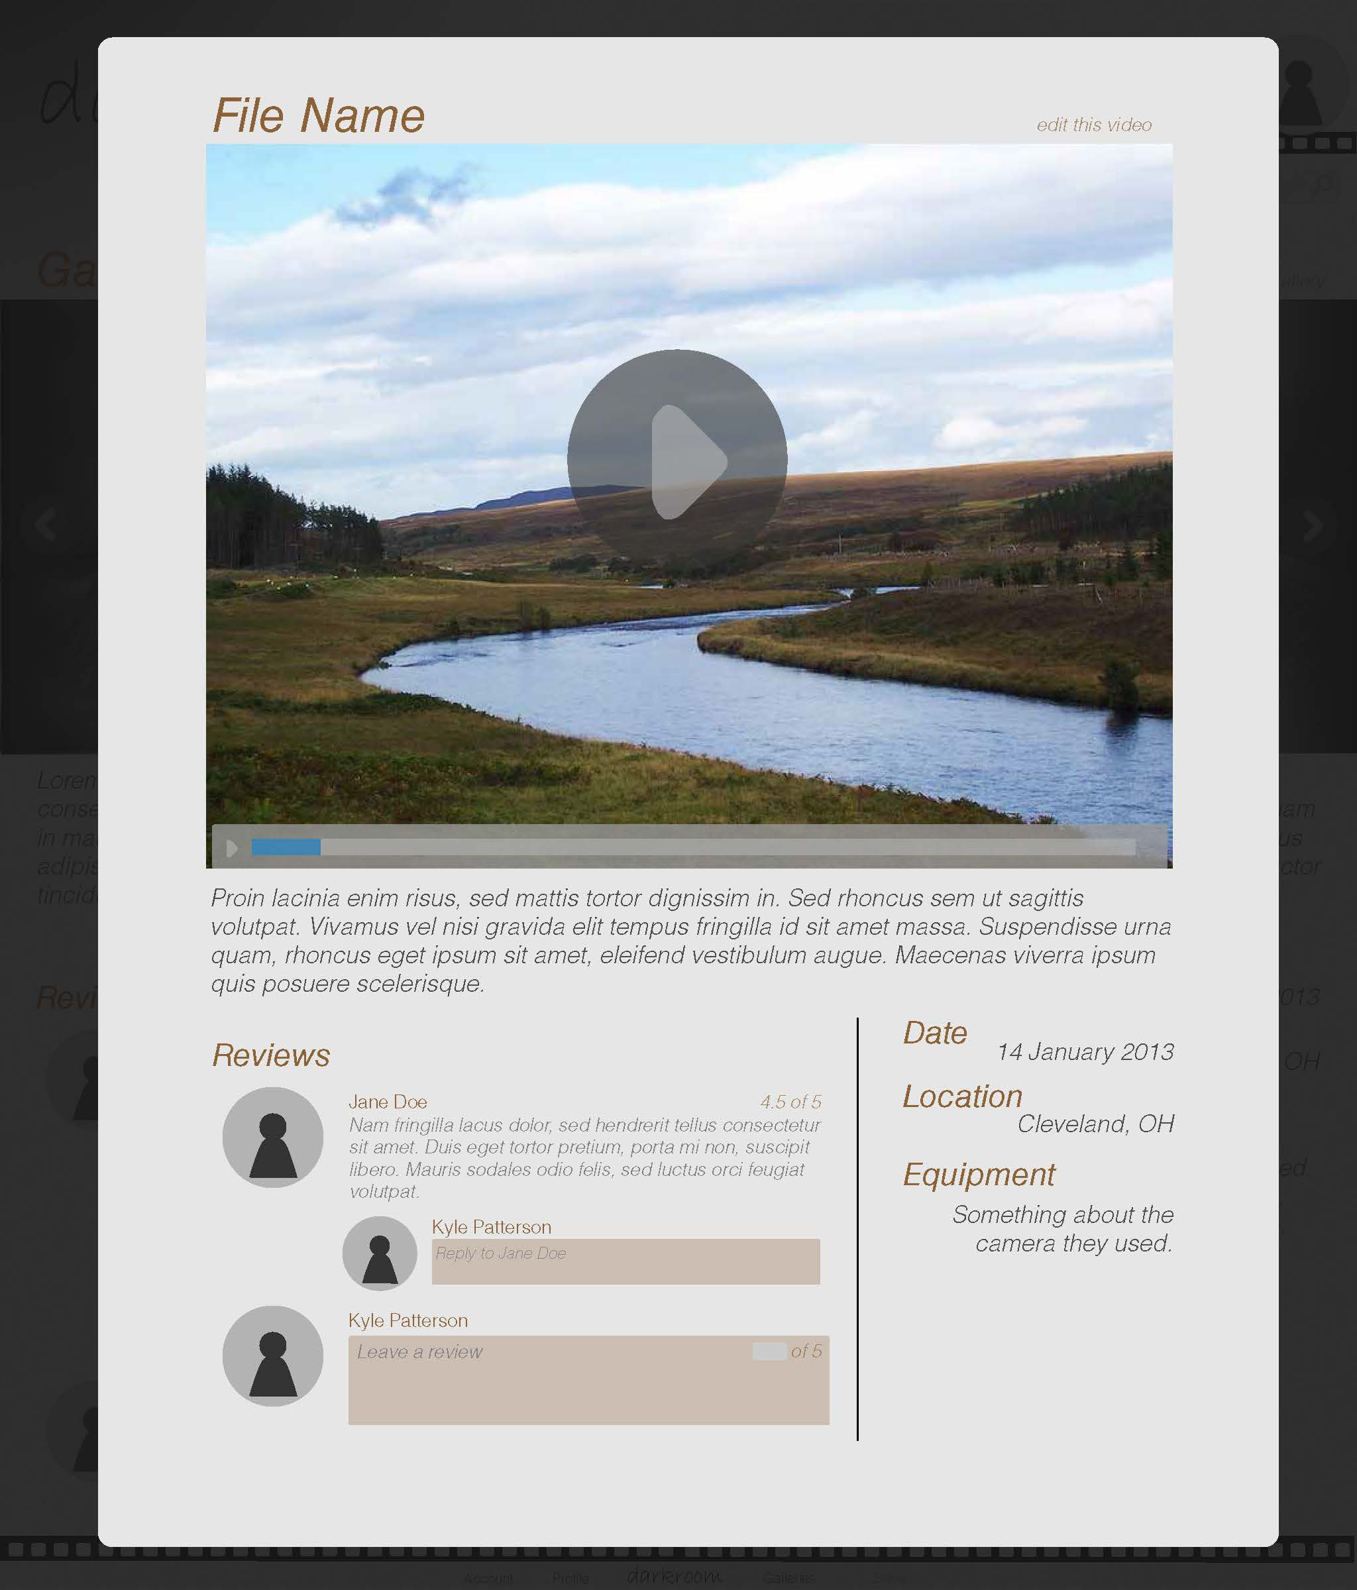

**Page 4** The image/video view from a gallery

Users may open individual items within a gallery to leave feedback on particular pieces, or enlarge the file to full-screen mode.

1. **Project Progress**

Development is underway for Darkroom, although behind schedule. The system framework has been constructed and the database built, and web page generation has been started. User account management is in progress, as is the file uploader. Progress can be seen on the current development server at IP 54.201.1.107

* 1. **Notable Issues**

Darkroom’s development faced three difficult issues within this development period:

* One of the group’s development machines suffered hardware damage this past week, rendering current progress unavailable. Data recovery is in progress, but slowed down development.
* An interrupted Windows Update caused irreparable damage to existing user interface designs; a backup of the designs was available, but outdated, causing data loss.
* Development was initially delayed by several days due to a complete topic change in the second week of February, effectively reducing the development window to two weeks.

In combination, these issues have forced a large delay in development. Darkroom should be back on schedule with more complete documentation by Progress Report #2.

**Appendices**

* 1. **Third-party software**

**Dropzone.js** – An open source library that provides a clean interface for users to upload files. It allows users the capability to either click and upload from the filepath, or drag and drop a file.

**php-login** – A php script incorporated in login page functions. The main features include Facebook login, user session tracking, email authentication, and hashing. This script will require edits to match Darkroom’s schema.