

ADDIS ABABA UNIVERSITY

**COLLEGE OF NATURAL AND COMPUTATIONAL SCIENCES**

**SCHOOL OF INFORMATION SCIENCES**

2025 A.Y 3RD YEAR INFORMATION SYSTEMS

INDIVIDUAL ASSIGNMENT : ADMINISTRATION OF SYSTEMS AND NETWORKS

NAME : ARSEMA MENGISTU MERGYA UGR : 9145/15

SECTION : 3

**Supervised by:** Dr. Workshet Lamenew Dep’t Of Information Systems

**Submission Date: Monday Mar 2, 2025 G.C**

ADMINISTRATION OF SYSTEMS AND NETWORKS INDIVIDUAL ASSIGNMENT

1. show with diagram the three way handshaking at time of connection establishment. Which transport protocol is used for such a purpose.

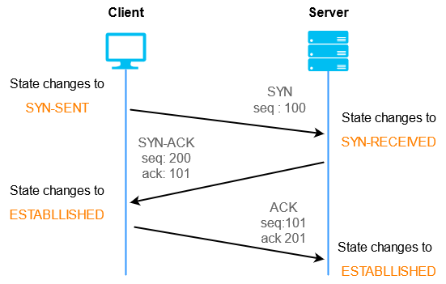

The three way handshake is established before the actual connection between the devices. It is used to make sure the device on the other side is synchronized and is able to receive and acknowledge data that is sent from the sender device.

The sender device first sends a synchronization message to the receiver end, then the receiver will send another message that acknowledges the synchronization that was sent. Lastly the client end will send acknowledgment that reassures the establishment of the connection for data transfer.

The protocol that is responsible for carrying out this operation at the fourth layer (transport layer) of the OSI model is TCP ~ transmission control protocol. We call this a connection oriented approach because we have to make sure the server/receiving side is ready to receive before starting to send the packets.

1. Assume there are 5 networks in an organization each consisting of a maximum number of 50, 24, 16, 5 and 3 computers respectively. You are given IP address 192.168.1.0/24. Using VLSM subnetting allocate IP addresses for each network. Determine also the network, broadcast, subnet mask and default gateway addresses for each network.

|  |  |  |  |
| --- | --- | --- | --- |
| **Branch Name** | **Maximum number of devices** | **Number of addresses** | **Host bits** |
| Branch 1 | 50 | 52 | 6 |
| Branch 2 | 24 | 26 | 5 |
| Branch 3 | 16 | 28 | 4 |
| Branch 4 | 5 | 7 | 3 |
| Branch 5 | 3 | 5 | 2 |

IP given = 192.168.1.0/24.

**Branch 1 =** Maximum 50 devices needed, IP = 192.168.1.0/24

|  |  |
| --- | --- |
|  | /26 |
| Network Address | 192.168.1.0 |
| Subnet Mask | 255.255.255.192 |
| Broadcast Address | 192.168.1.63 |
| Host Address Range | 192.168.1.1 - 192.168.1.62 |
| Default Gateway | 192.168.1.1 |

In this branch we needed to connect a maximum of 50 devices so we used the /26 representation, By borrowing 2 bits from the host side.

**Branch 2 =** Maximum 24 devices needed, IP = 192.168.1.64/24

|  |  |
| --- | --- |
|  | /27 |
| Network Address | 192.168.1.64 |
| Subnet Mask | 255.255.255.224 |
| Broadcast Address | 192.168.1.95 |
| Host Address Range | 192.168.1.65 - 192.168.1.94 |
| Default Gateway | 192.168.1.65 |

In this branch we needed to connect a maximum of 24 devices so we used the /27 representation, By borrowing 3 bits from the host side.

**Branch 3 =** Maximum 16 devices needed, IP = 192.168.1.96/24

|  |  |
| --- | --- |
|  | /28 |
| Network Address | 192.168.1.96 |
| Subnet Mask | 255.255.255.240 |
| Broadcast Address | 192.168.1.111 |
| Host Address Range | 192.168.1.97 - 192.168.1.110 |
| Default Gateway | 192.168.1.97 |

In this branch we needed to connect a maximum of 16 devices so we used the /28 representation, By borrowing 4 bits from the host side.

**Branch 4 =** Maximum 5 devices needed, IP = 192.168.1.112/24

|  |  |
| --- | --- |
|  | /29 |
| Network Address | 192.168.1.112 |
| Subnet Mask | 255.255.255.248 |
| Broadcast Address | 192.168.1.119 |
| Host Address Range | 192.168.1.113 - 192.168.1.118 |
| Default Gateway | 192.168.1.113 |

In this branch we needed to connect a maximum of 5 devices so we used the /29 representation, By borrowing 5 bits from the host side.

**Branch 5 =** Maximum 3 devices needed, IP = 192.168.1.120/24

|  |  |
| --- | --- |
|  | /30 |
| Network Address | 192.168.1.120 |
| Subnet Mask | 255.255.255.252 |
| Broadcast Address | 192.168.1.123 |
| Host Address Range | 192.168.1.121 - 192.168.1.122 |
| Default Gateway | 192.168.1.121 |

In this branch we needed to connect a maximum of 3 devices so we used the /30 representation, By borrowing 6 bits from the host side.

* 1. given organization needs to establish independent networks for its 10 branches. Assume it has been decided to use two class C IP addresses 200.200.22.0/24 and one 200.200.33.0/24. Use VLSM (Variable Length Subnet Mask) to subnet and allocate IP addresses for all branches.

|  |  |  |  |
| --- | --- | --- | --- |
| **Branch name** | **Maximum number of computers** | **Number of addresses** | **Host bits** |
| Branch 1 | 49 | 51 | 6 |
| Branch 2 | 58 | 60 | 6 |
| Branch 3 | 42 | 44 | 6 |
| Branch 4 | 119 | 121 | 7 |
| Branch 5 | 37 | 39 | 6 |
| Branch 6 | 25 | 27 | 5 |
| Branch 7 | 3 | 5 | 2 |
| Branch 8 | 4 | 6 | 2 |
| Branch 9 | 5 | 7 | 3 |
| Branch 10 | 5 | 7 | 3 |

a. Draw a diagram that shows all the networks and the interfaces of the routers.

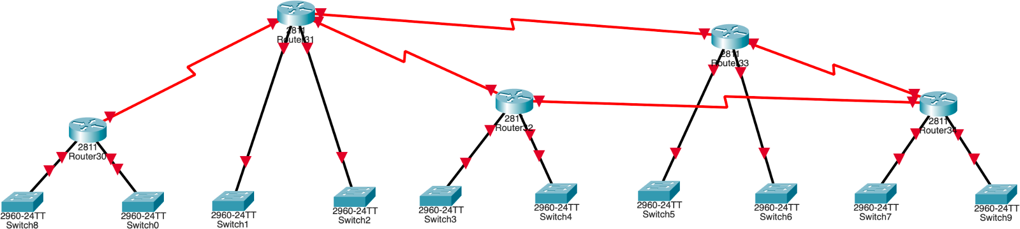

B. Write for all networks the network, broadcast, subnet mask addresses.

.

# **Branch 1 =** Maximum 49 devices needed, IP = 200.200.22.0/24

|  |  |
| --- | --- |
|  | /26 |
| Network Address | 200.200.22.0 |
| Subnet Mask | 255.255.255.192 |
| Broadcast Address | 200.200.22.63 |
| Host Address Range | 200.200.22.1- 200.200.22.62 |
| Default Gateway | 200.200.22.1 |

In this branch we needed to connect a maximum of 49 devices so we used the /26 representation, By borrowing 2 bits from the host side.

# **Branch 2 =** Maximum 58 devices needed, IP = 200.200.22.64/24

|  |  |
| --- | --- |
|  | /26 |
| Network Address | 200.200.22.64 |
| Subnet Mask | 255.255.255.192 |
| Broadcast Address | 200.200.22.127 |
| Host Address Range | 200.200.22.65- 200.200.22.126 |
| Default Gateway | 200.200.22.65 |

In this branch we needed to connect a maximum of 58 devices so we used the /26 representation, By borrowing 2 bits from the host side.

# **Branch 3 =** Maximum 42 devices needed, IP = 200.200.22.128/24

|  |  |
| --- | --- |
|  | /26 |
| Network Address | 200.200.22.128 |
| Subnet Mask | 255.255.255.192 |
| Broadcast Address | 200.200.22.191 |
| Host Address Range | 200.200.22.129- 200.200.22.190 |
| Default Gateway | 200.200.22.129 |

In this branch we needed to connect a maximum of 42 devices so we used the /26 representation, By borrowing 2 bits from the host side.

# **Branch 4 =** Maximum 119 devices needed, IP = 200.200.22.192/24

|  |  |
| --- | --- |
|  | /25 |
| Network Address | 200.200.22.128 |
| Subnet Mask | 255.255.255.128 |
| Broadcast Address | 200.200.22.255 |
| Host Address Range | 200.200.22.129- 200.200.22.254 |
| Default Gateway | 200.200.22.129 |

In this branch we needed to connect a maximum of 119 devices so we used the /25 representation, By borrowing 1 bits from the host side.

# **Branch 5 =** Maximum 37 devices needed, IP = 200.200.33.0/24

|  |  |
| --- | --- |
|  | /26 |
| Network Address | 200.200.33.0 |
| Subnet Mask | 255.255.255.192 |
| Broadcast Address | 200.200.33.63 |

|  |  |
| --- | --- |
| Host Address Range | 200.200.33.1- 200.200.33.62 |
| Default Gateway | 200.200.33.1 |

In this branch we needed to connect a maximum of 37 devices so we used the /26 representation, By borrowing 2 bits from the host side.

# **Branch 6 =** Maximum 25 devices needed, IP = 200.200.33.64/24

|  |  |
| --- | --- |
|  | /27 |
| Network Address | 200.200.33.64 |
| Subnet Mask | 255.255.255.224 |
| Broadcast Address | 200.200.33.95 |
| Host Address Range | 200.200.33.65- 200.200.33.94 |
| Default Gateway | 200.200.33.65 |

In this branch we needed to connect a maximum of 25 devices so we used the /27 representation, By borrowing 3 bits from the host side.

# **Branch 7 =** Maximum 3 devices needed, IP = 200.200.33.96/24

|  |  |
| --- | --- |
|  | /30 |
| Network Address | 200.200.33.96 |
| Subnet Mask | 255.255.255.240 |
| Broadcast Address | 200.200.33.111 |
| Host Address Range | 200.200.33.97- 200.200.33.110 |
| Default Gateway | 200.200.33.97 |

In this branch we needed to connect a maximum of 3 devices so we used the /30 representation, By borrowing 6 bits from the host side.

# **Branch 8 =** Maximum 4 devices needed, IP = 200.200.33.112/24

|  |  |
| --- | --- |
|  | /30 |
| Network Address | 200.200.33.112 |
| Subnet Mask | 255.255.255.240 |
| Broadcast Address | 200.200.33.127 |
| Host Address Range | 200.200.33.113- 200.200.33.126 |
| Default Gateway | 200.200.33.113 |

In this branch we needed to connect a maximum of 4 devices so we used the /30 representation, By borrowing 6 bits from the host side.

# **Branch 9 =** Maximum 5 devices needed, IP = 200.200.33.128/24

|  |  |
| --- | --- |
|  | /29 |
| Network Address | 200.200.33.128 |
| Subnet Mask | 255.255.255.248 |
| Broadcast Address | 200.200.33.135 |
| Host Address Range | 200.200.33.129- 200.200.33.134 |
| Default Gateway | 200.200.33.129 |

In this branch we needed to connect a maximum of 5 devices so we used the /29 representation, By borrowing 5 bits from the host side.

# **Branch 10 =** Maximum 5 devices needed, IP = 200.200.33.136/24

|  |  |
| --- | --- |
|  | /29 |
| Network Address | 200.200.33.136 |
| Subnet Mask | 255.255.255.248 |
| Broadcast Address | 200.200.33.143 |

|  |  |
| --- | --- |
| Host Address Range | 200.200.33.137- 200.200.33.142 |
| Default Gateway | 200.200.33.137 |

In this branch we needed to connect a maximum of 5 devices so we used the /29 representation, By borrowing 5 bits from the host side.

C. Assume RIP is configured on all routers. Write the routing table formed at Router 1 after convergence.

enable

configure terminal show ip route

|  |  |  |  |
| --- | --- | --- | --- |
| Destination Network | Subnet Mask | Next Hop | Interface |
| 200.200.22.0 | 255.255.255.192 | Directly connected | f0/0 |
| 200.200.22.64 | 255.255.255.192 | Directly connected | f0/1 |
| 200.200.22.128 | 255.255.255.192 | 200.200.22.129 | s0/2/0 |
| 200.200.22.192 | 255.255.255.128 | 200.200.22.129 | s/0/2/0 |