Before (Manually checking both passed and failed results. )

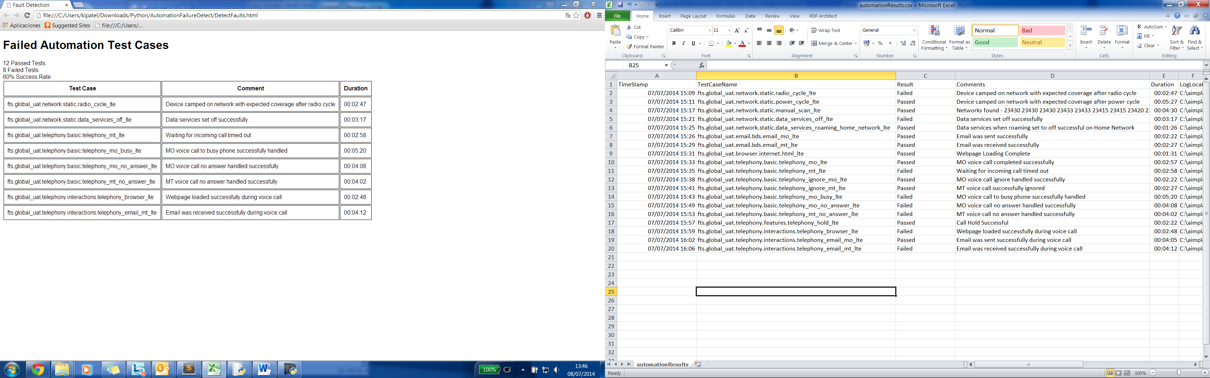

After (Presenting the information in a more readable manner)

