C:\Users\HP\Documents\BIT4107 Logbook (1).
ENHANCED PROFESSIONAL STUDENT LOGBOOK
Student Name: KIPCHUMBA TONNY
Admission Number: BIT/2024/54787
School/Faculty: COMPUTING AND INFORMATICS
Programme: MOBILE COMPUTING DEVELOPMENT
Academic Year: THREE
Semester: TWO
Lecturer: Mr. NYORO
Phone Number: 0725408765

Instructions
This logbook is used to document weekly learning activities, practical exercises, skills acquired, challenges encountered, solutions applied, and reflections. Students should complete all sections every week.
Each week to follow remarks in week 1 section.

Autogenerated Table of content

Week 1: Introduction to Mobile Application Development

Practical Activities Undertaken
only screenshots needed and labeling
Screenshots/Evidence Attached (Yes/No)

Tools/Software Used
ANDROID STUDIO
KOTLIN
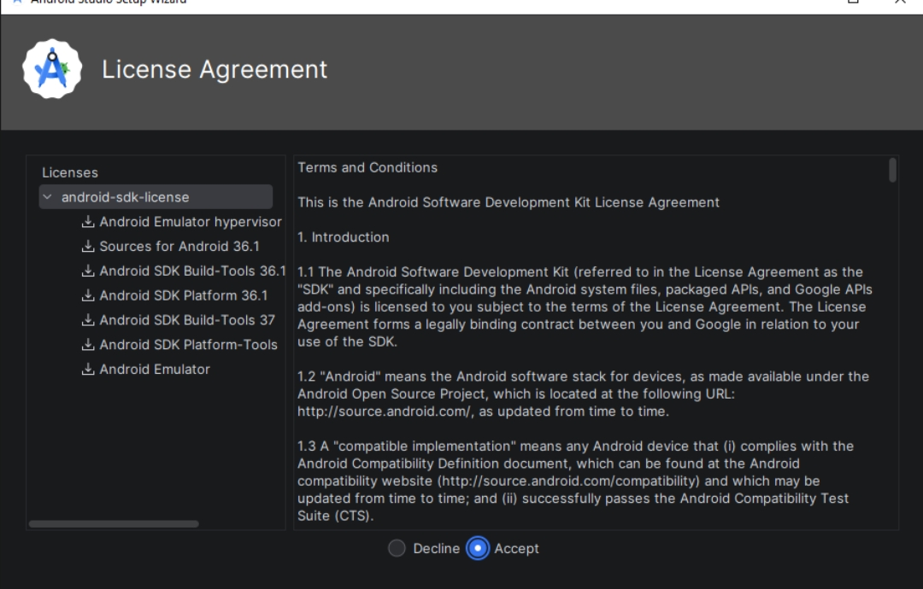

Personal Reflection
This project has challenged me, strengthened my creativity, and deepened my resilience. I feel proud of my progress, grateful for the lessons learned, and motivated to keep refining and growing toward success.

Week 2: Mobile Development Environment
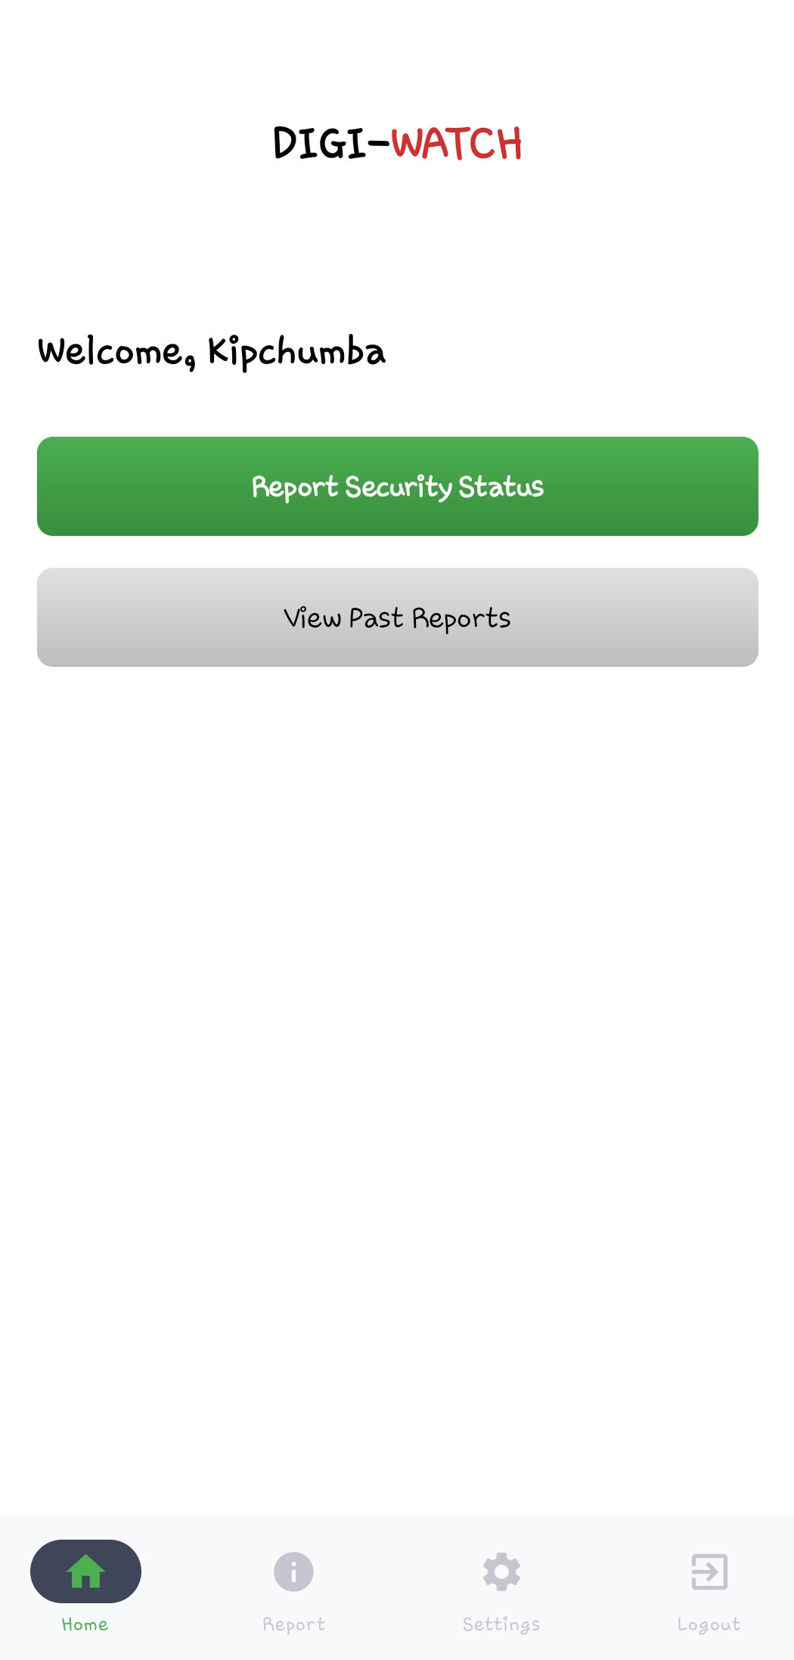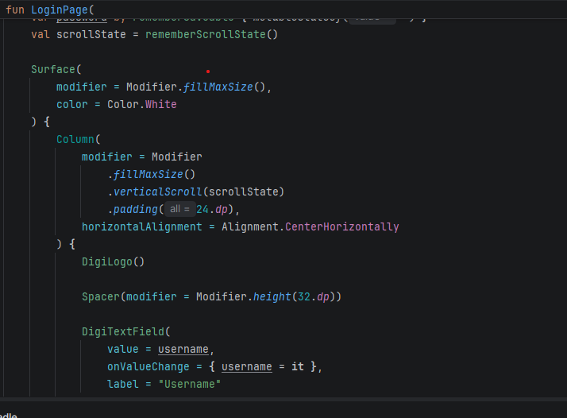
LOGIN PAGE

Week 3: User Interface Design

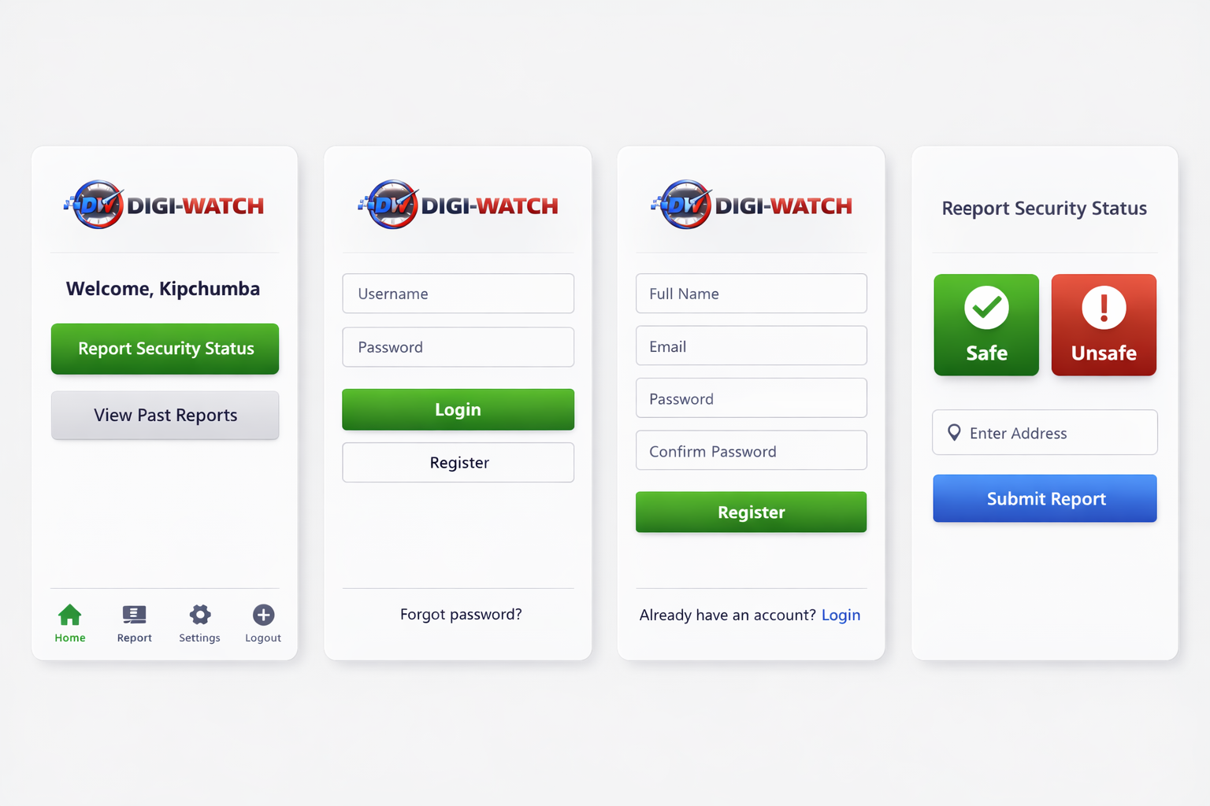

Week 4: Event Handling and User Interaction

Same as week 1

Week 5: Data Management

Same as week 1

Week 6: Networking and APIs

Same as week 1

Week 7: Application Architecture

Same as week 1

Week 8: Project Planning

Week 9: Device Features and Sensors

Same as week 1

Week 10: Notifications and Background Services

Same as week 1

Week 11: Mobile Security

Same as week 1

Week 12: Testing and Debugging

Same as week 1

Week 13: Application Deployment

Same as week 1

Week 14: Final Project Presentation

Same as week 1

Semester Project Tracking

Project Title

Project Objectives

Project Requirements

Development Milestones

Testing Results

Lessons Learned

Future Improvements

End of Semester Reflection

Summary of Skills Acquired

Most Interesting Topic

Major Challenges Faced

How Challenges Were Overcome

Professional Growth Achieved

Overall Course Experience

Final Approval
Student Name: __________________________
Student Signature: ______________________
Date: _________________________________
Lecturer Name: _________________________
Lecturer Remarks: _____________________
Date: _________________________________

