Objectives:

Improve your CSS skills via practicing including:

o Arrange your page into sections

o Spacing with padding and margins, backgrounds

o Float, alignment and clear

o Cosmetic finishing touches

o And even more…

Section measurement

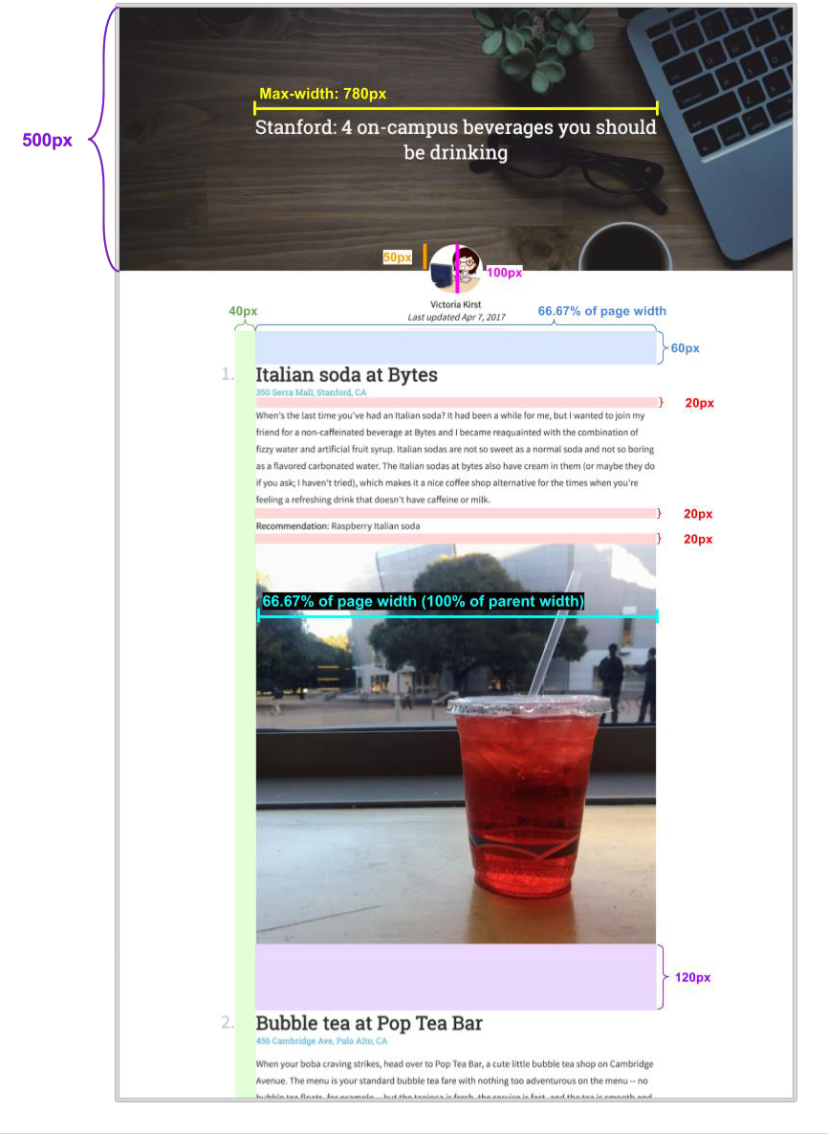

Font faces, sizes and color

Page title:



* The font face is 'Roboto Slab' and the fallback font is serif.
* The font size is 36px.
* The font weight is normal (not bold).
* The font color is white.
* The title is vertical and center aligned to the header image

Profile text:



* The font face is 'Source Sans Pro' and the fallback font is sans-serif.
* The font size is 18px.
* The font weight for the author name (“Victoria Kirst”) is bold
* The font style for the last updated (“Last updated Apr 7, 2017”) is italic.
* The font color is rgb(51, 51, 51).
* The line height 24px.
* The gray line under the “Last updated” line is 10px under the text, 2px wide, and the color is

#e6e6e6.

Body text:

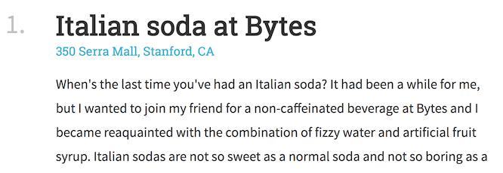

* Heading

1. The font face is 'Roboto Slab' and the fallback font is serif.
2. The font size is 36px.
3. The font weight is bold.
4. The number’s color is rgba(0, 0, 0, 0.25).

o The title color is rgb(51, 51, 51).

* Address

o The address under the heading is a link and is described in the *Links* section.

* Paragraphs
  1. The font face is 'Source Sans Pro' and the fallback font is sans-serif.

1. The font size is 18px.
2. The line height 32px.
   1. The font color is rgb(51, 51, 51).

* Recommendation
  1. The phrase “Recommendation:” is bold.



*Links*

Here is a description of how links should work on your page:

* Each address of the page is a link. The URL for each link is listed in *listicle-content.txt*.
* The link color is #42b4d6.
* The link is not bold, and the link is not underlined unless you hover over the link.
* When you hover over the link, the link becomes underlined.
* Hints:

1. To remove an underline, you can use CSS property text-decoration: none;
2. To add an underline, you can use CSS property text-decoration: underline;

*Images*

* Header image

1. The header is a background image (images/header.jpg).

* **Note:** To reference the image from the*css/*folder, the path needs to be

../images/header.jpg

1. The background does not repeat.
2. The background’s size is set to cover.
3. The background position is anchored to the top.
4. Its height is 500px.
5. There is a semi-transparent color overlay on top of the header image, which is rgba(0, 0, 0, .3)
   * **Note:** You can achieve this using the following CSS rule:

background-image: linear-gradient(rgba(0, 0, 0, .3), rgba(0, 0, 0, .3)), url(../images/header.jpg);

* Profile image

1. The profile image is images/vrk.png

* **Note:** To reference the image from the css/ folder, the path needs to be

../images/vrk.png

1. Its width is 100px.
2. It has rounded corners with radius 100%.
3. It has a white border that is 1px thick.