[IN CONFIDENCE]

Hi Mike, Mark (Thanks for discussing this yesterday)

The case to “Lift, Shift and minimally Tinker” key heritage processing is pretty compelling and can be made in just a few lines:

1. Heritage system is on its knees – see latest email from the heritage SAS team on inappropriate use of disk. Appended below without comment :-/
2. BAU code such as CRADC + Exclusions represents many man-years of work that will be needed for, realistically, a couple of years to keep the business running while KYC/RLT  is being built and Campaigns process is reworked. This is a best-case scenario - The worst case scenario is that KYC/Refined layer is not finished before the money runs out and so the business is reliant on a creaky old system for several more years. Not a pleasant thought.
3. We have a new system that is much more powerful than heritage but which is currently not being used:

|  |  |  |  |  |  |
| --- | --- | --- | --- | --- | --- |
| System | RAM | vCPU | Disk (Total) | Users at present | Prognosis |
| Heritage Compute | 32Gb | 4 | 4Tb | ~ 80 | Scheduled for decommissioning |
| DIP SAS 9 Compute | 244Gb | 32 | 8.8Tb | 2? | Paid for a ready to go |

It’s like we have 80 people crammed into an old mini while there is a brand-new bus idling nearby with nobody on it apart from the driver and ticket collector.

What on earth are we waiting for?

The only question in my mind is how best to do it. The isolated “Heritage to DIP” team as drawn by Alison Q is not the way, I think. Her ppt is attached.

What is not widely appreciated is how the existing delivery teams (D&R, GST etc) do what they do. There are large chunks of valuable of heritage code that are being used right now in D&R, GST, Property teams and staff in those teams like Tony Prisk, Ryan McGill, Wayne Tham etc will continue to develop this code as time goes by … and these modifications will not be captured unless there are frequent merges of the code between say the delivery teams’ branches and the trunk in the Heritage team. The vast majority of staff in those teams have not used version control before and do not even understand the meaning of the words “branch”, “trunk” and “merge”.  And conversely, the delivery teams will need to be kept up-to-date with what is happening in the platform space so they don’t reinvent the wheel. Education & Comms  is crucial – eg by representation at daily standups, demos and prezzos etc.

Long story short, I think it’s time to start giving people a view of what the BAU Platform team will look like. I’m so tired of all this beating round the bush by folk who do not have the experience.

The “KYC/Refined layer” and the “Heritage to DIP”  are best thought of as just programs of work within the Platform team, just as there were “new stuff” and “old stuff” programs of work in the IAP.  And there will be “raw (replica) layer” and “R&D, Contracts” programs of work in the platform team too, just as there were in the IAP.

We need this: the Platform team supports and is driven by the business through the value delivery teams

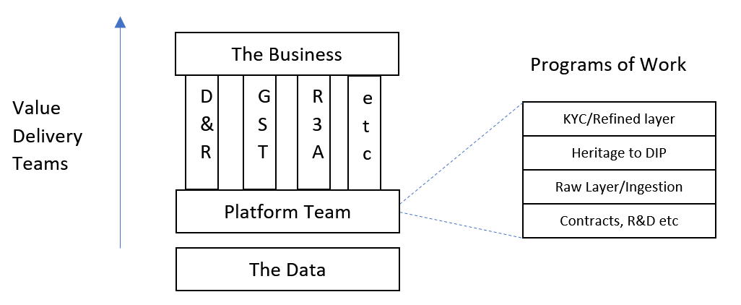

Whereas we should avoid what is proposed at the moment (Alisson’s PPT attached) There are several disconnects/silos because of the lack of partnering and the misguided notion that KYC/refined and Heritage-to-DIP  are delivery teams like D&R, GST etc. They are not because there are no direct links with the business and there’s no direct delivery of value.  It’s almost  painful to draw:

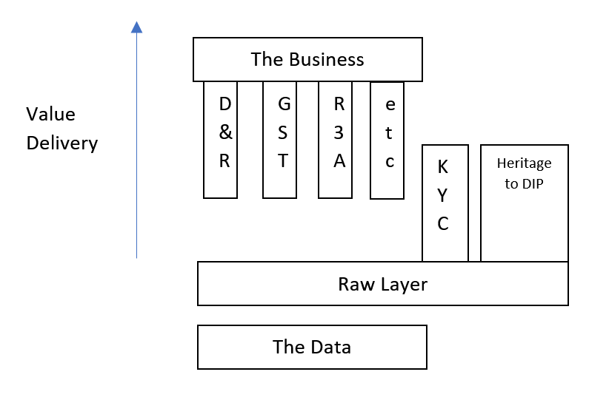

Happy to discuss or write it up properly. Let me know?

Cheers, Kip

EMAIL FROM REBECCA CLANCY, HERITAGE SAS TEAM.

Hi there,

As part of some clean up work we are doing in the SAS environment we have found two  **permanently** created folders in the SAS work space .

This space is shared for all users and for SCRATCH SPACE ONLY for SAS work sessions. It is only for temporary work and nothing should be stored there.

**sassrv@sasfccom-pp01:/data/saswork1/iic>**

**drwxr-x---  8 15rch3 sasusers 4096 May 23 10:27 cradc_files**

**drwxr-x---  9 17kipm sasusers 4096 Jun 11 11:33 cradc_testing**

**73G     cradc_files**

**193M    cradc_testing**

I know Richard we did speak about this space but I thought you were only temporarily using the space to run things not store things. These need to be removed as it has the potential to impact others queries. Please delete these by the end of the week, we are happy to do this for you.

Kind regards

Rebecca

Value Delivery Teams

Programs of Work

Contracts, R&D etc

Raw Layer/Ingestion

Heritage to DIP

KYC/Refined layer

D&R

GST

R3A

The Business

The Data

Platform Team

etc

Heritage to DIP

Raw Layer

The Data

KYC

D&R

GST

R3A

The Business

Value Delivery

etc