Medical Student Attitudes Toward Personalized Medicine Report

Kipp Johnson

May 4, 2015

Note: This analysis is conducted in R using R Markdown for report generation. The raw data as well as the source code for every table, figure, and calculation is accessible at <https://www.github.com/kippjohnson/PMQ/>

Begin by calling packages which will be used later in the report:

library(knitr)  
library(psych)

Reading in the data from the Github Repository (/kippjohnson/PMQ):

tmp <- tempfile()  
download.file("https://raw.githubusercontent.com/kippjohnson/PMQ/master/SurveyResponses.csv", destfile=tmp, method="curl")  
infile <- read.csv(tmp,header=TRUE)

### Demographics

|  |  |  |
| --- | --- | --- |
|  | Number of Students | PercentTotal |
| Male | 109 | 0.51 |
| Female | 101 | 0.48 |
| No Sex Given | 2 | 0.01 |
| MS1 | 65 | 0.31 |
| MS2 | 64 | 0.30 |
| MS3 | 64 | 0.30 |
| MS4 | 17 | 0.08 |
| No Year Given | 2 | 0.01 |
| Total Dual Degree | 178 | 0.84 |
| Total with Research Interest | 33 | 0.16 |

### EBPAS Statistics

The first step is to compute EBPAS total score, along with its subsets for scores of openness, divergence, and education. Questions 1-12 define the EBPAS scale on the survey, with its three subsets of openness, divergence, and education. There are a number of people who did not completely fill out the first 12 questions of the survey, and for this analysis they will be dropped.

Number of people who did not completely fill out the first 12 questions of the survey: **17**

Questions:

* Should the divergence Likert scores be reversed?__
* We will drop all of these individuals from the rest of the study?
* Should we also compute Cronbach's alpha for questions 18-21 (comfort in knowledge of genomic testing) and questions 22-25 (comfort in ability to use genomic testing) **or** should these be incorporated into the EBPAS?

Computing Crohnbach's Alpha: We use the alpha() function from the psych package in R. The EBPAS cronbach's alpha is taken from the literature (Overby et al., J Pers. Med. 2014), as was done in the paper on which we are modeling this.

|  |  |  |  |  |  |  |  |
| --- | --- | --- | --- | --- | --- | --- | --- |
|  | N | Mean | SD | Min | Max | Range | Alpha |
| EBPAS | 195 | 35.410 | 5.118 | 23 | 51 | 28 | 0.780 |
| education | 195 | 10.610 | 2.490 | 5 | 17 | 12 | 0.545 |
| divergence | 195 | 9.713 | 2.561 | 4 | 18 | 14 | 0.545 |
| openness | 195 | 15.087 | 2.949 | 5 | 20 | 15 | 0.814 |

## Analysis Plan

#### Step 1: Frequencies

*Question Response Frequencies*: Tables of each question's (13-25) response frequency. These questions include:

* Attitudes toward DTC (13-15)
* Comfort using technology (16, 17)
* Knowledge of genomic testing concepts (18-21)
* Ability to understand genomic testing concepts (22-25)

|  |  |
| --- | --- |
| Question 13 | Frequency |
| 0 | 50 |
| 1 | 161 |

|  |  |
| --- | --- |
| Question 14 | Frequency |
| 1 | 73 |
| 2 | 121 |
| 3 | 9 |

|  |  |
| --- | --- |
| Question 15 | Frequency |
| 1 | 35 |
| 2 | 30 |
| 3 | 72 |
| 4 | 58 |
| 5 | 14 |

|  |  |
| --- | --- |
| Question 16 | Frequency |
| 1 | 1 |
| 2 | 3 |
| 3 | 6 |
| 4 | 61 |
| 5 | 140 |

|  |  |
| --- | --- |
| Question 17 | Frequency |
| 1 | 38 |
| 2 | 26 |
| 3 | 38 |
| 4 | 72 |
| 5 | 35 |

|  |  |
| --- | --- |
| Question 18 | Frequency |
| 1 | 17 |
| 2 | 29 |
| 3 | 52 |
| 4 | 97 |
| 5 | 17 |

|  |  |
| --- | --- |
| Question 19 | Frequency |
| 1 | 35 |
| 2 | 46 |
| 3 | 62 |
| 4 | 61 |
| 5 | 8 |

|  |  |
| --- | --- |
| Question 20 | Frequency |
| 1 | 29 |
| 2 | 35 |
| 3 | 57 |
| 4 | 76 |
| 5 | 14 |

|  |  |
| --- | --- |
| Question 21 | Frequency |
| 1 | 45 |
| 2 | 49 |
| 3 | 49 |
| 4 | 59 |
| 5 | 9 |

|  |  |
| --- | --- |
| Question 22 | Frequency |
| 1 | 71 |
| 2 | 59 |
| 3 | 54 |
| 4 | 23 |
| 5 | 4 |

|  |  |
| --- | --- |
| Question 23 | Frequency |
| 1 | 49 |
| 2 | 58 |
| 3 | 55 |
| 4 | 45 |
| 5 | 5 |

|  |  |
| --- | --- |
| Question 24 | Frequency |
| 1 | 60 |
| 2 | 53 |
| 3 | 59 |
| 4 | 34 |
| 5 | 6 |

|  |  |
| --- | --- |
| Question 25 | Frequency |
| 1 | 79 |
| 2 | 63 |
| 3 | 47 |
| 4 | 19 |
| 5 | 4 |

*Should we also calculate these frequencies by covariate?*

#### Step 2: T-Tests

Answers for questions 13-15 were tested for an association with EBPAS Score (Questions 1-12) using ANOVA followed by Tukey Honest Signficant Differences. ANOVA+Tukey Results are not currently shown in the table following the code output.

Second, the answers were collapsed into binary categories and T-tests for association with EBPAS score were performed.

##### Question 13

##   
## Welch Two Sample t-test  
##   
## data: infile3$EBPAS by infile3$Q13  
## t = -0.7686, df = 50.594, p-value = 0.4457  
## alternative hypothesis: true difference in means is not equal to 0  
## 95 percent confidence interval:  
## -3.00062 1.33933  
## sample estimates:  
## mean in group 0 mean in group 1   
## 34.75000 35.58065

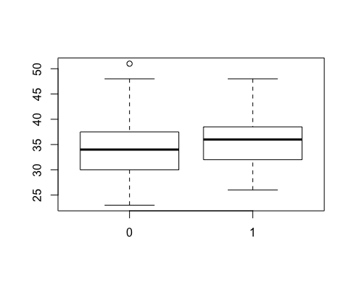

##### Question 14

## Df Sum Sq Mean Sq F value Pr(>F)   
## as.factor(infile3$Q14) 2 158 79.05 3.006 0.0519 .  
## Residuals 186 4892 26.30   
## ---  
## Signif. codes: 0 '***' 0.001 '**' 0.01 '*' 0.05 '.' 0.1 ' ' 1  
## 6 observations deleted due to missingness

## Tukey multiple comparisons of means  
## 95% family-wise confidence level  
##   
## Fit: aov(formula = infile3$EBPAS ~ as.factor(infile3$Q14))  
##   
## $`as.factor(infile3$Q14)`  
## diff lwr upr p adj  
## 2-1 1.9142186 0.05679307 3.771644 0.0417224  
## 3-1 1.6859903 -2.60801606 5.979997 0.6235130  
## 3-2 -0.2282282 -4.42745245 3.970996 0.9909511

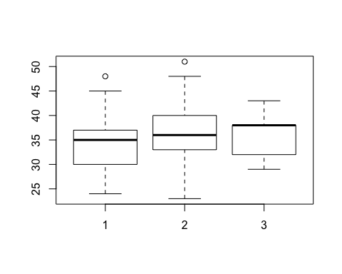

##   
## Welch Two Sample t-test  
##   
## data: infile3$EBPAS by infile3$Q14c  
## t = -2.4226, df = 136.229, p-value = 0.01672  
## alternative hypothesis: true difference in means is not equal to 0  
## 95 percent confidence interval:  
## -3.445649 -0.348554  
## sample estimates:  
## mean in group 1 mean in group 2   
## 34.2029 36.1000

##### Question 15

## Df Sum Sq Mean Sq F value Pr(>F)   
## as.factor(infile3$Q15) 4 552 138.12 5.762 0.000214 ***  
## Residuals 188 4507 23.97   
## ---  
## Signif. codes: 0 '***' 0.001 '**' 0.01 '*' 0.05 '.' 0.1 ' ' 1  
## 2 observations deleted due to missingness

## Tukey multiple comparisons of means  
## 95% family-wise confidence level  
##   
## Fit: aov(formula = infile3$EBPAS ~ as.factor(infile3$Q15))  
##   
## $`as.factor(infile3$Q15)`  
## diff lwr upr p adj  
## 2-1 1.0727969 -2.53377517 4.679369 0.9244222  
## 3-1 -0.8120915 -3.87974958 2.255567 0.9494875  
## 4-1 3.1191919 -0.04982958 6.288213 0.0560471  
## 5-1 2.9841270 -1.45735102 7.425605 0.3478604  
## 3-2 -1.8848884 -4.87587112 1.106094 0.4146113  
## 4-2 2.0463950 -1.04846344 5.141253 0.3644024  
## 5-2 1.9113300 -2.47753976 6.300200 0.7516559  
## 4-3 3.9312834 1.48561125 6.376956 0.0001559  
## 5-3 3.7962185 -0.16172819 7.754165 0.0669886  
## 5-4 -0.1350649 -4.17208278 3.901953 0.9999836

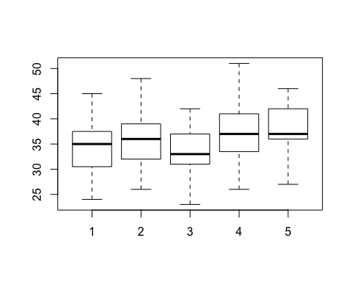

##   
## 1 2 3 4 5   
## 27 29 68 55 14

##   
## 1 2   
## 124 69

##   
## Welch Two Sample t-test  
##   
## data: infile3$EBPAS by infile3$Q15c  
## t = -4.2826, df = 124.076, p-value = 3.665e-05  
## alternative hypothesis: true difference in means is not equal to 0  
## 95 percent confidence interval:  
## -4.805023 -1.767441  
## sample estimates:  
## mean in group 1 mean in group 2   
## 34.25000 37.53623

##### Question 16

## Df Sum Sq Mean Sq F value Pr(>F)   
## as.factor(infile3$Q16) 4 368 92.08 3.712 0.0062 **  
## Residuals 190 4713 24.80   
## ---  
## Signif. codes: 0 '***' 0.001 '**' 0.01 '*' 0.05 '.' 0.1 ' ' 1

## Tukey multiple comparisons of means  
## 95% family-wise confidence level  
##   
## Fit: aov(formula = infile3$EBPAS ~ as.factor(infile3$Q16))  
##   
## $`as.factor(infile3$Q16)`  
## diff lwr upr p adj  
## 2-1 10.0000000 -5.8387964 25.838796 0.4127454  
## 3-1 8.6666667 -6.1491707 23.482504 0.4921742  
## 4-1 6.5932203 -7.2393353 20.425776 0.6836375  
## 5-1 9.2777778 -4.4933464 23.048902 0.3451185  
## 3-2 -1.3333333 -11.0325756 8.365909 0.9956046  
## 4-2 -3.4067797 -11.5250221 4.711463 0.7764000  
## 5-2 -0.7222222 -8.7353443 7.290900 0.9991558  
## 4-3 -2.0734463 -7.9511523 3.804260 0.8676726  
## 5-3 0.6111111 -5.1205285 6.342751 0.9983659  
## 5-4 2.6845574 0.5207062 4.848409 0.0068643

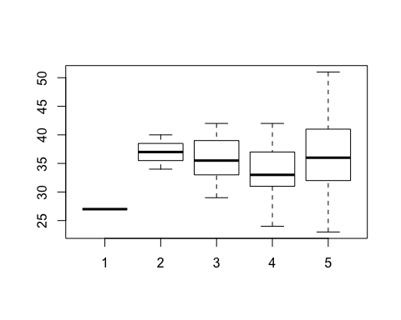

##   
## 1 2 3 4 5   
## 1 3 6 59 126

##   
## 1 2   
## 10 185

##   
## Welch Two Sample t-test  
##   
## data: infile3$EBPAS by infile3$Q16c  
## t = -0.1429, df = 10.174, p-value = 0.8892  
## alternative hypothesis: true difference in means is not equal to 0  
## 95 percent confidence interval:  
## -3.669391 3.226148  
## sample estimates:  
## mean in group 1 mean in group 2   
## 35.20000 35.42162

##### Question 17

## Df Sum Sq Mean Sq F value Pr(>F)  
## as.factor(infile3$Q17) 4 162 40.44 1.562 0.186  
## Residuals 190 4919 25.89

## Tukey multiple comparisons of means  
## 95% family-wise confidence level  
##   
## Fit: aov(formula = infile3$EBPAS ~ as.factor(infile3$Q17))  
##   
## $`as.factor(infile3$Q17)`  
## diff lwr upr p adj  
## 2-1 2.7487500 -0.9920090 6.489509 0.2586398  
## 3-1 2.1909722 -1.2138584 5.595803 0.3928244  
## 4-1 1.8455616 -1.1517262 4.842849 0.4389650  
## 5-1 2.7717803 -0.7051182 6.248679 0.1858258  
## 3-2 -0.5577778 -4.2062493 3.090694 0.9933830  
## 4-2 -0.9031884 -4.1746112 2.368234 0.9415241  
## 5-2 0.0230303 -3.6927867 3.738847 1.0000000  
## 4-3 -0.3454106 -3.2266952 2.535874 0.9974164  
## 5-3 0.5808081 -2.7966007 3.958217 0.9896372  
## 5-4 0.9262187 -2.0398818 3.892319 0.9110263

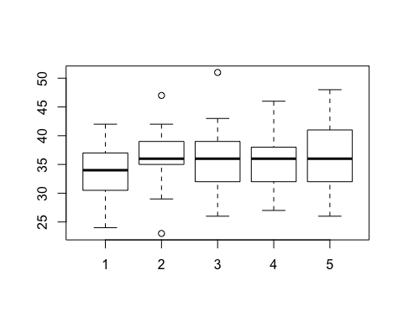

##   
## 1 2 3 4 5   
## 32 25 36 69 33

##   
## 1 2   
## 93 102

##   
## Welch Two Sample t-test  
##   
## data: infile3$EBPAS by infile3$Q17c  
## t = -0.7633, df = 192.999, p-value = 0.4462  
## alternative hypothesis: true difference in means is not equal to 0  
## 95 percent confidence interval:  
## -2.0006233 0.8842413  
## sample estimates:  
## mean in group 1 mean in group 2   
## 35.11828 35.67647

##### Question 18

## Df Sum Sq Mean Sq F value Pr(>F)   
## as.factor(infile3$Q18) 4 607 151.73 6.443 6.98e-05 ***  
## Residuals 190 4474 23.55   
## ---  
## Signif. codes: 0 '***' 0.001 '**' 0.01 '*' 0.05 '.' 0.1 ' ' 1

## Tukey multiple comparisons of means  
## 95% family-wise confidence level  
##   
## Fit: aov(formula = infile3$EBPAS ~ as.factor(infile3$Q18))  
##   
## $`as.factor(infile3$Q18)`  
## diff lwr upr p adj  
## 2-1 3.5384615 -1.0014391 8.078362 0.2049397  
## 3-1 3.4222920 -0.7473477 7.591932 0.1624973  
## 4-1 4.6186931 0.6612728 8.576113 0.0131822  
## 5-1 8.9835165 3.8357530 14.131280 0.0000305  
## 3-2 -0.1161695 -3.3589557 3.126617 0.9999784  
## 4-2 1.0802316 -1.8847208 4.045184 0.8535487  
## 5-2 5.4450549 1.0145656 9.875544 0.0076308  
## 4-3 1.1964011 -1.1628656 3.555668 0.6305733  
## 5-3 5.5612245 1.5109859 9.611463 0.0019295  
## 5-4 4.3648233 0.5334119 8.196235 0.0167098

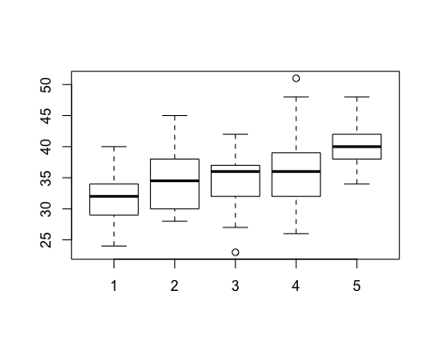

##   
## 1 2 3 4 5   
## 13 26 49 93 14

##   
## 1 2   
## 88 107

##   
## Welch Two Sample t-test  
##   
## data: infile3$EBPAS by infile3$Q18c  
## t = -3.1496, df = 192.4, p-value = 0.001896  
## alternative hypothesis: true difference in means is not equal to 0  
## 95 percent confidence interval:  
## -3.6407015 -0.8367836  
## sample estimates:  
## mean in group 1 mean in group 2   
## 34.18182 36.42056

##### Question 19

## Df Sum Sq Mean Sq F value Pr(>F)   
## as.factor(infile3$Q19) 4 793 198.25 8.784 1.58e-06 ***  
## Residuals 190 4288 22.57   
## ---  
## Signif. codes: 0 '***' 0.001 '**' 0.01 '*' 0.05 '.' 0.1 ' ' 1

## Tukey multiple comparisons of means  
## 95% family-wise confidence level  
##   
## Fit: aov(formula = infile3$EBPAS ~ as.factor(infile3$Q19))  
##   
## $`as.factor(infile3$Q19)`  
## diff lwr upr p adj  
## 2-1 2.3311688 -0.8318997 5.494237 0.2558179  
## 3-1 1.8460591 -1.1648935 4.857012 0.4434362  
## 4-1 5.5701970 2.5592445 8.581150 0.0000083  
## 5-1 5.9642857 0.4351954 11.493376 0.0274061  
## 3-2 -0.4851097 -3.1009273 2.130708 0.9862217  
## 4-2 3.2390282 0.6232106 5.854846 0.0070158  
## 5-2 3.6331169 -1.6911208 8.957355 0.3320093  
## 4-3 3.7241379 1.2944600 6.153816 0.0003594  
## 5-3 4.1182266 -1.1170709 9.353524 0.1970300  
## 5-4 0.3940887 -4.8412088 5.629386 0.9995856

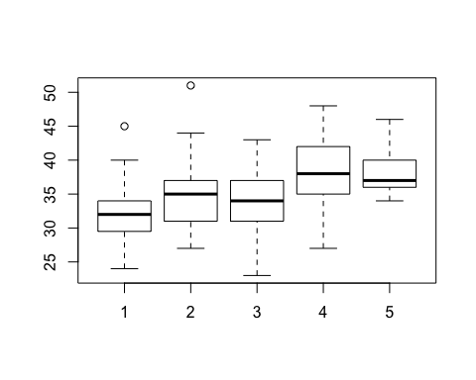

##   
## 1 2 3 4 5   
## 28 44 58 58 7

##   
## 1 2   
## 130 65

##   
## Welch Two Sample t-test  
##   
## data: infile3$EBPAS by infile3$Q19c  
## t = -5.4721, df = 125.04, p-value = 2.329e-07  
## alternative hypothesis: true difference in means is not equal to 0  
## 95 percent confidence interval:  
## -5.446703 -2.553297  
## sample estimates:  
## mean in group 1 mean in group 2   
## 34.07692 38.07692

##### Question 120

## Df Sum Sq Mean Sq F value Pr(>F)   
## as.factor(infile3$Q20) 4 527 131.84 5.486 0.000336 ***  
## Residuals 189 4542 24.03   
## ---  
## Signif. codes: 0 '***' 0.001 '**' 0.01 '*' 0.05 '.' 0.1 ' ' 1  
## 1 observation deleted due to missingness

## Tukey multiple comparisons of means  
## 95% family-wise confidence level  
##   
## Fit: aov(formula = infile3$EBPAS ~ as.factor(infile3$Q20))  
##   
## $`as.factor(infile3$Q20)`  
## diff lwr upr p adj  
## 2-1 2.9076923 -0.71019702 6.525582 0.1791485  
## 3-1 3.1923077 -0.05084593 6.435461 0.0560292  
## 4-1 3.8076923 0.72395014 6.891434 0.0072443  
## 5-1 7.4230769 2.83656508 12.009589 0.0001372  
## 3-2 0.2846154 -2.81104417 3.380275 0.9990868  
## 4-2 0.9000000 -2.02822956 3.828230 0.9156106  
## 5-2 4.5153846 0.03195362 8.998816 0.0474469  
## 4-3 0.6153846 -1.83480938 3.065579 0.9580776  
## 5-3 4.2307692 0.04387590 8.417663 0.0462849  
## 5-4 3.6153846 -0.44927970 7.680049 0.1068363

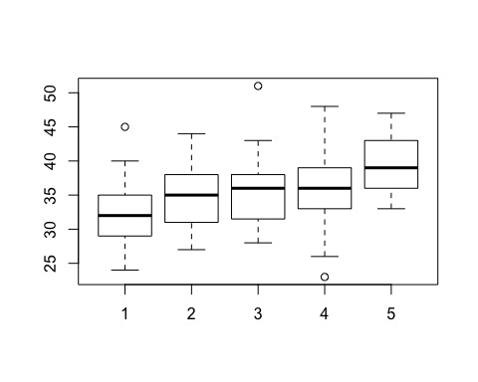

##   
## 1 2 3 4 5   
## 26 30 52 73 13

##   
## 1 2   
## 108 86

##   
## Welch Two Sample t-test  
##   
## data: infile3$EBPAS by infile3$Q20c  
## t = -2.7395, df = 177.028, p-value = 0.006782  
## alternative hypothesis: true difference in means is not equal to 0  
## 95 percent confidence interval:  
## -3.4570203 -0.5619288  
## sample estimates:  
## mean in group 1 mean in group 2   
## 34.53704 36.54651

##### Question 21

## Df Sum Sq Mean Sq F value Pr(>F)   
## as.factor(infile3$Q21) 4 410 102.52 4.158 0.00299 **  
## Residuals 189 4659 24.65   
## ---  
## Signif. codes: 0 '***' 0.001 '**' 0.01 '*' 0.05 '.' 0.1 ' ' 1  
## 1 observation deleted due to missingness

## Tukey multiple comparisons of means  
## 95% family-wise confidence level  
##   
## Fit: aov(formula = infile3$EBPAS ~ as.factor(infile3$Q21))  
##   
## $`as.factor(infile3$Q21)`  
## diff lwr upr p adj  
## 2-1 1.0400458 -1.9578322 4.037924 0.8744897  
## 3-1 2.5608187 -0.4520903 5.573728 0.1366663  
## 4-1 3.2302632 0.3560225 6.104504 0.0189972  
## 5-1 5.6052632 0.5355791 10.674947 0.0220669  
## 3-2 1.5207729 -1.3465760 4.388122 0.5891817  
## 4-2 2.1902174 -0.5310560 4.911491 0.1779866  
## 5-2 4.5652174 -0.4193353 9.549770 0.0899480  
## 4-3 0.6694444 -2.0683790 3.407268 0.9619046  
## 5-3 3.0444444 -1.9491629 8.038052 0.4492794  
## 5-4 2.3750000 -2.5361865 7.286187 0.6716523

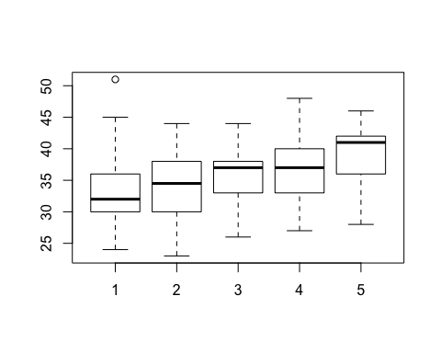

##   
## 1 2 3 4 5   
## 38 46 45 56 9

##   
## 1 2   
## 129 65

##   
## Welch Two Sample t-test  
##   
## data: infile3$EBPAS by infile3$Q21c  
## t = -2.983, df = 125.997, p-value = 0.003429  
## alternative hypothesis: true difference in means is not equal to 0  
## 95 percent confidence interval:  
## -3.8174444 -0.7724185  
## sample estimates:  
## mean in group 1 mean in group 2   
## 34.65891 36.95385

##### Question 22

## Df Sum Sq Mean Sq F value Pr(>F)   
## as.factor(infile3$Q22) 4 629 157.33 6.746 4.27e-05 ***  
## Residuals 189 4408 23.32   
## ---  
## Signif. codes: 0 '***' 0.001 '**' 0.01 '*' 0.05 '.' 0.1 ' ' 1  
## 1 observation deleted due to missingness

## Tukey multiple comparisons of means  
## 95% family-wise confidence level  
##   
## Fit: aov(formula = infile3$EBPAS ~ as.factor(infile3$Q22))  
##   
## $`as.factor(infile3$Q22)`  
## diff lwr upr p adj  
## 2-1 0.9338609 -1.50565758 3.373379 0.8294555  
## 3-1 2.5586885 0.02110047 5.096277 0.0470322  
## 4-1 5.2786885 1.91324805 8.644129 0.0002419  
## 5-1 7.0286885 0.16320203 13.894175 0.0419141  
## 3-2 1.6248276 -0.94215209 4.191807 0.4100366  
## 4-2 4.3448276 0.95717041 7.732485 0.0046550  
## 5-2 6.0948276 -0.78157673 12.971232 0.1089928  
## 4-3 2.7200000 -0.73894835 6.178948 0.1972926  
## 5-3 4.4700000 -2.44180432 11.381804 0.3875516  
## 5-4 1.7500000 -5.50671244 9.006712 0.9637507

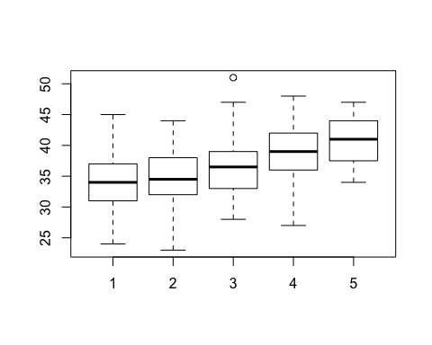

##   
## 1 2 3 4 5   
## 61 58 50 21 4

##   
## 1 2   
## 169 25

##   
## Welch Two Sample t-test  
##   
## data: infile3$EBPAS by infile3$Q22c  
## t = -3.883, df = 29.752, p-value = 0.0005316  
## alternative hypothesis: true difference in means is not equal to 0  
## 95 percent confidence interval:  
## -6.838896 -2.123471  
## sample estimates:  
## mean in group 1 mean in group 2   
## 34.79882 39.28000

##### Question 23

## Df Sum Sq Mean Sq F value Pr(>F)   
## as.factor(infile3$Q23) 4 563 140.81 5.922 0.000164 ***  
## Residuals 190 4518 23.78   
## ---  
## Signif. codes: 0 '***' 0.001 '**' 0.01 '*' 0.05 '.' 0.1 ' ' 1

## Tukey multiple comparisons of means  
## 95% family-wise confidence level  
##   
## Fit: aov(formula = infile3$EBPAS ~ as.factor(infile3$Q23))  
##   
## $`as.factor(infile3$Q23)`  
## diff lwr upr p adj  
## 2-1 1.8353576 -0.9555549 4.626270 0.3701578  
## 3-1 2.2626996 -0.5706751 5.096074 0.1843878  
## 4-1 4.8742964 1.8702884 7.878305 0.0001306  
## 5-1 6.1230769 -0.2564631 12.502617 0.0666839  
## 3-2 0.4273419 -2.1353790 2.990063 0.9907806  
## 4-2 3.0389388 0.2887405 5.789137 0.0221823  
## 5-2 4.2877193 -1.9763095 10.551748 0.3288327  
## 4-3 2.6115969 -0.1816826 5.404876 0.0791411  
## 5-3 3.8603774 -2.4226853 10.143440 0.4412312  
## 5-4 1.2487805 -5.1130533 7.610614 0.9829577

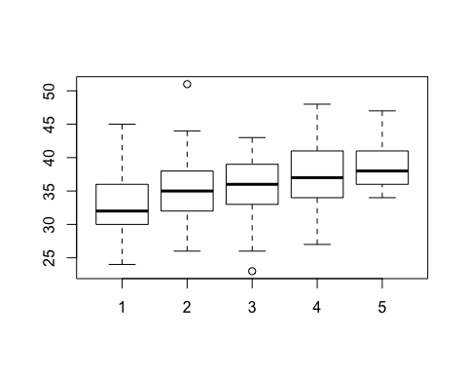

##   
## 1 2 3 4 5   
## 39 57 53 41 5

##   
## 1 2   
## 149 46

##   
## Welch Two Sample t-test  
##   
## data: infile3$EBPAS by infile3$Q23c  
## t = -4.0285, df = 69.655, p-value = 0.0001412  
## alternative hypothesis: true difference in means is not equal to 0  
## 95 percent confidence interval:  
## -5.237499 -1.768629  
## sample estimates:  
## mean in group 1 mean in group 2   
## 34.58389 38.08696

##### Question 24

## Df Sum Sq Mean Sq F value Pr(>F)   
## as.factor(infile3$Q24) 4 430 107.40 4.387 0.00205 **  
## Residuals 190 4652 24.48   
## ---  
## Signif. codes: 0 '***' 0.001 '**' 0.01 '*' 0.05 '.' 0.1 ' ' 1

## Tukey multiple comparisons of means  
## 95% family-wise confidence level  
##   
## Fit: aov(formula = infile3$EBPAS ~ as.factor(infile3$Q24))  
##   
## $`as.factor(infile3$Q24)`  
## diff lwr upr p adj  
## 2-1 1.274510 -1.42410544 3.973125 0.6910842  
## 3-1 2.634225 -0.01487057 5.283320 0.0520925  
## 4-1 3.939338 0.86614386 7.012533 0.0046841  
## 5-1 5.137255 -0.74424067 11.018750 0.1182445  
## 3-2 1.359715 -1.28938037 4.008810 0.6196582  
## 4-2 2.664828 -0.40836594 5.738023 0.1230142  
## 5-2 3.862745 -2.01875048 9.744241 0.3715147  
## 4-3 1.305114 -1.72468909 4.334916 0.7592033  
## 5-3 2.503030 -3.35590912 8.361970 0.7647395  
## 5-4 1.197917 -4.86459021 7.260424 0.9825327

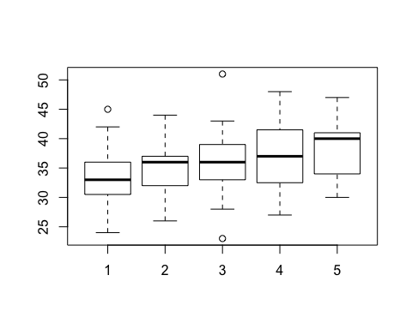

##   
## 1 2 3 4 5   
## 51 51 55 32 6

##   
## 1 2   
## 157 38

##   
## Welch Two Sample t-test  
##   
## data: infile3$EBPAS by infile3$Q24c  
## t = -2.7302, df = 49.686, p-value = 0.008733  
## alternative hypothesis: true difference in means is not equal to 0  
## 95 percent confidence interval:  
## -4.8457139 -0.7375915  
## sample estimates:  
## mean in group 1 mean in group 2   
## 34.86624 37.65789

##### Question 25

## Df Sum Sq Mean Sq F value Pr(>F)   
## as.factor(infile3$Q25) 4 559 139.7 5.87 0.000178 ***  
## Residuals 190 4522 23.8   
## ---  
## Signif. codes: 0 '***' 0.001 '**' 0.01 '*' 0.05 '.' 0.1 ' ' 1

## Tukey multiple comparisons of means  
## 95% family-wise confidence level  
##   
## Fit: aov(formula = infile3$EBPAS ~ as.factor(infile3$Q25))  
##   
## $`as.factor(infile3$Q25)`  
## diff lwr upr p adj  
## 2-1 1.8599532 -0.4935427 4.213449 0.1930917  
## 3-1 1.7396104 -0.8454387 4.324659 0.3462842  
## 4-1 5.7964286 2.0730950 9.519762 0.0002754  
## 5-1 6.4214286 -0.4861936 13.329051 0.0820550  
## 3-2 -0.1203428 -2.7779765 2.537291 0.9999450  
## 4-2 3.9364754 0.1623860 7.710565 0.0362122  
## 5-2 4.5614754 -2.3736368 11.496588 0.3699725  
## 4-3 4.0568182 0.1341549 7.979481 0.0387364  
## 5-3 4.6818182 -2.3352551 11.698892 0.3551412  
## 5-4 0.6250000 -6.8863282 8.136328 0.9993841

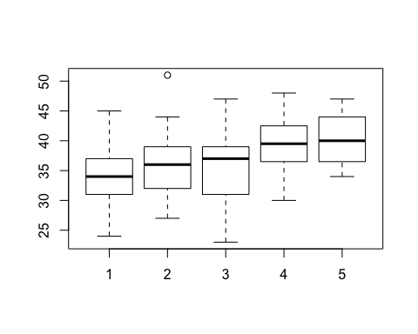

##   
## 1 2 3 4 5   
## 70 61 44 16 4

##   
## 1 2   
## 175 20

##   
## Welch Two Sample t-test  
##   
## data: infile3$EBPAS by infile3$Q25c  
## t = -4.0424, df = 23.205, p-value = 0.0004992  
## alternative hypothesis: true difference in means is not equal to 0  
## 95 percent confidence interval:  
## -7.309135 -2.362293  
## sample estimates:  
## mean in group 1 mean in group 2   
## 34.91429 39.75000

#### Summary Table of Results from Collapsed T-tests (Analagous to Table. 6, Overby et al.)

|  |  |  |  |  |
| --- | --- | --- | --- | --- |
|  | N | Mean | SD | T-Test P-Value |
| Question 14 Group 1 | 69 | 34.203 | 5.274 | 0.017 |
| Question 14 Group 2 | 120 | 36.100 | 5.022 | 0.017 |
| Question 15 Group 1 | 124 | 34.250 | 4.620 | 0.000 |
| Question 15 Group 2 | 69 | 37.536 | 5.362 | 0.000 |
| Question 16 Group 1 | 10 | 35.200 | 4.756 | 0.889 |
| Question 16 Group 2 | 185 | 35.422 | 5.148 | 0.889 |
| Question 17 Group 1 | 93 | 35.118 | 4.863 | 0.446 |
| Question 17 Group 2 | 102 | 35.676 | 5.349 | 0.446 |
| Question 18 Group 1 | 88 | 34.182 | 4.613 | 0.002 |
| Question 18 Group 2 | 107 | 36.421 | 5.309 | 0.002 |
| Question 19 Group 1 | 130 | 34.077 | 4.724 | 0.000 |
| Question 19 Group 2 | 65 | 38.077 | 4.855 | 0.000 |
| Question 20 Group 1 | 108 | 34.537 | 4.898 | 0.007 |
| Question 20 Group 2 | 86 | 36.547 | 5.212 | 0.007 |
| Question 21 Group 1 | 129 | 34.659 | 4.985 | 0.003 |
| Question 21 Group 2 | 65 | 36.954 | 5.094 | 0.003 |
| Question 22 Group 1 | 169 | 34.799 | 4.808 | 0.001 |
| Question 22 Group 2 | 25 | 39.280 | 5.466 | 0.001 |
| Question 23 Group 1 | 149 | 34.584 | 4.796 | 0.000 |
| Question 23 Group 2 | 46 | 38.087 | 5.261 | 0.000 |
| Question 24 Group 1 | 157 | 34.866 | 4.789 | 0.009 |
| Question 24 Group 2 | 38 | 37.658 | 5.846 | 0.009 |
| Question 25 Group 1 | 175 | 34.914 | 4.895 | 0.000 |
| Question 25 Group 2 | 20 | 39.750 | 5.087 | 0.000 |

#### Step 3: Linear Regression

Model EBPAS ~ Step 1 predictors + possible covariates

Covariates collected include:

* Age
* Gender
* Medical School Year
* Dual Degree
* Interest in Research