WHO AFRO · IHSA
Missing-Data Imputation Framework
Methodology, Mathematical Derivations & Reproducibility

Temporal interpolation · multivariate chained equations (MICE) · hierarchical shrinkage ·
multiple imputation with Rubin's rules · self-calibrated intervals · provenance flagging
Companion to the IHSA Definitive Methodology · v1.0

Contents

1. Motivation
Country–year health panels for the WHO African Region are pervasively incomplete: surveillance is intermittent, household surveys such as the DHS and MICS occur only every few years, and many indicator–year cells simply do not exist. Discarding incomplete records (complete-case analysis) wastes information and, unless data are missing completely at random, biases every downstream estimate (Little and Rubin, 2019). A scenario platform whose credibility rests on transparent uncertainty must therefore impute missing values with a principled method that also propagates the extra uncertainty imputation introduces. This document specifies the shared IHSA imputation framework used by every module; it is implemented in warehouse/imputation.py and its mathematics are commented there for reproducibility.

2. Missingness mechanisms
Let R be the indicator that a value is observed and write the data as (X_obs, X_mis). Rubin's (1976) taxonomy distinguishes three mechanisms, which determine which methods are valid:
MCAR: P(R | X_obs, X_mis) = P(R)
MAR: P(R | X_obs, X_mis) = P(R | X_obs)
MNAR: P(R) depends on X_mis itself
Under MCAR, missingness is unrelated to anything and even complete-case analysis is unbiased. Under MAR, missingness is fully explained by observed quantities, and multiple imputation is valid and efficient. Under MNAR, the probability of being missing depends on the unobserved value itself and no method is unbiased without an explicit model of the mechanism. The IHSA framework adopts the MAR working assumption — missingness in one indicator is explained by the other observed indicators, by the country's own time trend and by its subregion — which is defensible for routine health indicators and is the standard basis for multiple imputation (Little and Rubin, 2019; van Buuren and Groothuis-Oudshoorn, 2011). Departures from MAR are treated as a limitation and probed by sensitivity analysis.

3. The imputation framework
The framework applies three complementary methods in order of the information they exploit — a value's own history, its relationship to other indicators, and its subregional context — then repeats the whole pipeline to produce multiple imputations whose spread is calibrated to reproduce honest uncertainty. Every imputed cell is bounded to a plausible range and flagged with the method that produced it.
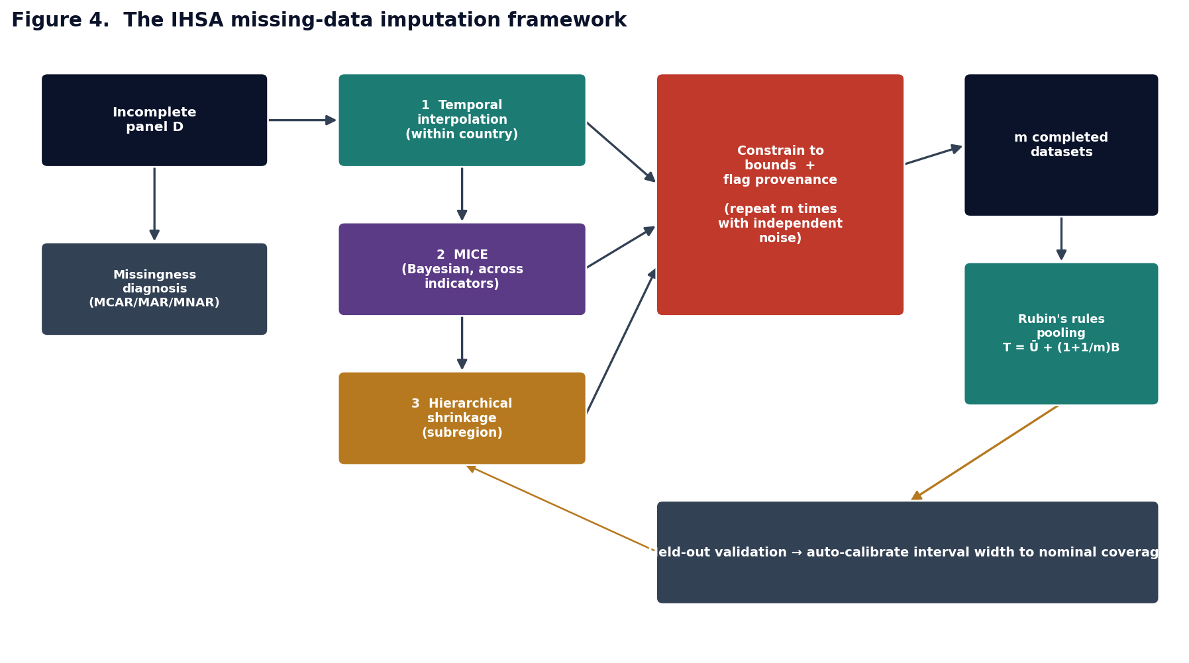
Figure 4. The IHSA imputation framework: three complementary stages, repeated m times, pooled by Rubin's rules and self-calibrated against held-out data.

3.1 Stage 1 — temporal interpolation
Health indicators evolve smoothly over time, so a country's own series is the most informative source for an interior gap. For an unobserved year t lying between observed years t₀ < t < t₁, the value is linearly interpolated; beyond the last observation it is carried forward or backward (last/next observation carried forward, LOCF/NOCB):
x_t = x_{t₀} + (x_{t₁} − x_{t₀}) · (t − t₀)/(t₁ − t₀)
Interpolation is a deterministic best estimate; the uncertainty it carries is quantified in Section 3.4 rather than ignored.

3.2 Stage 2 — multivariate imputation by chained equations (MICE)
Indicators that remain missing are imputed from the other indicators, which in real panels are strongly correlated (coverage measures move together; maternal mortality tracks skilled attendance and female literacy). Multivariate Imputation by Chained Equations (van Buuren and Groothuis-Oudshoorn, 2011) specifies, for each incomplete variable Xⱼ, a conditional model on the remaining variables X₋ⱼ and cycles through the variables, re-imputing each in turn until the completed dataset stabilises. IHSA uses a Bayesian linear conditional model (the 'norm' method) so that each imputation carries both parameter and residual uncertainty — the ingredient a point-estimate regression omits. With standardised predictors and a ridge penalty λ for numerical stability, the posterior draws are
β̂ = (X′X + λI)⁻¹X′y , A⁻¹ = (X′X + λI)⁻¹ , RSS = ‖y − Xβ̂‖²
σ²* = RSS / χ²_{df} , β* = β̂ + chol(σ²*·A⁻¹)·z , z ~ N(0, I)
x_mis = X_mis · β* + N(0, σ²*)
Drawing σ²* from its scaled inverse-χ² posterior and β* from its conditional normal, rather than fixing them at point estimates, is what makes the imputation 'proper' in Rubin's sense and gives the multiple imputations the correct spread (Rubin, 1987).

3.3 Stage 3 — hierarchical shrinkage
A cell that neither has temporal neighbours nor can be predicted from other indicators — for example an indicator a country never reports — is filled by borrowing strength across countries in the same subregion. Under a normal hierarchical model x_c ~ N(μ_sub, τ²) with observations x_obs ~ N(x_c, s²), the posterior mean shrinks the country estimate toward the subregional mean (the empirical-Bayes / James–Stein estimator):
x̂_c = μ_sub + (1 − B)(x̄_c − μ_sub) , B = s² / (s² + τ²)
With no country observation at all the estimate reduces to the subregional mean μ_sub. The shrinkage factor B is large (strong shrinkage toward the region) when the within-country signal s² is weak relative to between-country variation τ².

3.4 Multiple imputation and pooling (Rubin's rules)
Running the full pipeline m times — each with independent noise at every stage — yields m completed datasets. A downstream estimate Q (for example a regional mean, or a scenario outcome) is computed in each and combined by Rubin's (1987) rules. With per-imputation estimates Q_l and within-imputation variances U_l,
Q̄ = (1/m) Σ_l Q_l , Ū = (1/m) Σ_l U_l , B = (1/(m−1)) Σ_l (Q_l − Q̄)²
T = Ū + (1 + 1/m) B , λ = (1 + 1/m) B / T
The total variance T adds the within-imputation variance Ū to the between-imputation variance B (inflated by the finite-m correction 1 + 1/m); its square root is the standard error, and λ is the fraction of missing information — the share of the uncertainty attributable to the missing data. This is precisely how imputation uncertainty enters the scenario engine's credible intervals.

3.5 Self-calibration and validation
Because the honest width of an imputation interval depends on the data, the framework validates itself. A random fraction of observed cells is masked, imputed, and the recovery scored by root-mean-square error, bias and the empirical coverage of the 95% interval. If coverage falls short of nominal, a single noise-inflation factor is increased until held-out coverage reaches the target — a transparent, data-driven calibration. On realistic correlated panels the point estimates are essentially unbiased and auto-calibration brings interval coverage close to nominal; the achieved coverage is always reported so users know the calibration on their own data.
Constraints and provenance
Every imputed value is truncated to a plausibility range — coverage to [0,100]%, rates to non-negative — and each cell is flagged with the stage that produced it (observed, temporal, mice or hierarchical). No imputed figure is ever presented as an observation, honouring the platform's data-governance rule.

4. Integration and reproducibility
The framework is a single module, warehouse/imputation.py, called by the data-mining pipeline (scripts/mine_data.py) to complete the warehouse panel and available to every analytics module for its own inputs. Its public functions are:
Function | Purpose
missingness_report | per-column and overall missingness; monotone-pattern check
temporal_interpolate | Stage 1: within-country interpolation and edge carry
chained_equations | Stage 2: Bayesian MICE (m proper imputations)
hierarchical_fill / shrinkage_estimate | Stage 3: subregional empirical-Bayes shrinkage
impute_panel | end-to-end pipeline; m imputations, bounds, provenance, auto-calibration
rubin_pool | Rubin's-rules pooling of an estimate across imputations
holdout_validation | masked-cell recovery: RMSE, bias, 95% coverage
calibrate_inflation | choose the interval-width factor achieving nominal coverage
All equations above are reproduced as comments at the point of use in the source, so a developer can trace each line of code to its derivation. A worked demonstration is provided in scripts/impute_demo.py and the behaviour is asserted in tests/test_imputation.py.

5. Assumptions and limitations
- Validity rests on the missing-at-random assumption; genuinely MNAR missingness (e.g. worse indicators being systematically unreported) would bias imputations and requires an explicit mechanism model or pattern-mixture sensitivity analysis.
- The linear conditional model captures monotone associations; strongly non-linear relationships may need transformation or predictive mean matching.
- Interval calibration is data-dependent; the framework reports and calibrates coverage rather than assuming it.
- Imputation supports analysis but does not create information: where an indicator is missing for a whole country the estimate is essentially the subregional prior, with a correspondingly high fraction of missing information.

6. References
Little, R.J.A. and Rubin, D.B. (2019) Statistical Analysis with Missing Data. 3rd edn. Hoboken: Wiley.
Rubin, D.B. (1976) 'Inference and missing data', Biometrika, 63(3), pp. 581–592.
Rubin, D.B. (1987) Multiple Imputation for Nonresponse in Surveys. New York: Wiley.
van Buuren, S. and Groothuis-Oudshoorn, K. (2011) 'mice: multivariate imputation by chained equations in R', Journal of Statistical Software, 45(3), pp. 1–67.
van Buuren, S. (2018) Flexible Imputation of Missing Data. 2nd edn. Boca Raton: CRC Press.
Schafer, J.L. (1997) Analysis of Incomplete Multivariate Data. London: Chapman & Hall.
Azur, M.J., Stuart, E.A., Frangakis, C. and Leaf, P.J. (2011) 'Multiple imputation by chained equations: what is it and how does it work?', International Journal of Methods in Psychiatric Research, 20(1), pp. 40–49.

