WHO AFRO · IHSA
Health Systems Scenario Engine
Definitive Methodology: Mathematical Derivations, Method Selection, Model Specification & Evidence

Bayesian networks where appropriate; purpose-built epidemiological and statistical methods otherwise —
each derived from first principles, with every term defined and referenced (Harvard style)
Version 3.0 · Definitive · Enterprise release

Contents

1. Introduction and modelling philosophy
The Integrated Health Systems Analytics Platform (IHSA) supports scenario analysis across the health domains of the WHO African Region. Its central design decision is that health outcomes are not independent: the determinants of maternal mortality, HIV incidence, universal health coverage and health-information-system maturity overlap and influence one another, and a credible scenario engine must represent that structure. The default modelling paradigm is therefore the probabilistic graphical model, specifically the Bayesian network, in which each outcome is a node in a directed acyclic graph (DAG) of shared determinants and inference proceeds by the calculus of causality (Pearl, 2009; Koller and Friedman, 2009).
The Bayesian paradigm is powerful but it is not universally the most appropriate tool. Child-survival outcomes are best handled by cause-deletion accounting in the Lives Saved Tool tradition (Walker et al., 2013); premature non-communicable-disease mortality is naturally a comparative-risk-assessment problem (GBD 2019 Risk Factors Collaborators, 2020); universal health coverage is a financing production function; health-information-system maturity is a composite index (Aqil, Lippeveld and Hozumi, 2009); and SDG 3 attainment is a target-gap trajectory problem. Acting as the responsible modeller, IHSA selects the method that matches the science of each domain and embeds it in the shared engine, rather than forcing every domain into one template. Section 5 sets out this choice explicitly, and every method below is derived from first principles with each term defined.

2. The determinant hierarchy
Predictors are organised into five causal layers. Information flows upward from external shocks, through socioeconomic and system determinants, to the intermediate determinants that act directly on each outcome. Determinants are shared across domains, which is exactly what independent regressions cannot represent.
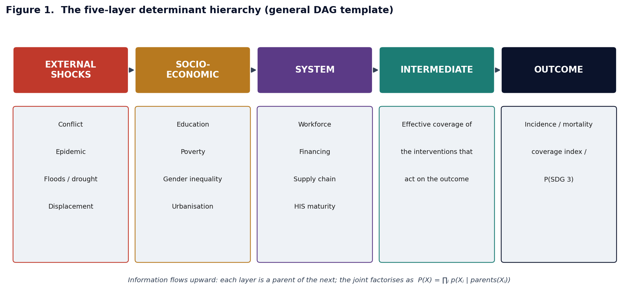
Figure 1. The five-layer determinant hierarchy and its factorisation.

3. Notation
The following symbols are used throughout. Each is defined here once and referred to by name thereafter.
Symbol | Meaning
Xⱼ | random variable at node j (an indicator, coverage, rate or index)
pa(j) | the set of parent nodes of node j in the DAG
xⱼ⁰ | observed baseline value of node j (the anchor)
gⱼ , gⱼ⁻¹ | link function of node j and its inverse (identity, log, or logit)
ηⱼ | linear predictor of node j (the argument of gⱼ⁻¹)
βⱼₖ ≥ 0 | non-negative effect magnitude of parent k on node j (on the link scale)
sⱼₖ ∈ {−1,+1} | structural sign of parent k on node j (evidence-implied direction)
κⱼₖ | scale that expresses parent k in its natural units
εⱼ ~ N(0,σⱼ²) | stochastic (aleatoric) node noise; σⱼ its standard deviation
θ = {β, σ} | the full parameter set
D | the observed country–year data (panel)
do(X_S = x_S) | intervention fixing the nodes in set S at values x_S
Y, y* | outcome of interest and a policy target value
N | number of Monte-Carlo draws
PAF | population attributable fraction (NCD method)
AARR | average annual rate of reduction (SDG 3 method)

4. Mathematical specification, derived

4.1 Graph and factorisation
A Bayesian network encodes the local Markov property: every node is conditionally independent of its non-descendants given its parents. Applying the chain rule of probability and then deleting, for each node, the conditioning variables that are not parents (which the Markov property permits), the joint distribution factorises over the graph (Koller and Friedman, 2009):
p(X₁,…,X_p) = ∏ⱼ p( Xⱼ | X_pa(j) )
This factorisation is the engine's data structure: sampling the network means sampling each node given its already-sampled parents, in topological order.

4.2 Structural equations, link functions and anchoring
Each conditional p(Xⱼ | pa(j)) is a generalised structural equation. Its mean is a sign-constrained additive function of the parents, formed on the scale of the link gⱼ and centred at the observed baseline:
gⱼ( E[Xⱼ] ) = ηⱼ = gⱼ(xⱼ⁰) + Σ_{k∈pa(j)} sⱼₖ · βⱼₖ · (Xₖ − xₖ⁰)/κⱼₖ , βⱼₖ ≥ 0
Anchoring follows immediately. Set every parent to its own baseline, Xₖ = xₖ⁰. Then each summand contains the factor (xₖ⁰ − xₖ⁰) = 0, so the entire sum vanishes and ηⱼ = gⱼ(xⱼ⁰). Applying the inverse link, E[Xⱼ] = gⱼ⁻¹(gⱼ(xⱼ⁰)) = xⱼ⁰. Therefore a do-nothing scenario reproduces the observed value of every node exactly — a property the automated tests assert (baseline invariance).
The link is chosen to match the node's support. For a probability node gⱼ = logit, so E[Xⱼ] = logistic(ηⱼ) ∈ (0,1). For a non-negative rate gⱼ = log, and exponentiating the structural equation shows the effects are multiplicative on the rate:
E[Xⱼ] = xⱼ⁰ · exp( Σₖ sⱼₖ βⱼₖ (Xₖ − xₖ⁰)/κⱼₖ )
so a protective parent (sⱼₖ = −1) scales the rate down and a risk parent (sⱼₖ = +1) scales it up, never producing a negative rate. For an index on a fixed range the identity link is used and the coefficients are interpretable as weights (Section 5.6). The stochastic node adds noise on the appropriate scale: Xⱼ = gⱼ⁻¹(ηⱼ)·exp(εⱼ) for rates (log-normal) or gⱼ⁻¹(ηⱼ)+εⱼ otherwise, with εⱼ ~ N(0,σⱼ²).

4.3 Sign-constrained priors
The sign sⱼₖ is fixed a priori from the evidence base, and the magnitude βⱼₖ is given a weakly-informative non-negative prior. Imposing the polarity rather than learning it removes the sign-flipping and collinearity pathologies that afflict unconstrained regression on correlated development indicators. The Half-Normal is the natural choice because it places all mass on the non-negative half-line:
βⱼₖ ~ Half-Normal(0, τ²) , σⱼ ~ Half-Normal(0, ω²) , sⱼₖ fixed

4.4 Likelihood, posterior and inference
Given the panel D, the parameters θ = {β, σ} have posterior obtained from Bayes' theorem, with the likelihood factorising over observations i and nodes j exactly as the graph prescribes:
p(θ | D) ∝ p(D | θ) · p(θ) = [ ∏ᵢ ∏ⱼ p( xᵢⱼ | xᵢ,pa(j), θ ) ] · p(θ)
Node likelihoods match the node kind: Log-Normal for rates (equivalently log Xⱼ ~ Normal(ηⱼ,σⱼ²)), Normal for continuous indices, and Beta or Binomial for probabilities. Because the posterior is not available in closed form, it is sampled by Hamiltonian Monte Carlo using the No-U-Turn Sampler (Hoffman and Gelman, 2014), with convergence judged by the potential scale-reduction factor and effective sample size (Gelman et al., 2013). Where a node is data-sparse, its coefficients are elicited from the literature and enter as informative priors, and the engine runs in prior-predictive mode.

4.5 Scenarios as interventions: the do-operator
A scenario fixes a set S of nodes at chosen values. This is an intervention, not an observation: it replaces the mechanism that ordinarily generates each Xⱼ (j∈S) with an externally set value, which graphically means deleting the incoming edges of the intervened nodes. The post-intervention distribution is the truncated factorisation (Pearl, 2009):
p( X | do(X_S = x_S) ) = ∏_{j∉S} p( Xⱼ | X_pa(j) ) evaluated at X_S = x_S
Operationally the sampler simply overwrites each intervened node with its set value and propagates to descendants; parents of intervened nodes therefore do not change, which is precisely what distinguishes do(·) from conditioning.

4.6 Uncertainty propagation and target probabilities
The object of inference is the posterior predictive distribution of an outcome Y under a scenario, which integrates the intervened model over the parameter posterior:
p( y | do(x_S), D ) = ∫ p( y | do(x_S), θ ) · p(θ | D) dθ
This integral is estimated by Monte Carlo. For each of N draws we sample θ⁽ⁿ⁾ ~ p(θ|D) (in the reference engine, the sign-constrained coefficient draws) and then y⁽ⁿ⁾ ~ p(y | do(x_S), θ⁽ⁿ⁾) by ancestral sampling with node noise. The scenario mean, a 95% credible interval and the probability of meeting a target y* are the sample summaries:
E[Y] ≈ (1/N) Σₙ y⁽ⁿ⁾ ; P( Y ≤ y* | do, D ) = E[ I(Y ≤ y*) ] ≈ (1/N) Σₙ I( y⁽ⁿ⁾ ≤ y* )
Total predictive variance decomposes, by the law of total variance, into an aleatoric part (node noise) and an epistemic part (parameter uncertainty), and both are carried end-to-end so a downstream outcome inherits the uncertainty of every determinant above it:
Var(Y) = E_θ[ Var(Y | θ) ] + Var_θ( E[Y | θ] )

4.7 Shocks
Shocks are exogenous root nodes with no parents whose activation shifts the linear predictors of the system-layer nodes they touch — a flood, for example, lowers road access and facility readiness and raises malaria transmission. Setting a shock is itself a do-intervention, so a single scenario can combine investments and shocks and the engine updates every downstream probability jointly.

5. Choice of method: where a Bayesian network is not the right tool
A Bayesian network is appropriate where an outcome is driven by a web of interacting determinants and where propagating uncertainty through that web is the point — the transmission and cascade domains (HIV, TB, malaria), the coverage index (UHC), and the integrating node (SDG 3). For several domains, however, a purpose-built method is both more faithful to the science and more transparent. IHSA uses the method that fits the domain and embeds its output in the shared engine.
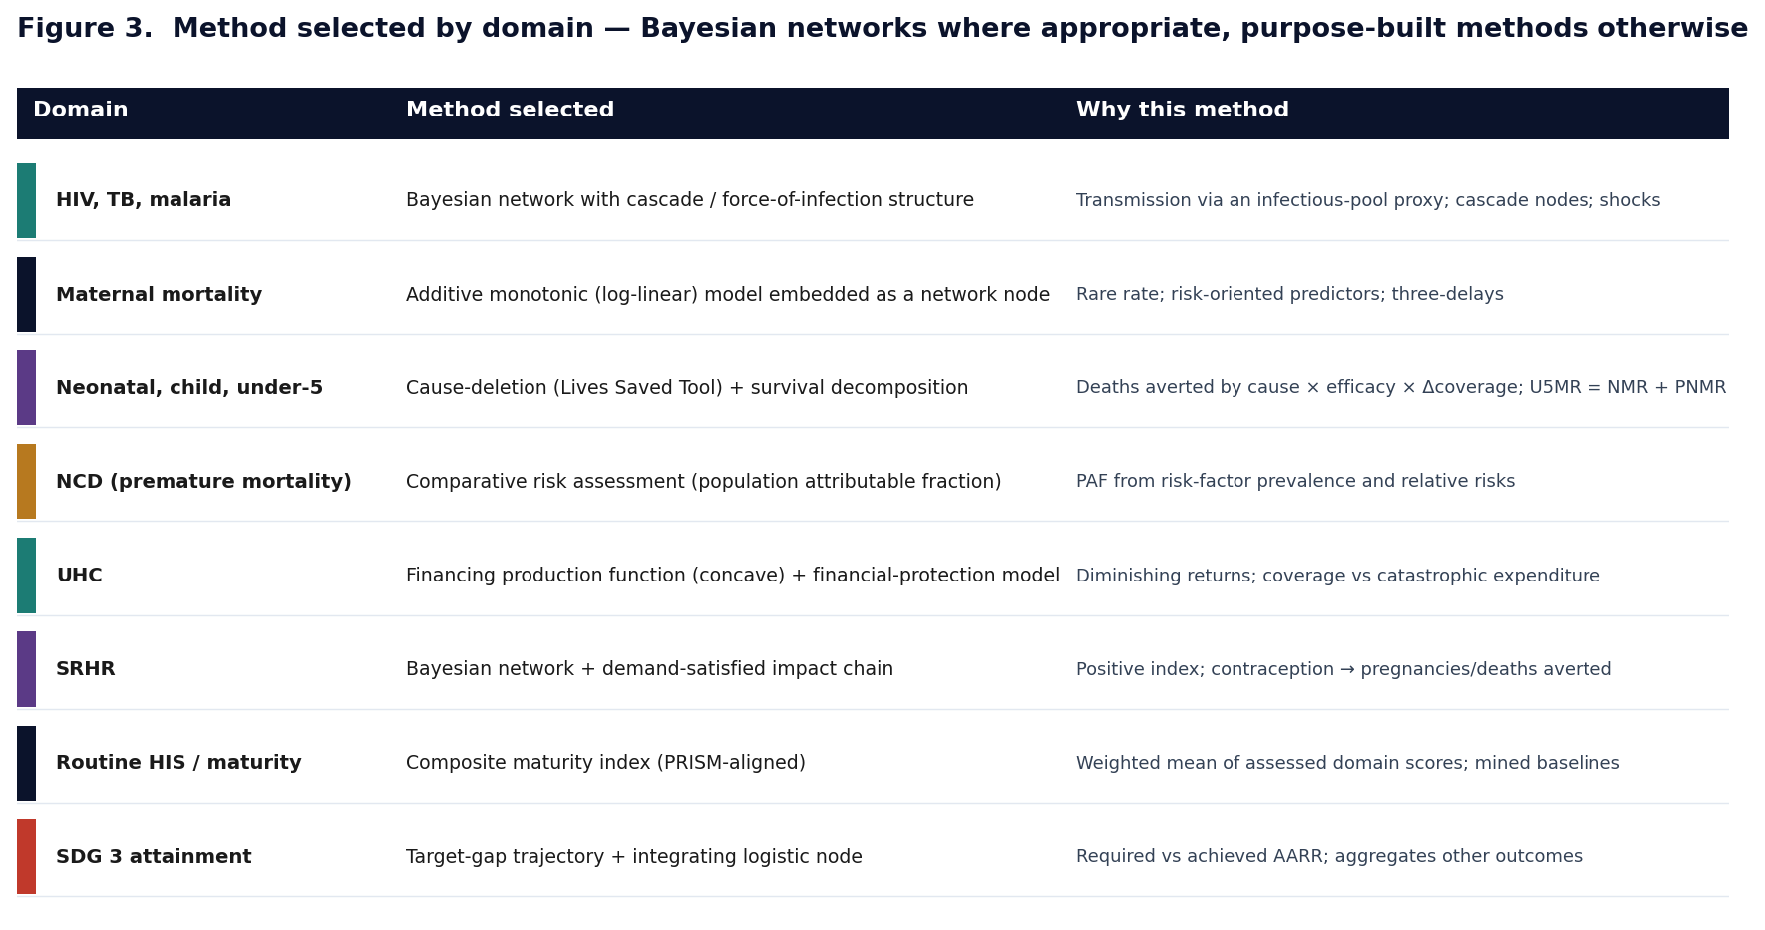
Figure 3. Method selected by domain, with the reason.

5.1 Cause-deletion (Lives Saved Tool) — neonatal and child mortality
Child deaths are dominated by a few causes with intervention-specific efficacies, which is exactly the structure the Lives Saved Tool formalises (Walker et al., 2013; Black et al., 2003). For a mortality rate R with causes c and interventions i of efficacy eᵢ and coverage change ΔCᵢ acting on cause c with affected fraction AF, the deaths averted and the surviving-rate multiplier are
ΔD = Σ_c D_c · [ 1 − ∏ᵢ (1 − eᵢ · AFᵢ · ΔCᵢ) ] ; R_scenario = R⁰ · ∏ᵢ (1 − impᵢ · ΔCᵢ)
where the reduced-form coefficient impᵢ folds cause share × affected fraction × efficacy into one interpretable number. The multiplicative product encodes that independent interventions each remove a proportion of the remaining deaths. This is derived and commented in analytics/child_survival/model.py.

5.2 Survival decomposition — under-five mortality
Under-five mortality is the composition of a neonatal and a post-neonatal segment. Writing survival probabilities and expressing deaths per 1,000 live births, the segments are exactly additive:
S_u5 = S_neo · S_post ; U5MR = NMR + PNMR (deaths per 1,000 live births)
because deaths before age five per 1,000 live births are the sum of deaths in the two disjoint age segments. Each segment is projected by its own cause-deletion model (5.1) and recombined, so the decomposition is coherent by construction (asserted in the tests).

5.3 Comparative risk assessment — premature NCD mortality
Premature NCD mortality is naturally an attributable-burden problem. For risk factors with prevalence pᵢ and relative risk RRᵢ, the population attributable fraction and the attributable mortality are (GBD 2019 Risk Factors Collaborators, 2020)
PAF = Σᵢ pᵢ(RRᵢ − 1) / [ 1 + Σᵢ pᵢ(RRᵢ − 1) ] ; M_attributable = M_total · PAF
An intervention that lowers a risk-factor prevalence pᵢ (a WHO best buy) or raises treatment-and-control lowers the PAF and hence mortality; IHSA implements this on the logit scale so the modelled probability stays in the unit interval.

5.4 Financing production function — UHC
Universal health coverage responds to financing and inputs with diminishing returns, which the logit link supplies automatically (the response flattens as coverage approaches saturation). Writing the service coverage index SCI as a fraction,
logit E[SCI] = logit(SCI⁰) + β₁(GHE−GHE⁰) + β₂(prepaid−·⁰) + β₃(readiness−·⁰) − β₄(OOP−·⁰)
with financial protection modelled as a separate outcome node whose catastrophic-expenditure risk rises with the out-of-pocket share and falls with prepayment and coverage. Treating coverage and protection as two outcomes makes explicit that services can expand while households still face hardship (WHO and World Bank, 2023).

5.5 Composite maturity index — routine HIS
Health-information-system maturity is a composite of assessed domains rather than a causal outcome, so it is modelled as a weighted mean, consistent with the PRISM framework (Aqil, Lippeveld and Hozumi, 2009) and the regional assessment (WHO Regional Office for Africa, 2026):
HIS maturity = Σ_d w_d · domain_d , Σ_d w_d = 1 ; bands: ≤20 nascent < 40 emerging < 60 early < 80 advanced ≤ optimized
with governance itself a weighted mean of its sub-domains. Country baselines are the mined assessment scores, so the module starts from observed national maturity.

5.6 Target-gap trajectory — SDG 3 attainment
Whether a country will meet an SDG 3 target by 2030 is a rate-of-change question. If an outcome must fall from its current value to a target over n years, the required average annual rate of reduction solves target = current·e^(−r*·n), giving
AARR_required = (1/n) · ln( current / target ) ; on-track ⇔ AARR_achieved ≥ AARR_required
and the integrating attainment probability is a logistic function of the constituent gaps, gap_m = (target_m − projected_m)/target_m, so improving any constituent network raises P(SDG 3) automatically.

5.7 Additive monotonic bootstrap — maternal mortality
For a rare rate with many correlated, risk-oriented predictors, IHSA uses the monotone-constrained additive model validated in the deployed maternal explorer, fitted by non-negative ridge and with uncertainty from a bootstrap ensemble; scenario deltas are anchored to the observed value through a log-gain factor:
log Y = β₀ + Σⱼ βⱼ sⱼ xⱼ , βⱼ ≥ 0 ; log Ŷ_scen = log Y_obs + g·[ f(x_scen) − f(x_base) ]
This model is embedded as the outcome node of the maternal network so upstream determinants and shocks can feed it. It is implemented and commented in analytics/predictive.py.

6. Data sources, API mining and simulation
Country–year panels are assembled by mining open agency APIs with a common pipeline — fetch (with retries and pagination), validate, impute sparse gaps, land in a medallion warehouse with version stamps — and, where an indicator has no open API, a clearly-labelled simulated value is generated so the DAG stays fully populated for all 47 member states.
Domain | Primary source(s) | Access
Outcomes, coverage, workforce | WHO Global Health Observatory | REST / OData
Expenditure, demography, poverty | World Bank Indicators API | REST
Child mortality, immunisation, nutrition | UNICEF (SDMX) and UN IGME | API / download
Maternal health, family planning, SRHR | UNFPA | API / portal
HIV | UNAIDS | API / download
TB; malaria | WHO TB and Global Malaria Programme | API / download
Conflict; disasters | ACLED; EM-DAT | REST / download
Routine data | DHIS2 Web API | REST

6.1 Mining HIS maturity from the regional assessment
The HIS maturity determinant is mined directly from the WHO AFRO assessment (WHO Regional Office for Africa, 2026), which scores each country across governance and leadership, data generation and management, data analysis and synthesis, and communication and use, and classifies maturity into five bands. IHSA extracts the tabulated governance and data-generation sub-scores for the 38 assessed countries, computes domain means and an overall index, and assigns bands; on the tabulated domains the Region is dominated by early and advanced maturity with none yet optimized, quantifying the assessment's conclusion that systems remain at an early stage.

7. Domain specifications
Each domain is documented with an introduction, a literature-grounded account of its predictors (Harvard citations), the modelling framework and its governing equation(s). The HIV chapter includes a worked network diagram; the general machinery of Sections 4–6 applies throughout.

7.1 HIV
Outcome & method. HIV incidence (per 1,000 uninfected adults 15–49); method: Bayesian network with an explicit treatment cascade.

Introduction
HIV remains one of the defining epidemics of the African Region, which carries the majority of the global burden. Although incidence has fallen since its peak, transmission continues and several countries face plateauing trends among adolescent girls and young women. The scenario question is how far new infections would fall if testing, treatment, viral suppression and combination prevention were scaled toward the 95-95-95 targets.
The module frames incidence as the product of an infectious reservoir and protective and structural modifiers, and connects to the maternal, TB and SRHR networks through shared determinants so that cross-cutting investments are represented coherently.

Predictors and evidence from the literature
Treatment-as-prevention is the dominant lever: durable viral suppression essentially eliminates onward sexual transmission, established by the HPTN 052 trial (Cohen et al., 2011) and the PARTNER studies (Rodger et al., 2019), which underpin the undetectable-equals-untransmittable principle. Viral suppression is therefore the strongest protective parent of incidence, with ART coverage and testing as its upstream drivers.
Biomedical prevention adds further protective parents. Voluntary medical male circumcision reduces female-to-male acquisition by roughly 60% in the three landmark trials (Auvert et al., 2005; Bailey et al., 2007; Gray et al., 2007); consistent condom use and pre-exposure prophylaxis reduce acquisition substantially; and sexually transmitted infections raise transmission as a biological cofactor.
System and structural determinants — workforce and laboratory capacity, supply-chain reliability and HIS maturity, together with female literacy, gender inequality and mobility — govern whether interventions reach people, and shocks (conflict, epidemics, floods) disrupt the supply chain and service delivery.

The modelling framework
Incidence is an outcome node on the log link, anchored at the observed value; protective parents carry negative signs and risk parents positive signs, so effects are multiplicative on the rate. The cascade is explicit: HIS maturity drives testing; testing and supply chain drive ART; ART and supply chain drive viral suppression; and viral suppression, with the prevention and structural parents, drives incidence.
Because the cascade is layered, an upstream intervention propagates correctly — a digital-transformation scenario that raises HIS maturity flows through testing and ART to suppression and finally to incidence via the do-operator. Coefficients are elicited from the trial and cohort evidence and updated to posteriors where panels are mined; Monte-Carlo propagation returns a credible interval and, where a target is set, the probability of reaching it. The reference engine reproduces the baseline and lowers incidence under an accelerate-treatment package while a conflict shock raises it.
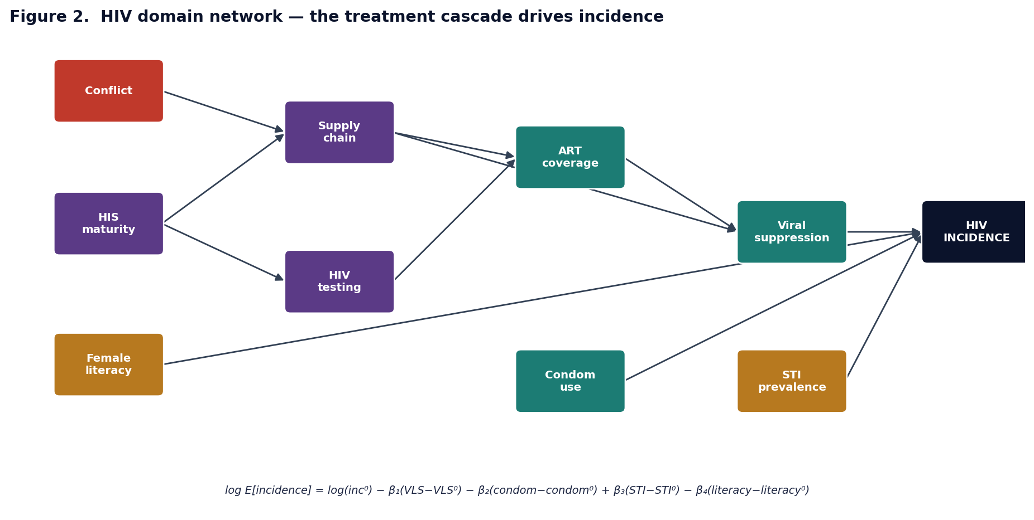
Figure 2. HIV network: HIS maturity and supply chain drive the ART→viral-suppression cascade, which drives incidence.
Governing equation(s)
log E[incidence] = log(inc⁰) − β₁(VLS−VLS⁰) − β₂(condom−condom⁰) + β₃(STI−STI⁰) − β₄(literacy−literacy⁰)
logit E[VLS] = logit(VLS⁰) + γ₁(ART−ART⁰) + γ₂(supply−supply⁰)

7.2 Maternal mortality
Outcome & method. Maternal mortality ratio (per 100,000 live births); method: additive monotonic model (Section 5.7) embedded as a network node.

Introduction
Maternal mortality is a sentinel indicator because survival depends on the whole chain of care functioning. The Region continues to account for a disproportionate share of global maternal deaths and progress is too slow for the SDG target (WHO MMEIG, 2023). The scenario question is how far the ratio could fall by strengthening specific links in the continuum of care.
The module generalises the deployed WHO AFRO maternal explorer into the Bayesian framework, letting planners weigh investments in emergency obstetric care against antenatal coverage and see the combined effect of a coordinated package with its uncertainty.

Predictors and evidence from the literature
The intermediate determinants are the continuum of care — skilled attendance and facility delivery, emergency obstetric care, caesarean availability, blood and referral — which determine whether the direct obstetric causes are survived, organised by the three-delays framework.
Reproductive determinants act earlier: antenatal care, modern contraception, birth spacing and adolescent fertility shape exposure and risk detection, and satisfying unmet need averts a substantial fraction of maternal deaths (Sully et al., 2020), linking to the SRHR network.
Structural, disease and infrastructural determinants — female education, poverty, fertility, gender inequality, rurality; anaemia, HIV and malaria; road access, travel time and ambulances — and system determinants such as workforce density and financing complete the network.

The modelling framework
The ratio is an outcome node on the log link, anchored to the observed value; protective parents carry negative signs and risk parents positive signs. The default statistical form is the monotone-constrained additive model of Section 5.7, embedded so upstream determinants and shocks feed the obstetric-care nodes.
Because the deployed model reported a modest ecological fit (an in-sample R² near one third), the module emphasises relative change, prediction intervals and cross-validation rather than point accuracy. Family-planning effects are routed through fertility, so a contraception scenario lowers both maternal and, via shared parents, child mortality.
Governing equation(s)
log E[MMR] = log(MMR⁰) − β₁(SBA−SBA⁰) − β₂(EmOC−EmOC⁰) − β₃(ANC−ANC⁰) + β₄(anaemia−anaemia⁰)

7.3 Neonatal mortality
Outcome & method. Neonatal mortality rate (deaths 0–28 days per 1,000 live births); method: cause-deletion / Lives Saved Tool (Section 5.1).

Introduction
Neonatal deaths now make up close to half of under-five mortality and have fallen more slowly than deaths at older ages, making the neonatal rate the binding constraint on child-survival gains (UN IGME, 2023). Most arise from preterm complications, intrapartum events and infections, which are largely preventable.
The module is aligned with the maternal network because intrapartum care quality is the primary determinant of newborn survival, and lets planners test newborn-care packages and the enabling inputs that gate them.

Predictors and evidence from the literature
The intermediate determinants are the newborn-care interventions with the strongest evidence: skilled attendance and emergency obstetric and newborn care, newborn resuscitation, kangaroo mother care and sepsis management, with efficacies synthesised in the Lives Saved Tool (Walker et al., 2013).
Clinical and biological determinants — maternal age extremes, prematurity and low birth weight — define the at-risk population, while antenatal care and postnatal care are protective.
Enabling inputs — referral, electricity, oxygen and blood — gate the effectiveness of the clinical interventions, consistent with the facility-readiness literature.

The modelling framework
The rate is a log-link outcome node anchored to the observed value, with cause-deletion coefficients (Section 5.1) so each intervention reduces the rate multiplicatively; enabling inputs are modelled as parents of the effectiveness of the clinical nodes rather than direct causes of death.
Monte-Carlo propagation gives the credible interval, and the outcome is one of the two segments that combine into under-five mortality (7.5).
Governing equation(s)
log E[NMR] = log(NMR⁰) − Σᵢ impᵢ · ΔCᵢ (cause-deletion; see §5.1)

7.4 Child mortality (1–59 months)
Outcome & method. Post-neonatal under-five mortality (per 1,000 live births); method: cause-deletion / Lives Saved Tool.

Introduction
Beyond the neonatal period, child deaths are dominated by pneumonia, diarrhoea, malaria, measles and undernutrition, for which cost-effective interventions exist (Black et al., 2003). The scenario question is how far the 1–59 month rate could fall with improved coverage.
The module lets planners compare the survival return on immunisation against case-management and nutrition and represent an integrated child-health package.

Predictors and evidence from the literature
The intermediate determinants target the leading causes: immunisation (measles, pneumococcal, rotavirus and DTP3), oral rehydration and zinc, pneumonia case-management and malaria interventions, with efficacies from the child-survival evidence (Walker et al., 2013).
Nutrition is pivotal as a risk multiplier — vitamin A, exclusive breastfeeding and the reduction of stunting are protective — and water and sanitation modify diarrhoeal risk.
Facility readiness, community health workers, travel time and maternal education shape delivery and demand, tying the module to the malaria network.

The modelling framework
The rate is a log-link outcome node with cause-deletion coefficients, sharing parents with the malaria and SRHR networks so vector-control or birth-spacing scenarios have coherent knock-on effects.
Interventions combine multiplicatively, a conservative approximation where they reach overlapping populations; the outcome is the post-neonatal segment feeding under-five mortality.
Governing equation(s)
log E[CMR] = log(CMR⁰) − Σₖ impₖ · ΔCₖ (cause-deletion; see §5.1)

7.5 Under-five mortality
Outcome & method. Under-five mortality rate (per 1,000 live births); method: survival decomposition (Section 5.2).

Introduction
Under-five mortality is the headline child-survival indicator and an SDG 3 target, naturally decomposed into a neonatal and a post-neonatal segment driven by different causes. The scenario question is how far it could fall under a coordinated package and which segment offers the greater return.
The module is an integrating node that combines the neonatal and child networks into one coherent under-five figure and feeds the SDG 3 node.

Predictors and evidence from the literature
Its parents are the two component outcomes — neonatal and child (1–59 month) mortality — each with its own predictors, so everything driving those segments drives under-five mortality.
Additional shared determinants act across both segments: health-system readiness, immunisation and nutrition, with poverty and conflict as structural and shock factors, and birth spacing (from SRHR) lowering mortality via fewer high-risk short-interval births.
The evidence base is the union of the neonatal and child evidence rather than a separate set (UN IGME, 2023; Walker et al., 2013).

The modelling framework
Under-five survival is the product of neonatal and post-neonatal survival, which makes the rate the exact sum of the two segment rates per 1,000 live births (Section 5.2); each segment is projected by its own network and recombined.
A scenario distributes to the appropriate segment, and Monte-Carlo propagation combines the uncertainty of both, so the under-five interval inherits the uncertainty of every determinant in both networks.
Governing equation(s)
S_u5 = S_neo · S_post ; U5MR = NMR + PNMR (per 1,000 live births)

7.6 Universal Health Coverage
Outcome & method. Service coverage index (0–1) and financial protection; method: financing production function (Section 5.4).

Introduction
Universal health coverage is the organising goal of the health system — that everyone can use quality services without financial hardship — monitored through a service coverage index and financial-protection measures (WHO and World Bank, 2023). The scenario question is how coverage and protection respond to financing, workforce, medicines and governance.
The module captures the whole system and exposes the trade-off between expanding coverage and protecting households from cost.

Predictors and evidence from the literature
Service-coverage predictors are the tracer interventions across RMNCH, infectious disease, NCD and service capacity; the index is a geometric mean of tracers, so any coverage gain raises it with diminishing returns.
Financing predictors are central: government health expenditure and prepaid pooling expand access while a high out-of-pocket share drives catastrophic expenditure and donor dependency introduces sustainability risk (WHO and World Bank, 2023).
System and structural predictors — workforce, medicines, readiness, HIS and digital maturity, governance, poverty and education — determine delivery capacity and enter as production inputs with concave returns.

The modelling framework
The service coverage index is a financing production function with diminishing returns (the logit link supplies concavity), and financial protection is a separate outcome node whose catastrophic-expenditure risk rises with the out-of-pocket share and falls with prepayment and coverage.
Governance and HIS maturity act as efficiency multipliers on the translation of spending into coverage; Monte-Carlo propagation gives credible intervals on both outcomes and the probability of crossing a threshold.
Governing equation(s)
logit E[SCI] = logit(SCI⁰) + β₁(GHE−GHE⁰) + β₂(prepaid−·⁰) + β₃(readiness−·⁰) − β₄(OOP−·⁰)
logit E[protection] = logit(FP⁰) + γ₁(prepaid−·⁰) − γ₂(OOP−·⁰) + γ₃(SCI−·⁰)

7.7 Tuberculosis
Outcome & method. TB incidence (per 100,000); method: Bayesian network with a find-treat-cure cascade.

Introduction
Tuberculosis remains a leading infectious cause of death in the Region and is tightly coupled to HIV, the strongest risk factor for progression to disease (WHO, 2023a). Control depends on finding cases promptly, curing them and preventing progression.
The module represents transmission through a find-treat-cure cascade analogous to the HIV cascade: the infectious untreated pool determines transmission and shortening the infectious period is the central lever (Styblo, 1991).

Predictors and evidence from the literature
The cascade determinants are case detection — driven by rapid molecular diagnostics, community and contact screening and HIS maturity — and treatment success, driven by drug availability and adherence support; together they shorten the infectious period (Styblo, 1991; WHO, 2023a).
Preventive therapy reduces progression from latent infection, especially in people with HIV and household contacts, and active case-finding has modest population effects in community-randomised trials.
HIV co-infection is the dominant amplifier and enters as a strong positive parent partly offset by ART coverage; undernutrition, smoking, diabetes, poverty and overcrowding are further risk factors.

The modelling framework
Incidence is a log-link outcome node anchored to the observed value; case detection and treatment success are intermediate logit nodes with their own system parents and enter incidence with negative signs, while HIV and the risk factors carry positive signs.
A scenario that raises diagnostics and screening increases detection, lowering incidence, and improving drug availability and adherence raises treatment success with a further reduction; the reference engine shows a combined package lowering incidence by roughly a third.
Governing equation(s)
log E[TB inc] ≈ log(inc⁰) − β₁(detection·success − ·⁰) − β₂(TPT − ·⁰) + β₃(HIV − ·⁰) − β₄(ART − ·⁰)

7.8 Malaria
Outcome & method. Malaria incidence (per 1,000 at risk); method: Bayesian network with multiplicative vector control and a climate shock.

Introduction
Malaria remains hyperendemic across much of the Region, which bears the majority of global cases and deaths concentrated in young children (WHO, 2023b). Control rests on vector control, chemoprevention, prompt treatment and, increasingly, vaccination, and is sensitive to supply chains and climate.
The module represents incidence as the baseline scaled by multiplicative intervention reductions with an explicit environmental and shock layer.

Predictors and evidence from the literature
The core interventions are insecticide-treated nets — roughly halving clinical malaria and reducing child mortality (Lengeler, 2004) — indoor residual spraying, seasonal chemoprevention and prompt treatment with artemisinin-based therapy, with vaccines an added layer.
Environmental and shock determinants — rainfall, temperature and floods — drive transmission (Smith et al., 2012; Macdonald, 1957), while improved housing is protective.
Surveillance, supply chains and community health workers gate delivery; the historical African decline is attributed to coordinated commodity scale-up (Bhatt et al., 2015).

The modelling framework
Incidence is a log-link outcome node with vector-control and chemoprevention interventions as negative-sign parents combining multiplicatively (a reduction in the entomological inoculation rate), and floods as a positive-sign shock that also degrades the supply chain.
This dual pathway is deliberate: the reference engine shows a severe flood raising incidence by around 60% and a vector-control scale-up roughly halving it, both with credible intervals.
Governing equation(s)
log E[malaria inc] = log(inc⁰) − β₁(ITN−·⁰) − β₂(IRS−·⁰) − β₃(chemoprev−·⁰) + β₄(flood)

7.9 Non-communicable diseases
Outcome & method. Probability of premature (30–70) NCD mortality; method: comparative risk assessment / PAF (Section 5.3).

Introduction
NCDs are a rising share of mortality as populations age and urbanise, yet systems remain configured for acute and infectious care. The SDG 3.4 target is a one-third reduction in premature NCD mortality. The scenario question is how far this probability could fall through action on risk factors and treatment.
The module uses a comparative-risk-assessment structure in which risk-factor prevalences and relative risks drive attributable mortality and service interventions reduce it.

Predictors and evidence from the literature
The behavioural and metabolic risk factors — tobacco, harmful alcohol, physical inactivity, high-salt diet and obesity — raise mortality through blood pressure, glucose and lipids, quantified by the Global Burden of Disease relative risks (GBD 2019 Risk Factors Collaborators, 2020).
Service determinants — hypertension and diabetes control, screening, primary-care readiness, medicine availability and digital follow-up — reduce mortality given exposure, informed by the WHO best-buy and HEARTS evidence (WHO, 2017).
Urbanisation is a structural risk parent and insurance a protective one.

The modelling framework
The premature-mortality probability is a logit-link outcome node anchored to the observed value; risk factors carry positive signs and control nodes negative signs, equivalent to a comparative-risk assessment in which the PAF combines prevalences and relative risks (Section 5.3).
A scenario lowers a risk factor (a best buy) or raises a control node (HEARTS); the reference engine shows best-buy and HEARTS packages reducing premature mortality by roughly a third while urbanisation raises it.
Governing equation(s)
PAF = Σᵢ pᵢ(RRᵢ−1)/[1+Σᵢ pᵢ(RRᵢ−1)] ; logit E[q(30,70)] = logit(q⁰) + Σₖ sₖ βₖ(riskₖ−·⁰) − γ(control−·⁰)

7.10 SRHR
Outcome & method. SRHR coverage index (0–1, higher is better); method: Bayesian network + demand-satisfied impact chain.

Introduction
Sexual and reproductive health and rights underpin maternal and newborn survival and women's autonomy, yet unmet need for contraception and service gaps remain substantial. The scenario question is how far a composite SRHR coverage index could rise through investment in services and structural enablers.
The module treats SRHR as a positive index driven by service coverage and enablers and lowered by risk factors, connected to the maternal and child networks through a demand-satisfied impact chain.

Predictors and evidence from the literature
The intermediate service determinants are modern contraception, antenatal care, facility delivery and skilled attendance; satisfying unmet need averts large numbers of unintended pregnancies and downstream deaths (Sully et al., 2020), motivating contraception's strong positive weight.
System determinants — youth-friendly and GBV services, commodity availability, workforce and digital SRHR — translate demand into use.
Structural determinants are decisive: girls' education raises the index while gender inequality and adolescent fertility lower it, among the best-established relationships in the literature.

The modelling framework
The index is a positive-outcome logit node; because the outcome is beneficial, service drivers carry positive signs and risk factors negative signs, and contraception is an intermediate node driven by commodities and youth services.
The demand-satisfied chain converts additional contraceptive users into averted unintended pregnancies and hence averted maternal and newborn deaths, linking SRHR to the maternal and child networks.
Governing equation(s)
logit E[SRHR] = logit(idx⁰) + β₁(FP−·⁰) + β₂(education−·⁰) − β₃(gender ineq.−·⁰)
pregnancies averted = Δusers·(1 − failure) → maternal & newborn deaths averted

7.11 Routine HIS / maturity
Outcome & method. HIS maturity index (0–100, higher is better); method: composite index (Section 5.5), mined baselines.

Introduction
A functional health-information system is the foundation on which every other outcome depends. The WHO AFRO assessment found the Region's systems at an early stage of maturity with wide variation (WHO Regional Office for Africa, 2026). The scenario question is how far a country's maturity could rise through targeted investment.
Uniquely, the country baselines are mined from the assessment itself, and because HIS maturity is an upstream determinant in every other network, better information systems improve outcomes across domains.

Predictors and evidence from the literature
The predictors are the four assessed domains — governance and leadership, data generation and management, data analysis and synthesis, and communication and use — each a composite of sub-items scored on a six-point scale, following the PRISM logic (Aqil, Lippeveld and Hozumi, 2009).
The assessment's findings inform the structure: near-universal DHIS2 adoption has improved data availability while financing is consistently the weakest sub-domain (WHO Regional Office for Africa, 2026).
Because the module uses mined data, predictor values are empirical — governance and data-generation sub-scores taken directly from the assessment tables for the 38 participating countries.

The modelling framework
The maturity index is an identity-link outcome node computed as a weighted mean of the four domains, with governance itself a weighted mean of its sub-domains (Section 5.5); coefficients are interpretable as domain weights and the index keeps the 0–100 scale and bands.
Country baselines load from the mined data, so a governance-strengthening or digitalisation scenario starts from each country's actual profile; the node is exported as a system-layer determinant into every other network.
Governing equation(s)
HIS maturity = Σ_d w_d · domain_d , Σ_d w_d = 1

7.12 SDG 3 attainment
Outcome & method. Probability of achieving SDG 3 targets; method: target-gap trajectory + integrating logistic node (Section 5.6).

Introduction
SDG 3 is monitored through a family of targets spanning maternal, newborn and child mortality, the major communicable diseases, NCDs and UHC. Whether a country is on track depends on the joint trajectory of all of these. The scenario question is the integrating one: what is the probability of attainment and what would change it?
The module sits at the top of the platform, aggregating the outputs of the domain networks into a single attainment estimate and identifying countries likely to miss the targets.

Predictors and evidence from the literature
The parents are the constituent outcomes — maternal, neonatal and under-five mortality; HIV, TB and malaria incidence; and premature NCD mortality — each entering as a gap-to-target so that reductions raise attainment.
Enabling determinants — UHC and financial protection, health expenditure, HIS maturity and governance — are positive parents, consistent with the SDG monitoring literature.
The evidence base is the SDG indicator framework and the required-versus-achieved rate-of-change methodology, with shocks as exogenous risks.

The modelling framework
Attainment is a logit-link outcome node anchored to a baseline probability; mortality and incidence parents carry negative signs scaled by their baselines while the enablers carry positive signs and conflict a negative sign.
The target-gap logic compares the required and achieved average annual rates of change to 2030 (Section 5.6); applying scenario improvements in the constituent networks recomputes attainment, and the reference engine lifts the probability from roughly one third to nearly two thirds under an integrated reform.
Governing equation(s)
AARR_required = (1/n)·ln(current/target) ; P(SDG3) = σ( α + Σₘ λₘ·gapₘ )

8. Cross-cutting assumptions and validation
- Structural assumptions: the DAG encodes assumed causal direction and the Markov condition; results are conditional on this elicited structure, which is open to revision.
- Sign-constrained magnitudes: polarities are fixed a priori as an identifiability aid, not learned.
- Ecological, mostly single-period: dynamic feedbacks are represented through forecasting and shock nodes, not full mechanistic dynamics.
- Validation: baseline invariance (do-nothing reproduces observed outcomes), directionality (each intervention moves its outcome the evidence-implied way), leave-one-country-out calibration of intervals, and external coherence against UNAIDS/Spectrum, UN MMEIG, UN IGME, WHO Global TB and Global Malaria Programmes and the WHO/World Bank UHC monitoring.
- Simulated indicators are labelled and must not be read as observations; outputs are decision-support illustrations, not official estimates.

9. References
Aqil, A., Lippeveld, T. and Hozumi, D. (2009) 'PRISM framework: a paradigm shift for designing, strengthening and evaluating routine health information systems', Health Policy and Planning, 24(3), pp. 217–228.
Auvert, B., Taljaard, D., Lagarde, E., Sobngwi-Tambekou, J., Sitta, R. and Puren, A. (2005) 'Randomized, controlled intervention trial of male circumcision for reduction of HIV infection risk (ANRS 1265)', PLoS Medicine, 2(11), e298.
Bailey, R.C., Moses, S., Parker, C.B. et al. (2007) 'Male circumcision for HIV prevention in young men in Kisumu, Kenya: a randomised controlled trial', The Lancet, 369(9562), pp. 643–656.
Bhatt, S., Weiss, D.J., Cameron, E. et al. (2015) 'The effect of malaria control on Plasmodium falciparum in Africa between 2000 and 2015', Nature, 526, pp. 207–211.
Black, R.E., Morris, S.S. and Bryce, J. (2003) 'Where and why are 10 million children dying every year?', The Lancet, 361(9376), pp. 2226–2234.
Cohen, M.S., Chen, Y.Q., McCauley, M. et al. (2011) 'Prevention of HIV-1 infection with early antiretroviral therapy (HPTN 052)', New England Journal of Medicine, 365, pp. 493–505.
GBD 2019 Risk Factors Collaborators (2020) 'Global burden of 87 risk factors in 204 countries and territories, 1990–2019', The Lancet, 396(10258), pp. 1223–1249.
Gelman, A., Carlin, J.B., Stern, H.S., Dunson, D.B., Vehtari, A. and Rubin, D.B. (2013) Bayesian Data Analysis. 3rd edn. Boca Raton: CRC Press.
Gray, R.H., Kigozi, G., Serwadda, D. et al. (2007) 'Male circumcision for HIV prevention in men in Rakai, Uganda: a randomised trial', The Lancet, 369(9562), pp. 657–666.
Hoffman, M.D. and Gelman, A. (2014) 'The No-U-Turn Sampler: adaptively setting path lengths in Hamiltonian Monte Carlo', Journal of Machine Learning Research, 15, pp. 1593–1623.
Koller, D. and Friedman, N. (2009) Probabilistic Graphical Models: Principles and Techniques. Cambridge, MA: MIT Press.
Lengeler, C. (2004) 'Insecticide-treated bed nets and curtains for preventing malaria', Cochrane Database of Systematic Reviews, (2), CD000363.
Macdonald, G. (1957) The Epidemiology and Control of Malaria. London: Oxford University Press.
Pearl, J. (2009) Causality: Models, Reasoning, and Inference. 2nd edn. Cambridge: Cambridge University Press.
Rodger, A.J., Cambiano, V., Bruun, T. et al. (2019) 'Risk of HIV transmission through condomless sex in serodifferent gay couples with the HIV-positive partner taking suppressive ART (PARTNER2)', The Lancet, 393(10189), pp. 2428–2438.
Smith, D.L., Battle, K.E., Hay, S.I. et al. (2012) 'Ross, Macdonald, and a theory for the dynamics and control of mosquito-transmitted pathogens', PLoS Pathogens, 8(4), e1002588.
Styblo, K. (1991) Epidemiology of Tuberculosis. 2nd edn. The Hague: Royal Netherlands Tuberculosis Association (KNCV).
Sully, E.A., Biddlecom, A., Darroch, J.E. et al. (2020) Adding It Up: Investing in Sexual and Reproductive Health 2019. New York: Guttmacher Institute.
UN Inter-agency Group for Child Mortality Estimation (2023) Levels & Trends in Child Mortality: Report 2023. New York: UNICEF.
Walker, N., Tam, Y. and Friberg, I.K. (2013) 'Overview of the Lives Saved Tool (LiST)', BMC Public Health, 13(Suppl 3), S1.
World Health Organization (2017) Tackling NCDs: 'best buys' and other recommended interventions for the prevention and control of noncommunicable diseases. Geneva: WHO.
World Health Organization (2023a) Global Tuberculosis Report 2023. Geneva: WHO.
World Health Organization (2023b) World Malaria Report 2023. Geneva: WHO.
World Health Organization and World Bank (2023) Tracking Universal Health Coverage: 2023 Global Monitoring Report. Geneva: WHO.
World Health Organization Maternal Mortality Estimation Inter-agency Group (2023) Trends in Maternal Mortality 2000 to 2020. Geneva: WHO.
World Health Organization Regional Office for Africa (2026) Assessment of the Maturity and Functionality of Health Information Systems in the WHO African Region. Brazzaville: WHO AFRO.

Disclaimer
Illustrative decision-support
Every output is a posterior-predictive or model-based scenario illustration; simulated indicators are labelled where an open API is unavailable, and coefficients are elicited from the cited literature until fitted on mined panels. Outputs do not replace official agency estimates or detailed dynamic models and must not be cited as authoritative. All structure, priors, code and assumptions are open to scientific review and must be validated against national data before operational use.

