Kip taylor

Final exam

CCN

1. Answers written below :
2. please excuse my writing it was hard to fit.

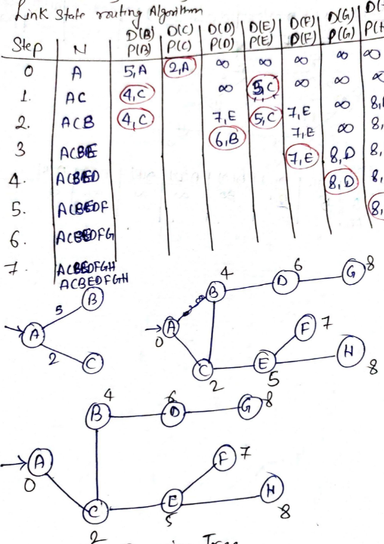

ii. if that happens it will choose the minimum cost path.

1. my drawing should answer part I. this was very time consuming 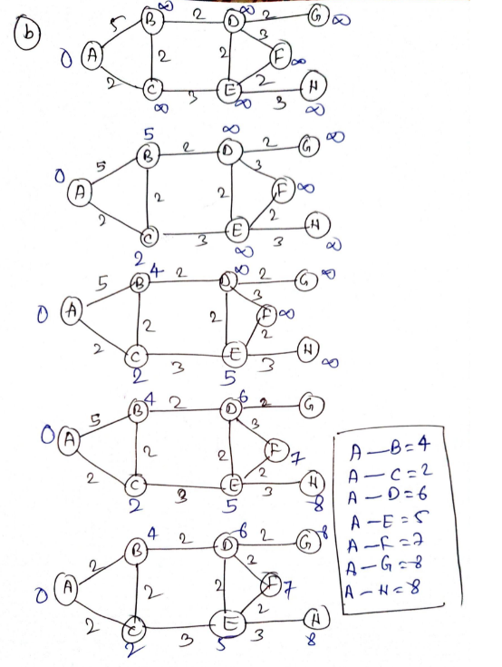
2. Answers below:

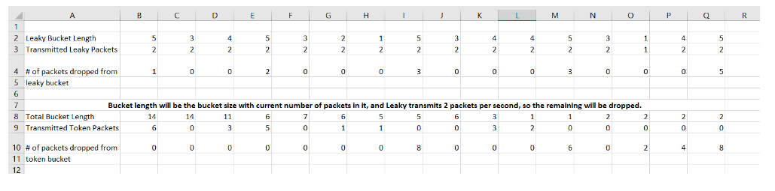

a. is done in excel above.

b. 28/15 = 1.87 packets/second

c. (21+28)/30 = 1.64 packets/second

1. Answers below :
2. If slow start opens until the sender window size reach = long then = 10240 kb , in 13rtt the sender window size = 2^13 therefore 14rtt to reach the sender window to 10 mb , total rtt to reach until 10mb = 14rtt
3. In slow sent we can have send data = 26,623 kb and often it will find 10 mb windows size , 64 mb – 26,623k / 10mb -= 4 therefore total rtt = 18 rtt.
4. Effective throughput = 64mb / 18rtt = 1.42*10^8 bps
5. So if we go off that log2(16) you can see that it seems congested at RTT 4. The total data sent at this moment is 31kb. 65536 – 31 = 65505. If we assume the window size does grow after congestion 65505 / 16 = 4094.06 +4 = 4099 RTT.
6. Answers below:

Given that usable sequence no = 2^31 , trans speed = 2^20

1. **Wraparound time = (2^31 / 10*2^20/2^3 = .4551**
2. **Segement size = 8 bytes , wraparound time (2^31 / 10*2^20/2^6 = 36.408 hours.**
3. **if we use large segment size ,which increases size of MTU in data link layer Maximum transmission unit is the maximum size of a packet or frame that can flow across the network, without being fragmented, which lead to overhead of fragmentation at network layer.**
4. **Maximum network throughput equals the TCP window size divided by the round-trip time of communications data packets.**

**Round trip time = 2^6 ms**

**window size = 2^16**

**Throughput = (2^16)/(2^6) = 2^10 KBps.**

|  |  |  |  |  |  |  |  |
| --- | --- | --- | --- | --- | --- | --- | --- |
| **Ackarrives after** | **32** | **34** | **36** | **32** | **30** | **28** | **28** |
| **Est. RTT** | **30.4** | **31.12** | **32.1** | **32.08** | **31.66** | **30.93** | **29.94** |
| **TO** | **60.8** | **62.24** | **64.2** | **64.16** | **61.32** | **61.86** | **59.88** |

1. **Answers below**

**d = .8 B = .2 ERTT =30 dev= 0**

**ERTT =.8 + .2(sample)**

**TO = 2*ERTT**

1. **^ above**

|  |  |  |  |  |  |  |  |
| --- | --- | --- | --- | --- | --- | --- | --- |
| **Ack** | **32** | **34** | **36** | **32** | **30** | **28** | **26** |
| **Diff** | **2** | **3.6** | **4.88** | **-.1** | **-2.08** | **-3.66** | **-4.93** |
| **ESTRTT** | **30.4** | **31.12** | **32.1** | **32.08** | **31.66** | **30.93** | **29.94** |
| **Dev** | **.4** | **1.04** | **1.81** | **2.15** | **3** | **4.33** | **6.18** |
| **TO** | **32** | **35.28** | **39.33** | **40.69** | **43.66** | **48.26** | **54.67** |

**ERTT = 30 Dev = 0 µ= 1 ϴ= 4 Diff = Samp – Est**

**δ= .2 ERTT = ERTT + δxDiff**

**Dev = Dev + δ | diff – dev|**

**TO = 1xERTT + 4xDev**

1. **Is above^**

|  |  |  |  |  |  |  |  |
| --- | --- | --- | --- | --- | --- | --- | --- |
| **Ack** | **32** | **34** | **X** | **32** | **30** | **28** | **26** |
| **Diff** | **2** | **3.6** | **X** | **.88** | **-1.3** | **-3.04** | **-4.43** |
| **EstRtt** | **30.4** | **31.12** | **X** | **31.3** | **31.04** | **30.43** | **29.54** |
| **Dev** | **0.4** | **1.04** | **X** | **1.07** | **1.54** | **2.46** | **3.84** |
| **TO** | **32** | **35.28** | **X** | **35.58** | **37.22** | **40.25** | **44.89** |

1. **I above^**
2. **The benefit to short time-outs is to help with congestion control however timeouts can be annoying to users. Also short time outs are shorter and that’s better, we can compute the timeout time when we are given sample of the RTT and the deviation of RTT.**