Lab 4

Ccn

Below is my code execution

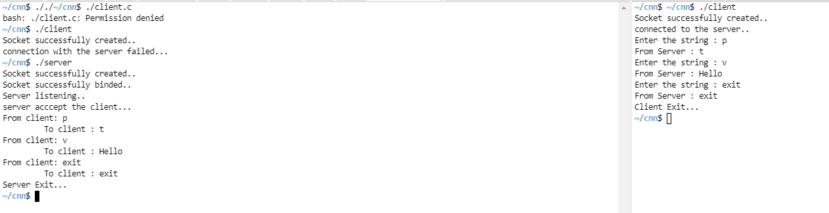

Got it to kinda work, screenshot shows. Thanks for the good semester have a great summer!