Kip taylor

Lab 2

1. Screenshots

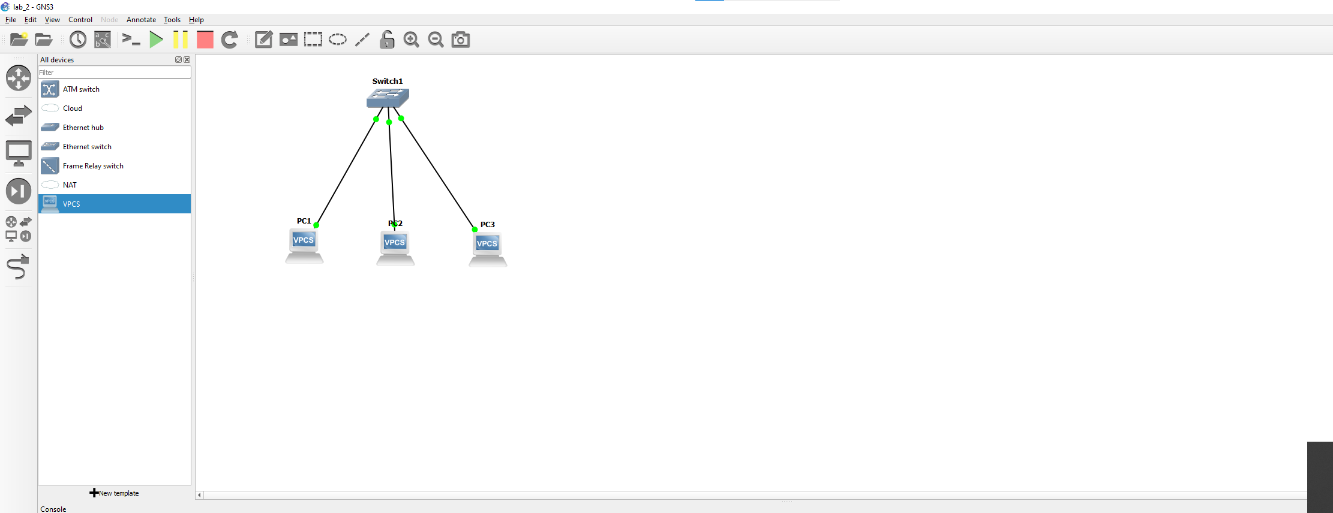

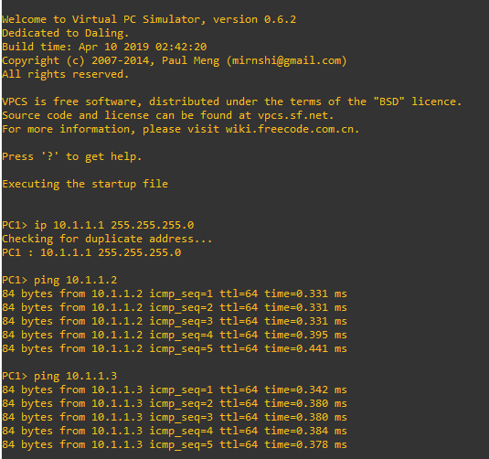

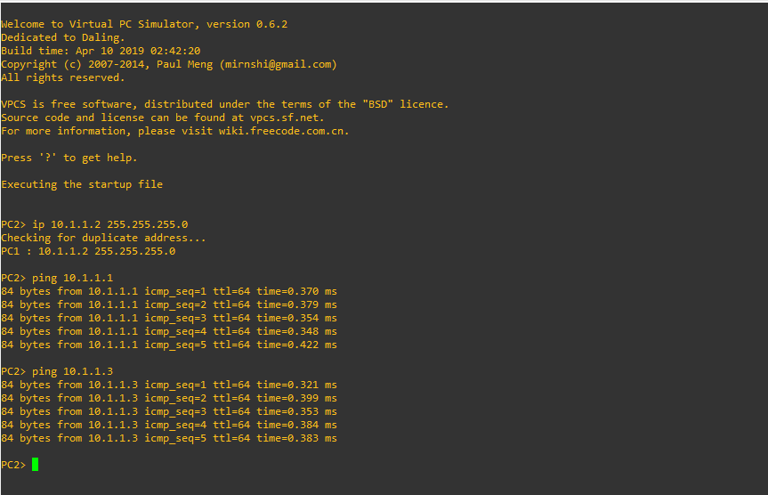

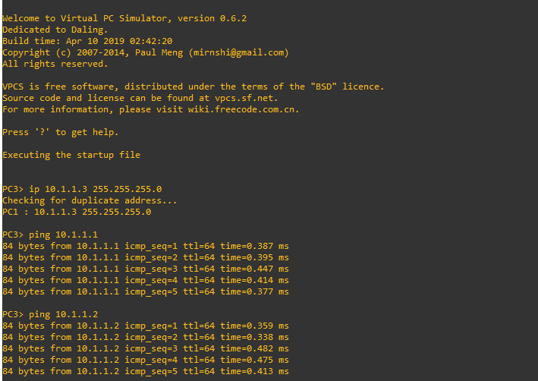

Questions:

1. The delays are not identical but similar , this is due to nature of the machines and uncontrollable factors , normal delay shown in all other previous attempts , as in our last project too.
2. Yes, because latency between pc 1 and pc3 is similar going the other way like going 1 , 3 to 1. So yes.