|  |
| --- |
| university of nairobi  project proposal  UoN Logo.jpg |
| **Tenders for Youth Information Portal** |
| by |
| EVANS KIPTOO CHIRCHIR  P15/36829/2010 |
|  |
|  |

SUPERVISER- Mr. CHRISTOPHER MOTURI

|  |
| --- |
|  |

A project proposal submitted in partial fulfillment of the degree of Bachelor of Science in Computer Science of University of Nairobi.

Table of Contents

CHAPTER 1: INTRODUCTION 3

1.1 Background 3

1.2 problem 3

1.3 Objectives 4

1.4 Research Question 4

1.5 Justification 4

CHAPTER 2: LITERATURE REVIEW 5

CHAPTER 3. METHODOLOGY 6

3.1.1 Justification for using Xp methodology 7

3.3 Design and Implementation 9

3.3.1 Development Environment 9

3.4 Testing and Evaluation 10

3.5 Timeline 10

CHAPTER 4.APPENDICES 11

Appendix A – References 11

[November 14, 2012]. 11](#_Toc378538112)

# CHAPTER 1: INTRODUCTION

## 1.1 Background

In line with Kenya’s vision 2030, A national long-term development blue-print to create a globally competitive and prosperous nation with a high quality of life by 2030, that aims to transform Kenya into a newly industrializing, middle-income country providing a high quality of life to all its citizens by 2030 in a clean and secure environment, the government is empowering the youth by rolling out new policies in order to ensure the youth who are among the disadvantaged groups in our society are given the opportunity to grow the economy and sustain themselves.

For a very long time cut throat competition posed by established companies, organized groups and individuals had denied a majority of the youth, women and persons with disabilities the opportunity to secure tenders to supply goods and services to public sector entities.

However, to address the challenge, the government which is the single largest consumer of goods and services has dedicated 30 per cent of all its procurement to the youth, women and persons with disabilities as part of the broader affirmative action.

This policy direction is one of the innovative affirmative action measures the government has undertaken to empower disadvantaged groups in our society. The others include the UWEZO Fund, Women Fund and Youth Enterprise Fund.

## 1.2 problem

As the government roll out the 30 per cent of all its procurement to the youth, women and persons with disabilities policy, issues arise as to how information can be accessed by this affected people. The youth should be able to get the right, accurate and up-to-date information about new tenders from the government in time and equally to all.

Also there’s no single point for information, information come from different angles, example this include:-

1. Ministry of Youth affairs

2. Youth Enterprise Fund

3. Treasury

This leads to confusion among the youth as to where to get information.

## 1.3 Objectives

1. Create a Web portal that collects and handles information from different relevant institutions that disseminate the information and consolidate it into a single point.
2. Create a user friendly and interactive interface that will display to the users of all existing tenders and relevant information on a real-time basis.
3. Create a platform where other non-governmental organizations and businesses can advertise for their tenders as well.
4. Create a daily notification system for the subscribers in order to Increase information access, fast and timely delivery and sharing to and between the youth respectively.

## 1.4 Research Question

How can Information Communication Technology (ICT) be used to disseminate information to the youth for their empowerment?

## 1.5 Justification

There is urge to reduce the gap and the extra mile the youth have to go in order to get relevant information for government tenders. This will encourage the youth to apply for the tenders.

# CHAPTER 2: LITERATURE REVIEW

The government has provided youth, women and persons with disability with the opportunity to participate in government tenders totaling Sh200 billion for wealth creation. For the first time in Kenya’s history, deliberate efforts are being made by government to passionately address youth problems ranging from unemployment, poverty and unexploited expertise.

Youth empowerment is one of the red carpet flagship projects envisaged in the Jubilee manifesto as part of the radical surgery in solving youth problems.

This fundamental pledge that forms one of the central key pillars of the Jubilee Government must be jealously safeguarded to give the youth, persons with disability and women at least 30 per cent of all supply contracts to the government.

It is the government’s policy that 30 per cent of these tenders must be awarded to the youth, women and people with disabilities. Having being officially launched, our young people must reciprocate by seizing every opportunity to maximize their potential. Youth unemployment problem is clearly visible in the urban areas and replicated the rural villages.

In the past, our country has been troubled by lack of youth empowerment and unemployment. This is part of the long-term affirmative action to empower these groups that have perennially been sidelined either in nation building and economic advancement not forgetting other programmes like Uwezo Fund, Women Fund and Youth Enterprise Fund.

It is about time this directive is implemented to the letter to boost youth-run enterprises in economic development.

The Youth Enterprise and Capital Fund that has been modeled as Constituency Development Fund is part of the kitty is provided to facilitate business financing among the youth without necessarily having to provide a collateral security.

However, it is imperative for our young people to familiarize themselves with the already published amendment regulations of the Public Procurement Preference and Reservations 2013.

Previous white elephant programmes guised as youth empowerment platforms have miserably flopped with huge investments going into waste.

These guidelines are a prerequisite to enable our young people follow the right procedure in tendering process to avoid unnecessary hiccups that can eventually deny them the opportunity to trade with government.

Rationalizing these guidelines will enable the National Treasury and all the Treasuries in the 47 county governments to maintain a database for all registered youth companies, Small or Micro-Enterprises or disadvantaged groups that wish to participate in public procurement.

This idea that paves way for the youth to trade directly with the government must be embraced like yesterday. However, this will only be achieved if the procurement departments abide by the government directive in opening up avenues that have perennially been framed as the preserve of the few.

It is an indisputable fact that youths are majority of the Kenyan population and therefore play an integral part in the political, socio-economic development of this country and whose engagements have an undisputable direct impact on national progression and stability. In the past, owing to their vulnerability due to weak economic and social status, youths have been misused by politicians as agents of violence.

# CHAPTER 3: METHODOLOGY

**3.1 Extreme Programming (XP)**

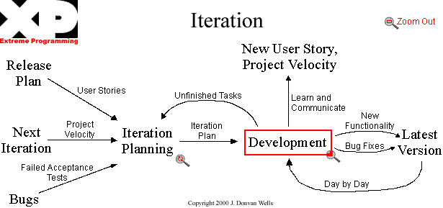

The original XP recipe is based on four simple values – simplicity, communication, feedback, and courage and twelve supporting practices:

* Planning Game
* Small Releases
* Customer Acceptance Tests
* Simple Design
* Pair Programming
* Test-Driven Development
* Refactoring
* Continuous Integration
* Collective Code Ownership
* Coding Standards
* Metaphor
* Sustainable Pace

In XP, the “Customer” works very closely with the development team to define and prioritize granular units of functionality referred to as "User Stories". The development team estimates, plans, and delivers the highest priority user stories in the form of working, tested software on an iteration by iteration basis. In order to maximize productivity, the practices provide a supportive, lightweight framework to guide a team and ensure high-quality software.

### 3.1.1 Justification for using Xp methodology

* Due to short releases and constant feedback, makes it becomes easier to cope with changes.
* Regular meetings make it possible to measure individual productivity. This leads to the improvement in the productivity of each of the team members.
* The overhead cost in terms of process and management is minimal thus leading to a quicker, cheaper result.
* It is easier to deliver a quality product in a scheduled time.

**3.2 Research Methodology**

**3.2.1 Introduction**

In this chapter the research that be used in the study is described. The geographical area where the study will be conducted, the study design and the population and sample are described. The instrument used to collect the data, including methods implemented to maintain validity and reliability of the instrument are described.

**3.2.2 Research Approach and Design**

A qualitative approach will be followed. Burns and Grove (1993:777) define qualitative research as a formal, objective, systematic process to describe and test relationships and examine cause and effect interactions among variables. Surveys will be used to collect original data for describing a population too large to observe directly (Mouton 1996:232). A survey obtains information from a sample of people by means of self-report, that is, the people respond to a series of questions posed by the investigator (Polit and Hungler 1993:148). In this project information will be collected through self-administered questionnaires and interviews from healthcare professionals.

A descriptive survey is selected because it provides an accurate portrayal or account of the characteristics, for example behavior, opinions, abilities, beliefs, and knowledge of a particular individual, situation or group.

**3.2.3 Target Population**

The research will mainly target the youth either having SME’s or individual businesses.

**3.2.4 Sampling Technique and Instruments**

Data collection is very important and has to be done right for the research to be correct and provide the vest possible outcome and expected results. Thus a method that allows effective collections form all possible users is important as well as the ability to avoid false data. In this research purposive sampling will be used. Purposive sampling is form of non-probability sampling in which decisions concerning the individuals to be included in the sample are taken by the researcher, based upon a variety of criteria, which may include specialist knowledge of the research issue, or capacity and willingness to participate in the research. Some types of research design necessitate researchers taking a decision about the individual participants who would be most likely to contribute appropriate data, both in terms of relevance and depth.

For example, in this research, some potential participants may be willing to be interviewed, but may not be able to provide sufficiently rich data (Oliver 2006).

**3.2.5 Data Collection Procedures**

This involves the methods to be used in the data-gathering phase of the project. I will use various instruments to collect the data to meet the problem of the study. Primary data will be obtained through face-to-face interview with selected youth from different regions. This will be supplemented by personal observations where necessary to establish the reliability of these instruments. Observation will be employed side by side with the interview. I will use this technique to gather data related to the feelings and opinions of the different healthcare professionals involved in the research. I will therefore use the following methods for collecting data: Questionnaires, ethnography and interviews and observation.

3.3 Design and Implementation

3.3.1 Development Environment

The following hardware and software technologies will be used in the development of this application:

1. PHP

An Object oriented programming language is to be used to build the web component of the application. It will be integrated to a database backend for storage of information.

1. MySQL

This is will the backend database software. It is light, flexible and secure. It also integrates will with the PHP programming language and therefore a good choice for this application.

1. Code Igniter Framework

Code Igniter is an Application Development Framework - a toolkit - for people who build web sites using PHP. Its goal is to enable you to develop projects much faster than you could if you were writing code from scratch, by providing a rich set of libraries for commonly needed tasks, as well as a simple interface and logical structure to access these libraries. Code Igniter lets you creatively focus on your project by minimizing the amount of code needed for a given task.

1. HP g62 Laptop with Intel Core i3 2450M 2.4 GHz Core, 4GB RAM, 5000GB Hard Disk

3.4 Testing and Evaluation

Evaluation and testing will be a continuous operation all throughout the project period. It will be modular to ensure that all the different parts of the project will work well separately and also when they are integrated into the overall system.

3.5 Timeline

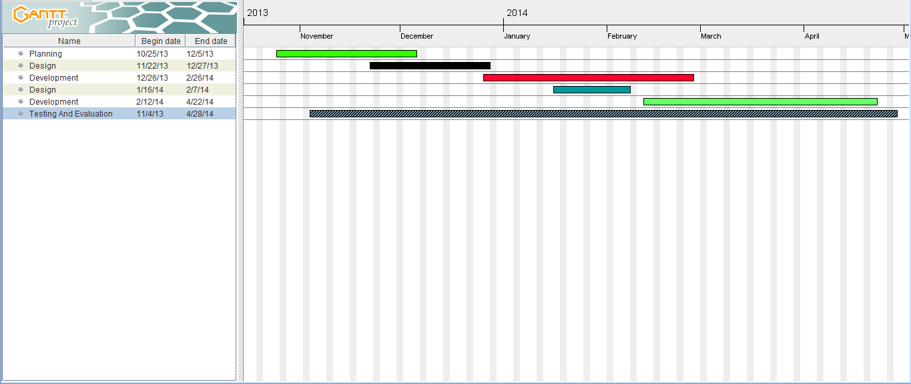

# CHAPTER 4: APPENDICES

Appendix A – References

1. Anon, WellPoint. Available at:

http://www.wellpoint.com/index.htm[Accessed November 14, 2012].

2. Anon, IBM Watson: Ushering in a new era of computing. Available at:

http://www-03.ibm.com/innovation/us/watson/index.shtml [Accessed

November 14, 2012].