|  |
| --- |
| university of nairobi  project proposal  UoN Logo.jpg |
| **Tenders for Youth Information Portal** |
| A system to. |
| EVANS KIPTOO CHIRCHIR  P15/36829/2010 |
|  |
|  |

SUPERVISER- Mr. CHRISTOPHER MOTURI

|  |
| --- |
|  |

Table of Contents

1. INTRODUCTION 3

1.1 BACKGROUND 3

1.2 PROBLEM 3

1.3 OBJECTIVES 3

1.4 RESEARCH QUESTION 4

1.5 SCOPE 4

1.6 JUSTIFICATION 4

2. LITERATURE REVIEW 5

3.METHODOLOGY 9

3.1 Introduction 9

3.2 Design and Implementation 10

3.2.1 Overview of the interface 12

3.2.2 Development Environment 12

3.3 Testing and Evaluation 13

3.4 Timeline 13

4. Appendices 14

Appendix A – References 14

# INTRODUCTION

## 1.1 BACKGROUND

People use cheques in their daily lives to pay bills, loans, renumeration, fees and other bussineses.In order for one to pay with a cheque he/she has to have a valid cheque book given by a specific bank under his name and on it is where one writes the amount of money payable. After that he/she walks to the intended bank where he/she has to queue for some minutes and cashes in the cheque.The cheque then takes 2-3 days for processing and validation after which the cheque either is accepted or rejected. If accepted, the bank authorizes the transfer of money else the cheque is disposed.

In order for one to get paid using a cheque the payee has to first get a cheque from the payer then walks to the intended bank and cashes in the cheque.This shows how one has to do in order to use a cheque. These and many other factors have brought about the need for a cheque processing system, that will allow sending of cheques from one person to another without having to meet each other and even cashing it to the bank without even walking to a bank.

## 1.2 PROBLEM

In order for one to use a cheque for payment he/she ahs to physically acquire it first then walk into a bank so as to cash it in, this wastes a lot of time since at times there are long queues in the bank.

This project aims to create a software system to help remedy this situation by allowing users to send and receive cheques in form of an image, and use them to perform their desired tasks without necessarily physically meeting up or walking to a bank.

## 1.3 OBJECTIVES

1. Create a cheque processing system that will allow sending and receiving of cheques from one person to another without having to meet each other and even cashing it to the bank without even walking to a bank.
2. To create a mobile interface to ensure the software system can be accessed and used in decentralized locations.
3. To ensure that cheques sent /received in the system from its users are valid and up-to-date in order to avoid fraud.

## 1.4 RESEARCH QUESTION

How can technology be used to revolutionalize the banking sector in Kenya?

## 1.5 SCOPE

This project aims to build a mobile application complimented by a web based software application. The web based software will act as a store of all the data/details and cheques of all the users. The application will also have the ability to produce various reports that may be useful.

A Cheque validation component of the application will allow all the photos taken by the users in order to be used to be of a valid cheque consisting of all required fields of a cheque.This will help avoid fraud in the system.

A mobile component will consist of an Android Mobile application that will allow users to interact with the system remotely. This is the core part of the system since validation and all other operations will be done. It will serve to provide flexibility for users to send and receive cheques, wherever an internet connection is available.

## 1.6 JUSTIFICATION

1. The decision to make the system on a Android mobile phone came from the fact that it supports a camera and internet this two are important resources needed in the entire system. It also allows easy mobility since they will be carried by the patient from one doctor to the other, thus enabling ease of sending and receiving of cheques by the user.
2. The government recently passed an act for banks to reduce the days used to process cheques and by so doing the bankers association of Kenya introduced a new way of processing cheques in order to reduce the time needed that included scanning the cashed in cheques and sending them by email to respective banks for approval and clearance. This has currently been rolled out since August by all banks. This is a good time since integration will not be much of a challenge anymore.

# LITERATURE REVIEW

Cheques and cheque clearing

**Although cheque usage has declined in recent years as businesses have started to use automated payments and cards, it still remains a very important payment method, particularly for small businesses.**

The clearing system

Cheques are paper items which are physically transferred between banks at the same time as the electronic data is processed. Although the paying bank receives some of the data electronically, the physical cheques themselves must also be transferred so that they can be examined by the paying bank for security and fraud prevention purposes.

The clearing system works within a three working day period (it does not operate on Saturdays, Sundays or Bank Holidays).

**Day 1**

When a cheque is paid into an account (at the collecting bank) it is sent to the bank's clearing centre at the end of the working day.

**Day 2**  
All cheques received are sorted at the clearing centre and the sort code, account number and serial number on the bottom of the cheque, together with the amount of the cheque, are sent electronically to the banks on which they are drawn (the paying bank) by 11am. The physical cheque is then sent to the bank on which it is drawn.

**Day 3**  
The paying bank debits the payer's bank account with the amount of the cheque on the morning of day 3. At the same time, all banks calculate the amount they must pay each other on the basis of the value of all the cheques exchanged on the previous day. The net balances are then settled across accounts held at the Bank of England.

**This is the end of the central clearing cycle.**

However, if the paying bank was unable to pay the cheque, for instance if the cheque owner has insufficient funds in their account, placed a stop on the cheque, or filled it out incorrectly, it would return the cheque to the original collecting bank on day 3, or in certain specific circumstances, by 12 noon on day 4. Cheques are generally returned by first class post, so the earliest the collecting bank will know that the cheque will not be paid is day 4, or possibly day 5.

A cheque may be returned later than day 5 if it is found to be fraudulent. For instance if a fraudster has bought goods using a stolen cheque, the genuine owner may not discover until sometime after the goods have been exchanged that money is missing from their account. In this case, the money that has been paid into the seller's account belongs to the genuine cheque owner and could be withdrawn once the fraud is discovered. If you accept a cheque that subsequently turns out to be fraudulent, you may be required to return the funds. See the section below for tips on Avoiding Cheque Fraud.

Individual banks set their own policies on the point at which they credit funds on cheques paid into their customers' accounts. Under The Banking Code, banks are required to provide clear details of their policies on the issues to their customers, and whether they add extra days to the central clearing cycle. Most high street banks allow customers to withdraw funds on the fourth or fifth working day, but some banks allow customers to withdraw funds as early as day 1.

Cheque guarantee services

Some specialist private companies offer cheque clearance and collection services. Here they advise you before the cheque enters the clearing system if it is likely to be honoured. If they approve the cheque and it is later returned by the bank, the company will reimburse you.

They will also follow up on returned cheques and arrange prompt repayment of the debt. They often operate on a no collection, no fee basis.

Banks also offer cheque guarantee cards, where one cheque per transaction is guaranteed up to the value limit shown on the accompanying cheque guarantee card.

Receiving cheques

Always ensure you know the creditworthiness of your customers to minimise the risk of a bounced cheque as accepting a cheque for payment does not necessarily mean payment will be made. For high value payments consider using more secure methods of payment such as CHAPS (formerly known as a telegraphic transfer).

Shop around for an account that provides the best service for your needs as different banks have different policies on when customers may withdraw funds from cheques.

Pay cheques into your account straight away to reduce the risk of loss or theft.

Consult your bank on the best payment method when dealing with cross-border customers, as foreign cheques cannot be cleared through the UK cheque clearing system and will therefore add time and cost to the payment.

Issuing cheques

Do not use post dated cheques as they may cause problems if paid in before the date shown by being returned unpaid or being cleared before you are expecting it.

Always keep cheque guarantee cards and cheque books separate.

Help prevent fraud by adding extra information on the payee line after the name such as invoice or contract numbers.

Draw a line through unused space on the cheque to avoid unauthorised people adding extra details.

Record details of cheques issued on chequebook counterfoils and carefully check against bank statements so discrepancies can be picked up and reported to your bank or building society.

Try to allocate responsibility for issuing cheques and undertaking reconciliation with bank statements to at least two different people.

Consult your bank on the best payment method when dealing with cross-border suppliers, as cheques issued by UK banks (even if denominated in another currency) are for use in the UK only.

Avoiding cheque fraud

The industry is fighting fraud through the Cheque Printer Accreditation Scheme which lays down security standards for printing cheques to protect against counterfeiting and fraudulent alteration of cheques. In addition, the Dedicated Cheque and Plastic Crime Unit, funded by the banking industry targets organised criminal gangs heavily involved in counterfeiting.

The banking industry continues to identify most fraudulent and stolen cheques as they pass through the clearing system before there is a victim, but there are several ways businesses can help to guard against fraud:

Don't accept a cheque, or banker's draft from someone unless you absolutely know and trust them.

Remember that, even after the value of the cheque has been credited to your account there is still a risk that the money could be reclaimed if the cheque turns out to be stolen or counterfeit.

Consider other types of payment for high-value goods and services such as automated payment or **CHAPS** – if the customer is unwilling to pay, or share with you, the relatively small cost involved with **CHAPS**, then seriously consider if you should be doing business with them.

Be aware that banker's drafts and building society cheques are not necessarily safe forms of payment, as the money may not be paid if they are found to be stolen.

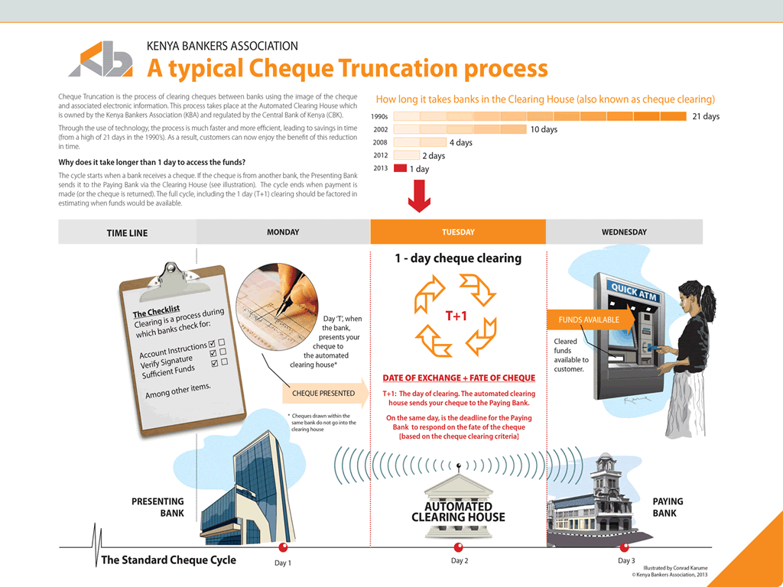

# 3.METHODOLOGY

3.1 Introduction

Scrum Methodology



* The suitable methodology for this project will be scrum methodology. Scrum is a simple agile development methodology through which onecan manage complex project. Scrum allows rapidly and repeated inspection of actual working product (at least once a month or twice) hence provides ability for the project to adapt to rapidly changing market and other complex external factors. The focus of the scrum methodology is to deliver the highest business value of the project in the shortest possible time. Testing and documentation shall be inherent in every stage of development.
* The best part of Scrum for product development is the requirement to demonstrate a real working product every two weeks or once a month. This helps to take a calculated decision for the project’s future at a regular and a shorter interval. Hence scrum gives the ability to adjust with the changing requirements and needs and also to take go-or-no-go decision well in time hence saving lots of resources.

Justification for using scrum methodology

• Due to short sprints and constant feedback, it becomes easier to cope with changes. Regular meetings make it possible to measure individual productivity. This leads to the improvement in the productivity of each of the team members.

• The overhead cost in terms of process and management is minimal thus leading to a quicker, cheaper result.

• It is easier to deliver a quality product in a scheduled time.

• Agile scrum saves time and resources.

• It is a lightly controlled method, which insists on frequent updating of the progress in work through regular meetings. Thus there is clear visibility of the project development

**3.2 Research Methodology**

**3.2.1 Introduction**

In this chapter the research that be used in the study is described. The geographical

area where the study will be conducted, the study design and the population and

sample are described. The instrument used to collect the data, including methods

implemented to maintain validity and reliability of the instrument are described.

**3.2.2 Research Approach and Design**

A qualitative approach will be followed. Burns and Grove (1993:777) define

qualitative research as a formal, objective, systematic process to describe and test

relationships and examine cause and effect interactions among variables. Surveys will

be used to collect original data for describing a population too large to observe

directly (Mouton 1996:232). A survey obtains information from a sample of people

by means of self-report, that is, the people respond to a series of questions posed by

the investigator (Polit and Hungler 1993:148). In this project information will be

collected through self-administered questionnaires and interviews from healthcare

professionals.

A descriptive survey is selected because it provides an accurate portrayal or account

of the characteristics, for example behavior, opinions, abilities, beliefs, and

knowledge of a particular individual, situation or group.

**3.2.3 Target Population**

The research will mainly target People with small and medium size businesses (SME’s) and individuals who use cheques for their daily payments.

**3.2.4 Sampling Technique And Instruments**

Data collection is very important and has to be done right for the research to be

correct and provide the vest possible outcome and expected results. Thus a method

that allows effective collections form all possible users is important as well as the

ability to avoid false data. In this research purposive sampling will be used. Purposive

sampling is form of non-probability sampling in which decisions concerning the

individuals to be included in the sample are taken by the researcher, based upon a

variety of criteria, which may include specialist knowledge of the research issue, or

capacity and willingness to participate in the research. Some types of research design

necessitate researchers taking a decision about the individual participants who would

be most likely to contribute appropriate data, both in terms of relevance and depth.

For example, in this research, some potential participants may be willing to be

interviewed, but may not be able to provide sufficiently rich data (Oliver 2006).

**3.2.5 Data Collection Procedures**

This involves the methods to be used in the data-gathering phase of the project. I will

use various instruments to collect the data to meet the problem of the study. Primary

data will be obtained through face-to-face interview with selected healthcare

professionals. This will be supplemented by personal observations where necessary to

establish the reliability of these instruments. Observation will be employed side by

side with the interview. I will use this technique to gather data related to the feelings

and opinions of the different healthcare professionals involved in the research. I will

therefore use the following methods for collecting data: Questionnaires, ethnography,

and interviews and observation.

3.3 Design and Implementation

3.3.1 Overview of the interface

The application is to employ a Mobile application as the main usage interface. The interface will provide the user with the option to take a photo of the completed cheque and some more options to send delete the image or cancel the operation.

The web application will act as an interface to the administrative side of the application.

3.3.2 Development Environment

The following hardware and software technologies will be used in the development of this application:

1. Java web

Object Oriented java is to be used to build the web component of the application. It will be integrated to a database backend for storage of information.

1. MySQL

This is will the backend database software. It is light, flexible and secure. It also integrates will with the PHP programming language and therefore a good choice for this application.

1. Spring Framework

This is a java based framework used for rapid development of remote systems.In order to exchange data remotely from the server(web application) and the client(Android mobile application),Spring framework will be a great asset.

1. Vaadin UI Framework

Vaadin framework is a java based framework used to create interfaces for a web application, and provides a fast and easy way to create dynamic, and user friendly front end interfaces for a wide variety of platforms.

1. Android Software Development Kit for Java

The mobile component of the application will be built for and deployed on the Android platform. This platform is powerful enough to handle the features required on the application, and allows the application to be reached on a growing number of mobile devices in Kenya.

1. HP g62 Laptop with Intel Core i3 2450M 2.4 GHz Core, 4GB RAM, 5000GB Hard Disk
2. Android Version 2.2 or Higher Mobile Phone Handset.

3.4 Testing and Evaluation

Evaluation and testing will be a continuous operation all throughout the project period. It will be modular to ensure that all the different parts of the project will work well separately and also when they are integrated into the overall system.

3.5 Timeline

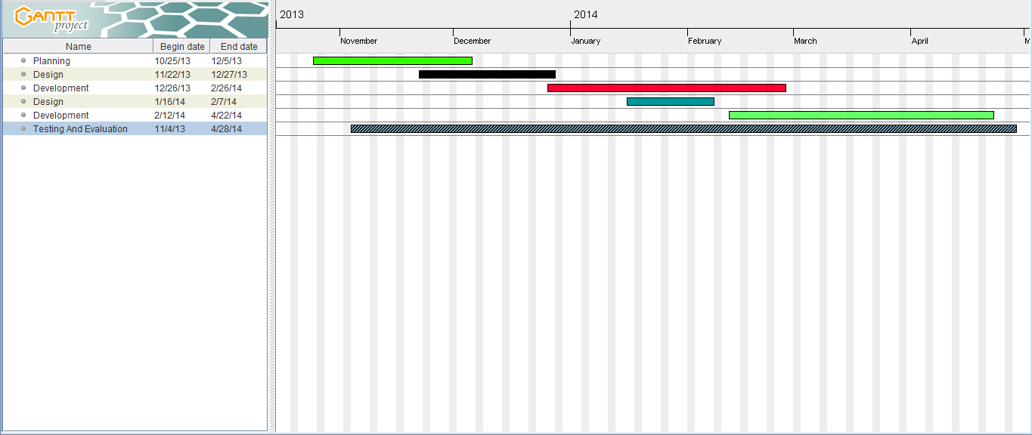

# 4. Appendices

Appendix A – References

1. Anon, WellPoint. Available at:

http://www.wellpoint.com/index.htm[Accessed November 14, 2012].

2. Anon, IBM Watson: Ushering in a new era of computing. Available at:

http://www-03.ibm.com/innovation/us/watson/index.shtml [Accessed

November 14, 2012].