Assgiment 5.2

Problem 1. Find out the top 5 most visited destinations.

Coding

REGISTER 'piggybank-0.15.0.jar';

A = LOAD ‘DelayedFlights.csv' USING org.apache.pig.piggybank.storage.CSVExcelStorage(',','NO_MULTILINE','UNIX','SKIP_INPUT_HEADER');

B = foreach A generate (int)$1 as year, (int)$10 as flight_num, (chararray)$17 as origin,(chararray) $18 as dest;

C = filter B by dest is not null;

D = group C by dest;

E = foreach D generate group, COUNT(C.dest);

F = order E by $1 DESC;

Result = LIMIT F 5;

A1 = LOAD 'airports.csv' USING org.apache.pig.piggybank.storage.CSVExcelStorage(',','NO_MULTILINE','UNIX','SKIP_INPUT_HEADER');

A2 = foreach A1 generate (chararray)$0 as dest, (chararray)$2 as city, (chararray)$4 as country;

joined_table = join Result by $0, A2 by dest;

dump joined_table;

OutPut:

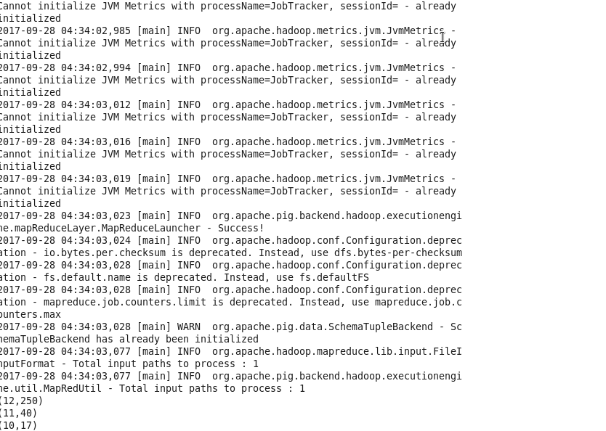

Problem 2: Which month has seen the most number of cancellations due to bad weather?

Coding

B = foreach A generate (int)$2 as month,(int)$10 as flight_num,(int)$22 as cancelled,(chararray)$23 as cancel_code;

C = filter B by cancelled == 1 AND cancel_code =='B';

D = group C by month;

E = foreach D generate group, COUNT(C.cancelled);

F= order E by $1 DESC;

Result = limit F 1;

dump Result;

Output

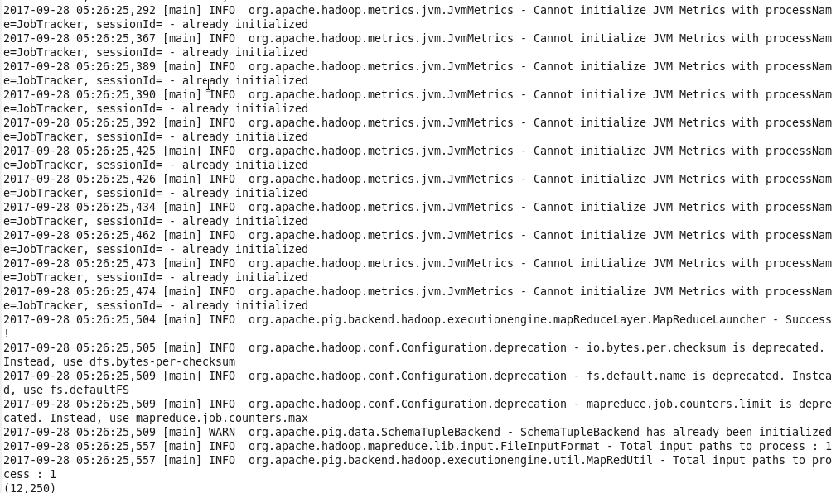

Problem 3: Top ten origins with the highest AVG departure delay

Coding :

B1 = foreach A generate (int)$16 as dep_delay, (chararray)$17 as origin;

C1 = filter B1 by (dep_delay is not null) AND (origin is not null);

D1 = group C1 by origin;

E1 = foreach D1 generate group, AVG(C1.dep_delay);

Result = order E1 by $1 DESC;

Top_ten = limit Result 10;

Lookup = LOAD 'airports.csv' USING org.apache.pig.piggybank.storage.CSVExcelStorage(',','NO_MULTILINE','UNIX','SKIP_INPUT_HEADER');

Lookup1 = FOREACH Lookup generate (chararray)$0 as origin, (chararray)$2 as city, (chararray)$4 as country;

Joined = JOIN Lookup1 by origin, Top_ten by $0;

Final = FOREACH Joined generate $0,$1,$2,$4;

Final_Result = ORDER Final by $3 DESC;

DUMP Final_Result;

Output

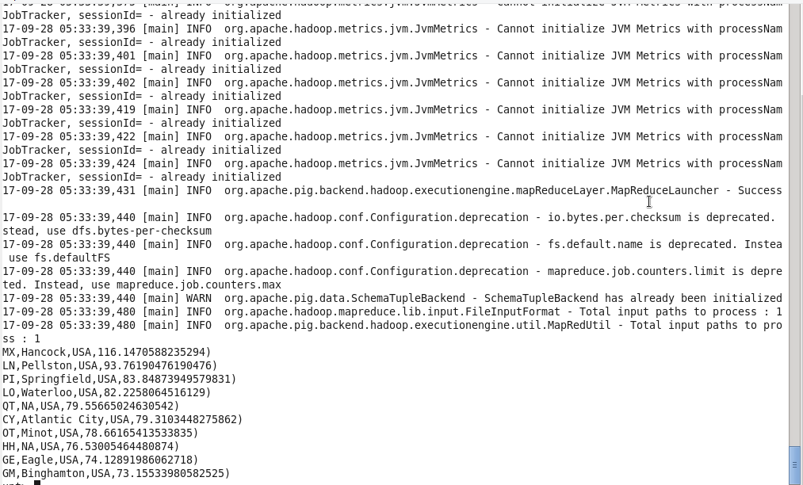

Problem 4: Which route (origin & destination) has seen the maximum diversion?

Coding

B = FOREACH A GENERATE (chararray)$17 as origin, (chararray)$18 as dest, (int)$24 as diversion;

C = FILTER B BY (origin is not null) AND (dest is not null) AND (diversion == 1);

D = GROUP C by (origin,dest);

E = FOREACH D generate group, COUNT(C.diversion);

F = ORDER E BY $1 DESC;

Result = limit F 10;

DUMP Result;

Output

