Дано: f = (1111010011111010)

**Алгоритм А1**

Так как 0 меньше, строим СКНФ.

| x | y | z | w | f | Член СКНФ | Член СДНФ |
| --- | --- | --- | --- | --- | --- | --- |
| 0 | 0 | 0 | 0 | 1 |  | !x!y!z!w |
| 0 | 0 | 0 | 1 | 1 |  | !x!y!zw |
| 0 | 0 | 1 | 0 | 1 |  | !x!yz!w |
| 0 | 0 | 1 | 1 | 1 |  | !x!yzw |
| 0 | 1 | 0 | 0 | 0 | x+!y+z+w |  |
| 0 | 1 | 0 | 1 | 1 |  | !xy!zw |
| 0 | 1 | 1 | 0 | 0 | x+!y+!z+w |  |
| 0 | 1 | 1 | 1 | 0 | x+!y+!z+!w |  |
| 1 | 0 | 0 | 0 | 1 |  | x!y!z!w |
| 1 | 0 | 0 | 1 | 1 |  | x!y!zw |
| 1 | 0 | 1 | 0 | 1 |  | x!yz!w |
| 1 | 0 | 1 | 1 | 1 |  | x!yzw |
| 1 | 1 | 0 | 0 | 1 |  | xy!z!w |
| 1 | 1 | 0 | 1 | 0 | !x+!y+z+!w |  |
| 1 | 1 | 1 | 0 | 1 |  | xyz!w |
| 1 | 1 | 1 | 1 | 0 | !x+!y+!z+!w |  |

СКНФ: (x+!y+z+w)(x+!y+!z+w)(x+!y+!z+!w)(!x+!y+z+!w)(!x+!y+!z+!w)

СДНФ: !x!y!z!w + !x!y!zw +

Схема:

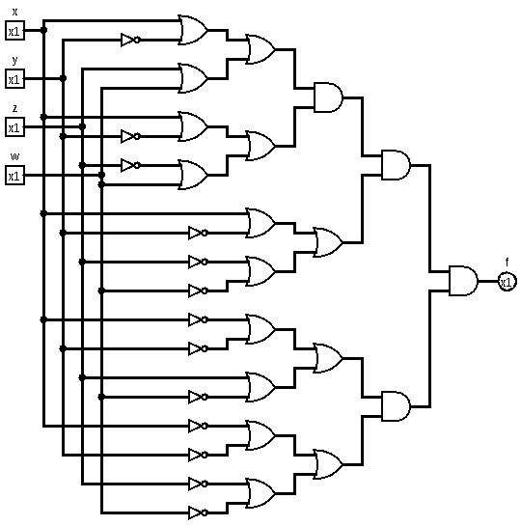

Рис. 1 - Схема по алгоритму А1

**Алгоритм А2**

Выражение после упрощения: !y + !x !z w + x !w

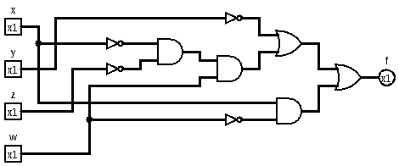Рис. 2 - Схема по алгоритму А2

**Алгоритм А3**

Fw = w(11101100) + !w(11001111)

F1

| x | y | z | f1 |
| --- | --- | --- | --- |
| 0 | 0 | 0 | 1 |
| 0 | 0 | 1 | 1 |
| 0 | 1 | 0 | 1 |
| 0 | 1 | 1 | 0 |
| 1 | 0 | 0 | 1 |
| 1 | 0 | 1 | 1 |
| 1 | 1 | 0 | 0 |
| 1 | 1 | 1 | 0 |

F1x = x(1100) + !x(1110)

F1x = x !y + !x (!y + !z)

F1x = !y + !x !z

| x | y | z | f2 |
| --- | --- | --- | --- |
| 0 | 0 | 0 | 1 |
| 0 | 0 | 1 | 1 |
| 0 | 1 | 0 | 0 |
| 0 | 1 | 1 | 0 |
| 1 | 0 | 0 | 1 |
| 1 | 0 | 1 | 1 |
| 1 | 1 | 0 | 1 |
| 1 | 1 | 1 | 1 |

F2x = x(1111) + !x(1100)

F2x = x + !x !y

Fw = w(!y + !x !z) + !w(x + !x !y)

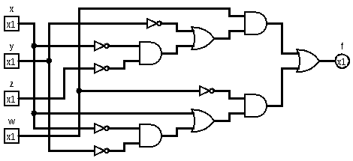

**Алгоритм А4**

Fж = 1 ⊕ y ⊕ y w ⊕ x y ⊕ y z w ⊕ x y z w

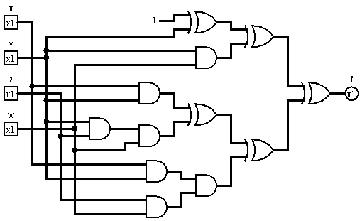

**Алгоритм А5**

1111 0100 1111 1010 '

fx = !x f'x ^ f1x = !x f0x ^ x f1x

| y | z | w | f0x |
| --- | --- | --- | --- |
| 0 | 0 | 0 | 1 |
| 0 | 0 | 1 | 1 |
| 0 | 1 | 0 | 1 |
| 0 | 1 | 1 | 1 |
| 1 | 0 | 0 | 0 |
| 1 | 0 | 1 | 1 |
| 1 | 1 | 0 | 0 |
| 1 | 1 | 1 | 0 |

gy = !y g'y(z,w) ^ g1y(z,w)

g0y = 1

g1y = !z w

g'y = 1 ^ (!z w)

gy = !y (1 ^ (!z w)) ^ (!z w)

| y | z | w | f1x |
| --- | --- | --- | --- |
| 0 | 0 | 0 | 1 |
| 0 | 0 | 1 | 1 |
| 0 | 1 | 0 | 1 |
| 0 | 1 | 1 | 1 |
| 1 | 0 | 0 | 1 |
| 1 | 0 | 1 | 0 |
| 1 | 1 | 0 | 1 |
| 1 | 1 | 1 | 0 |

hy = !y h'y(z,w) ^ h1y(z,w)

h0y = 1

h1y = !w

h'y = 1 ^ !w = w

hy = (!y w) ^ !w

fx = (!x (!y (1 ^ (!z w)) ^ (!z w))) ^ (x ((!y w) ^ !w )) =   
!y + !w x + w !x !z

