**Лескин 9892**

**Триггеры RS и T**

**ИД3 №3.**

1. Провести анализ последовательностной схемы. Построить таблицу переходов/выходов и диаграмму абстрактного автомата.

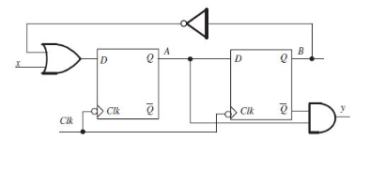

y = -Q2 and Q1

D1 = x or -Q2

D2 = Q1

|  |  |  |  |  |  |  |  |
| --- | --- | --- | --- | --- | --- | --- | --- |
| x | Q2 | Q1 | y | Q2 | Q1 | D2 | D1 |
| 0 | 0 | 0 | 0 | 0 | 1 | 0 | 1 |
| 0 | 0 | 1 | 1 | 1 | 1 | 1 | 1 |
| 0 | 1 | 0 | 0 | 0 | 0 | 0 | 0 |
| 0 | 1 | 1 | 0 | 1 | 0 | 1 | 0 |
| 1 | 0 | 0 | 0 | 0 | 1 | 0 | 1 |
| 1 | 0 | 1 | 1 | 1 | 1 | 1 | 1 |
| 1 | 1 | 0 | 0 | 0 | 1 | 0 | 1 |
| 1 | 1 | 1 | 0 | 1 | 1 | 1 | 1 |

Q = { 00, 01, 10, 11 }

Aвх = { 0, 1 }

Bвых = { 0, 1 }

|  |  |  |  |  |
| --- | --- | --- | --- | --- |
| Aвх / Q2Q1 | 00 | 01 | 10 | 11 |
| 0 | 01 / 0 | 11 / 1 | 00 / 0 | 10 / 0 |
| 1 | 01 / 0 | 11 / 1 | 01 / 0 | 11 / 0 |

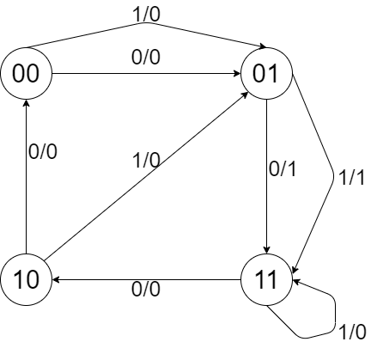

1. Синтезировать логическую схему, используя базис «И, ИЛИ, НЕ» и указанные в варианте типы триггеров.

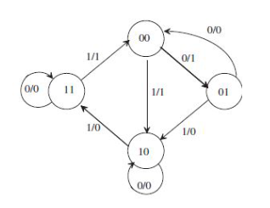

|  |  |  |  |  |  |  |  |  |  |  |
| --- | --- | --- | --- | --- | --- | --- | --- | --- | --- | --- |
| Таблица переходов | | | | |  | Таблица выходов | | | | |
| x / Q0Q1 | 00 | 01 | 10 | 11 |  | x / Q0Q1 | 00 | 01 | 10 | 11 |
| 0 | 01 | 00 | 10 | 11 |  | 0 | 1 | 0 | 0 | 0 |
| 1 | 10 | 10 | 11 | 00 |  | 1 | 1 | 0 | 0 | 1 |

|  |  |  |  |  |  |  |  |  |
| --- | --- | --- | --- | --- | --- | --- | --- | --- |
| x | QRS | QT | y | QRS | QT | R | S | T |
| 0 | 0 | 0 | 1 | 0 | 1 | - | 0 | 1 |
| 0 | 0 | 1 | 0 | 0 | 0 | - | 0 | 1 |
| 0 | 1 | 0 | 0 | 1 | 0 | 0 | - | 0 |
| 0 | 1 | 1 | 0 | 1 | 1 | 0 | - | 0 |
| 1 | 0 | 0 | 1 | 1 | 0 | 0 | 1 | 0 |
| 1 | 0 | 1 | 0 | 1 | 0 | 0 | 1 | 1 |
| 1 | 1 | 0 | 0 | 1 | 1 | 0 | - | 1 |
| 1 | 1 | 1 | 1 | 0 | 0 | 1 | 0 | 1 |

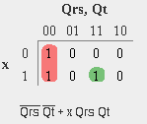

y = -QRS -QT + x QRS QT

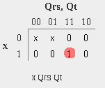

R = x QRS QT

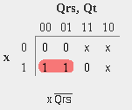

S = x -QRS

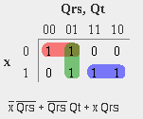

T = -x -QRS + -QRS QT + x QRS

