Дано: f = (1111010011111010)
Алгоритм А1
Так как 0 меньше, строим СКНФ.
x | y | z | w | f | Член СКНФ | Член СДНФ
0 | 0 | 0 | 0 | 1 |  | !x!y!z!w
0 | 0 | 0 | 1 | 1 |  | !x!y!zw
0 | 0 | 1 | 0 | 1 |  | !x!yz!w
0 | 0 | 1 | 1 | 1 |  | !x!yzw
0 | 1 | 0 | 0 | 0 | x+!y+z+w
0 | 1 | 0 | 1 | 1 |  | !xy!zw
0 | 1 | 1 | 0 | 0 | x+!y+!z+w
0 | 1 | 1 | 1 | 0 | x+!y+!z+!w
1 | 0 | 0 | 0 | 1 |  | x!y!z!w
1 | 0 | 0 | 1 | 1 |  | x!y!zw
1 | 0 | 1 | 0 | 1 |  | x!yz!w
1 | 0 | 1 | 1 | 1 |  | x!yzw
1 | 1 | 0 | 0 | 1 |  | xy!z!w
1 | 1 | 0 | 1 | 0 | !x+!y+z+!w
1 | 1 | 1 | 0 | 1 |  | xyz!w
1 | 1 | 1 | 1 | 0 | !x+!y+!z+!w

СКНФ: (x+!y+z+w)(x+!y+!z+w)(x+!y+!z+!w)(!x+!y+z+!w)(!x+!y+!z+!w)
СДНФ: !x!y!z!w + !x!y!zw +

Схема:

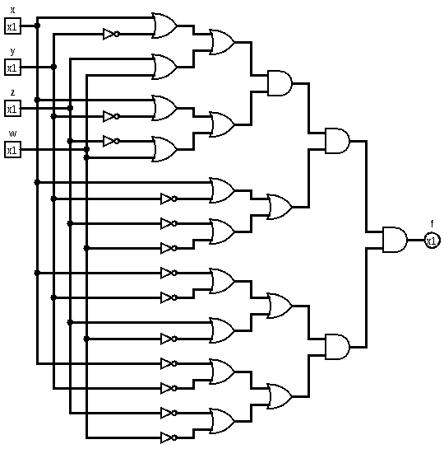
Рис. 1 - Схема по алгоритму А1

Алгоритм А2
Выражение после упрощения: !y + !x !z w + x !w
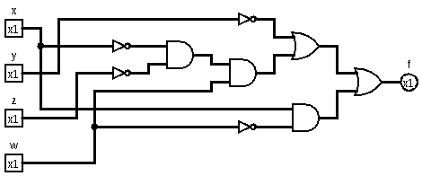Рис. 2 - Схема по алгоритму А2

Алгоритм А3
Fw = w(11101100) + !w(11001111)

F1
x | y | z | f1
0 | 0 | 0 | 1
0 | 0 | 1 | 1
0 | 1 | 0 | 1
0 | 1 | 1 | 0
1 | 0 | 0 | 1
1 | 0 | 1 | 1
1 | 1 | 0 | 0
1 | 1 | 1 | 0

F1x = x(1100) + !x(1110)
F1x = x !y + !x (!y + !z)
F1x = !y + !x !z

x | y | z | f2
0 | 0 | 0 | 1
0 | 0 | 1 | 1
0 | 1 | 0 | 0
0 | 1 | 1 | 0
1 | 0 | 0 | 1
1 | 0 | 1 | 1
1 | 1 | 0 | 1
1 | 1 | 1 | 1

F2x = x(1111) + !x(1100)
F2x = x + !x !y

Fw = w(!y + !x !z) + !w(x + !x !y)

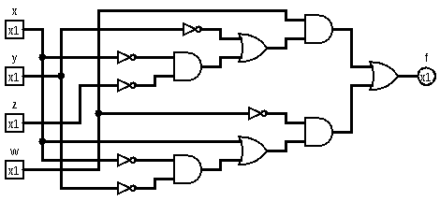

Алгоритм А4
Fж = 1 ⊕ y ⊕ y w ⊕ x y ⊕ y z w ⊕ x y z w

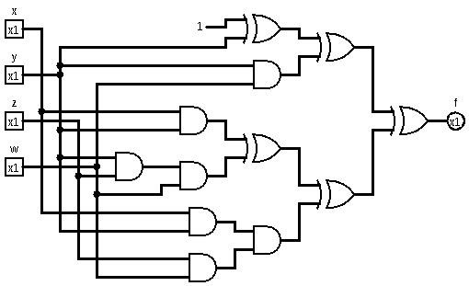

Алгоритм А5
1111 0100 1111 1010 '
fx = !x f'x ^ f1x = !x f0x ^ x f1x

y | z | w | f0x
0 | 0 | 0 | 1
0 | 0 | 1 | 1
0 | 1 | 0 | 1
0 | 1 | 1 | 1
1 | 0 | 0 | 0
1 | 0 | 1 | 1
1 | 1 | 0 | 0
1 | 1 | 1 | 0

gy = !y g'y(z,w) ^ g1y(z,w)
g0y = 1
g1y = !z w
g'y = 1 ^ (!z w)

gy = !y (1 ^ (!z w)) ^ (!z w)

y | z | w | f1x
0 | 0 | 0 | 1
0 | 0 | 1 | 1
0 | 1 | 0 | 1
0 | 1 | 1 | 1
1 | 0 | 0 | 1
1 | 0 | 1 | 0
1 | 1 | 0 | 1
1 | 1 | 1 | 0

hy = !y h'y(z,w) ^ h1y(z,w)
h0y = 1
h1y = !w
h'y = 1 ^ !w = w
hy = (!y w) ^ !w

fx = (!x (!y (1 ^ (!z w)) ^ (!z w))) ^ (x ((!y w) ^ !w )) =
!y + !w x + w !x !z

