**ARTIFICIAL INTELLIGENCE LAB**

**Exp-1**

**Tamojit Sarkar**

**RA1811027010034**

**CSE-BD Sec-I2**

**Aim:** To find a solution for Camels and Bananas Problem in python.

**Problem:**

A person has n bananas and a camel. The person wants to transport the maximum number of bananas to a destination which is d KMs away, using only the camel as a mode of transportation. The camel cannot carry more than c bananas at a time and eats a banana every km it travels. What is the maximum number of bananas that can be transferred to the destination using only camel (no other mode of transportation is allowed).

**Solution:**

Eg: n = 3000, d = 1000, c = 1000

We can say that person won’t we able to transfer any banana to the destination

as the camel is going to eat all the banana on its way to the destination.

But the trick here is to have intermediate drop points, then, the camel can make several short trips in between.

Also, we try to maintain the number of bananas at each point to be multiple of 1000.

Let’s have 2 drop points in between the source and destination.

With 3000 bananas at the source. 2000 at a first intermediate point and 1000 at 2nd intermediate point.

**Source**————–**IP1**—————–**IP2**———————-**Destination**

3000 **x km** 2000 **y km** 1000 **z km**

——————–> | —————> | ———————–>

<——————- | <————– |

——————-> | —————> |

<—————— | |

——————-> | |

* To go from source to IP1 point camel has to take a total of 5 trips 3 forward and 2 backward. Since we have 3000 bananas to transport.
* The same way from IP1 to IP2 camel has to take a total of 3 trips, 2 forward and 1 backward. Since we have 2000 bananas to transport.
* At last from IP2 to a destination only 1 forward move.

Let’s see the total number of bananas consumed at every point.

* From the **source to IP1** its 5x bananas, as the distance between the source and IP1 is x km and the camel had 5 trips.
* From **IP1 to IP2** its 3y bananas, as the distance between IP1 and IP2 is y km and the camel had 3 trips.
* From **IP2 to destination** its z bananas.

We now try to calculate the distance between the points:

**1. 3000 – 5x = 2000** so we get **x = 200**

1. **2000-3y = 1000** so we get **y = 333.33** but here the distance is also the number of bananas and it cannot be fraction so we take y =333 and at **IP2** we have the number of bananas equal **1001,** so its **2000-3y = 1001**
2. **So** the remaining distance to the market is **1000 -x-y =z** i.e **1000-200-333**

# => z =467.

So from **IP2 to the destination** point camel eats **467 bananas.** The remaining bananas are 533.

**Programming Language:** Python

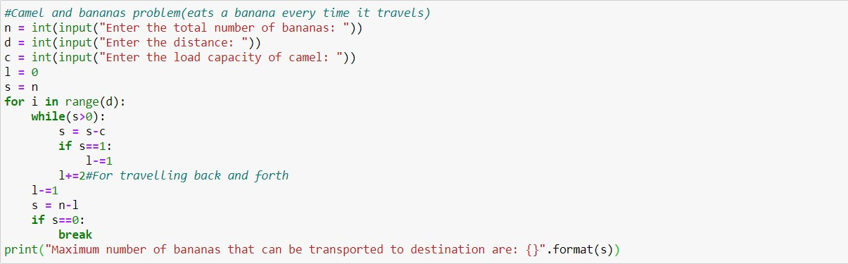**Code:**

**Output:**



**Conclusion:**

Camels and Bananas problem is solved using python programming.