**Artificial Intelligence Lab**

**Exp-2**

**Tamojit Sarkar**

**RA1811027010034**

**CSE-BD Sec-I2**

**Aim:** Edge coloring of graph with vertices and number of given

Vertices.

**Procedure:**

1. Edge coloring is basically like no adjacent edges have same color
2. Pass through the first edge assign one color and let a holder to store all the colors that are assigned for the edge using vertices.
3. As the main aim is to use least number of colors check from the colors that are already used if it is impossible then only move to the new color.
4. After coloring just print the edge and the color used.
5. At worst case all colors are used if all edges have a common vertex so make sure number of colors you have are more than number of edges

# Programming Language: Python

# Code:

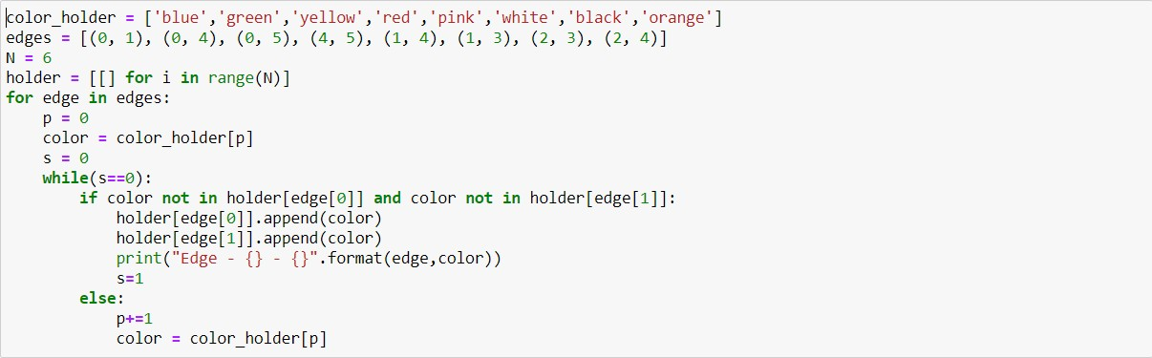

**Output :**



**Conclusion:**

Edge coloring of graph is done.