**Artificial Intelligence**

**Exercise-3**

**Tamojit Sarkar**

**RA1811027010034**

**CSE-BD Sec-I2**

**Aim:** Cryptarithmetic Problem (Assigning digits to letters – addition)

**Procedure:**

1. Take input string of two numbers and their sums
2. Using itertools and dictionaries create all permutations by mapping all the digits to the unique letters.
3. Check for the condition to satisfy by checking the sum of the numbers generated and the digits mapped to the letters.
4. If both are same print the strings and number assigned. 5)At worst case if there is no possible iteration print –1.

# Programming Language: Python

**Code:**

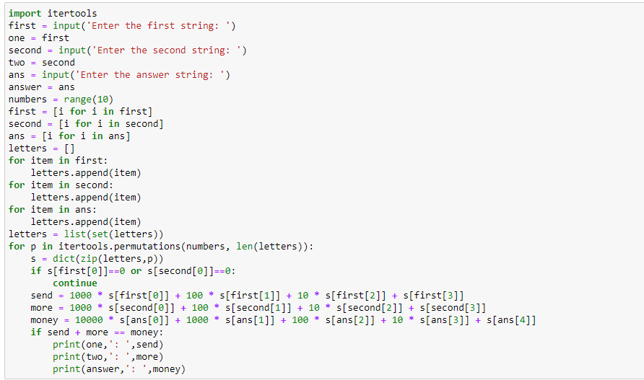

**Output:**

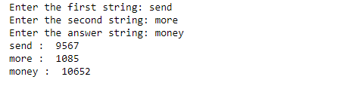

**Conclusion:**

Constraint satisfaction problem (crypt arithmetic) is being implemented.