# ARTIFICIAL INTELLIGENCE LAB – 5 (Informed Search)

**Tamojit Sarkar**

**RA1811027010034**

**CSE-BD Sec-I2**

**Aim:** Application of best first search and A* algorithm for traversing TSP path and maze path.

# Procedure:

1. Take input of the graphs using adjacent list
2. Make a best first search algorithm that can find the minimum cost path to a destination of a graph
3. Make a A* algorithm that can find the path in the maze

# Programming Language: Python

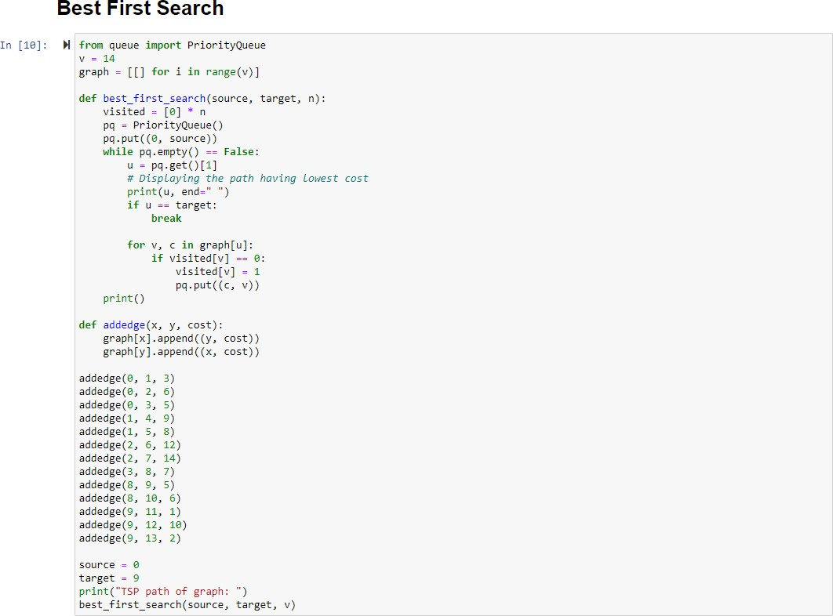**Best first Search - Code:**

**Output:**



# A* algorithm - Code:

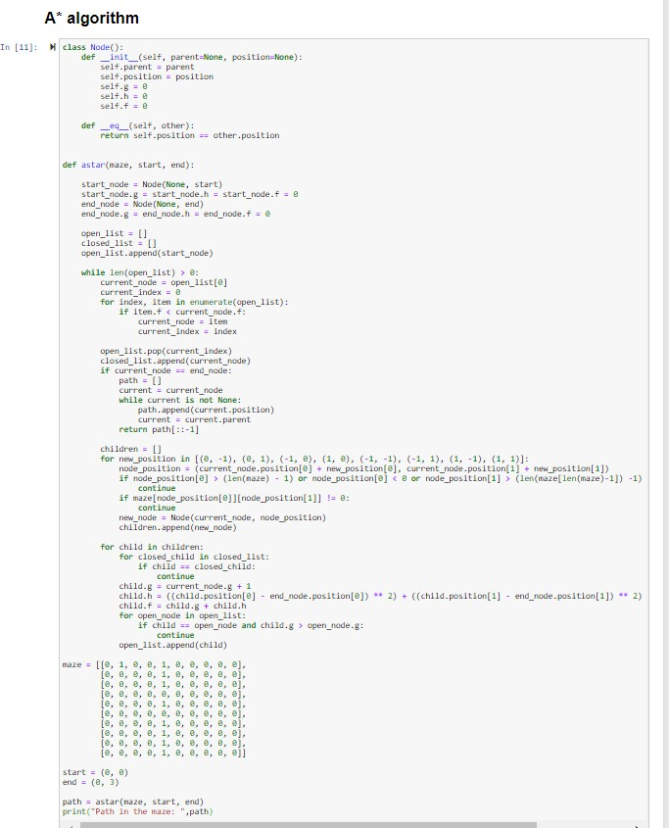

**Output:**



# Conclusion:

Application of Best first search and A* algorithm for solving TSP path and maze path is implemented.