**ARTIFICIAL INTELLIGENCE**

**LAB–6 (Min Max Algorithm)**

**Tamojit Sarkar**

**RA1811027010034**

**CSE-BD Sec-I2**

**Aim:** Application of MIN MAX algorithm for finding the next optimal move in theTIC-TAC-TOE game board.

**Procedure:**

1)Take input of the board

2)Follow the MIN-MAX algorithm by appointing max and min pointers to traverse through the tree of possible moves and find the scores(rewards).

3)Then find the best move by comparing all the scores and moves which has best score and helps the player to win or save from losing

4)In this way we can make a optimal move in TIC-TAC-TOE game board

**Programming Language: Python**

**MIN MAX ALGORITHM - Code:**

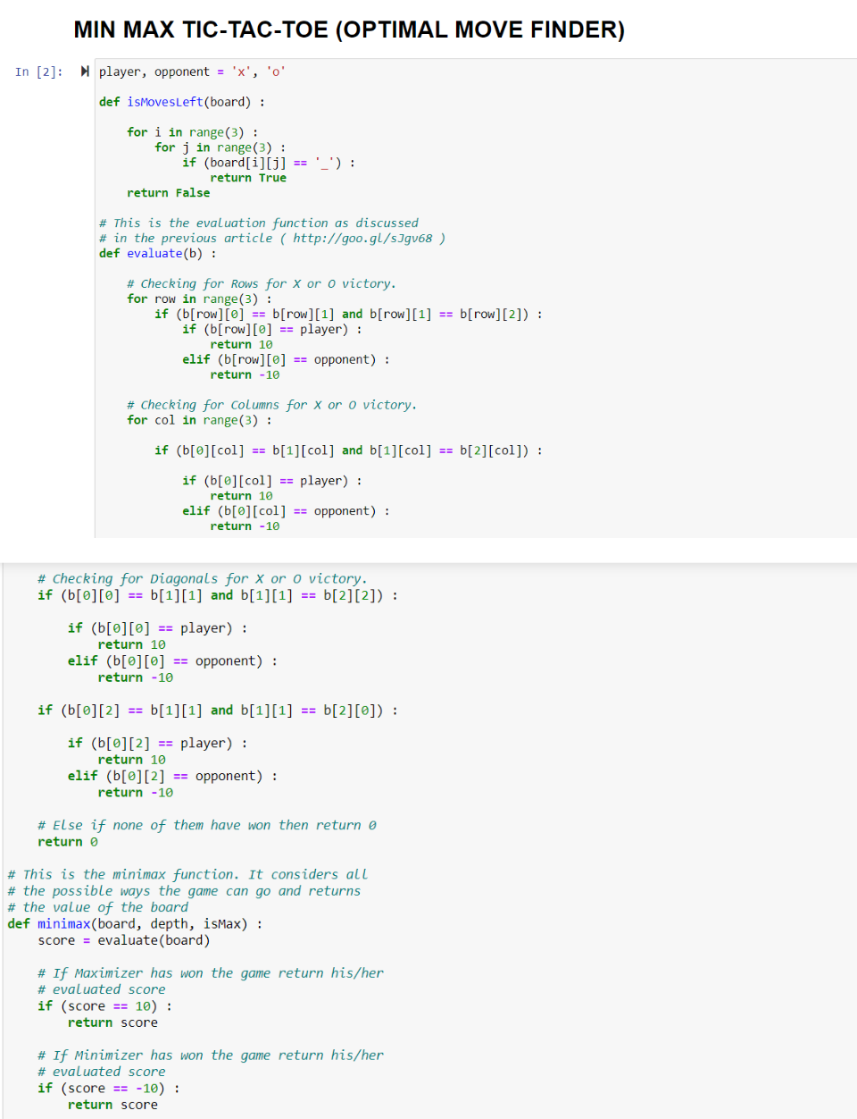

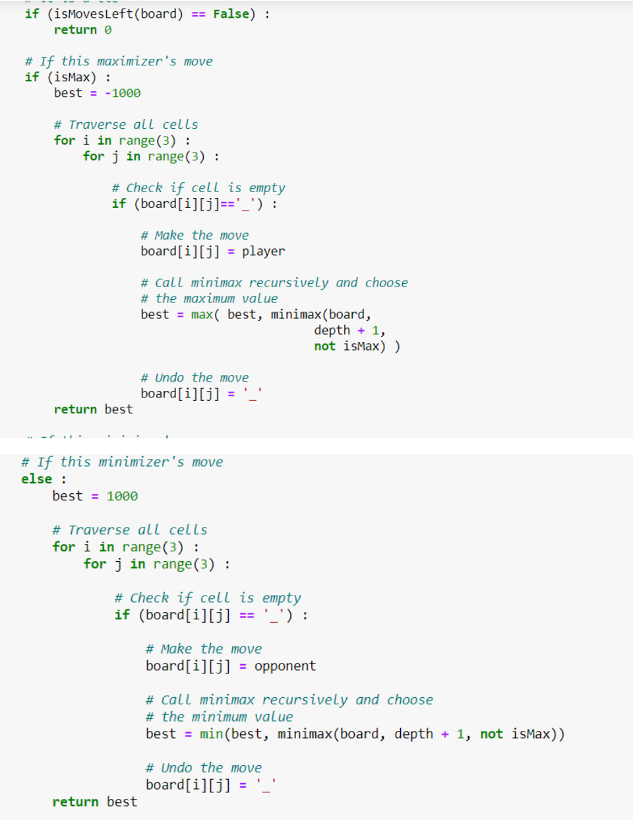

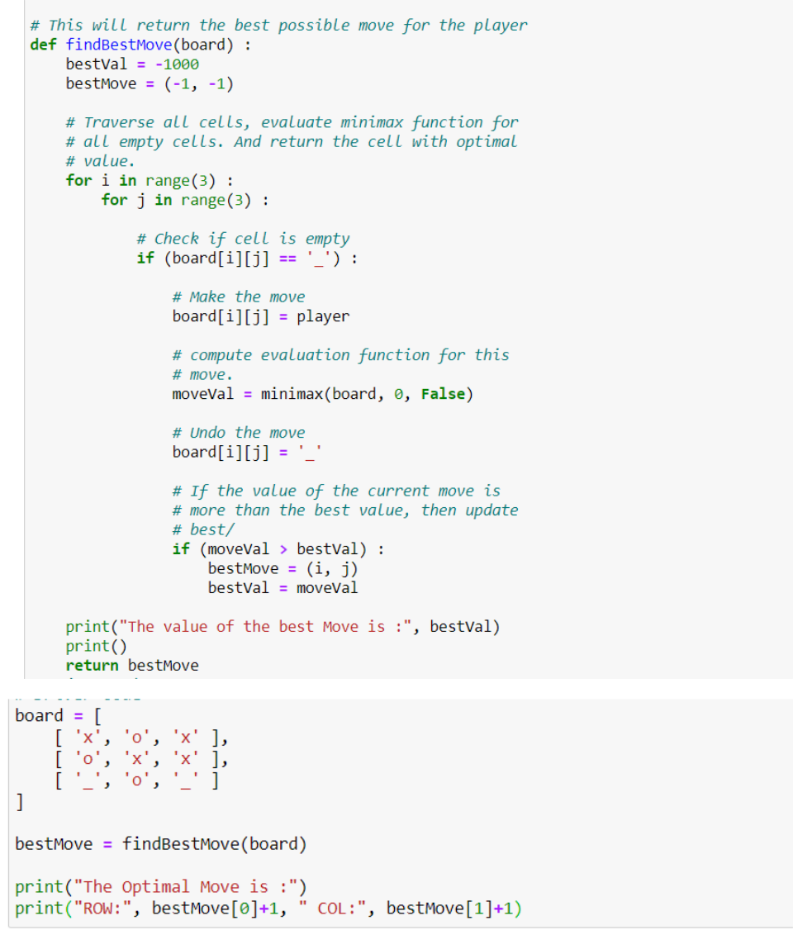

**Output:**

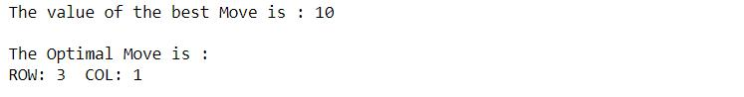

**Conclusion:**

Application of MIN-MAX algorithm for finding the optimal move in a tic-tac-toe game is implemented.