**COMPILER DESIGN LAB**

**Ex-1 File Handling Operation**

Tamojit Sarkar

RA1811027010034

CSE-BD Sec-I2

Date: 22/01/21

**Aim:** To perform the following operation:

Insertion/Create

Deletion

Read

Write and edit

Print

**Language Used:** Python

**Procedure :**

1. Create a python file

2. Create function for each operation mentioned above.

3. Create a file and perform all the operations using the functions written and see the changes in the text file.

4. Display the output of the file by printing the content in the file after all changes.

5. Delete the file.

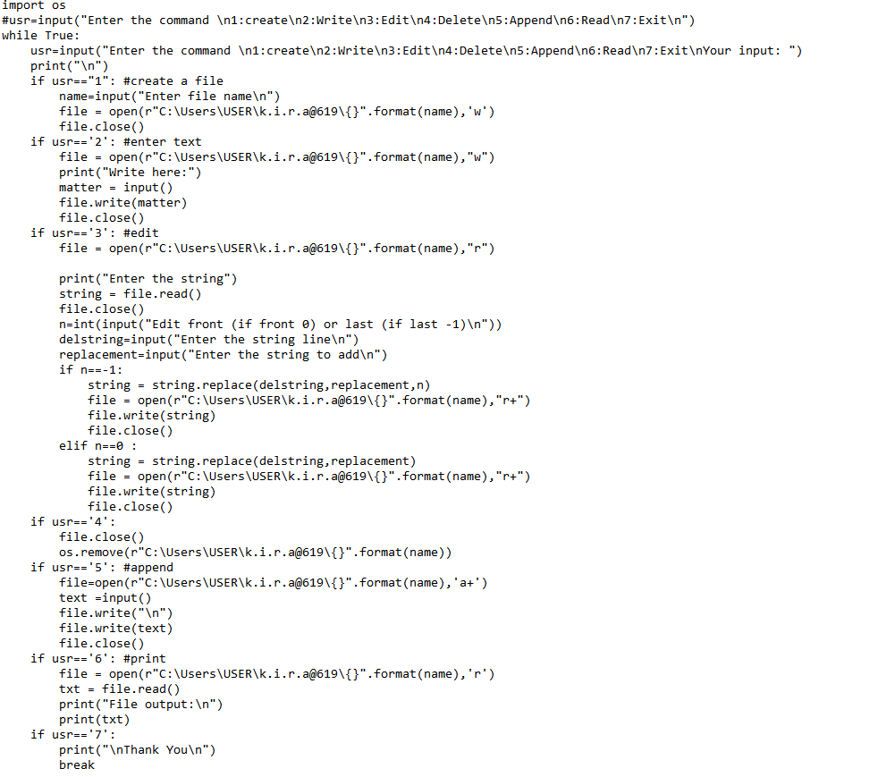**CODE:**

**Ouput:**

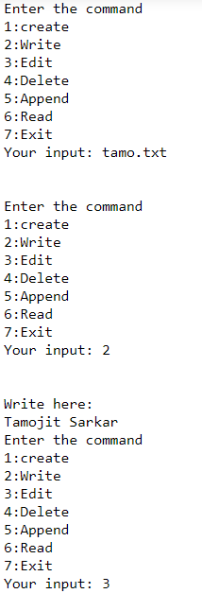

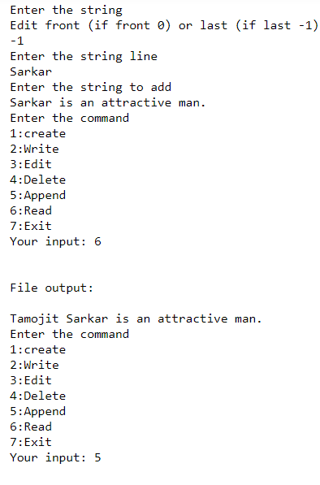

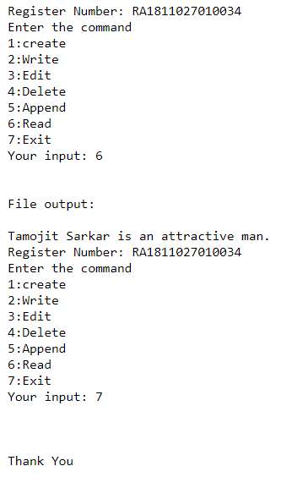

**Text file outputs:**

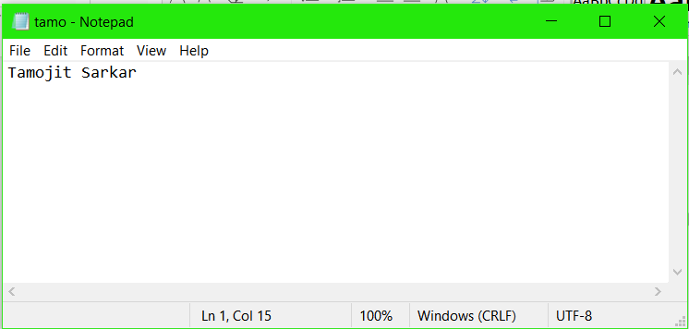**Write:**

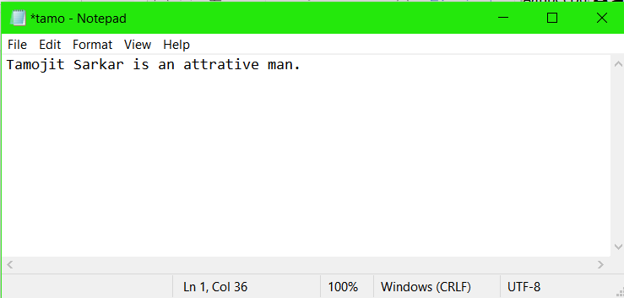**Edit:**

**Append:**

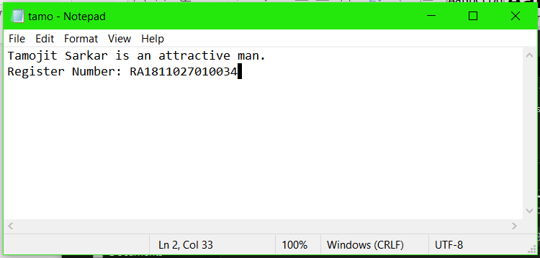

**Result:**

Using the code for file handling we were able to execute the operations on file.