**Compiler Design**

**Exp-2 (RE to NFA)**

**Tamojit Sarkar**

**RA1811027010034**

**CSE-BD Sec-I2**

**Aim:** To perform RE to NFA in python

# **Language Used :**

# Python

# Procedure:

1. Create a python file
2. Create function for taking the input as string and reads all the operators in the string and create a 2-dimensional array for number of states needed to be present as per Thompson’s rule.
3. Check whether it follows all the rules of transition in Thompson's rule
4. Display the output of the file by detecting and printing each and every part of the code.
5. Make the table in such a way that it can display all the transitions.

# Code:

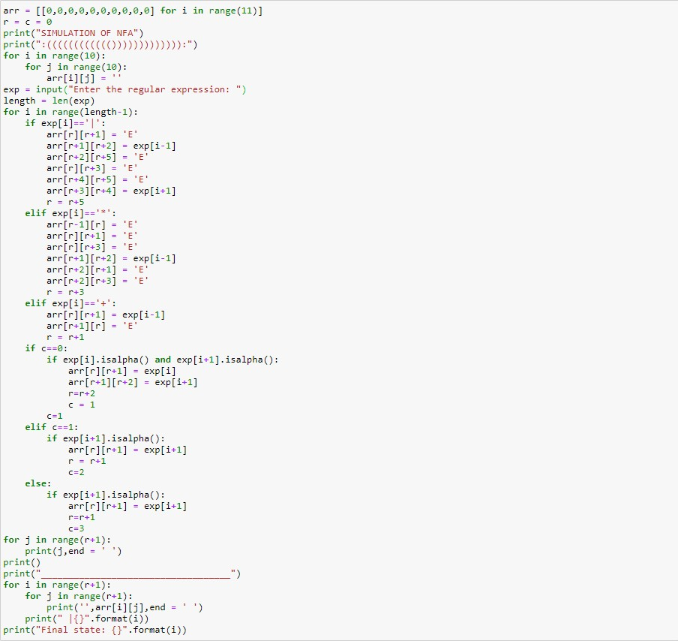

**Output:**

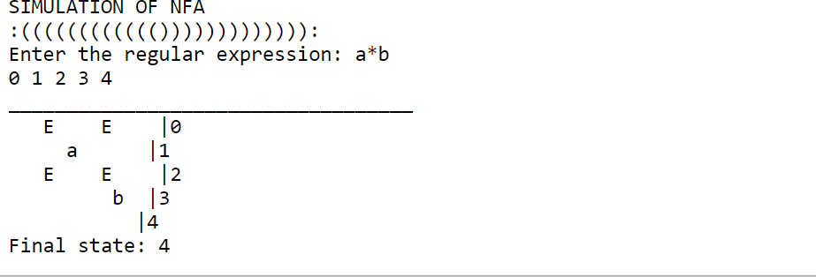

**Conclusion: Regular Expression to NFA convertor is being created in python.**