**COMPILER DESIGN**

# **EXP 4(b) – ELIMINATION OF LEFT FACTORING FROM CFG**

**Tamojit Sarkar**

**RA1811027010034 Date :03/03/2021**

**CSE-BD Sec-I2**

**Aim:** To perform elimination of left factoring from context free grammar

# Language Used: Python

# Procedure:

1. Create a python file
2. Take in the input of statements present in the grammar
3. Remove left recursion present in the statements by following the rules If **A->xb |xg** (x = alpha, b = beta, g= gamma) is statement

* A->xA’
* A’ = b|g (These both are the statements after removing left factoring)

1. Then print the statements after conversion.

**Code:**

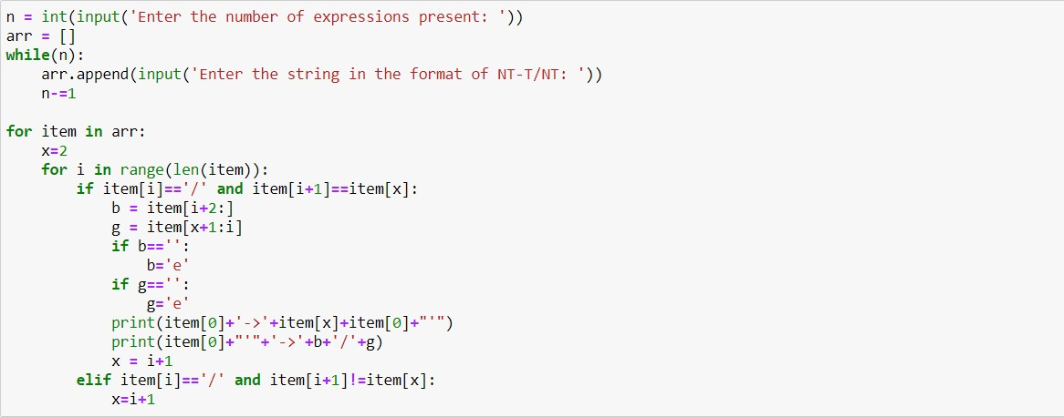

**Output :**

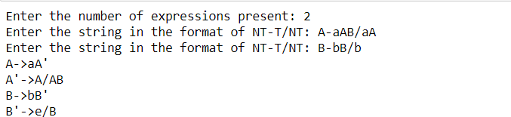

**Conclusion: Left factoring is being removed from the given CFG.**