**COMPILER DESIGN**

**EXP 4(a) – ELIMINATION OF LEFT RECURSION FROM CFG**

**Date:24/02/2021**

**Tamojit Sarkar**

**RA1811027010034**

**CSE-BD Sec-I2**

**Aim:** To perform elimination of left recursion from context free grammar

**Language Used: Python**

**Procedure:**

1. Create a python file
2. Take in the input of statements present in the grammar
3. Remove left recursion present in the statements by following the rules

If **A->Ax |b** (x = alpha, b = beta) is statement

* A->bA’
* A’ = xA’|e (These both are the statements after removing left recursion)

**4.** Then print the statements after conversion.

**Code:**

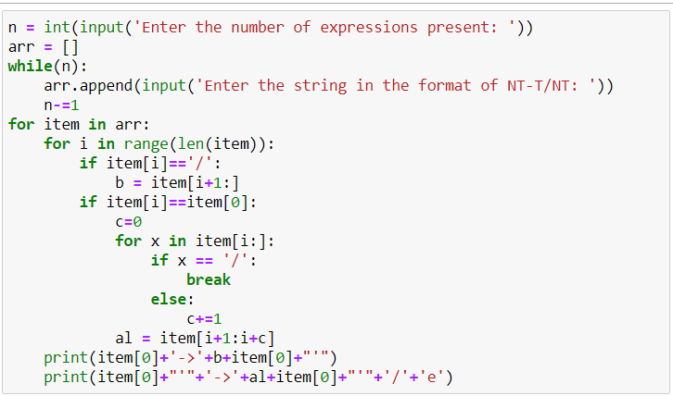

**Output:**

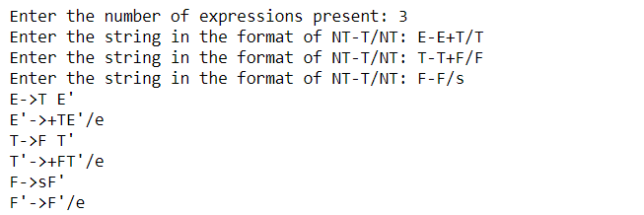

**Conclusion: Left recursion is being removed from the given CFG.**