**COMPILER DESIGN**

**EXP – 9 Intermediate Code Generation**

**Tamojit Sarkar**

**RA1811027010034**

**CSE-BD Sec-I2**

**Aim:** To compute intermediate code generation – prefix, postfix and three address code generation.

**Language Used: Python**

**Algorithm:**

1. Define the set of operators.
2. Define function for infix to postfix, create a stack and then in the formula check for operators and parentheses and enter the parentheses into the stack and characters directly in output.
3. If there is any operator in middle of open and close parentheses pop it to the output.
4. Define function infix to prefix, and perform infix to prefix generation.
5. Atlast we have postfix, prefix and infix so we can go to code generation.

**Code and Output:**

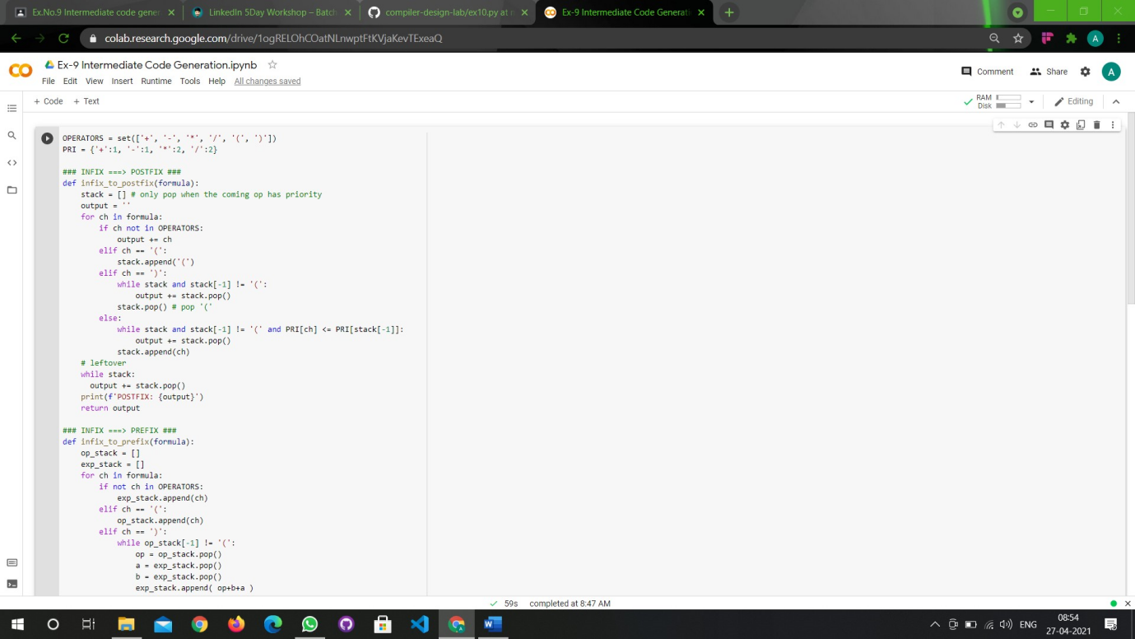

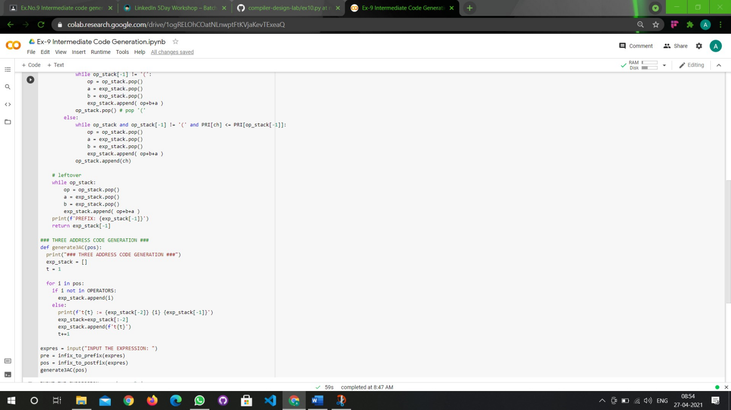

**Output:**

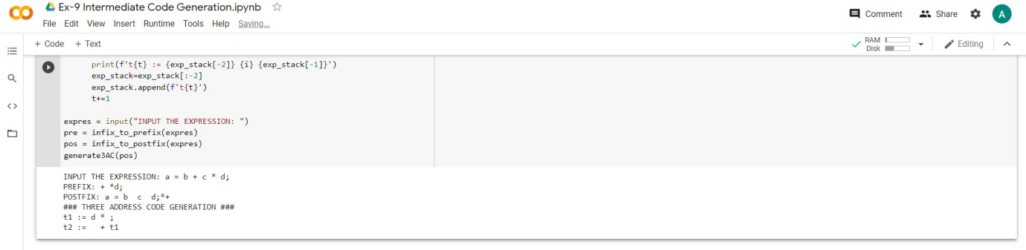

**Result:** Intermediate Code generated successfully.