COMPILER DESIGN
Exp-5(B)

 | Tamojit Sarkar |  |  |  |  |  |  | Date: 17/03/2021
RA1811027010034
CSE-BD Sec-I2
Aim: Computation of First and Follow
 | Language Used: Python
 | Procedure:

- Create a python file

- Take in the input of statements present in the grammar

- To compute FIRST( X ) for all grammar symbols X apply the following rules until no more terminals or ∈ can be added to any FIRST set:

- if X is terminal, then FIRST( X ) is { X }.

- if X → ∈ is a production, then add ∈ to FIRST( X ).

- if X is nonterminal and X → Y1, Y2, ..., Yk is a production, then place a in FIRST( X) if a is in FIRST(Yi ) for some i, and ∈ is in all of FIRST(Y1), FIRST(Y2 ),

...,FIRST(Yi-1 ); that is Y1, Y2, ..., Yi-1 ⇒* ∈. If ∈ is in FIRST(Yj ), all j = 1,2, ..., k then add ∈ to FIRST( X ).

4.Print the computation of first(x)

5.To compute Follow(X) for all grammar symbols X apply the following rules

- FOLLOW(S) = { $ } // where S is the starting Non-Terminal

- If A -> pBq is a production, where p, B and q are any grammar symbols, then everything in FIRST(q) except Є is in FOLLOW(B).

- If A->pB is a production, then everything in FOLLOW(A) is in FOLLOW(B).

- If A->pBq is a production and FIRST(q) contains Є, then FOLLOW(B) contains { FIRST(q) – Є } U FOLLOW(A)

Code:
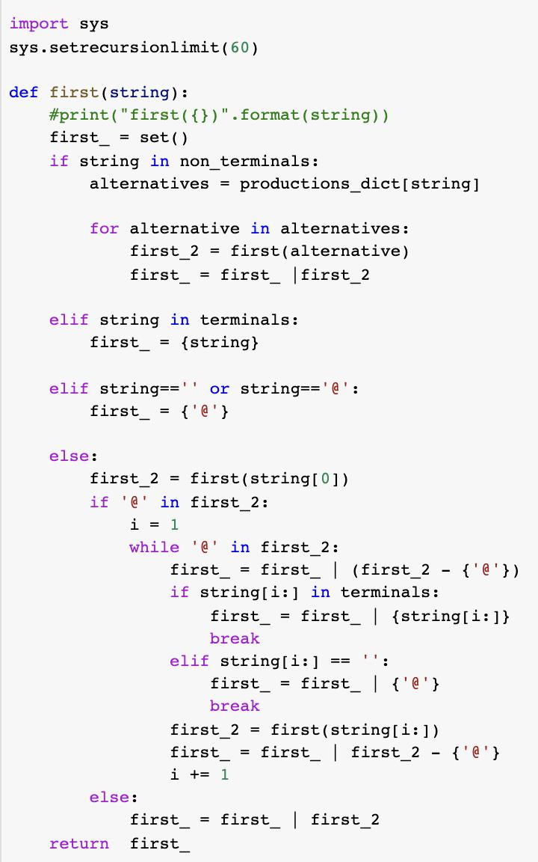

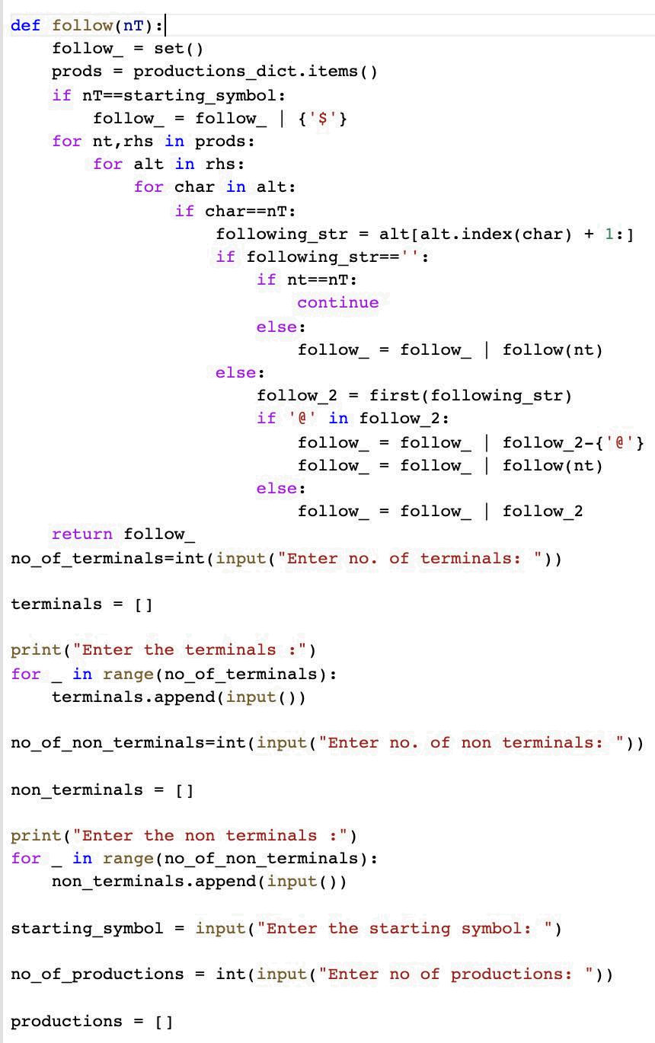
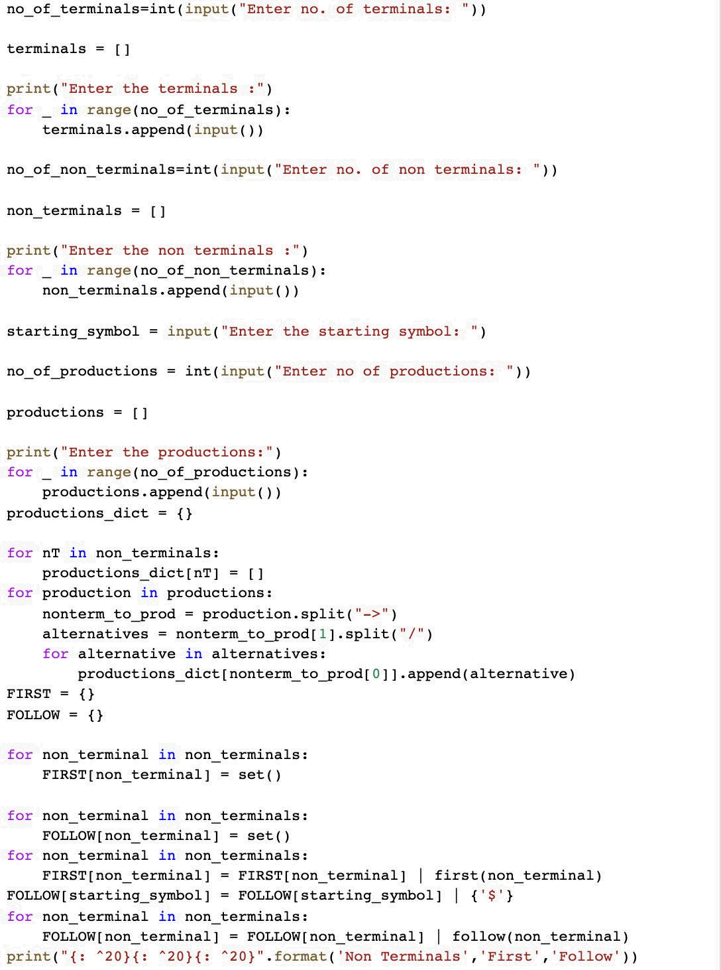
Output:

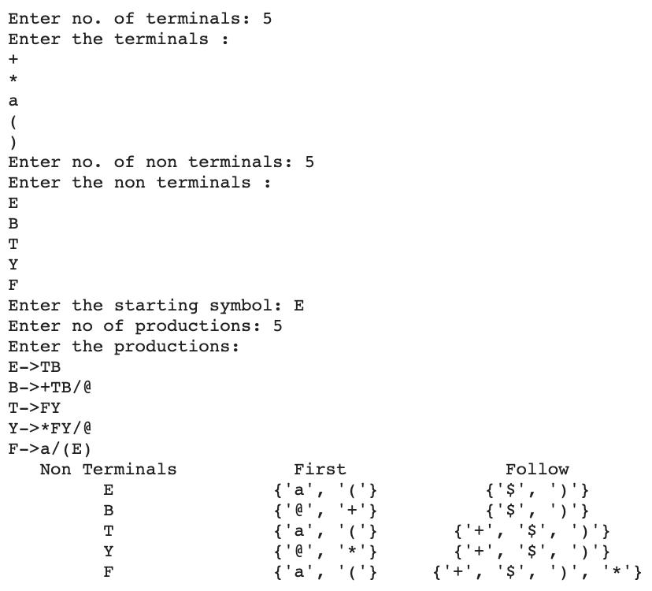

Result: Computed First and Follow of given grammar successfully.

