**DBMS Lab**

**Exp-3 (INBUILT SQL FUNCTIONS)**

**Tamojit Sarkar**

**RA1811027010034**

**CSE-BD**

**AIM:** To study and execute various inbuilt SQL functions

**COMMANDS:**

* Character/String functions:
  + UPPER- Convert the string to uppercase characters.
  + LOWER- Convert the string to lowercase characters.
  + INITCAP- Convert the first character of each word in the string to upper case.
  + LTRIM & RTRIM- Strip the trailing spaces on left hand side and righthand side respectively.
  + CONCAT- Concatenate the two strings.
  + LENGTH- Return the length of the string.
  + REPLACE- Replace a particular substring with the given string.
  + SUBSTR- Returns the required substring, using the index and length of substring.
  + RPAD & LPAD- Adds padding of a character on right hand side and left hand side of the string respectively.
  + TRANASLATE- Characters specified in the second argument are translated to that of the third argument in the given string.
* Date/Time functions:
  + SYSDATE- Returns the system default date.
  + ADD_MONTHS- Adds a number of months to the given date.
  + LAST_DAY- Returns the last date of the month specified in the date.
  + DATE+x- Adds a number of days to the given date.
  + NEXT_DAY- Returns the date of the next weekday specified.
* Numeric functions:
  + ROUND- Rounds the given floating-point number to a given number of decimal places.
  + CEIL- Returns the smallest integer value greater than or equal to the number.
  + FLOOR- Returns the greatest integer value lesser than or equal to the number.
  + TRUNC- Truncates the number to a given number of decimal places.
  + SIGN- Returns the sign of a number.
* Math functions:
  + ABSOLUTE- Returns the absolute value of the given number.
  + POWER- Returns the value of a number raised to the power of another number.
  + MOD- Returns the remainder when a number is divided by another number.
  + EXP- Returns the value of ‘e’ raised to a specified number.
  + SQRT- Returns the square root of a given number.

**QUERIES AND OUTPUTS:**

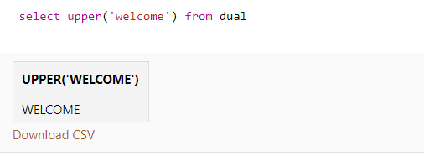

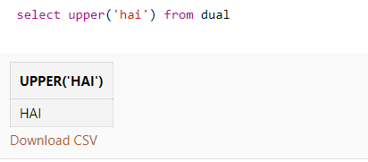

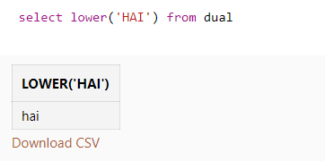

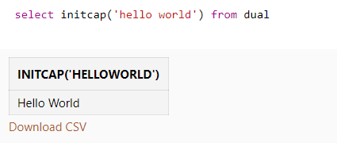

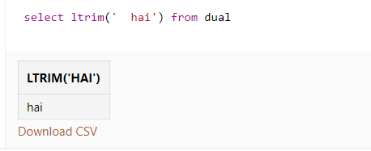

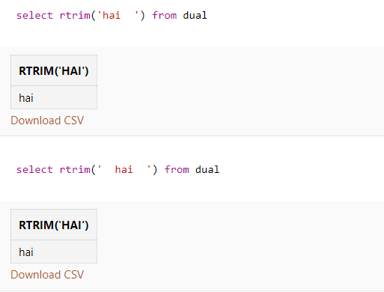

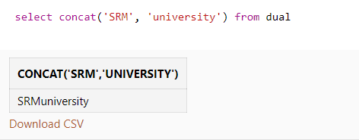

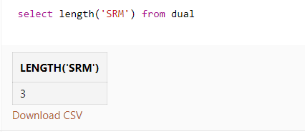

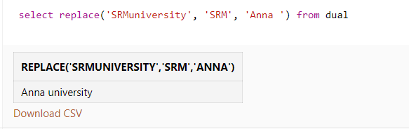

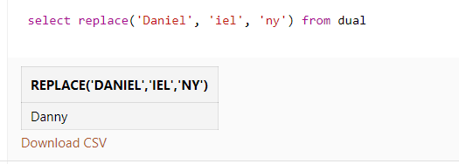

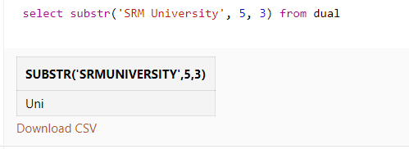

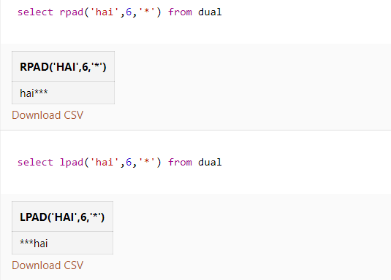

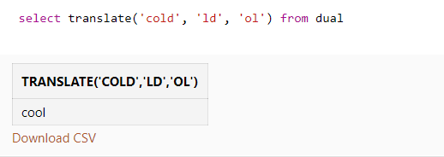

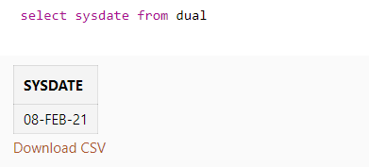

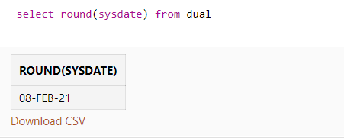

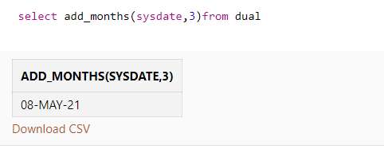

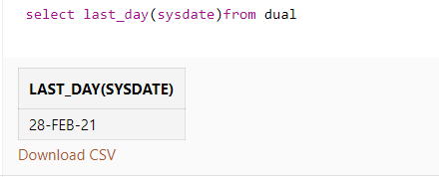

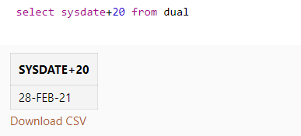

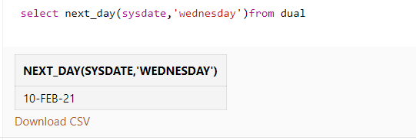

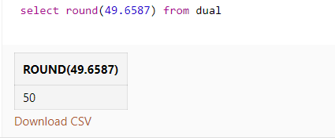

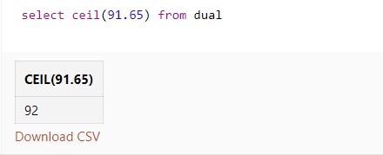

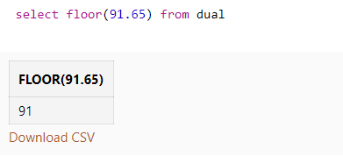

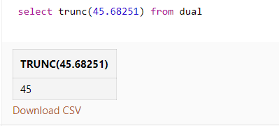

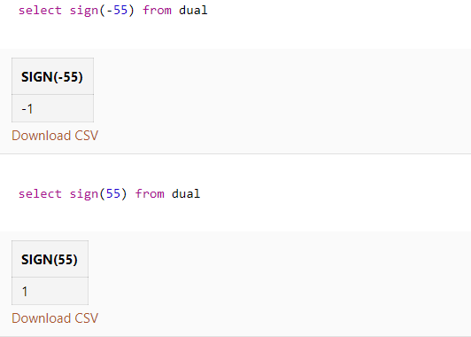

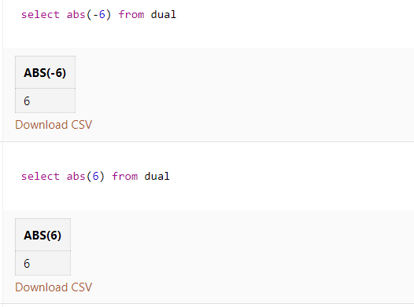

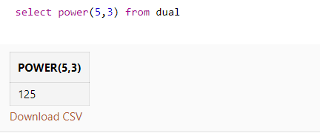

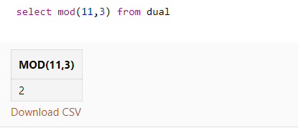

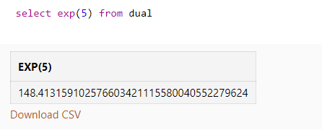

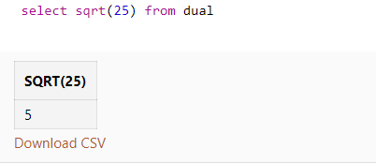

**RESULT:** The inbuilt SQL functions were studied and executed successfully.