DBMS LAB

Experiment-4 (DCL)

Tamojit Sarkar

RA1811027010034

CSE-BD Sec-I2

# **Aim:** To run DCL(Data Control Language) statements in SQL.

DCL(Data Control Language) : -

DCL includes commands such as GRANT and REVOKE which mainly deals with the rights, permissions and other controls of the database system.

1. **GRANT**-gives user’s access privileges to the database.

Example:

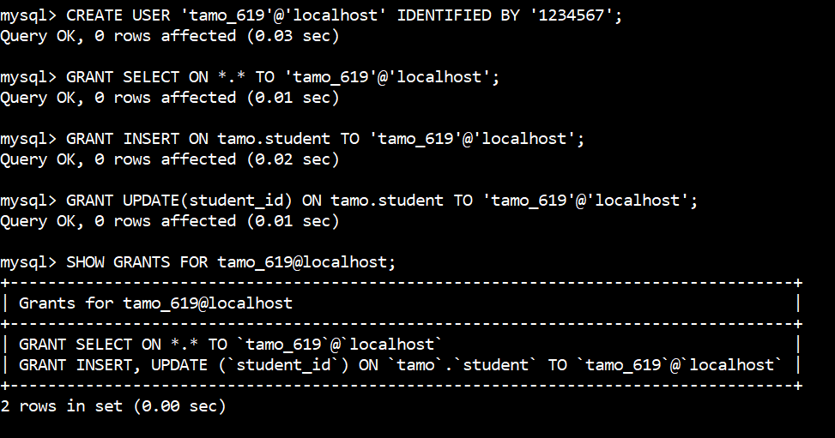

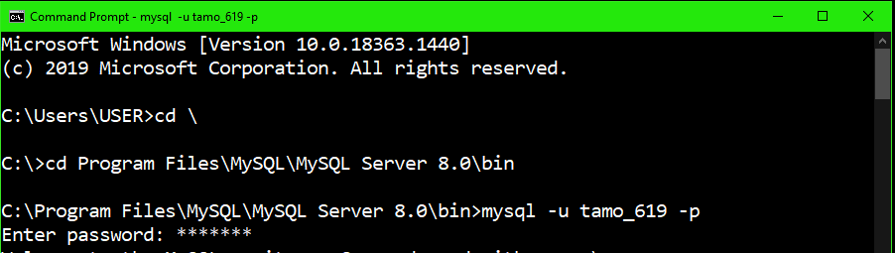

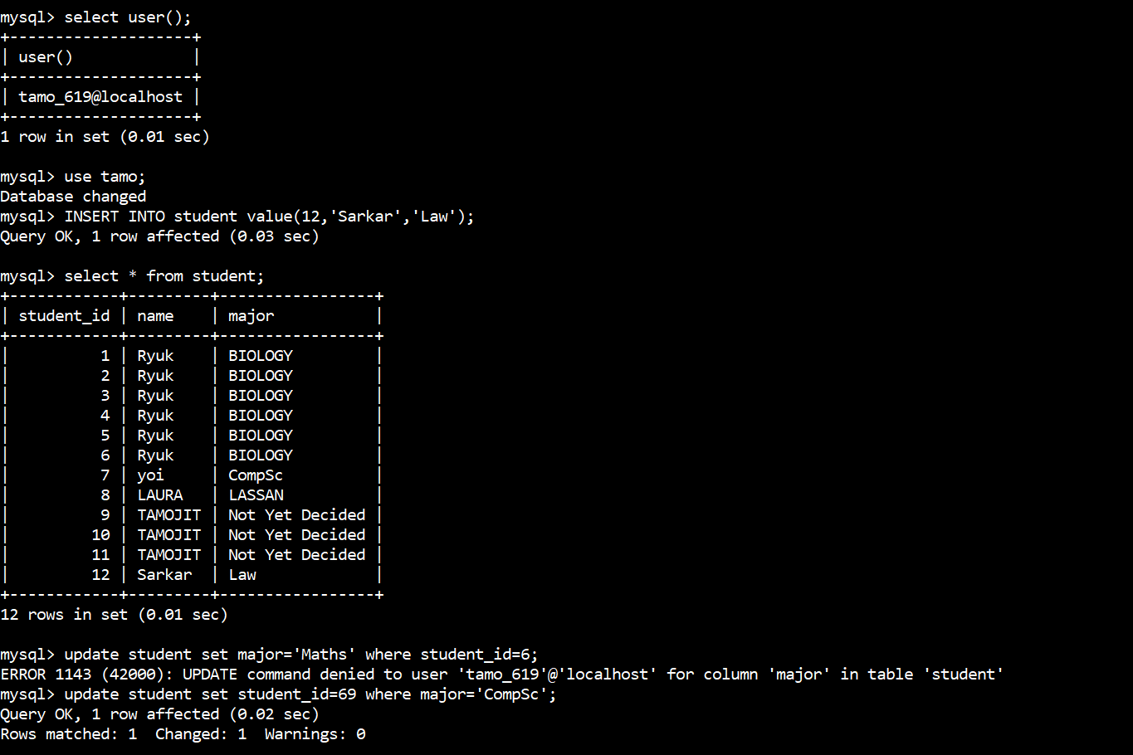

1. **REVOKE**-withdraw user’s access privileges given by using theGRANT command.

Example:

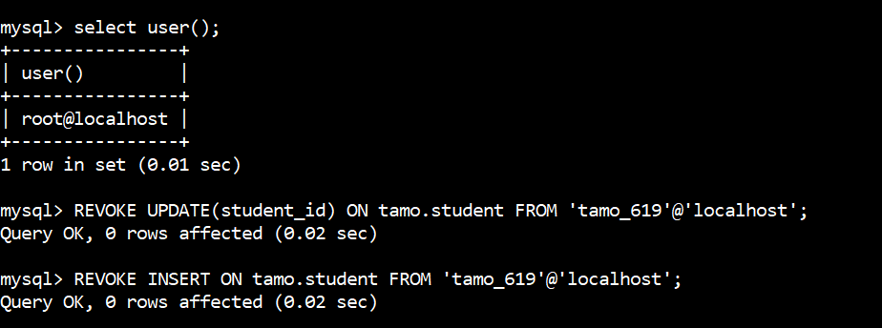

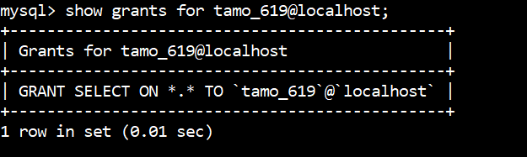

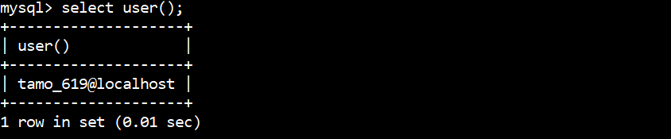

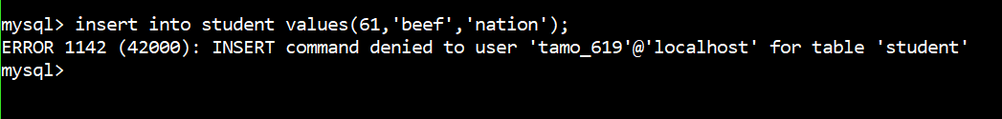

**Result:** Hence we have successfully demonstrated the use of DCL Commands.